
DOCUMENTATION SERIES
Operations SOP
Detailed, in-app procedures for creating, routing, updating, approving, and closing operational records.
PURPOSE Use this document at the point of work. It identifies the PULSE workspace, the fields that make each record usable, the allowed handoffs, and the record that must exist at completion.

AUDIENCE  Users, project leads, travelers, reviewers, approvers, and administrators | STATUS  Final delivery
VERSION  2026.07 | REVIEW  After a material change

How to use this SOP
A workflow starts in the named workspace and ends only when the stated record is saved and visible in PULSE. Required below means required for a usable operational record even where the screen permits a temporary draft or blank value.
Term | Meaning
Record owner | Person accountable for accurate fields and follow-through.
Official record | The saved PULSE record in its workspace; supporting files alone do not replace it.
Status | The current workflow state shown to other users; update it when the work state changes.
Control | The check that prevents an incomplete, unauditable, or misleading record.

SOP 01 — Create and maintain a project
Workspace: Projects | Owner: project lead or delegate | Use: when a new project, subproject, or portfolio workstream needs an accountable home.

Create the project
- Navigate to Projects and select New Project.
- Enter Project name (reader-facing), Portfolios, and a clear Description.
- Add Members using the people picker to establish the initial roster. (Optionally add a cover image).
- Save the new project, then open it to configure Settings: set Lifecycle status, Technical health, and essential Dates (start, due, completion) before assigning work.
Project field | Enter | Use it for
Project name | Clear project or effort name | Navigation, reports, and the project banner.
Portfolios | Applicable portfolio names | Portfolio rollups and filtering.
Description | Plain-language purpose and expected outcome | Shared context for users entering the project.
Members | People or groups who participate | Roster, meeting participation, and owner selection.
Settings → status | Lifecycle and current technical health | Portfolio health and escalation views.
Settings → dates | Start, due, and completion dates | Schedule views and overdue identification.
Settings → roles | Named project roles and contacts | Accountability and handoff context.

CONTROL Before creating tracker work, verify the project name, portfolio, members, lifecycle status, and due date. Do not use a project description as a substitute for an owner or a dated task.

Maintain tracker work and risks
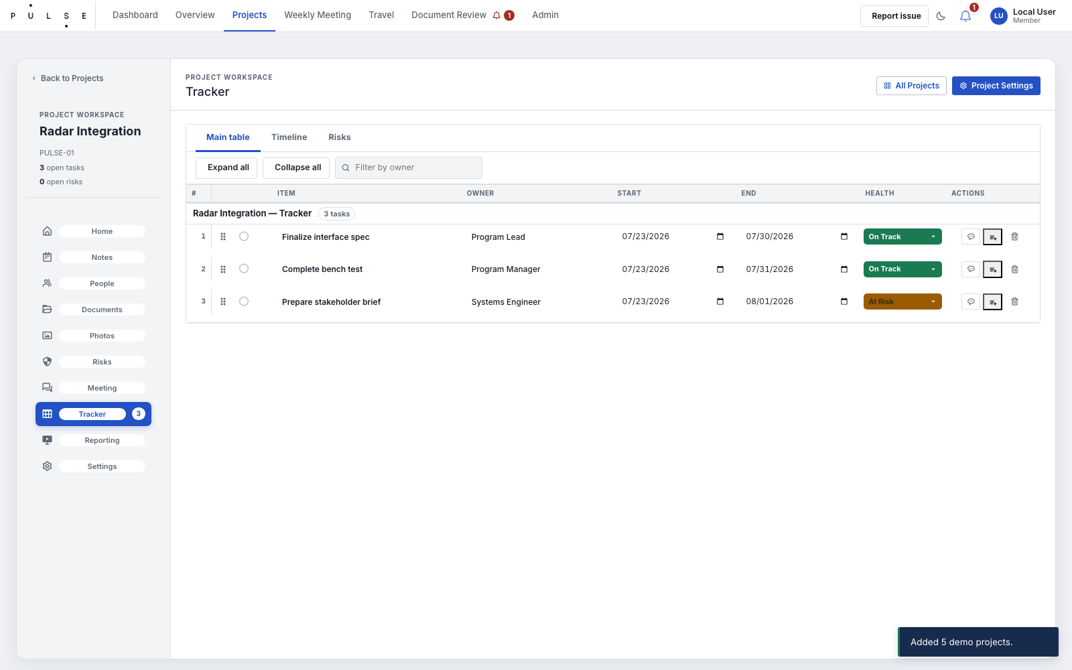
Current Project Tracker.
- Within the project, open the Tracker and create or edit the work item.
- Give the item a concise action title, then assign an owner and define Start date, Due date, Action status, and Health.
- Use Not Started, In Progress, Blocked, On Hold, Complete, Done, or Cancelled for Action status.
- Use Health to communicate On Track, At Risk, Off Track, Blocked, On Hold, or Complete.
- If a task is Blocked, you must enter the dependency in the Blocked reason field. If On Hold, enter the On-hold reason.
- For a risk, enter a name, description, owner, likelihood, impact, category, mitigation plan, due date, response strategy, and current risk status.
- Review red or amber project health, blocked work, overdue dates, and open risks during the project meeting; update the record instead of leaving the change only in notes.
COMPLETION Project information is current; every active task has an owner, status, and usable date; every blocked or high-risk condition has a documented cause and recovery path.

SOP 02 — Run a weekly or project meeting
Workspace: Weekly Meeting or Project → Meeting | Owner: facilitator or project lead | Use: scheduled operational review and decision capture.
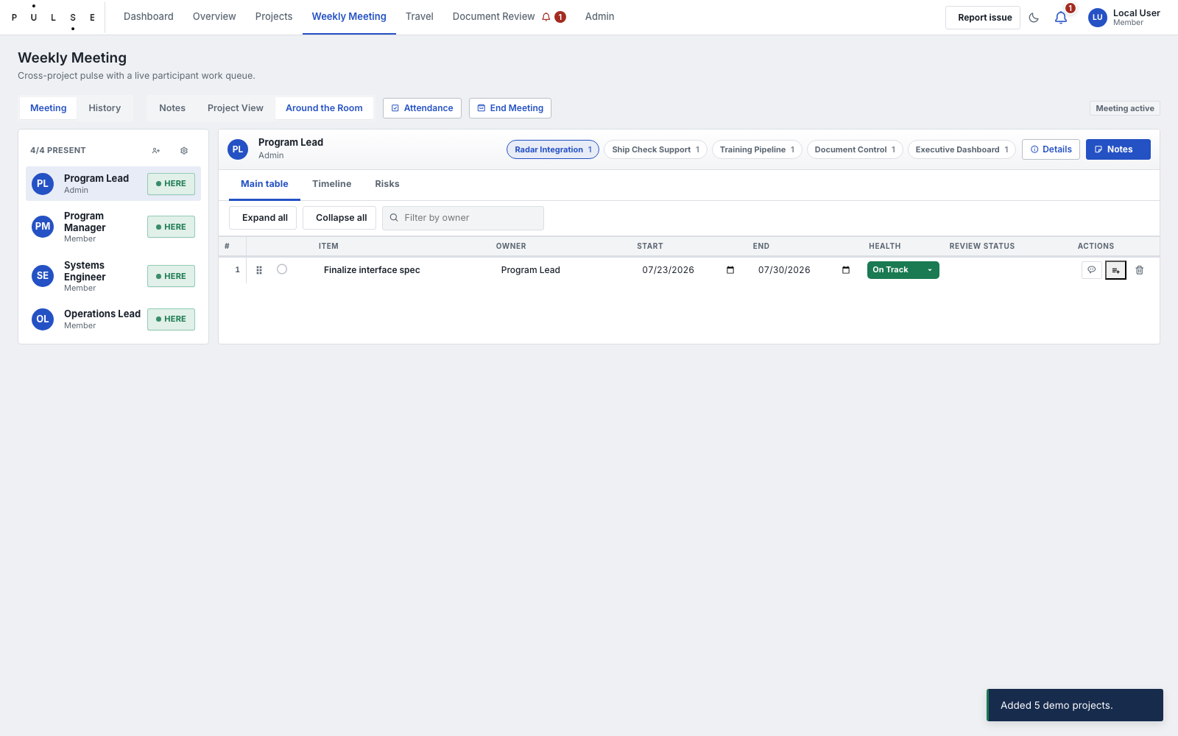
Weekly Meeting.
- Open the correct meeting scope. Use Weekly Meeting for the general series; use the project Meeting tab when the discussion is project-specific.
- Set or confirm Meeting date, Meeting series, and attendees. Use the project roster as the default participant source for a project meeting.
- Review the agenda, current Rocks, tracker items, risks, and carry-forward work before beginning discussion.
- During the meeting, enter Notes for context; record Decisions separately when a choice, approval, or direction must be traceable.
- For every follow-up, create or update the underlying tracker item with owner, due date, status, health, and notes. Do not rely only on Action items in meeting notes.
- Record risk changes and project status changes when the meeting changes a condition visible to the portfolio.
- End the session only after the follow-ups are visible in the tracker and the meeting Session status is ended.
Meeting field | What it records | Rule
Meeting date / series | Which session the record represents | Use the scheduled date and a recognizable series name.
Attendees / attendance | Who was invited or present | Keep the roster aligned to actual participants.
Agenda | Topics to be covered | Use it to structure the session, not to store decisions.
Notes | Discussion context | Summarize facts, issues, and rationale.
Decisions | Traceable choices or approvals | State the decision and owner/context.
Action items / carry-forward | Follow-up work | Create a corresponding tracker item when action is required.
Session status | planned, active, or ended | End only when notes and actions are complete.

CONTROL Meeting notes do not replace owned, dated tracker work. A decision without an owner or a resulting record is not closed.

SOP 03 — Submit and manage travel
Workspace: Travel → New Request | Owner: requester; approver and finance roles act at the assigned stage | Use: standard, engineering, project, contractor, or leave requests.

Create the request
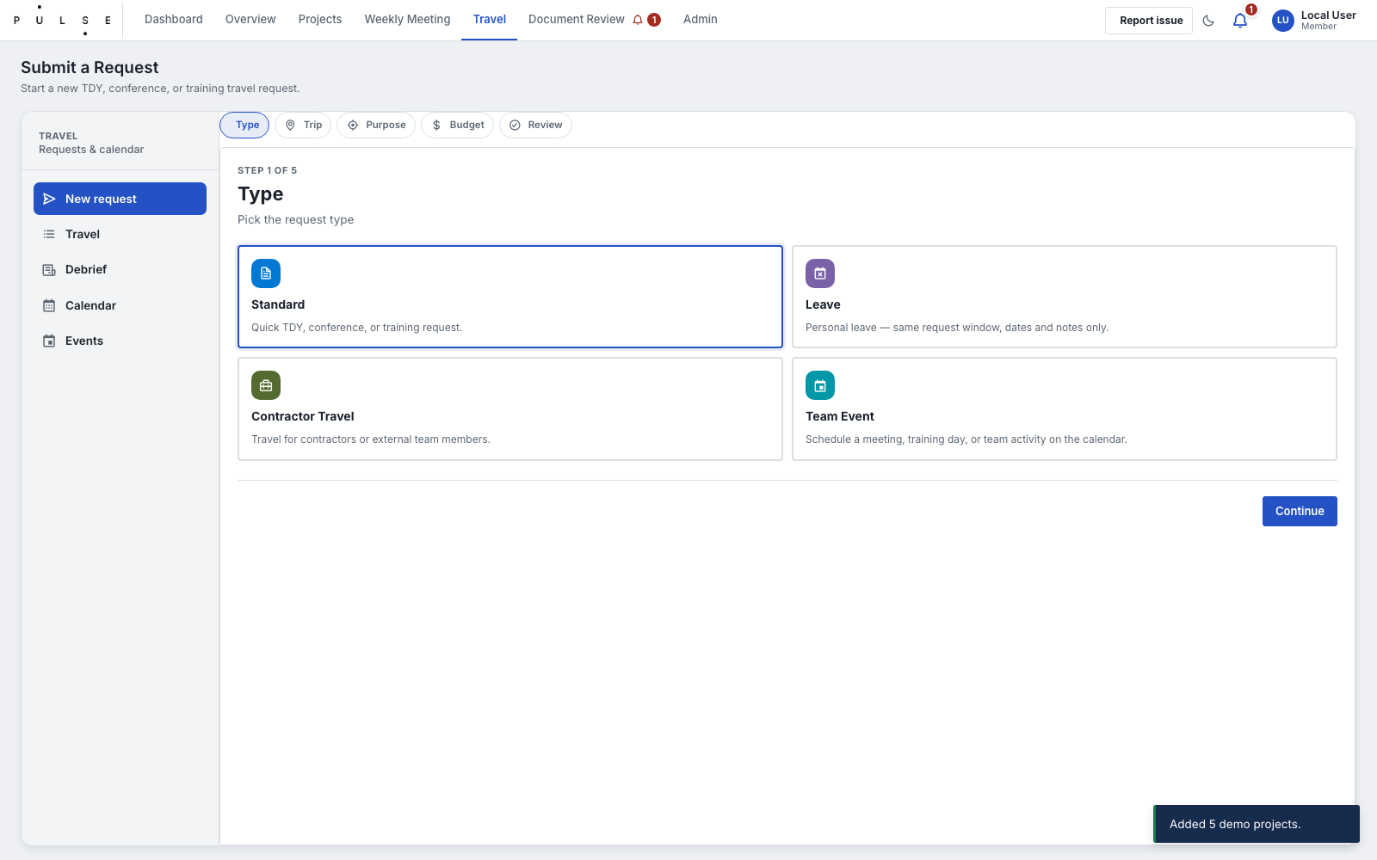
Travel Request Wizard.
- Choose the correct request type. Select the specialized engineering form only when the request requires its additional travel details.
- Enter the trip title, traveler roster, destination, start date, end date, time information when applicable, purpose, and impact if not approved.
- Select related project records when travel supports project work. Enter travel type, estimate, alternatives considered, and travel notes when those fields apply.
- For an engineering request, complete its additional traveler, location, date, transportation, and funding detail fields before submission.
- Review the summary, then submit. The system assigns the request identifier and creates the Travel request record.
- Use My Travel to monitor a request you submitted or are traveling on. While it is pending, correct it through Edit or withdraw it through Revoke when appropriate.
Travel field | What to enter | Why it matters
Trip title / Request type | Clear purpose and correct form category | Identifies the request and drives the applicable form.
Travelers | Requester plus every traveler | Controls visibility and links individual debriefs.
Destination / dates / times | Actual location and planned travel window | Calendar, duration, and approval context.
Purpose / impact | Business need and consequence of non-approval | Decision rationale for the approver.
Project / travel type | Related project and TDY, conference, training, or other | Reporting and operational context.
Estimate / alternatives / notes | Cost context, options, and restrictions | Supports an informed approval.
Charge object | Finance assignment when required | Completes the finance handoff.

Approve, assign finance, or close
- Approvers use Travel → All Travel. Review the identifier, travelers, destination, dates, purpose, impact, estimate, project, and attached form details before acting.
- For a non-leave request in Pending, select Approve to move it to Pending Finance, or Deny and enter a clear denial reason. Leave requests follow their concurrence action.
- Finance users open Pending Finance, enter the charge object, and finalize the approval. The request then shows Approved.
- Requesters may cancel an approved request they no longer need; authorized administrators may cancel when required. Do not overwrite history to represent cancellation.
- After approved travel, each traveler opens Debrief, selects the request, and enters trip dates, systems or subjects, classification, summary, and follow-up. Save one debrief per traveler.
STATUS PATH Pending → Pending Finance → Approved. Other terminal or corrective states are Denied, Revoked, and Cancelled. Calendar visibility is not authorization evidence.

SOP 04 — Route and complete document review
Workspace: Document Review | Owner: document owner; reviewers and signers perform assigned actions | Use: auditable review, concurrence, final-pack, and signature workflows.
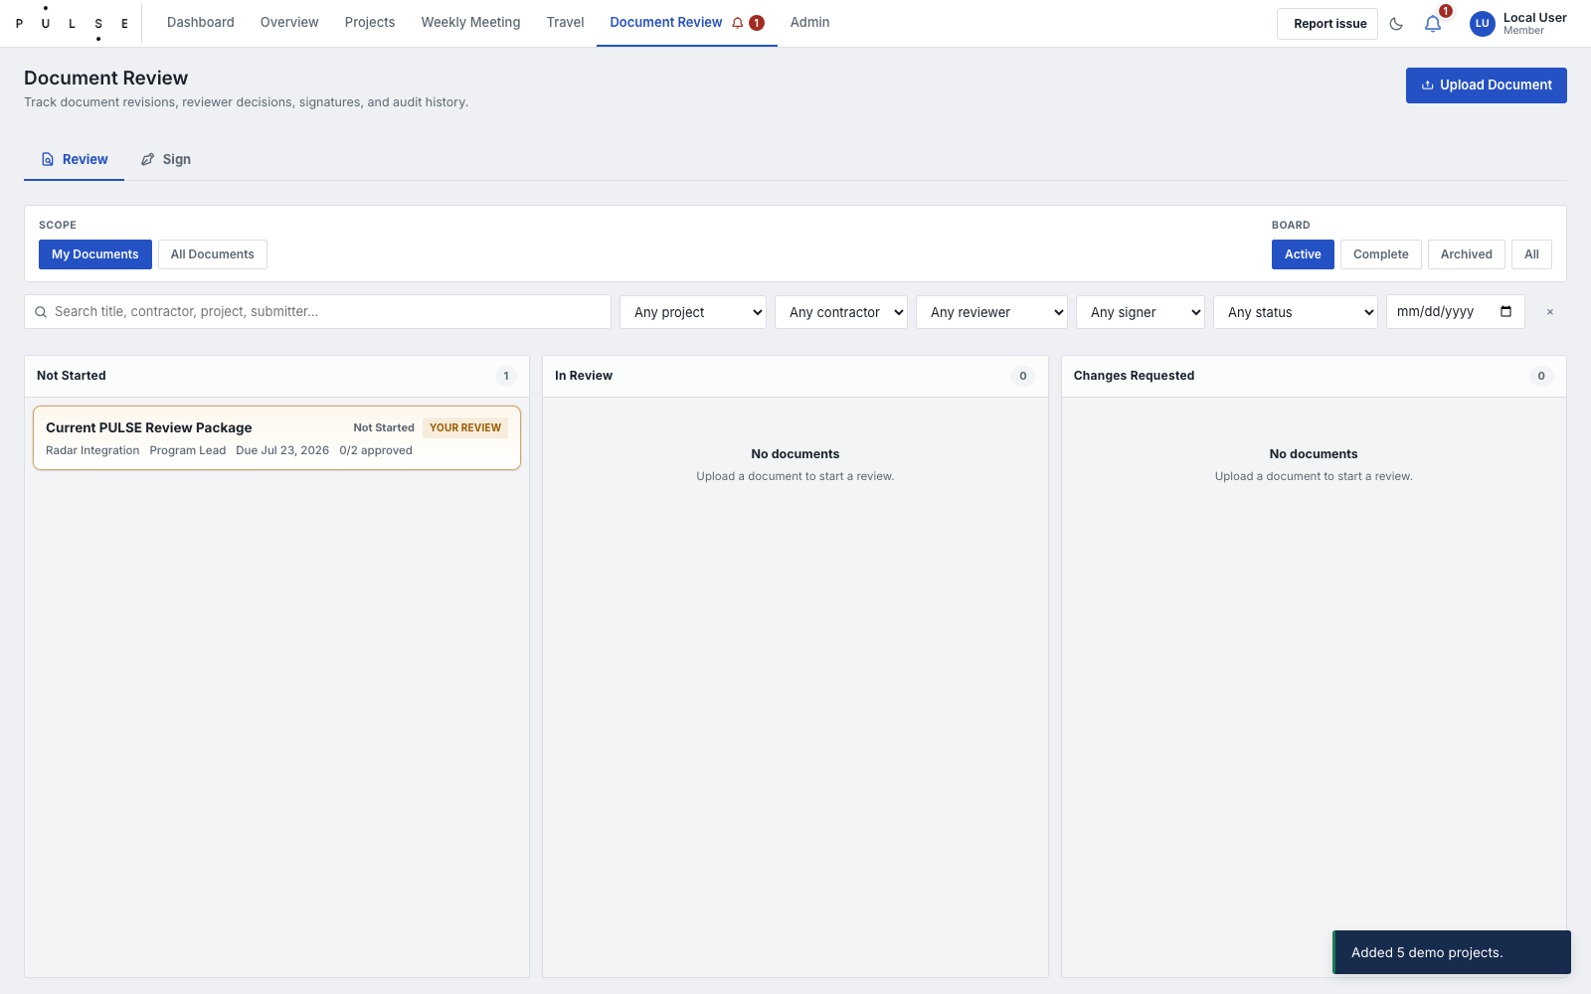
Document Review Board.
- Navigate to Document Review and click New Review. Select the related project, document type, and kind. Provide the Title, Due Date, and Revision Label (e.g. v1.0).
- Upload the Current File representing the exact version to be reviewed. The system retains revision history.
- Add individual Reviewers or a reviewer group. Designate specific reviewers as Signers only if sequential signatures are required after review.
- Submit the review. Reviewers will receive notifications and must log their decision (Approved/Changes Requested) along with any actionable comments against the current revision.
- If any reviewer requests changes, the owner must update the local file, upload it as a new revision, and restart the review cycle for the new revision. Do not overwrite history.
- When all reviewers approve, the record enters Review Complete when no signature is required.
- If signatures are required, upload the Final Pack PDF to move it to Awaiting Final Pack and begin sequential signing.
- Signers download the pack, sign externally, and upload the signed file to advance the record to Signed.
Document-review field | What to enter | Control
Project / document type / kind | Business context and record class | Use the correct project and document classification.
Owner / submitter / deadline | Accountability, source, and due date | Owner is accountable for routing and follow-up.
Revision label / current file | The exact revision under review | New revision resets review decisions for the new content.
Reviewers / reviewer group | People required to decide | Use named people; group selection expands to people.
Signers / signing order | Sequential signatory roster | Lock and preserve the order once signing begins.
Comments / decisions | Actionable review outcome | Comments must explain requested change or approval rationale.
Final pack | PDF used for signature stage | Upload only after review completion; it is not a draft revision.

STATUS PATH Not Started → In Review → Changes Requested or Review Complete. Signature-required records continue through Awaiting Final Pack, Signing in Progress, and Signed; archive only after the record is complete.

SOP 05 — Administer access and setup
Workspace: Admin | Owner: authorized administrator | Use: onboarding, offboarding, role maintenance, and controlled setup.
- Open Admin and confirm current-user and target-site diagnostics before changing roles or schema.
- In Users, create or update the person’s PULSE App Role. Maintain user email, display name, active state, role, job title, access selections, and notification preferences as applicable.
- Choose the least-privileged role that supports the person’s work: Admin, Meeting Admin, Finance Admin, Document Admin, Manager, Member, or Viewer.
- For offboarding, set the role record inactive rather than deleting the operational history associated with the user.
- Use SharePoint Setup to validate or provision the required lists and fields. Do not manually improvise a list or column as a substitute for the schema.
- Review logs or activity records after sensitive changes and retain at least one active recovery-capable administrator.
CONTROL Site membership alone is not the normal application authorization model. Role, active state, and the live role record must agree before an access issue is considered resolved.

Incident reporting minimum
For any workflow defect, record the time, workspace and route, affected project/request/document identifier, user role, exact field or action, expected result, actual result, browser or device, and approved screenshot. Preserve logs or activity evidence. Do not repair production roles or schema while the cause is still unknown.

