
DOCUMENTATION SERIES
User Guide
The practical path through daily work, project delivery, meetings, travel, and reviews.
PURPOSE Use this guide as a quick working reference. It explains where to act, what creates an official record, and when to request help.

AUDIENCE  Authorized users | STATUS  Final delivery
VERSION  2026.07 | REVIEW  After a material change

1. Begin each work session
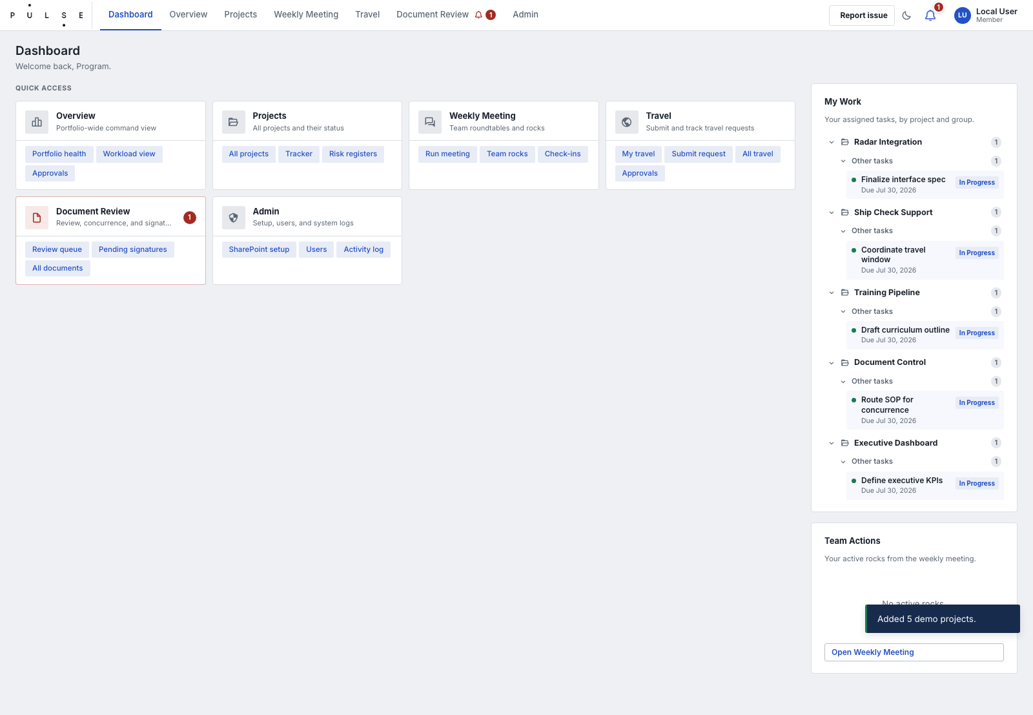
Dashboard — Start-of-session attention items.
Open PULSE from the approved SharePoint page. Your existing SharePoint session establishes your access; there is no separate PULSE password.

Your opening check
Confirm name  and role | Review attention  items | Open My Work  and priorities | Act, assign,  or schedule

- Use Dashboard as the start-of-session checkpoint.
- Use Overview → My for assigned work and Overview → Team for the portfolio-level summary.
- Use the bell and user menu for attention items and notification preferences.
- If the application opens outside SharePoint, local fallback is non-persistent. Do not treat that data as an official record.

2. Find the right workspace
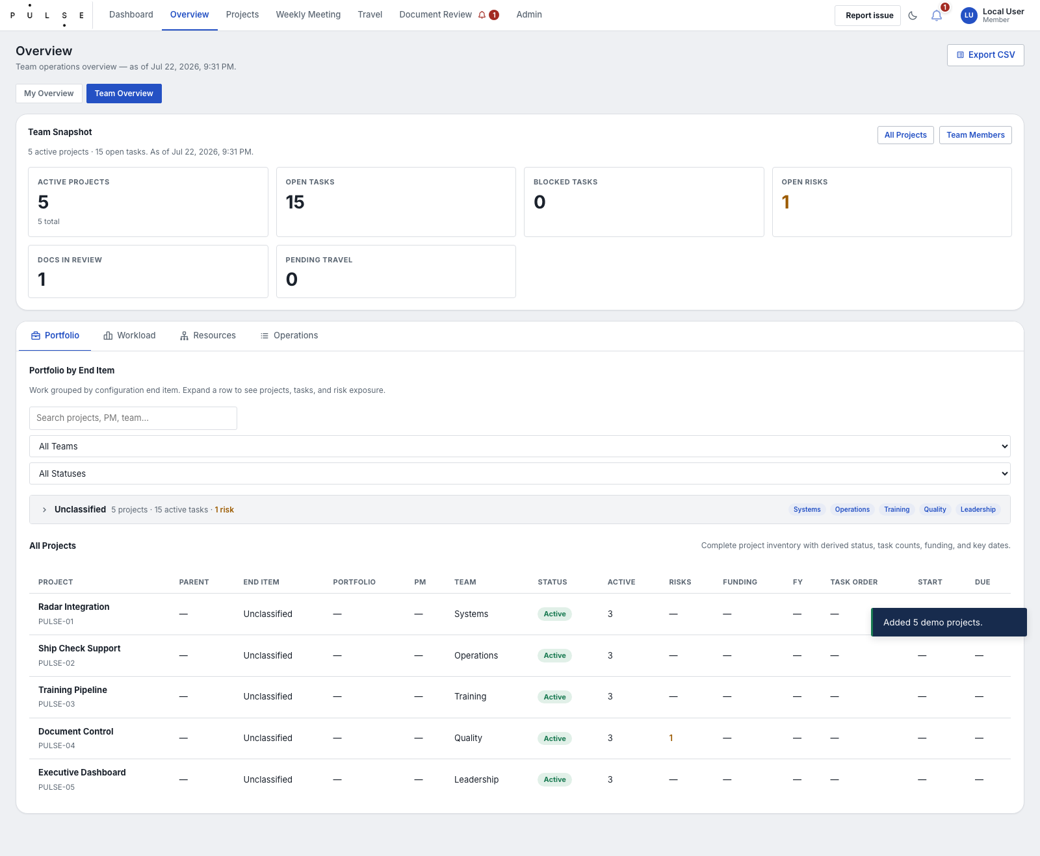
Overview — Live portfolio summary.
Need | Use | What to do
Portfolio health | Overview | Read the summary; make edits in the underlying workspace.
Project delivery | Projects | Maintain scope, roles, dates, tracker work, risks, and project context.
Meeting decisions | Weekly Meeting | Capture decisions and convert follow-ups into owned actions.
Travel request | Travel | Create, submit, monitor, and update the request.
Formal concurrence | Document Review | Route the correct revision to named reviewers and preserve history.

3. Maintain project work
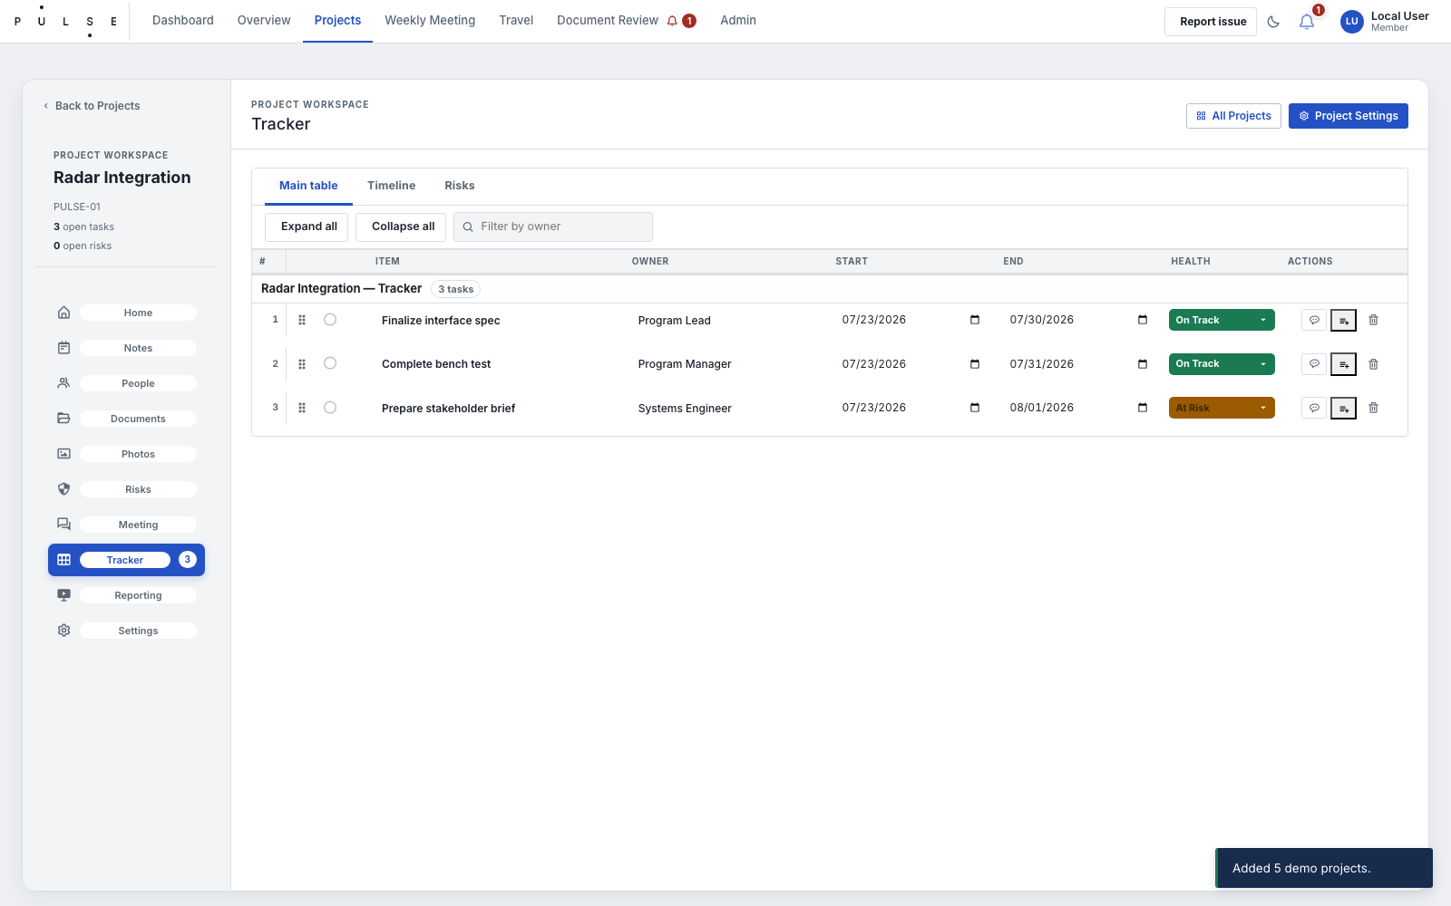
Project Tracker — Record actionable dates and health.
- Open Projects and select the required project.
- Confirm project health, dates, lifecycle details, and named roles before changing records.
- Create or update tracker work with an owner, practical date, status, and clear execution context.
- Use Blocked only when work cannot proceed. State the dependency and raise the recovery action in the appropriate meeting.
WORKING RULE Boards and checklists help visualize a workflow. The tracker is the authoritative work list for ownership, dates, and portfolio health.

4. Run a meeting that creates follow-through
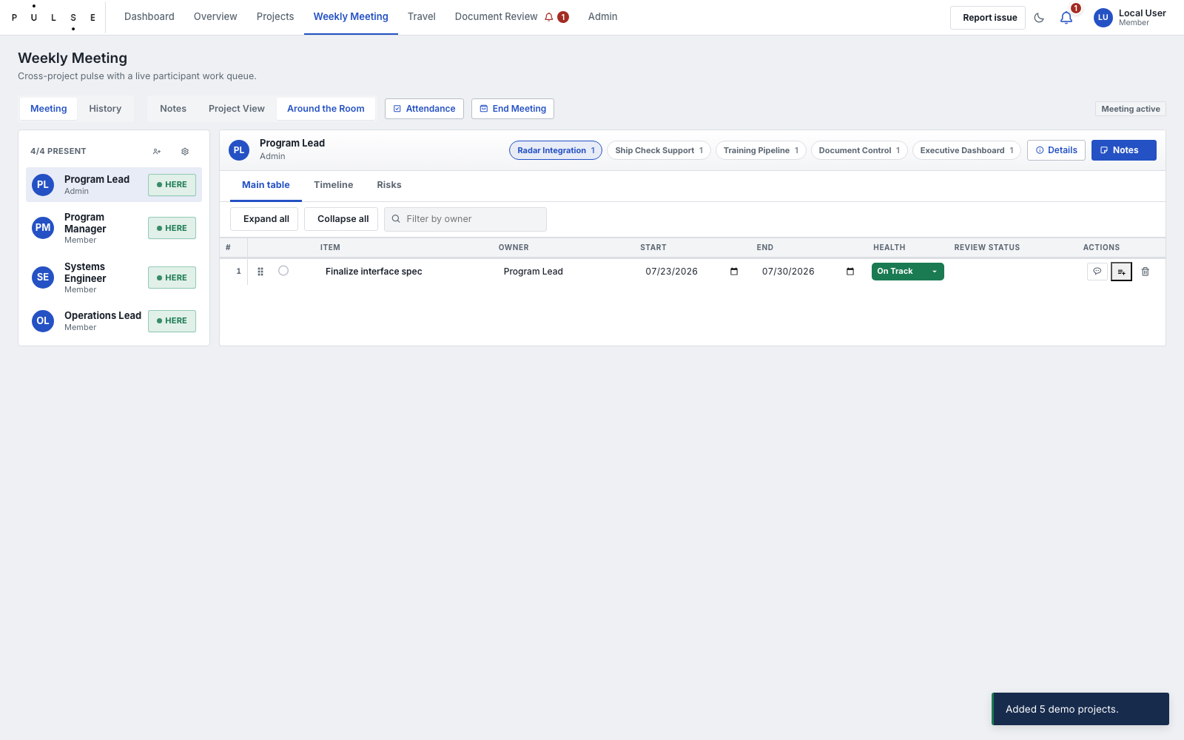
Weekly Meeting — Decisions and carry-forward actions.
- Confirm the meeting scope and participant roster.
- Review prior actions, priorities, and blocked work.
- Capture material decisions and discussion notes.
- Create or update named tracker actions before closing the meeting.
- Verify each action has an owner and date in the appropriate tracker.

5. Submit travel and route reviews
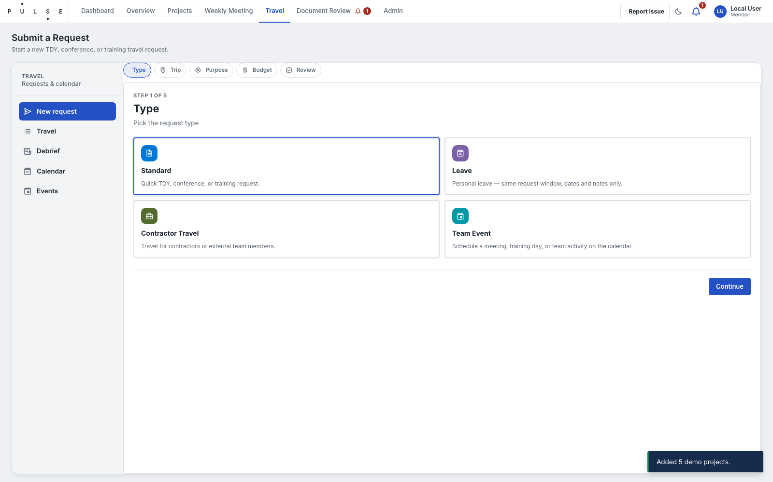
Travel Request — Enter required details.
Workflow | Before submission | After submission
Travel | Enter accurate purpose, dates, travelers, location, estimates, and support detail. | Monitor status, update material changes, and complete any required debrief.
Document Review | Use the current revision, due date, context, and required reviewers. | Monitor decisions and feedback; preserve the revision trail before advancing.

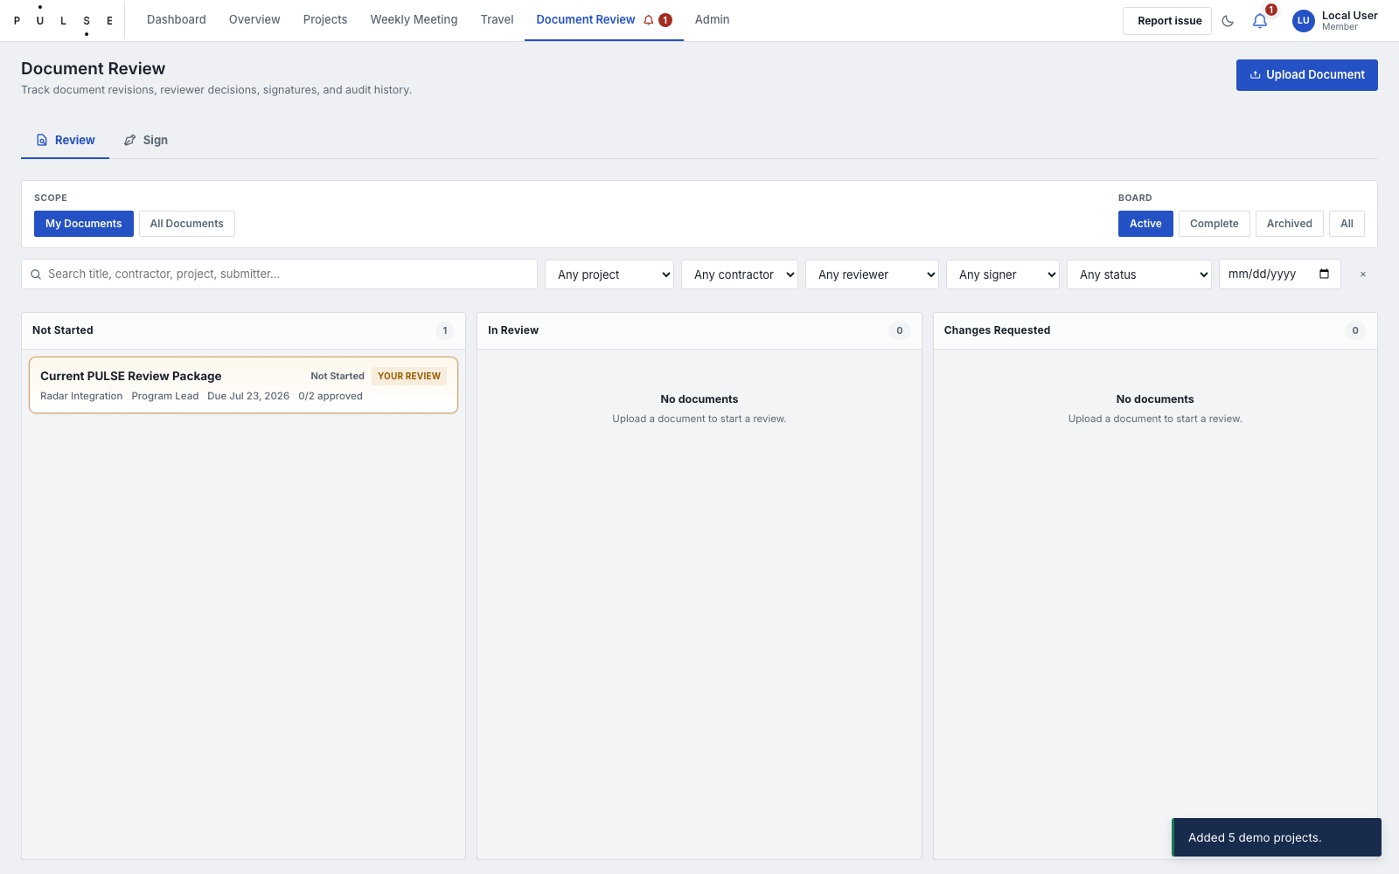
Document Review — Track formal concurrence.
IMPORTANT Calendar visibility is not authorization. A file stored in a project library is not a formal concurrence record.

6. Get help safely
For a defect, capture the time, SharePoint page or route, affected record identifier, your role, expected result, actual result, and an approved screenshot. Refresh first and confirm you are in the approved SharePoint-hosted version. Do not alter roles or schema unless you are authorized to administer them.

