PULSE-IPT — User Guide
Document | PULSE-IPT User Guide
Audience | AEWTTR IPT personnel (all roles)
Scope | Every screen and feature currently implemented in the application
Prepared for | AEWTTR IPT

How to read this manual
This guide is organized the same way the application's top navigation bar is organized — left to right, top to bottom. Each section covers one module: what it's for, how to reach it, what's on the screen, and how to use it. Screenshots are pulled directly from a running instance of the application, so what you see in this document is what you will see on screen.
Callouts are used throughout:
NOTE — Additional context that helps you understand *why* something works the way it does.

CAUTION — An action that is easy to get wrong or has a consequence you should know about before proceeding.

ADMIN ONLY — This screen or control is only visible to users holding the Admin (or a specifically named) role.

Table of Contents

(Right-click and choose "Update Field" after opening in Word to populate page numbers.)

1. Getting Started
PULSE-IPT runs inside your SharePoint site — there is nothing to install. You open it the same way you'd open any other page or web part on your team's SharePoint site, using your existing SharePoint/CAC login. There is no separate PULSE-IPT username or password.

1.1 The App Shell
Every screen in PULSE-IPT shares the same top bar:
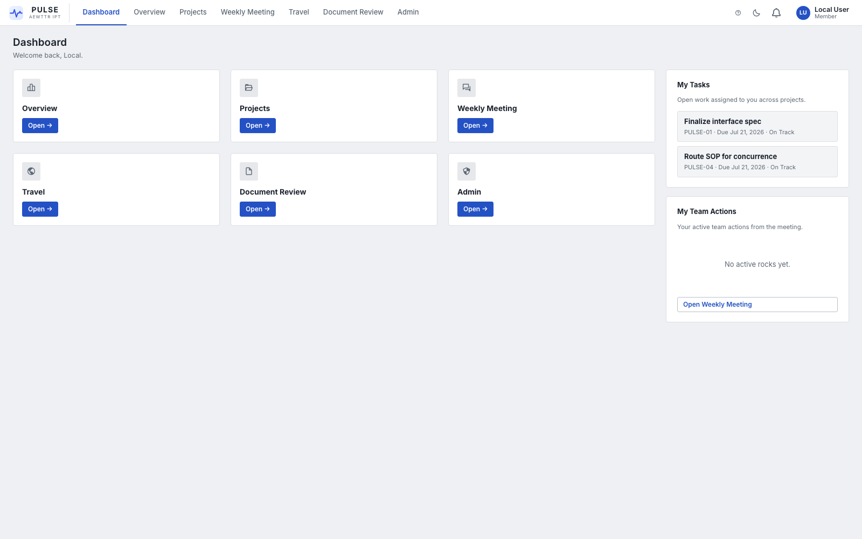
Dashboard and app shell
Element | Location | What it does
PULSE logo | Top-left | Click to jump to the Dashboard from anywhere
Main navigation | Top-center | Dashboard, Overview, Projects, Weekly Meeting, Travel, Document Review, Admin (Admin only shows if you hold an admin-level role)
Help toggle (?) | Top-right | Turns on inline hint text next to fields and controls across the app
Theme toggle (moon/sun) | Top-right | Switches between light and dark mode. Your preference is remembered.
Notification bell | Top-right | Shows an unread badge and a dropdown of recent notifications
Your name / role badge | Top-right | Click it to open your Notification Settings

NOTE — A small red badge can appear on a nav item (e.g. Travel, Document Review, Admin) when something in that module needs your attention — a pending approval, a document waiting on your review decision, etc.

1.2 Local / Offline Fallback
If PULSE-IPT is ever opened somewhere it cannot detect a SharePoint site (for example, a developer testing on a laptop), it automatically starts in a local fallback mode with an empty, non-persisted workspace instead of failing to load. In normal day-to-day use inside SharePoint, you will never see this — it exists purely so the app never shows a blank white screen.

2. Dashboard
Reach it: Nav bar → Dashboard, or click the PULSE logo.
The Dashboard is your landing page and quick-launch pad.

Dashboard
- Quick-launch tiles — one tile per module (Overview, Projects, Weekly Meeting, Travel, Document Review, Admin). Click Open → to jump straight in.
- My Tasks (right rail) — every open tracker task, across every project, that is assigned to you. Click a task to jump to that project's Tracker.
- My Rocks (right rail) — your active quarterly Rocks from the Weekly Meeting module, with a shortcut to open the meeting.

3. Overview
Reach it: Nav bar → Overview.
Overview is the portfolio-level lens on everything happening across AEWTTR IPT. It has five tabs.

3.1 Executive Summary
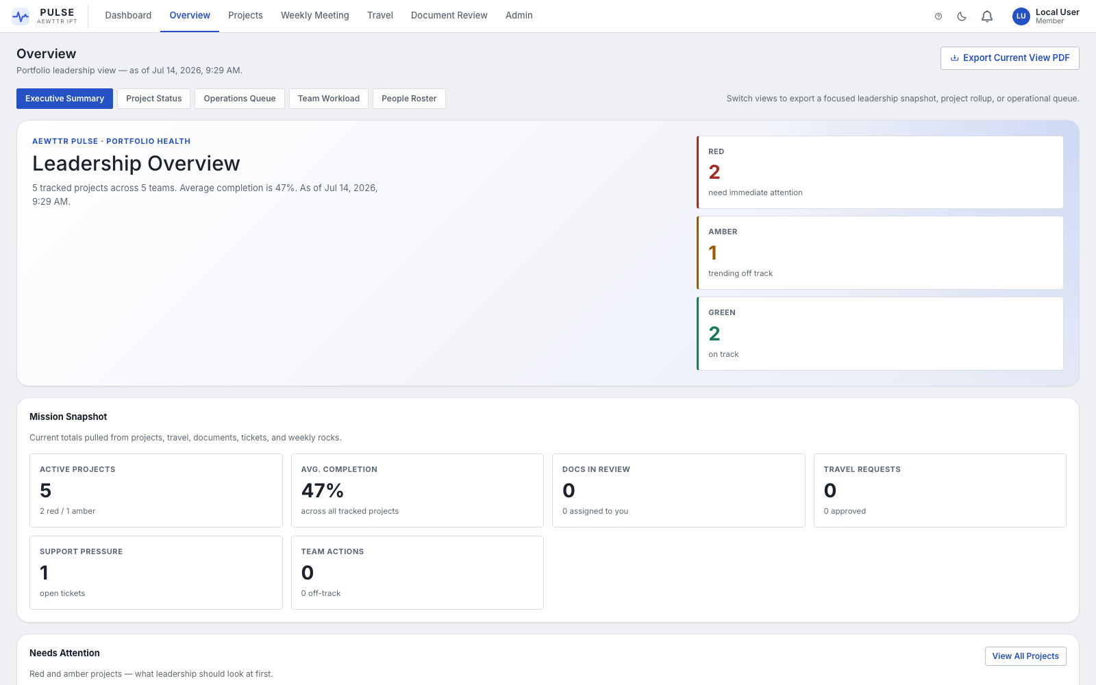
Overview — Executive Summary
The default tab. Top-to-bottom:
- Leadership Overview banner — total tracked projects, average completion %, and a Red / Amber / Green project count.
- Mission Snapshot — active projects, docs in review, travel requests, open support tickets, off-track Rocks, all in one glance.
- Needs Attention — the Red and Amber projects leadership should look at first.
Use the Export Current View PDF button (top-right) to generate a printable leadership snapshot of whichever tab is currently open.

3.2 Project Status
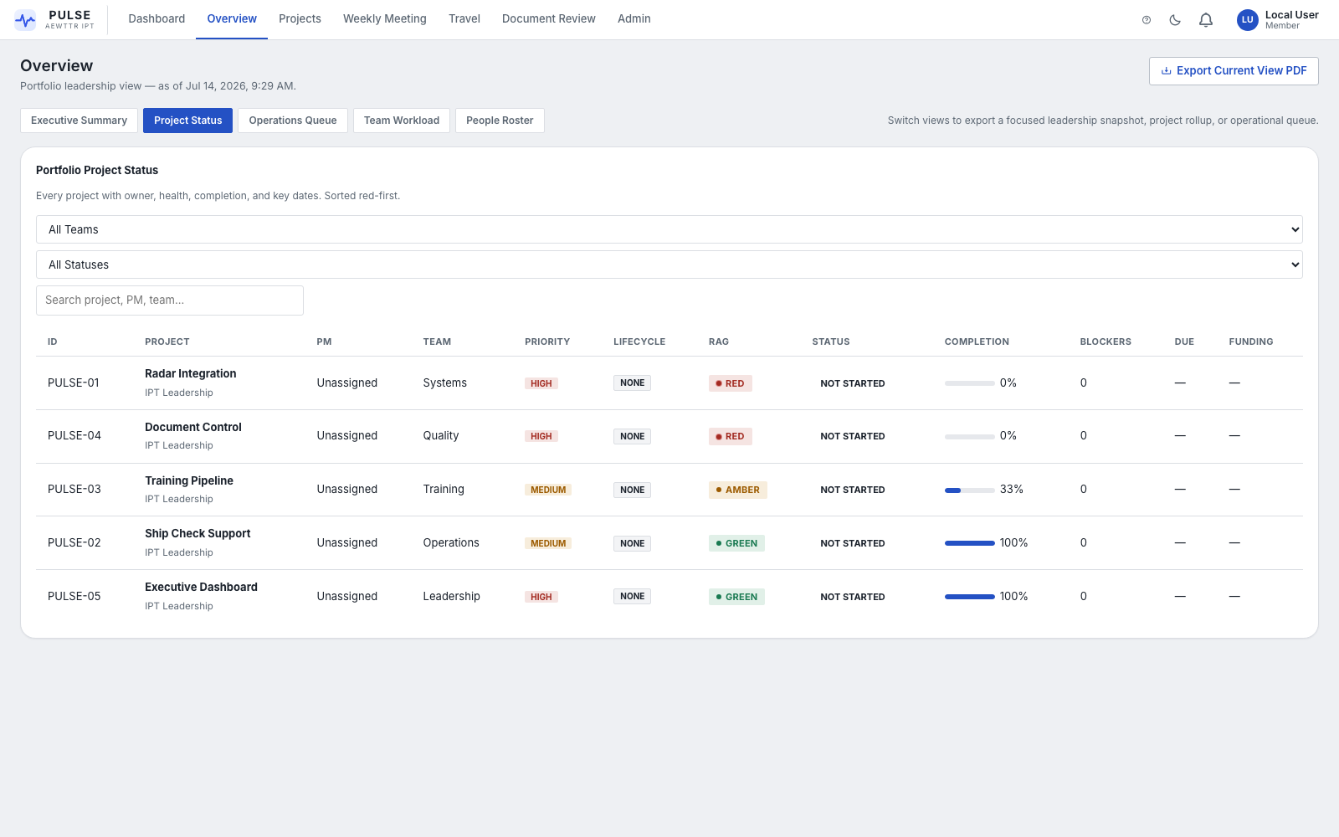
Overview — Project Status
A single sortable, filterable table of every project: PM, Team, Priority, Lifecycle, RAG status, completion %, blocker count, due date, and funding status — sorted Red-first so the projects needing attention surface automatically. Filter by Team or RAG status, or search by name.

3.3 Operations Queue
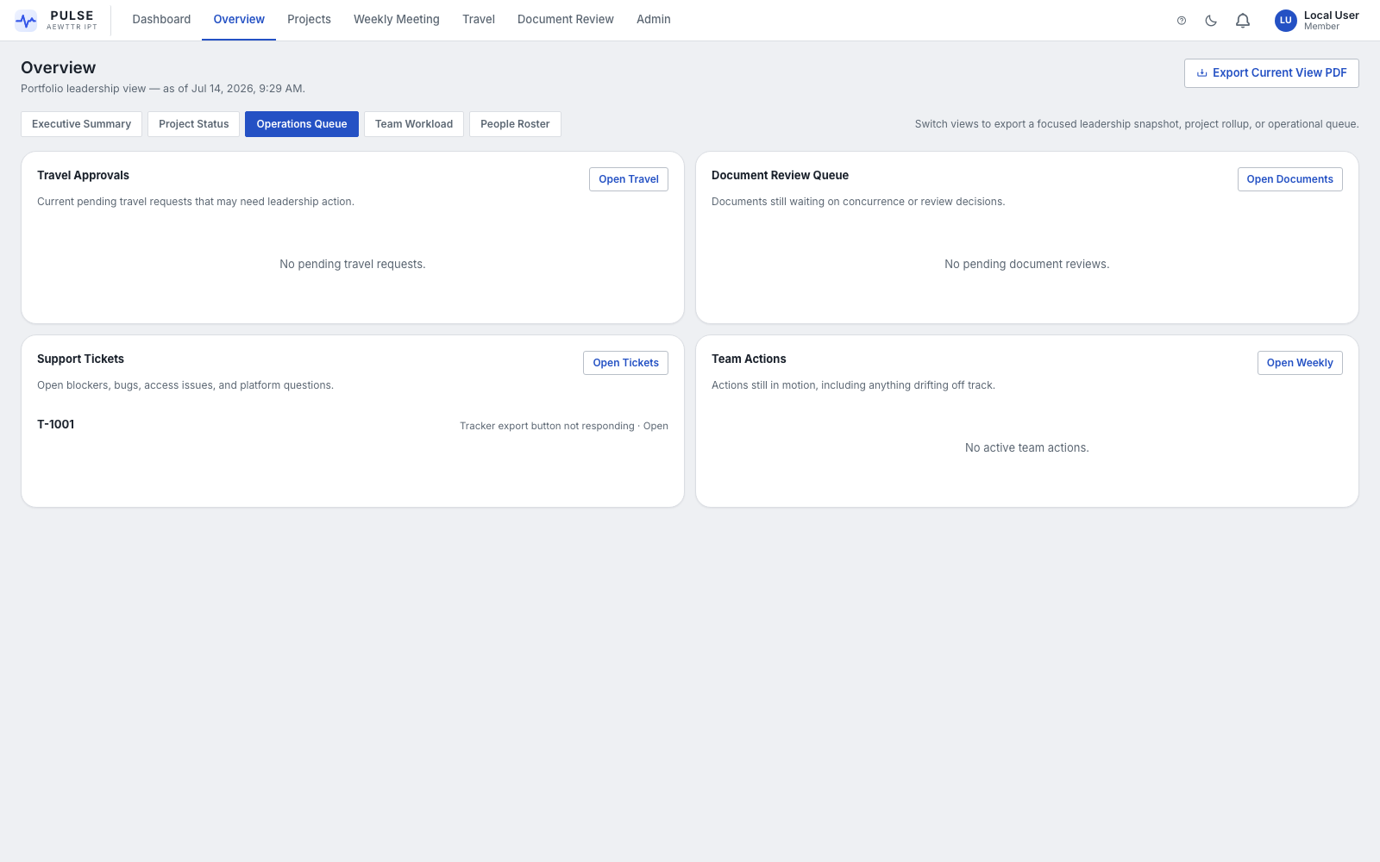
Overview — Operations Queue
Four cross-cutting work queues in one screen, each with a shortcut into its home module:
Panel | Shows | Shortcut
Travel Approvals | Pending travel requests needing a decision | Open Travel
Document Review Queue | Documents still waiting on a review/concurrence decision | Open Documents
Support Tickets | Open blockers, bugs, and access requests | Open Tickets
Team Actions | Active Weekly Meeting Rocks not yet Done | Open Weekly

3.4 Team Workload
Aggregates every open tracker task across all projects by the person assigned to it, showing active task count and estimated effort (hours). Useful for spotting who is overloaded and who has headroom. Click any row to open that person's full detail page.

3.5 People Roster
A directory of everyone with tasks or travel history in the system. Click a person to open their detail page: open tasks (with a jump-to-project link on each), a task-health breakdown (on track / at risk / off track), and their travel history.

4. Projects
Reach it: Nav bar → Projects.

4.1 Portfolio View
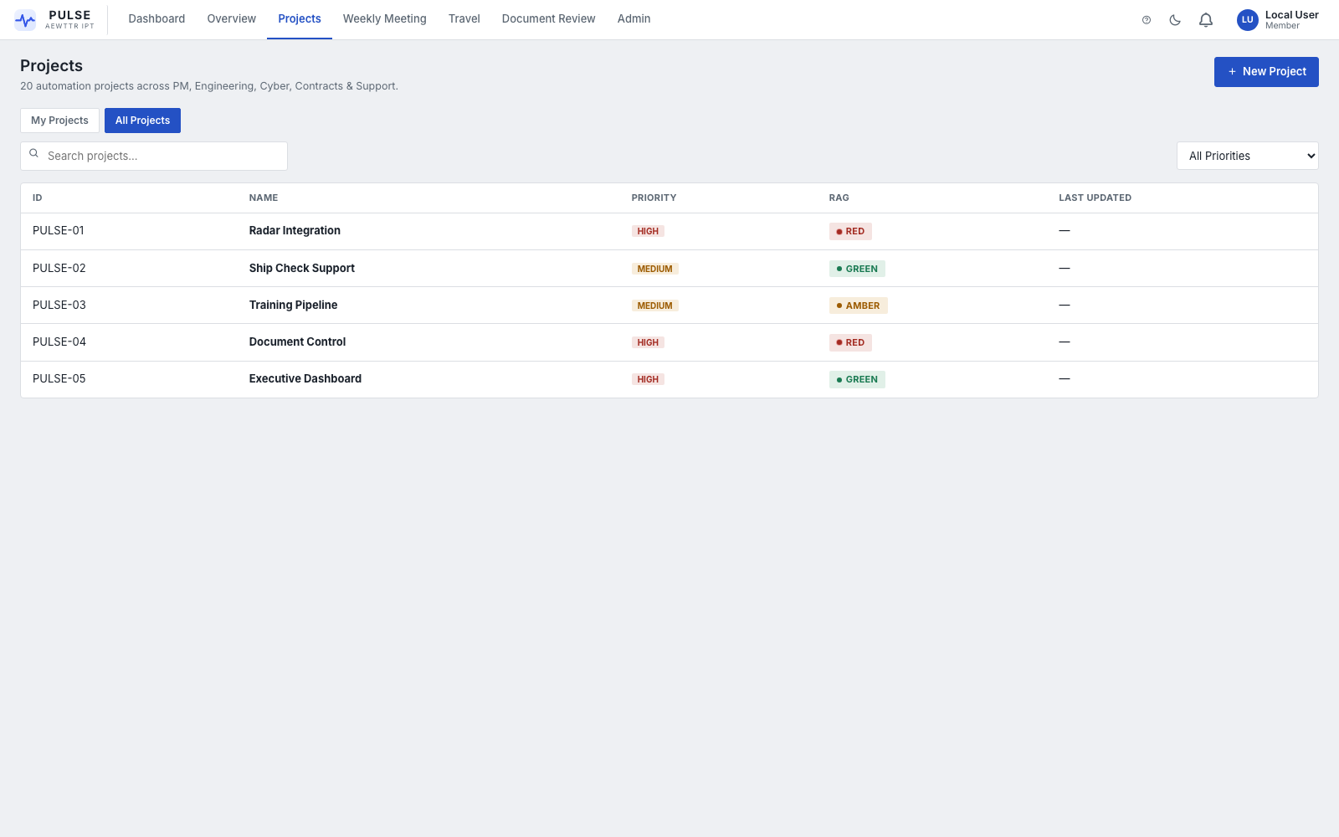
Project Portfolio
The full list of projects, toggle between My Projects (projects you're attached to) and All Projects. Filter by priority or search by name. Columns: ID, Name, Priority, RAG status, Last Updated. Click + New Project to stand up a new project, or click any row to open it.

4.2 Inside a Project
Every project opens into its own workspace with a left-hand rail of tabs. This is the "front door" of PULSE-IPT — from here you can reach every tool relevant to that specific project.

Home
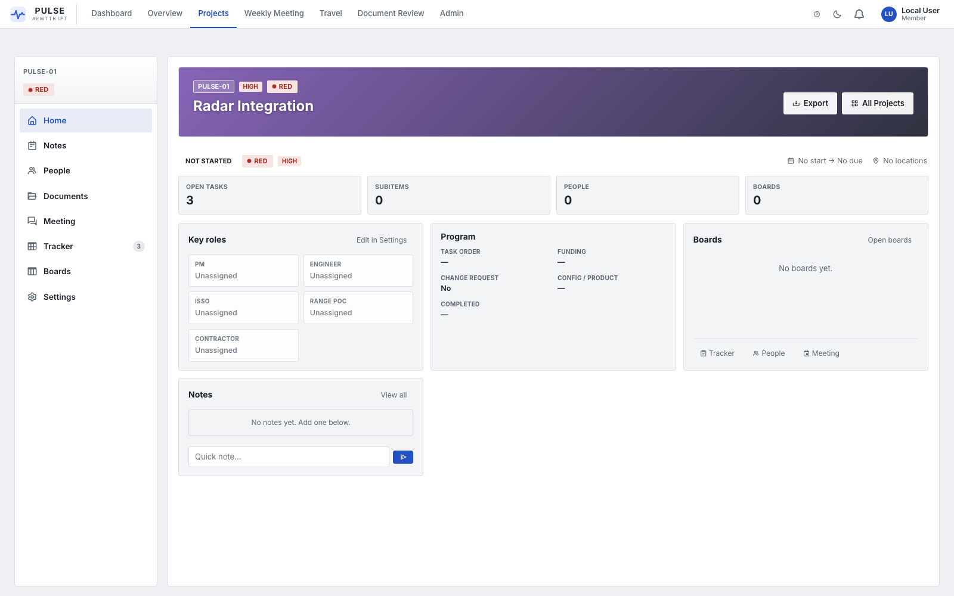
Project Home
The project's cover page: name, RAG badge, priority, lifecycle stage, key dates, and quick counts (open tasks, subitems, people, boards). The Project details panel shows role assignments (PM, Engineer, ISSO, Range POC, Contractor), tools in use, stakeholders, funding, and change-request status. The Boards panel gives one-click shortcuts into that project's Tracker, People, and Meeting.

People
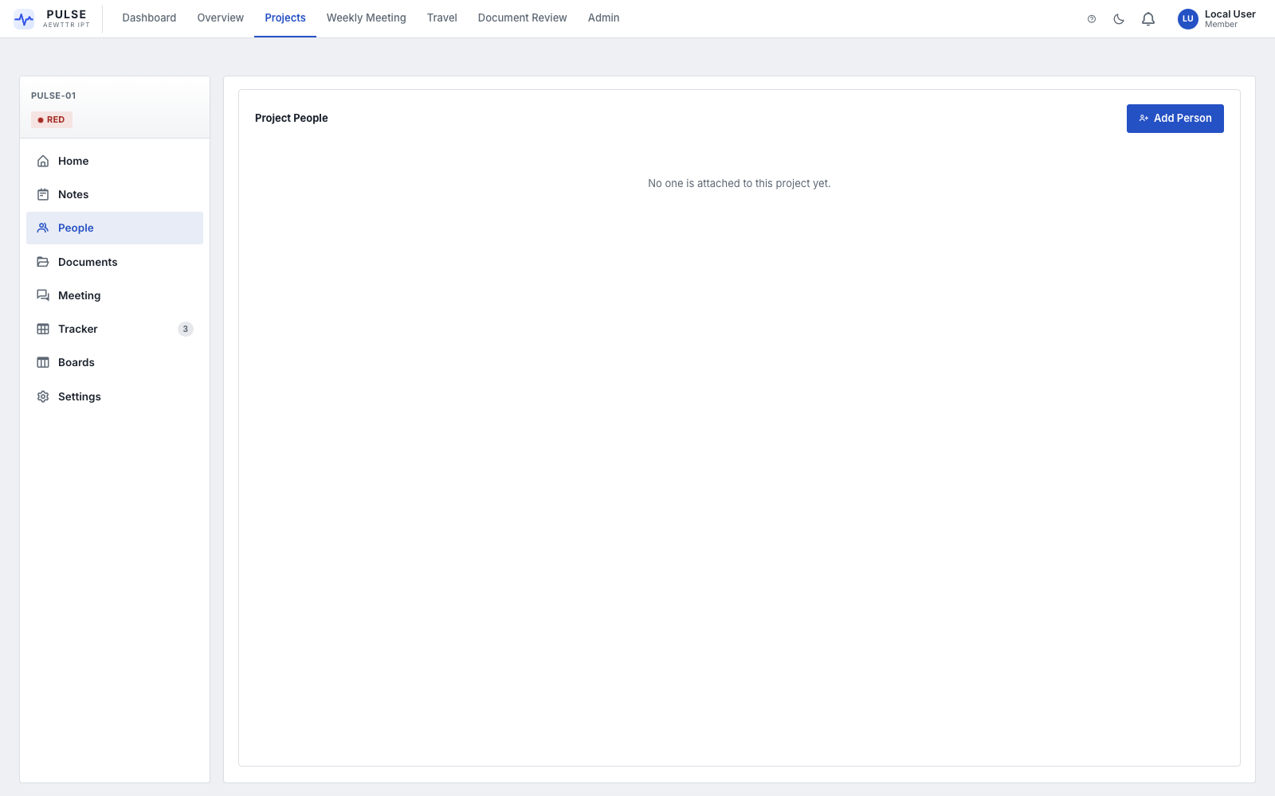
Project People
The project's roster. Click Add Person to attach an internal team member (picked from the org directory), a named contractor, or a company. This roster automatically becomes the participant list for the project's own Weekly Meeting sessions.

Documents
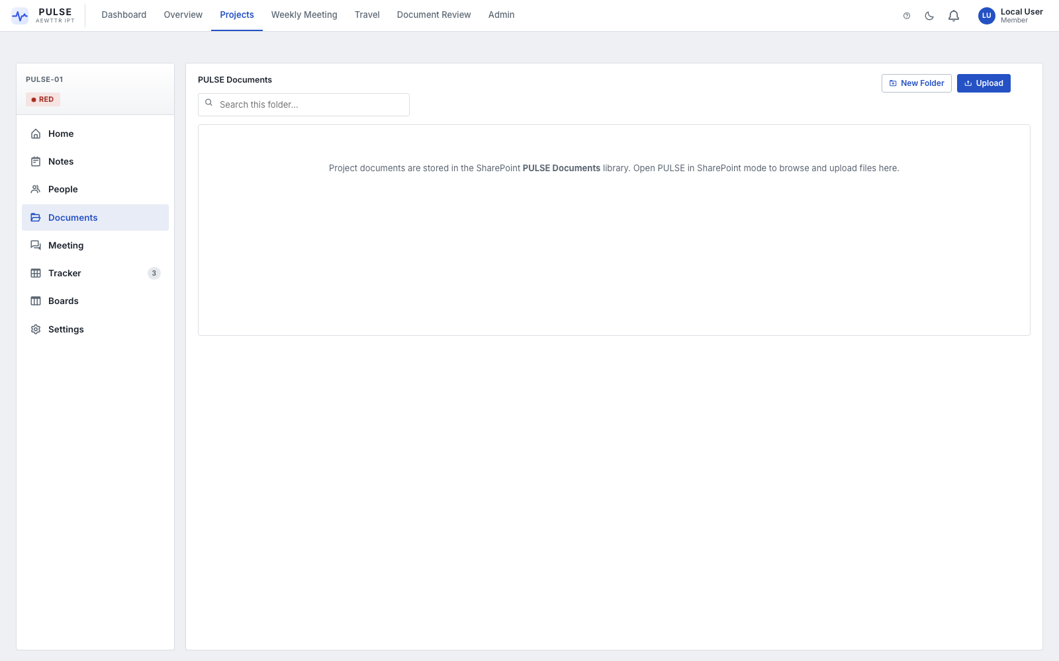
Project Documents
A file browser (folders, upload, search, drag-and-drop) scoped to that one project's SharePoint document library. This is raw file storage — a shared drive for the project.
NOTE — This is not the same thing as the top-level Document Review module. Documents here have no approval workflow attached; Document Review is where a document goes through a formal reviewer sign-off process.

Tracker
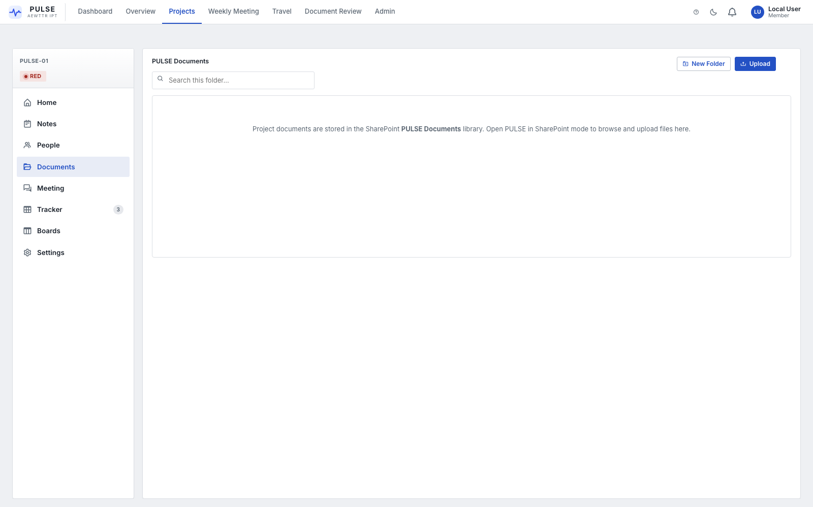
Project Tracker
The project's task list / Gantt chart — the working schedule. Switch between Main table and Gantt view. Each task has an owner, start/end dates, a health flag (On Track / At Risk / Off Track), and can carry subtasks with their own assignee, dates, and related documents. Click + New task to add one, drag a Gantt bar to reschedule it, or drag a row to reorder.
NOTE — Task health here directly drives the project's RAG status. See RAG Configuration for how the thresholds work.

Boards
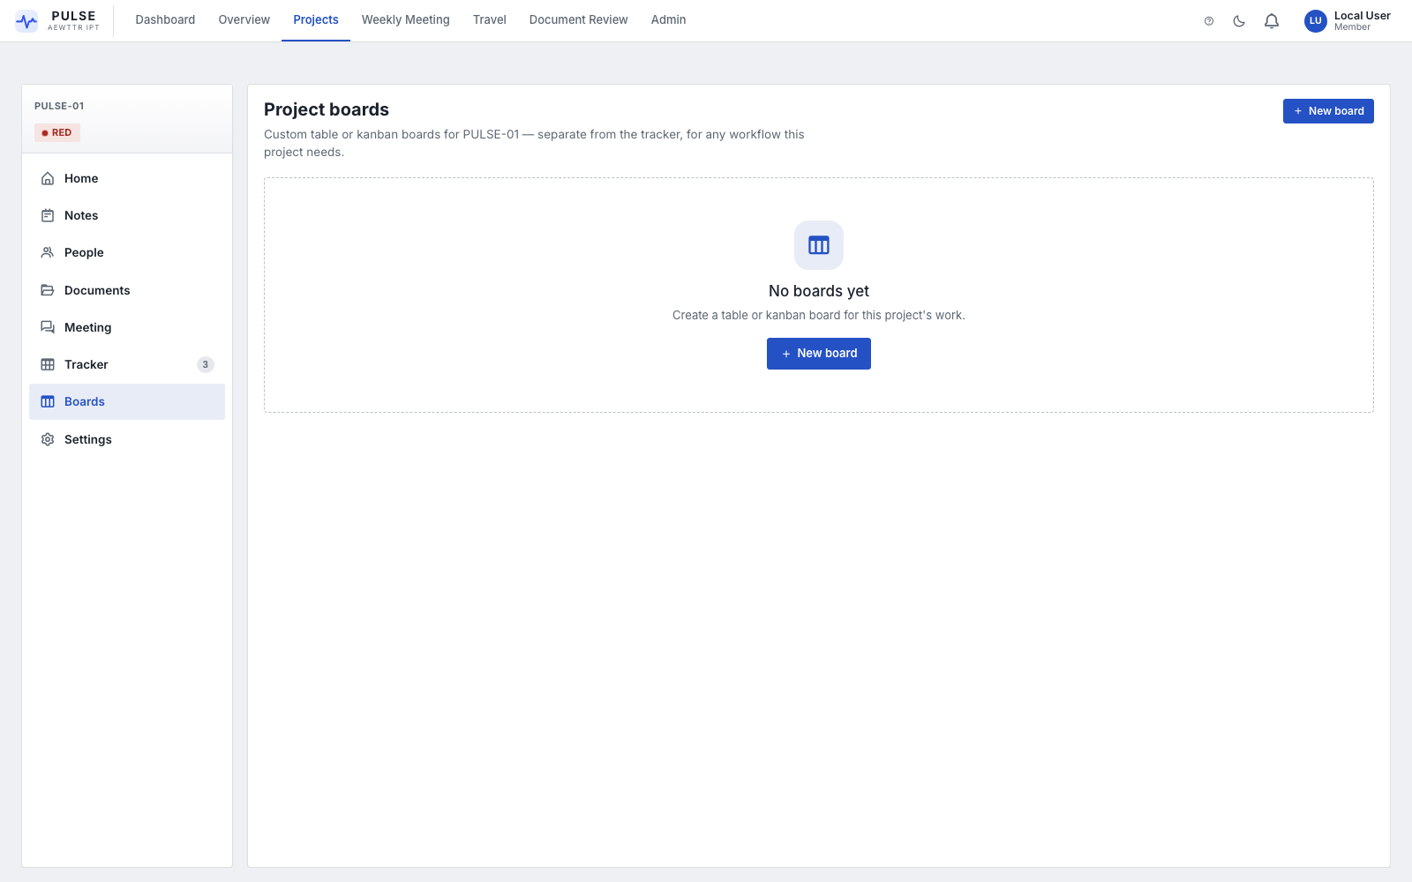
Project Boards
A separate, ad-hoc Kanban/checklist tool for workflows that don't belong on the formal Tracker — intake queues, review checklists, anything with its own set of custom stages. Click + New board to create one as either a table board (spreadsheet-style rows with expandable subitems) or a kanban board (drag cards across columns). Columns are fully customizable — add, rename, recolor, or remove them, and add custom fields that show as tags on each card.

Settings
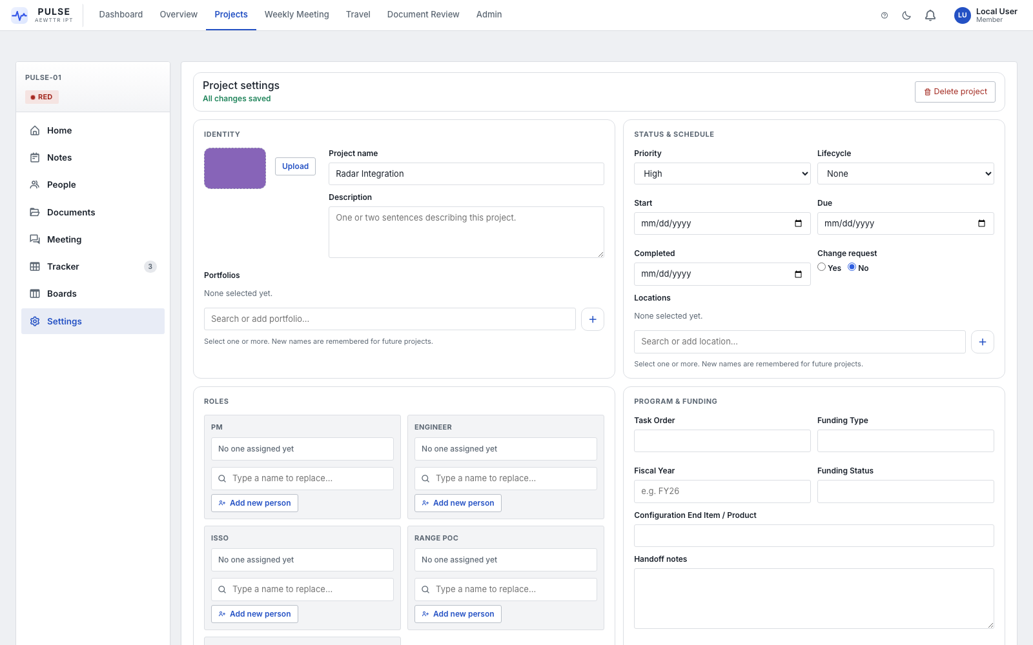
Project Settings
The project's configuration form — autosaves as you type, no Save button needed. Covers identity (name, description, cover image, Portfolios), status & schedule (priority, lifecycle, dates, change-request flag), locations, role assignments, and program/funding fields (Task Order, Funding Type, Fiscal Year, Configuration End Item, handoff notes). Delete project lives here too, top-right.
CAUTION — Deleting a project also deletes its Tracker tasks and checklist items. There is no undo.

Notes
A freeform project journal/notes panel — separate from Weekly Meeting notes — for anything worth writing down that doesn't belong in a specific task.

Meeting
Launches the same Weekly Meeting engine described in Section 5, scoped to just this project and its own roster (drawn from the People tab).

5. Weekly Meeting
Reach it: Nav bar → Weekly Meeting (portfolio-wide), or a project's Meeting tab (that project only).
The Weekly Meeting module runs your standing status meeting live, in the room, with everyone's tasks pulled up automatically instead of a shared slide deck.

5.1 Starting a Meeting
A Meeting Admin starts the session with the Start Meeting button. Once live, a second row of tabs appears:

5.2 Project View
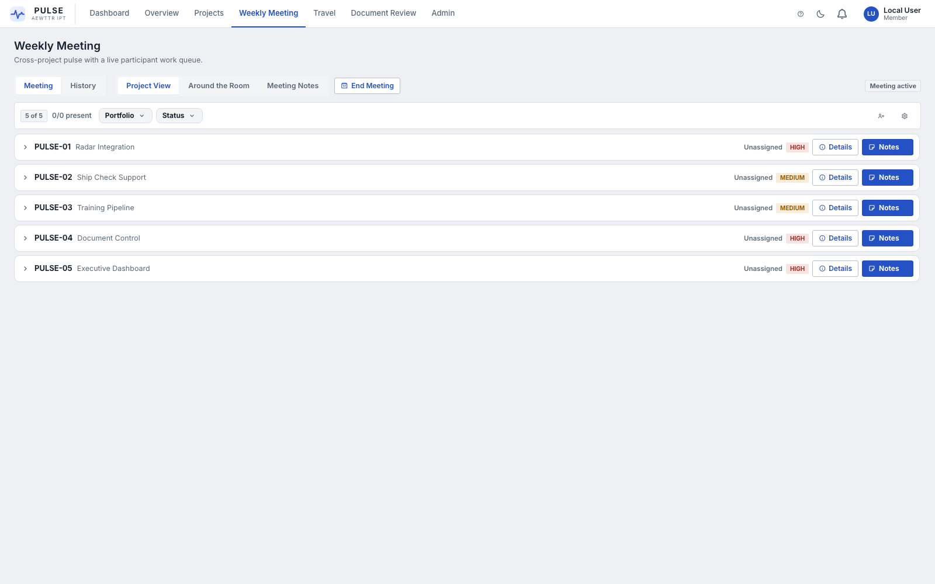
Weekly Meeting — Project View
Every project listed down the left with its live RAG status and open/at-risk task counts. Click a project to pull up its Tracker in the main panel and work through it with the room. Rocks for the selected project/portfolio appear on the right.

5.3 Around the Room
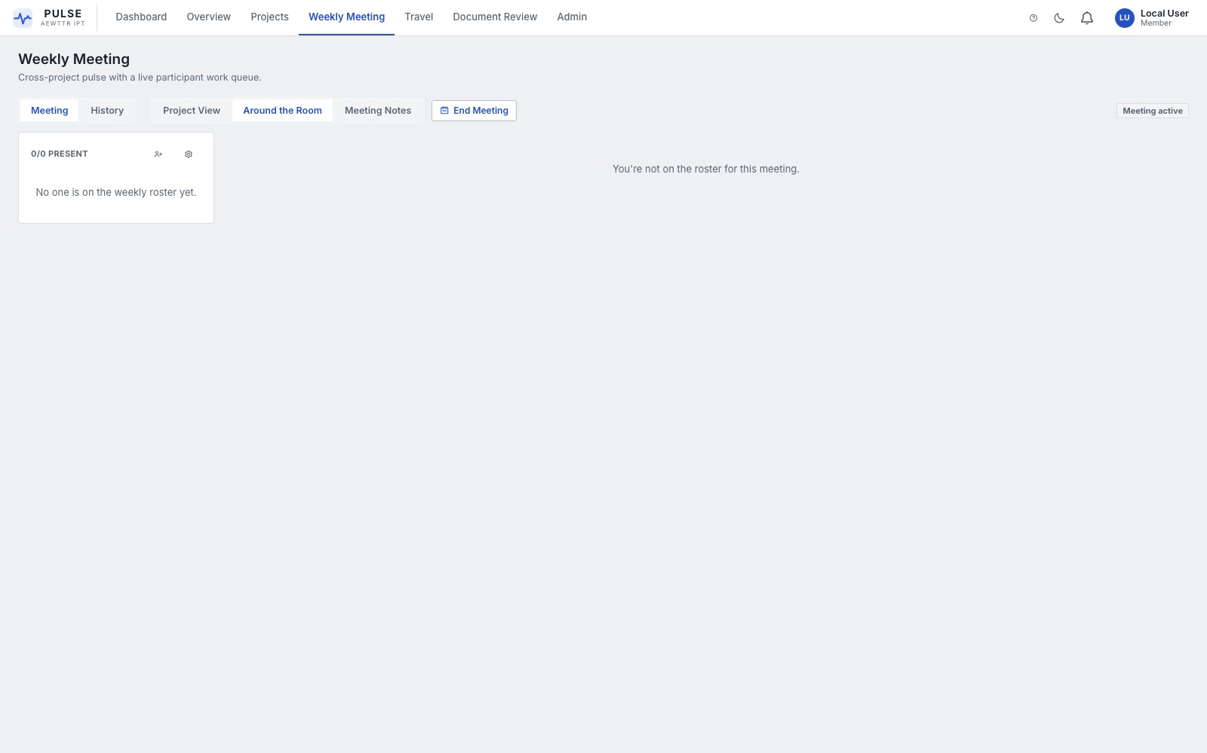
Weekly Meeting — Around the Room
The facilitation mode for going person-by-person instead of project-by-project. The left rail lists meeting participants (drawn from the roster); click a name and their tasks/Rocks come up one at a time — built for literally going "around the room."

5.4 Meeting Notes
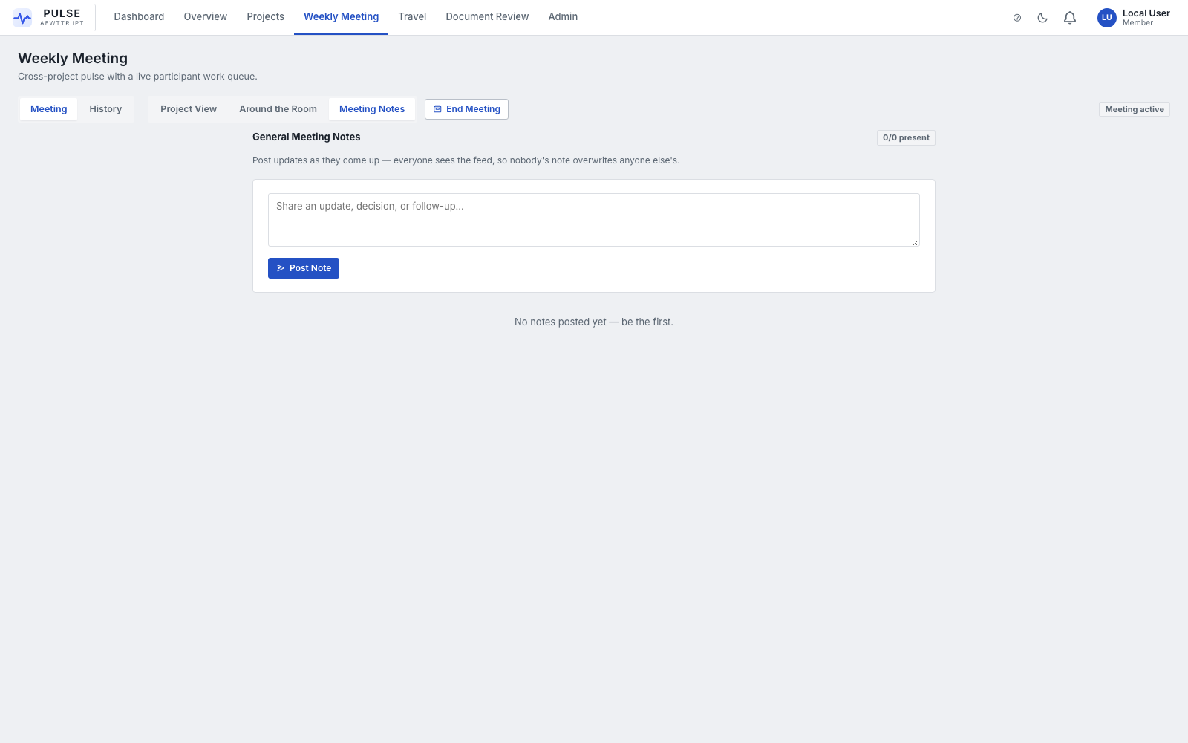
Weekly Meeting — Meeting Notes
A shared, chat-style notes feed for the session. Type an update, decision, or follow-up and press Post Note (Enter posts, Shift+Enter adds a line break). Everyone in the meeting sees the same feed — nobody's note overwrites anyone else's.

5.5 History
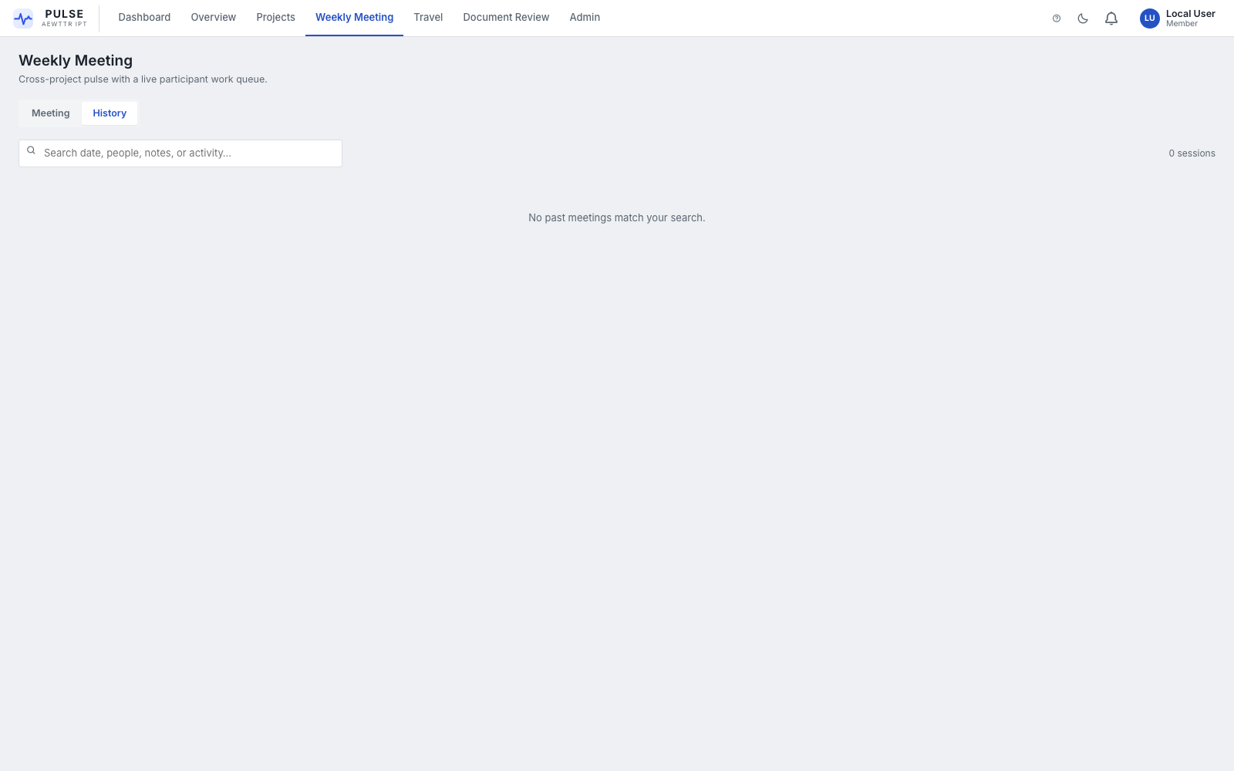
Weekly Meeting — History
Every past session, searchable by date, people, notes, or activity. Use this to answer "what did we say about this two weeks ago" without digging through email.

5.6 Rocks
Rocks are quarterly-goal-style objectives — a title, an owner, an optional linked project, a due date, and a status (On Track / Off Track / Done). Each Rock has a "checkups" drawer for posting dated progress notes without changing the Rock itself. Rocks can be tied to a specific project or kept portfolio-wide, and reassigning ownership sends the new owner a notification.

6. Travel
Reach it: Nav bar → Travel.

6.1 Submitting a Request
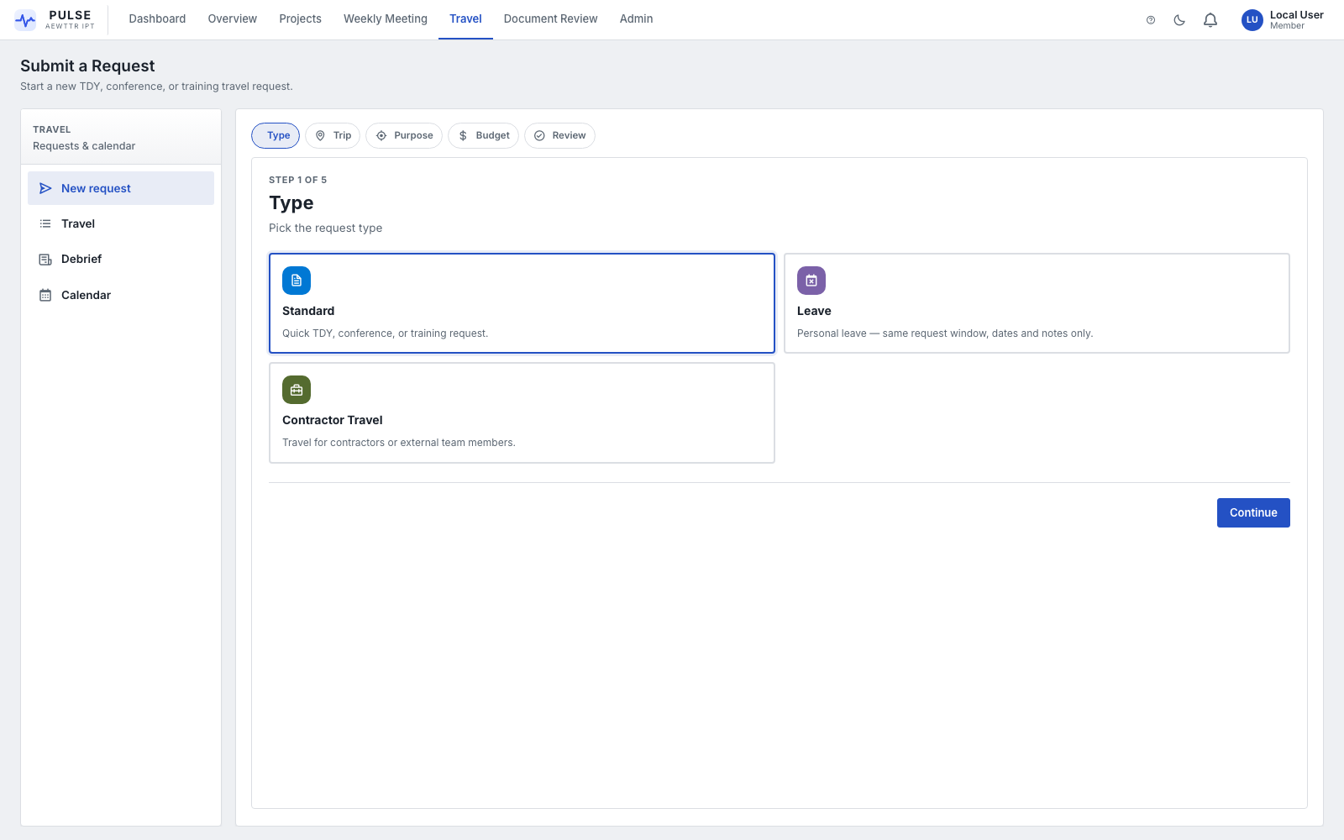
Travel — New Request
Click New request and pick a type:
Type | For
Standard | Quick TDY, conference, or training request
Leave | Personal leave / time away from the project (shorter, single-step form)
Contractor Travel | Travel for contractors or external team members

The wizard then walks you through Trip → Purpose → Budget → Review, with a step tracker across the top and a "jump back and edit" link on every section of the final Review step before you submit.
NOTE — Editing a request that's already Approved switches to an expanded 5-step flow (Flights → Transport → Lodging → Details → Review) to capture final booking details.

6.2 Tracking Requests
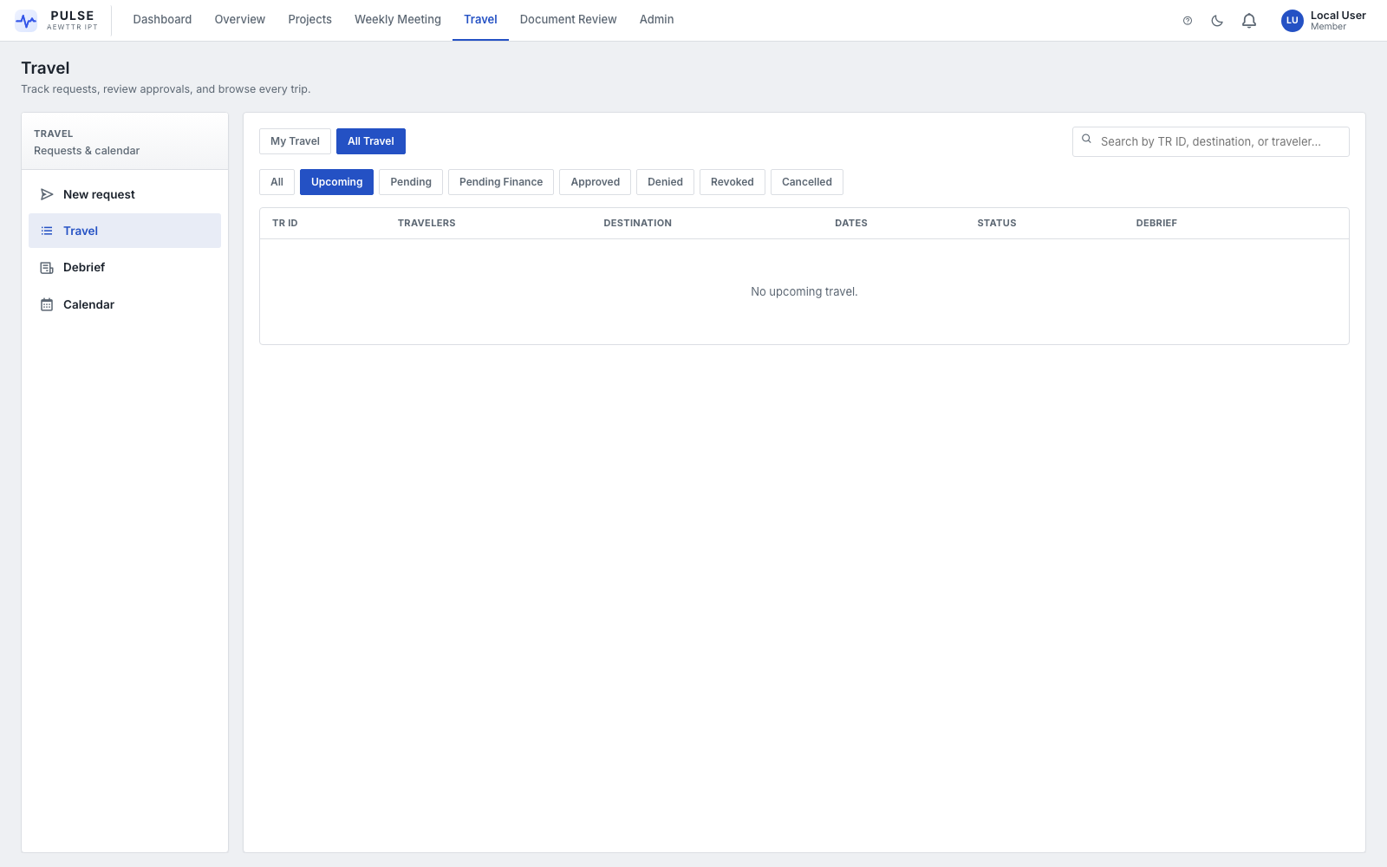
Travel — My Travel / All Travel
Toggle between My Travel (just yours) and All Travel. Filter by status: All, Upcoming, Pending, Pending Finance, Approved, Denied, Revoked, Cancelled. If you hold approval rights, Approve / Deny / Assign-C/O actions appear directly in the table — there's no separate Approvals screen to hunt for.

6.3 Debrief
After an approved (non-Leave) trip, file a debrief: systems and locations visited, trip classification, a technical summary, issues/follow-ups, and file attachments. Debriefs link back to the original request, and a View Debrief button appears on that request once filed.

6.4 Calendar
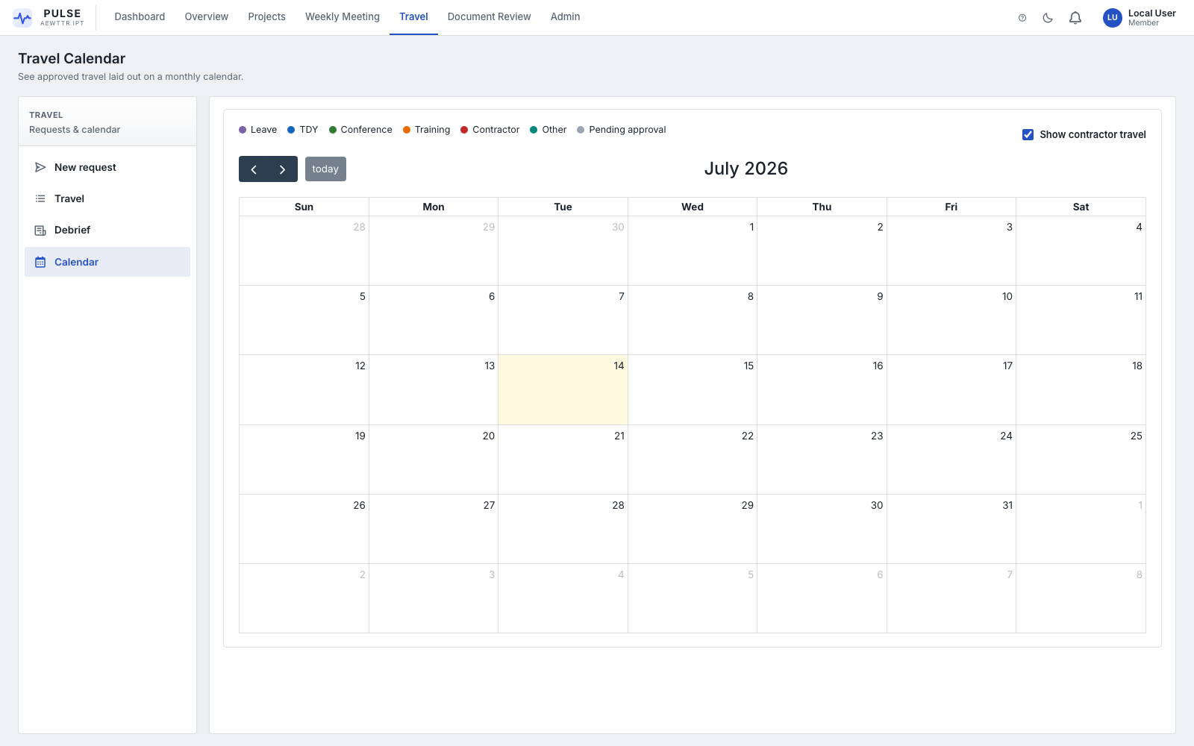
Travel — Calendar
A monthly calendar of all non-Denied/Cancelled/Revoked travel, color-coded by type (Leave, TDY, Conference, Training, Contractor, Other, Pending approval). Toggle contractor travel on/off with the checkbox, top-right.

7. Document Review
Reach it: Nav bar → Document Review.
This is the formal document approval workflow — distinct from a project's own Documents file browser (Section 4.2).
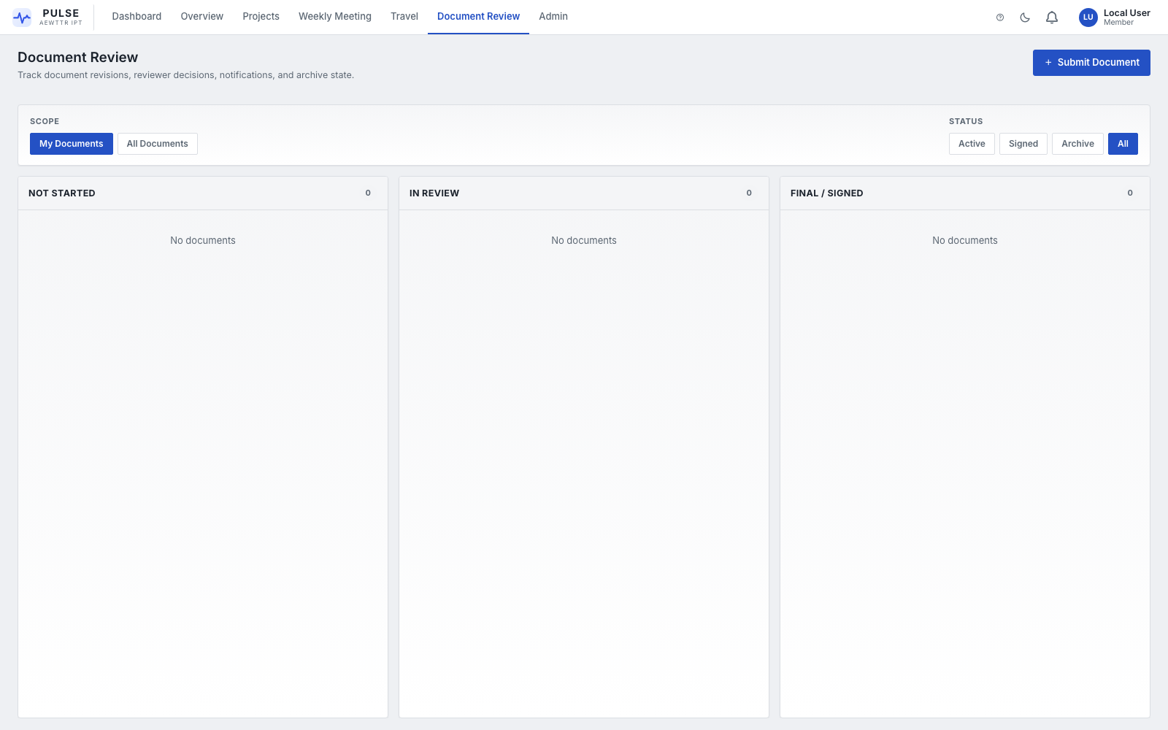
Document Review Board
- Board columns: Not Started → In Review → Concurrence → Final / Signed, plus an Archive bucket.
- Scope toggle: My Documents vs. All Documents.
- Status filter: Active / Concurrence / Signed / Archive / All.
- Each card shows the linked project, submitter, current revision, and a reviewer-decision fraction (e.g. "2/3 approved").
Click + Submit Document to start a new review: give it a title, type, project, deadline, upload the first revision, and add reviewers (you're added automatically as the submitter).
How the review works: each reviewer records a decision — Pending, Approved, or Requested Changes — with an optional note. Uploading a new revision resets every reviewer back to Pending, since the document has changed. A document with no outstanding review action for 7+ days auto-archives. Reviewers get reminder notifications on a scheduled sweep if their decision has been pending too long.

8. Support Tickets
Reach it: Nav bar link (or Overview → Operations Queue → Open Tickets).
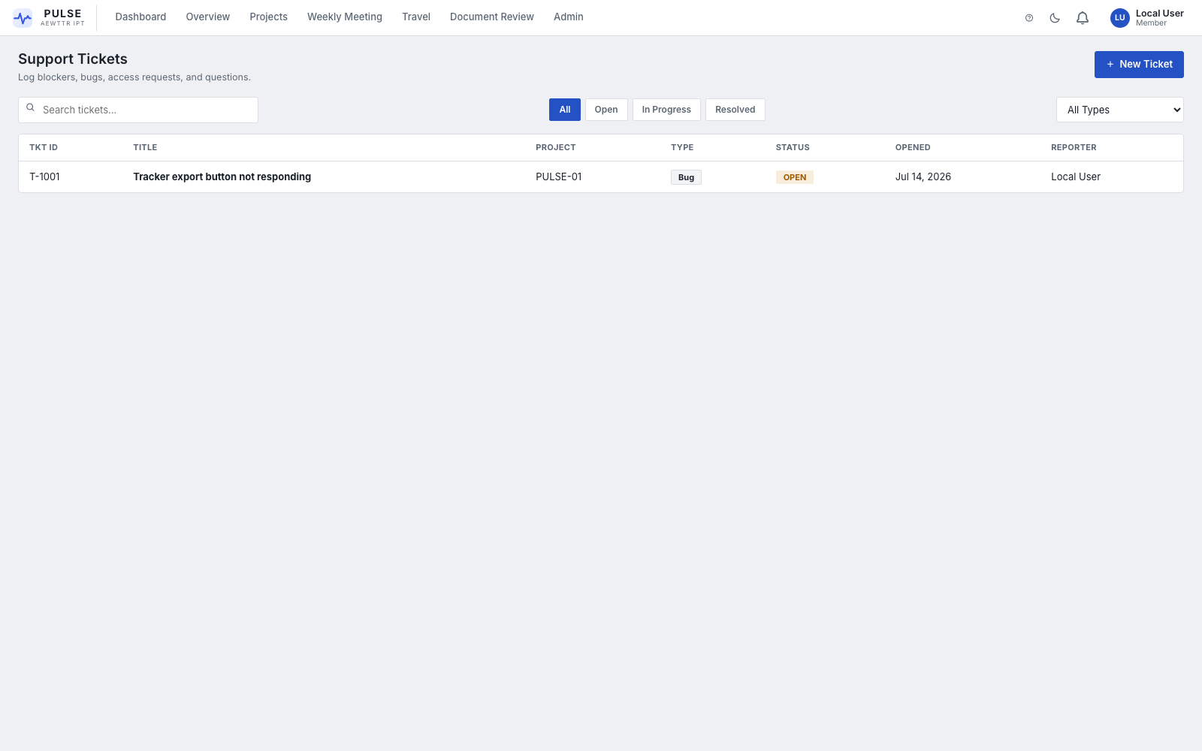
Support Tickets
A lightweight internal helpdesk. Filter by status (Open / In Progress / Resolved) or type (Blocker / Bug / Access / Platform / Question), and search by keyword. Click + New Ticket to file one — optionally locked to a specific project. Opening a ticket shows its description, workaround notes, an escalation-path field, and a running updates timeline where you can post progress and change status.
NOTE — Filing a new ticket notifies all admin users; status changes and updates notify the original reporter (you won't be notified of your own updates).

9. Admin Tools
Reach it: Nav bar → Admin (only visible if you hold an admin-level role).
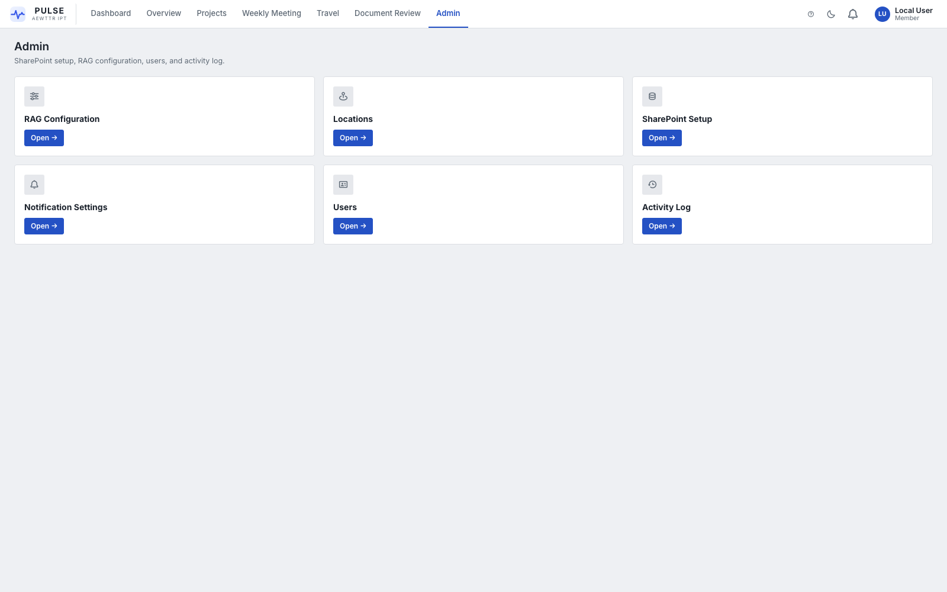
Admin launcher
Six tools, each described below.

9.1 RAG Configuration
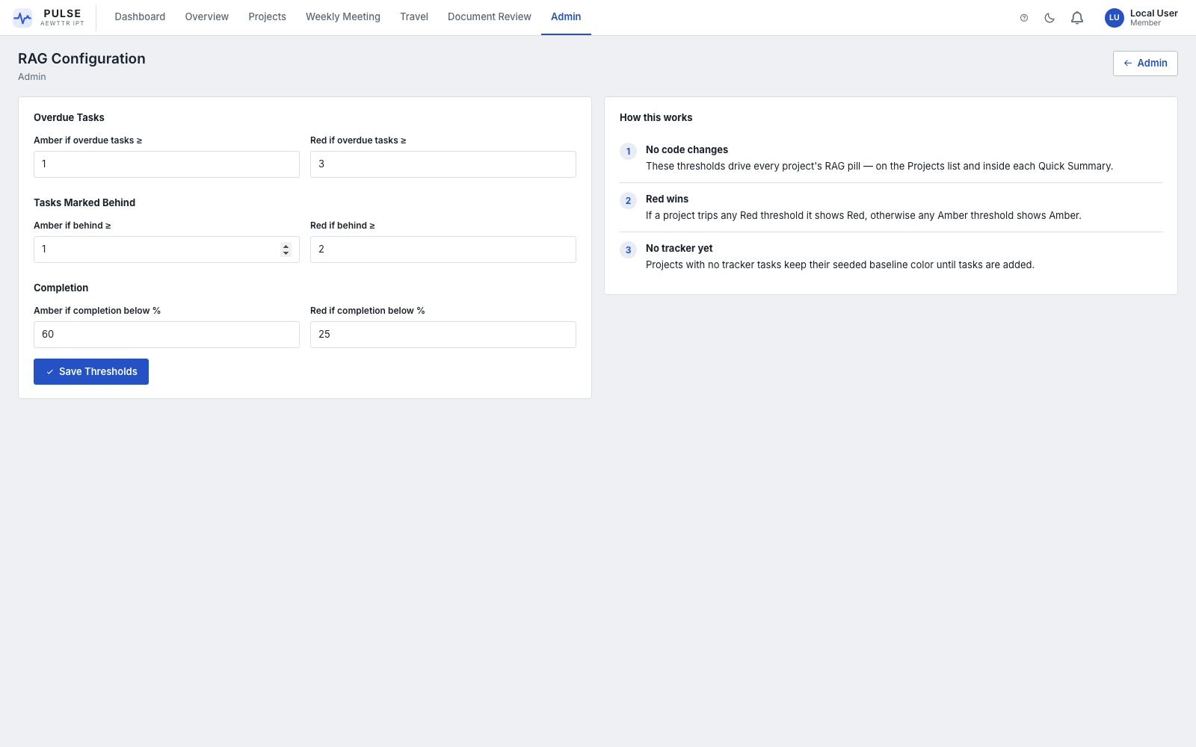
RAG Configuration
Sets the thresholds that automatically compute every project's Red/Amber/Green status — no code changes needed to retune them:
Group | Controls
Overdue Tasks | Amber if ≥ N overdue tasks, Red if ≥ N
Tasks Marked Behind | Amber/Red thresholds on tasks flagged At Risk or Off Track
Completion | Amber if completion % is below X, Red if below Y

If a project trips any Red threshold, it shows Red regardless of the others ("Red wins"). A project with no tracker tasks yet keeps its seeded baseline color until tasks are added.

9.2 Locations
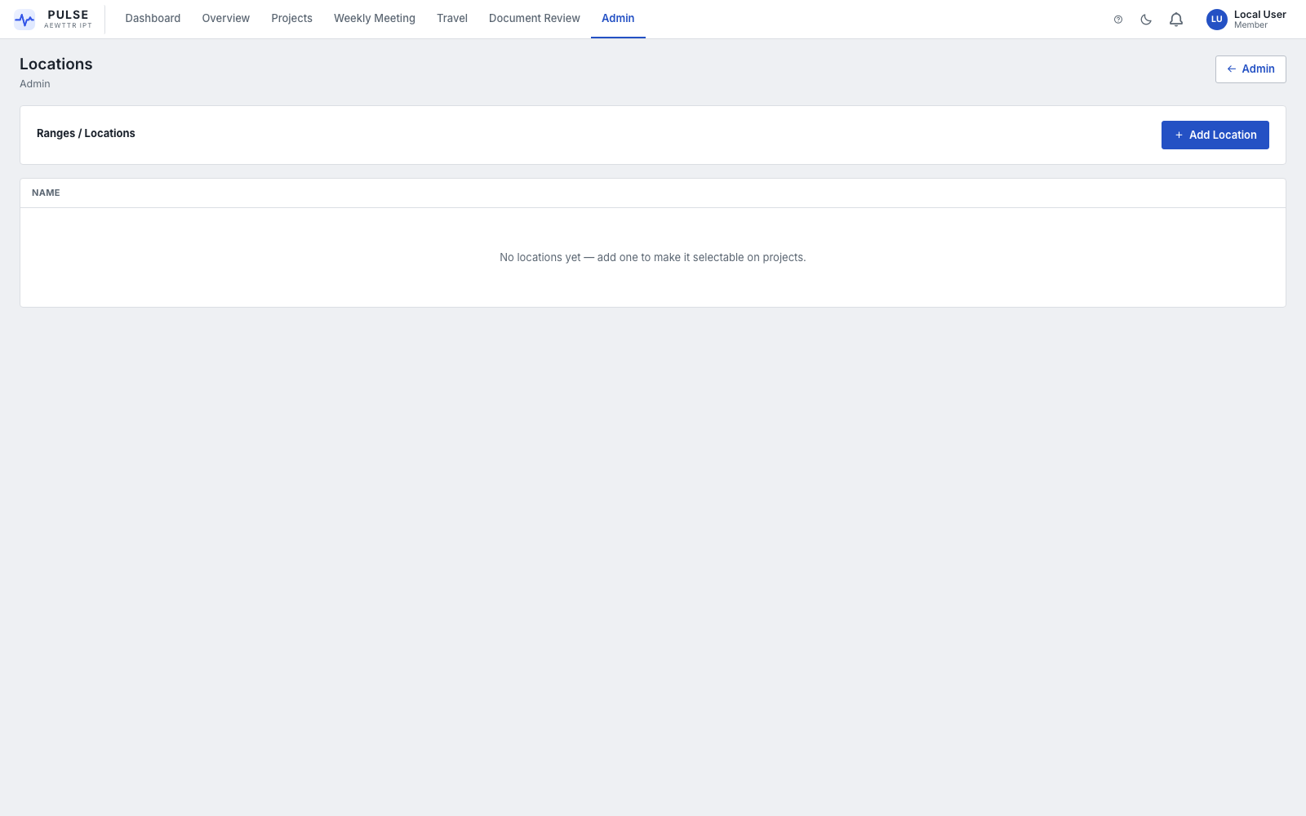
Locations
Manages the list of ranges/locations selectable on every project's Settings tab. Add, rename, or remove entries; duplicate names are blocked and deletion asks for confirmation.

9.3 SharePoint Setup
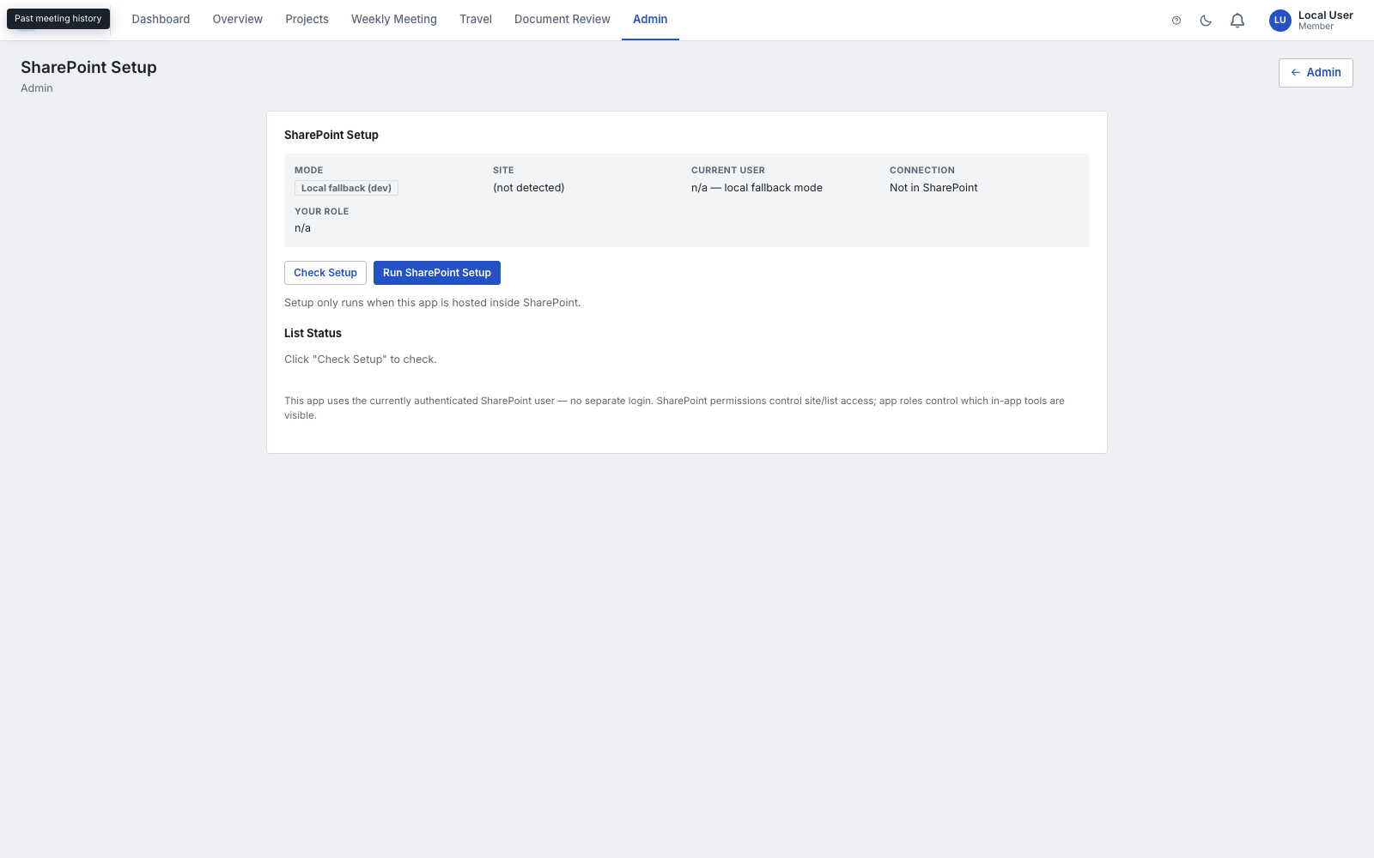
SharePoint Setup
Backend connection status and provisioning tools — see the Technical Reference for what each button does under the hood. In everyday admin use: Check Setup tells you if any SharePoint lists/columns are missing, Run SharePoint Setup creates or repairs them, and the Diagnostics panel on the right helps answer "why am I not showing as Admin?" without opening a support ticket.

9.4 Users
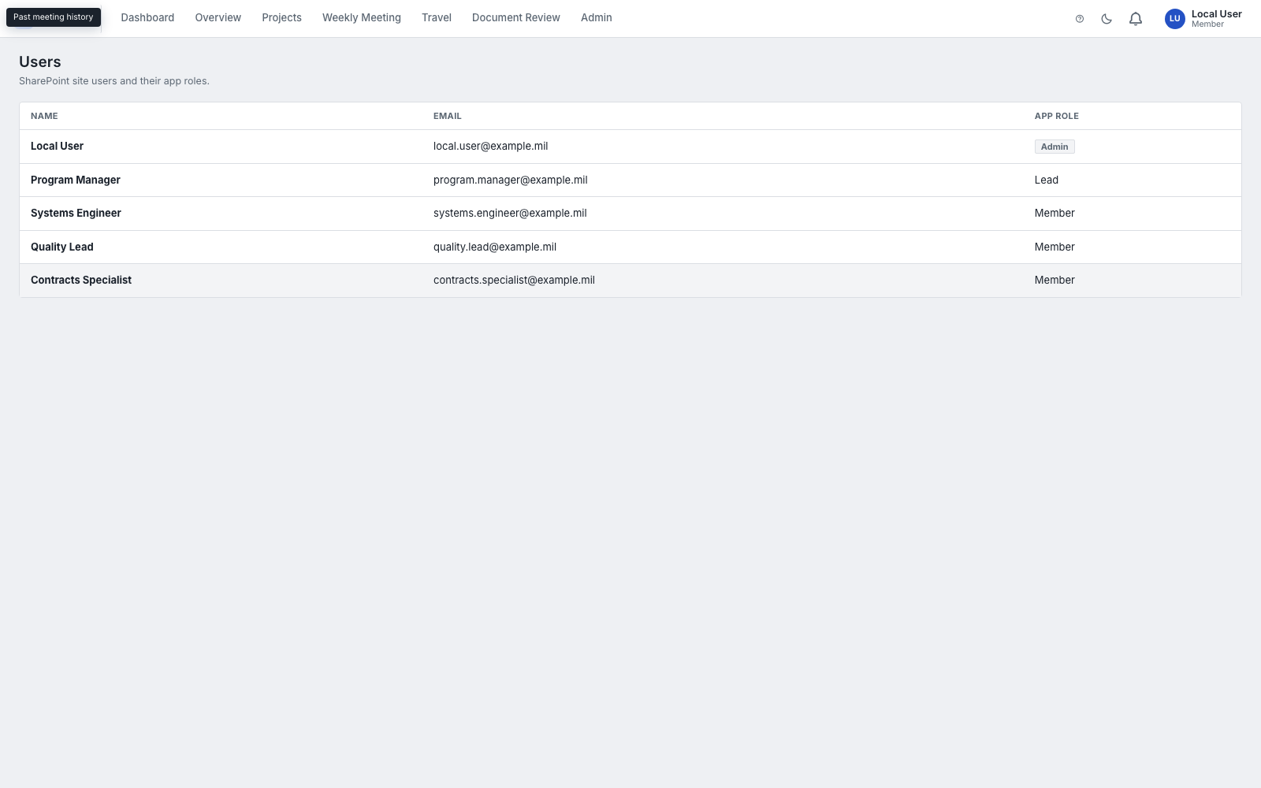
Users & App Roles
Every site user and their PULSE-IPT app role (Admin, Lead, Member, etc.), synced from SharePoint site membership.

9.5 Activity Log
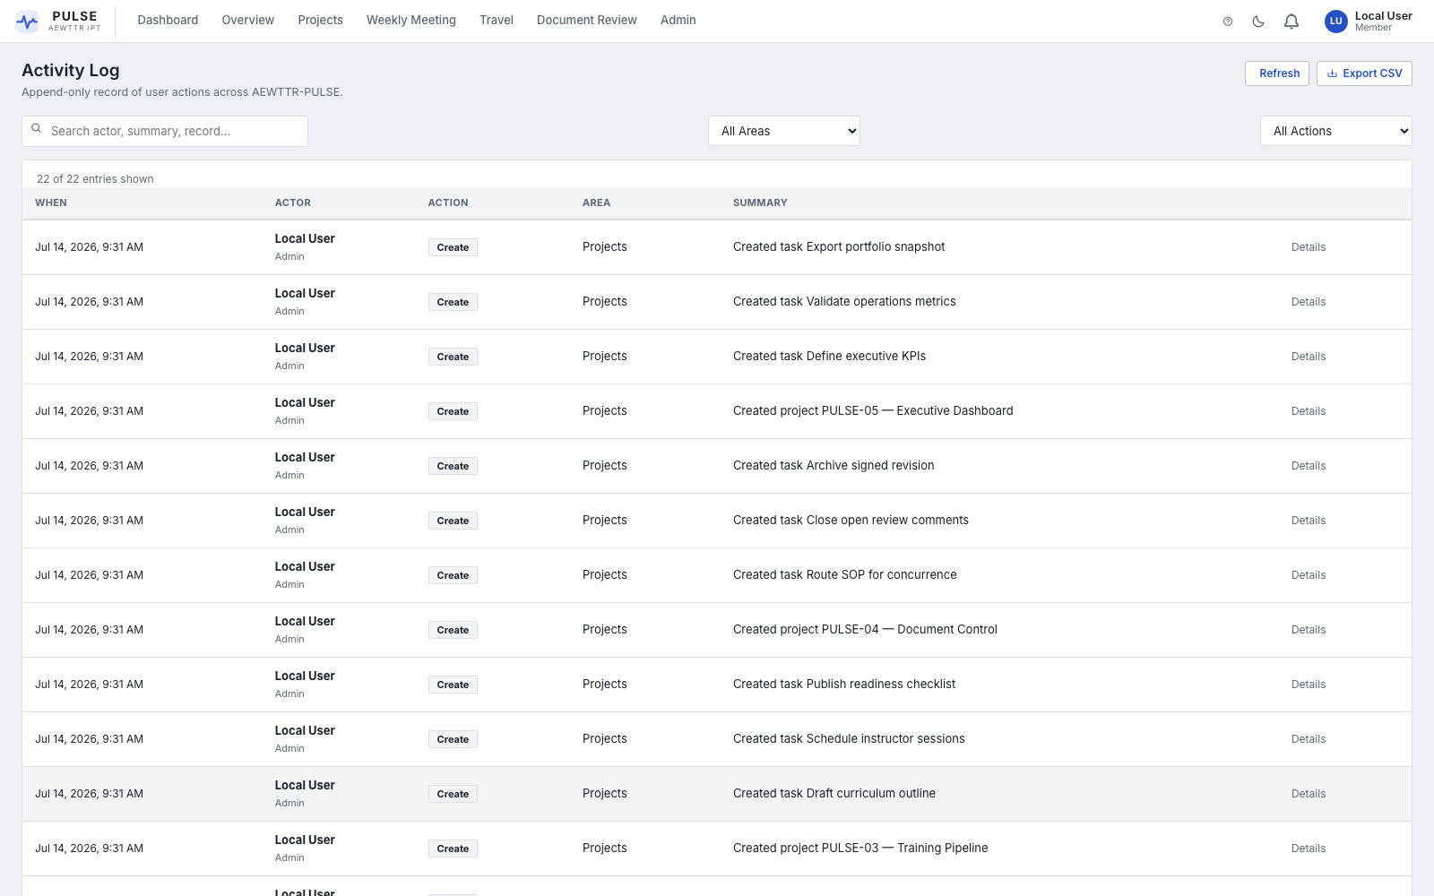
Activity Log
An append-only record of every create/update/delete/navigation action taken in the app — who, what, when, and where. Filter by area or action type, search by actor/summary/record, and expand Details on any row to see the raw change payload. Export CSV downloads the currently filtered rows (and is itself logged as an audit entry).

9.6 Notification Settings
Shortcut to the same screen described in Section 10 — included here because it's also a site-wide admin concern (channel overrides).

10. Notification Settings
Reach it: Click your name/role badge, top-right of any screen.
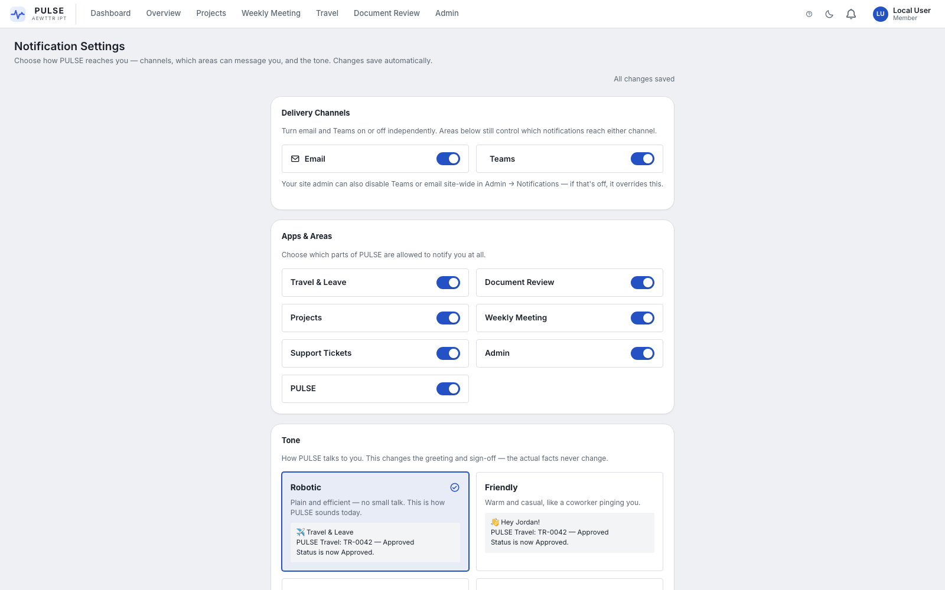
Notification Settings
Self-service and autosaving — there's no Save button, changes take effect as you make them.
- Delivery Channels — turn Email and Teams notifications on or off independently. (A site-wide admin toggle can override this if disabled tenant-wide.)
- Apps & Areas — choose which parts of PULSE-IPT are allowed to notify you at all (Travel & Leave, Document Review, Projects, Weekly Meeting, Support Tickets, Admin, general PULSE notices).
- Tone — pick how PULSE-IPT "talks" to you in its messages (e.g. Robotic vs. Friendly). Only the greeting/sign-off changes — the facts in the message never change.
Use Send Test Notification to confirm delivery is working before you rely on it.

11. Roles & Permissions Reference
Role | Can do
Admin | Everything, including all Admin Tools, RAG/Locations configuration, and SharePoint Setup
Meeting Admin | Start/end Weekly Meeting sessions, manage the roster and guests
Finance Admin | Travel finance-stage actions
Manager / Lead | Elevated visibility and approval actions within their scope
Member | Standard day-to-day access: projects, tasks, travel, documents, tickets
Viewer | Read-only

NOTE — Your role comes from your SharePoint site membership, synced automatically — there is nothing to request separately inside the app. If a screen looks locked and you believe it shouldn't be, ask your site's PULSE-IPT Admin to check Admin → Users.

12. Glossary
Term | Meaning
IPT | Integrated Product/Project Team
RAG | Red / Amber / Green status indicator
Rock | A quarterly-goal-style objective tracked in Weekly Meeting
Tracker | A project's task list / Gantt schedule
Board | A custom Kanban or table workflow inside a project, separate from the Tracker
Debrief | The after-action report filed following an approved trip
TDY | Temporary Duty (a travel request type)
Concurrence | A Document Review status meaning the document has stakeholder sign-off pending

