Firepit & Forge
Architecture Guide
How a browser-based build tool (Forge) produces self-contained HTML applications that run inside a locked-down SharePoint web part (Firepit)
Reverse-engineered from: Forge.html, firepit-src-7.1.0.zip, firepit-prod.sppkg, firepit_7.0.7.0.sppkg
Compiled 2026-07-02

Table of Contents

1. Executive Summary
Firepit and Forge are two halves of one system for shipping custom, single-file HTML/JavaScript applications inside SharePoint — specifically inside a highly restricted, government/military SharePoint tenant (evidence points to a U.S. Navy “Flank Speed” / NAVWAR PEO Digital deployment, with allow-listed API endpoints at api.genai.mil, api.genai.army.mil, and api.capra.flankspeed.us.navy.mil).
- Firepit is a SharePoint Framework (SPFx) web part named internally “HtmlFileRendererWebPart.” It takes a single HTML file (uploaded to a document library, or pasted directly into its property pane) and renders it inside a sandboxed <iframe> on a SharePoint page, after re-writing the HTML to inject a family of network and navigation security guards.
- Forge is a large, single-file browser IDE (Forge.html, ~8MB) that developers run entirely offline / client-side. It provides project editing (CodeMirror 6), an AI coding agent (“Prometheus”), version checkpoints, a static-security auditor tuned to DoD STIG controls, and — most importantly — a compiler that bundles a multi-file project into exactly the kind of single self-contained HTML file Firepit expects, complete with the same security-guard scripts pre-injected.
The two tools share a security design: the guard scripts Firepit injects at render time (Content-Security-Policy, a link-hint guard, a query-parameter/navigation guard, and a network guard that intercepts fetch/XHR/WebSocket/EventSource/sendBeacon) are, per comments in the SPFx source, “ported from the Forge compiler” — Forge's own compiler.js builds the identical guard family into anything it ships. Firepit re-implements them so that hand-written HTML (not produced by Forge) is still constrained the same way.
This guide walks through the full lifecycle end to end, then documents each subsystem of Forge and Firepit in turn, and closes with a security-architecture deep dive and the deployment/governance context uncovered during analysis.

2. End-to-End Lifecycle
A developer opens Forge.html in a browser (no install, no server — it runs from a local file or a SharePoint-hosted copy) and grants it access to a project folder via the File System Access API. They edit HTML/CSS/JS files directly, optionally delegate work to the built-in AI agent, and periodically create checkpoints. Before shipping, they can run the built-in Security Reviewer. When ready, Forge's compiler bundles the whole project into one self-contained .html file with all security guards embedded. That file is uploaded to a SharePoint document library (or pasted inline), and the Firepit web part loads it into a sandboxed iframe on a SharePoint page for end users — re-injecting the same guard family plus SharePoint/Dataverse-specific context so the app behaves correctly (and safely) inside the host page.
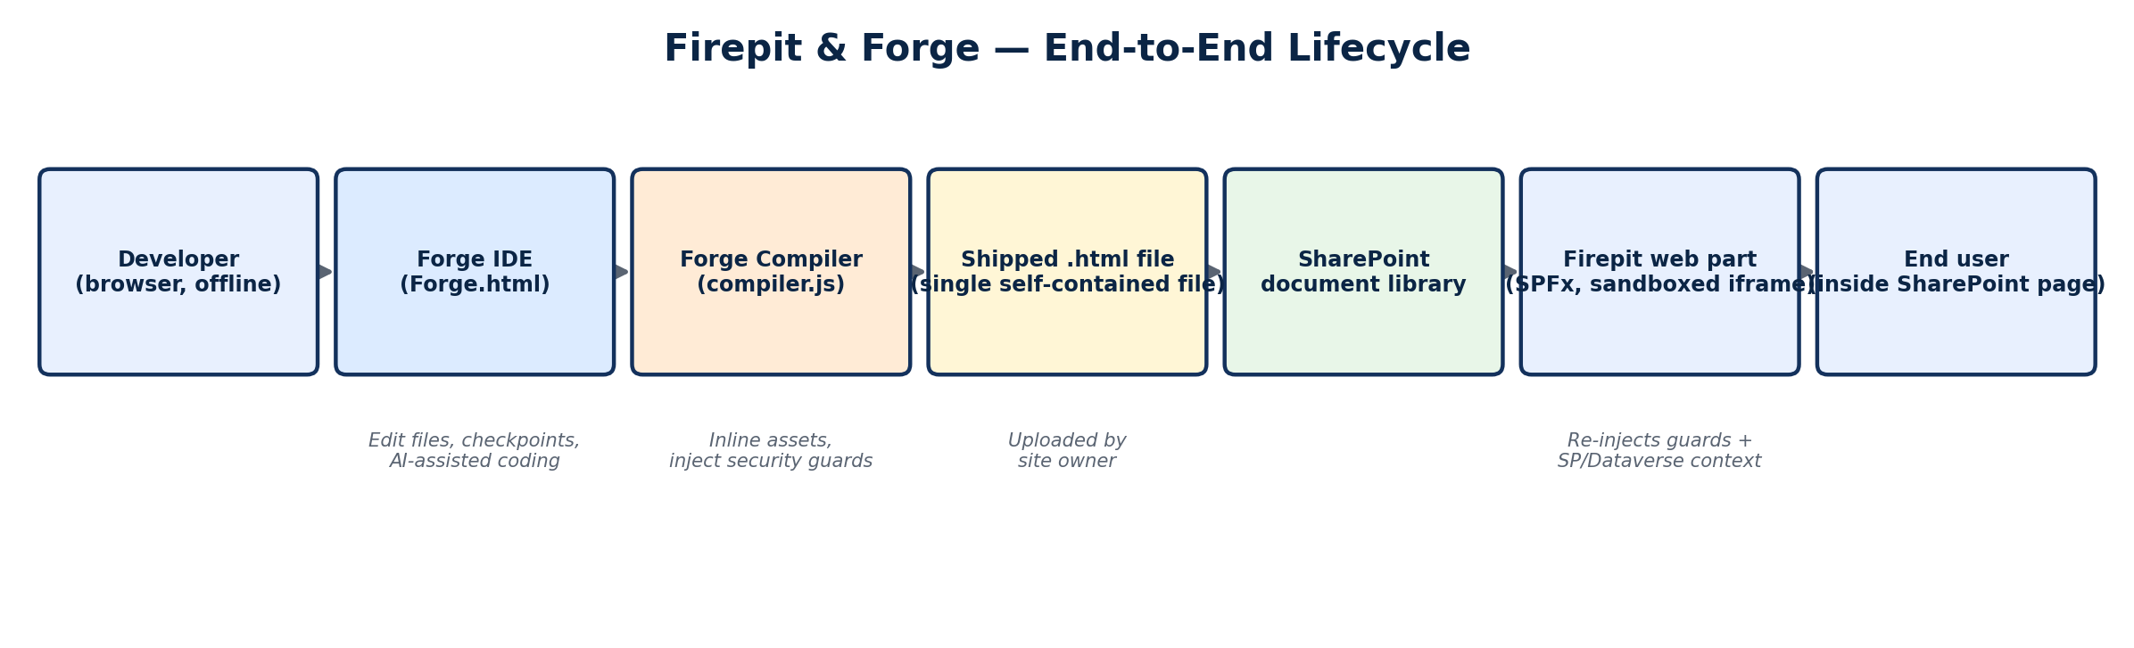
Figure 1. The full path from a developer's local Forge session to an end user viewing the app inside SharePoint.

3. Firepit — the SharePoint Runtime

3.1 What It Is
Firepit ships as an SPFx client-side solution (firepit-client-side-solution, ProductID 6dd7e353-52da-4020-8eaf-4ff0de1ec35a). Internally the web part is aliased “HtmlFileRendererWebPart” but is titled “Firepit: HTML Application Host” in the SharePoint web-part picker. It supports four hosts: SharePointWebPart, TeamsPersonalApp, TeamsTab, and SharePointFullPage, and declares supportsThemeVariants so it can pick up the host page's theme.
The analyzed package (AppManifest.xml) is deployed to /sites/NAVWAR_PEODIGITAL_SPFx/ — i.e. a U.S. Navy NAVWAR (Naval Information Warfare Systems Command) PEO Digital SharePoint site. Two package versions were found side by side: 7.0.7.0 and 7.1.0.0. The only functional diff between them at the manifest level is a new WebApiPermissionRequest for “Microsoft Dataverse” (scope user_impersonation) added in 7.1.0 — matching the new dataverseEnvironmentUrl property described below.

3.2 Property Pane Configuration
Site owners configure each Firepit instance through the standard SPFx property pane. The available fields:
Property | Purpose
htmlFileUrl | Site-relative or absolute URL to an .html file in a document library. Loaded via spHttpClient if no inline code is set.
htmlCode | Inline HTML, pasted directly into the property pane. Automatically split into htmlCode_0..N chunk properties if it exceeds 250KB (see 3.3).
fullScreen | Expands the iframe to fill the viewport — disabled automatically while the page is in SharePoint Edit mode so the property pane stays reachable.
iframeHeight | CSS height for the iframe (default 600px) when not full-screen.
dataverseEnvironmentUrl | Origin of a Microsoft Dataverse environment. When set, the app inside the iframe gets a window.firepit.dataverse bridge (see 3.5).
lockDown | Toggle that disables the network guard's allow-list entirely (connect-src 'none', frame-src 'none') and disables the Dataverse bridge — for maximum-restriction deployments.

3.3 Content Loading and the 250KB Chunking Scheme
SharePoint web-part properties have a size ceiling, so large inline apps can't be stored as one htmlCode string. HtmlFileRendererWebPart works around this by splitting content into 250,000-character chunks (CHUNK_SIZE) stored as htmlCode_0, htmlCode_1, … up to a hard cap of 120 chunks (MAX_CHUNKS) — roughly 30MB of HTML/JS/CSS. On load, _reassembleChunks() concatenates them back into one string before further processing; on save, _saveChunkedContent() re-splits and _clearChunks() removes any stale chunk properties left over from a shorter previous version.

3.4 Render Pipeline
Rendering happens in a fixed sequence inside HtmlFileRendererWebPart.render() / onInit():
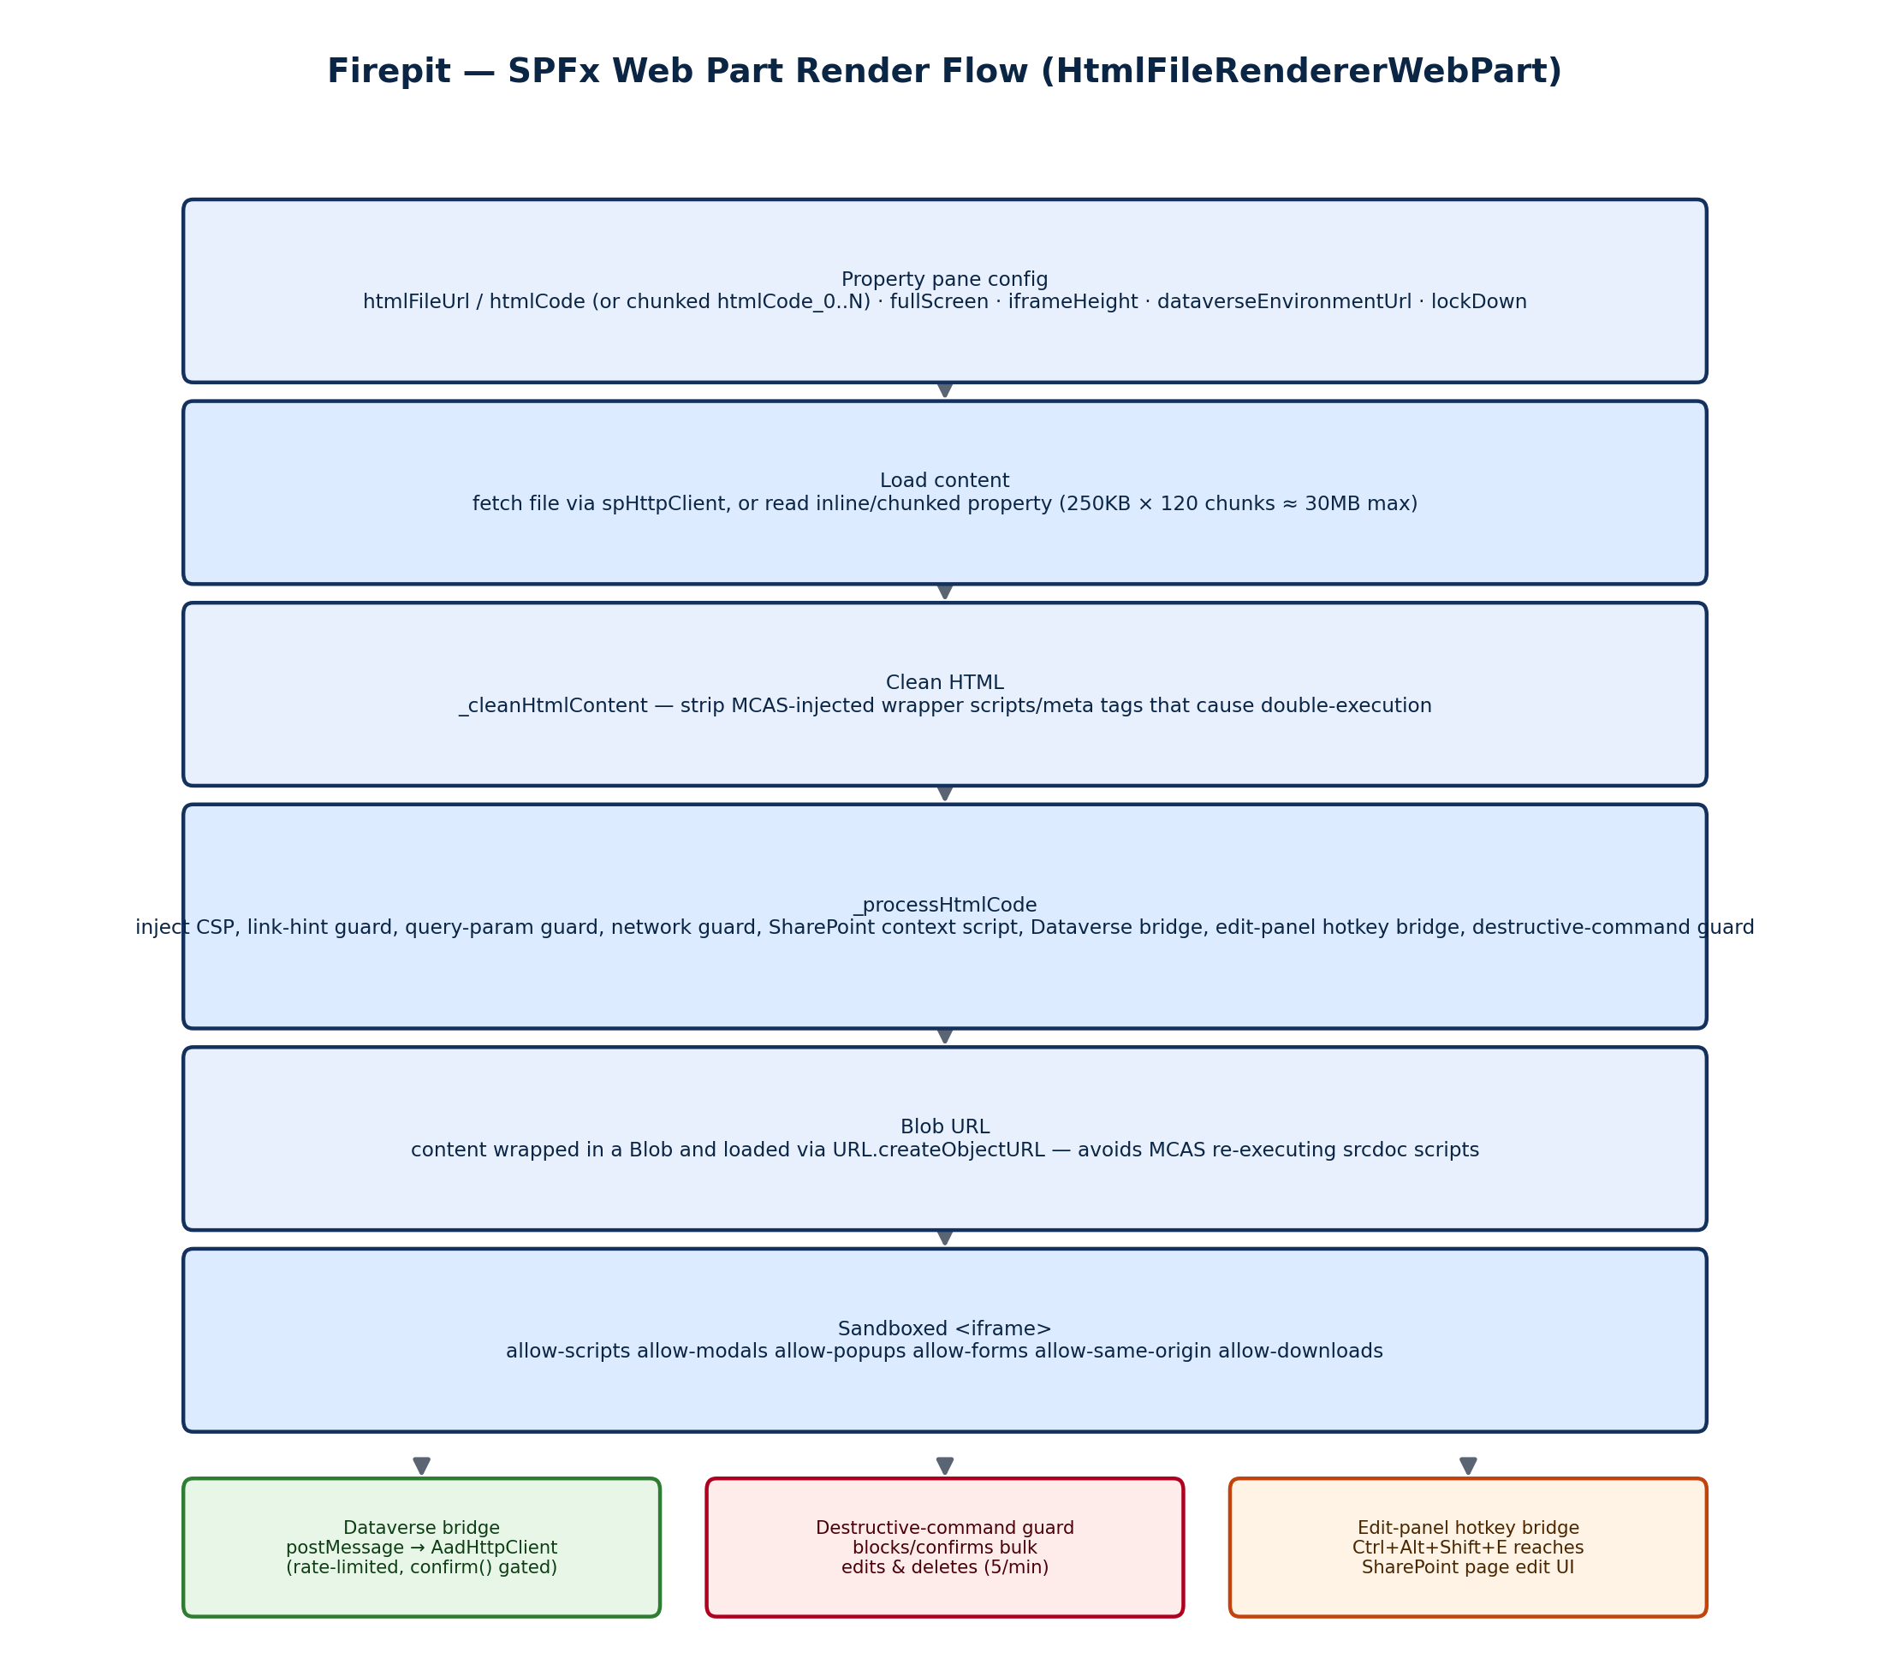
Figure 2. Firepit's render pipeline, from property-pane configuration to a sandboxed iframe on the page.
Two implementation details are worth calling out. First, the HTML is deliberately never assigned via iframe.srcdoc or innerHTML — instead it's wrapped in a Blob and loaded through a blob: URL (URL.createObjectURL), with the URL revoked immediately after the iframe's load event. The source comments explain why: Microsoft Cloud App Security (MCAS), a CASB proxy some tenants route traffic through, injects a “js-wrapper” script that intercepts innerHTML/srcdoc writes and re-executes any inline <script> it finds — which double-declares every top-level const/let in the app and throws. Blob URLs bypass that interception path entirely. Second, _cleanHtmlContent() strips MCAS's own injected markup (meta tags, wrapper <script> tags, and McasCtx/McasTsid query-string parameters) from fetched files before they're processed further, since a file round-tripped through MCAS on the way in can already be contaminated.

3.5 Dataverse Bridge and the Destructive-Command Guard
When dataverseEnvironmentUrl is set (and lockDown is off), _processHtmlCode() injects a small script that exposes window.firepit.dataverse / window.firepitDataverse inside the sandboxed app. Calls to it are serialized as postMessage requests (firepit:dataverse-request) to the parent frame, which validates the target URL stays within the configured Dataverse origin, forwards it through context.aadHttpClientFactory (so it rides the user's own Azure AD identity), and posts the response back (firepit:dataverse-response).
Layered on top of that bridge is a destructive-command guard shared by both the Dataverse path and ordinary SharePoint REST calls made from inside the iframe. It parses each outgoing request (including $batch bodies and X-HTTP-Method-Override tricks) to detect DELETE/PATCH/MERGE/PUT operations, and distinguishes a full table/list delete from a bulk item edit. If more than 5 mutating operations hit the same target within a 60-second window, or a full-table delete is attempted, the user sees a native confirm() dialog (“Firepit confirmation required… Allow this command to be sent?”) before the request is allowed through — a lightweight rate-limit/confirmation gate against a runaway or malicious embedded app, not a hard permission boundary (the guard is duplicated almost verbatim inside the injected iframe script itself, plus enforced again at the SPFx layer).

3.6 Edit-Panel Hotkey Bridge
Because the embedded app runs full-screen inside a sandboxed iframe, SharePoint's own page-edit chrome can become unreachable. Firepit works around this with a hotkey bridge: Ctrl+Alt+Shift+E, captured both at the host-page level and inside the iframe (which posts a firepit:open-edit-panel message to its parent), searches the host page's DOM for a visible, enabled “Edit” control (trying a jQuery-based click first, then a list of ARIA/attribute selectors) and clicks it — restoring the ability to reconfigure the web part without leaving full-screen mode.

3.7 Sandbox and CSP Details
The iframe's sandbox attribute is fixed at allow-scripts allow-modals allow-popups allow-popups-to-escape-sandbox allow-forms allow-same-origin allow-downloads — deliberately broad within-origin so apps can use dialogs, popups, forms, and file downloads, while still being sandboxed. _getHostCspNonce() walks the host page's own <script>/<style> tags to find whatever CSP nonce SharePoint issued, and _applyNonceToScriptTags() (via DOMParser, with a regex fallback) stamps that same nonce onto every script/style tag in the embedded app so it runs cleanly under the host page's CSP as well as the one Firepit injects.

4. Forge — the Authoring Tool
Forge.html is a bootstrap file: it is itself just a tiny script containing one base64 string (CHILD_HTML_B64) which, when decoded, is the real ~6MB application — a design choice reused throughout Forge's own compiler output (see 4.5). Unpacked, the app is a single giant inline <script> containing roughly two dozen concatenated modules (jQuery, Bootstrap, FileSaver.js, SheetJS, Mammoth.js, PDF.js, and a fully offline-bundled CodeMirror 6, followed by Forge's own first-party modules).

4.1 Module Map
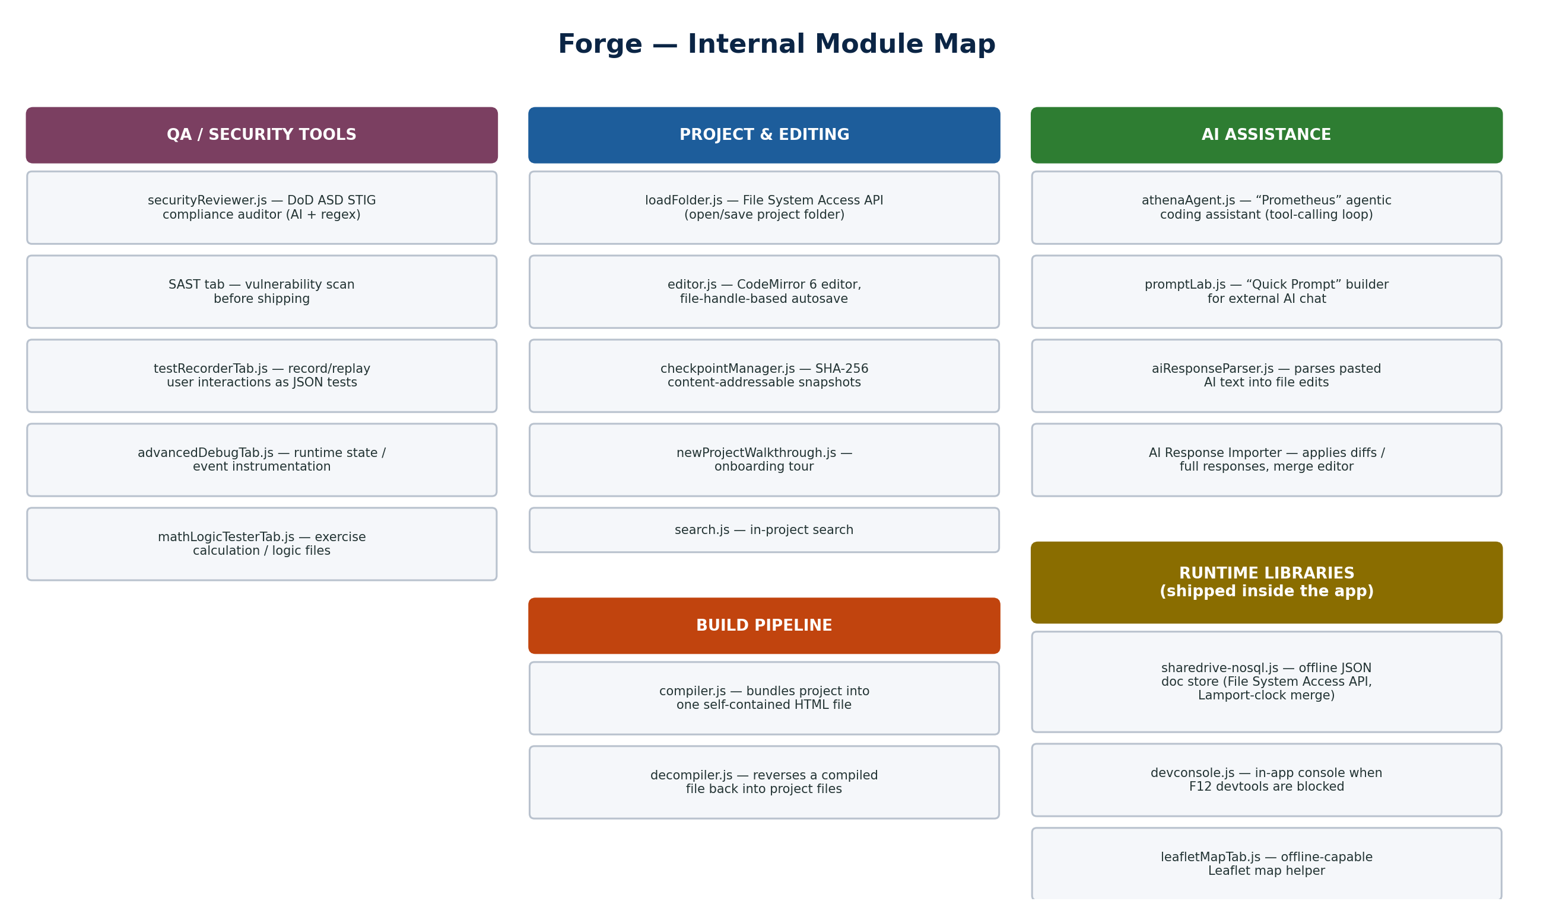
Figure 3. Forge's first-party modules, grouped by function.

4.2 Project Loading, Editing, and Autosave
Forge has no server component and no upload step. loadFolder.js uses the browser's File System Access API (window.showDirectoryPicker, with a window.top fallback for iframe-embedded contexts) to get read-write access to a folder on the developer's own machine, recursively reads its contents into a file tree, and starts a lightweight auto-sync loop (a 5-second poll plus focus/visibilitychange listeners) so external edits to the folder are picked up.
The editor itself (editor.js, wrapping a CodeMirror 6 instance for syntax highlighting/autocomplete) saves through the same File System Access handles rather than by path or UUID lookup — each open file keeps a live reference to its FileSystemFileHandle, which is why saves survive a file-tree refresh or a UUID regeneration that would break a path-keyed cache. Autosave debounces two seconds after the last keystroke (_scheduleAutoSave), validates that HTML files still have matching <html>/</html> tags before writing, auto-restores devconsole.js/testRecorder.js <script> tags if they were accidentally stripped, and stamps an “unshipped” warning banner into HTML that doesn't look like Forge's own compiled output (a nudge not to hand-edit already-compiled files and not to paste unreviewed code straight into a CUI-handling environment).

4.3 Onboarding Walkthrough
newProjectWalkthrough.js drives a Bootstrap-modal “product tour” for first-time projects, highlighting UI elements step by step. It ships a canned starter prompt (“Create a single-file, vanilla, offline html file application that …”) and includes a “paste cue” watcher that detects when the user pastes AI-generated code into index.html and nudges the tour forward — bridging the walkthrough with the AI-assisted workflows described in Section 5.

4.4 Checkpoints — Git-Like Versioning Without Git
checkpointManager.js implements a content-addressable snapshot system stored on disk inside the project folder itself, under .checkpoints/manifests/ and .checkpoints/objects/ — no external version control tool required. Every file is SHA-256-hashed (via crypto.subtle.digest) so identical content across checkpoints is stored once. create() snapshots every non-excluded file (binaries, media, node_modules, and .checkpoints itself are excluded by pattern), computing a diff against the prior checkpoint. restore(id) is destructive by design: it diffs the requested checkpoint against the live file tree, shows the user a confirmation dialog listing exactly what will be overwritten, created, or deleted, then rewrites the folder to match. delete(id) garbage-collects any objects no longer referenced by a remaining manifest.

4.5 The Compiler
compiler.js's startCompilation() is the core of Forge — the function that turns an editable, multi-file project into the single file Firepit (or any other host) actually runs.
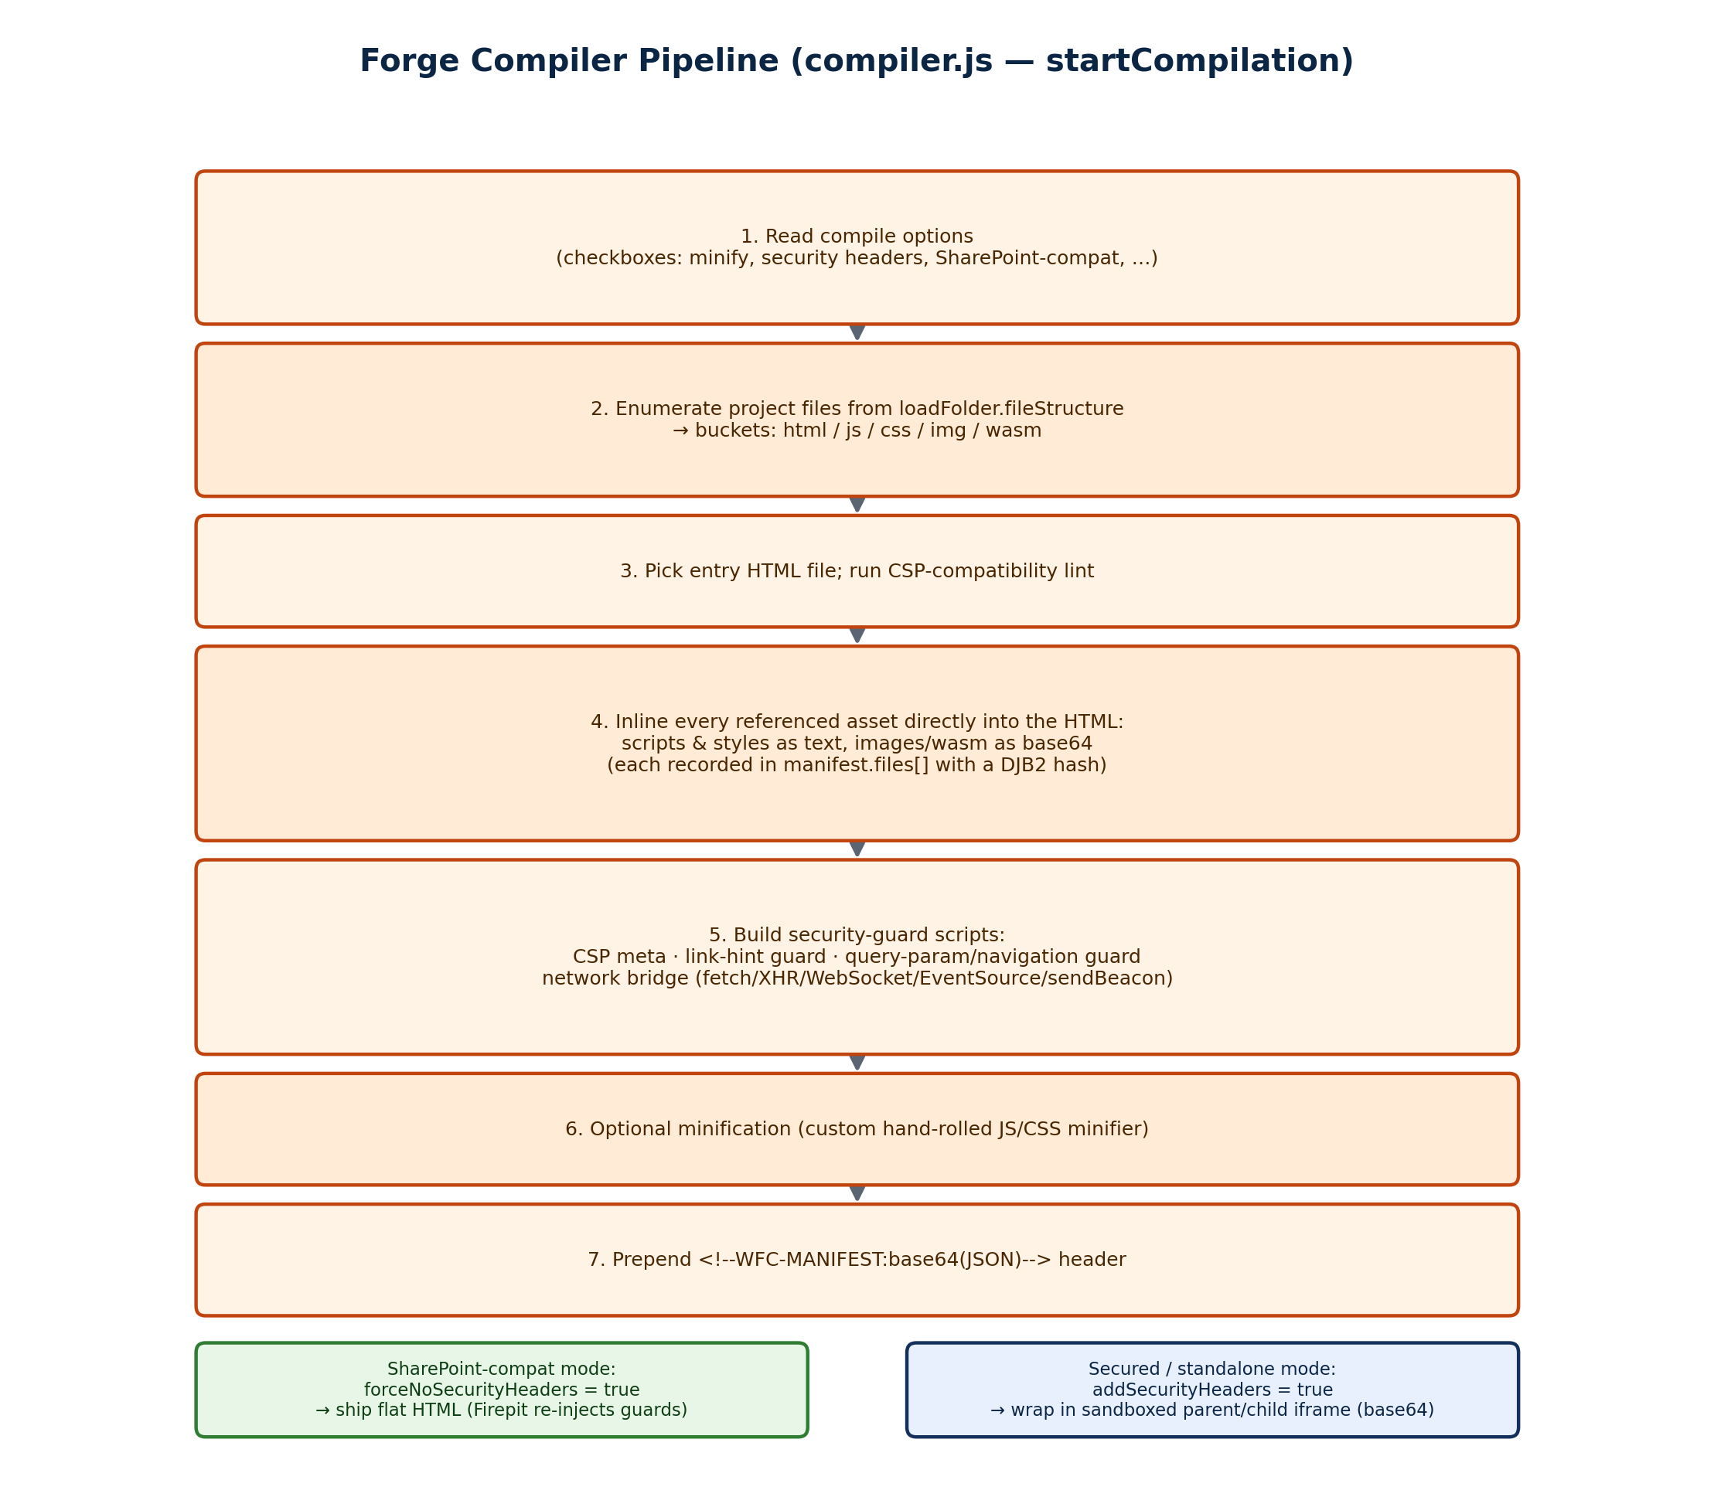
Figure 4. The seven-step build pipeline inside compiler.js.
Two build modes exist. In SharePoint-compat mode (forceNoSecurityHeaders = true), the compiler ships the inlined HTML flat, because Firepit will re-inject the equivalent guards itself at render time (Section 3.4/3.7) — duplicating them would be redundant and would fight with the SPFx-injected CSP. In secured/standalone mode (addSecurityHeaders = true, for apps not hosted behind Firepit), buildParentBridgeShellHtml() goes further: it base64-encodes the entire guard-injected app into a CHILD_HTML_B64 constant inside a tiny outer HTML shell containing a sandboxed <iframe id="forge-secure-app-frame">, and assigns the decoded string to the iframe's srcdoc at runtime. This is the same self-decoding-bootstrap pattern Forge.html itself uses (Section 4).
Why base64-in-an-iframe instead of just serving the app directly? It is a sandbox-isolation technique, not obfuscation. Putting the real app inside a sandboxed iframe without allow-same-origin means the child document cannot navigate the top-level page, read the parent's cookies or storage, or escape its origin lock — the parent mediates every network and storage request through the postMessage bridge described in Section 4.5 and 3.5. Encoding as base64 and assigning to srcdoc (rather than document.write) avoids serving a second file and sidesteps HTML-escaping problems from nesting one full HTML document inside a JS string literal.
The network bridge itself (buildChildBridgeBootstrapScript) overrides fetch, XMLHttpRequest, WebSocket, EventSource, and navigator.sendBeacon inside the child, checks every URL against a NETWORK_ALLOWLIST (SharePoint, a fixed set of CDNs for jQuery/Bootstrap/etc., and the .genai.mil / CAPRA / Army GenAI endpoints), and routes anything permitted through postMessage to the parent using a random, per-build bridgeToken. A visible “network request blocked” toast appears in the UI on denial rather than failing silently.

4.6 The Decompiler
A separate decompiler object (decompiler.decompile()) reverses the process: given a compiled artifact, it parses the WFC-MANIFEST header, extracts CHILD_HTML_B64 if the file used the secured parent/child split, strips all compiler-injected security scripts and meta tags, then re-matches inline <script>/<style> blocks and data-URI images back to their original file paths using the same DJB2 hash algorithm the compiler recorded them with — reconstructing an editable multi-file project (plus a cleaned index.html) from a single shipped file. This is what lets a developer pull an existing Firepit-hosted app back into Forge for further editing.

4.7 AI Response Parser and Response Importer
aiResponseParser.js is a small UMD utility that takes raw text pasted from an AI chat session and extracts file edits from it, trying several formats in order: explicit “File: <path>” sections, fenced code blocks (inferring the filename from the fence's info string or from up to 500 characters of surrounding chat text), markdown-heading-delimited sections, and finally a single-HTML-document fallback. It strips UI noise scraped along with copy-pasted chat text (“Copy” buttons, icon glyphs), validates that content plausibly matches its inferred language, and returns a structured list of file blocks plus warnings.
A companion AI Response Importer modal (built by athenaAgent.js's ensureModal(), functioning as Forge's merge editor) accepts either a full pasted AI response or a unified diff, applies it against the live project (auto-creating missing files as needed), and can generate a follow-up “retry prompt” automatically if the pasted diff doesn't parse cleanly.

5. Prometheus — the In-App AI Coding Agent
athenaAgent.js (the largest single module in Forge, ~12,500 lines) implements a full agentic coding assistant that Forge's UI brands “Prometheus.” It is a genuine multi-step, tool-calling agent loop — not a single-shot “generate this file” function.
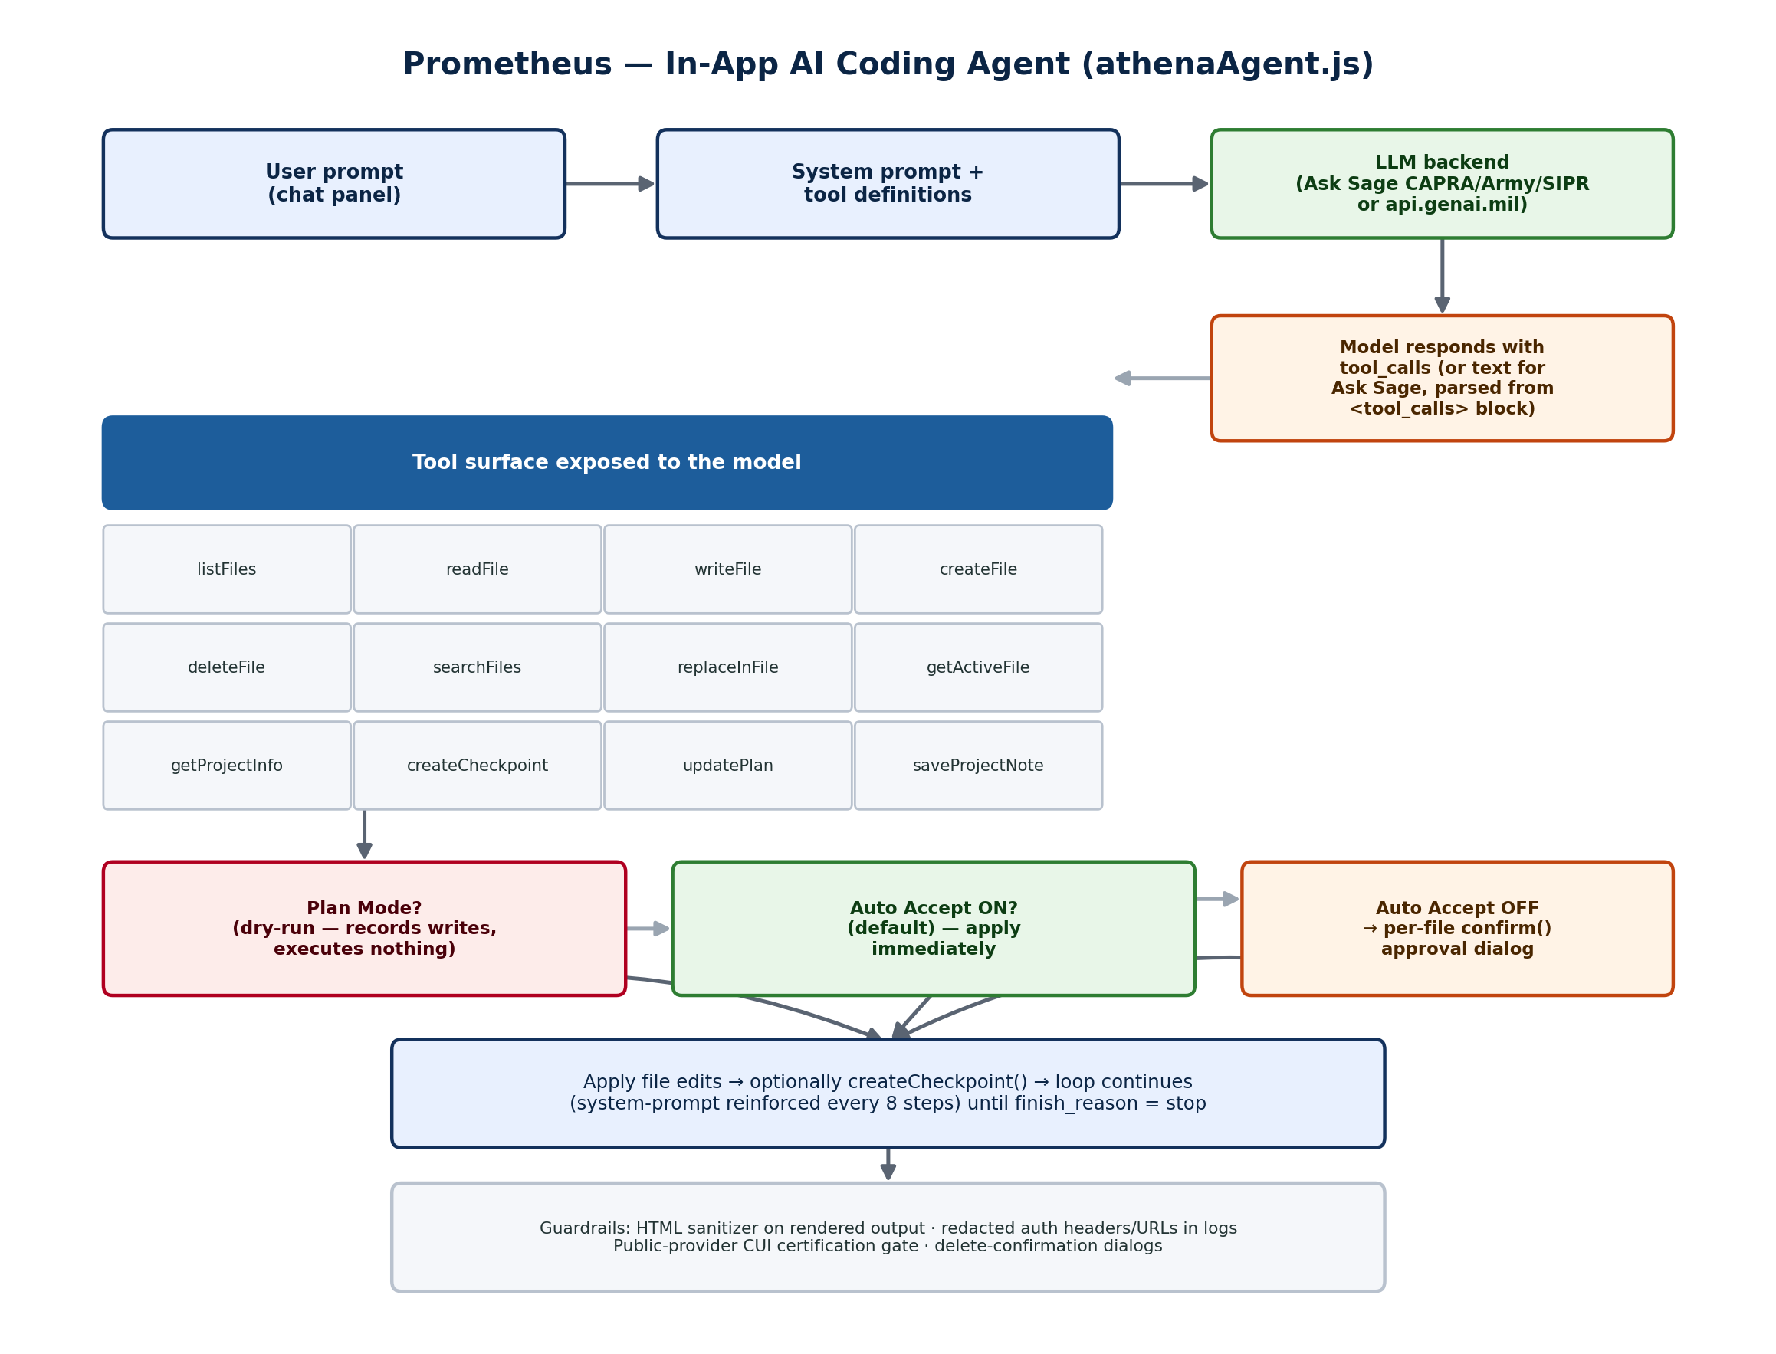
Figure 5. Prometheus's request/response loop, tool surface, and approval gates.

5.1 Supported LLM Backends
A multi-provider configuration object lets Prometheus target several backends, each gated by the same NETWORK_ALLOWLIST used by the compiled apps' network guard:
Backend | Notes
Ask Sage (CAPRA/NAVAIR, Army, SIPR variants) | Proxies to GPT-4.1. No native tool-calling support, so Prometheus falls back to a text protocol: the system prompt instructs the model to emit <tool_calls>[{"name":...,"args":...}]</tool_calls> blocks, which are regex-parsed with recovery logic for unclosed tags.
GenAI.mil | https://api.genai.mil/v1/chat/completions, OpenAI-compatible chat-completions shape, model gemini-3.5-flash, routed through a local proxy (usesLocalProxy: true).
Other / public providers (e.g. xAI/Grok) | Available but gated behind a separate “public-provider certification” acknowledgment (Section 5.4) since they are not CUI-compliant like Ask Sage/GenAI.mil.

Request payloads follow the OpenAI chat-completions shape (model, messages, tools, tool_choice, max_tokens, temperature 0.2, stream), with a separate branch for Gemini's generationConfig/tool_config.function_calling_config shape.

5.2 Tool Surface
The model is given twelve callable tools, dispatched from a single loop that tracks each response's stop reason (tool_calls vs. stop vs. max_tokens) and re-issues the system prompt every eight steps to keep long sessions on track:
listFiles, readFile, writeFile, createFile, deleteFile, searchFiles, replaceInFile, getActiveFile, getProjectInfo, createCheckpoint, updatePlan, saveProjectNote

5.3 Plan Mode and Approval Gates
Two independent settings shape how aggressively Prometheus is allowed to act. Plan Mode is a dry run: write-tool calls are recorded into a plan (presented to the user as “Ready to execute this plan?”) but nothing is actually written until the user approves. Independently, Auto Accept (on by default, persisted to localStorage as forge:ai-auto-accept) controls whether approved/non-plan edits apply immediately or require a per-file confirm() dialog (“Prometheus wants to change …”), with a separate, stricter confirmation for file deletions.

5.4 Safety Guardrails
- A public-provider certification modal gates use of non-CUI-compliant providers, distinct from the always-available Ask Sage / GenAI.mil options — a data-classification control appropriate to a DoD deployment.
- Rendered AI markdown output is passed through an HTML sanitizer that strips scripts, iframes, event handlers, and inline styles, and forces safe target/rel attributes on any links, before being shown to the user.
- Outbound request logging redacts Authorization headers and API keys embedded in logged URLs.
- createCheckpoint is exposed as a tool the model itself can call before a risky change, in addition to the user's own manual checkpoints (Section 4.4).

5.5 Prompt Lab — the Manual Alternative
promptLab.js is architecturally distinct from Prometheus: it makes no network calls at all. It is a “Quick Prompt” builder that assembles structured prompt text (task templates like edit-code and debug-code, with strict unified-diff output instructions) for the developer to copy and paste into an external AI chat interface, then paste the reply back into Forge's AI Response Importer (Section 4.7) for incorporation. It integrates with the Dev Console tab to pull captured runtime errors into debug prompts automatically. In short: Prometheus is the live in-app agent loop; Prompt Lab is the manual, take-it-elsewhere workflow for developers who use a different AI tool.

6. Runtime Data Library: sharedrive-nosql.js
Because a shipped app's network guard blocks essentially everything except SharePoint and a short allow-list, apps can't call an arbitrary backend database. sharedrive-nosql.js is Forge's answer: a library apps can include that gives them a simple document-store API backed entirely by the client-side File System Access API rather than any server — the developer picks (or creates) a single shared JSON file, typically on a synced/mapped network drive, and every user's browser reads and writes that same file directly.

6.1 Storage Model
Each record is stored as { _meta: {id, createdAt, deleted, fieldsDeleted}, fields: { key: {v, ts, actor} } } inside one JSON document — freeform, with no collections or schema enforcement. Multi-user concurrency is handled with a Lamport logical clock plus last-write-wins field-level merge, and tombstones for deleted records/fields rather than immediate removal, so two users editing the shared file at slightly different times merge predictably instead of clobbering each other. A background poller (adaptive backoff) periodically re-reads the file to detect changes made by other users, and localStorage is used only to persist a per-browser clientId — never as the actual data store.

6.2 API Surface
Method | Purpose
open() | File picker to open an existing shared database file.
create(name) | File picker to create a new one.
reload(first) | Re-read the file from disk and merge in any external changes.
snapshot() | Return all live (non-deleted) records.
get(id) | Fetch one record's flattened field values.
put(id, obj) / patch(id, partial) | Upsert full or partial field values on a record.
delete(id) / deleteField(id, key) | Soft-delete (tombstone) a record or a single field.
query(fn) | Filter the snapshot with a predicate function.
saveNow() | Force an immediate flush, bypassing the normal debounce.
startPolling() / stopPolling() | Control the background remote-change poller.

A companion “Sharedrive/NoSQL” tab in Forge is not a data browser — it's an integration-management panel that checks whether the library file is present in the current project, offers to add or update it, and includes a prompt-builder that assembles the relevant project files into an AI prompt (aimed at Prometheus or an external model) with instructions for wiring the library into the app's save/load logic correctly, including its collaboration and tombstone semantics.

7. Built-In QA and Security Tooling

7.1 Security Reviewer — DoD ASD STIG Compliance
securityReviewer.js is not a general-purpose SAST scanner; it's purpose-built to check offline single-file HTML/JS apps against DoD Application Security & Development (ASD) STIG controls before they're shipped. Its primary mode is AI-driven: it builds a large audit prompt naming specific STIG control IDs and instructing a model to return structured JSON findings, which the tool then renders as a report (the user pastes the model's JSON reply back in — mirroring the Prompt Lab workflow in Section 5.5). A secondary, optional local regex pre-scanner (runScan()) flags likely evidence for a handful of controls without waiting on a model call:
STIG Control | What it flags
V-222642 | Hardcoded secrets, API keys, tokens, and passwords (plus AWS/Google/GitHub/Slack key-pattern hints)
V-222602 | Unsafe DOM sinks: innerHTML, outerHTML, insertAdjacentHTML, document.write
V-222388 | Sensitive data left in localStorage, sessionStorage, IndexedDB, or cookies
V-222665 | Legacy/unapproved mobile code: <object>, <embed>, <applet>, ActiveXObject
V-222601 | Sensitive data in hidden form fields
V-222600 | Console logging that may expose sensitive data
V-222606 / V-222627 / V-222614 | Input validation and third-party library currency — AI-reviewed only, no local regex

Results render as per-control cards with a status badge (Compliant / Non-Compliant / Partially Compliant / Unable to Determine), collapsible evidence snippets with file:line references, and copyable remediation prompts. The same tool can also generate an RMF “Security Implementation Summary” document and export a Software Bill of Materials (SBOM), and onboarding copy elsewhere in Forge instructs developers to “re-run SAST/Security Reviewer before shipping.”

7.2 Other Tool Tabs
- Dev Console — injects a devconsole.js runtime script into the shipped app that captures console output and errors even in locked-down network environments where F12 developer tools are disabled by policy.
- Test Recorder — injects testRecorder.js; records a user's clicks and input in the running app and replays them as JSON test scenarios (opened in the shipped app with Ctrl/Cmd+Alt+R).
- Advanced Debug — injects advanceddebug.js, a runtime instrumentation library the app's own code can call (AdvancedDebug.registerStateProvider, .trackFunction, .wrapObject, .record) for structured state/event logging.
- Math Logic Tester — a tab for exercising a project's calculation/logic files in isolation against test inputs.
- Leaflet Map — helps embed an offline-capable Leaflet.js map by bundling a local copy of the map library and GeoJSON data, since the shipped app's network guard would otherwise block live map-tile requests.

8. Security Architecture Deep Dive
The single most consistent design theme across both tools is that the app being shipped is never trusted with the open internet or with the host page's full privileges — and the guard mechanism is deliberately implemented twice, once inside Forge's compiler and once inside Firepit's runtime, so it applies whether or not a given file actually passed through Forge.
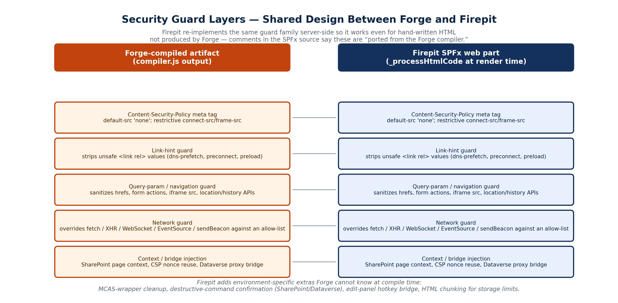
Figure 6. The identical five-layer guard family, implemented independently at build time (Forge) and at render time (Firepit).

8.1 Content-Security-Policy
A restrictive CSP meta tag (default-src 'none', with a narrowly scoped connect-src/frame-src) is the first line of defense in both tools. In Firepit's lockDown mode, connect-src and frame-src collapse to 'none' entirely.

8.2 Link-Hint Guard
CSP alone doesn't stop <link rel="dns-prefetch"/"preconnect"/"preload"> hints, which some browsers will still act on as a passive network signal. Both tools run a MutationObserver-backed script that strips any <link rel> value outside a small allow-list (stylesheet, icon, canonical, etc.).

8.3 Query-Parameter / Navigation Guard
The most invasive layer: it monkey-patches anchor clicks, form submissions, Location.assign/replace/href, and History.pushState/replaceState, stripping query strings and validating destinations against the SharePoint site path before allowing navigation — explicitly aimed at preventing exfiltration of sensitive data through URL query parameters, the one channel CSP and the network guard don't fully cover.

8.4 Network Guard
Overrides window.fetch, XMLHttpRequest, WebSocket, EventSource, and navigator.sendBeacon so that every outbound call is checked against an allow-list (the SharePoint origin, its MCAS-wrapped equivalent, and — where configured — the Dataverse origin) before being permitted. Denied calls show a visible toast (“Blocked outbound …”) rather than failing silently, and are logged.

8.5 Context and Bridge Injection
Finally, both tools inject a small context script exposing SharePoint page identity (site/web IDs, user email/login) to the embedded app, reuse the host page's CSP nonce on every injected script/style tag, and — where applicable — set up the Dataverse postMessage bridge described in Section 3.5.

8.6 What Firepit Adds That Forge Cannot Know at Compile Time
Because Forge compiles offline with no knowledge of the specific SharePoint tenant an app will eventually run in, several pieces of the guard stack can only be finished at render time, inside Firepit: MCAS-wrapper cleanup (Section 3.4), the destructive-command confirmation/rate-limit gate for SharePoint and Dataverse mutations (Section 3.5), the edit-panel hotkey bridge (Section 3.6), and the 250KB property-chunking scheme needed to fit large inline apps into SharePoint's property-size limits (Section 3.3).

9. Deployment Context and Governance
Several independent signals in the analyzed files point to the same operating environment: a U.S. military/government Microsoft 365 tenant under CUI (Controlled Unclassified Information) handling rules.
- The AppManifest deploys to /sites/NAVWAR_PEODIGITAL_SPFx/ — a U.S. Navy NAVWAR (Naval Information Warfare Systems Command) PEO Digital SharePoint site.
- Forge's network allow-list names api.capra.flankspeed.us.navy.mil (“Flank Speed” is the U.S. Navy's enterprise Microsoft 365 tenant), api.genai.army.mil, api.genai.army.smil.mil (a SIPR/classified-network variant), and api.genai.mil.
- Prometheus's LLM backend options are named for Ask Sage's CAPRA/NAVAIR, Army, and SIPR deployments, plus a separate, explicitly gated “public provider certification” flow for anything not on that CUI-compliant list.
- The Security Reviewer targets DoD ASD (Application Security and Development) STIG control IDs by name and can generate an RMF Security Implementation Summary and SBOM — both standard DoD Authorization-to-Operate (ATO) artifacts.
- Forge's own editor stamps an “unshipped” warning banner reading, in effect, “Not Secured – Ship in Forge before entering CUI/sensitive data” into any HTML file that doesn't look like Forge's own compiled output — an explicit data-handling control aimed at the CUI boundary.

9.1 Version History (observed)
Version | Change
7.0.7.0 | Baseline package; AppManifest has no WebApiPermissionRequests.
7.1.0.0 | Adds a WebApiPermissionRequest for “Microsoft Dataverse” (scope user_impersonation), matching the new dataverseEnvironmentUrl property, Dataverse postMessage bridge, and Dataverse-aware destructive-command guard described in Section 3.5.

10. Appendix: Source File Inventory
This guide was produced by unpacking and statically analyzing four files supplied for review:
File | Contents
Forge.html | The Forge IDE itself — a self-decoding bootstrap around a ~6MB bundled single-page application (editor, compiler, decompiler, Prometheus AI agent, checkpoint manager, security reviewer, and supporting tool tabs).
firepit-prod.sppkg / firepit_7.0.7.0.sppkg | SharePoint client-side solution packages (.sppkg, a CAB-style container) for two versions of the Firepit SPFx web part, including its compiled JS bundle, manifest, and app icon assets.
firepit-src-7.1.0.zip | TypeScript source for HtmlFileRendererWebPart (the web part backing Firepit), including its property-pane definition and localized strings.

