**EE2112- Lab 2 Submission Sheet**

**Student Full Name: Eli Schmitter**

**Laboratory Section: L02**

**Laboratory TA Name: Ashfiqur Rahman**

**Date of submission: 9/27/19**

Table 2 and Ta initials

Table 2: Resistance measurements of resistors, and the measurements in the circuit with the calculated resistance.

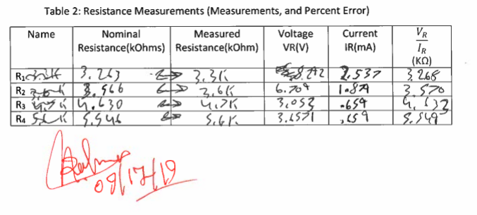

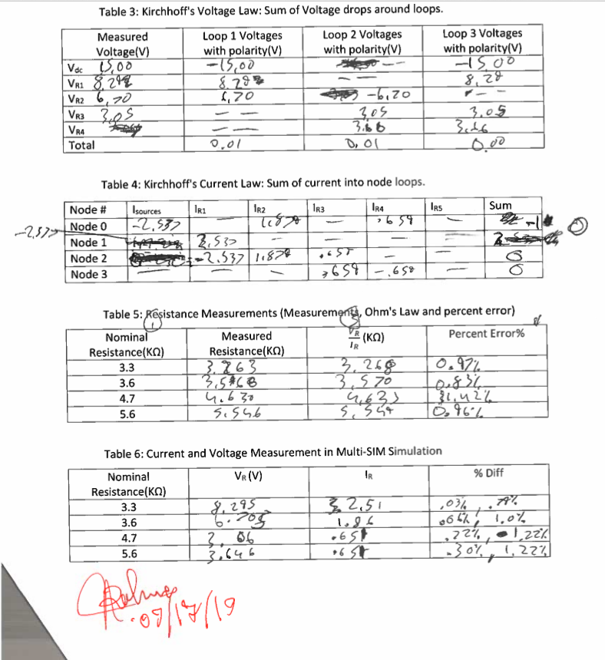How does it compare to the measured quantities? Use (5) to compare measured value and actual value of resistor.

The resistors values that where calculated in circuit where less than 1.5% off (see table 5 for actual values). The calculated values tended to be greater than the measured resistance. This could be because of the resistances in the bread board

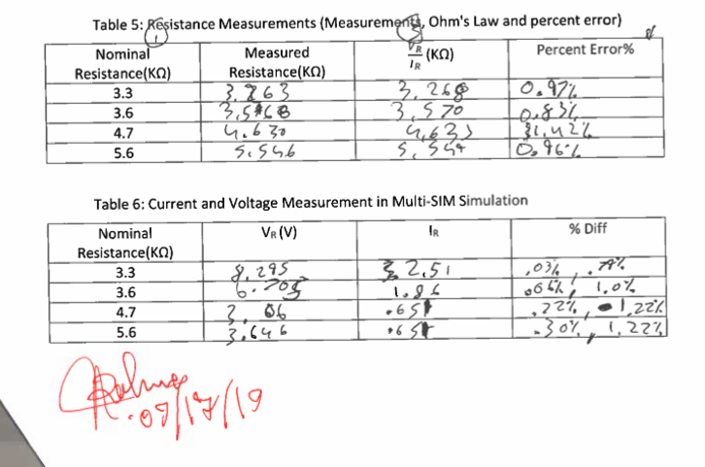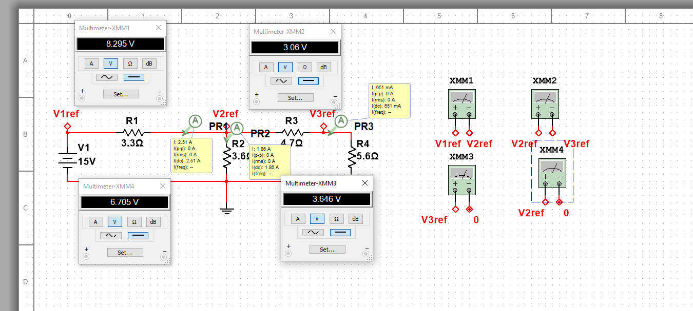

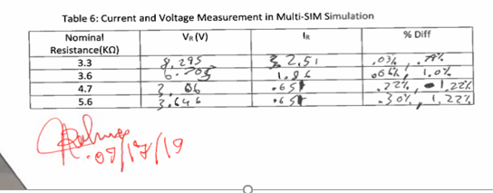

How does the value calculated in the previous step compare with those of your actual circuit measure values in Section 4.2 Table 2?

The values calcutaed had less of a present error to the measured value than the values in the actual circuit, but where still not perfect.

Where there any general trends? Explain.

Some general trends where that the %off where not just one direction away some of the error is grater and some are less. This could be how Multi-SIM handles things, or it could be human error while measuring.

Short conclusion:

This lab has shown how errors differ in different things. For example, we saw how the errors differ in the Multisim and how it differs from the real circuit. The voltage of it varies .05% off the voltage measured in the circuit. All the values are just estimation because all the tools can only be or accurate