This software serves as a data pipeline with the purpose of extracting kinematic features from three-dimensional paw tracking data sets generated during behavioral experiments conducted using the closed-loop automated reaching apparatus (CLARA).

*General workflow: create a spreadsheet with session means*

1. Create a curators folder with a subfolder for each curation to process. Each curation folder should contain the excel files generated during curation for each session to analyze (same file structure as created by the Curator).

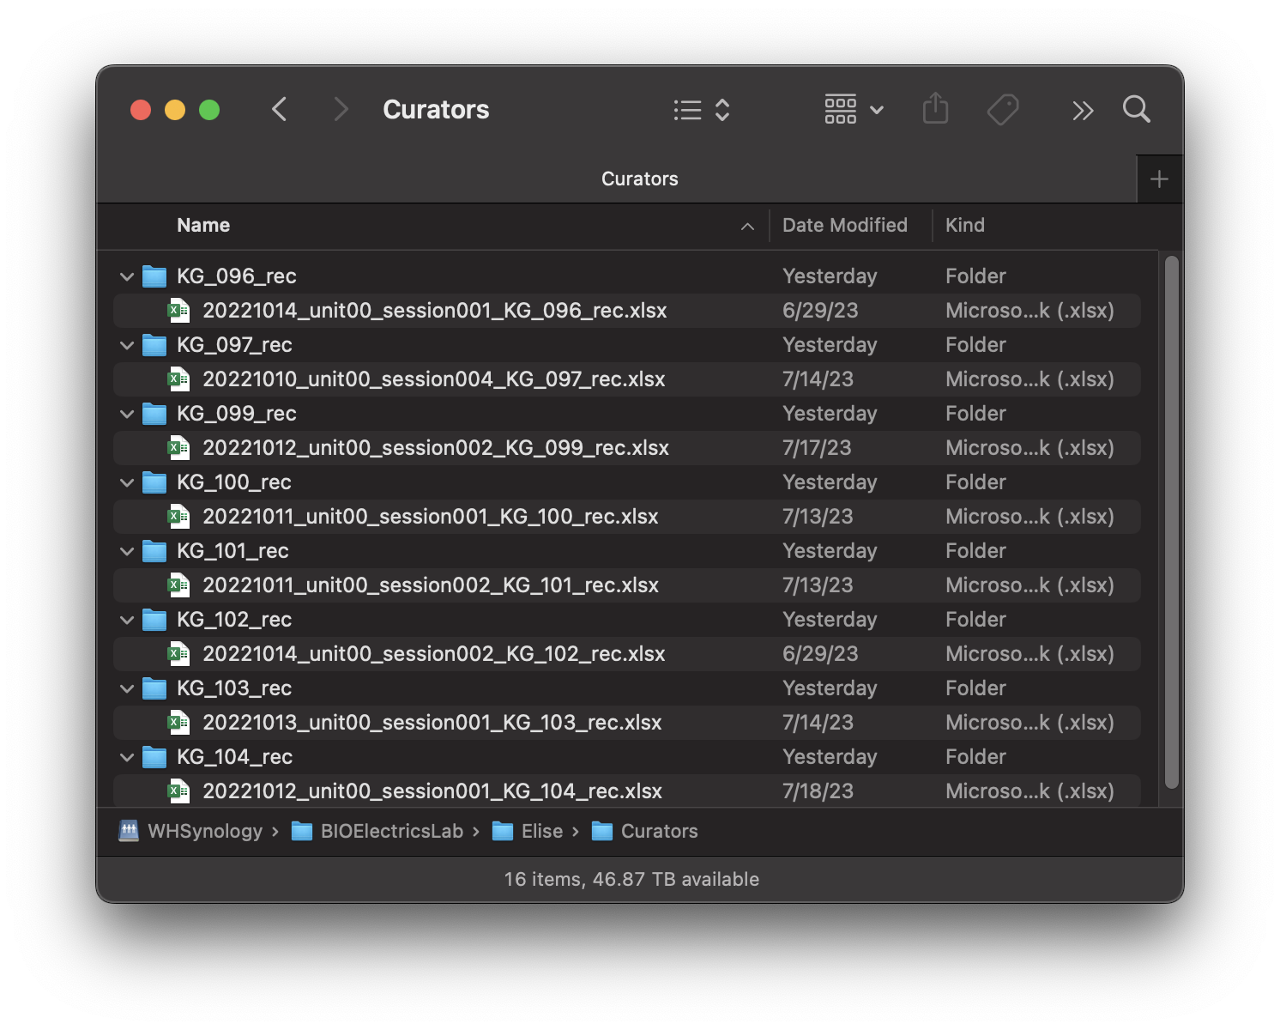

1. Run kda.m in MATLAB making sure that bioelectrics-kda is the working directory. Keep the command window visible as important messages will be displayed there.
2. In the File menu, select Load Raw Data and select the curators folder created in step 1. This loads in the Curation and MATLAB 3D files for all the sessions contained in the curators folder and saves this raw data in the specified output directory as kda files. Alternatively, if you have already loaded the raw data in the past, you may load raw kda files using the File menu. *Note: Yellow warning messages indicate that a reach was deleted due to a mistake in the curator file (details provided in displayed message).*
3. In the Analysis menu, select Extract Kinematics. Click through the pop-up menus to input plotting and filtering options (recommend not filtering by velocity unless necessary). Deleted reaches are shown in the command line. The extracted kinematic features defined in Appendix A are saved as both json and kda files in the output directory.
4. In the Export menu, select Session Means. This exports session means to an excel file in the specified output directory. Select “yes” when prompted by the option to group by experimental condition to populate the “group” column in this file.

*Exporting individual trajectories*

1. Ensure that kda files with the correct status (KinematicsExtracted) are loaded in the workspace.
2. In the Export Menu, select Individual Trajectories and click through the pop-up menus to input plotting options. Within the Trajectory Plots folder, there will be a folder named “Individual Reaches” within each mouse folder.

*Exploring kda files in MATLAB*

1. Load the kda files using the File menu.
2. In the Export menu, select “Kda File(s) to Base Workspace”. The data from the kda workspace will now be visible in the base workspace in MATLAB.

**Appendix A.** Kinematic Features

|  |  |
| --- | --- |
| **Per animal** | Expert reach (mm) |
| **Per session** | Number of reaches |
| Deleted reaches |
| Success percent (decimal %) |
| Expert percent (decimal %) |
| Mean correlation of all reaches to expert reach (decimal %) |
| Mean correlation of successful reaches to expert reach (decimal %) |
| Mean correlation of failed reaches to expert reach (decimal %) |
| Percent improvement of failures (decimal %) |
| Session consistency (decimal %) |
| Mean target distance from pellet (mm) |
| Mean Euclidean velocity (mm/s) |
| Mean absolute velocity (mm/s) |
| Mean maximum absolute velocity (mm/s) |
| Mean location of absolute velocity (decimal %) |
| Mean duration (s) |
| Mean path length – 3D, XY, XZ (mm) |
| Stimulation accuracy (decimal %) |
| Percentages of failure types (decimal %) |
| **Per reach** | Duration (s) |
| Hand position normalized by pellet position (mm) |
| Raw Euclidean velocity (mm/s) |
| Interpolated Euclidean velocity (mm/s) |
| Interpolated absolute velocity (mm/s) |
| Maximum absolute velocity (mm/s) |
| Location of maximum velocity (decimal %) |
| Interpolated hand position (mm) |
| Dynamic time warped hand position (mm) |
| Path length – 3D, XY, XZ (mm) |

# **Appendix B.** Definitions

# Deleted reaches

This is the number of reaches deleted due to poor tracking (>50% of datapoints in a reach have <90% tracking confidence), errors in the DTW function (repeated consecutive datapoints), path length (< 0.2 mm, chosen due to downstream errors in path length calculation), and, optionally, velocity (reaches with velocity > the user-defined threshold are deleted).

# Dynamic time warped hand position

Dynamic time warping a reach allows the spatial component of trajectories to be compared by removing the time and speed components. The algorithm used in this analysis projects each trajectory onto 100 linearly spaced points.

# Expert reach

The expert reach for each animal is defined as the mean of the successful dynamic time warped trajectories during the last two days of training. If there is only one session per mouse, the expert trajectory is defined as the mean of the successful dynamic time warped trajectories during the single training session.

# Expert percent

Any reach that has a correlation of 95% or higher to the expert reach is considered an expert attempt. The expert percent in a given session is the number of expert attempts divided by the number of reaches (not including the deleted reaches) in that session.

# Hand position normalized by pellet position

The pellet position for each reach is defined by first finding the mean of the pellet position during the first 3 frames when the mean tracking confidence for those frames is >90%. The median of those pellet locations is defined as the pellet position for that session. Each trajectory in a session is normalized by subtracting the pellet location.

# .kda files

KDA files are just MAT files with a custom file extension to minimize user error by attempting to load variables into the workspace that are not compatible with the program.

# kda workspace

Data that is accessible by the program will be listed on the kda window. Any actions done using the menus will be done to each animal shown in the workspace.

# Location of maximum velocity

The location of absolute velocity is where the maximum absolute velocity occurs in a reach, shown as a percentage of the duration of the reach.

# Output directory

This is a folder that the user creates and is where the output folders/files created during analysis are saved to.

# Percentages of failure types

The percentages that each failure type (reach, grasp, retrieval) accounts for in the total number of failed reaches.

# Percent improvement of failures

The percent improvement of failures (I.F.) is the change in the mean correlation of failed reaches to expert reach in a given session (Rn) relative to the mean correlation of failures to expert reach on the first day (R1).

# Session consistency

Session consistency is defined as the mean of the pairwise correlations between all reaches in a session.

# Stimulation accuracy

Stimulation accuracy refers to the proportion of stimulation occurring on success (true positive) and no stimulation for failure (true negative) for all reaches in a given session.

$$Accruracy=\frac{TP+TN}{\# of reaches}$$