Elise DECOURVAL

Roman KRYVCHENKO

**“Fitness Trail Assistant” Project**

*Jacques Klein, Tegawendé F. Bissyandé, and Médéric Hurier*



**Table des matières**

Introduction 3

1. Environment 3

2. Achievement of the application 4

2.1. Analysis 4

2.2. Application design 4

3. Results and Perspectives 4

# Introduction

The main objective of the “Fitness Trail Assistant” project is to develop an Android application, by reusing as much as possible the concepts, methods and tools presented in the Principles of Software Development course. The goal of this trail assistant is to help trailer to track their activities, but also to give training instructions.

The trail assistant proposes two modes:

1. Predefined Route: the trailer runs following a route which is already defined in the app. In other words, the app knows what the itinerary is and indicates this itinerary to the trailer.

2. Free Trail: The trailer decides by him (her) self the itinerary.

This project allows us to explore the development of android application. For that we had a lot of help during our teacher course but also a lot of tutorials on the internet.

Our challenge was to achieve an innovative project, useful, related to current events and meets the school's project criteria.

# Environment

For this project we worked with Android Studio provides an API that panel. Thanks to our SDK Manager we have download a lot of tool which allow us to facilitate the conception of our application (figure 1). The most important tool is Google Play Service, indeed, we will see that this API offer a lot of functionality really interesting.

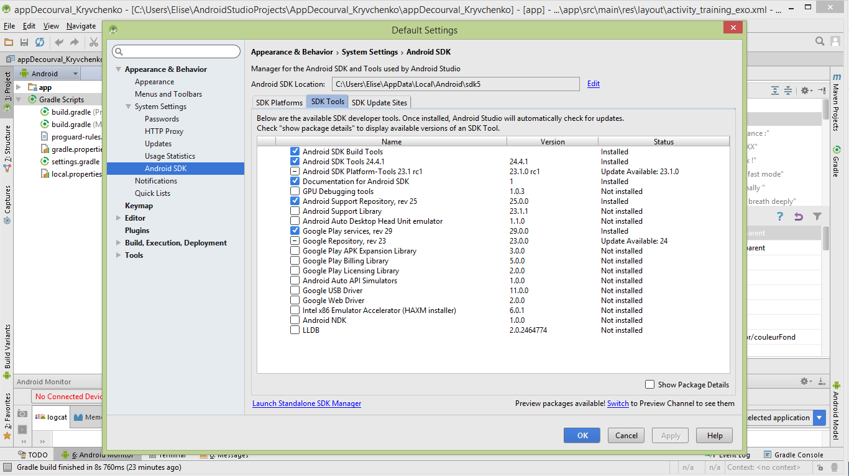

Figure 1 : SDK Manager

We did not use emulator, namely virtual machine because we have Android device which permit to directly test the evolution of our application.

Our project was also directly update in our git repository:

[*https://github.com/elisedcvl/appDecourval_Kryvchenko.git*](https://github.com/elisedcvl/appDecourval_Kryvchenko.git)

# Achievement of the application

The conception of our application was made in several step, which you can see on the figure below:

*Creation of the main activities - Pseudo-code*

*Programming different features*

*Thinking design and functionality*

*Design*

*Analysis*

Figure 2: Step Conception Application

## Analysis

Concerning the analysis. Our application has 4 main step.

The first Step of our application is the **connection** of the user thanks to its Google Play account, *mainActivity*. It’s a very important step because in the application we use several Google Services which can work only with a Google account.

The second step was configuration and programming for obtaining a **Google** **map**. This step was quite complicated because we have never used such tools. In addition many configuration are also done on the google site to obtain authorization.

The next two steps involve the two main ways that our proposed application. Namely, **Predefined route** and **Free Trail**.

Once the user is connected to this Google account, he is lead to the *welcomeActivity*, where is proposed the two principal modes.

Figure 3 : Diagram Welcome Activity

## Application design

# Results and Perspectives