***Supplementary file S4. Forest plots of fear learning processes not included in meta-analysis***

*Supplementary figure 4A. Forest plot of extinction learning to context with corresponding study characteristics per experiment.*

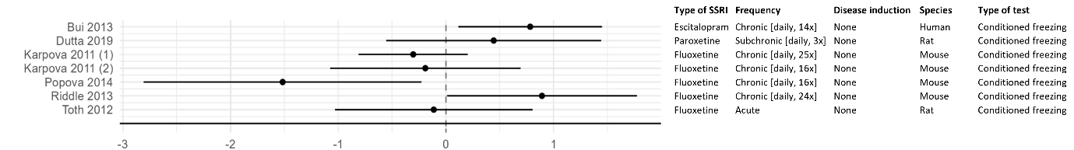

*Supplementary figure 4B. Forest plot of cued fear expression* *after extinction learning with corresponding study characteristics per experiment.*

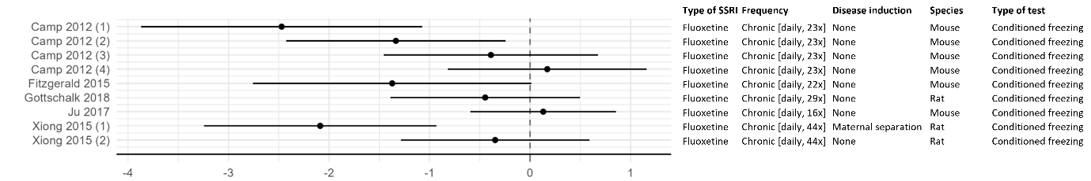

*Supplementary figure 4C. Forest plot of contextual fear expression after extinction learning with corresponding study characteristics per experiment.*