***Supplementary file S7. Meta-analysis with CMA software***

## Materials and Methods

**Data-analysis**

The Comprehensive Meta-Analysis (CMA) V3.3 software was used to perform the statistical analysis the accompanying forest plots were produced in GraphPad Prism 9. The Hedges’s g standardized mean difference (SMD) was used as the effect size measure.

In case of multiple use of the same control group the number of animals used in that control group was divided by the number of times that control group was used in the meta-analysis. A meta-analysis was conducted for each fear learning process that was reported in ten or more independent comparisons from at least five different references. We used the random effects model which takes into account the precision of individual studies and the variation between studies and weights each study accordingly. An overall SMD with a 95% confidence interval was calculated for each of these fear learning processes by pooling all the individual effect sizes (SMDs). A random effects model was used since a variation in the true effect was expected between experiments.

Moderators were predefined (type of SSRI, frequency of administration, species, disease induction and type of fear learning test) and registered in the protocol (supplementary file S1). Subgroup analyses were performed within these moderators whenever five or more independent comparisons from at least three different references were included reporting the same fear learning outcome measures (acquisition/extinction learning or fear expression (after acquisition or extinction learning) to cue/context). Comparisons between subgroups were made by calculating the SMD and the 95% confidence interval of the difference (∆SMD and ∆95% CI) between the subgroups. We expected the variance to be comparable within the subgroups; therefore, we assumed a common among-study variance across subgroups. For subgroup analyses, we adjusted our significance level according to the conservative Bonferroni method to account for multiple analyses (p* number of comparisons). However, differences between subgroups should be interpreted with caution and should only be used for constructing new hypotheses rather than for drawing final conclusions. In addition, heterogeneity was evaluated by measuring the I2 value, the ratio of true heterogeneity to total variance across the observed effect estimates.

## Results

**Acquisition learning to cue**

Meta-analysis

A total of 39 experiments (k = 39) were included in the meta-analysis that investigated the effect of SSRIs on the acquisition learning to cue. Of these 39 experiments, 24 experiments measured acquisition learning to cue, and 15 experiments acquisition learning measured as expression to cue. No effect of SSRIs on acquisition learning to cue was observed (SMD (95% CI) 0.02 (-0.32, 0.35); I2 81%; k = 39) (figure 7A).

None of the four SSRIs that could be included in the subgroup analysis had a significant effect on acquisition learning to cue: citalopram (SMD (95% CI) 0.19 (-0.37, 0.75); P=0.50; I2 75%; k = 8), escitalopram (SMD (95% CI) -0.19 (-0.90, 0.51); P=0.59; I2 45%; k = 5), fluoxetine (SMD (95% CI) 0.19 (-0.20, 0.57); P=0.35; I2 62%; k = 18) and paroxetine (SMD (95% CI) 0.06 (-0.66, 0.77); P=0.88; I2 85%; k = 5) (figure 7B).

Subgroup analysis showed that acute (SMD (95% CI) 0.50 (0.01, 0.99); P=0.04; I2 51%; k = 17) SSRI administration significantly increased fear behaviour during acquisition learning to cue. However, chronic SSRI administration had no significant effect on acquisition learning to cue (SMD (95% CI) -0.37 (-0.84, 0.10); P=0.12; I2 87%; k = 20). Additional analysis revealed that acute SSRI administration had a significantly different effect on fear behaviour than chronic SSRI administration (∆SMD (95% CI) 0.87 (0.19, 1.55); P=0.02) (figure 7B).

Subgroup analysis of disease induction showed no significant effect of SSRIs on acquisition learning to cue in healthy (SMD (95% CI) 0.07 (-0.31, 0.44); P=0.72; I2 78%; k = 29) and stressed subjects (SMD (95% CI) 0.11 (-0.59, 0.81); P=0.76; I2 86%; k = 9)(figure 7B).

A subgroup analysis of species revealed no significant effect of SSRIs on acquisition learning to cue in mice (SMD (95% CI) -0.56 (-1.40, 0.28); P=0.19; I2 87%; k = 7) nor in rats (SMD (95% CI) 0.19 (-0.25, 0.62); P=0.40; I2 81%; k = 28) (figure 7B).

Subgroup analysis comparing different types of fear learning tests revealed no significant effect of SSRIs on acquisition learning neither in the active avoidance (SMD (95% CI) -0.17 (-1.24, 0.90); P=0.76; I2 95%; k = 5) nor in the conditioned freezing test (SMD (95% CI) 0.02 (-0.38, 0.42); P=0.93; I2 76%; k = 31) (figure 7B).

*Supplementary figure 7A. Forest plot of acquisition learning to cue with corresponding study characteristics per experiment. The overall effect was negative (favouring SSRIs) and non-significant (SMD (95% CI) -0.10 (-0.55, 0.36) (P=0.68)).* *VGV 5-HT2CR = valine-glycine-valine isoform of the serotonin 2C receptor, NR = not reported.*



*Supplementary figure 7B. Summary of subgroup analyses on the fear learning process acquisition learning to cue. Subgroup analyses were performed on type of SSRI, frequency of administration, disease induction, species, and type of test. Data are shown as standardized mean differences (SMDs) ± 95% confidence interval (CI). Missing values indicate subgroups that were reported, but had insufficient data to include in the subgroup analyses.*

**Acquisition learning to context**

Meta-analysis

A total of 39 experiments (k = 39) were included in the meta-analysis that investigated the effect of SSRIs on the acquisition learning to context. 2 papers comprising of 4 experiments were not included in the meta-analysis since information on the dispersion of the data was missing. Of these 39 experiments, 25 experiments measured acquisition learning to context and 14 experiments acquisition learning measured as expression to context. No effect of SSRIs on acquisition learning to context was observed (SMD (95% CI) -0.24 (-0.60, 0.11); P=0.18; I2 83%; k = 39) (figure 7C).

None of the three SSRIs that were included in the subgroup analysis revealed a significant effect on acquisition learning to context: citalopram (SMD (95% CI) -0.61 (-1.47, 0.26); P=0.17; I2 87%; k = 7), escitalopram (SMD (95% CI) -0.07 (-1.09, 0.95); P=0.90; I2 87%; k = 5) and fluoxetine (SMD (95% CI) 0.02 (-0.47, 0.51); P=0.94; I2 82%; k = 22) (figure 7D).

Subgroup analysis of frequency of administration showed that both acute (SMD (95% CI) 0.17 (-0.37, 0.71); P=0.54; I2 85%; k = 16) and subchronic (SMD (95% CI) -0.27 (-1.16, 0.61); P=0.54; I2 88%; k = 6) SSRI administration had no significant effect on acquisition learning to context. However, chronic SSRI administration significantly reduced fear behaviour as assessed by acquisition learning to context (SMD (95% CI) -0.64 (-1.17, -0.10); P=0.02; I2 75%; k = 17). Further analysis showed that chronic SSRI administration had a significantly different effect on fear behaviour compared to acute SSRI administration (∆SMD (95% CI) 0.81 (0.05, 1.57); P=0.046) (figure 7D).

Subgroup analysis of disease induction on the effect of SSRIs on acquisition learning to context showed no significant effect in both healthy subjects (SMD (95% CI) -0.14 (-0.56, 0.28); P=0.51; I2 82%; k = 29) and stressed subjects (SMD (95% CI) -0.49 (-1.34, 0.35); P=0.25; I2 89%; k = 8) (figure 7D).

A subgroup analysis of species revealed that SSRIs significantly reduced fear behaviour during acquisition learning to context in mice (SMD (95% CI) -0.92 (-1.53, -0.32); P=0.00; I2 49%; k = 12) but not in rats (SMD (95% CI) 0.08 (-0.34, 0.51); P=0.70; I2 85%; k = 26). Additional analysis revealed that SSRI administration had a significantly different effect on fear behaviour in mice than in rats (∆SMD (95%) 1.01 (0.27, 1.75); P=0.01) (figure 7D).

No significant effect of SSRIs on acquisition learning to context was measured in both the conditioned freezing (SMD (95% CI) -0.37 (-0.81, 0.07); P=0.10; I2 82%; k = 26) and the passive avoidance test (SMD (95% CI) -0.13 (-1.10, 0.85); P=0.80; I2 90%; k = 6) in the subgroup analysis of types of fear learning tests (figure 7D).

*Supplementary figure 7C. Forest plot of acquisition learning to context with corresponding study characteristics per experiment. The overall effect was negative (favouring SSRIs) and non-significant (SMD (95% CI) -0.02 (-0.43, 0.38) (P=0.92)). Zfpm1CKO = Zfpm1 conditional knockout.*



*Supplementary figure 7D. Summary of subgroup analyses on the fear learning process acquisition learning to context. Subgroup analyses were performed on type of SSRI, frequency of administration, disease induction, species and type of test. Data are shown as standardized mean differences (SMDs) ± 95% confidence interval (CI). Missing values indicate subgroups that were reported, but had insufficient data to include in the subgroup analyses.*

**Cued fear expression after acquisition learning**

Meta-analysis

A total of 41 experiments (k = 41) were included in the meta-analysis that investigated the effect of SSRIs on cued fear expression after acquisition learning. One article, comprising of one experiment was not included in the meta-analysis since the results were not extractable due to the low quality of figures in the paper, the figures were not readable. No effect of SSRIs on cued fear expression after acquisition learning was observed (SMD (95% CI) -0.13 (-0.40, 0.14); P=0.33; I2 75%; k = 41) (figure 7E).

Both fluoxetine (SMD (95% CI) -0.27 (-0.64, 0.10); P=0.16; I2 69%; k = 21) and paroxetine (SMD (95% CI) -0.07 (-0.62, 0.47); P=0.79; I2 78%; k = 10) were included in the subgroup analysis and did not have a significant effect on cued fear expression after acquisition learning (figure 7F).

Subgroup analysis showed that both acute (SMD (95% CI) 0.48 (0.06, 0.89); P=0.02; I2 74%; k = 15) and chronic (SMD (95% CI) -0.51 (-0.85, -0.18); P=0.003; I2 67%; k = 23) SSRI administration had a significant effect on cued fear expression after acquisition learning. The difference in effect of these two subgroups was significant (∆SMD (95%) 0.99 (0.46, 1.52); P=0.00). Acute SSRI administration led to significantly increased fear behaviour whereas chronic SSRI administration caused fear behaviour to decrease (figure 7F).

Subgroup analysis on the effect of SSRIs on cued fear expression after acquisition learning in healthy subjects showed no significant effect (SMD (95% CI) 0.08 (-0.20, 0.37); P=0.57; I2 73%; k = 32) but significantly reduced fear behaviour in stressed subjects (SMD (95% CI) -0.97 (-1.59, -0.34); P=0.00; I2 72%; k = 7). Furthermore, the anxiolytic effect of SSRIs was found to be significantly stronger in stressed subjects than in healthy subjects (∆SMD (95%) 1.05 (0.37, 1.74); P=0.00) (figure 7F).

A subgroup analysis of species revealed no significant effect of SSRIs on cued fear expression after acquisition learning in rats (SMD (95% CI) 0.18 (-0.22, 0.57); P=0.38; I2 79%; k = 19) whereas a significant effect was found for mice (SMD (95% CI) -0.48 (-0.87, -0.09); P=0.02; I2 66%; k = 20). Additional analysis showed that the effect of SSRIs had a significantly different effect in mice compared to rats (∆SMD (95%) 0.66 (0.10, 1.21); P=0.03) (figure 7F).

SSRIs were shown to have a significant effect on cued fear expression after acquisition learning when measured in the conditioned freezing test, fear behaviour was significantly decreased (SMD (95% CI) -0.40 (-0.70, -0.10); P=0.009; I2 74%; k = 29). No significant effect of SSRIs on cued fear expression after acquisition learning was found when fear behaviour was measured using the fear potentiated startle test (SMD (95% CI) 0.38 (-0.08, 0.85); P=0.11; I2 56%; k = 11) (figure 7F). Further analysis showed that the effect of SSRIs measured in tests based on conditioned freezing was significantly different from that measured in fear potentiated startle tests (∆SMD (95%) 0.79 (0.23, 1.34); P=0.02).

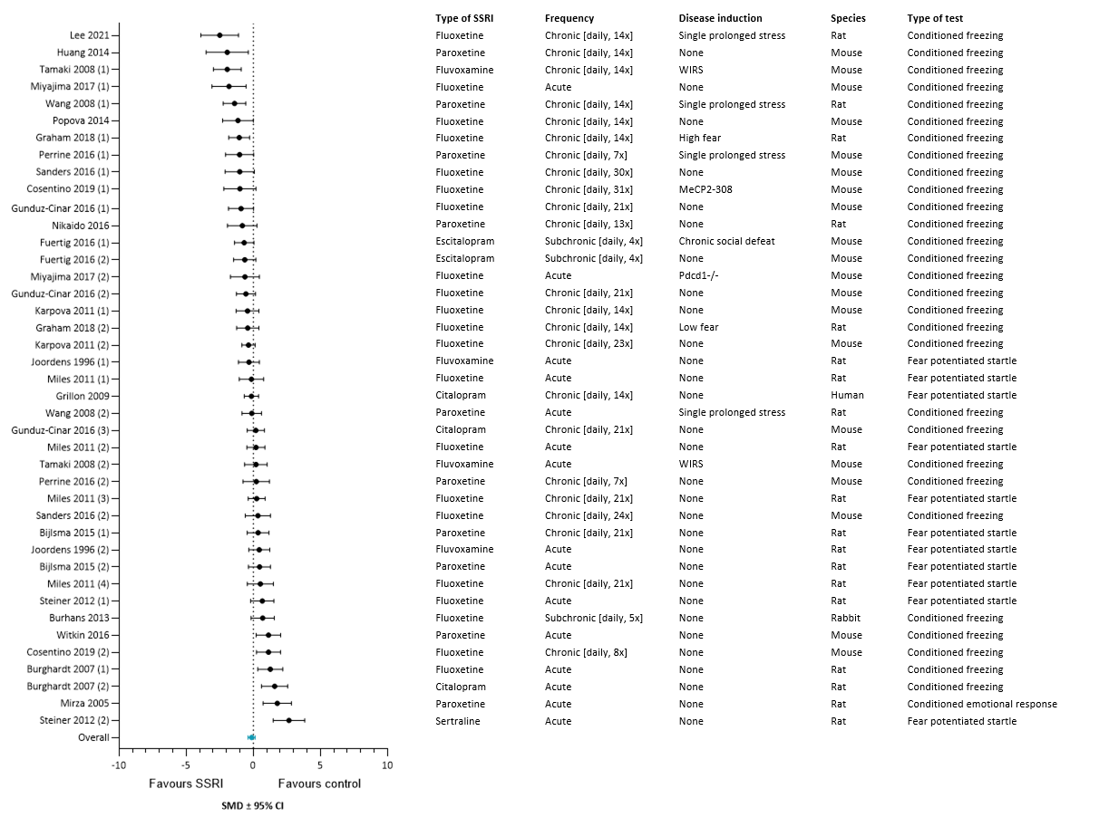

*Supplementary figure 7E. Forest plot of cued fear expression after acquisition learning* *with corresponding study characteristics per experiment. The overall effect was negative (favouring SSRIs) and non-significant (SMD (95% CI) -0.13 (-0.40, 0.14) (P=0.33)). WIRS = water immersion restraint stress,* *MeCP2-308 = truncated form of methyl-CpG binding protein 2, Pdcd1-/- = PD-1 deficient.*



*Supplementary figure 7F. Summary of subgroup analyses on the fear learning process cued fear expression after acquisition learning. Subgroup analyses were performed on type of SSRI, frequency of administration, disease induction, species and type of test. Data are shown as standardized mean differences (SMDs) ± 95% confidence interval (CI). Missing values indicate subgroups that were reported, but had insufficient data to include in the subgroup analyses.*

**Contextual fear expression after acquisition learning**

Meta-analysis

A total of 118 experiments (k = 118) were included in the meta-analysis that investigated the effect of SSRIs on contextual fear expression after acquisition learning. SSRIs were found to have a significant anxiolytic effect on this fear learning process (SMD (95% CI) -0.82 (-1.06, -0.59); P=0.00; I2 85%; k = 118) (figure 7G).

Subgroup analyses showed that most SSRIs were favoured over placebo (citalopram: SMD (95% CI) -0.75 (-1.20, -0.31); P=0.00; I2 70%; k = 29, fluoxetine: SMD (95% CI) -0.56 (-0.97, -0.14); P=0.01; I2 84%; k = 33, fluvoxamine: SMD (95% CI) -1.66 (-2.38, -0.94); P=0.00; I2 87%; k = 12, and sertraline: SMD (95% CI) -1.55 (-2.10, -1.01); P=0.00; I2 84%; k = 21). Except for escitalopram (SMD (95% CI) 0.34 (-0.42, 1.09); P=0.38; I2 90%; k = 10) and paroxetine (SMD (95% CI) -0.69 (-1.37, 0.00); P=0.05; I2 85%; k = 13), for which the effect on contextual fear expression after acquisition learning did not differ from placebo (figure 7H). Further analyses showed that the anxiolytic effect of sertraline was significantly stronger than that of fluoxetine (∆SMD (95%) 1.00 (0.31, 1.68); P=0.04).

Subgroup analysis showed that both acute (SMD (95% CI) -0.59 (-0.90, -0.27); P=0.00; I2 86%; k = 62) and chronic (SMD (95% CI) -1.27 (-1.65, -0.89); P=0.00; I2 83%; k = 45) SSRI administration significantly reduced fear behaviour as assessed by contextual fear expression after acquisition learning. However, chronic SSRI administration caused a significantly larger reduction in fear behaviour than acute SSRI administration (SMD (95%) 0.68 (0.19, 1.17); P=0.02). Sub chronic treatment of SSRIs did not have a significant effect on contextual fear expression after acquisition learning (SMD (95% CI) -0.45 (-1.19, 0.29); P=0.24; I2 79%; k = 11) (figure 7H).

SSRI administration was found to cause a significant reduction in fear behaviour in both healthy (SMD (95% CI) -0.66 (-0.91, -0.40); P=0.00; I2 85%; k = 97) and stressed (SMD (95% CI) -1.68 (-2.30, -1.06); P=0.00; I2 83%; k = 17) subjects as measured by contextual fear expression after acquisition learning. In addition, the anxiolytic effect of SSRIs was found to be significantly stronger in stressed subjects than in healthy subjects (∆SMD (95%) 1.02 (0.36, 1.69); P=0.00) (figure 7H).

A subgroup analysis of species revealed that the administration of SSRIs in both mice (SMD (95% CI) -1.07 (-1.53, -0.62); P=0.00; I2 86%; k = 34) and rats (SMD (95% CI) -0.77 (-1.06, -0.48); P=0.00; I2 85%; k = 80) significantly reduced fear behaviour as assessed by contextual fear expression after acquisition learning (figure 7H).

Fear behaviour was significantly reduced by SSRIs when measured in the conditioned freezing test as shown by a subgroup analysis of types of fear learning tests (SMD (95% CI) -1.06 (-1.32, -0.80); P=0.00; I2 85%; k = 93). No significant effect on contextual fear expression after acquisition learning was found when fear behaviour was measured using the fear potentiated startle test (SMD (95% CI) 0.25 (-0.71, 1.20); P=0.61; I2 74%; k = 6) (figure 7H). Furthermore, comparing the outcome measures of these two types of tests revealed that significantly lower levels of fear behaviour were measured in the conditioned freezing test after SSRI administration as compared to the fear potentiated startle test (∆SMD (95%) 1.31 (0.32, 2.29); P=0.01).

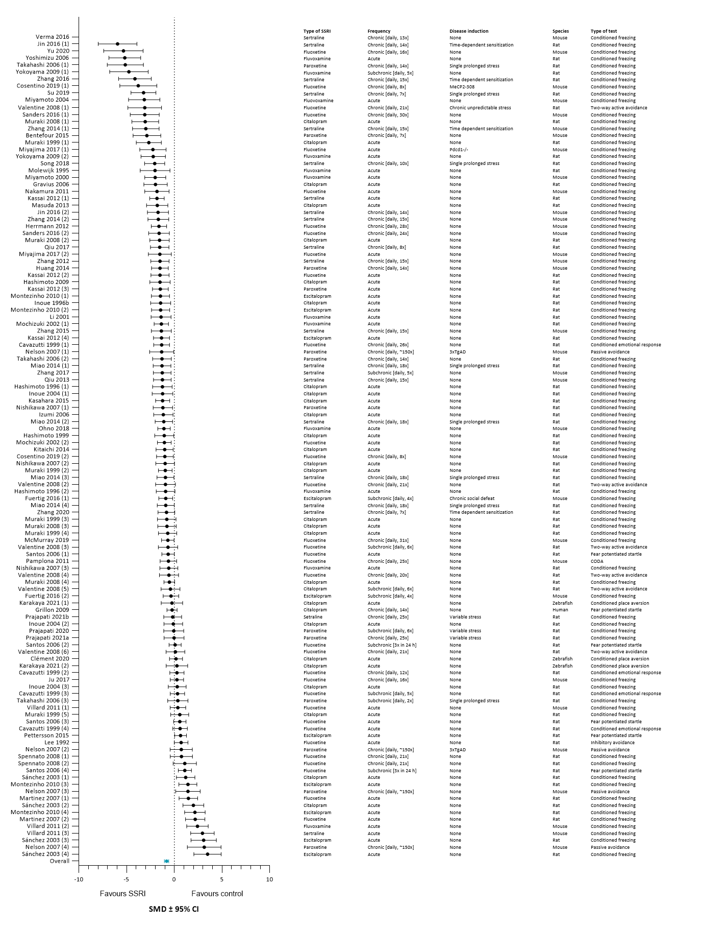

*Supplementary figure 7G. Forest plot of contextual fear expression after acquisition learning with corresponding study characteristics per experiment. The overall effect was negative (favouring SSRIs) and significant (SMD (95% CI) -0.82 (-1.05, -0.58) (P=0.00)). MeCP2-308 = truncated form of methyl-CpG binding protein 2, Pdcd1-/- = PD-1 deficient, 3xTgAD = triple transgenic Alzheimer’s disease, CODA = conditioned odor avoidance task.*



*Supplementary figure 7H. Summary of subgroup analyses on the fear learning process contextual fear expression after acquisition learning. Subgroup analyses were performed on type of SSRI, frequency of administration, disease induction, species and type of test. Data are shown as standardized mean differences (SMDs) ± 95% confidence interval (CI). Missing values indicate subgroups that were reported, but had insufficient data to include in the subgroup analyses.*

**Extinction learning to cue**

Meta-analysis

A total of 17 experiments (k = 17) were included in the meta-analysis that investigated the effect of SSRIs on the extinction learning to cue. Of these 17 experiments, 14 experiments measured extinction learning to cue and 3 experiments extinction learning measured as fear expression to cue. SSRIs were observed to have a significant anxiolytic effect on extinction learning to cue (SMD (95% CI) -0.96 (-1.60, -0.32); P=0.00; I2 88%; k = 17) (figure 7J).

The only SSRI that was included in the subgroup analysis on type of SSRI was paroxetine and showed a significant effect on extinction learning to cue in the subgroup analysis, fear behaviour was significantly reduced after administration (SMD (95% CI) -1.53 (-2.36, -0.70); P=0.00; I2 85%; k = 9) (figure 7K).

Subgroup analysis showed that acute SSRI administration significantly reduced fear behaviour as measured during extinction learning to cue (SMD (95% CI) -2.14 (-3.16, -1.11); P=0.00; I2 87%; k = 6). However, chronic SSRI administration did not have a significant effect on extinction learning to cue (SMD (95% CI) -0.14 (-0.98, 0.70); P=0.74; I2 85%; k = 8) (figure 7K).

Subgroup analysis of disease induction on the effect of SSRIs on extinction learning to cue in healthy subjects showed no significant effect on fear behaviour (SMD (95% CI) -0.40 (-0.97, 0.17); P=0.17; I2 83%; k = 13) (figure 7K).

A subgroup analysis of species revealed that SSRIs significantly reduced fear behaviour as assessed during extinction learning to cue in mice (SMD (95% CI) -1.47 (-2.41, -0.53); P=0.00; I2 90%; k = 9) whereas no significant effect was found for rats (SMD (95% CI) -0.43 (-1.48, 0.61); P=0.42; I2 86%; k = 7) (figure 7K).

A subgroup analysis of types of fear learning tests showed that SSRIs significantly reduced fear behaviour measured during extinction learning to cue in the conditioned freezing test (SMD (95% CI) -0.97 (-1.69, -0.25); P=0.01; I2 89%; k = 15) (figure 7K).

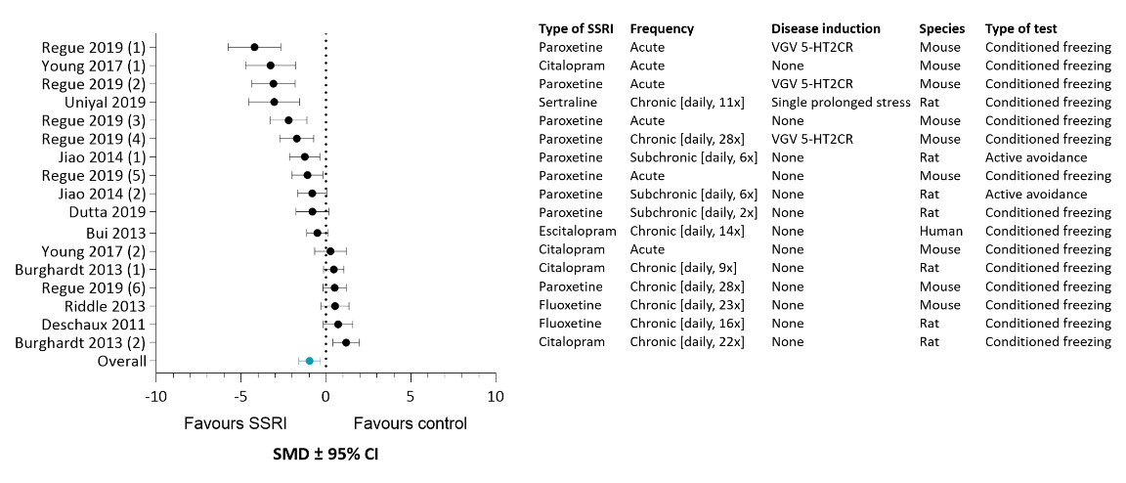

*Supplementary figure 7J.* *Forest plot of extinction learning to cue with corresponding study characteristics per experiment. The overall effect was negative (favouring SSRIs) and significant (SMD (95% CI) -0.90 (-1.61, -0.20) (P=0.01)). VGV 5-HT2CR = valine-glycine-valine isoform of the serotonin 2C receptor.*



*Supplementary figure 7K. Summary of subgroup analyses on the fear learning process extinction learning to cue. Subgroup analyses were performed on type of SSRI, frequency of administration, disease induction, species and type of test. Data are shown as standardized mean differences (SMDs) ± 95% confidence interval (CI). Missing values indicate subgroups that were reported, but had insufficient data to include in the subgroup analyses.*

**Extinction learning to context**

*Supplementary figure 7L. Forest plot of extinction learning to context with corresponding study characteristics per experiment.*

**Cued fear expression** **after extinction learning**

*Supplementary figure 7M. Forest plot of cued fear expression* *after extinction learning with corresponding study characteristics per experiment.*

**Contextual fear expression after extinction learning**

*Supplementary figure 7N. Forest plot of contextual fear expression after extinction learning with corresponding study characteristics per experiment.*

**Summary of meta-analysis data**

Findings in this systematic review suggest that acute and chronic treatment with SSRIs during acquisition learning to cue may have opposing effects. The cued fear response was significantly enhanced following acute SSRI treatment, whereas chronic SSRI treatment tended to decrease the fear response during acquisition.

Results of this systematic review indicate that chronic SSRI treatment during acquisition learning may reduce the contextual fear response, whereas no effects were found with shorter treatment duration. Furthermore, the effect of SSRIs on contextual fear learning may well depend on the species in which the SSRIs are tested. SSRIs significantly reduced fear learning in mice whereas no effects of SSRIs were found in rats. Currently available data do not indicate that the effects of SSRIs on contextual fear acquisition in naive animals differ from those in stressed animals.

No beneficial effect of SSRIs on cued fear expression after acquisition learning was indicated by the findings of this systematic review. Findings suggest that the effects of SSRIS are moderated by three factors. First of all, acute treatment had a significant anxiogenic effect whereas chronic treatment had a significant anxiolytic effect. Secondly, SSRIs significantly reduced fear expression in mice while no effect of SSRIs was found in rats. Lastly, SSRIs had a significant anxiolytic effect when measured in the conditioned freezing test, whereas no effect was found in the fear potentiated startle test.

Findings in this systematic review indicate that SSRIs have a robust beneficial effect on contextual fear expression after acquisition learning. The effect was not dependent on duration of treatment, was found in both healthy and stressed subjects, and in both mice and rats. SSRIs had a strong effect on contextual anxiety when measured as conditioned freezing, whereas the currently available data do not suggest an effect on fear potentiated startle. Interestingly, four SSRIs (citalopram, fluoxetine, fluvoxamine and sertraline) had an anxiolytic effect whereas the other two SSRIs (escitalopram and paroxetine) did not have an effect on contextual fear expression. These last two SSRIs (n = 5 and n = 8, respectively) were the least investigated SSRIs and therefore probably did not substantially affect the general effect of SSRIs on contextual fear expression after acquisition learning.

The papers included in this systematic review indicate that SSRIs have a beneficial effect on extinction learning to cue. However, this was only the case for acutely administered SSRIs, chronic SSRI treatment did not have an effect on extinction learning to cue. Also, SSRIs were able to significantly reduce extinction learning in mice while no effect of SSRIs was found in rats.

*Supplementary figure 7P. Summary of the meta-analysis data on the effect of SSRIs on different fear learning processes, both within and between subgroups.* *If no meta-analysis was performed for a subgroup within a certain fear learning process, the corresponding box was coloured light grey. NS = not significant, ↓ = significant decrease in measured fear behaviour, ↑ significant increase in measured fear behaviour, light grey area = no meta-analysis was performed.*

**Sensitivity analysis**

Multiple sensitivity analyses were performed per fear learning process in order to check the robustness of the meta-analysis results. Exclusion of the articles by the characteristics described in the method section did not alter the significance or direction of the effect of SSRIs on acquisition learning to cue, acquisition learning to context and cued and contextual fear expression after acquisition learning. However, exclusion of the articles that gave the SSRI during both the measured fear learning process and one or more previous process(es) of fear learning (during acquisition and extinction); altered the significance but not the direction of the effect of SSRIs on extinction learning to cue. The overall effect of SSRIs on extinction learning to cue was no longer significant after performing the sensitivity analysis.