Historic Effects of Climate Change on Tree Crop Phenology in California

# Introduction

Fruit and nut crops, like almonds, walnuts and prunes, made up about 40% of the California agricultural sector by income in 2017 (Ross 2018). Almonds individually are the third highest valued commodity California produces, second only to milk and cream (Ross 2018). Unlike field crops and other annuals that are replanted every spring, tree crops stay in the same place for multiple decades. They also require more upfront investment as most trees do not fruit until a couple years after planting. Because of this, they are more vulnerable to changes in climate.

The impact of climate change in California are fairly well documented, especially with respect to drought (Griffin and Anchukaitis 2014; Diffenbaugh, Swain, and Touma 2015). However, groundwater based irrigation systems currently provide a buffer for many agricultural systems from significant water stress during droughts (Medellín-Azuara et al. 2016). Temperatures in California are also changing due to climate change and this many already have impacted the phenology for more sensitive crops (Luedeling 2012b). Many papers have has also been demonstrated temperature to be one of the key, if not the key climatic variable when predicting crop phenology (Day, Lopez, and DeJong 2007; Luedeling et al. 2009; DeBuse, Lopez, and DeJong 2010; Tombesi et al. 2010; Ruml et al. 2011; Pope et al. 2014 among others).Additionally, many studies have investigated the potential and realized impacts of climate change on flowering and leaf-out dates in tree crops (Luedeling, Zhang, and Girvetz 2009; Luedeling 2012; Benmoussa et al. 2017). However, very few if any studies have looked at changes in season length.

The majority of variation in California temperatures over the past century is not due to climate change, but rather is inter-annual. Since temperature variablility between years is so great, we can use crops’ phenological responses over many years to fit models relating temperature and crop phenology (Weinberger 1948; B. M. Mimoun and DeJong 1998). These models can then be used to interpret changes in season length (days from full bloom or leaf-out to maturity).

This paper documents temperature changes in California over the past century and relates those changes to changes in almond, prune and walnut phenology in the Central Valley. Because tree crop maturity is influenced by so many factors, detecting changes in season length over time due to climate change can be difficult. By looking at tree response to interannual temperature variation, we can explain past phenological trends and predict future ones.

# Methods

## Data

### Climate Data

Climate data for each of the focal orchard sites was obtained from the National Climatic Data Center (NCDC, Menne and Houston 2015) and from California Irrigation Management Information System (CIMIS, California Department of Water Resources 2015). The NCDC provided daily minumum and maxiumum temperature data going back to the early 1900s, and CIMIS provided hourly data back to 1983. A number of climate stations were chosen for each orchard location to ensure there would be data for every day in the time span of the orchard datasets for each location (Table 1). The closest station to the site with at least 85% completeness was chosen as the primary station. Temperature data from other stations was related to temperature data from the primary station via a linear regression. This model was then used to fill in gaps in the primary station’s data. In cases where there were nearby NCDC and CIMIS weather stations, one primary station was chosen for each data source.

### Phenological Data

Though the almond and walnut datasets have records for a large number of cultivars, only a subset will be analyzed – the current most commercially popular variety, as well as one or two other cultivars with different phenological timing. It is expected that if there is variability in response to warming, examining cultivars that cover the spectrum of flowering and harvest dates is the most likely way to reveal that variability. The prune industry in California is planted almost exclusively with one cultivar and thus only one cultivar will be analyzed.

Almond bloom and harvest records came from the University of California (UC) Regional Almond Variety Trial (RAVT). Data from the UC Regional Almond Variety Trial were recorded in Chico and Modesto by UC Cooperative Extension advisors assigned to the county where the data was recorded. The bloom record in a given year represents the average bloom of a number of trees of similar age in the same orchard. We report data for cultivars ‘Nonpareil’, and ‘Mission’ which represent the range of bloom timing in commercially cultivated almonds, and both have sufficiently long data records. Prune bloom and harvest timing data was recorded by the University of California Prune Breeding, provided by current breeder Sarah Castro. Because the ‘Improved French’ cultivar makes up almost all of the prune acreage in California, it is the only prune cultivar analyzed. We used walnut phenology data from the University of California at Davis Walnut Breeding Program. Leaf out dates (LD) and Harvest readiness dates (HRD) were collected by Charles Leslie, Gale McGranahan and the members of the Walnut Improvement Program. The cultivars ‘Chandler’, ‘Payne’, and ‘Franquette’ were chosen as cultivars that both span the range of flowering and harvest dates as well as having long data records (>30 years).

## Analysis

All analysis was completed in R Statistical Programming Environment (R Core Team 2018) using the ‘phenoclim’ package (citation) to estimate thermal time accumulation parameters.

NCDC and CIMIS weather station information by orchard location.

Source

Location

Orchard Location

Start

End

NCDC

Chico University Farm

Chico

1982

2014

Primary

NCDC

Oroville Municipal Airport

Chico

1906

2014

NCDC

Orland CA

Chico

1998

2014

CIMIS

Durham CA

Chico

1982

2014

Primary

NCDC

Davis Experimental Farm

Davis

1893

2014

Primary

NCDC

Winters CA

Davis

1942

2014

NCDC

Woodland CA

Davis

1911

2014

CIMIS

Davis CA

Davis

1982

2014

Primary

NCDC

Modesto City Co Airport

Modesto

1906

2014

Primary

NCDC

Stockton Metropolitan Airport

Modesto

1948

2014

CIMIS

Manteca CA

Modesto

1987

2014

Primary

CIMIS

Parlier CA

Parlier

1983

2014

Primary

NCDC

Visalia CA

Parlier

1895

2014

Season lengths for almonds and prunes started at full bloom, while walnut season length began at leaf-out. Maturity for almonds and walnuts was counted at hull-split while prunes were considered mature at 3-4 lbs of pressure. All phenological data were analyzed separately by location and cultivar using ordinary linear regression.

Thermal time was calculated using the asymcur model described by (Anderson and Kesner 1986). We used the ‘phenoclim’ package to determine the optimal number of days of thermal time accumulation after bloom or leaf-out to use for predicting season length for each cultivar using ‘phenoclim’ package. Mean season length (null model) as well as thermal time accumulation 30 days after full bloom (GDH30) were also calculated as a comparison as these are the most commonly used methods for predicting season length (Day, Lopez, and DeJong 2007; Tombesi et al. 2010; Ruml et al. 2011; Pope et al. 2014). Because latitude can effect phenological requirements (citation), we also separated data by location.

Thermal time accumulation was then calculated for each year with full bloom or leaf-out data. Next we related thermal time accumulation to season length using linear models. Finally, we examined trends in thermal time accumulation over the entire bloom time series for each cultivar and location.

# Results

## Model Optimization

Length of optimized thermal time accumulation varied significantly between crop, location and cultivar (Table 2). Accumulation lengths varied from 35 days for Mission almonds in Modesto to 74 days for prunes in Parlier. The optimized models consistently performed better than both the GDH30 models and the null model, by an average of 0.91 days and 2.17 days respectively.

Optimized length of thermal time accumulation in days for predicting season length, by crop, location and cultivar, and a comparison of 5-fold crossvalidated RMSE values for the optimized GDH models, GDH30 models, and mean season length.

Crop

Location

Cultivar

Days

Opt. GDH

GDH30

NULL

almond

Chico

Mission

45

7.21

8.63

9.14

almond

Modesto

Mission

35

12.28

13.71

17.32

almond

Chico

Nonpareil

53

6.65

7.86

10.62

almond

Modesto

Nonpareil

46

4.59

5.26

4.83

prune

Parlier

French

74

7.02

7.75

8.20

walnut

Davis

Chandler

49

6.71

6.78

7.98

walnut

Davis

Payne

65

5.87

7.47

8.15

walnut

Davis

Franquette

36

5.10

5.26

6.51

## Almonds

Mean almond season lengths did not appear to decrease over the 10 years of the Regional Almond Variety Trials. (Figure 3). However because the time series are so short, we cannot make any longterm predictions based on this. Almond season lengths respond fairly well to optimized thermal time accumulation (Figure 4, Table 7), with GDH explaining between 30% and 65% of season length variation. Despite this, the model relating thermal time accumulation for Nonpareil Almonds to season length in Modesto was not strongly significant.

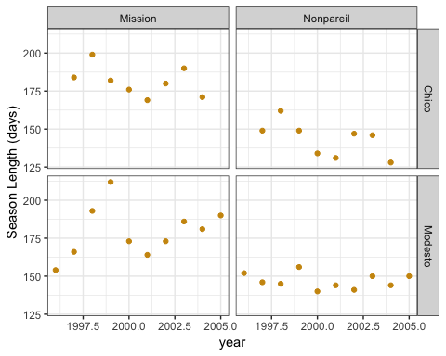

Almond season lengths over 10 years in Chico, California.

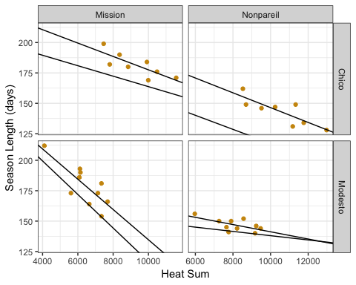

Almond season length by heat sum in Chico, California.

In Chico, thermal time accumulation increased by 22 GDH per year for Mission almonds and 30 GDH per year for Nonpareil almonds. In Modesto, thermal time accumulation actually decreased over time during the period of study (Table 7). This is in stark contrast to the mostly increasing mean monthly temperatures in Modesto (Table 3).

Summary of linear regression models relating year, season length and thermal time accumulation in almonds.

Location

Cultivar

Predictor

Response

Coefficient

p-value

R2

Chico

Mission

Year

Season Length

-1.774

0.276

0.059

Modesto

Mission

Year

Season Length

1.624

0.413

-0.029

Chico

Nonpareil

Year

Season Length

-2.810

0.112

0.260

Modesto

Nonpareil

Year

Season Length

-0.291

0.631

-0.091

Chico

Mission

GDH45

Season Length

-0.006

0.020

0.562

Modesto

Mission

GDH35

Season Length

-0.012

0.007

0.569

Chico

Nonpareil

GDH53

Season Length

-0.006

0.010

0.649

Modesto

Nonpareil

GDH46

Season Length

-0.003

0.055

0.311

Chico

Mission

Year

GDH45

22.139

0.029

0.061

Modesto

Mission

Year

GDH35

-80.414

0.013

0.237

Chico

Nonpareil

Year

GDH53

30.668

0.005

0.107

Modesto

Nonpareil

Year

GDH46

-106.482

0.003

0.309

Chico

Mission

GDH30

Season Length

-0.004

0.123

0.240

Modesto

Mission

GDH30

Season Length

-0.014

0.011

0.520

Chico

Nonpareil

GDH30

Season Length

-0.006

0.086

0.314

Modesto

Nonpareil

GDH30

Season Length

-0.002

0.428

-0.035

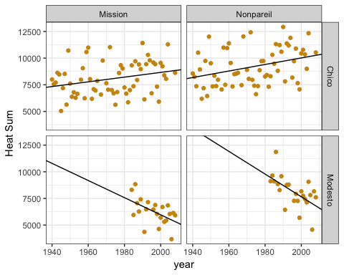

Almond heat sums over 80 years in Chico and Modesto, California.

## Prunes

French Prune season lengths in Parlier shortened by an average of 0.49 days per year over the past 25 years, with a p-value of 0.041 and an adjusted R-squared of 0.160 (Figure 6, Table 8). Prune season length responded strongly to the optimized thermal time accumulation (Figure 7). Additionally, thermal time accumulated in the first 74 days after bloom showed a statistically significant increasing trend over time (Figure 8). However, this trend accounted for less variation than modeling season length over time (Table 8).

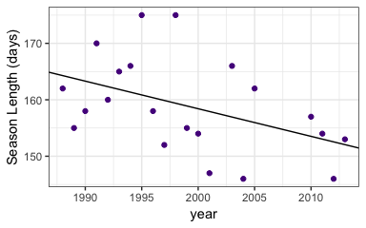

Prune season lengths over 25 years in Parlier, California.

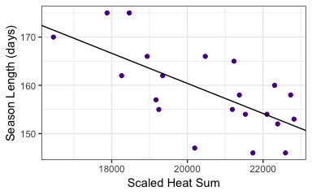

Prune season lengths by heat sum in Parlier, CA.

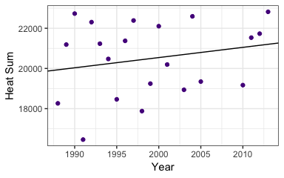

Prune heat sum over 25 years in Parlier, CA.

Summary of linear regression models relating year, season length and thermal time accumulation in prunes.

Location

Cultivar

Predictor

Response

Coefficient

p-value

R2

Parlier

French

Year

Season Length

-0.489

0.041

0.160

Parlier

French

GDH74

Season Length

-0.003

0.001

0.431

Parlier

French

Year

GDH74

50.908

0.348

-0.004

Parlier

French

GDH30

Season Length

-0.004

0.005

0.313

## Walnuts

Mean season length in Payne walnuts decreased an average of 0.24 days per year over the past 60 years (Figure 9, Table 9). Chandler and Franquette season lengths seem to have stayed fairly stable. However, because of the variability in the data, it is possible that a longer time series will exhibit a significant trend. This is particularly relevant for Chandler walnuts, as they were only developed in the last 50 years. Season lengths for all three cultivars correlated very strongly with optimized thermal time accumulation with R^2 values ranging from 0.32 for Chandler to 0.52 for Payne (Table 9).

Thermal time accumulation values for all three cultivars appear to be increasing over time, meaning decreasing season lengths. However, the confidence in those trends is fairly low for Chandler and Franquette cultivars. Hopefully a longer time series will either reinforce or remove those trends.

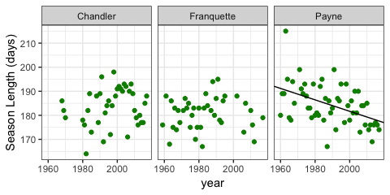

Walnut season lengths over the past 60 years for Chandler, Franquette and Payne Cultivars.

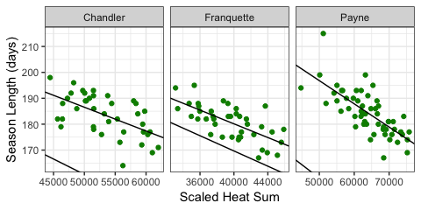

Heat sum correlation with walnut season lengths over the past 60 years in Davis.

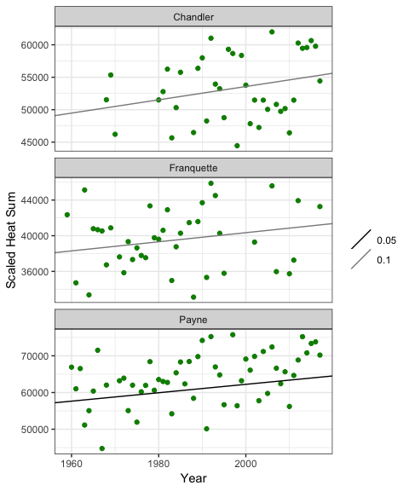

Walnut heat sums over the past 80 years.

Summary of linear regression models relating year, season length and thermal time accumulation in walnuts

Location

Cultivar

Predictor

Response

Coefficient

p-value

R2

Davis

Chandler

Year

Season Length

0.105

0.281

0.005

Davis

Payne

Year

Season Length

-0.238

0.000

0.209

Davis

Franquette

Year

Season Length

0.020

0.774

-0.024

Davis

Chandler

GDH49

Season Length

-0.001

0.000

0.322

Davis

Payne

GDH65

Season Length

-0.001

0.000

0.528

Davis

Franquette

GDH36

Season Length

-0.001

0.000

0.447

Davis

Chandler

Year

GDH49

102.429

0.078

0.055

Davis

Payne

Year

GDH65

114.534

0.014

0.084

Davis

Franquette

Year

GDH36

51.169

0.090

0.043

Davis

Chandler

GDH30

Season Length

-0.001

0.000

0.308

Davis

Payne

GDH30

Season Length

-0.001

0.000

0.273

Davis

Franquette

GDH30

Season Length

-0.001

0.000

0.409

# Discussion

### Model optimization

Relative improvement of predictions over GDH30 models depending strongly on the optimal length of thermal time accumulation. However, the difference the accuracy between of the GDH30 and the optimized length models did not seem to depend on the difference between 30 and the optimized length. ‘Improved French’ prunes had the longest thermal time accumulation length, but the difference between the RMSEs for the two models was only 0.71 days, whereas ‘Mission’ almonds in Modesto had a much lower thermal time accumulation length but a difference in RMSE values of 1.43. Relative model quality likely has more to do with the overall optimization landscape of each particular cultivar, than the difference in thermal time accumulation length between the standard and optimized models.

### Almonds

Using optimized thermal time accumulation lengths produced better predictions than the GDH30 model (Figure 4, Table 2). Tombesi et al. (2010) produced similar results using a slightly different model (growing degree days instead of growing degree hours), and a longer thermal time accumulation length (90 days). Both Tombesi et al. (2010) and this study show weaker results for a thermal time accumulation length of 30 days, indicating a benefit to optimizing thermal time accumulation length in almonds.

Despite the small number of years with harvest data for almonds, extensive almond flowering records allowed us to get a better sense of potential trends in almond season length. Trends in thermal time accumulation during the first two months after flowering point towards shortening season lengths for almonds in Chico, and lengthening ones in Modesto (Figure 5). It is unclear why season lengths in Modesto appear to be lengthening, though the fact that both thermal sums for Nonpareil and Mission cultivars show the same trend increases the conclusions robustness.

### Prunes

Given the difference between the optimal number of days for thermal time accumulation and the standard length of thermal time accumulation (DeBuse, Lopez, and DeJong 2010), the difference in model RMSE values is not large (Table 2). However, this may not be the case for other locations, like is the case for ‘Nonpareil’ almonds in Chico and Modesto.

French prune season lengths have gotten, on average, 12 days shorter between 1988 and 2014 (Figure 6). This is supported by the increasing trend in GDH74 over those same years and the strong relationship between GDH 74 and season length (Figure 7-8). We confidently expect prune season lengths will continue to shorten as the climate warms.

### Walnuts

Both ‘Chandler’ and ‘Franquette’ walnuts saw very marginal gain from optimization, while the model for ‘Payne’ walnuts benefited the most of any in the study. Given that most acreage is planted with ‘Chandler’, it may not be worth the additional investment of time and energy to do the optimization, at least for growers around Davis.

‘Payne’ walnut season lengths have shortened by approximately 11 days since 1960, while no discernable temporal trend exists yet for ‘Chandler’ or ‘Franquette’ walnuts (Figure 9). Based on the upwards trends in the thermal time accumulation (Table 5), Payne season lengths will continue to get shorter as climate change intensifies. Even though ‘Chandler’ and ‘Franquette’ season lengths have not changed appreciably over the past 50 years, there is some evidence that thermal time accumulation has (Figure 11, Table 5). Consequently, it is likely that season lengths will shorten in the future.

# Agronomic Implications

Overall, season lengths in California seem to be getting shorter. This may decrease the risk of precipitation during post-harvest drying, especially for walnuts. However, it will also likely to decrease fruit and nut size (Warrington et al. 1999) For prunes, this is problematic because fruit size strongly impacts the price farmers get for their crop. In nut crops, size is also at a premium, however there is an additional complication. Post harvest processing requires specialized equipment that is calibrated to a certain size of nut. Shorter season lengths may result in sub-optimal nut cracking, which also reduces nut quality. In many fruit crops, farmers will thin the crop to produce larger fruits. This is not common in nuts, but may become necessary as the climate warms.

# References

Anderson, JL, and EA Richardson CD Kesner. 1986. “Validation of Chill Unit and Flower Bud Phenology Models for ’Montmorency’ Sour Cherry.”

Benmoussa, Haïfa, Mohamed Ghrab, Mehdi Ben Mimoun, and Eike Luedeling. 2017. “Chilling and Heat Requirements for Local and Foreign Almond (Prunus Dulcis Mill.) Cultivars in a Warm Mediterranean Location Based on 30 Years of Phenology Records.” *Agricultural and Forest Meteorology* 239. Elsevier: 34–46.

Day, K, G Lopez, and T DeJong. 2007. “Using Growing Degree Hours Accumulated Thirty Days After Bloom to Predict Peach and Nectarine Harvest Date.” In *VIII International Symposium on Modelling in Fruit Research and Orchard Management 803*, 163–67.

DeBuse, C, G Lopez, and T DeJong. 2010. “Using Spring Weather Data to Predict Harvest Date for’Improved French’Prune.” In *IX International Symposium on Plum and Prune Genetics, Breeding and Pomology 874*, 107–12.

Diffenbaugh, Noah S, Daniel L Swain, and Danielle Touma. 2015. “Anthropogenic Warming Has Increased Drought Risk in California.” *Proceedings of the National Academy of Sciences* 112 (13). National Acad Sciences: 3931–6.

Griffin, Daniel, and Kevin J Anchukaitis. 2014. “How Unusual Is the 2012–2014 California Drought?” *Geophysical Research Letters* 41 (24). Wiley Online Library: 9017–23.

Luedeling, Eike. 2012. “Climate Change Impacts on Winter Chill for Temperate Fruit and Nut Production: A Review.” *Scientia Horticulturae* 144. Elsevier: 218–29.

Luedeling, Eike, Minghua Zhang, and Evan H Girvetz. 2009. “Climatic Changes Lead to Declining Winter Chill for Fruit and Nut Trees in California During 1950–2099.” *PloS One* 4 (7). Public Library of Science: e6166.

Luedeling, Eike, Minghua Zhang, Gale McGranahan, and Charles Leslie. 2009. “Validation of Winter Chill Models Using Historic Records of Walnut Phenology.” *Agricultural and Forest Meteorology* 149 (11). Elsevier: 1854–64.

Medellín-Azuara, Josué, D MacEwan, RE Howitt, DA Sumner, and JR Lund. 2016. “Economic Analysis of the 2016 California Drought on Agriculture.” Center for Watershed Sciences, UC Davis.

Mimoun, Ben M, and TM DeJong. 1998. “Using the Relation Between Growing Degree Hours and Harvest Date to Estimate Run-Times for Peach: A Tree Growth and Yield Simulation Model.” In *V International Symposium on Computer Modelling in Fruit Research and Orchard Management 499*, 107–14.

Pope, KS, David Da Silva, PH Brown, and TM DeJong. 2014. “A Biologically Based Approach to Modeling Spring Phenology in Temperate Deciduous Trees.” *Agricultural and Forest Meteorology* 198. Elsevier: 15–23.

R Core Team. 2018. *R: A Language and Environment for Statistical Computing*. Vienna, Austria: R Foundation for Statistical Computing. <https://www.R-project.org/>.

Ross, K. 2018. “California Agricultural Statistics Review 2017-2018.” Agricultural Resource Report. National Agricultural Statistics Service, California Department of Food; Agriculture.

Ruml, Mirjana, Dragan Milatović, Todor Vulić, and Ana Vuković. 2011. “Predicting Apricot Phenology Using Meteorological Data.” *International Journal of Biometeorology* 55 (5). Springer: 723–32.

Tombesi, S, R Scalia, J Connell, B Lampinen, and TM DeJong. 2010. “Fruit Development in Almond Is Influenced by Early Spring Temperatures in California.” *The Journal of Horticultural Science & Biotechnology* 85 (4): 317.

Warrington, IJ, TA Fulton, EA Halligan, and HN De Silva. 1999. “Apple Fruit Growth and Maturity Are Affected by Early Season Temperatures.” *Journal of the American Society for Horticultural Science* 124 (5). American Society for Horticultural Science: 468–77.

Weinberger, JH. 1948. “Influence of Temperature Following Bloom on Fruit Development Period of Elberta Peach.” In *Proceedings of the American Society for Horticultural Science*, 51:175–78. JUN. AMER SOC HORTICULTURAL SCIENCE 701 NORTH SAINT ASAPH STREET, ALEXANDRIA, VA ….