Magazin

Un magazin vinde produse pentru care are o descriere caracterizata de urmatoarele atribute (nume, cod_produs, pret_unitar, unit_masura).

Se pot opera mai multe vanzari simultane !

Permanent se mentine o evidenta actualizata pentru:

• stocurile existente: lista de stocuri; stoc= (cod_produs, cantitate)

• vanzarile efectuate: lista de vanzari; vanzare = (data, produs, cantitate)

• facturile emise; lista de facturi, factura = (nume, vanzare, suma_totala),

• soldul total (suma existenta in casa).

Periodic sistemul face o verificare a stocurilor prin verificarea corespondentei corecte intre stoc, totalitatea produselor vandute (de la ultima verificare pana in prezent), sumele incasate in aceeasi perioada si soldul total.

Sistemul foloseste un mecanism de tip ‘Thread-Pool’ pentru rezolvarea concurenta a vanzarilor.

Pentru testare se vor implementa urmatoarele variante:

1. initierea vanzarilor printr-o UI (interfata utilizator) minimala;
2. 2) crearea unui thread paralel care initiaza/creeaza la interval de 5 sec o noua vanzare folosind date generate aleatoriu;
3. 3) adaptarea problemei pentru a fi o aplicatie client-server prin care vanzarile sunt initiate remote de client, iar pe server se face gestiunea magazinului. (Clientul va folosi interfata de la punctul 1)

Pentru verificare se cere salvarea pe suport extern a stocurilor, a listei vanzarilor si a facturilor si a rezultatelor operatiilor de verificare executate periodic. Limbajul de implementare: la alegere

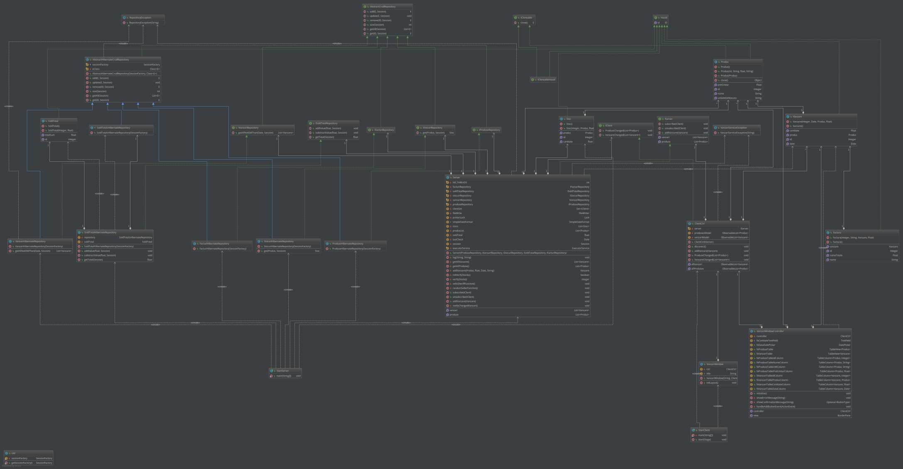Proiectare

Detalii de implementare

Aplicatie e proiectata pe arhitectura client server.

Pe partea de client un utilizator poate adauga vanzari pe baza produselor existente in aplicatie. Atunci cand se adauga noi vanzari, acestea vor fi afisate in aplicatie, indiferent daca utilizatorul curent sau alt utilizator le-a facut.

Serverul va raspunde la cererile facute de utilizatori, clientii conectandu-se prin protocolul Java RMI. Toate cererile vor fi onorate cu ajutorul unui Thread-pool de 10 threaduri. Cererile de la clienti vor fi logate cu prefixul *Client.*

Pe server va rula si un thread care va adauga vanzari cu date generate aleator la un interval de 5 secunde. Acesta va loga mesaje cu prefixul *randomSeller.*

Tot pe server va rula un alt thread care va verifica validitatea vanzarilor tot din 5 in 5 secunde. Acesta va loga mesaje cu prefixul *SellSherif*.

Testare

[2017-12-04 15:31:21] [randomSeller] addVanzare called: Produs:(id: 10, nume: Cartofi, pretUnitar: 1.2, unitateDeMasura: kg) cantitate: 5.5905414  
[2017-12-04 15:31:26] [randomSeller] addVanzare called: Produs:(id: 10, nume: Cartofi, pretUnitar: 1.2, unitateDeMasura: kg) cantitate: 2.2522826  
[2017-12-04 15:31:26] [SellSherif] Check verification successfully finished with OK Status!  
[2017-12-04 15:31:31] [SellSherif] Check verification successfully finished with OK Status!  
[2017-12-04 15:31:31] [randomSeller] addVanzare called: Produs:(id: 3, nume: Cartoafe, pretUnitar: 0.6, unitateDeMasura: kg) cantitate: 6.3447256  
[2017-12-04 15:31:36] [SellSherif] Check verification successfully finished with OK Status!  
[2017-12-04 15:31:36] [Client] getAllProduse call  
[2017-12-04 15:31:36] [randomSeller] addVanzare called: Produs:(id: 6, nume: Cartofi, pretUnitar: 1.2, unitateDeMasura: kg) cantitate: 5.1213884  
[2017-12-04 15:31:36] [Client] getAllVanzare call  
[2017-12-04 15:31:38] [Client] getAllVanzare call  
[2017-12-04 15:31:41] [SellSherif] Check verification successfully finished with OK Status!  
[2017-12-04 15:31:41] [randomSeller] addVanzare called: Produs:(id: 11, nume: Cartofi, pretUnitar: 1.2, unitateDeMasura: Masa) cantitate: 6.7774816  
[2017-12-04 15:31:41] [randomSeller] addVanzare called: Produs:(id: 3, nume: Cartoafe, pretUnitar: 0.6, unitateDeMasura: kg) cantitate: 2.1140451  
[2017-12-04 15:31:46] [SellSherif] Check verification successfully finished with OK Status!  
[2017-12-04 15:31:46] [randomSeller] addVanzare called: Produs:(id: 6, nume: Cartofi, pretUnitar: 1.2, unitateDeMasura: kg) cantitate: 7.689  
[2017-12-04 15:31:51] [SellSherif] Check verification successfully finished with OK Status!  
[2017-12-04 15:31:51] [randomSeller] addVanzare called: Produs:(id: 2, nume: Cartoafele, pretUnitar: 0.6, unitateDeMasura: kg) cantitate: 8.614181  
[2017-12-04 15:31:56] [SellSherif] Check verification successfully finished with OK Status!  
[2017-12-04 15:31:57] [randomSeller] addVanzare called: Produs:(id: 4, nume: Cartofi, pretUnitar: 1.2, unitateDeMasura: kg) cantitate: 3.1502461  
[2017-12-04 15:32:01] [SellSherif] Check verification finished with FAILED STATUS!  
[2017-12-04 15:32:02] [randomSeller] addVanzare called: Produs:(id: 6, nume: Cartofi, pretUnitar: 1.2, unitateDeMasura: kg) cantitate: 9.378695  
[2017-12-04 15:32:06] [SellSherif] Check verification finished with FAILED STATUS!  
[2017-12-04 15:32:07] [randomSeller] addVanzare called: Produs:(id: 6, nume: Cartofi, pretUnitar: 1.2, unitateDeMasura: kg) cantitate: 8.131637  
[2017-12-04 15:32:11] [SellSherif] Check verification finished with FAILED STATUS!  
[2017-12-04 15:32:12] [randomSeller] addVanzare called: Produs:(id: 8, nume: Cartofi, pretUnitar: 1.2, unitateDeMasura: kg) cantitate: 5.9885054  
[2017-12-04 15:32:16] [SellSherif] Check verification finished with FAILED STATUS!  
[2017-12-04 15:32:17] [randomSeller] addVanzare called: Produs:(id: 8, nume: Cartofi, pretUnitar: 1.2, unitateDeMasura: kg) cantitate: 1.7743027  
[2017-12-04 15:32:21] [SellSherif] Check verification finished with FAILED STATUS!  
[2017-12-04 15:32:22] [randomSeller] addVanzare called: Produs:(id: 9, nume: Cartofi, pretUnitar: 1.2, unitateDeMasura: kg) cantitate: 8.938816  
[2017-12-04 15:32:26] [SellSherif] Check verification finished with FAILED STATUS!  
[2017-12-04 15:32:27] [randomSeller] addVanzare called: Produs:(id: 6, nume: Cartofi, pretUnitar: 1.2, unitateDeMasura: kg) cantitate: 8.872754  
[2017-12-04 15:32:31] [SellSherif] Check verification finished with FAILED STATUS!  
[2017-12-04 15:32:32] [randomSeller] addVanzare called: Produs:(id: 4, nume: Cartofi, pretUnitar: 1.2, unitateDeMasura: kg) cantitate: 5.348879  
[2017-12-04 15:32:36] [SellSherif] Check verification finished with FAILED STATUS!  
[2017-12-04 15:32:37] [randomSeller] addVanzare called: Produs:(id: 8, nume: Cartofi, pretUnitar: 1.2, unitateDeMasura: kg) cantitate: 7.0009923  
[2017-12-04 15:32:38] [Client] getAllProduse call  
[2017-12-04 15:32:38] [Client] getAllVanzare call  
[2017-12-04 15:32:41] [SellSherif] Check verification finished with FAILED STATUS!  
[2017-12-04 15:32:42] [randomSeller] addVanzare called: Produs:(id: 3, nume: Cartoafe, pretUnitar: 0.6, unitateDeMasura: kg) cantitate: 3.6110802  
[2017-12-04 15:32:42] [Client] getAllVanzare call  
[2017-12-04 15:32:46] [SellSherif] Check verification finished with FAILED STATUS!  
[2017-12-04 15:32:47] [randomSeller] addVanzare called: Produs:(id: 11, nume: Cartofi, pretUnitar: 1.2, unitateDeMasura: Masa) cantitate: 1.6046953  
[2017-12-04 15:32:47] [randomSeller] addVanzare called: Produs:(id: 7, nume: Cartofi, pretUnitar: 1.2, unitateDeMasura: kg) cantitate: 9.835108  
[2017-12-04 15:32:47] [Client] getAllVanzare call  
[2017-12-04 15:32:50] [Client] getAllProduse call  
[2017-12-04 15:32:50] [Client] getAllVanzare call  
[2017-12-04 15:32:51] [SellSherif] Check verification finished with FAILED STATUS!  
[2017-12-04 15:32:52] [randomSeller] addVanzare called: Produs:(id: 3, nume: Cartoafe, pretUnitar: 0.6, unitateDeMasura: kg) cantitate: 4.7084384  
[2017-12-04 15:32:52] [Client] getAllVanzare call  
[2017-12-04 15:32:52] [Client] getAllVanzare call  
[2017-12-04 15:32:56] [SellSherif] Check verification finished with FAILED STATUS!  
[2017-12-04 15:32:57] [Client] addVanzare called: Produs:(id: 5, nume: Cartofi, pretUnitar: 1.2, unitateDeMasura: kg) cantitate: 13.0  
[2017-12-04 15:32:57] [Client] getAllVanzare call  
[2017-12-04 15:32:57] [Client] getAllVanzare call  
[2017-12-04 15:32:57] [randomSeller] addVanzare called: Produs:(id: 4, nume: Cartofi, pretUnitar: 1.2, unitateDeMasura: kg) cantitate: 5.5367017  
[2017-12-04 15:32:57] [Client] getAllVanzare call  
[2017-12-04 15:32:57] [Client] getAllVanzare call  
[2017-12-04 15:32:58] [Client] addVanzare called: Produs:(id: 5, nume: Cartofi, pretUnitar: 1.2, unitateDeMasura: kg) cantitate: 13.0  
[2017-12-04 15:32:58] [Client] getAllVanzare call  
[2017-12-04 15:32:58] [Client] getAllVanzare call  
[2017-12-04 15:32:58] [Client] addVanzare called: Produs:(id: 5, nume: Cartofi, pretUnitar: 1.2, unitateDeMasura: kg) cantitate: 13.0  
[2017-12-04 15:32:58] [Client] getAllVanzare call  
[2017-12-04 15:32:58] [Client] getAllVanzare call  
[2017-12-04 15:32:58] [Client] addVanzare called: Produs:(id: 5, nume: Cartofi, pretUnitar: 1.2, unitateDeMasura: kg) cantitate: 13.0  
[2017-12-04 15:32:58] [Client] getAllVanzare call  
[2017-12-04 15:32:58] [Client] getAllVanzare call  
[2017-12-04 15:32:58] [Client] addVanzare called: Produs:(id: 5, nume: Cartofi, pretUnitar: 1.2, unitateDeMasura: kg) cantitate: 13.0  
[2017-12-04 15:32:58] [Client] getAllVanzare call  
[2017-12-04 15:32:58] [Client] getAllVanzare call  
[2017-12-04 15:32:59] [Client] addVanzare called: Produs:(id: 5, nume: Cartofi, pretUnitar: 1.2, unitateDeMasura: kg) cantitate: 13.0  
[2017-12-04 15:32:59] [Client] getAllVanzare call  
[2017-12-04 15:32:59] [Client] getAllVanzare call  
[2017-12-04 15:33:01] [SellSherif] Check verification finished with FAILED STATUS!  
[2017-12-04 15:33:02] [randomSeller] addVanzare called: Produs:(id: 9, nume: Cartofi, pretUnitar: 1.2, unitateDeMasura: kg) cantitate: 5.0883174  
[2017-12-04 15:33:02] [Client] getAllVanzare call  
[2017-12-04 15:33:02] [Client] getAllVanzare call  
[2017-12-04 15:33:06] [SellSherif] Check verification finished with FAILED STATUS!  
[2017-12-04 15:33:07] [randomSeller] addVanzare called: Produs:(id: 4, nume: Cartofi, pretUnitar: 1.2, unitateDeMasura: kg) cantitate: 2.8144555  
[2017-12-04 15:33:07] [Client] getAllVanzare call  
[2017-12-04 15:33:07] [Client] getAllVanzare call  
[2017-12-04 15:33:11] [SellSherif] Check verification finished with FAILED STATUS!  
[2017-12-04 15:33:12] [randomSeller] addVanzare called: Produs:(id: 4, nume: Cartofi, pretUnitar: 1.2, unitateDeMasura: kg) cantitate: 3.8075953  
[2017-12-04 15:33:12] [Client] getAllVanzare call  
[2017-12-04 15:33:12] [Client] getAllVanzare call  
[2017-12-04 15:33:16] [SellSherif] Check verification finished with FAILED STATUS!  
[2017-12-04 15:33:17] [randomSeller] addVanzare called: Produs:(id: 8, nume: Cartofi, pretUnitar: 1.2, unitateDeMasura: kg) cantitate: 9.176325  
[2017-12-04 15:33:17] [Client] getAllVanzare call  
[2017-12-04 15:33:17] [Client] getAllVanzare call  
[2017-12-04 15:33:22] [SellSherif] Check verification finished with FAILED STATUS!  
[2017-12-04 15:33:22] [randomSeller] addVanzare called: Produs:(id: 8, nume: Cartofi, pretUnitar: 1.2, unitateDeMasura: kg) cantitate: 0.9080267  
[2017-12-04 15:33:22] [Client] getAllVanzare call  
[2017-12-04 15:33:22] [Client] getAllVanzare call  
[2017-12-04 15:33:27] [SellSherif] Check verification successfully finished with OK Status!  
[2017-12-04 15:33:27] [randomSeller] addVanzare called: Produs:(id: 8, nume: Cartofi, pretUnitar: 1.2, unitateDeMasura: kg) cantitate: 4.4248767  
[2017-12-04 15:33:27] [Client] getAllVanzare call  
[2017-12-04 15:33:27] [Client] getAllVanzare call