Appendix A: **Figures**

**Figure 4 in Paper:**

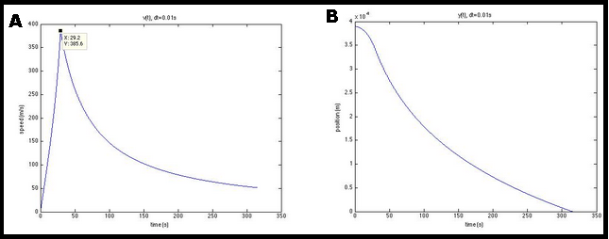

Other Figures:

Felix in simple Free Fall

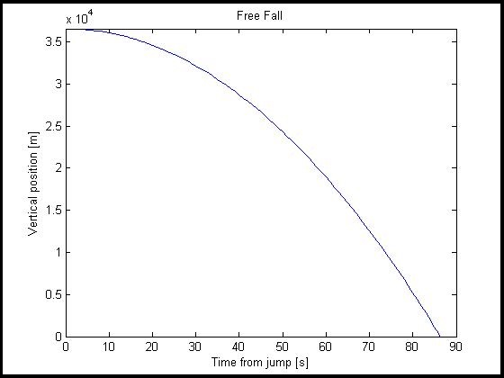

Final Simulation using a time step of 0.001 seconds.

