Software Requirements Specification
for
Trivia Maze
Version 1.0 approved
Prepared by Elise Peterson and Zak Steele
CSCD 350 Spring 2014
May 15, 2014
Table of Contents
Table of Contents ii
Revision History ii
1. Introduction 1
1.1 Purpose 1
1.2 Document Conventions 1
1.3 Intended Audience and Reading Suggestions 1
1.4 Project Scope 1
1.5 References 2
2. Overall Description 2
2.1 Product Perspective 2
2.2 Product Features 2
2.3 User Classes and Characteristics 3
2.4 Operating Environment 3
2.5 Design and Implementation Constraints 3
2.6 User Documentation 3
2.7 Assumptions and Dependencies 3
3. System Feature 3
3.1 Description and Priority 3
3.2 Stimulus/Response Sequences 3
3.3 Functional Requirements 4
4. External Interface Requirements 4
4.1 User Interfaces 4
4.2 Hardware Interfaces 4
4.3 Software Interfaces 5
5. Other Nonfunctional Requirements 5
5.1 Performance Requirements 5
5.2 Safety Requirements 5
5.3 Security Requirements 5
5.4 Software Quality Attributes 5
Appendix A: Glossary 5
Appendix B: Analysis Models 6
Appendix C: Issues List 6

Revision History
Name | Date | Reason For Changes | Version
Elise Peterson and Zak Steele | 5/15/14 | Initial Creation | 1.0
Elise Peterson and Zak Steele | 6/10/14 | Modification | 1.1

Introduction

Purpose
This Software Requirements Specification Document provides a complete description of all the functions and specifications of the Blue Team’s Trivia Maze.

Document Conventions
Term | Definition
User | Someone who interacts with the Trivia Maze application
GUI | Graphical user interface
TF | True/false
MC | Multiple choice
DB | Database

Intended Audience and Reading Suggestions
This document is intended for the class instructor, stakeholders, and developers. This project is a college level project and is being implemented as instructed by our college professor. This project is useful to anyone who likes trivia and/or mazes.

Project Scope
This software will allow a user to traverse a maze by correctly answering TF and MC trivia questions. The user will interface with the maze in a GUI format. Our objective is to provide a fun entertaining intuitively interactive game.

Goals
- Scope 1
  - Make a functional maze
  - Fill our database with questions
- Scope 2
  - Allow dynamic maze size within the range 3x3 to 8x8
  - Select player icon
  - Add key to open locked doors
  - Allow user to save the maze and reload a previously saved maze
  - Allow selection of question category
- Scope 3
  - Add sounds
  - Zoom and pan to follow player through maze
  - Provide “life lines”
  - Keep track of local high scores

References
[1] Andrew Troelsen, Pro C#5.0 and the .NET 4.5 Framework, 6th ed. New York: Apress,
2012.

Overall Description

Product Perspective
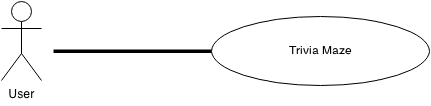
The Trivia Maze is the final project for Software Engineering Spring 2014. This is a new self-contained product.

Product Features
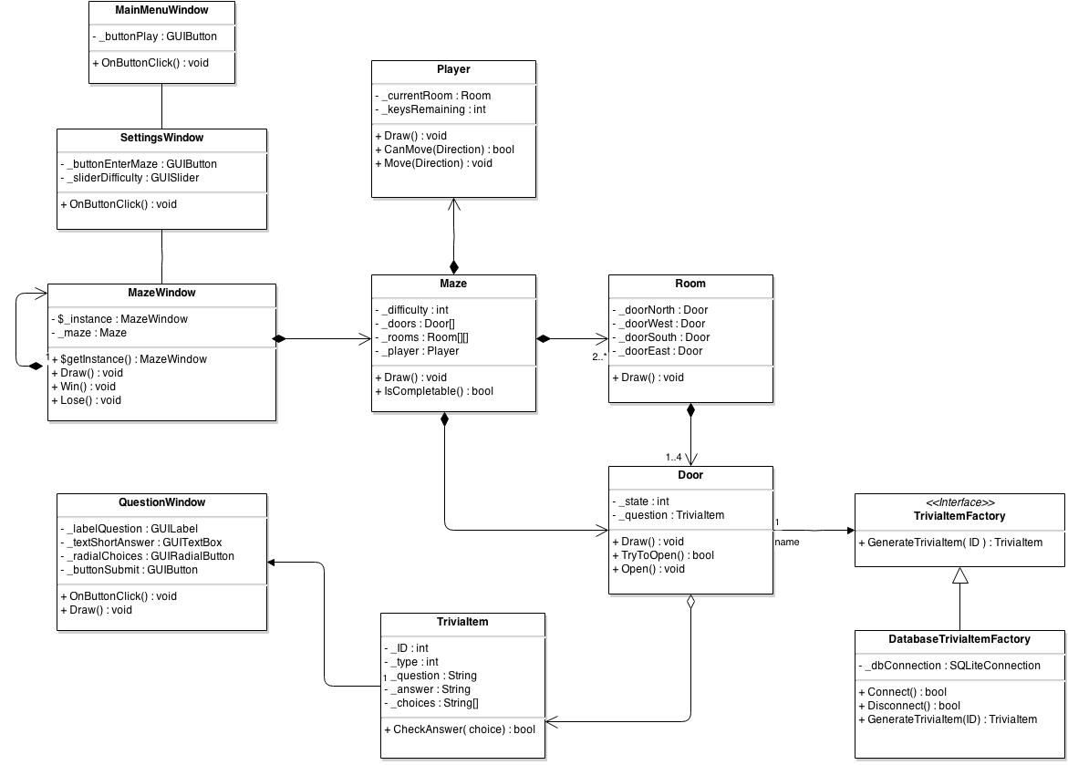
The major features of our Trivia Maze are shown in the Class Diagram below

The basic order of events is shown in the Sequence Diagram below

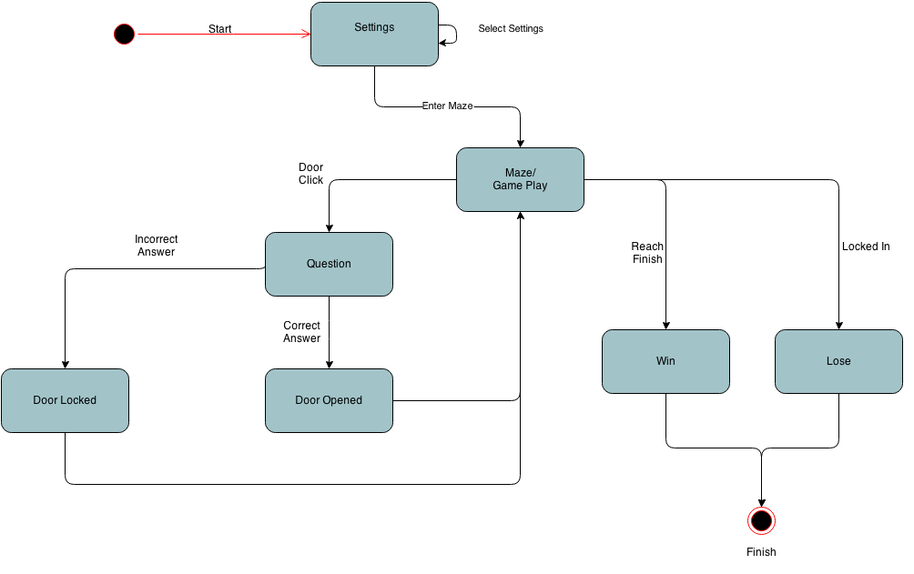
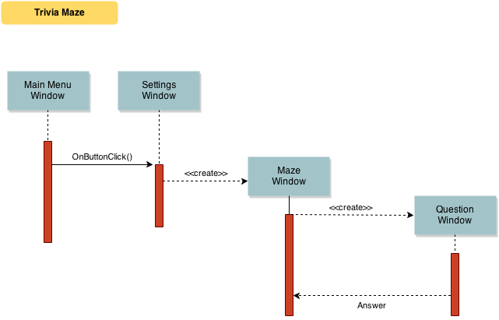
The basic flow of our program is shown in the State Diagram below

User Classes and Characteristics
Users of the Trivia Maze should be able to begin a new game. Upon beginning a new game the user will choose their preferred settings and enter the maze. While in the maze, the user will move be able to move vertically or horizontally from room to room by correctly answering a trivia question with the goal of reaching the final room.
- Being a new game
  - Settings
  - Enter Maze
    - Traverse maze
    - Win/Lose

Operating Environment
Operating environment for the Trivia Maze as listed below
- Operating system: Windows 7 or newer
- Database: SQLite
- Platform: C# (WPF)
- Framework: .NET 4.5

Design and Implementation Constraints
- SQL commands for above queries/applications

User Documentation
- The instructions for playing the game will be provided in-game through help menu items such as “Rules”.

Assumptions and Dependencies
- Let us assume that a properly named DB exists with proper schema and that the DB is populated with appropriate data.

System Feature
Trivia Maze

Description and Priority
The Trivia Maze consists of Rooms, Doors, and TriviaItems. This project is of high priority because our grades depend on it.

Stimulus/Response Sequences
- Click “Start”
- Displays a settings window
- Select customized settings
- Click “Enter Maze”
- User selects direction to travel
- Trivia question is asked
- User answers trivia question
  - If correct move is granted,
  - If incorrect door is locked
- User continues to travel toward the finish
  - User exhausts all possible paths and loses
  - User arrives at the end room and wins
- User may play again

Functional Requirements
- SQLite Database
A database table filled with trivia questions

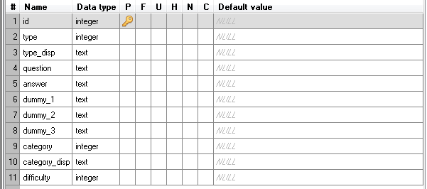

External Interface Requirements

User Interfaces
- Front-end software: C# .NET (WPF)
- Back-end software: SQLite

Hardware Interfaces
- Windows 7

Software Interfaces
Software used | Description
Operating system | We have chosen Windows 7 operating system for its because it is widely distributed.
Database | To store our questions, we have chosen SQLite because it was a requirement specified by the client.
C# .NET (WPF) | To implement the project we have chosen C#.NET language for its interactive support ad GUI functionality.

Other Nonfunctional Requirements

Performance Requirements
- There are currently no performance requirements that we are aware of.

Safety Requirements
- There should be a backup of the database

Security Requirements
- No sensitive data is stored or required by this application, thus there are no security requirements.

Software Quality Attributes
- Portability
  - Trivia Maze executable could be used on any Windows 7 machine
- Availability
  - Should always be available to users who have installed it
Appendix A: Glossary
Term | Definition
User | Someone who interacts with the Trivia Maze application
GUI | Graphical user interface
TF | True/false
MC | Multiple choice
TriviaItem | A question provided by the SQLite database
Door | An interactive maze item used to move between rooms
Room | The maze is composed of an array of rooms
SQLite | A special file that stores the trivia questions
Appendix B: Analysis Models
- Class Diagram
- Product Feature
- SQLite Database
- State Diagram
- Sequence Diagram
Appendix C: Issues List
- Scope 2
- Allow dynamic maze size within the range 3x3 to 8x8
- Select player icon
- Add key to open locked doors
- Allow user to save the maze and reload a previously saved maze
- Allow selection of question category

