[robot-name]’s Input Ports

(used to connect sensors to the EV3 Brick)

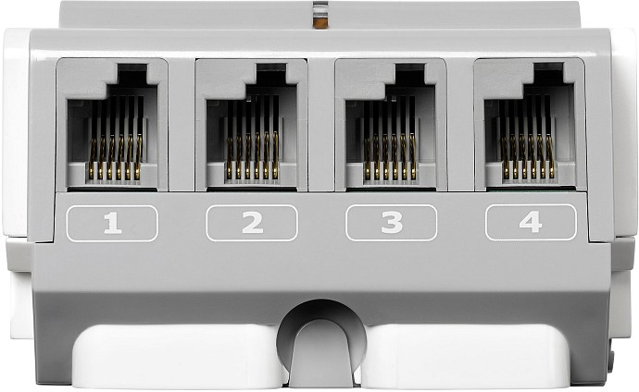

[robot-name]’s Output Ports

(used to connect motors to the EV3 Brick)

