**ELEC_ENG 202 – 0 — INTRODUCTION TO ELECTRICAL ENGINEERING**

**FINAL EXAM**

**Eliseu Antonio Kloster Filho**

**1a)**

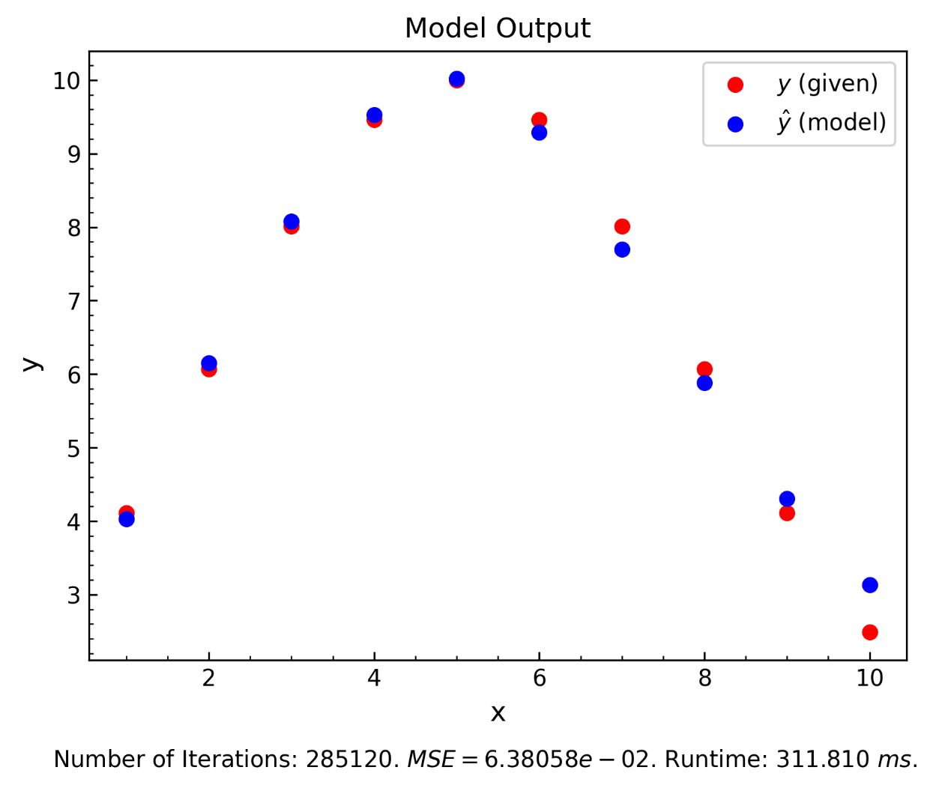

Figure 1: Model output for question 1a.

$$w=\{-0.656,-1.084, 4.715, -4.888\}$$

$$b=\{5.790,5.483,1.360\}$$

$$k=285120$$

$$MSE=6.3805⋅{10}^{-2}$$

$$t=311.9 ms$$

**1b)**

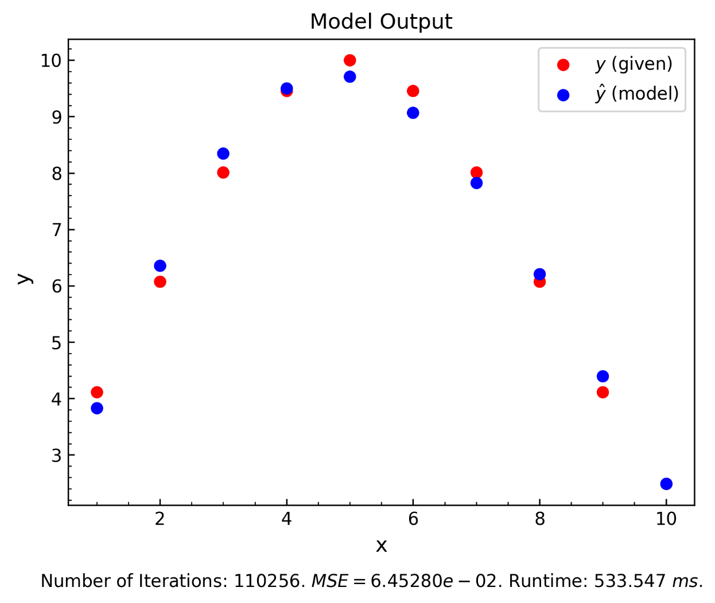

Figure 1: Model output for question 1b.

$$w=\{-1.527, 0.668, -1.249, -0.782, 0.776, 0.665, -0.098, -0.052, -0.540, -0.045, 0.570, -2.391,$$

$$0.799, -3.936, 0.127, -0.109, 3.666, 2.340, -2.184, 2.026\}$$

$$b=\{-0.262, -2.164, -0.433, 3.424, 0.568, 0.349, 2.598, 1.404, 1.407, 1.134, 1.415\}$$

$$k=110256$$

$$MSE=6.4528⋅{10}^{-2}$$

$$t=533.5 ms$$

**2)**

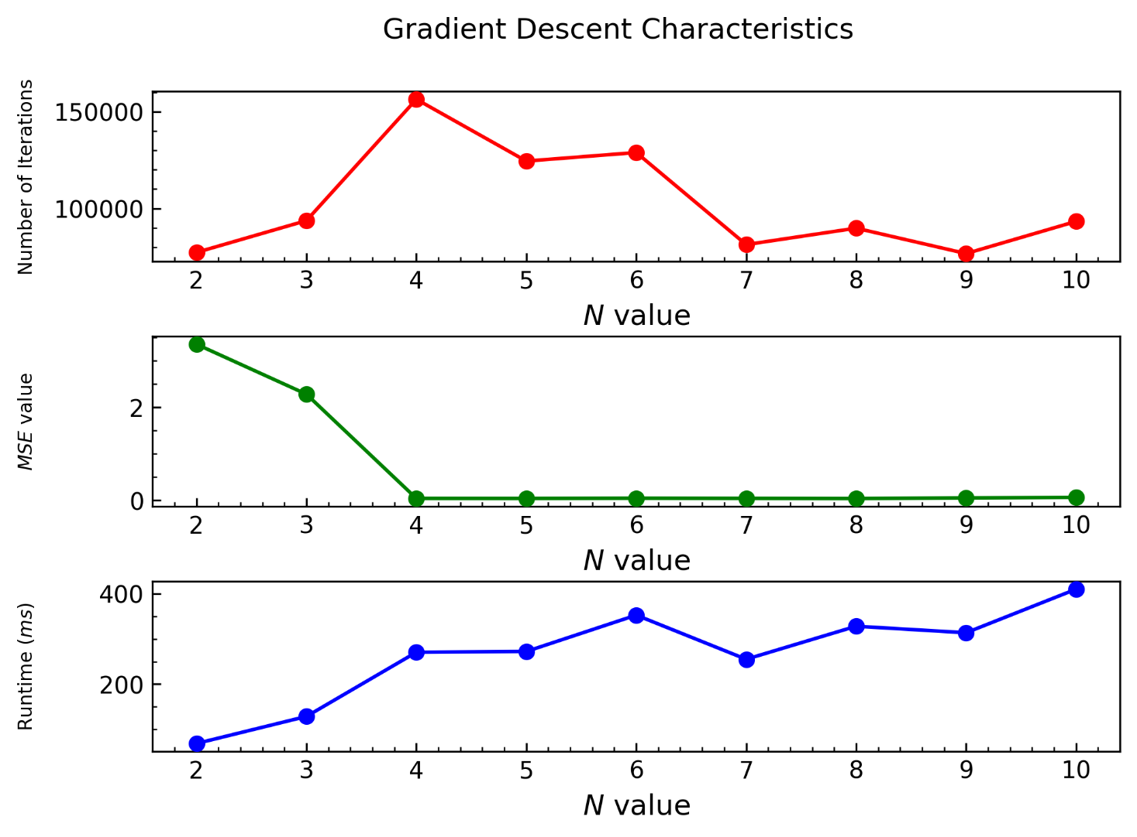

Figure 1: Gradient Descent Characteristics for question 2.

For this problem, 4 seems the optimal number of hidden nodes. Above 4 nodes, the MSE value stays around the same for every N, while the runtime increases compared to the lower N values. The number of iterations was a bit higher than the others, but nothing too far away from the total average, and assuming we have the necessary computational power, the runtime (which was good) is a more relevant characteristic.

I spent 3h doing this assignment in Python. Then, since I had some free time and everything was working, I spent another 9h coding in C (3 of which were spent tracking down a bug that boiled down to a missing parenthesis in my activation function). In total, I probably spent around 12h in this final.