Aluminum, Deodorant, and Sustainability: A Life Cycle Assessment Linked to NURE Geochemical Data and L’Oréal Case Study

Elise Waller
Industrial Ecology
Dr. Davarpanah
May 3rd, 2026

Introduction
In modern-day, the environmental impacts associated with the cosmetic industry have garnered increasing attention. Because many cosmetic ingredients utilize naturally occurring elements and minerals, the tracking, analyzing, and assessing of resource use/environmental impact is crucial. Identifying these aspects mark the first step in the push for more sustainable industry practices. Such assessment will be conducted through both a life cycle assessment (LCA) and National Uranium Resource Evaluation (NURE) dataset data analysis.
The selected element for analysis, Aluminum (Al) is a highly abundant metallic element heavily associated with aluminosilicate materials and aluminum salts in industry applications. This element was selected due to its proximity to the element Silicon, which was the select element in the initial LCA. Because the NURE dataset did not include silicon measurements, aluminum was analyzed as a proxy, as both elements dominate Earth’s crust chemistry, control silicate mineral formation, and substitute for each other in mineral structures.
Additionally, due to its chemical stability, frequent geochemical distribution, and recyclability, aluminum has widespread use in both geology and cosmetic science, crucial in pigments, antiperspirants, and packaging. Aluminum extraction and processing has increased in recent years due to a demand for eco-friendly packaging, making it a crucial example in how sustainability and industrial ecology intersect with the cosmetic and FDA-product industries. With focus placed on the L’Oréal product system, the following report will analyze how aluminum contributes to environmental impacts and industrial ecology designs.
Selected Element and NURE Geochemical Analysis
Using Jupyter Notebook, the NURE dataset was analyzed for Aluminum geochemical distributions in Georgia, resulting in the graphs shown below in Figure I and II.
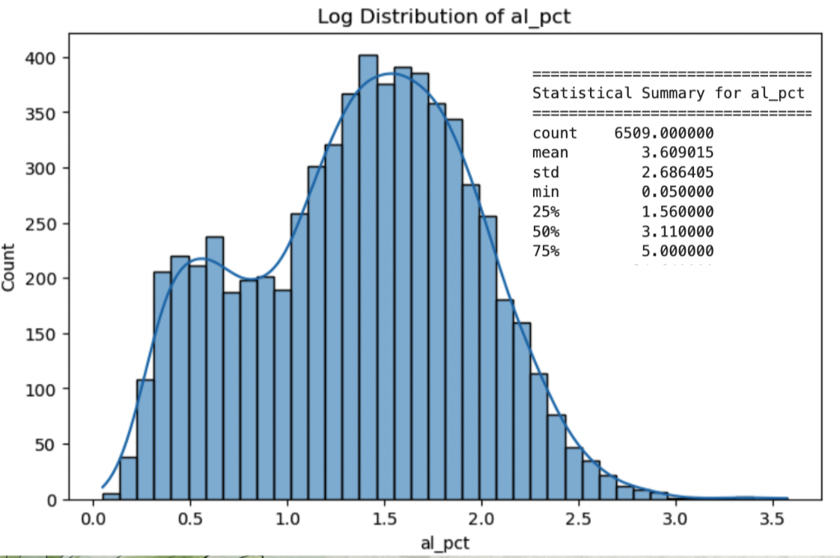
Figure I

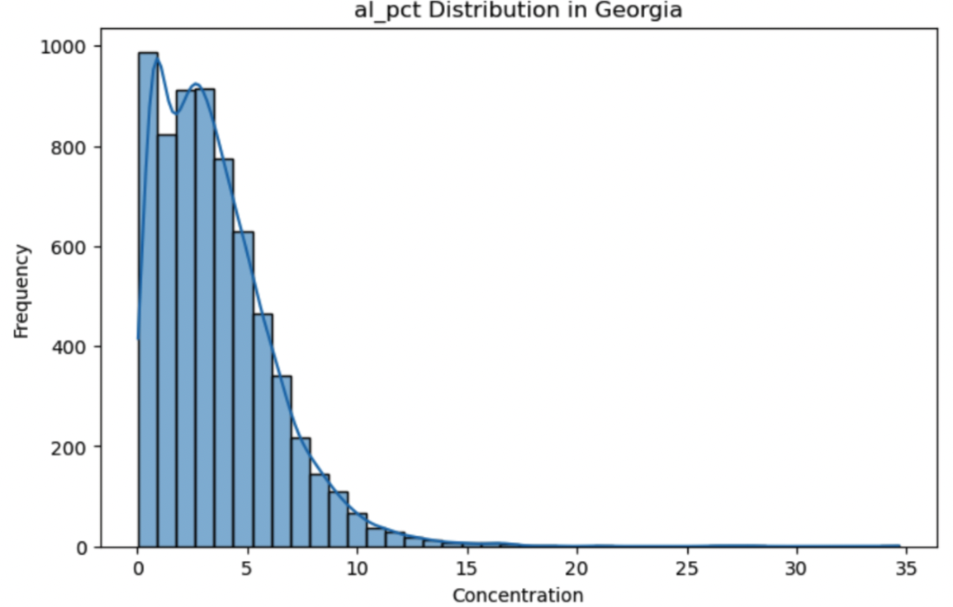

Figure II
Figure I shows a bell-shaped logarithmic transformation of Aluminum pct count across Georgia. While Aluminum concentration follow a log-normal distribution, the graph’s asymmetry suggests that deposits are influenced by various different geological sources such as the mixing of different soils. This explains why in Figure II, the frequency of high, moderate, and low concentrations has such a large range.
Figure II shows a raw spatial distribution with a strong left-skew. The graph indicates that some areas of Georgia are highly enriched with Aluminum though most have low-to-moderate concentrations. With a 0.744 coefficient of variation, the data implies that while variability is high, it is due to rare but large extremes in Aluminum concentration. This supports OpenAI analysis conducted in Jupyter Notebook which claims that aluminum is not evenly distributed but instead is spread with geochemically controlled deposits. This means that variation is due to local geological factors such as soil composition and mineral deposits rather than clustering.
Geochemically, aluminum distributions serve as indicators of lithology, reflecting an underlying bedrock composition, light or heavy weathering intensity, and clay-rich (high-concentration) or sandy (low-concentration) soils.
Ultimately the samples of aluminum provided by the NURE dataset, while having high variation, showed moderate enrichment levels and a widespread consistency in localized enrichment. The data did not indicate spatial clustering in Georgia. This shows a high potential for industrial sourcing and cosmetic application. Higher enrichment level areas in Northwest and general Northern Georgia would be good regions for industrial application.
Python Workflow and Reflection
Aluminum data derived from the updated NURE dataset was geochemically analyzed using Jupyter Notebook. This Python platform organized both code and OpenAI in a single, accessible environment. In order to run the program, the following packages were installed, as listed below:
- The program “pandas” was used for reading, cleaning, organizing, and analyzing tabular geochemical data uploaded to program in csv format.
- The program “numpy” was used for numerical operations (array manipulation, statistical calculations).
- The program “matplotlib” was utilized in the creation of basic visualizations such as scatter plots and histograms.
- The program “seaborn” was used for advanced data visualization.
- The program “plotly” was used to generate interactive graphs, allowing for a dynamic exploration of the dataset.
- The program “geopandas” mapped the spatial distribution of element concentrations.
- The program “scikit-learn” was used for more basic data modeling and pattern recognition.
- The program “scipy” was used for statistical analysis and hypothesis testing.
- The program “folium” was used to create interactive maps for visualizing geospatial data.
The aluminum geochemical analysis conducted in Jupyter had several challenges. While the initial installation process for all programs and packages was straight forward, translating the code to Mac-friendly took a lot of trial and error. All packages ended up requiring “conda install” to properly run. Even after getting the correct prompts, the entire program and Terminal had to be reset several times due to compatibility issues. The program was also not compatible with Neo4J, making a direct connect to the proper environment challenging. This issue took the longest to resolve, requiring Java and additional package installation.
Through these challenges I gained significant understanding in Python package installation and management as well as debugging, the importance of clean data and organization. AI tools helped me analyze the data, determine the spatial distribution, identify any environmental concerns that may be associated with raw material extraction, and interpret the graph and data nuances. Still data provided by AI was verified using real sources or asking AI to provide its sources upon further questioning. The numbers such as the interquartile range and coefficient of variation were also verified to make sure they were scientifically sound. I also acquired a lot of knowledge on file organization, environments, and how numerous applications and programs can work together. The process strengthened my data analysis skills, handling of large datasets, and knowledge of ontological analysis.
Connection to Cosmetic Science and L’Oréal
Presently constituting 8% of the Earth’s crust, aluminum is the third most abundant element on Earth’s crust. Through data analysis using Jupyter Notebook, one can observe Georgia's aluminum concentrations across geographic regions. Aluminum presented as highly abundant and widely accessible for industrial and commercial and cosmetic applications. According to the Aluminum Association’s Sustainability Report (2023), over 75% of all aluminum ever produced is still used today, making it a sustainable packaging alternative to plastic. Due to its widespread use and abundancy, it is crucial to investigate how aluminum connects to sustainability issues particularly in cosmetic productions through the L’Oréal case study.
Aluminum is directly related to cosmetic chemistry though more common in the transportation industry. Naturally occurring, aluminum is a significant resource in cosmetic aerosol packaging such as spray-on deodorants and hair sprays. Additionally, aluminum is a common active ingredient in anti-perspirants. L’Oréal most commonly utilizes aluminum in their hair sprays and deodorant. Aluminum salts are chemically effective in anti-perspirants by blocking sweat pores when they dissolve in liquid, forming a barrier in sweat ducts. Additionally, aluminum is effective in aerosol cans due to its high-corrosion resistivity and chemical compatibility with oxygen and various pressurized liquids and propellants. However, most directly cosmetically effective in anti-perspirants, this study will focus on L’Oréal’s “Men’s Expert 48H Aerosol Anti-Perspirant”.
This product requires raw aluminum extraction, connecting it directly to the NURE dataset analysis. The data analysis conducted revealed the geochemical distribution of aluminum deposits, emphasizing the importance of viewing aluminum as resource and understanding its accessibility and environmental implications.
Goal and Scope Definition
The purpose of this study is to evaluate the life cycle of L’Oréal’s “Men’s Expert 48H Aerosol Anti-Perspirant”, particularly through an assessment of the environmental and sustainable impacts associated with its aluminum-derived ingredients. The active ingredient in the deodorant, aluminum chloralhydrate, or aluminum salt was assessed to determine the environmental viability and life cycle of the product.
The Life Cycle Assessment (LCA) system parameters are as follows: raw material extraction, manufacturing and processing, transportation and distribution, consumer use, and disposal/end-of-life.
Through analyzing these stages, we will see the target areas for environmental impact, identifying areas for improvement and needed strategies for improving sustainability within the cosmetic industry.
Life Cycle Inventory (LCI)
The key inputs within the deodorant's life cycle are as follows:
- Raw materials- bauxite ore, alumina powder
- Energy- electricity and fuel for mining and manufacturing, fuel used in distribution
- Water- for extraction and processing
- Packaging materials- plastics for the cap and labels
The key outputs within the deodorant's life cycle are as follows:
- Product- the deodorant
- Emissions- carbon dioxide, other greenhouse gases, particulate matter
- Wastewater from processing- red mud waste
- Solid waste from packaging- aluminum can
Life Cycle Impact Assessment (LCIA)
Areas of focus within the LCA for L’Oréal Men’s Expert Anti-Perspirant, include raw material extraction, manufacturing/production, and end-of-life, the three sectors having the highest environmental costs, respectively. The mining of Aluminum has high energy requirements, mandating massive amounts of heat and electricity for extraction and alumina refinement. This energy use during raw material extraction contributes to significant carbon emissions. Water use is also significant during both extraction and manufacturing. Extraction at localized sites also causes biodiversity loss. The production process is heavily dependent on the burning of fossil fuels and electricity, with aluminum smelting for packaging being one of the most energy demanding processes in industry due to its use of electrolysis. Due to the cosmetic industry’s strict contamination regulations aluminum product recycling and repurpose is variable though L’Oréal in their Annual Sustainability Report does claim to reuse their aluminum packaging. However, the highest energy cost in the entire life cycle lies in the red mud waste produced. Aluminum is mined from bauxite ore and the bauxite residue produced in alumina refinement presents significant environmental risks. Red mud has a very high pH and is hazardous to both groundwater and soil. Despite this, over three billion tons are currently stored globally in “red mud lakes”. Still the waste has high reuse potential in cement and brick production, as well as iron recovery.
Ontology Visualization
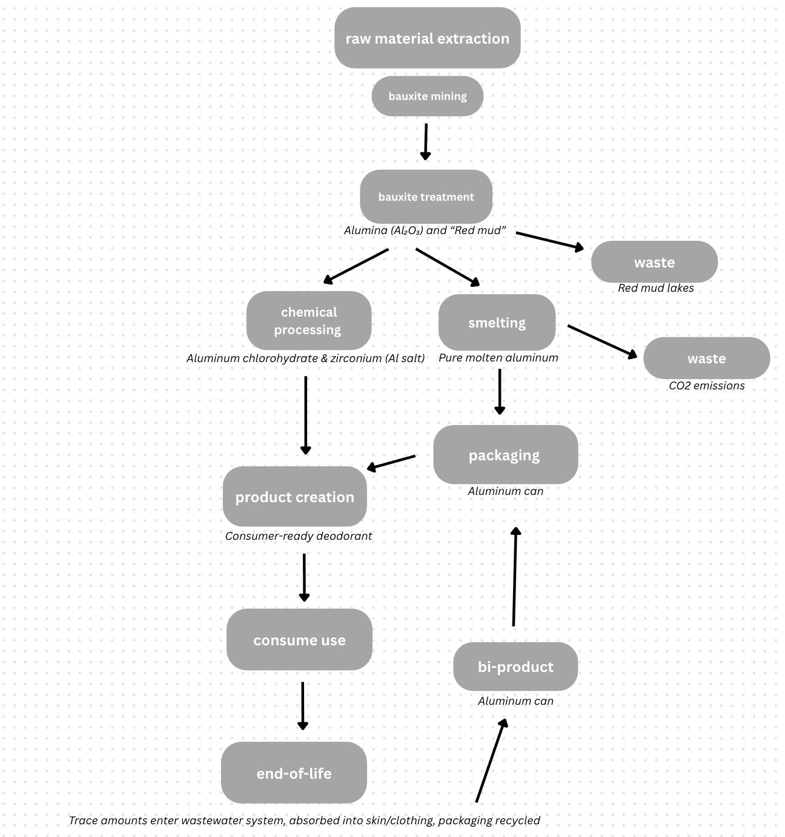
Figure III

Interpretation and Sustainability Recommendations
For improved sustainability in the raw material extraction, manufacturing, and consumer-use stages the following recommendations are proposed:
- Litigation mandating a fixed percentage of red mud to be reused should be implemented. Additionally red mud deposits into storage ponds should undergo mineralization or neutralization with seawater, lowering alkaline content and toxicity.
- In production a lower carbon smelting technology should replace the current systems. Heat waste can also be managed with the implementation of waste heat recovery systems, and more localized production.
- To limit environmental costs in the consumer use and end-of-life processes, consumers should have increased incentives to recycle. For example, the purchase of aluminum products could mandate a small deposit or tax which would be refunded upon recycling. Additionally, L’Oreal should clearly label the products recyclability during the packaging process.
Limitations and Uncertainty
Uncertainties in this analysis include limited access to Al-specific data from L’Oréal and variability in environmental impacts depending on geographic location and production methods. There were several limitations in regard to available information that was public. Information pertaining to aluminum use in production was completely lacking in data. As a result, there was significant difficulty with the quantification of emissions and energy across all life cycle stages. Assumptions were made and extrapolated from general industry data rather than L’Oréal. Such uncertainties will affect the accuracy and precision of the analysis but are still relevant for sustainability concerns.
Conclusion and Reflection
Aluminum plays a large role in both cosmetic and environmental science. The abundant use of this element introduces various sustainability concerns related to extraction and processing. The Python data analysis provides increased understanding of the connection between raw material resources and the cosmetic industry. While Aluminum itself supports circular economy goals, as evidenced by its semi-cyclic Type II system shown in Figure III, its overall sustainability depends heavily on system-level improvements rather than material choice alone, stressing the importance of industrial ecology and biomimicry in these industries. In doing so, this report aims to highlight the importance of sustainability in the cosmetic industry and further emphasize the need for environmentally conscientious production practices.

References
Archambo, M., & Kawatra, S. K. (2020). Red Mud: Fundamentals and New Avenues for Utilization. Mineral Processing and Extractive Metallurgy Review, 1–24. https://doi.org/10.1080/08827508.2020.1781109
Liu, G.; Müller, D. B. Addressing Sustainability in the Aluminum Industry: A Critical Review of Life Cycle Assessments. Journal of Cleaner Production 2012, 35, 108–117. https://doi.org/10.1016/j.jclepro.2012.05.030.
L’Oréal Group: Our Product Eco-Design Tool. (n.d.). L’Oréal. https://www.loreal.com/en/commitments-and-responsibilities/for-our-products/our-product-eco-design-tool/
‌ L’Oreal Men Expert Shirt Protect 48h Anti-perspirant Deodorant Roll-on ingredients (Explained). (2022, September 5). Incidecoder.com; INCIDecoder. https://incidecoder.com/products/loreal-men-expert-shirt-protect-48h-anti-perspirant-deodorant-roll-on
L’Oréal - 2024 universal registration document. (2024). Loreal-Finance.com. https://www.loreal-finance.com/eng/2024-universal-registration-document/en/article/184/
‌OpenAI. (2024). ChatGPT-4o (May 10 version) [Large language model]. https://chat.openai.com
Sustainability – Reports | Aluminum Association. (n.d.). Www.aluminum.org. https://www.aluminum.org/SustainabilityReports

‌

