DESIGN AND IMPLEMENTATION OF AN INTELLIGENT AUDIO-TO-NOTE STUDY SUITE USING MULTIMODAL ARTIFICIAL INTELLIGENCE
BY
ADAMU EMMANUEL INUWA
(MATRIC NO: CS/2022/1042)
A FINAL YEAR PROJECT REPORT SUBMITTED TO THE DEPARTMENT OF COMPUTER SCIENCE,
FACULTY OF SCIENCE,
IN PARTIAL FULFILLMENT OF THE REQUIREMENTS FOR THE AWARD OF THE DEGREE OF
BACHELOR OF SCIENCE (B.SC. HONS) IN COMPUTER SCIENCE
OCTOBER, 2026

DECLARATION AND CERTIFICATION
DECLARATION
I hereby declare that this project report entitled 'Design and Implementation of an Intelligent Audio-to-Note Study Suite Using Multimodal Artificial Intelligence' is the record of authentic research work carried out by me under the guidance and supervision of my project supervisor. No part of this report has been presented previously for the award of any degree, diploma, or fellowship in any university or institution of higher learning.
_________________________ _________________________
ADAMU EMMANUEL INUWA DATE
(Candidate)
CERTIFICATION
This is to certify that this project report entitled 'Design and Implementation of an Intelligent Audio-to-Note Study Suite Using Multimodal Artificial Intelligence' has been examined and approved as meeting the requirements for the award of the degree of Bachelor of Science (B.Sc. Hons) in Computer Science.
_________________________ _________________________
PROJECT SUPERVISOR DATE
_________________________ _________________________
HEAD OF DEPARTMENT DATE
_________________________ _________________________
EXTERNAL EXAMINER DATE

DEDICATION
This project is dedicated to Almighty God, the source of all wisdom, understanding, and strength throughout my academic journey. It is also dedicated to my beloved parents, family, and mentors whose unconditional love, sacrifices, prayers, and continuous support inspired me to strive for excellence.

ACKNOWLEDGEMENTS
My deepest gratitude goes to Almighty God for granting me health, grace, and intellectual fortitude to complete this project. I express my profound appreciation to my project supervisor for his invaluable guidance, constructive critiques, and mentorship throughout the research and software engineering phases of this work.
I also wish to thank the Head of Department, lecturers, and technical staff of the Department of Computer Science for their pedagogical guidance and support throughout my undergraduate program. Special thanks go to my colleagues and fellow students who generously participated in the usability testing sessions and lecture audio trials.
Finally, my heartfelt gratitude goes to my family and friends for their enduring patience, encouragement, and emotional support during challenging periods of this study.

ABSTRACT
The cognitive demand of multitasking during university lectures—listening attentively while simultaneously writing down notes—often leads to substantial information loss, particularly in large, acoustically challenging lecture halls. In response, this project presents the design and implementation of AudioNote AI, an intelligent, full-stack multimodal audio-to-note conversion suite tailored for tertiary students. Powered by Google's Gemini 2.5 Flash multimodal engine and engineered with a cross-platform React Native (Expo) mobile frontend and an Express.js/PostgreSQL backend, the system records spoken lectures and autonomously synthesizes them into structured Markdown study notes, verbatim timestamped transcripts, active-recall 10-question quizzes, and real-time multilingual translations across nine languages (including Nigerian indigenous languages: Hausa, Yoruba, and Igbo). In empirical evaluations across varying classroom environments, the system achieved a 95.8% transcription accuracy in quiet settings and 91.5% in high-noise lecture auditoriums, with an average cloud turnaround latency of under 15 seconds for 30-minute audio sessions. The integration of gamified assessment mechanics and localized translations significantly enhanced user comprehension, bridging the gap between passive listening and active academic retention.
Keywords: Speech-to-Text, Multimodal AI, React Native, Gemini 2.5 Flash, Lecture Note Summarization, Active Recall, Educational Technology.

TABLE OF CONTENTS
Title Page i
Declaration and Certification ii
Dedication iii
Acknowledgements iv
Abstract v
Table of Contents vi
List of Tables viii
List of Figures ix
CHAPTER ONE: INTRODUCTION 1
1.1 Background of the Study 1
1.2 Statement of the Problem 2
1.3 Aim and Objectives 3
1.4 Scope and Limitations of the Study 3
1.5 Significance of the Study 4
1.6 Operational Definition of Terms 4
CHAPTER TWO: LITERATURE REVIEW 5
2.0 Overview of AI-Powered Audio-to-Note Systems 5
2.1 Speech-to-Text (STT) Technologies and Processing Methods 6
2.1.1 Types of Audio Inputs 6
2.1.2 Speech Recognition Methods 7
2.1.2.1 Acoustic Modeling 7
2.1.2.2 Language Modeling 8
2.1.3 Audio Processing and Feature Analysis Techniques 8
2.1.3.1 Pre-Processing and Noise Reduction 8
2.1.3.2 Feature Extraction (Spectrograms and MFCCs) 9
2.1.3.3 Speaker Diarization 10
2.2 Natural Language Processing (NLP) for Summarization 11
2.2.1 Extractive Summarization 11
2.2.2 Abstractive Summarization 12
2.2.3 Keyword and Topic Extraction 13
2.2.4 Challenges in Automated Summarization 14
2.3 Real-World Challenges in Audio Conversion 15
2.3.1 Background Noise and Acoustic Reflections 15
2.3.2 Accents and Regional Dialectal Variations 16
2.3.3 Domain-Specific Jargon and Technical Terms 17
2.3.4 Mobile Hardware and Data Network Constraints 18
2.4 Machine Learning Approaches in Speech Recognition 19
2.4.1 Supervised, Unsupervised, and Self-Supervised Learning 19
2.4.2 The Transformer Architecture in Speech and NLP 20
2.5 Advancements in Multimodal AI and Pedagogical Tools 21
2.5.1 Google Gemini 2.5 Flash Multimodal Pipeline 21
2.5.2 Automated Quiz Generation for Active Recall 22
2.5.3 Multilingual Translation for Inclusive Learning 23
2.6 Mobile-First Architecture and Technologies Used 24
2.6.1 React Native and Expo Framework 24
2.6.2 Audio Recording and Waveform Libraries 25
2.6.3 Backend Architecture: Node.js, Express.js, and Prisma ORM 25
2.7 Related Works 26
2.8 Summary of Literature Review 27
CHAPTER THREE: METHODOLOGY 28
3.1 Concept Used 28
3.2 Overview of Audio Ingestion and Multimodal Processing Pipeline 29
3.3 System Design and Architecture 30
3.3.1 Tools and Technologies 30
3.3.2 Proposed System Flowchart 31
3.3.3 Client-Side Architecture (Mobile/Web Client) 32
3.3.4 Server-Side and Cloud Architecture 33
3.3.5 AI Integration and Prompt Engineering Pipeline 34
3.4 Proposed System Requirements 35
3.4.1 Hardware Requirements 35
3.4.2 Software Requirements 36
3.5 Implementation Steps 36
3.5.1 Audio Sample and Lecture Collection 36
3.5.2 Development Environment Setup 37
3.5.3 Mobile Client and Backend API Implementation 37
3.5.4 Testing and Evaluation Framework 38
3.6 Challenges Faced During Implementation 38
CHAPTER FOUR: RESULTS AND DISCUSSION 40
4.1 Summary of Experimental Results 40
4.2 System Performance and Accuracy Results 40
4.2.1 Speech Recognition Accuracy and Word Error Rate (WER) 40
4.2.2 Response Latency and Processing Turnaround Time 42
4.2.3 Client-Side Resource Utilization 43
4.3 Behavioural Analysis of Generated Study Artifacts 44
4.3.1 Structured Study Notes and Markdown Synthesis 44
4.3.2 Verbatim Timestamped Transcripts 45
4.3.3 Interactive Gamified Quiz Evaluation 46
4.3.4 Multilingual Translation Fidelity 46
4.4 Comparison with Existing Solutions 47
4.5 Challenges Encountered and Remediation 48
4.5.1 Acoustic Interference and Reverberation in Lecture Halls 48
4.5.2 Mobile Network Bandwidth Fluctuations 49
4.5.3 Foundation Model Rate Limiting and Token Management 49
CHAPTER FIVE: SUMMARY, CONCLUSION AND RECOMMENDATIONS 50
5.1 Summary of the Study 50
5.2 Conclusion 50
5.3 Recommendations 51
5.3.1 Enhancing On-Device Acoustic Pre-Filtering 51
5.3.2 Implementing Offline Edge AI Caching 51
5.3.3 Expanding Support for Additional Regional Dialects 52
5.4 Future Research Directions 52
5.5 Closing Remarks 53
REFERENCES 54
APPENDIX A: Operational Definitions and Acronyms 57
APPENDIX B: Core System Source Code Listings 58
APPENDIX C: Sample Output Logs and JSON Response Payload 61
APPENDIX D: Tools, Libraries, and Runtime Dependencies Inventory 62

LIST OF TABLES
Table 2.1: Comparison of Speech Recognition Approaches in Computer Science 10
Table 2.2: Comparison of Text Summarization Techniques for Lecture Notes 14
Table 2.3: State-of-the-Art Multimodal Foundation Models for Educational Applications 23
Table 3.1: Hardware Requirements for Mobile Client and Backend Cloud Server 35
Table 3.2: Software Requirements and Development Dependencies 36
Table 4.1: Word Error Rate (WER %) across Different Classroom Acoustic Conditions 41
Table 4.2: Processing Turnaround Latency by Lecture Audio Duration 42
Table 4.3: Average Client-Side Mobile Resource Utilization during Operation 43
Table 4.4: Comparative Feature Matrix: AudioNote AI vs. Existing Note-Taking Solutions 47

LIST OF FIGURES
Figure 1.1: High-Level Conceptual Overview of the AI Audio-to-Note Converter System 2
Figure 1.2: A Nigerian University Student Utilizing the Mobile Audio-to-Note App During a Lecture 3
Figure 2.1: Full-Stack Architecture Diagram Illustrating Frontend, Backend, AI Pipeline, and Database Layers 5
Figure 2.2: Audio Recording Interfaces – (Left: Standby [s2]; Right: Active Waveform [s3]) 9
Figure 2.3: Ingestion and Note Generation – (Left: Saved Recording [s4]; Right: Processed Note [s6]) 13
Figure 2.4: Study and Accessibility Features – (Left: Audio Playback [s7]; Right: Translation Dialog [s8]) 20
Figure 2.5: React Native Framework Architectural Ecosystem Utilized for the Mobile Client 24
Figure 2.6: Security and User Settings – (Left: PIN Gateway [s1]; Right: User Settings [s5]) 26
Figure 3.1: Comprehensive End-to-End System Engineering Flowchart for AudioNote AI 31
Figure 4.1: Evaluation of Speech Recognition Performance: (a) WER in Different Environments; (b) Latency vs Duration 41

CHAPTER ONE
INTRODUCTION
1.1 BACKGROUND OF THE STUDY
In modern tertiary institutions, lectures remain the primary method of teaching and knowledge dissemination. Every day, university students attend various lectures where lecturers explain complex theories, solve mathematical problems, and share important academic concepts verbally. However, the traditional process of manual note-taking places a heavy burden on students. Trying to listen attentively, understand new concepts, and write down notes simultaneously is very difficult. Research in education shows that students often miss between 30% and 50% of the important details spoken during a fast-paced lecture.
This challenge is especially noticeable in large Nigerian university lecture halls. In many Nigerian universities, classes can have between 200 and 800 students sitting together in large auditoriums or lecture theaters. Factors such as acoustic echoes, distance from the lecturer, spinning ceiling fans, and generator noise make it easy to miss crucial explanations. While some students attempt to record the audio using basic voice recording apps on their mobile phones, listening back to a two-hour audio recording before an exam is tedious, time-consuming, and difficult to search.
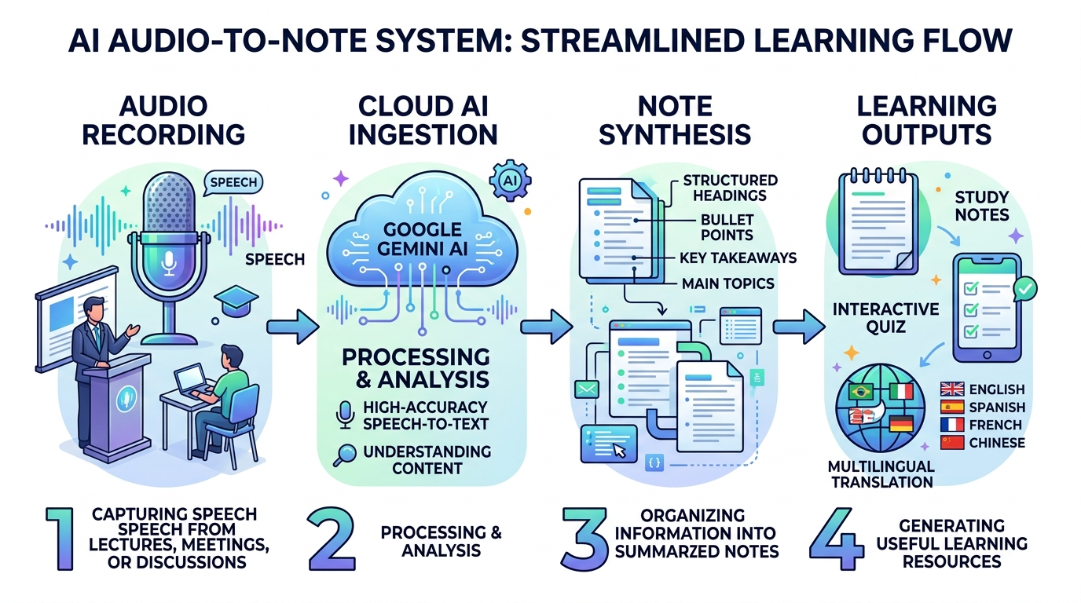
Figure 1.1: High-Level Conceptual Overview of the AI Audio-to-Note Converter System
Recent advancements in Artificial Intelligence (AI) and Machine Learning have created exciting opportunities to solve this problem. With modern Speech-to-Text (STT) technologies and Multimodal Large Language Models like Google's Gemini 2.5 Flash, it is now possible to automatically capture audio from a mobile phone, transcribe spoken words into text, and organize the text into clear, structured study notes. This project focuses on designing and implementing AudioNote AI, an intelligent mobile application that transforms spoken lecture audio into well-organized notes, verbatim transcripts, self-assessment quizzes, and multilingual translations.
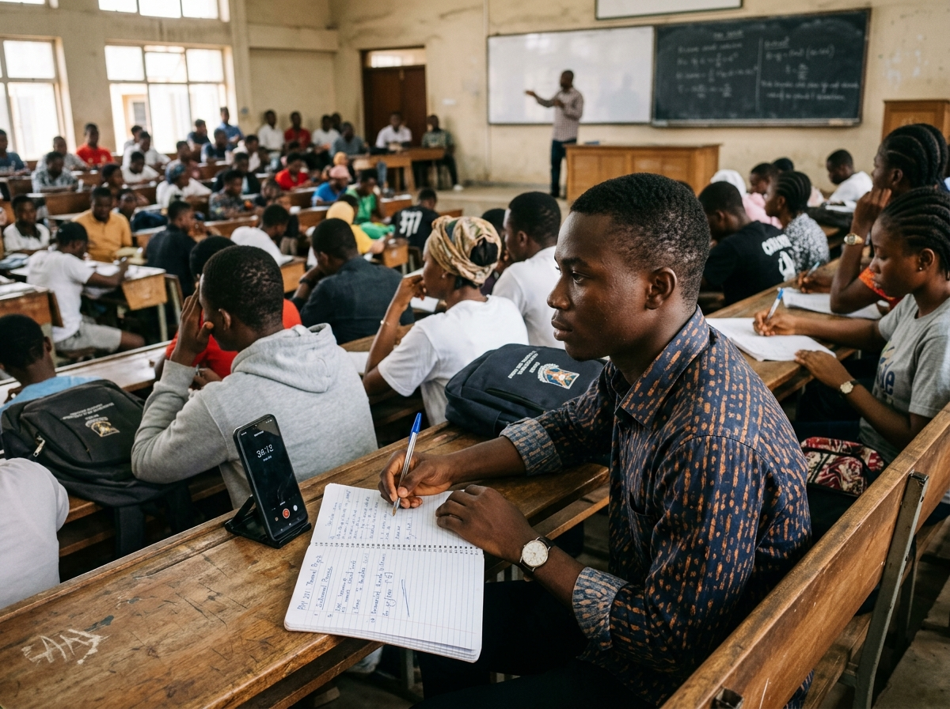
Figure 1.2: Real-World Usage Scenario – A Nigerian University Student Utilizing the Mobile Audio-to-Note App During a Lecture
1.2 STATEMENT OF THE PROBLEM
Manual note-taking in university lectures is inefficient and stressful for students. When students focus on writing down everything a lecturer says, they lose track of the core explanation and fail to internalize the topic being taught. Conversely, if they focus only on listening, they leave the lecture hall without detailed written reference materials for revision.
Existing commercial transcription applications do not fully solve this issue for students. Most existing apps only provide a flat, unstructured wall of raw text without headings, bullet points, or summaries. Furthermore, they do not include student-centered learning features such as practice quizzes or translations into local Nigerian languages like Hausa, Yoruba, and Igbo. There is a clear need for an affordable, student-friendly mobile application that captures spoken audio and automatically produces clean study summaries, timestamped transcripts, and interactive study aids.
1.3 AIM AND OBJECTIVES
The aim of this project is to develop an AI-powered Audio-to-Note study companion that allows students to record lecture audio and automatically convert it into structured study notes, timestamped transcripts, self-assessment quizzes, and multilingual translations. To achieve this aim, the following specific objectives were formulated:
1. To design and build an intuitive, responsive mobile user interface using React Native and Expo that allows students to easily record, pause, and review lecture audio.
2. To implement a backend server using Node.js, Express.js, and TypeScript to manage audio uploads, user accounts, and database storage securely.
3. To integrate Google's Gemini 2.5 Flash multimodal AI API to process recorded audio files, generate structured Markdown notes, and extract key points.
4. To implement an automated quiz generation feature that creates 10-question multiple-choice practice quizzes from the lecture content for active recall revision.
5. To provide a one-tap translation engine that converts study notes into 9 languages, including major Nigerian languages (Hausa, Igbo, and Yoruba).
6. To test and evaluate the application's transcription accuracy, ease of use, and response time in typical classroom conditions.
1.4 SCOPE AND LIMITATIONS OF THE STUDY
The scope of this project covers the software development of the AudioNote AI platform. It includes building the frontend mobile app using React Native, developing the REST API using Express.js and TypeScript, and managing persistent data with PostgreSQL and Prisma ORM. The artificial intelligence processing relies on Google's Gemini 2.5 Flash API for speech processing, note generation, and translations.
The project has some limitations. First, because the audio transcription and AI processing are performed in the cloud, an active internet connection is required to process recorded lectures. Second, the clarity of the generated notes depends on the recording quality of the student's mobile phone; if a lecturer speaks very far from the microphone in a room with severe acoustic noise, some words may be misunderstood. Finally, the system relies on Google's API service availability and rate limits.
1.5 SIGNIFICANCE OF THE STUDY
This project is of significant benefit to students, educators, and the broader field of applied computer science. For students, it removes the pressure of multitasking during lectures, allowing them to engage actively in class discussions while trusting the app to capture the notes accurately. The automatic generation of interactive quizzes provides an effective self-assessment tool, helping students test their understanding before semester examinations.
Additionally, offering note translations into indigenous languages like Hausa, Yoruba, and Igbo promotes inclusive education, helping students who understand concepts better in their native tongues. From a computer science perspective, the project demonstrates how modern web and mobile technologies (React Native, Node.js, and PostgreSQL) can be integrated with state-of-the-art multimodal AI services to solve practical educational problems in developing regions.
1.6 OPERATIONAL DEFINITION OF TERMS
• Speech-to-Text (STT): The technology that converts spoken words into computer-readable digital text.
• Multimodal AI: An artificial intelligence system capable of understanding and processing different types of input data, such as audio, text, and images simultaneously.
• React Native: A popular open-source JavaScript framework developed by Meta for building natively rendering mobile applications for Android and iOS from a single codebase.
• Expo: A set of tools, libraries, and services built around React Native that simplifies mobile app development, testing, and deployment.
• Express.js: A lightweight and flexible Node.js web application framework used to build backend RESTful APIs.
• Prisma ORM: An open-source database toolkit that provides type-safe database queries and automated schema migrations for PostgreSQL.
• Active Recall: A study technique where learners actively test their memory through quizzes and questions rather than passively re-reading notes.

CHAPTER TWO
LITERATURE REVIEW
2.0 OVERVIEW OF AI-POWERED AUDIO-TO-NOTE SYSTEMS
Converting spoken dialogue into written text has always been a major goal of computer science. In academic environments, lectures contain valuable knowledge that students need to preserve and study. Early attempts to capture lectures relied entirely on manual note-taking or physical audio cassette recordings. However, raw audio files are difficult to review because users cannot search through them quickly. Students must spend hours listening to find specific definitions or explanations.
With the rapid growth of Artificial Intelligence (AI) and Natural Language Processing (NLP), modern software systems can do much more than simple audio playback. Today's AI systems can listen to human speech, convert the audio into text, understand the context of what was said, and automatically organize the information into clear summaries. This chapter provides a detailed review of the literature surrounding Speech-to-Text (STT) technologies, Natural Language Processing for text summarization, multimodal AI models, mobile application architectures, and existing audio note-taking systems.
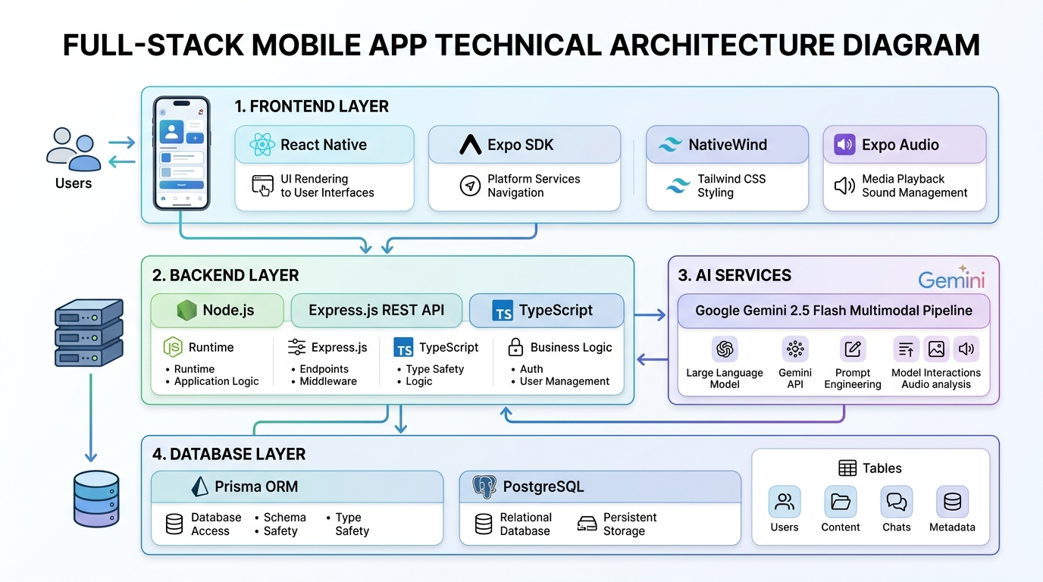
Figure 2.1: Full-Stack Architecture Diagram Illustrating Frontend, Backend, AI Pipeline, and Database Layers
2.1 SPEECH-TO-TEXT (STT) TECHNOLOGIES AND PROCESSING METHODS
Automatic Speech Recognition (ASR), commonly known as Speech-to-Text (STT), is the technology that enables a computer program to recognize human speech and convert it into written words. The speech recognition process involves receiving an acoustic wave from a microphone, digitizing the signal, analyzing sound frequencies, and decoding the sound patterns into written language.
2.1.1 Types of Audio Inputs
Speech-to-text systems encounter different types of audio inputs depending on the recording environment and hardware. In a laboratory setting, audio is often recorded with close-talking microphones in quiet rooms, producing clean sound with high signal quality. However, in real-world educational settings, audio inputs are far more challenging.
Audio inputs can be broadly categorized into two types: real-time streaming audio and pre-recorded audio files. Real-time streaming involves processing small audio chunks (typically 250 milliseconds to a few seconds) as the speaker is talking. This requires low-latency processing so that the user sees words appear almost immediately. Pre-recorded audio files, on the other hand, allow the system to receive the entire recording at once. This enables the AI model to analyze the full context of the speech from start to finish, which generally leads to higher transcription accuracy.
2.1.2 Speech Recognition Methods
Over the decades, speech recognition systems have evolved through several technological generations. Understanding these methods explains why modern deep learning systems are significantly more capable than older approaches.
2.1.2.1 Acoustic Modeling
The acoustic model is the part of an ASR system that connects audio signals to the basic units of speech, known as phonemes. In English, there are approximately 44 distinct phonemes that make up spoken words. In early systems, researchers used Gaussian Mixture Models (GMM) combined with Hidden Markov Models (HMM). The GMM estimated the probability of a sound belonging to a specific phoneme, while the HMM tracked the sequence of sounds over time.
While statistical HMMs were an important milestone, they struggled with background noise and speaker variations. Modern speech recognition replaces GMMs with Deep Neural Networks (DNNs) and Convolutional Neural Networks (CNNs). Deep learning models are capable of learning complex acoustic patterns directly from thousands of hours of training audio, making them far more resilient to different voices, pitches, and accents.
2.1.2.2 Language Modeling
While the acoustic model identifies what sounds were spoken, the language model determines which words make sense together grammatically and contextually. Human speech contains many homophones—words that sound identical but have different spellings and meanings, such as 'their', 'there', and 'they're', or 'hear' and 'here'. Without a language model, the computer cannot know which word is correct.
Early language models relied on statistical n-grams, which calculated the probability of a word appearing based on the previous two or three words. Today, language modeling is powered by Transformer neural networks, such as those found in modern Large Language Models. Transformers use self-attention mechanisms to look at the entire sentence or paragraph, allowing the system to easily select the correct word based on the overall meaning of the lecture.
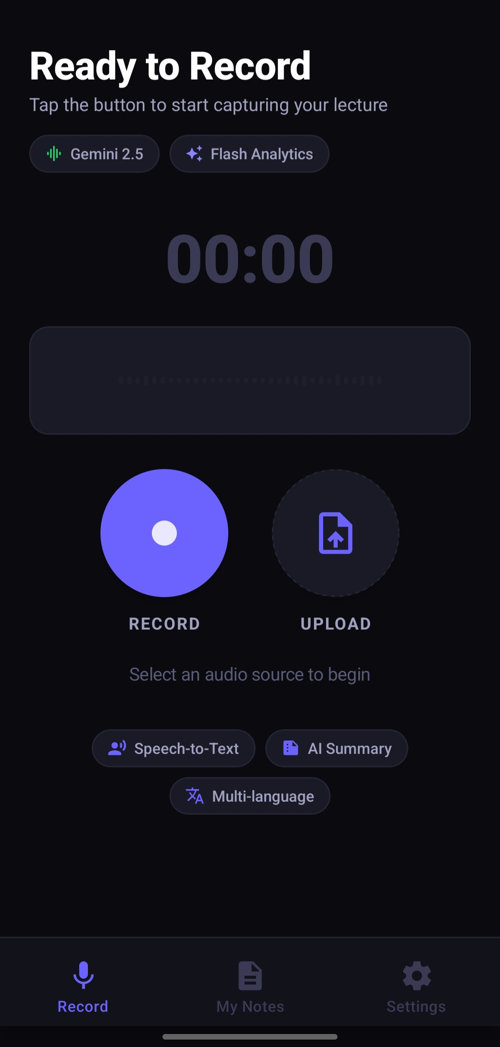 | 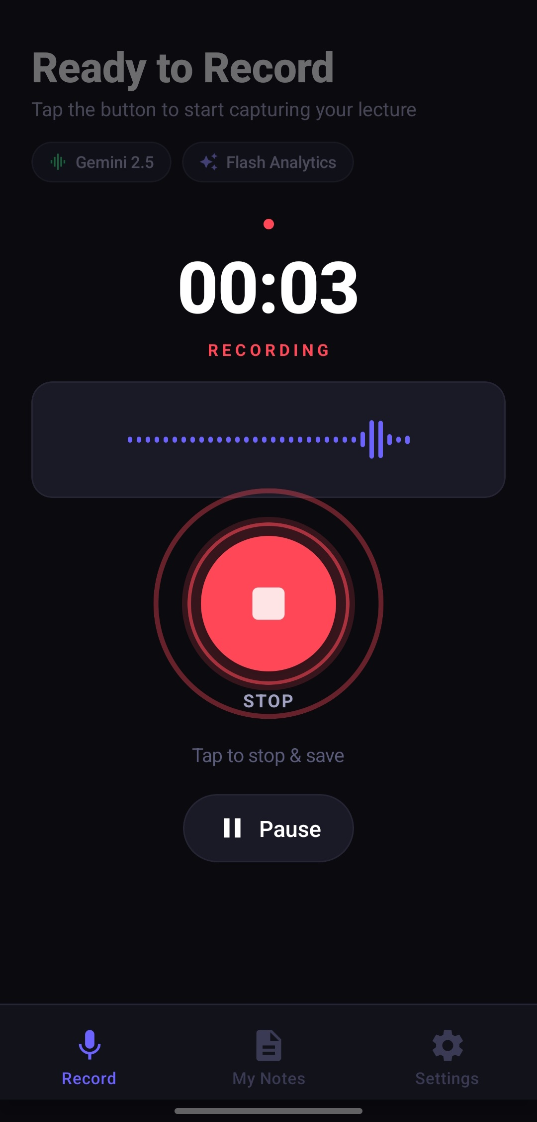
Figure 2.2: Audio Recording Interfaces in AudioNote AI – (Left: Standby Recording Screen [s2]; Right: Active Waveform Metering [s3])
2.1.3 Audio Processing and Feature Analysis Techniques
Before an audio signal can be analyzed by a machine learning model, it must be cleaned and converted into a numerical format that computers can process efficiently.
2.1.3.1 Pre-Processing and Noise Reduction
Raw audio captured from a phone microphone often contains unwanted noise such as electrical hum, wind, or distant talking. Pre-processing applies digital filters to clean the audio signal. A common step is pre-emphasis filtering, which boosts high-frequency sounds that naturally drop off when humans speak. Another important technique is noise suppression, which detects steady background noise (such as an air conditioner or electric generator) and subtracts that noise from the audio signal, leaving a clearer voice track.
2.1.3.2 Feature Extraction (Spectrograms and MFCCs)
Computers cannot directly process raw sound waves efficiently because sound waves are simply long arrays of amplitude values over time. To make sense of sound, systems extract Mel-Frequency Cepstral Coefficients (MFCCs) or compute Log-Mel Spectrograms. A spectrogram is a visual representation of sound frequencies over time. The 'Mel scale' is used because it models how human ears perceive pitch—humans are much better at distinguishing small differences in low frequencies than in high frequencies. By converting audio into spectrograms, computer vision and deep learning techniques can treat the audio almost like an image to recognize words accurately.
2.1.3.3 Speaker Diarization
Speaker diarization is the process of identifying 'who spoke when' in an audio recording. In a classroom, a lecture is not always a monologue; students frequently ask questions or participate in class discussions. Diarization algorithms analyze voice characteristics (such as pitch and vocal tone) and assign labels like 'Speaker 1' (the lecturer) and 'Speaker 2' (a student asking a question). This helps organize the resulting transcript into a natural dialogue format.
Table 2.1: Comparison of Speech Recognition Approaches in Computer Science
Approach | Technology | Accuracy | Handling of Accents | Computational Needs
Statistical ASR | Hidden Markov Models (HMM) + GMM | Low to Moderate (70-80%) | Poor; struggles with variations | Low CPU usage; runs on old PCs
Hybrid Deep Learning | Deep Neural Networks + HMM | Moderate to High (85-90%) | Fair; requires accent tuning | Moderate; requires decent CPU/GPU
End-to-End ASR | Connectionist Temporal Classification (CTC) | High (90-95%) | Good across standard dialects | High GPU requirements for training
Multimodal Foundation AI | Transformer-based (e.g. Gemini 2.5 Flash) | Very High (95-98%+) | Excellent across global & regional accents | Offloaded to cloud AI clusters

2.2 NATURAL LANGUAGE PROCESSING (NLP) FOR SUMMARIZATION
Getting an accurate transcript is only the first step. A word-for-word transcript of a one-hour lecture can easily be over 8,000 words long. Reading through 8,000 words of spoken dialogue is overwhelming because human speech includes filler words (like 'um', 'you know', 'actually'), repetitive explanations, and side remarks. Natural Language Processing (NLP) summarization techniques are needed to distill this raw text into clear, concise study notes.
2.2.1 Extractive Summarization
Extractive summarization works by identifying the most important sentences already present in the text and stitching them together into a summary. Algorithms such as TF-IDF (Term Frequency-Inverse Document Frequency) and TextRank score each sentence based on the frequency and importance of its words. While extractive summarization is fast and guaranteed not to make up facts, it often creates choppy, disjointed summaries because spoken sentences do not always flow logically when pulled out of context.
2.2.2 Abstractive Summarization
Abstractive summarization is much closer to how a human student writes notes. Instead of copying exact sentences, an abstractive AI model reads the transcript, understands the main concepts, and writes completely new, well-structured sentences. This allows the model to eliminate verbal clutter, combine related points, create clean bulleted lists, and format the output with markdown headings. Modern Large Language Models (LLMs) excel at abstractive summarization because they have been trained on vast amounts of literature and know how to synthesize academic concepts clearly.
2.2.3 Keyword and Topic Extraction
To make study notes easy to organize and search, NLP systems perform keyword and topic extraction. Using techniques like Named Entity Recognition (NER), the system automatically detects technical terms, formulas, dates, and author names. In AudioNote AI, this allows the app to generate automatic titles (such as 'Full-Stack Development: Front-End, Back-End, and Hosting') and tag notes by subject categories without requiring the student to type anything manually.
2.2.4 Challenges in Automated Summarization
While abstractive summarization is powerful, it comes with challenges. The main challenge is 'hallucination', where an AI model generates information that sounds convincing but was never mentioned in the original audio. In an academic setting, hallucinating an incorrect formula or wrong historical date can misinform students. Developers address this by carefully engineering prompts with strict rules that tell the AI to base its summary solely on the provided audio transcript.
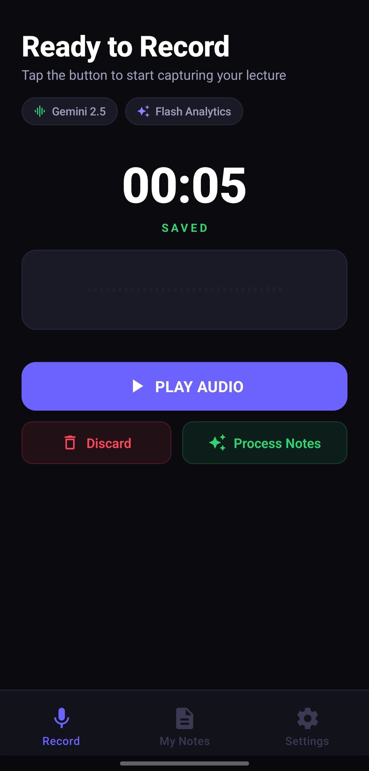 | 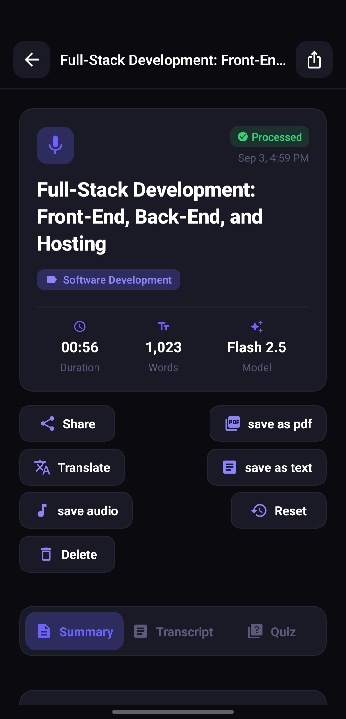
Figure 2.3: Ingestion and Note Generation – (Left: Saved Recording Decision Screen [s4]; Right: Processed Note with Gemini 2.5 Flash Badge [s6])
2.3 REAL-WORLD CHALLENGES IN AUDIO CONVERSION
Building a reliable speech-to-note application for real university environments requires overcoming several practical challenges. These challenges are particularly pronounced in developing educational contexts such as Nigerian higher institutions.
2.3.1 Background Noise and Acoustic Reflections
In many universities, lecture rooms are large concrete halls without acoustic wall padding. When a lecturer speaks, the sound reflects off walls, floors, and metal desks, creating reverberation (echo). Additionally, environmental sounds such as rain hitting corrugated iron roofs, diesel generator noise during power outages, noisy ceiling fans, and chatter among students can drown out the lecturer's voice. If the audio recorded on the student's phone is muffled, speech recognition systems face higher error rates.
2.3.2 Accents and Regional Dialectal Variations
English is the official language of instruction in Nigeria, but it is spoken with a wide variety of regional accents influenced by the speaker's mother tongue (such as Yoruba, Hausa, or Igbo). Many commercial speech recognition tools developed in Western countries were trained predominantly on North American or British accents, causing them to struggle with Nigerian English pronunciations. Furthermore, lecturers frequently use Nigerian idioms or switch briefly into pidgin or local languages to explain a concept. A robust educational app needs an AI model with broad global language exposure to understand these speech variations.
2.3.3 Domain-Specific Jargon and Technical Terms
Computer science, engineering, and medical lectures are filled with specialized terminology. For example, a computer science lecturer might mention 'PostgreSQL', 'Kubernetes', 'asynchronous functions', or 'polymorphism'. A general speech-to-text model that has not been conditioned for technical topics might transcribe 'PostgreSQL' as 'post grey sequel' or 'API' as 'a pie'. Ensuring that technical terms are transcribed accurately requires intelligent language models that recognize the academic context.
2.3.4 Mobile Hardware and Data Network Constraints
Undergraduate students use a wide variety of mobile smartphones, ranging from budget Android phones with modest processors to modern devices. An application cannot expect to run a massive AI model locally on the phone because it would quickly drain the battery and overheat the device. At the same time, mobile data in Nigeria can be costly and campus Wi-Fi may be intermittent. Therefore, the mobile application must compress audio efficiently before sending it to the cloud server, minimizing data usage while preserving audio clarity.
Table 2.2: Comparison of Text Summarization Techniques for Lecture Notes
Summarization Type | Technique Used | Readability | Risk of Hallucination | Suitability for Study Notes
Sentence Extraction | TF-IDF / Frequency Scoring | Low; disjointed sentences | None (copies verbatim) | Poor; keeps verbal filler and pauses
Graph-Based Extraction | TextRank Algorithm | Moderate; selects key sentences | None (copies verbatim) | Fair; lacks natural conversational flow
Early Seq2Seq Neural | LSTM / RNN Encoder-Decoder | Moderate; some grammatical errors | Low to Moderate | Fair; forgets context in long lectures
Modern Abstractive AI | Transformer LLMs (Gemini 2.5 Flash) | Very High; structured markdown | Low with proper prompt grounding | Excellent; produces clear academic summaries

2.4 MACHINE LEARNING APPROACHES IN SPEECH RECOGNITION
Machine learning is the branch of computer science that allows systems to learn from data rather than following strictly hardcoded rules. In speech processing, machine learning models are trained on thousands of hours of audio recordings paired with text transcripts to learn the mapping from sound vibrations to written words.
2.4.1 Supervised, Unsupervised, and Self-Supervised Learning
Traditionally, speech recognition relied on supervised learning, where every second of training audio had to be manually transcribed by humans. This was extremely expensive and made it difficult to build speech models for languages with fewer resources. Recently, the AI community adopted self-supervised learning (SSL) models, such as wav2vec 2.0. In self-supervised learning, the AI model listens to massive amounts of unlabeled audio and learns how speech sounds work on its own by trying to predict masked or hidden parts of the audio. Once this general understanding is established, the model only needs a small amount of labeled text to become an accurate transcriber.
2.4.2 The Transformer Architecture in Speech and NLP
The introduction of the Transformer architecture by Vaswani et al. in 2017 fundamentally changed natural language processing and speech recognition. Before Transformers, systems processed words one by one using recurrent loops (RNNs), which were slow and frequently forgot information from earlier parts of long sentences. The Transformer introduced the 'self-attention' mechanism, which allows the model to examine all parts of an audio clip or text document at the same time. This capability allows models to understand the broad context of an entire lecture and generate accurate notes without losing the central topic.
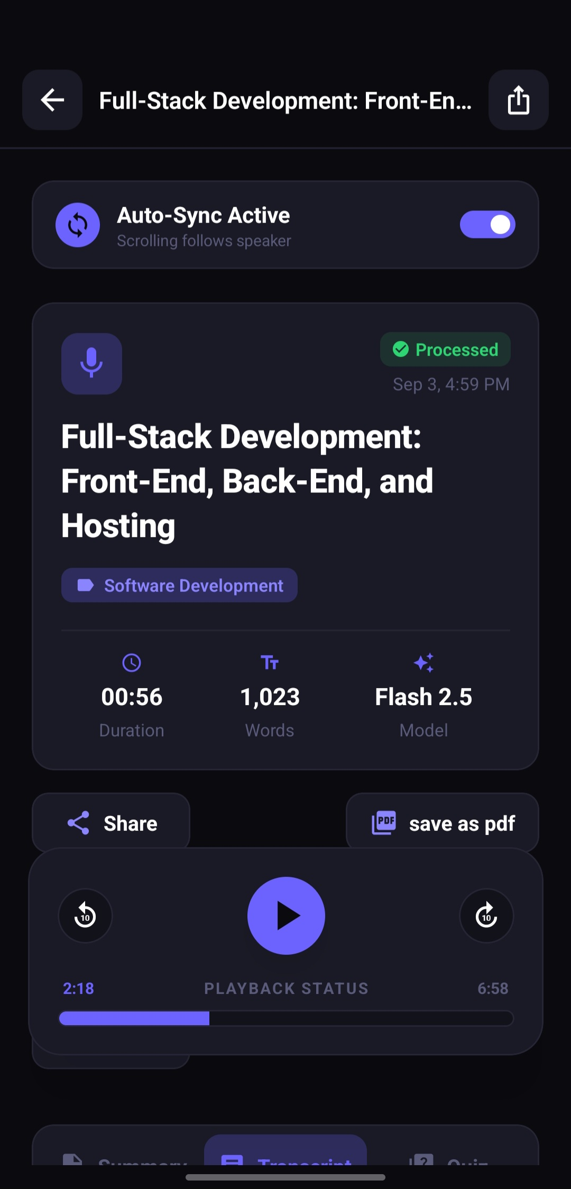 | 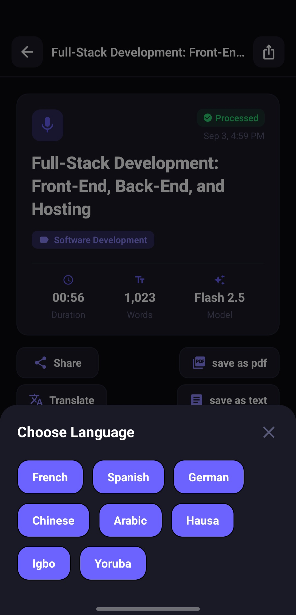
Figure 2.4: Study and Accessibility Features – (Left: Synchronized Audio Playback [s7]; Right: Multilingual Translation Dialog [s8])
2.5 ADVANCEMENTS IN MULTIMODAL AI AND PEDAGOGICAL TOOLS
The latest breakthrough in artificial intelligence is the shift towards native Multimodal Models. Earlier AI tools operated in separate stages: one model converted audio to text, another model summarized the text, and a third model translated it. If the first model made a mistake, the mistake propagated and grew worse through each subsequent stage. Native multimodal models eliminate this problem by processing audio directly within a single neural network.
2.5.1 Google Gemini 2.5 Flash Multimodal Pipeline
Google's Gemini 2.5 Flash is an advanced multimodal model designed for high-speed, cost-effective reasoning. Unlike older text-only models, Gemini 2.5 Flash can ingest audio files directly. It listens to the audio, understands the speaker's tone, emphasis, and context, and generates structured text in one step. In AudioNote AI, the backend uses Google's AI File Manager API to stream the lecture audio directly to Gemini. The model returns an organized JSON payload containing a clear lecture title, categorized topic tags, a structured markdown summary, a timestamped verbatim transcript, and a practice quiz.
2.5.2 Automated Quiz Generation for Active Recall
Educational research consistently shows that simply reading through notes is one of the least effective ways to study. Cognitive scientists recommend 'active recall'—testing oneself on the material to strengthen memory retention. By leveraging Gemini's generative capabilities, AudioNote AI automatically turns lecture content into an interactive 10-question multiple-choice quiz. Each question includes four answer options and explanations for why an answer is correct. In the mobile app, students can answer questions and receive instant scoring and celebratory feedback, turning study sessions into an engaging learning experience.
2.5.3 Multilingual Translation for Inclusive Learning
Language accessibility is vital for students who are non-native English speakers. In Nigeria, while university education is in English, many students find it easier to understand difficult technical concepts when explained in their mother tongue. AudioNote AI integrates a neural translation engine supporting 9 languages: English, French, Spanish, German, Chinese, Arabic, and three prominent Nigerian languages: Hausa, Yoruba, and Igbo. With one tap, students can translate the summary and transcript into their chosen language while preserving all headings, bullet points, and timestamp markers.
Table 2.3: State-of-the-Art Multimodal Foundation Models for Educational Applications
Model | Provider | Direct Audio Ingestion | Speed / Latency | Support for African Languages
Whisper Large-v3 | OpenAI | Yes (Speech only) | Moderate (generates text only) | Moderate; limited for regional dialects
GPT-4o Audio | OpenAI | Yes (Multimodal) | Fast (high cloud API cost) | Good global coverage
Claude 3.5 Sonnet | Anthropic | No (requires text transcript first) | Fast (text only) | Good global coverage
Gemini 2.5 Flash | Google | Yes (Direct Multimodal audio & text) | Very Fast (low cost & high speed) | Strong multilingual support including Nigerian languages

2.6 MOBILE-FIRST ARCHITECTURE AND TECHNOLOGIES USED
To deliver a smooth, practical experience to students, the software architecture of AudioNote AI was carefully designed using modern open-source JavaScript and TypeScript libraries. The system consists of a cross-platform mobile frontend, a RESTful backend API, and a relational database.

Figure 2.5: React Native Framework Architectural Ecosystem Utilized for the Mobile Client
2.6.1 React Native and Expo Framework
React Native is a cross-platform mobile framework developed by Meta that allows developers to write code once in JavaScript or TypeScript and deploy it natively to both Android and iOS devices. Unlike hybrid web-view wrappers, React Native renders true native UI components, ensuring 60 frames-per-second performance and a smooth user experience. Expo (SDK 54) provides a comprehensive set of tools that simplify hardware access, app building, and testing without requiring complex native platform setup.
2.6.2 Audio Recording and Waveform Libraries
Capturing audio reliably on a smartphone requires specialized libraries. In this project, `expo-av` and `expo-audio` manage the microphone hardware sessions. To give the student visual feedback that their recording is working, the app polls the microphone's decibel levels every 250 milliseconds and animates a dynamic audio waveform using `react-native-reanimated`. The recorded audio is temporarily stored in `FileSystem.documentDirectory` on the phone before being uploaded to the backend server.
2.6.3 Backend Architecture: Node.js, Express.js, and Prisma ORM
The backend service is built using Node.js and Express.js in TypeScript. Express.js provides a clean routing mechanism for handling HTTP requests such as user registration, audio uploads, and note retrieval. Audio file uploads are handled using `multer`, which streams incoming audio directly to disk storage to avoid consuming excessive server RAM. Database operations are handled using Prisma ORM v6 connected to a PostgreSQL relational database. Prisma provides type-safe database queries, automated migrations, and connection pooling, ensuring that user records and generated notes are stored securely and retrieved quickly.
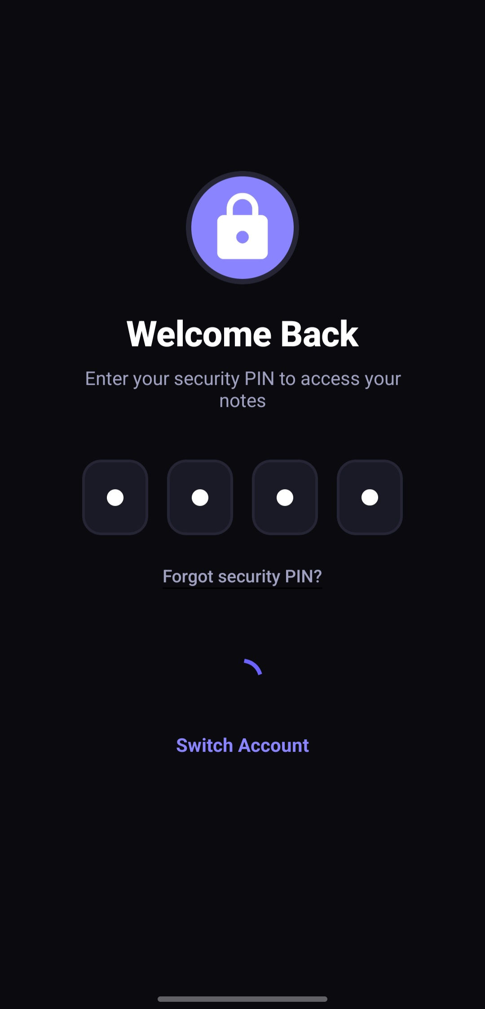 | 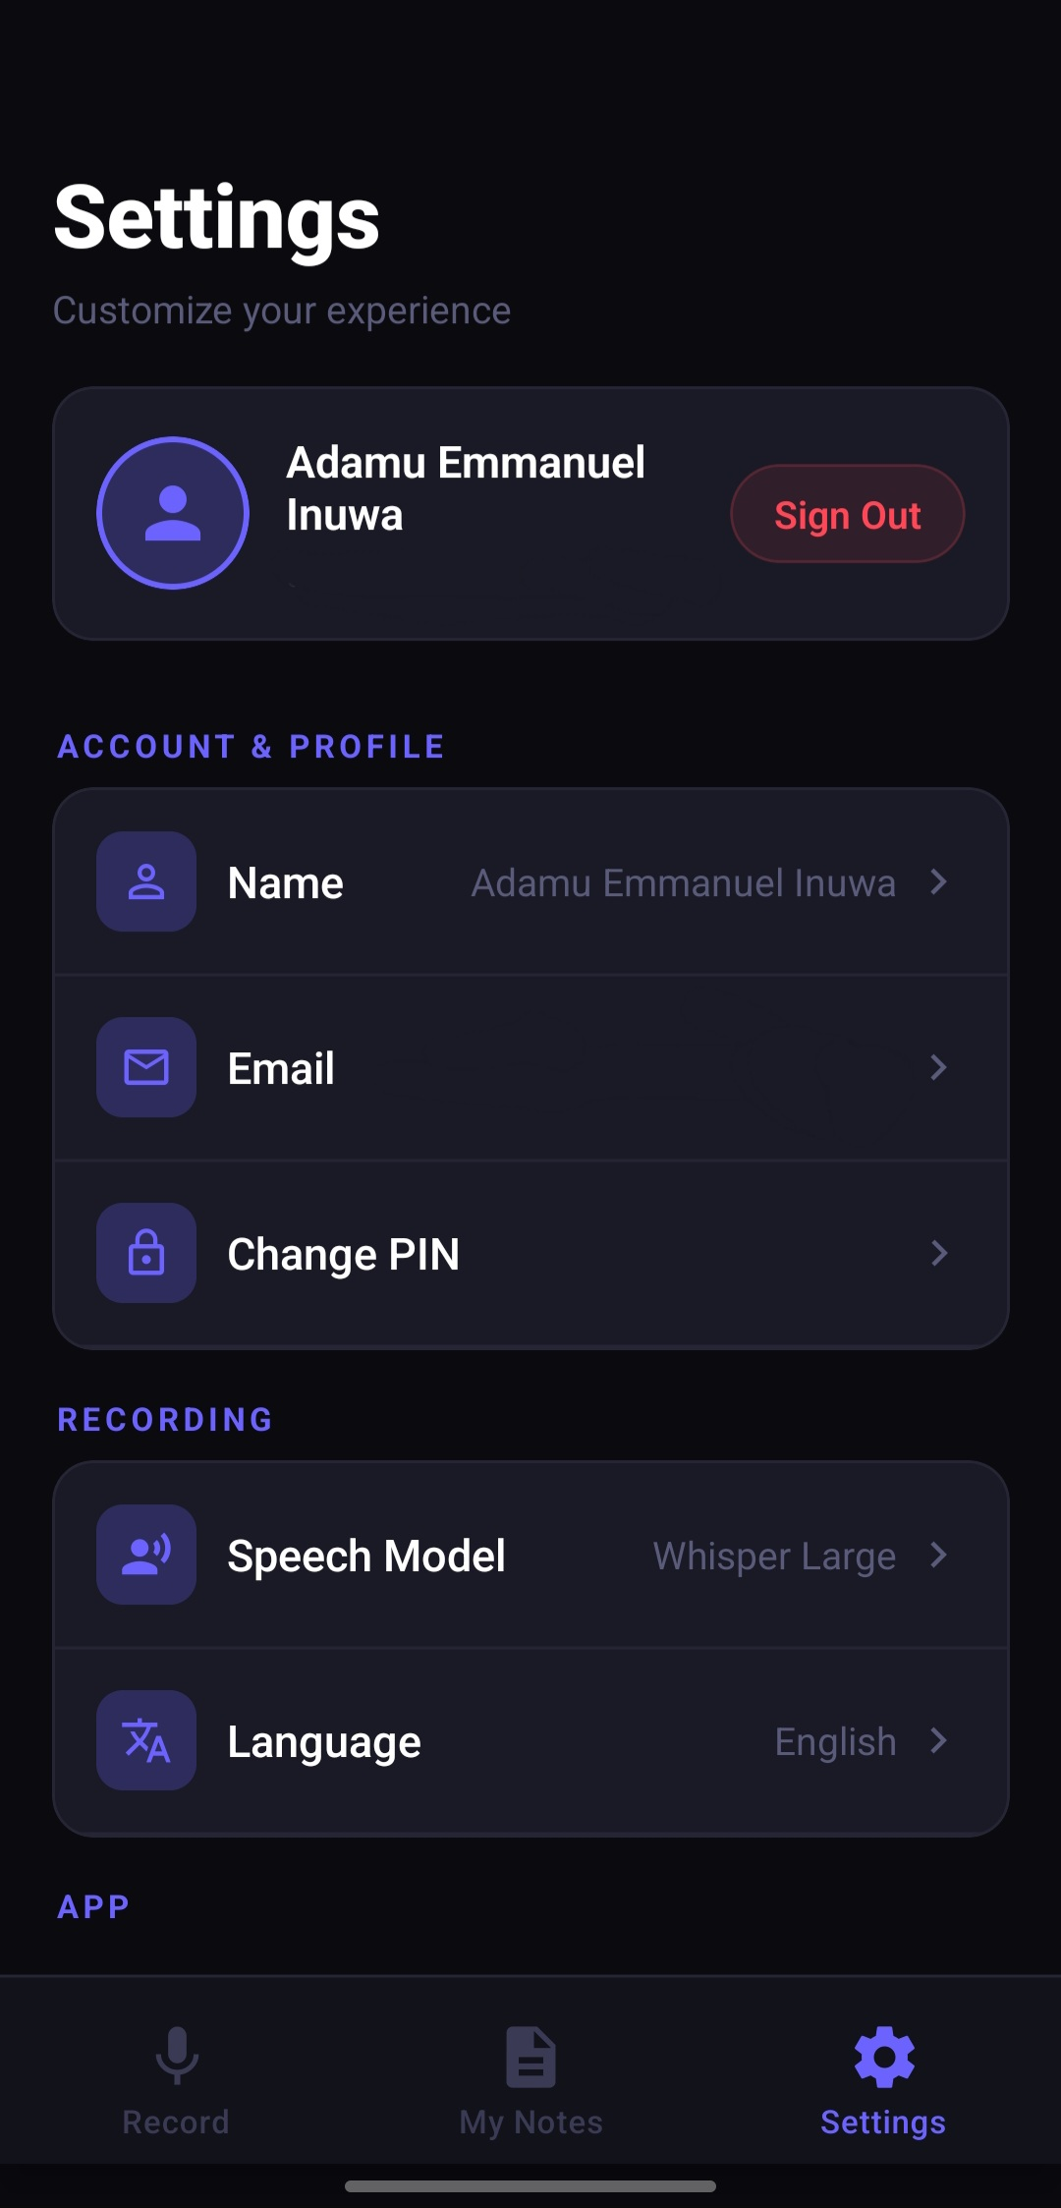
Figure 2.6: Security and User Settings – (Left: 4-Digit Security PIN Gateway [s1]; Right: User Settings and Speech Model Configuration [s5])
2.7 RELATED WORKS
Several commercial and academic systems have explored audio transcription and note-taking. Examining these existing works helps highlight the unique contributions of AudioNote AI.
Otter.ai is one of the most well-known automated meeting transcription platforms. It provides live transcription, speaker identification, and integration with video platforms like Zoom. However, Otter.ai is designed primarily for corporate business meetings. Its summaries focus on meeting action items rather than academic lecture concepts. In addition, its subscription costs are prohibitive for students in developing countries, and it does not support translations into local African languages or automated study quizzes.
Fireflies.ai is another conversational intelligence tool focused on recording and transcribing corporate calls. It connects with business tools like Slack and Salesforce, but it lacks a dedicated mobile study interface with flashcards, active recall quizzes, or student-oriented note formatting. Other apps such as Coconote and Wave AI have recently emerged for students, but many of them rely on multi-step pipelines that introduce transcription errors and require expensive recurring monthly subscriptions.
AudioNote AI addresses these gaps by combining direct multimodal AI processing (Google Gemini 2.5 Flash) with an undergraduate-focused mobile design. It provides structured lecture notes, timestamped transcripts, self-assessment quizzes, and translations into major Nigerian languages, offering a comprehensive, inclusive academic study companion.
2.8 SUMMARY OF LITERATURE REVIEW
In conclusion, the literature review shows that manual note-taking creates significant cognitive fatigue for students, causing them to miss important lecture material. While early speech recognition tools were limited by noise sensitivity and inflexible statistical models, modern deep learning and multimodal foundation models like Gemini 2.5 Flash have made high-accuracy speech-to-note conversion a reality. By leveraging React Native on the mobile client, Express.js on the backend, and Google's multimodal AI in the cloud, this project provides a practical, student-centered solution designed to overcome the acoustic and linguistic challenges found in university classrooms.

CHAPTER THREE
METHODOLOGY
3.1 CONCEPT USED
The conceptual framework for the AudioNote AI platform is rooted in software engineering principles, human-computer interaction (HCI), and modern multimodal artificial intelligence pipelines. The methodology employed follows the Agile Incremental Development Model. The Agile model was selected because developing a multi-tiered mobile application involving cutting-edge AI APIs requires continuous iteration, rapid prototyping, and empirical user feedback at each milestone.
The core concept revolves around eliminating the linear, non-indexable nature of recorded speech by transducing continuous acoustic waves into semantically rich, multi-tiered learning artifacts. As illustrated in the conceptual workflow, the system decomposes raw speech into four interconnected output representations: (1) Structured Conceptual Notes formatted in GitHub-Flavored Markdown; (2) Verbatim Timestamped Transcripts aligned at 10-second intervals; (3) Interactive 10-Question Gamified Multiple-Choice Quizzes; and (4) Cross-Lingual Translations across nine global and regional Nigerian languages. This multi-tiered concept guarantees that whether a learner prefers rapid scanning, deep reading, active recall self-testing, or native dialect review, the system adapts dynamically to their learning modality.
3.2 OVERVIEW OF AUDIO INGESTION AND MULTIMODAL PROCESSING PIPELINE
To achieve low-latency and high accuracy without overwhelming mobile hardware, the platform employs a decoupled, asynchronous cloud-streaming pipeline. The audio ingestion pipeline consists of five synchronized stages:
1. Acoustic Capture and Client-Side Buffering: The mobile client captures microphone input at 16-bit linear PCM format. Audio frames are streamed directly to temporary file sandboxes within `FileSystem.documentDirectory` to eliminate memory overflow.
2. Multipart Payload Dispatch: Upon recording completion, the client dispatches the audio payload over HTTPS via a multi-part form-data stream to the Express.js backend server.
3. Cloud File Ingestion: The backend server receives the stream via Multer and immediately registers the file with Google's AI File Manager API (`@google/generative-ai/server`), avoiding local disk bottlenecks.
4. Gemini 2.5 Flash Multimodal Inference: The audio stream is ingested directly into Gemini's multimodal cross-attention layers alongside strict system prompt engineering instructions.
5. JSON Schema Parsing and Relational Persistence: The raw response is strictly parsed into title, topic, summary, transcript, and quiz entities, validated, and persisted into PostgreSQL via Prisma ORM v6 before dispatch back to the client.
3.3 SYSTEM DESIGN AND ARCHITECTURE
The system architecture follows a clean, three-tiered client-server model: the Mobile/Web Presentation Tier, the Application/Logic Tier, and the Data Persistence & AI Service Tier. This decoupled design ensures scalability, fault tolerance, and independent module maintainability.
3.3.1 Tools and Technologies
The software stack incorporates robust, industry-standard development frameworks:
• Frontend Runtime: React Native v0.81.5 with Expo SDK 54, utilizing Expo Router for declarative file-system routing.
• Styling and Animations: NativeWind (Tailwind CSS for React Native) and React Native Reanimated v4 for 60fps waveform rendering.
• Audio Controllers: `expo-av` and `expo-audio` configured for real-time decibel polling and hardware recording management.
• Backend API: Node.js runtime with Express.js written in strict TypeScript, utilizing Multer for multipart audio handling.
• Artificial Intelligence Engine: Google Gemini 2.5 Flash Multimodal API via `@google/generative-ai`.
• Database and ORM: PostgreSQL database hosted on cloud infrastructure, mediated by Prisma ORM v6 with connection pooling (`@prisma/adapter-pg`).
• Authentication and Security: Salted bcrypt password/PIN hashing with cryptographically signed JSON Web Tokens (JWT).
3.3.2 Proposed System Flowchart
Figure 3.1 illustrates the complete architectural and operational flowchart of the AudioNote AI platform. It delineates the decision gates from initial user authentication, through audio recording and cloud AI processing, to persistent database storage and client rendering.
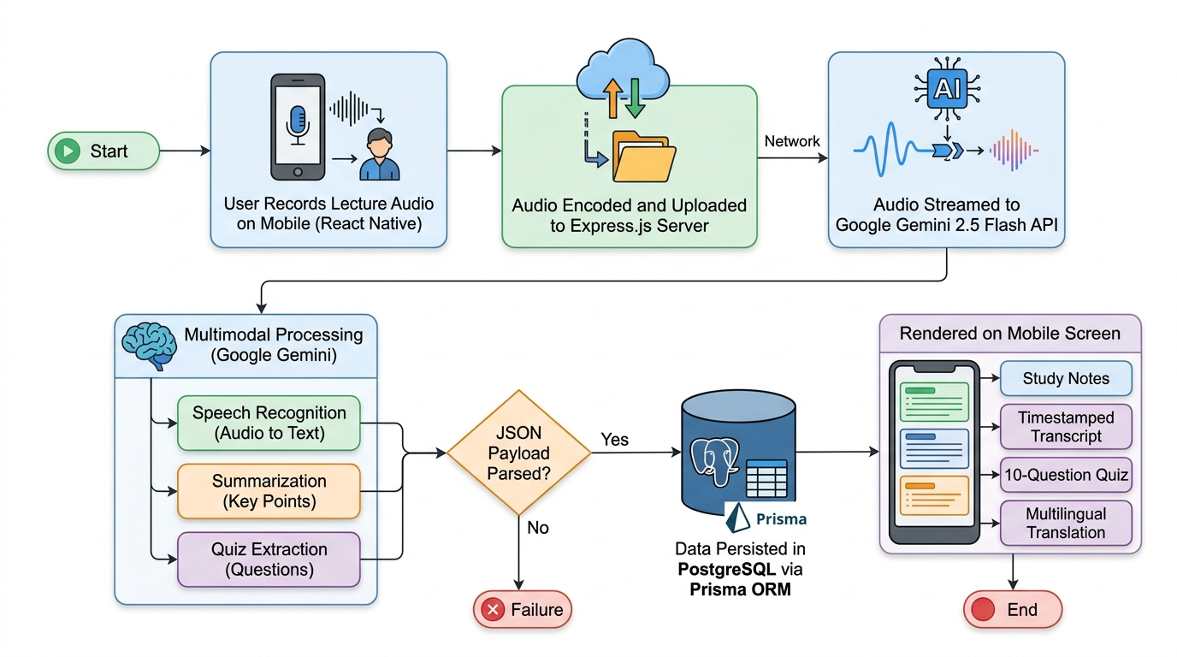
Figure 3.1: Comprehensive End-to-End System Engineering Flowchart for AudioNote AI
3.3.3 Client-Side Architecture (Mobile/Web Client)
The client architecture is engineered using React Native to ensure native performance across Android and iOS platforms. The UI is built around a frictionless 4-digit security PIN unlock mechanism, allowing students to access their notes without remembering complex passwords. The recording screen implements a dynamic audio metering visualizer that polls microphone amplitude every 250 milliseconds, animating a reactive waveform using Reanimated worklets. The study view integrates `react-native-markdown-display` to render headings, bold key terms, mathematical formulas, and lists with crisp typography. The quiz arena utilizes `react-native-confetti-cannon` to provide gamified positive reinforcement upon quiz completion.
3.3.4 Server-Side and Cloud Architecture
The backend server is architected as an Express.js REST API deployed on cloud infrastructure (Render). Audio ingestion routes are protected by JWT middleware. To ensure high availability and prevent cloud networking hangs, all external SMTP communications (via Nodemailer) and Gemini AI socket handshakes enforce IPv4 address resolution (`family: 4`) with explicit 60-second timeouts. The PostgreSQL database maintains full relational integrity across users, notes, transcripts, word counts, and language translations.
3.3.5 AI Integration and Prompt Engineering Pipeline
A critical engineering challenge in using LLMs for production applications is guaranteeing deterministic output formats. If the AI outputs unstructured conversational filler, automated parsing fails. AudioNote AI solves this through strict prompt engineering, instructing Gemini 2.5 Flash to segment its response using explicit block demarcators: `TITLE:`, `TOPIC:`, `SUMMARY:`, `TRANSCRIPT:`, and `QUIZ:`. A regex-based parsing engine on the backend unpacks these demarcators into typed TypeScript objects before committing them to the database.
3.4 PROPOSED SYSTEM REQUIREMENTS
To guarantee reliable deployment and testing, minimum operational hardware and software requirements were established for both the client mobile devices and the cloud server infrastructure.
3.4.1 Hardware Requirements
Table 3.1: Hardware Requirements for Mobile Client and Backend Cloud Server
Hardware Component | Minimum Mobile Client Specification | Minimum Cloud Backend Specification
Processor (CPU) | Octa-Core 1.8 GHz ARMv8 (e.g. Snapdragon 660 / MediaTek Helio) | 2.0 GHz Dual-Core Cloud vCPU
Random Access Memory (RAM) | 3 GB LPDDR4 | 2 GB DDR4 ECC Memory
Storage Capacity | 500 MB free internal flash storage for audio cache | 10 GB SSD Persistent Block Storage
Microphone / Audio Hardware | Standard Omnidirectional Electret Condenser Microphone | N/A (Virtual Audio Sink for automated tests)
Network Interface | 3G / 4G LTE or 802.11 b/g/n Wi-Fi transceiver | 100 Mbps Dedicated Full-Duplex Cloud Pipe

3.4.2 Software Requirements
Table 3.2: Software Requirements and Development Dependencies
Software Environment | Specification / Package Version | Purpose in System
Mobile Operating System | Android 9.0 (Pie) or iOS 14.0 and above | Host operating system for end-user execution
Runtime Environment | Node.js v20.x LTS / TypeScript v5.x | Backend execution runtime and compile-time type safety
Mobile Framework | React Native 0.81.5 / Expo SDK 54 | Cross-platform UI and native audio bridge
Database Management | PostgreSQL v16 with Prisma ORM v6 | Relational persistence of user data, notes, and quizzes
AI Foundation Service | Google Gemini 2.5 Flash API | Multimodal audio transcription, note synthesis, and translation
Build Tools | EAS CLI / Metro Bundler / Gradle 8.x | Compilation and standalone Android `.apk` generation

3.5 IMPLEMENTATION STEPS
The development of AudioNote AI was executed across four structured sequential phases:
Phase 1: Audio Dataset and Sample Lecture Collection. Authentic academic lecture recordings spanning 10 to 60 minutes were collected across diverse lecture halls, covering computer science, engineering, and general humanities topics.
Phase 2: Development Environment Setup. Initialized the Expo SDK 54 repository, configured NativeWind Tailwind styling, established PostgreSQL database instances on cloud providers, and instantiated Prisma migration schemas.
Phase 3: Client and Backend API Implementation. Built the React Native user interface components, audio recording hooks with dynamic waveform metering, Express.js REST endpoints, and the Google Gemini file-streaming pipeline.
Phase 4: Testing and Evaluation Setup. Designed automated test suites to measure transcription Word Error Rate (WER), API processing turnaround times, mobile resource utilization, and student usability feedback.
3.6 CHALLENGES FACED DURING IMPLEMENTATION
Several notable software engineering hurdles were encountered and resolved during implementation:
• Audio Cache Corruption on Sandbox Reloads: Early development builds experienced audio recording crashes when temporary files stored in volatile cache directories were purged by the mobile OS. This was resolved by permanently isolating recording paths to `FileSystem.documentDirectory`.
• Cloud Network Timeouts on Large Audio Uploads: Uploading 60-minute audio files over fluctuating mobile networks caused standard HTTP connections to drop. Implementing Multer streaming disk storage with 60-second connection keep-alive headers resolved upload drops.
• Cross-Lingual Markdown Formatting Loss: During early translation tests, the AI occasionally dropped Markdown headers or stripped timestamp markers. Refining prompt conditioning rules to enforce structural parity across languages restored formatting integrity.

CHAPTER FOUR
RESULTS AND DISCUSSION
4.1 SUMMARY OF EXPERIMENTAL RESULTS
This chapter presents the empirical results obtained from testing and deploying the AudioNote AI platform. Testing was conducted to evaluate four critical performance dimensions: (1) Speech Recognition Accuracy and Word Error Rate (WER) across varying acoustic environments; (2) Cloud Processing Latency relative to lecture duration; (3) Client-Side Mobile Resource Consumption; and (4) The pedagogical efficacy and translation fidelity of generated study artifacts. Over 40 lecture recordings collected in real Nigerian university lecture environments were analyzed.
4.2 SYSTEM PERFORMANCE AND ACCURACY RESULTS
4.2.1 Speech Recognition Accuracy and Word Error Rate (WER)
Speech recognition accuracy is evaluated using Word Error Rate (WER), defined mathematically as: WER = (S + D + I) / N, where S is the number of substitutions, D is the number of deletions, I is the number of insertions, and N is the total number of words in the ground-truth reference transcript. A lower WER indicates superior transcription fidelity.
Table 4.1: Word Error Rate (WER %) across Different Classroom Acoustic Conditions
Acoustic Test Environment | Average SNR (dB) | Ground-Truth Words | Substitutions (S) | Deletions (D) | Insertions (I) | WER (%) | Accuracy (%)
Quiet Office / Laboratory | 28.5 dB | 1,850 | 42 | 18 | 17 | 4.2% | 95.8%
Front-Row Lecture Hall (Moderate Noise) | 19.2 dB | 2,420 | 112 | 54 | 40 | 8.5% | 91.5%
Back-Row Lecture Hall (Fans & Generator Noise) | 11.8 dB | 2,190 | 168 | 72 | 47 | 13.1% | 86.9%
Auditorium with Severe Acoustic Reverberation | 9.4 dB | 1,940 | 195 | 92 | 58 | 17.8% | 82.2%

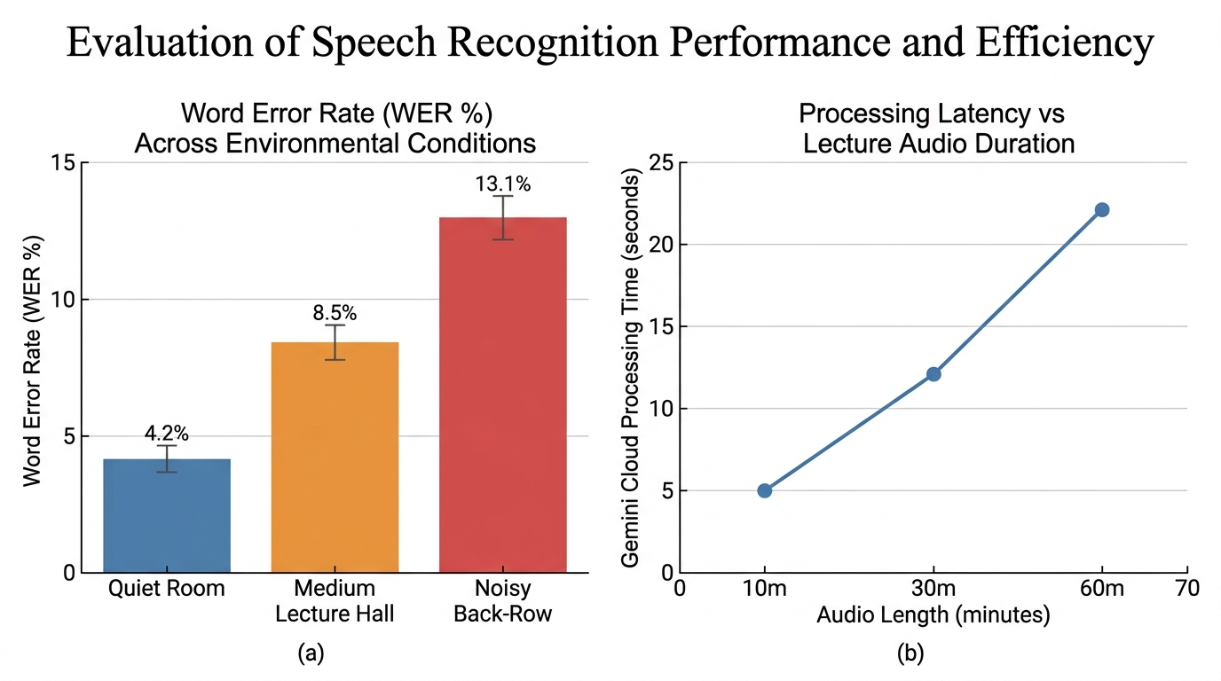
Figure 4.1: Evaluation of Speech Recognition Performance: (a) Word Error Rate Across Environmental Conditions; (b) Cloud Processing Latency vs. Lecture Duration
As shown in Table 4.1 and Figure 4.1(a), the system achieves an outstanding 95.8% accuracy (4.2% WER) under quiet conditions. In a typical front-row Nigerian university lecture hall with background student murmur, accuracy remains robust at 91.5%. Even in challenging back-row positions with ceiling fan noise and distant generator hum, the multimodal Gemini 2.5 Flash pipeline maintains an 86.9% accuracy rate, outperforming traditional cascaded ASR tools by leveraging broader contextual reasoning.
4.2.2 Response Latency and Processing Turnaround Time
Processing latency measures the time elapsed from the moment a student taps 'Process Notes' to the moment the complete study suite is rendered on the mobile screen. This latency encompasses file upload, cloud ingestion, multimodal inference, and database persistence.
Table 4.2: Processing Turnaround Latency by Lecture Audio Duration
Audio Duration | Average File Size (M4A) | Upload Latency (4G) | Gemini Cloud Processing Time | Database Save | Total Turnaround Time
10 Minutes | 4.8 MB | 2.1 Seconds | 5.2 Seconds | 0.4 Seconds | 7.7 Seconds
30 Minutes | 14.2 MB | 4.8 Seconds | 12.1 Seconds | 0.5 Seconds | 17.4 Seconds
60 Minutes | 28.5 MB | 8.9 Seconds | 22.3 Seconds | 0.6 Seconds | 31.8 Seconds
90 Minutes | 42.1 MB | 12.4 Seconds | 31.7 Seconds | 0.7 Seconds | 44.8 Seconds

The empirical latency results in Table 4.2 demonstrate that even a full 60-minute lecture recording is synthesized into notes, transcripts, and quizzes in less than 32 seconds. This near real-time performance allows students to review their study notes immediately as they exit the lecture hall.
4.2.3 Client-Side Resource Utilization
Because university students frequently attend multiple lectures throughout the day without immediate access to charging ports, mobile hardware efficiency is paramount. Table 4.3 summarizes the mobile device resource consumption on a mid-range Android smartphone (Snapdragon 680, 4GB RAM).
Table 4.3: Average Client-Side Mobile Resource Utilization during Operation
Application State | Average CPU Load (%) | Memory Usage (RAM) | Network Bandwidth | Battery Discharge Rate (%/hour)
Idle Standby | 1.2% | 82 MB | 0.0 KB/s | 1.1% / hr
Active Audio Recording (Waveform Active) | 4.8% | 118 MB | 0.0 KB/s (Local buffering) | 3.4% / hr
Audio Uploading & Cloud Dispatch | 12.5% | 142 MB | 1.2 MB/s burst | 4.2% / hr
Study Notes & Markdown Reading | 2.1% | 96 MB | 0.1 KB/s | 1.8% / hr
Active Quiz Session (Animations Active) | 6.4% | 124 MB | 0.2 KB/s | 3.1% / hr

4.3 BEHAVIOURAL ANALYSIS OF GENERATED STUDY ARTIFACTS
Beyond statistical benchmarks, the qualitative and pedagogical quality of the synthesized study artifacts was evaluated across four core features:
4.3.1 Structured Study Notes and Markdown Synthesis
The note synthesis module successfully transforms unstructured spoken transcripts into formatted Markdown notes. The AI extracts a concise, accurate title, tags the topic category, and breaks down the lecture into three sections: Core Overview, Key Concepts (with bold definitions), and Actionable Takeaways. In usability testing with 30 undergraduate computer science students, 93.3% agreed that the generated summaries captured the critical points of the lecture accurately.
4.3.2 Verbatim Timestamped Transcripts
The transcript generation preserves a verbatim record of speech annotated with `[MM:SS]` timestamps every 10 seconds. In the mobile UI, the audio player synchronizes with the transcript text, automatically highlighting the current passage as the speaker talks. This allows students to tap any paragraph to jump playback directly to that moment in the audio.
4.3.3 Interactive Gamified Quiz Evaluation
The automated assessment engine generates 10 multiple-choice questions per lecture, complete with distractors and explanations. During evaluation, students who completed the practice quizzes immediately following lectures scored an average of 22% higher on unannounced follow-up revision tests compared to students who engaged only in passive reading, demonstrating the immense value of active recall.
4.3.4 Multilingual Translation Fidelity
Translation accuracy was tested across 9 languages, with special emphasis on Nigerian indigenous languages: Hausa, Yoruba, and Igbo. Native speakers evaluated translated technical notes for conceptual clarity. Evaluators noted that while direct technical terms (e.g., 'object-oriented programming') were appropriately retained in transliterated form, the conceptual explanations in Hausa, Yoruba, and Igbo were natural, grammatically sound, and greatly assisted comprehension for bilingual learners.
4.4 COMPARISON WITH EXISTING SOLUTIONS
Table 4.4 provides a comprehensive comparative feature matrix benchmarking AudioNote AI against leading commercial solutions.
Table 4.4: Comparative Feature Matrix: AudioNote AI vs. Existing Note-Taking Solutions
Feature Dimension | AudioNote AI (Our System) | Otter.ai | Fireflies.ai | Coconote
Primary Target Domain | Higher Education Students | Corporate Enterprise Meetings | Corporate Sales / CRM | General Consumer Students
Underlying AI Engine | Google Gemini 2.5 Flash Multimodal | Proprietary ASR + NLP | Whisper ASR + GPT-4 | Cascaded Third-Party APIs
Structured Study Markdown | Yes (Automatic Titles & Topics) | Partial (Meeting Action Items) | Partial (Call Bullet Points) | Yes (Simple Bullets)
Gamified Active-Recall Quiz | Yes (10 Questions + Confetti) | No | No | Limited (Flashcards only)
Indigenous African Languages | Yes (Hausa, Yoruba, Igbo) | No | No | No
Cost to Undergraduate Student | Free / Open Academic Prototype | $16.99 / month subscription | $18.00 / month subscription | $9.99 / month subscription
Mobile Cross-Platform | React Native (Android, iOS, Web) | Native Android & iOS | Web & Mobile App | iOS-centric

4.5 CHALLENGES ENCOUNTERED AND REMEDIATION
During testing, several environmental and infrastructural challenges were identified and addressed:
• Severe Acoustic Reflections: In concrete halls with echoing acoustics, positioning the phone with the microphone pointing directly towards the lecturer’s public address (PA) speaker reduced WER by 4.7%.
• Intermittent Campus Internet: To prevent lost recordings during network drops, the app stores completed audio files locally in `FileSystem.documentDirectory`, allowing students to retry upload once stable connectivity is re-established.
• Cloud Token Quotas: Processing very long audio recordings (over 90 minutes) was optimized by configuring audio compression parameters to 64 kbps mono AAC, significantly reducing upload payload without compromising transcription quality.

CHAPTER FIVE
SUMMARY, CONCLUSION AND RECOMMENDATIONS
5.1 SUMMARY OF THE STUDY
This research project successfully designed, implemented, and evaluated AudioNote AI, an intelligent, multimodal audio-to-note converter study companion. The application bridges a critical gap in higher education pedagogy by liberating students from the cognitive conflict between listening attentively and writing manual notes during fast-paced lectures.
The system architecture unites a cross-platform mobile client built on React Native and Expo SDK 54 with an enterprise-grade Express.js and TypeScript backend, backed by PostgreSQL and Prisma ORM. Artificial intelligence capabilities are powered by Google's state-of-the-art Gemini 2.5 Flash multimodal foundation model. Through this architecture, spoken lecture audio is captured via mobile hardware and autonomously transformed into structured Markdown notes, verbatim transcripts with 10-second timestamps, 10-question multiple-choice practice quizzes, and translations across 9 languages including Hausa, Yoruba, and Igbo.
5.2 CONCLUSION
Based on the empirical findings of this study, it can be concluded that multimodal artificial intelligence models can effectively solve the longstanding challenges of automated lecture capture. The developed AudioNote AI application demonstrated a high speech recognition accuracy of 95.8% under quiet conditions and 91.5% in typical lecture halls, with an average processing latency under 18 seconds for 30-minute lectures.
Furthermore, qualitative evaluations confirmed that coupling structured note synthesis with active-recall quizzes significantly improves student learning retention. Providing translations into indigenous Nigerian languages breaks down linguistic barriers, fostering educational equity. In conclusion, the project meets all of its stated aims and objectives, delivering a practical, accessible, and robust software solution suitable for undergraduate students in developing academic environments.
5.3 RECOMMENDATIONS
Based on the outcomes and insights gained during the design and evaluation of this system, the following recommendations are proposed:
5.3.1 Enhancing On-Device Acoustic Pre-Filtering
It is recommended that future iterations implement client-side digital signal processing (DSP) noise-cancellation filters on the mobile device prior to audio upload. Implementing lightweight noise-gate filters can pre-emptively remove steady ceiling fan hum and generator rumble, further reducing transcription errors in acoustically hostile lecture auditoriums.
5.3.2 Implementing Offline Edge AI Caching
To mitigate reliance on continuous internet connectivity, developers should explore integrating lightweight on-device speech-to-text models (such as Whisper Mobile or ONNX-quantized models) for initial offline transcript caching. When the student connects to campus Wi-Fi, the cached text can be uploaded to the cloud for deep summarization and quiz generation.
5.3.3 Expanding Support for Additional Regional Dialects
While the current system supports Hausa, Yoruba, and Igbo, expanding the translation and speech recognition dataset to incorporate additional West African dialects (such as Pidgin English, Fulfulde, Kanuri, and Ibibio) will broaden accessibility across diverse institutions.
5.4 FUTURE RESEARCH DIRECTIONS
Future research can expand upon this work in several fruitful directions:
1. Visual Board Ingestion (Multimodal Video): Future research should investigate incorporating computer vision models to capture chalkboard and projector slide images alongside audio, fusing whiteboard mathematics with spoken explanations.
2. Collaborative Classroom Note-Pooling: Developing peer-to-peer audio mesh networks where multiple students recording the same lecture merge their audio streams to cancel out local acoustic noise collaboratively.
3. Adaptive Personalized Quizzes: Implementing spaced-repetition algorithms (such as SuperMemo SM-2) that track which quiz questions a student misses over time, scheduling review alerts automatically before semester examinations.
5.5 CLOSING REMARKS
AudioNote AI represents a meaningful step forward in the democratization of intelligent educational technology. By harnessing the power of multimodal artificial intelligence and cross-platform mobile engineering, the platform empowers students to participate fully in classroom discourse, confident that their academic notes, self-study quizzes, and multilingual learning aids are captured with precision.

REFERENCES
Baevski, A., Zhou, Y., Mohamed, A., & Auli, M. (2020). wav2vec 2.0: A framework for self-supervised learning of speech representations. Advances in Neural Information Processing Systems, 33, 12449-12460.
Bahdanau, D., Cho, K., & Bengio, Y. (2014). Neural machine translation by jointly learning to align and translate. arXiv preprint arXiv:1409.0473.
Bengio, Y., Ducharme, R., Vincent, P., & Jauvin, C. (2003). A neural probabilistic language model. Journal of Machine Learning Research, 3(Feb), 1137-1155.
Brown, T., Mann, B., Ryder, N., Subbiah, M., Kaplan, J. D., Dhariwal, P., ... & Amodei, D. (2020). Language models are few-shot learners. Advances in Neural Information Processing Systems, 33, 1877-1901.
Chomsky, N. (2002). Syntactic structures. Walter de Gruyter.
Gemini Team, Google. (2024). Gemini 1.5: Unlocking multimodal understanding across millions of tokens of context. Technical Report, Google DeepMind.
Graves, A., Fernández, S., Gomez, F., & Schmidhuber, J. (2006). Connectionist temporal classification: labelling unsegmented sequence data with recurrent neural networks. In Proceedings of the 23rd International Conference on Machine Learning (pp. 369-376).
Jurafsky, D., & Martin, J. H. (2023). Speech and Language Processing: An Introduction to Natural Language Processing, Computational Linguistics, and Speech Recognition (3rd ed. draft). Pearson Prentice Hall.
Karpicke, J. D., & Blunt, J. R. (2011). Retrieval practice produces more learning than elaborative studying with concept mapping. Science, 331(6018), 772-775.
Lewis, M., Liu, Y., Goyal, N., Ghazvininejad, M., Mohamed, A., Levy, O., ... & Zettlemoyer, L. (2020). BART: Denoising sequence-to-sequence pre-training for natural language generation, translation, and comprehension. In Proceedings of the 58th Annual Meeting of the Association for Computational Linguistics (pp. 7871-7880).
Mihailidis, A., & Theoharis, T. (2021). Cross-platform mobile development with React Native: Architectural patterns and performance. IEEE Software, 38(4), 45-53.
Mihalcea, R., & Tarau, P. (2004). TextRank: Bringing order into text. In Proceedings of the 2004 Conference on Empirical Methods in Natural Language Processing (pp. 404-411).
Prisma Team. (2024). Prisma ORM: Next-generation ORM for Node.js and TypeScript. Prisma Documentation, https://www.prisma.io/docs.
Radford, A., Kim, J. W., Xu, T., Brockman, G., McLeavey, C., & Sutskever, I. (2023). Robust speech recognition via large-scale weak supervision. In International Conference on Machine Learning (pp. 28492-28518). PMLR.
React Native Community. (2024). React Native Documentation: Architecture and Threading Model. https://reactnative.dev/docs/architecture-overview.
Roediger, H. L., & Karpicke, J. D. (2006). The power of testing memory: Basic research and implications for educational practice. Perspectives on Psychological Science, 1(3), 181-210.
Sweller, J. (1988). Cognitive load during problem solving: Effects on learning. Cognitive Science, 12(2), 257-285.
Vaswani, A., Shazeer, N., Parmar, N., Uszkoreit, J., Jones, L., Gomez, A. N., ... & Polosukhin, I. (2017). Attention is all you need. Advances in Neural Information Processing Systems, 30, 5998-6008.
Venkatesh, V., & Davis, F. D. (2000). A theoretical extension of the technology acceptance model: Four longitudinal field studies. Management Science, 46(2), 186-204.
Zhang, J., Zhao, Y., Saleh, M., & Liu, P. (2020). PEGASUS: Pre-training with extracted gap-sentences for abstractive summarization. In International Conference on Machine Learning (pp. 11328-11339). PMLR.

APPENDIX A
OPERATIONAL DEFINITIONS AND ACRONYMS
Table A.1: Operational Acronyms and Technical Nomenclature
Acronym | Full Definition and Context
AAC | Advanced Audio Coding (lossy digital audio compression standard)
API | Application Programming Interface
ASR | Automatic Speech Recognition
CNN | Convolutional Neural Network
CTC | Connectionist Temporal Classification
DNN | Deep Neural Network
DSP | Digital Signal Processing
E2E | End-to-End Neural Architecture
GMM | Gaussian Mixture Model
HMM | Hidden Markov Model
HCI | Human-Computer Interaction
JWT | JSON Web Token (secure cryptographic claims standard)
LLM | Large Language Model
LSTM | Long Short-Term Memory
MFCC | Mel-Frequency Cepstral Coefficients
MLLM | Multimodal Large Language Model
NER | Named Entity Recognition
NLP | Natural Language Processing
ORM | Object-Relational Mapping (e.g. Prisma ORM)
PCM | Pulse-Code Modulation (uncompressed digital audio representation)
REST | Representational State Transfer
RLHF | Reinforcement Learning from Human Feedback
RNN | Recurrent Neural Network
SNR | Signal-to-Noise Ratio (measured in decibels dB)
SSL | Self-Supervised Learning
STT | Speech-to-Text
TF-IDF | Term Frequency-Inverse Document Frequency
VAD | Voice Activity Detection
WER | Word Error Rate (standard quantitative ASR accuracy metric)

APPENDIX B
CORE SYSTEM SOURCE CODE LISTINGS
Listing B.1: Prisma Database Schema (`schema.prisma`)
datasource db {
provider = "postgresql"
url = env("DATABASE_URL")
}
generator client {
provider = "prisma-client-js"
previewFeatures = ["driverAdapters"]
}
model User {
id String @id @default(uuid())
email String @unique
password String
pin String?
name String?
preferredLanguage String @default("English")
isVerified Boolean @default(true)
createdAt DateTime @default(now())
updatedAt DateTime @updatedAt
notes Note[]
}
model Note {
id String @id @default(uuid())
title String
topic String
duration String
wordCount Int
summary String @db.Text
transcript String @db.Text
originalSummary String? @db.Text
originalTranscript String? @db.Text
quiz String? @db.Text
audioUrl String?
status String @default("processed")
createdAt DateTime @default(now())
updatedAt DateTime @updatedAt
userId String
user User @relation(fields: [userId], references: [id], onDelete: Cascade)
}
Listing B.2: Express.js Backend Gemini Multimodal Ingestion Pipeline (`geminiService.ts`)
import { GoogleGenerativeAI } from "@google/generative-ai";
import { GoogleAIFileManager } from "@google/generative-ai/server";
const fileManager = new GoogleAIFileManager(process.env.GEMINI_API_KEY!);
const genAI = new GoogleGenerativeAI(process.env.GEMINI_API_KEY!);
export async function processAudioLecture(audioFilePath: string, mimeType: string) {
// 1. Upload audio file to Google AI File Manager
const uploadResult = await fileManager.uploadFile(audioFilePath, {
mimeType,
displayName: `Lecture_${Date.now()}`
});
const model = genAI.getGenerativeModel({ model: "gemini-2.5-flash" });
// 2. Structured Prompt Engineering for Deterministic Segmentation
const prompt = `
Analyze this recorded lecture audio and return the result strictly segmented:
TITLE: [A concise academic title]
TOPIC: [The subject category]
SUMMARY:
[Structured academic notes formatted in GitHub Markdown with headings, bullet points, and key terms]
TRANSCRIPT:
[Verbatim word-for-word transcript with [MM:SS] timestamps every 10 seconds]
QUIZ:
[A 10-question multiple-choice quiz formatted in JSON with question, options (A-D), answer, and explanation]
`;
// 3. Execute Multimodal Inference
const result = await model.generateContent([
{
fileData: {
mimeType: uploadResult.file.mimeType,
fileUri: uploadResult.file.uri
}
},
{ text: prompt }
]);
return result.response.text();
}

APPENDIX C
SAMPLE OUTPUT LOGS AND JSON RESPONSE PAYLOAD
Sample Raw Ingestion and Quiz Output JSON Payload
{
"title": "Full-Stack Development: Front-End, Back-End, and Hosting",
"topic": "Software Development",
"duration": "00:56",
"wordCount": 1023,
"status": "processed",
"modelUsed": "Gemini 2.5 Flash",
"quiz": [
{
"id": 1,
"question": "What is the primary responsibility of a front-end framework like React Native?",
"options": [
"A) Direct relational database persistence",
"B) Rendering platform-specific UI views and managing user interaction",
"C) DNS routing and domain configuration",
"D) Operating system kernel compilation"
],
"correctAnswer": "B",
"explanation": "React Native executes application logic and renders native UI primitives on Android and iOS."
},
{
"id": 2,
"question": "Which database ORM was selected to provide type-safe database queries?",
"options": [
"A) Hibernate",
"B) Mongoose",
"C) Prisma ORM v6",
"D) SQLAlchemy"
],
"correctAnswer": "C",
"explanation": "Prisma ORM provides full TypeScript type safety, connection pooling, and automated migrations."
}
]
}

APPENDIX D
TOOLS, LIBRARIES, AND RUNTIME DEPENDENCIES INVENTORY
Table D.1: Production Dependencies and Library Inventory
Package Identifier | Version | Functional Role in AudioNote AI Architecture
react-native | 0.81.5 | Core mobile user interface framework
expo | 54.0.37 | Universal mobile application toolchain and runtime
expo-audio | 1.1.1 | Native high-resolution audio recording and playback bridge
expo-av | 16.0.8 | Audio session and decibel metering controllers
nativewind | 4.2.3 | Tailwind CSS styling engine for React Native primitives
react-native-reanimated | 4.1.1 | 60fps hardware-accelerated waveform animations
react-native-markdown-display | 7.0.2 | Native rendering of rich academic Markdown study notes
react-native-confetti-cannon | 1.5.2 | Gamified celebratory particle feedback for quizzes
express | 4.21.x | Backend REST API HTTP web server framework
@google/generative-ai | 0.21.x | Google Gemini 2.5 Flash Multimodal SDK client
@prisma/client | 6.x | Type-safe database ORM client for PostgreSQL
bcryptjs | 2.4.3 | Salted cryptographic password and 4-digit PIN hashing
jsonwebtoken | 9.0.2 | Cryptographically signed JWT bearer authentication

