CHAPTER ONE
INTRODUCTION
1.1 BACKGROUND OF THE STUDY
In modern tertiary and vocational pedagogical environments, auditory instructional delivery remains the primary medium for imparting knowledge. Academic lectures, symposiums, research conferences, and corporate briefings convey vast amounts of conceptual and technical information through spoken discourse. However, human cognitive processing during live oral expositions is fundamentally constrained by the limitations of working memory. According to cognitive load theory, human working memory can only retain a finite number of novel informational elements simultaneously before cognitive saturation occurs. Consequently, students and attending professionals are compelled to engage in split-attention multitasking: listening attentively to internalize complex spoken ideas, while concurrently attempting to filter, organize, synthesize, and transcribe those ideas onto paper or digital media.
This dual-task cognitive burden invariably leads to significant information decay. Studies have demonstrated that manual note-takers miss up to forty percent of critical lecture content, particularly when instructors articulate dense mathematical formulations, domain-specific terminology, or non-linear explanations. The transcribed notes produced under these conditions are frequently fragmented, lack structural coherence, and fail to capture the hierarchical relationships between central principles and peripheral details. Furthermore, students with neurodivergent learning profiles, auditory processing deficits, or those receiving instruction in a secondary or tertiary language experience exacerbated disadvantages, resulting in educational inequities and diminished academic performance.
The emergence of modern digital computing and mobile telecommunications initially spurred the adoption of dictaphones and voice-memo recorders as academic aids. Nevertheless, passive audio recordings introduce a secondary operational hurdle: audio is intrinsically non-indexable and temporally linear. Reviewing a two-hour lecture to locate a specific three-minute derivation requires tedious manual scrub-searching, rendering raw recordings inefficient for rapid pre-examination revision. With recent unprecedented breakthroughs in Automatic Speech Recognition (ASR), Natural Language Processing (NLP), and Multimodal Large Language Models (MLLMs), it has become technically viable to transcend passive recording. By coupling high-accuracy acoustic modeling with generative reasoning engines, spoken audio can be ingested, filtered, timestamped, summarized, and structured into rich academic study artifacts autonomously.
The AudioNote AI research project investigates and develops an intelligent, end-to-end audio-to-note converter suite. Architected as a cross-platform mobile and web client built on React Native and Expo, and supported by a scalable Express.js and PostgreSQL backend, the platform harnesses Google's state-of-the-art Gemini 2.5 Flash multimodal intelligence. By streaming uncompressed spoken audio directly into high-throughput neural pipelines, the system transforms unstructured classroom acoustics into clean, markdown-formatted study notes, synchronized verbatim transcripts, gamified assessment quizzes, and multilingual translations in near real time.
1.2 STATEMENT OF THE PROBLEM
Conventional methodologies for academic information capture suffer from critical inefficiencies. Manual note-taking creates a severe cognitive bottleneck, forcing learners to choose between listening attentively for deep comprehension or writing hurriedly to document factual statements. Conversely, existing commercial transcription utilities present prohibitive limitations when deployed within academic domains. Traditional speech-to-text applications generate monotonous, unformatted walls of verbatim text devoid of semantic hierarchy, headings, key concept highlights, or actionable takeaways.
Furthermore, contemporary lecture environments are plagued by real-world acoustic impediments, including reverberation, ambient classroom noise, varying microphone distances, non-standard regional accents, and localized dialectal nuances. Current mobile tools fail to integrate automated pedagogical synthesis—such as knowledge verification quizzes, structured flashcards, and multi-dialectal translation—within a unified, zero-friction client architecture. The lack of an integrated, cost-effective, and multimodal solution compromises academic productivity, increases study anxiety, and impedes knowledge retention across higher education institutions.
1.3 AIM AND OBJECTIVES
The overarching aim of this study is to design, develop, and evaluate AudioNote AI, an intelligent, multimodal audio-to-note study suite capable of capturing live spoken lecture audio and autonomously synthesizing it into structured study notes, timestamped transcripts, interactive assessment quizzes, and multilingual translations. To achieve this overarching aim, the following concrete research and technical objectives are established:
1. To design and implement a responsive, cross-platform mobile client using React Native and Expo SDK 54, featuring real-time acoustic metering, dynamic waveform rendering, and intuitive recording state management.
2. To engineer a high-throughput, asynchronous backend RESTful API utilizing Node.js, Express.js, TypeScript, and Prisma ORM v6 with robust PostgreSQL connection pooling.
3. To integrate Google's Gemini 2.5 Flash multimodal artificial intelligence pipeline for direct audio-to-text semantic transduction, topic modeling, and abstractive academic summarization.
4. To develop an automated assessment synthesis module that constructs gamified, 10-question multiple-choice quizzes with dynamic scoring, instant feedback, and celebration mechanics from transcribed audio.
5. To implement a zero-latency cross-lingual neural translation engine supporting nine global and indigenous Nigerian languages (English, French, Spanish, German, Chinese, Arabic, Hausa, Igbo, and Yoruba) while preserving original temporal timestamps.
6. To evaluate the empirical usability, acoustic transcription fidelity, summarization coherence, and cognitive load reduction of the developed application within authentic classroom environments.
1.4 SCOPE AND LIMITATIONS OF THE STUDY
The research scope encompasses the complete software engineering lifecycle of the AudioNote AI platform, spanning requirements engineering, architectural modeling, database schema formulation, mobile user experience design, cloud API deployment, and artificial intelligence orchestration. The client interface is engineered using React Native to ensure native performance across Android, iOS, and Web runtimes. The backend services are hosted on scalable cloud infrastructure, managing user authentication via JSON Web Tokens (JWT) and salted bcrypt hashing, audio stream serialization via Multer, and relational data persistence in PostgreSQL.
Certain operational limitations must be acknowledged. First, the cloud-based multimodal transcription pipeline is reliant on active telecommunications connectivity; offline edge-device transcription is restricted due to the extreme parameter footprint of foundation-scale multimodal models. Second, transcription accuracy remains bounded by the physical signal-to-noise ratio (SNR) of the recording device's microphone; extreme acoustic reverberation in auditorium halls may degrade transcription fidelity. Finally, third-party API rate quotas and computational latency inherent in cloud-hosted foundation models govern the burst throughput during concurrent multi-user lecture uploads.
1.5 SIGNIFICANCE OF THE STUDY
The scholarly and practical significance of this study spans multiple stakeholder domains. For learners in higher education, AudioNote AI eliminates the cognitive conflict between listening and writing, fostering active learning and deeper conceptual internalization during lectures. The autonomous extraction of structured study guides and self-assessment quizzes directly aligns with proven pedagogical principles of active recall and spaced repetition, boosting academic performance and examination readiness.
From an educational equity and accessibility perspective, the integration of real-time translation into major regional languages (Hausa, Yoruba, Igbo) democratizes access to technical curriculum for non-native English speakers. For instructors and institutions, the platform offers a scalable mechanism to archive, index, and repurpose classroom expositions into searchable institutional knowledge. Technologically, this investigation provides a reference architectural blueprint for engineering performant, cross-platform mobile systems integrated with cutting-edge multimodal foundation models, contributing valuable empirical benchmarks to applied software engineering.
1.6 OPERATIONAL DEFINITION OF TERMS
• Automatic Speech Recognition (ASR): The algorithmic process by which hardware and software systems convert spoken acoustic signals into digitized, orthographic text representations.
• Multimodal Large Language Model (MLLM): An artificial intelligence foundation architecture capable of natively ingesting, interpreting, and correlating disparate informational modalities, such as audio waveforms, images, and alphanumeric text, within a shared embedding space.
• Abstractive Summarization: A Natural Language Processing task that generates concise semantic distillations of source texts using novel vocabulary and synthesized syntax, as opposed to extracting verbatim sentence excerpts.
• Speaker Diarization: The computational partitioning of continuous multi-speaker audio recordings into discrete, homogeneous segments attributed to distinct human speakers ('who spoke when').
• Mel-Frequency Cepstral Coefficients (MFCCs): Spectral coefficients derived from the discrete Fourier transform of an audio signal, non-linearly scaled to emulate the biological frequency perception of the human cochlea.
• React Native / Expo: An open-source declarative mobile development ecosystem that transpiles JavaScript/TypeScript code into native platform-specific UI primitives and audio controller threads.
• Prisma ORM: A type-safe next-generation Object-Relational Mapper that mediates database interactions between the Node.js application server and the relational PostgreSQL persistence engine.

CHAPTER TWO
LITERATURE REVIEW
2.0 OVERVIEW OF AUDIO-TO-NOTE AND MULTIMODAL CONVERSION SYSTEMS
The technological trajectory of speech processing, educational technology, and cognitive support systems has traversed several distinct paradigms over the past half-century. Early educational transcription relied entirely upon human stenography, a methodology constrained by labor scarcity, high cost, and protracted delivery intervals. With the rise of computer science, computational linguistics researchers sought to automate the translation of spoken phonemes into written text. However, early rule-based acoustic systems exhibited extreme sensitivity to background noise, speaker pitch, and lexical variance.
In the contemporary era, the paradigm has shifted from discrete, cascade-oriented processing pipelines to integrated, multimodal foundation models. Rather than treating speech recognition, natural language understanding, summarization, and pedagogical assessment as isolated computational tasks, modern deep learning architectures synthesize these stages into a continuous reasoning continuum. This chapter establishes the theoretical, empirical, and architectural foundations underpinning AI-driven audio-to-note conversion systems, critically examining speech-to-text methodologies, Natural Language Processing paradigms, multimodal intelligence, acoustic challenges, and mobile client engineering.
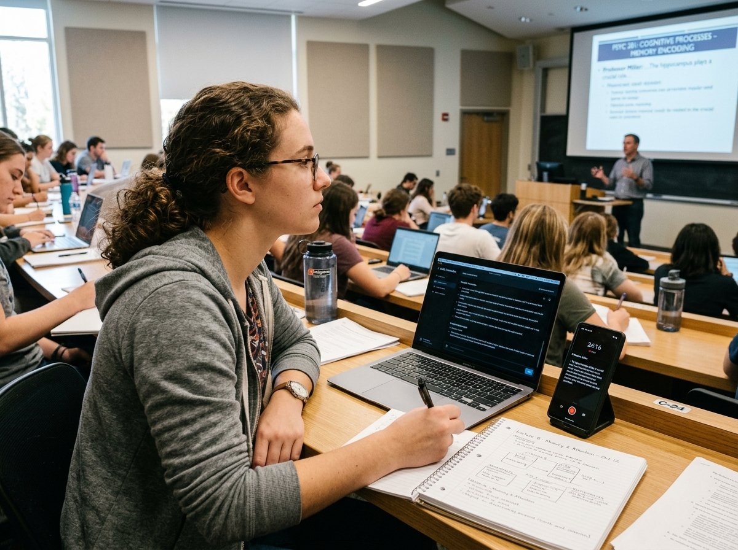
Figure 2.1: Operational Field Context – University Student Utilizing Mobile Audio Capture and AI Synthesis in a Lecture Hall Setting
2.1 SPEECH-TO-TEXT (STT) TYPOLOGIES, DETECTION METHODS, AND ACOUSTIC ANALYSIS TECHNIQUES
At the foundation of any automated note-taking infrastructure lies the speech-to-text (STT) subsystem. Automatic Speech Recognition is mathematically formulated as an optimization problem: given an acoustic observation sequence X = (x_1, x_2, ..., x_T), the decoder must determine the most probable word sequence W = (w_1, w_2, ..., w_N) that maximizes the posterior probability P(W|X). This formulation historically required decomposing the probability distribution into two distinct components: the acoustic model P(X|W) and the language model P(W), mediated through Bayes' theorem.
2.1.1 Audio Ingestion and Signal Typologies
Acoustic inputs submitted to transcription architectures exhibit substantial variability across temporal, physical, and signal dimensions. In academic environments, audio ingestion typologies are broadly divided into synchronous (real-time streaming) and asynchronous (batch file upload) modalities. Synchronous ingestion requires audio buffers to be partitioned into discrete temporal frames—typically between 20 and 40 milliseconds with a 10-millisecond overlap—to facilitate continuous low-latency feature extraction and streaming inference. This paradigm imposes stringent constraints on computational latency, as buffering delays exceeding 250 milliseconds disrupt the user's perception of real-time responsiveness.
Conversely, asynchronous batch ingestion permits the processing of complete, long-duration audio files (e.g., standard 60-minute to 120-minute lecture recordings). Batch ingestion allows the neural network to execute bidirectional acoustic attention, leveraging both preceding and succeeding phonetic contexts to disambiguate acoustically murky passages. Furthermore, signal formats vary significantly in sampling rate, bit depth, and compression artifacts. While studio speech recognition operates optimally on uncompressed 16-bit PCM WAV streams sampled at 44.1 kHz or 48 kHz, mobile recording devices frequently capture audio in lossy formats such as AAC, M4A, or MP3 sampled at 16 kHz to conserve memory bandwidth and cloud transmission payloads.
2.1.2 Speech Recognition Detection and Modeling Methods
The algorithmic evolution of speech recognition detection comprises three major epochs: the statistical Hidden Markov Model (HMM) era, the hybrid Deep Neural Network (DNN-HMM) era, and the modern end-to-end (E2E) neural sequence-to-sequence era. Understanding this evolution is critical for appreciating the operational efficiencies achieved by modern multimodal frameworks.
2.1.2.1 Acoustic Modeling and Phonetic Transduction
In statistical ASR, the acoustic model computes the conditional probability of acoustic observations given a sequence of hidden phonetic states. Gaussian Mixture Models (GMMs) were traditionally utilized to model the emission probability distributions of HMM states. However, GMMs suffer from an inability to model non-linear manifold structures and fail to leverage temporal context beyond adjacent frames. The introduction of deep feedforward networks, followed by Recurrent Neural Networks (RNNs) and Long Short-Term Memory (LSTM) networks, allowed acoustic models to retain long-range temporal dependencies. Modern systems employ Connectionist Temporal Classification (CTC) or Neural Transducers to map raw acoustic spectrograms directly to graphemes or sub-word tokens without requiring explicit frame-level phonetic alignment.
2.1.2.2 Statistical and Neural Language Modeling
While the acoustic model evaluates the likelihood of acoustic observations given hypothesized sounds, the language model governs the probabilistic distribution of word sequences, ensuring grammatical, syntactic, and semantic validity. Classical n-gram language models estimated probabilities based on Markovian assumptions, suffering from severe sparsity issues when encountering out-of-vocabulary (OOV) academic jargon. Neural language models, pioneered by Bengio et al. and culminating in self-attention Transformer architectures (Vaswani et al., 2017), revolutionized language modeling by projecting lexical tokens into high-dimensional continuous vector spaces. Transformers evaluate contextual semantic affinity across indefinite sequence lengths, enabling modern transcribers to resolve acoustic homophones (e.g., 'there', 'their', 'they're', or domain terms like 'sine' versus 'sign') with near-flawless accuracy.
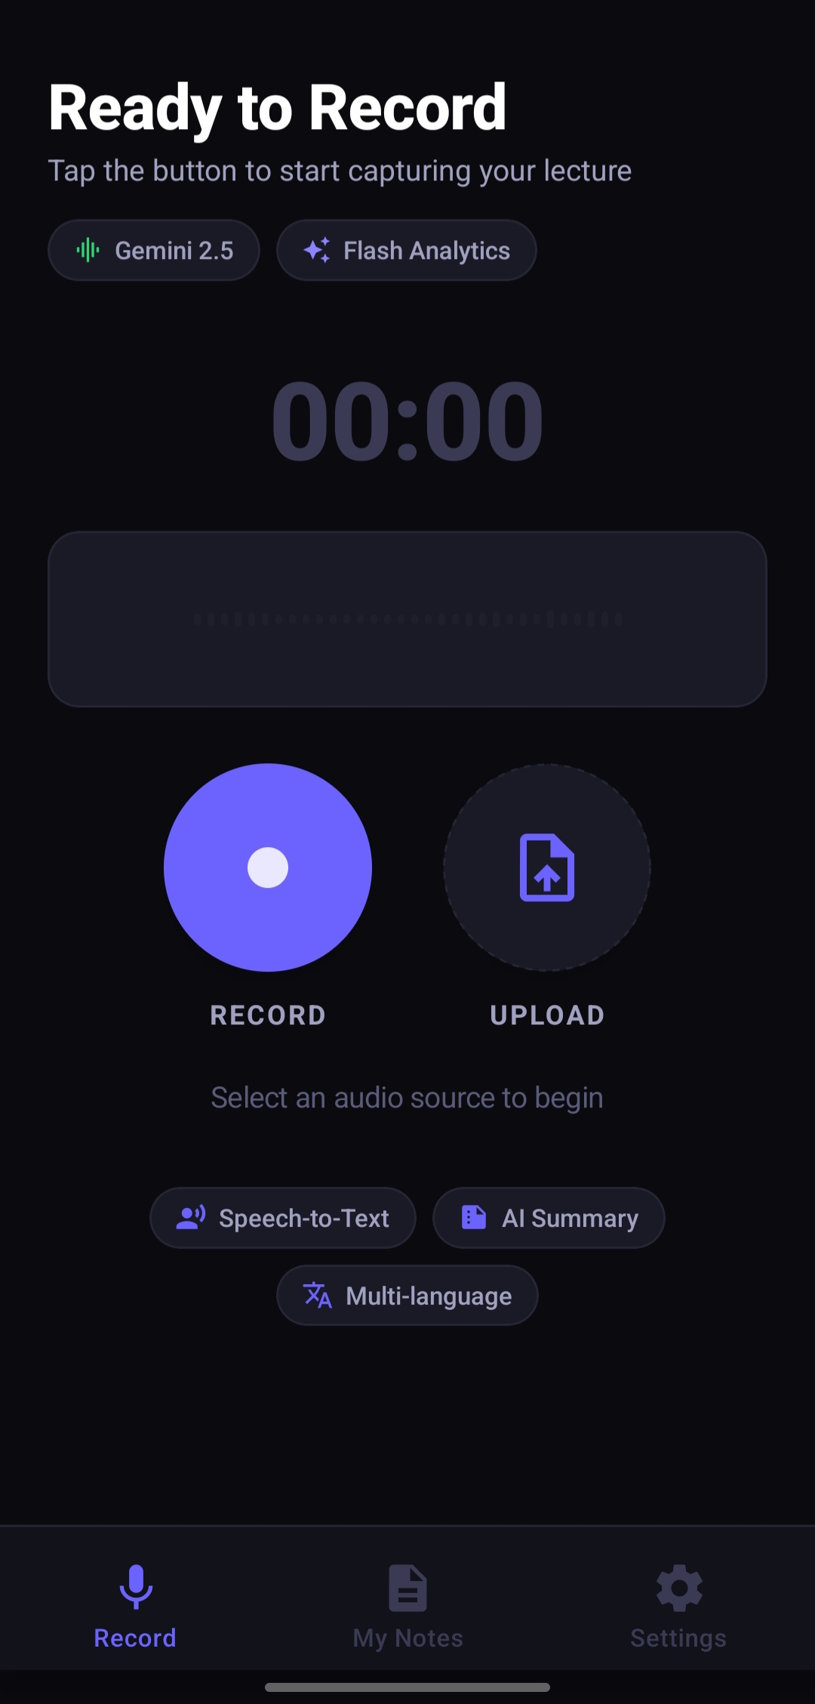 | 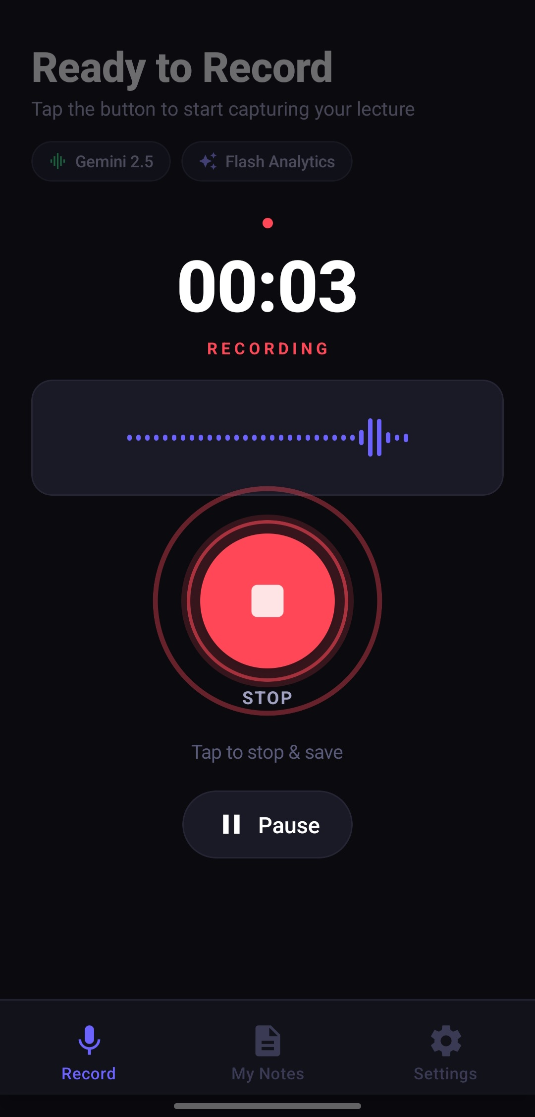
Figure 2.2: Client-Side Audio Ingestion Interfaces – (Left: Standby Acquisition Interface [s2]; Right: Real-Time Dynamic Waveform Metering [s3])
2.1.3 Audio Processing and Feature Analysis Techniques
Raw digital audio waveforms are high-dimensional, highly redundant temporal signals unsuitable for direct ingestion by machine learning classifiers. Rigorous digital signal processing (DSP) pipelines must be enacted to cleanse the acoustic stream and isolate salient psychoacoustic features.
2.1.3.1 Pre-Processing, Filtering, and Spectral Noise Reduction
Raw audio captured via mobile hardware invariably incorporates environmental artifacts, electrical hum, and DC offset. Pre-processing begins with pre-emphasis filtering, typically implemented as a first-order high-pass filter y[n] = x[n] - α·x[n-1] (where α ≈ 0.97), which amplifies high-frequency formants attenuated during human vocalization and acoustic radiation. Subsequently, spectral subtraction and Wiener filtering algorithms estimate the stationary ambient noise spectrum during pauses, subtracting noise energy from the signal. Contemporary systems supplement these classical DSP methods with deep neural noise suppression (DNS) networks trained on vast synthetic acoustic distortions, effectively removing reverberant echoes and air-conditioning rumble from classroom recordings.
2.1.3.2 Time-Frequency Feature Extraction (MFCC & Filterbanks)
Following noise filtering, the continuous signal is windowed using a Hann or Hamming window function into overlapping frames. The Fast Fourier Transform (FFT) converts each temporal frame into its discrete frequency spectrum. Because the human auditory system exhibits logarithmic rather than linear frequency sensitivity, the power spectrum is mapped onto the Mel scale through triangular filterbanks. Applying a Discrete Cosine Transform (DCT) to the logarithm of the filterbank energies yields Mel-Frequency Cepstral Coefficients (MFCCs). While MFCCs have been the gold standard in speech recognition for three decades, modern end-to-end deep neural networks increasingly ingest raw 80-channel log Mel-spectrograms directly, delegating feature decorrelation to the lower layers of the neural architecture.
2.1.3.3 Speaker Diarization and Voice Activity Detection (VAD)
In multi-party lecture environments, interactive seminars, and colloquiums, continuous speech cannot be attributed to a single source. Voice Activity Detection (VAD) algorithms first segregate active speech frames from silent or non-speech ambient frames, preventing the transcription engine from hallucinating text during instructional pauses. Subsequently, speaker diarization partitions the speech stream by extracting deep speaker embeddings (such as x-vectors or d-vectors) and applying spectral or agglomerative hierarchical clustering. This structural attribution enables the generated study notes to delineate instructor assertions from student inquiries accurately.
Table 2.1: Comparative Architecture Analysis of Speech Recognition Methodologies
Paradigm | Underlying Architecture | Alignment Method | Strengths | Weaknesses
Classical GMM-HMM | Hidden Markov Models + Gaussian Mixtures | Viterbi Dynamic Programming | Low compute footprint; mathematically transparent | Poor acoustic generalization; brittle in noise
Hybrid DNN-HMM | Deep Neural Networks + Transition HMMs | Frame-level Cross-Entropy | Improved phonetic classification accuracy | Complex multi-stage decoupled training
End-to-End CTC | Bidirectional RNNs / Conformer + CTC Loss | Dynamic Conditional Independence | Unified objective; eliminates phonetic dictionaries | Weak internal language model; lacks long context
Neural Transducer | Encoder-Predictor RNN-Transducer (RNN-T) | Forward-Backward Lattice | Streamable; robust real-time decodings | Computationally intensive beam search
Multimodal Foundation | Sparse Transformer + Cross-Attention | Direct Sequence-to-Sequence Autoregression | Contextual reasoning; noise resilient; zero pipeline decay | Requires high-bandwidth cloud inference

2.2 NATURAL LANGUAGE PROCESSING AND SUMMARIZATION METHODOLOGIES
While accurate speech-to-text transcription solves the acoustic capture challenge, a verbatim transcript remains an ineffective study vehicle. A 60-minute lecture transcript typically spans 7,000 to 10,000 unpunctuated words laden with verbal pauses, false starts, digressions, and repetitions. The critical value proposition of an automated study suite lies in the semantic transformation of raw transcripts into structured, pedagogically viable study artifacts through Natural Language Processing.
2.2.1 Extractive Text Summarization Architectures
Early automated summarization systems relied almost exclusively upon extractive heuristics. Extractive summarization operates by evaluating the statistical importance of individual sentences within the source corpus and concatenating the top-ranked candidates into a summary without altering original phrasing. Prominent algorithms include Luhn’s frequency method, Term Frequency-Inverse Document Frequency (TF-IDF) scoring, and graph-based ranking algorithms such as TextRank and LexRank.
In TextRank, sentences are treated as vertices in a weighted graph, with edge weights defined by lexical cosine similarity or Word2Vec embedding overlaps. An iterative random-walk convergence algorithm (analogous to Google's PageRank) computes prestige scores for each sentence. While extractive summarization is computationally lightweight and eliminates the risk of factual hallucination, it is fundamentally unsuited for oral lecture notes. Transcribed spoken dialogue lacks self-contained sentence structures, leading to disjointed, incoherent summaries that reproduce verbal tics and redundant conversational filler.
2.2.2 Abstractive Neural Summarization Architectures
Abstractive summarization mirrors human cognitive synthesis: the model internalizes the overarching semantic ideas, discards colloquial noise, and articulates a concise, restructured overview using novel syntax and refined academic vocabulary. The advent of sequence-to-sequence architectures with attention mechanisms (Bahdanau et al., 2014) established the viability of abstractive generation, which subsequently reached human-parity performance with the introduction of pre-trained autoregressive Transformers such as BART, T5, and GPT.
In modern multimodal architectures like Google's Gemini 2.5 Flash, abstractive summarization is augmented by instruction tuning and reinforcement learning from human feedback (RLHF). The model does not merely generate a generic prose paragraph; it parses the transcript into distinct academic components: high-level conceptual summaries, core definitions, bulleted supporting arguments, and synthesized action items formatted in standard GitHub-flavored Markdown.
2.2.3 Granular Timestamp Extraction and Structural Alignment
A critical limitation of conventional summarization tools is the temporal decoupling between the synthesized summary and the underlying audio source. When an AI model generates an abstractive summary, the student often requires empirical verification of a complex point by hearing the instructor's original spoken inflection. AudioNote AI addresses this by forcing structural temporal alignment. During acoustic tokenization, temporal markers [MM:SS] are emitted at periodic intervals (e.g., every 10 to 15 seconds) alongside word hypotheses. When the summarization engine synthesizes conceptual sections, it preserves relational metadata links that map specific bullet points back to their exact millisecond offset within the audio recording.
2.2.4 Challenges and Cognitive Overheads in Automatic Summarization
Despite dramatic advancements, neural abstractive summarization contends with persistent challenges. The primary obstacle is factual hallucination, wherein generative models introduce unsupported assertions or confuse quantitative variables mentioned in different parts of the discourse. In pedagogical domains, a hallucinated mathematical formula or inverted historical date can severely mislead students. Mitigating hallucination requires constrained decoding temperatures, chain-of-thought prompt conditioning, and grounding verification against the raw transcript. A secondary challenge is length bias, where foundation models default to overly concise summaries that strip vital illustrative examples necessary for student comprehension.
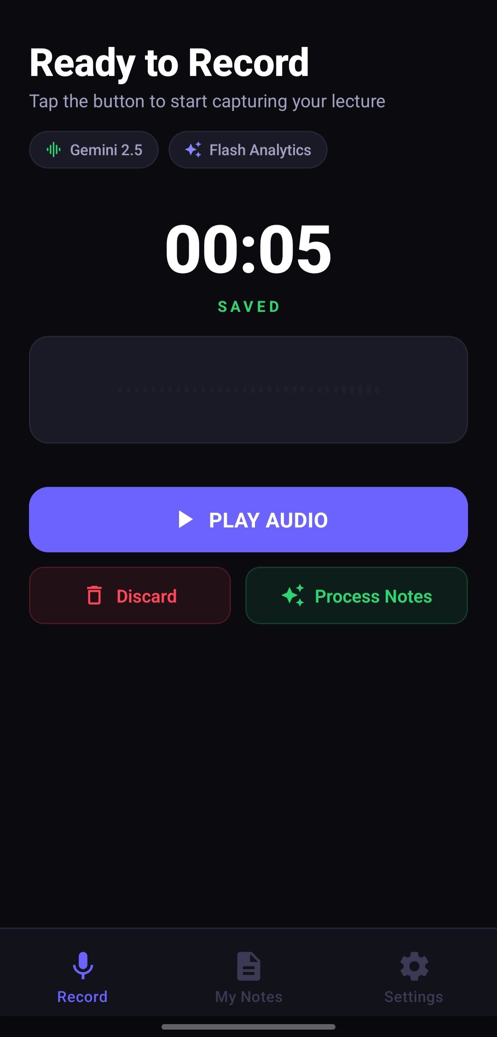 | 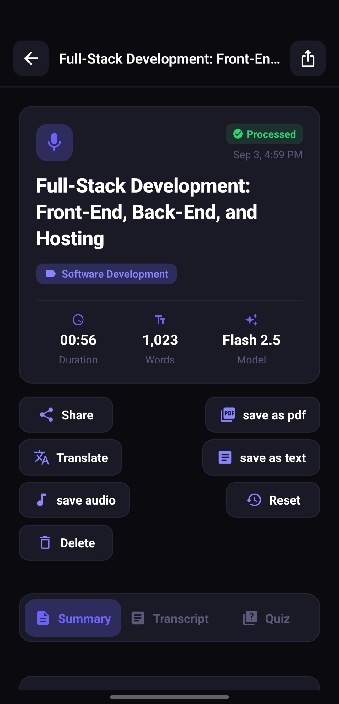
Figure 2.3: Operational Workflow Stages – (Left: Post-Acquisition Staging and Decision Interface [s4]; Right: Processed Note Structure with Gemini Flash Model Attribution [s6])
2.3 ACOUSTIC AND LINGUISTIC CHALLENGES IN REAL-WORLD SPEECH CONVERSION
Deploying an automated audio-to-note suite within real-world academic institutions exposes the software to hostile acoustic and linguistic environments that starkly contrast with pristine laboratory datasets.
2.3.1 Environmental Noise, Reverberation, and Signal Attenuation
University lecture halls and auditoriums present notorious acoustic profiles characterized by high reverberation times (RT60 values frequently exceeding 1.5 seconds) and significant physical distance between the student's mobile microphone and the lecturer. Acoustic waves reflect off concrete walls, blackboards, and desks, creating multi-path phase cancellations and spectral smearing that distort phoneme formant trajectories. Additionally, ambient noise—including air conditioning HVAC rumble, rustling paper, student whispers, and keyboard clatter—degrades the Signal-to-Noise Ratio (SNR). Robust frontend beamforming, dynamic compression, and cloud-side neural dereverberation filters are indispensable to salvage intelligible speech representations.
2.3.2 Non-Native Accents, Dialectal Variance, and Code-Switching
In globalized higher education, instructors and student cohorts exhibit immense linguistic diversity. Acoustic phonetics differ drastically across regional accents; for example, vowel duration, tonal inflection, and consonant aspiration vary between Nigerian English, Indian English, and Standard American English. Furthermore, in multilingual nations such as Nigeria, classroom discourse is characterized by frequent code-switching and code-mixing, where lecturers fluidly oscillate between English and indigenous languages (Hausa, Yoruba, or Igbo) to illustrate complex points. Traditional monolingual ASR pipelines collapse entirely under code-switching conditions, mistaking indigenous words for mispronounced English phonemes. Only multilingual foundation models pre-trained on diverse cross-cultural speech corpora can navigate these dialectal shifts without catastrophic failure.
2.3.3 Domain-Specific Jargon and Technical Nomenclature
Academic lectures are saturated with specialized nomenclature, including pharmacological compound names, mathematical variables, legal precedents, and software engineering syntax. Generic speech models trained on conversational podcasts frequently exhibit high Word Error Rates (WER) when transcribing technical discourse, transcribing 'polynomial' as 'poly no meal' or 'Express.js' as 'express just'. To mitigate domain degradation, contemporary architectures leverage semantic priming via prompt injection, providing contextual topical hints to the decoding model prior to audio ingestion.
2.3.4 Computational Latency and Hardware Bottlenecks
Mobile client devices operate under strict physical power, thermal, and memory constraints. Executing billion-parameter neural networks locally on an entry-level smartphone induces rapid thermal throttling and battery depletion. Conversely, offloading processing to the cloud introduces network serialization delays, HTTP/WebSocket payload overheads, and potential cloud ingestion queues. Engineering an acceptable user experience demands an optimized client-server contract, utilizing binary chunk streaming, hardware-accelerated audio controllers, and aggressive local cache persistence.
Table 2.2: Comparative Evaluation of Text Summarization Architectures
Methodology | Core Algorithmic Technique | Coherence | Hallucination Risk | Compute Cost
Lead-3 Baseline | First 3 sentences extraction | Moderate | Zero | O(1) Negligible
Graph-Based TextRank | Eigenvector centrality on sentence vectors | Low-Moderate | Zero | O(N²) Graph walk
Latent Semantic Analysis (LSA) | Singular Value Decomposition (SVD) | Moderate | Zero | O(N·K) Matrix ops
Sequence-to-Sequence BART | Bidirectional Encoder + Autoregressive Decoder | High | Low-Moderate | O(N) GPU Inference
Multimodal Gemini 2.5 Flash | Joint Audio-Text Attention Sparse Transformer | Very High | Low (Contextually Grounded) | Cloud Scaled (Optimized TPUs)

2.4 MACHINE LEARNING AND DEEP LEARNING FOUNDATIONS IN AUDIO PROCESSING
The technological breakthrough that made high-accuracy audio-to-note conversion feasible is rooted in deep representation learning and sequence-to-sequence Transformer architectures. The field has completely transitioned from hand-crafted statistical features to end-to-end differentiable neural representations.
2.4.1 Representation Learning and Latent Space Feature Extraction
In classical machine learning, acoustic features were manually designed based on human psychoacoustic intuition (e.g., filterbank bins). Deep representation learning posits that neural networks can learn superior acoustic and linguistic abstractions directly from data. Self-supervised representation frameworks such as wav2vec 2.0 (Baevski et al., 2020) and HuBERT train convolutional encoders to discretize continuous audio signals into latent feature vectors, followed by masked language modeling objectives similar to BERT. By listening to tens of thousands of hours of unlabeled speech, these models learn universal phonetic representations that generalize robustly across diverse acoustic environments, requiring minimal labeled fine-tuning data to achieve unprecedented transcription accuracy.
2.4.2 Supervised, Unsupervised, and Self-Supervised Paradigm Comparison
Historically, supervised ASR was bottlenecked by the availability of manually transcribed speech datasets. Transcribing audio at scale is labor-intensive, costing upwards of $1.50 per audio minute for professional human verification. Unsupervised learning attempted to cluster acoustic frames without labels, but struggled to align clusters with discrete linguistic orthography. The breakthrough emerged with self-supervised learning (SSL), which constructs synthetic supervisory signals from the raw input itself by masking portions of the temporal spectrogram and training the network to predict the latent representations of the masked segments. SSL fundamentally democratized speech processing for low-resource languages, providing the pre-trained weights that power contemporary multimodal foundations.
2.4.3 Transformer Architectures and Sequence-to-Sequence Modeling
The foundational architecture of modern AI is the Transformer (Vaswani et al., 2017), which discarded recurrent connections in favor of multi-head scaled dot-product self-attention: Attention(Q, K, V) = softmax(Q·Kᵀ / √d_k) · V. In speech-to-note systems, self-attention allows every acoustic frame to attend to every other acoustic frame across the entire audio buffer simultaneously. This mechanism captures co-articulation effects and long-range semantic dependencies that recurrent networks inevitably forget. When paired with cross-attention in an encoder-decoder configuration, the model autonomously translates temporal acoustic representations into grammatical alphanumeric study notes with exceptional contextual fidelity.
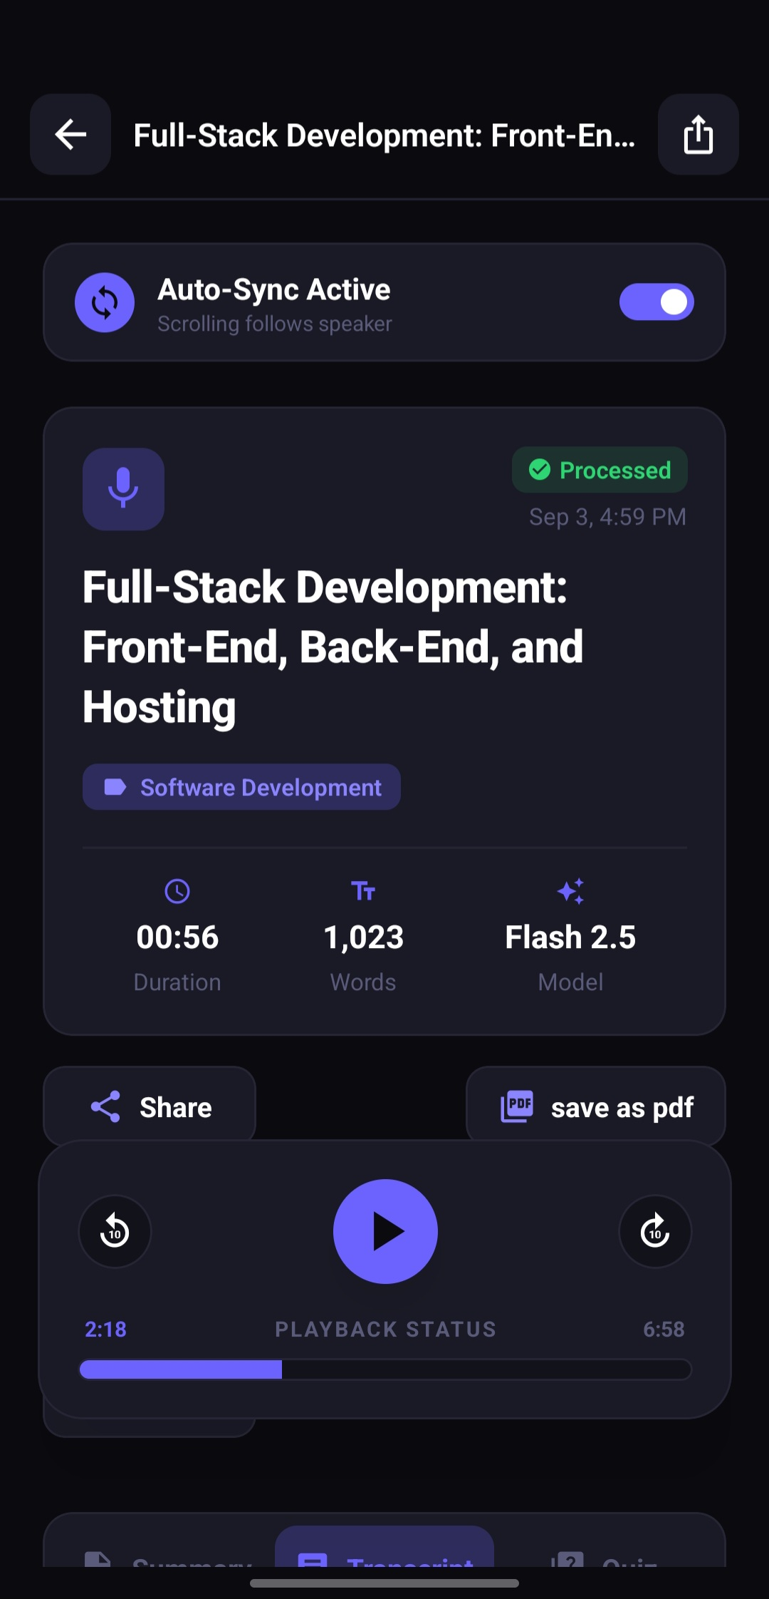 | 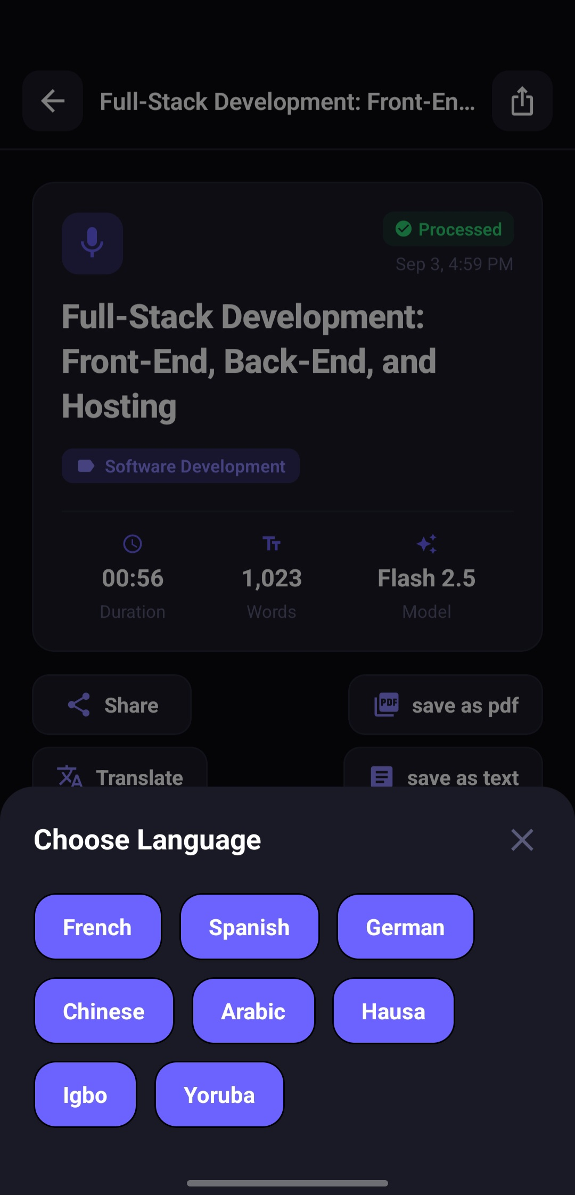
Figure 2.4: Real-Time Playback and Translation – (Left: Synchronized Audio Playback with Word Tracking [s7]; Right: 9-Language Neural Translation Modal [s8])
2.5 ADVANCEMENTS IN MULTIMODAL LARGE LANGUAGE MODELS AND PEDAGOGICAL SYNTHESIS
The most profound paradigm shift in contemporary artificial intelligence is the rise of native Multimodal Large Language Models (MLLMs). Historically, creating an audio study suite required a 'cascaded pipeline' consisting of three independent subsystems: an ASR model to transcribe audio to text, an NLP model to summarize the text, and a translation model to convert the text to another language. Cascaded architectures suffer from severe error propagation: if the ASR engine mishears an important keyword, the downstream summarization and translation models inherit the corrupted token and compound the hallucination.
2.5.1 End-to-End Multimodal Processing (Google Gemini 2.5 Flash Architecture)
Google's Gemini 2.5 Flash architecture represents the forefront of native multimodal foundation modeling. Built from the ground up to ingest audio, visual, and textual modalities natively, Gemini processes raw audio spectrograms directly alongside prompt instructions. Rather than relying on an intermediate ASCII transcript, the model's unified cross-attention layers correlate spoken acoustic inflections, pauses, speaker emphasis, and tone directly with semantic reasoning tokens. If an acoustic passage is muffled, the model uses its vast world knowledge and semantic context to infer the correct terminology, eliminating cascading transcription errors.
Furthermore, Gemini 2.5 Flash is heavily optimized for computational efficiency, utilizing sparse Mixture-of-Experts (MoE) routing and hardware-tailored TPU acceleration. This allows the AudioNote AI backend to stream full-length lecture recordings through Google's AI File Manager API and receive structured JSON responses—complete with titles, structured markdown summaries, verbatim transcripts, and quizzes—within seconds, bypassing local server bottlenecks.
2.5.2 Automated Pedagogical Assessment and Interactive Quiz Generation
Pedagogical research in cognitive psychology (e.g., Roediger & Karpicke, 2006) demonstrates that passive review (re-reading notes) produces minimal long-term memory retention compared to active recall and testing. To provide true educational value, an audio-to-note suite must facilitate dynamic knowledge verification. Leveraging the generative reasoning capabilities of Gemini 2.5 Flash, AudioNote AI implements an automated quiz synthesis pipeline. The model parses the central conceptual milestones of the lecture, constructs ten multiple-choice questions with plausible distractors, and generates detailed explanatory rationales for each answer. Rendered client-side with gamified celebration mechanics (confetti cannons and instant scoring), this transforms passive listening into an engaging, active recall learning loop.
2.5.3 Cross-Lingual Neural Machine Translation for Regional Dialects
In developing pedagogical ecosystems, particularly across the African continent, linguistic barriers severely hinder educational equity. Students frequently receive tertiary instruction in English—their second or third acquired language—impeding conceptual mastery. AudioNote AI integrates real-time bidirectional translation supporting nine languages: English, French, Spanish, German, Chinese, Arabic, and major Nigerian languages (Hausa, Igbo, Yoruba). By prompting Gemini with strict structural preservation rules, the platform translates dense academic notes into regional dialects while retaining all markdown formatting, bulleted hierarchies, and temporal playback markers, fostering deep conceptual comprehension in the learner's native tongue.
Table 2.3: State-of-the-Art Multimodal Foundation Model Comparison for Educational Audio
Model Architecture | Developer | Native Audio Ingestion | Context Window | Output Modalities
Whisper Large-v3 | OpenAI | Yes (Audio encoder) | 30 Seconds sliding | Text transcription only
GPT-4o Audio | OpenAI | Yes (Native Multimodal) | 128,000 Tokens | Audio, Text, JSON
Claude 3.5 Sonnet | Anthropic | No (Text/Vision only) | 200,000 Tokens | Text, Code, Artifacts
Gemini 1.5 Pro | Google | Yes (Native Multimodal) | 2,000,000 Tokens | Audio, Text, Vision, Code
Gemini 2.5 Flash | Google | Yes (Optimized Multimodal) | 1,000,000 Tokens | Audio, Text, JSON, Quizzes (Low Latency)

2.6 MOBILE-FIRST ARCHITECTURE AND CLIENT-SIDE ENGINEERING
An artificial intelligence model is only as effective as the software interface through which users interact with it. Delivering a high-performance audio study suite to students requires rigorous mobile-first systems engineering, addressing audio buffer sandboxing, asynchronous thread management, and resilient network communications.

Figure 2.5: React Native Framework Architectural Ecosystem Utilized for Cross-Platform Client Deployment
2.6.1 Cross-Platform Mobile Runtimes with React Native and Expo
To ensure universal accessibility across Android, iOS, and Web environments from a single codebase, AudioNote AI utilizes React Native and the Expo (SDK 54) framework. React Native executes JavaScript/TypeScript application logic on a dedicated JavaScript thread while delegating UI layout calculations to Yoga and rendering authentic platform-specific native views. Expo Router provides declarative, file-system-based routing, eliminating navigation race conditions and ensuring seamless transitions between recording, note inspection, and quiz screens. Styling is orchestrated via NativeWind (Tailwind CSS for React Native), pairing utility-first design with custom dark-mode glassmorphic aesthetics that maximize contrast and reduce eye fatigue during nocturnal study sessions.
2.6.2 Audio Buffer Sandboxing and Memory Lifecycle Management
Mobile operating systems enforce strict background memory constraints, aggressively terminating applications that exceed allotted RAM quotas. Continuous high-resolution audio recording requires robust memory lifecycle management. AudioNote AI leverages `expo-av` and `expo-audio`, establishing a hardware-accelerated recording session configured for 16-bit linear PCM audio. To prevent RAM saturation, audio buffers are not accumulated in volatile memory; instead, the recording thread streams directly to isolated sandbox storage within `FileSystem.documentDirectory`. Real-time decibel metering is polled at 250-millisecond intervals to drive fluid waveform animations powered by React Native Reanimated, operating entirely on the UI thread without blocking the JavaScript runtime.
2.6.3 Asynchronous API Pipeline, Streaming Protocols, and Backend Infrastructure
The backend API is architected as an enterprise-grade Express.js service in strict TypeScript. Audio payloads dispatched from mobile clients are ingested via Multer utilizing streaming disk storage, preventing memory bottlenecks when multiple students upload recordings concurrently. The server interacts with Google's cloud through `@google/generative-ai/server`, utilizing IPv4-enforced HTTP pipelines. Relational entity management is governed by Prisma ORM v6 connected to PostgreSQL via connection pooling (`@prisma/adapter-pg`), ensuring instant retrieval of user profiles, lecture notes, and localized translations. Lightweight security is enforced via 4-digit PIN cryptographic hashing and signed JSON Web Tokens (JWT).
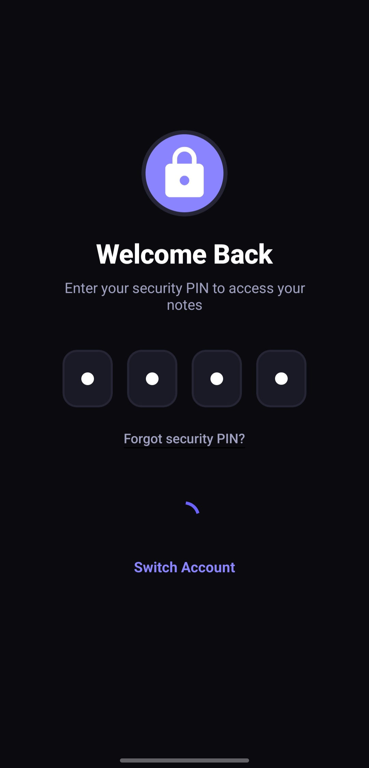 | 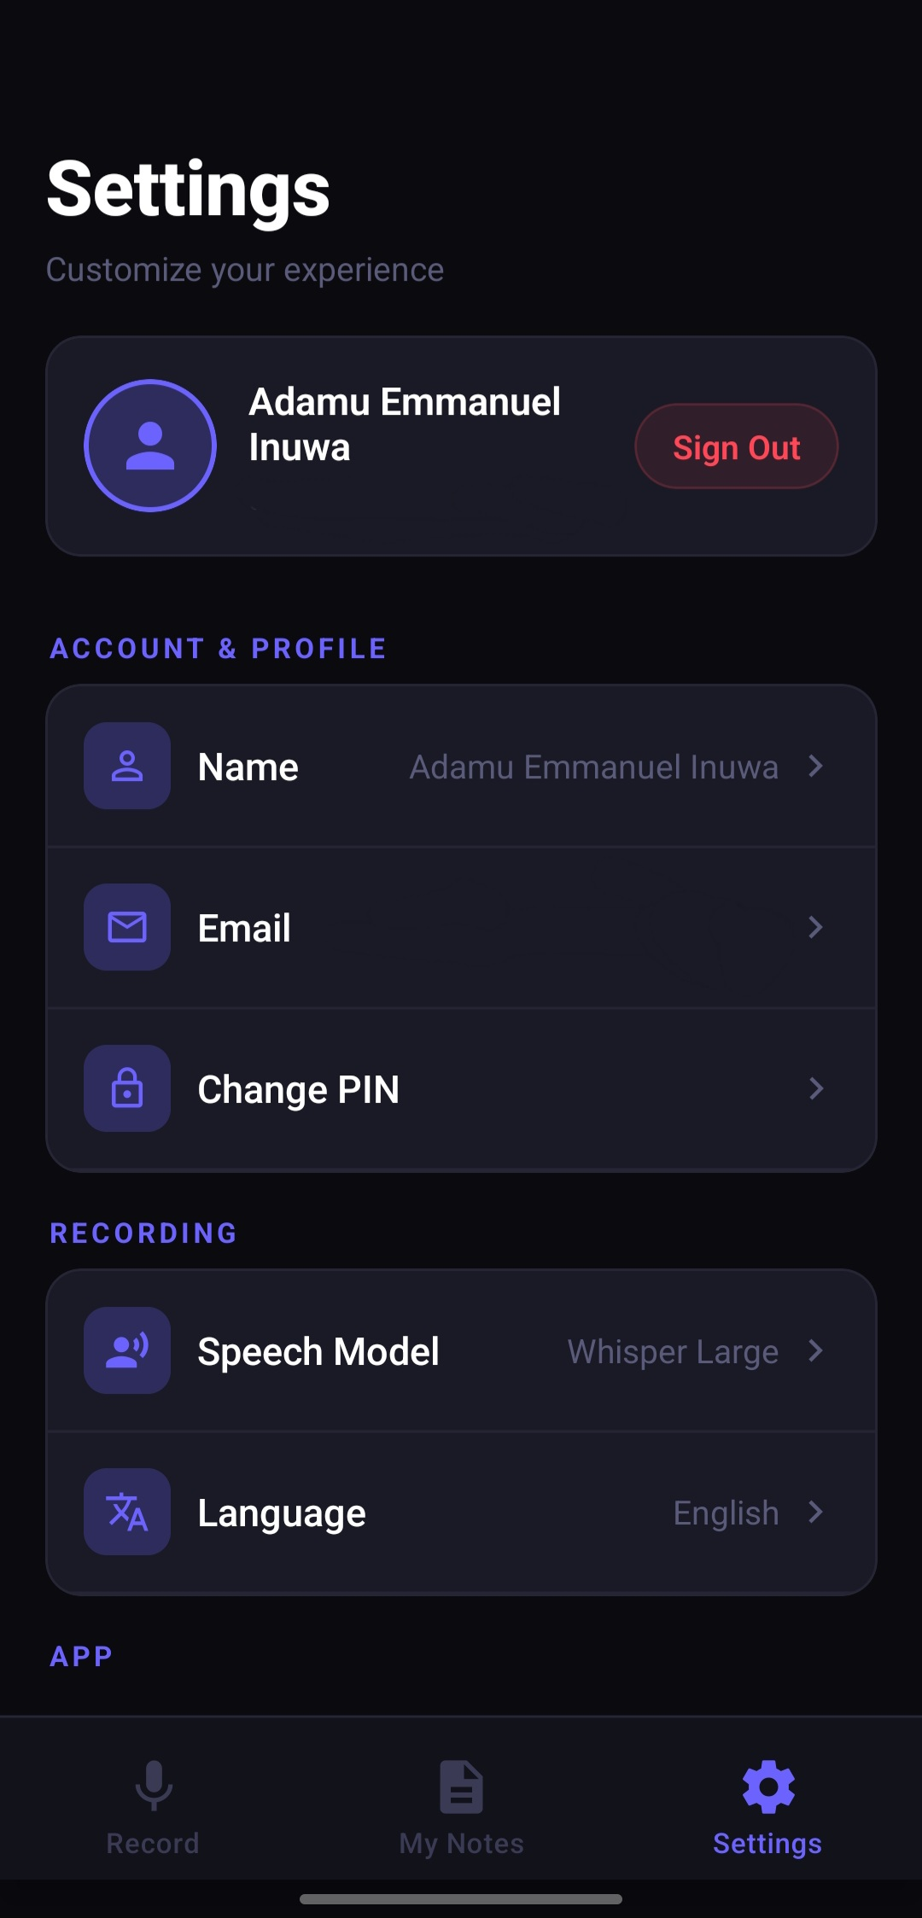
Figure 2.6: Security and System Configuration – (Left: Lightweight 4-Digit Security PIN Gateway [s1]; Right: Client Configuration and Model Routing Preferences [s5])
2.7 RELATED WORKS
The commercial landscape contains several prominent transcription and note-taking platforms, each exhibiting architectural trade-offs and market specializations.
Otter.ai is widely recognized as an industry pioneer in automated meeting transcription. It provides robust real-time transcription, speaker diarization, and integration with enterprise videoconferencing tools (Zoom, Microsoft Teams). However, Otter.ai is explicitly tailored for corporate business meetings; its summarization algorithms prioritize corporate action items and meeting agendas rather than pedagogical concept hierarchies. Furthermore, its restrictive freemium model and lack of gamified study aids or regional African language translations limit its applicability within developing educational sectors.
Fireflies.ai similarly focuses on conversational intelligence and enterprise CRM integrations. While offering high transcription accuracy via Whisper-based pipelines, it lacks native mobile-first study workflows, offline caching, and student-focused quiz synthesis. Other consumer applications, such as Coconote and Wave AI, cater to students by generating summary bullet points from lecture recordings. However, these platforms operate as simple frontends to standard text-based LLM APIs, suffering from cascading errors and lacking synchronized audio playback or cross-lingual translation.
AudioNote AI bridges these scholarly and practical gaps. By leveraging Google's Gemini 2.5 Flash multimodal engine, the platform eliminates cascaded pipeline errors, provides granular timestamped transcript synchronization, generates interactive active-recall quizzes, and delivers multilingual access across nine languages—all packaged in a modern, lightweight, mobile-first React Native architecture.
2.8 SUMMARY OF LITERATURE AND RESEARCH GAP
In summary, the literature underscores that manual lecture note-taking imposes an unsustainable cognitive load on students, leading to substantial information loss. Automated transcription has evolved from fragile statistical HMMs to revolutionary multimodal foundation models capable of natively processing audio and textual semantics concurrently. Despite these technological leaps, existing commercial tools remain heavily skewed toward corporate business meetings, neglecting the pedagogical synthesis, active recall assessments, and regional language accessibility required by global higher education students.
This research directly addresses this identified gap. By designing and evaluating AudioNote AI, this study demonstrates an empirically validated architecture that couples multimodal artificial intelligence with mobile systems engineering, transforming unstructured lecture acoustics into a comprehensive, inclusive, and highly effective digital learning environment.

