CHAPTER ONE
INTRODUCTION
1.1 BACKGROUND OF THE STUDY
In modern tertiary institutions, lectures remain the primary method of teaching and knowledge dissemination. Every day, university students attend various lectures where lecturers explain complex theories, solve mathematical problems, and share important academic concepts verbally. However, the traditional process of manual note-taking places a heavy burden on students. Trying to listen attentively, understand new concepts, and write down notes simultaneously is very difficult. Research in education shows that students often miss between 30% and 50% of the important details spoken during a fast-paced lecture.
This challenge is especially noticeable in large Nigerian university lecture halls. In many Nigerian universities, classes can have between 200 and 800 students sitting together in large auditoriums or lecture theaters. Factors such as acoustic echoes, distance from the lecturer, spinning ceiling fans, and generator noise make it easy to miss crucial explanations. While some students attempt to record the audio using basic voice recording apps on their mobile phones, listening back to a two-hour audio recording before an exam is tedious, time-consuming, and difficult to search.
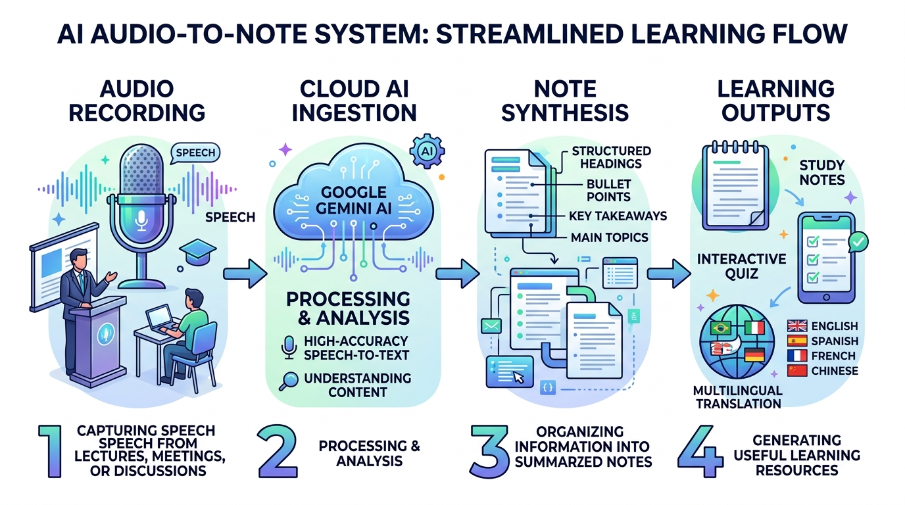
Figure 1.1: High-Level Conceptual Overview of the AI Audio-to-Note Converter System
Recent advancements in Artificial Intelligence (AI) and Machine Learning have created exciting opportunities to solve this problem. With modern Speech-to-Text (STT) technologies and Multimodal Large Language Models like Google's Gemini 2.5 Flash, it is now possible to automatically capture audio from a mobile phone, transcribe spoken words into text, and organize the text into clear, structured study notes. This project focuses on designing and implementing AudioNote AI, an intelligent mobile application that transforms spoken lecture audio into well-organized notes, verbatim transcripts, self-assessment quizzes, and multilingual translations.

Figure 1.2: Real-World Usage Scenario – A Nigerian University Student Utilizing the Mobile Audio-to-Note App During a Lecture
1.2 STATEMENT OF THE PROBLEM
Manual note-taking in university lectures is inefficient and stressful for students. When students focus on writing down everything a lecturer says, they lose track of the core explanation and fail to internalize the topic being taught. Conversely, if they focus only on listening, they leave the lecture hall without detailed written reference materials for revision.
Existing commercial transcription applications do not fully solve this issue for students. Most existing apps only provide a flat, unstructured wall of raw text without headings, bullet points, or summaries. Furthermore, they do not include student-centered learning features such as practice quizzes or translations into local Nigerian languages like Hausa, Yoruba, and Igbo. There is a clear need for an affordable, student-friendly mobile application that captures spoken audio and automatically produces clean study summaries, timestamped transcripts, and interactive study aids.
1.3 AIM AND OBJECTIVES
The aim of this project is to develop an AI-powered Audio-to-Note study companion that allows students to record lecture audio and automatically convert it into structured study notes, timestamped transcripts, self-assessment quizzes, and multilingual translations. To achieve this aim, the following specific objectives were formulated:
1. To design and build an intuitive, responsive mobile user interface using React Native and Expo that allows students to easily record, pause, and review lecture audio.
2. To implement a backend server using Node.js, Express.js, and TypeScript to manage audio uploads, user accounts, and database storage securely.
3. To integrate Google's Gemini 2.5 Flash multimodal AI API to process recorded audio files, generate structured Markdown notes, and extract key points.
4. To implement an automated quiz generation feature that creates 10-question multiple-choice practice quizzes from the lecture content for active recall revision.
5. To provide a one-tap translation engine that converts study notes into 9 languages, including major Nigerian languages (Hausa, Igbo, and Yoruba).
6. To test and evaluate the application's transcription accuracy, ease of use, and response time in typical classroom conditions.
1.4 SCOPE AND LIMITATIONS OF THE STUDY
The scope of this project covers the software development of the AudioNote AI platform. It includes building the frontend mobile app using React Native, developing the REST API using Express.js and TypeScript, and managing persistent data with PostgreSQL and Prisma ORM. The artificial intelligence processing relies on Google's Gemini 2.5 Flash API for speech processing, note generation, and translations.
The project has some limitations. First, because the audio transcription and AI processing are performed in the cloud, an active internet connection is required to process recorded lectures. Second, the clarity of the generated notes depends on the recording quality of the student's mobile phone; if a lecturer speaks very far from the microphone in a room with severe acoustic noise, some words may be misunderstood. Finally, the system relies on Google's API service availability and rate limits.
1.5 SIGNIFICANCE OF THE STUDY
This project is of significant benefit to students, educators, and the broader field of applied computer science. For students, it removes the pressure of multitasking during lectures, allowing them to engage actively in class discussions while trusting the app to capture the notes accurately. The automatic generation of interactive quizzes provides an effective self-assessment tool, helping students test their understanding before semester examinations.
Additionally, offering note translations into indigenous languages like Hausa, Yoruba, and Igbo promotes inclusive education, helping students who understand concepts better in their native tongues. From a computer science perspective, the project demonstrates how modern web and mobile technologies (React Native, Node.js, and PostgreSQL) can be integrated with state-of-the-art multimodal AI services to solve practical educational problems in developing regions.
1.6 OPERATIONAL DEFINITION OF TERMS
• Speech-to-Text (STT): The technology that converts spoken words into computer-readable digital text.
• Multimodal AI: An artificial intelligence system capable of understanding and processing different types of input data, such as audio, text, and images simultaneously.
• React Native: A popular open-source JavaScript framework developed by Meta for building natively rendering mobile applications for Android and iOS from a single codebase.
• Expo: A set of tools, libraries, and services built around React Native that simplifies mobile app development, testing, and deployment.
• Express.js: A lightweight and flexible Node.js web application framework used to build backend RESTful APIs.
• Prisma ORM: An open-source database toolkit that provides type-safe database queries and automated schema migrations for PostgreSQL.
• Active Recall: A study technique where learners actively test their memory through quizzes and questions rather than passively re-reading notes.

CHAPTER TWO
LITERATURE REVIEW
2.0 OVERVIEW OF AI-POWERED AUDIO-TO-NOTE SYSTEMS
Converting spoken dialogue into written text has always been a major goal of computer science. In academic environments, lectures contain valuable knowledge that students need to preserve and study. Early attempts to capture lectures relied entirely on manual note-taking or physical audio cassette recordings. However, raw audio files are difficult to review because users cannot search through them quickly. Students must spend hours listening to find specific definitions or explanations.
With the rapid growth of Artificial Intelligence (AI) and Natural Language Processing (NLP), modern software systems can do much more than simple audio playback. Today's AI systems can listen to human speech, convert the audio into text, understand the context of what was said, and automatically organize the information into clear summaries. This chapter provides a detailed review of the literature surrounding Speech-to-Text (STT) technologies, Natural Language Processing for text summarization, multimodal AI models, mobile application architectures, and existing audio note-taking systems.
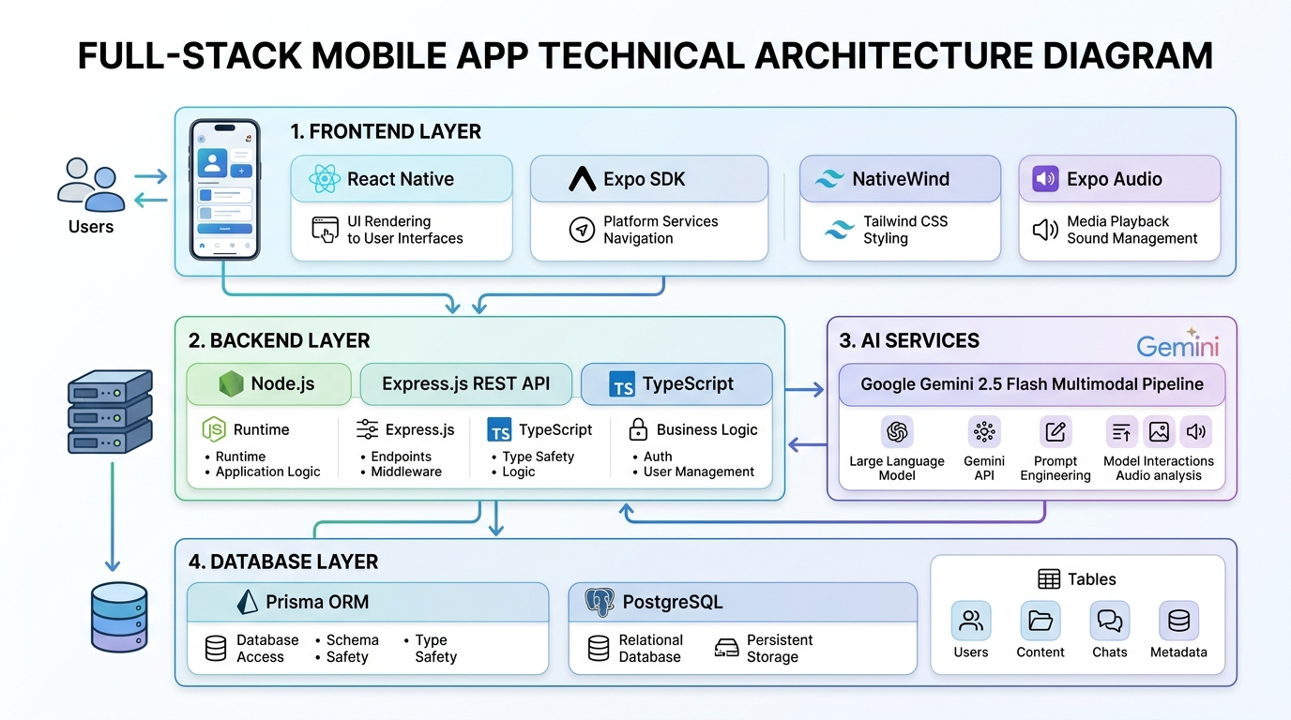
Figure 2.1: Full-Stack Architecture Diagram Illustrating the Frontend, Backend, AI Pipeline, and Database Layers
2.1 SPEECH-TO-TEXT (STT) TECHNOLOGIES AND PROCESSING METHODS
Automatic Speech Recognition (ASR), commonly known as Speech-to-Text (STT), is the technology that enables a computer program to recognize human speech and convert it into written words. The speech recognition process involves receiving an acoustic wave from a microphone, digitizing the signal, analyzing sound frequencies, and decoding the sound patterns into written language.
2.1.1 Types of Audio Inputs
Speech-to-text systems encounter different types of audio inputs depending on the recording environment and hardware. In a laboratory setting, audio is often recorded with close-talking microphones in quiet rooms, producing clean sound with high signal quality. However, in real-world educational settings, audio inputs are far more challenging.
Audio inputs can be broadly categorized into two types: real-time streaming audio and pre-recorded audio files. Real-time streaming involves processing small audio chunks (typically 250 milliseconds to a few seconds) as the speaker is talking. This requires low-latency processing so that the user sees words appear almost immediately. Pre-recorded audio files, on the other hand, allow the system to receive the entire recording at once. This enables the AI model to analyze the full context of the speech from start to finish, which generally leads to higher transcription accuracy.
2.1.2 Speech Recognition Methods
Over the decades, speech recognition systems have evolved through several technological generations. Understanding these methods explains why modern deep learning systems are significantly more capable than older approaches.
2.1.2.1 Acoustic Modeling
The acoustic model is the part of an ASR system that connects audio signals to the basic units of speech, known as phonemes. In English, there are approximately 44 distinct phonemes that make up spoken words. In early systems, researchers used Gaussian Mixture Models (GMM) combined with Hidden Markov Models (HMM). The GMM estimated the probability of a sound belonging to a specific phoneme, while the HMM tracked the sequence of sounds over time.
While statistical HMMs were an important milestone, they struggled with background noise and speaker variations. Modern speech recognition replaces GMMs with Deep Neural Networks (DNNs) and Convolutional Neural Networks (CNNs). Deep learning models are capable of learning complex acoustic patterns directly from thousands of hours of training audio, making them far more resilient to different voices, pitches, and accents.
2.1.2.2 Language Modeling
While the acoustic model identifies what sounds were spoken, the language model determines which words make sense together grammatically and contextually. Human speech contains many homophones—words that sound identical but have different spellings and meanings, such as 'their', 'there', and 'they're', or 'hear' and 'here'. Without a language model, the computer cannot know which word is correct.
Early language models relied on statistical n-grams, which calculated the probability of a word appearing based on the previous two or three words. Today, language modeling is powered by Transformer neural networks, such as those found in modern Large Language Models. Transformers use self-attention mechanisms to look at the entire sentence or paragraph, allowing the system to easily select the correct word based on the overall meaning of the lecture.
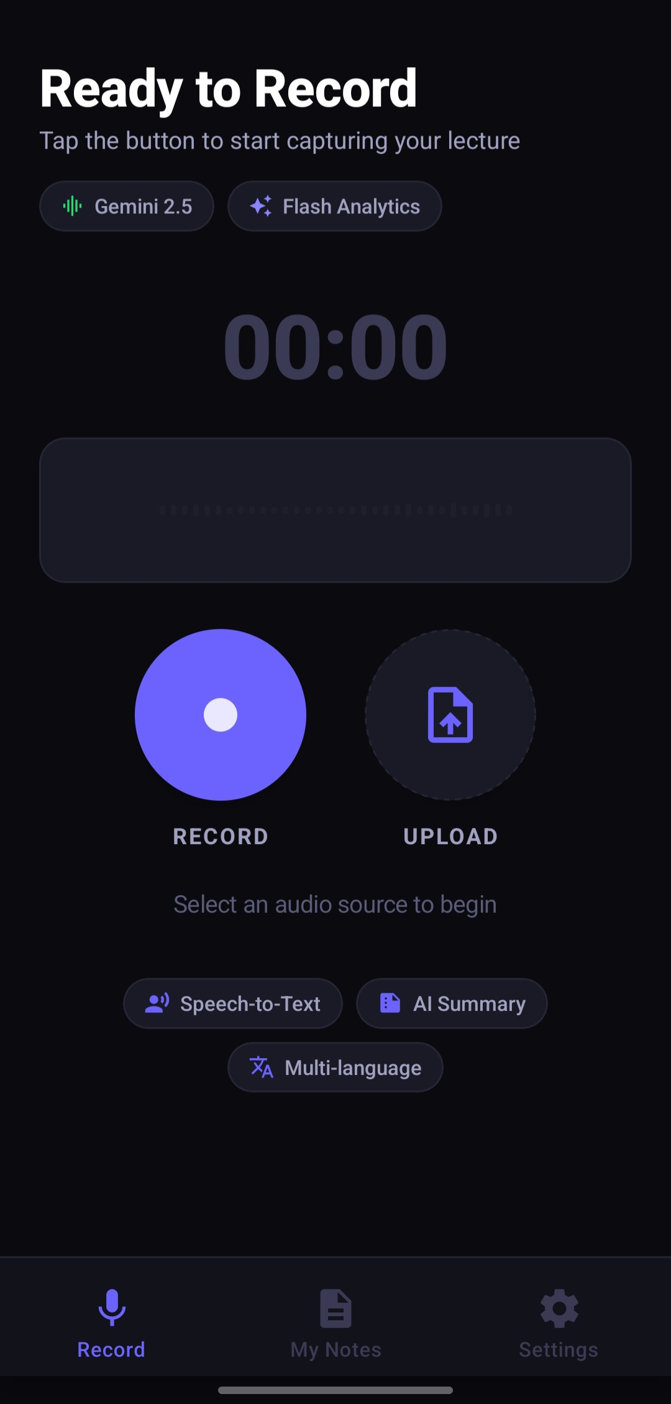 | 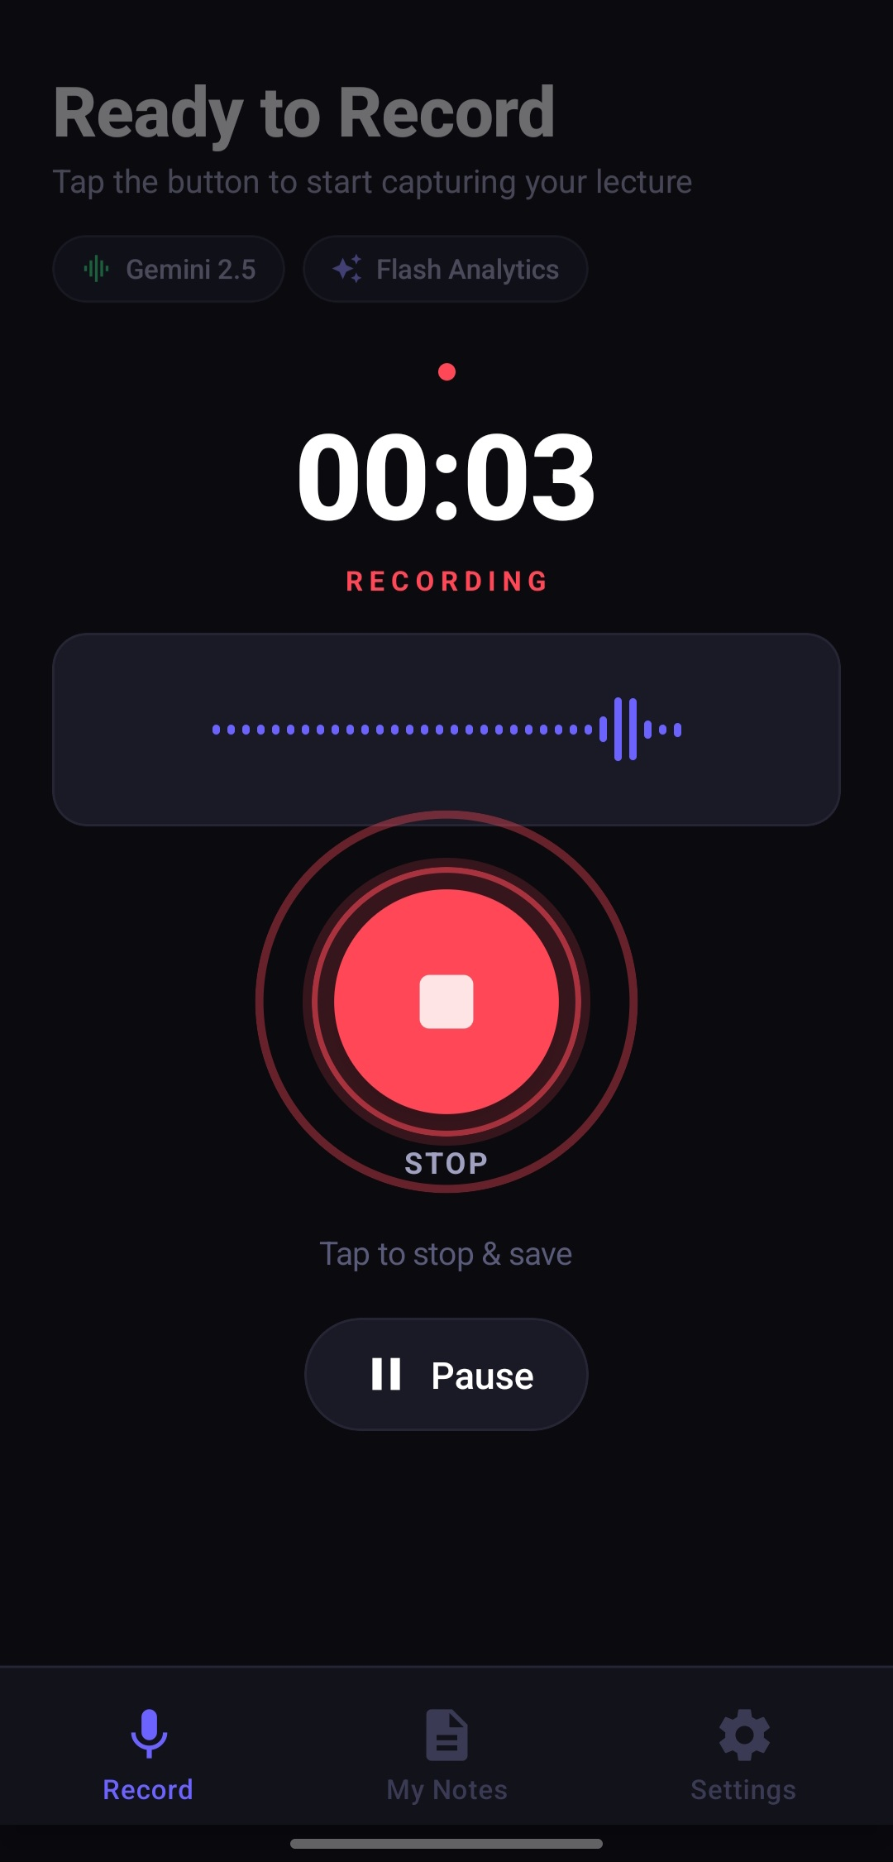
Figure 2.2: Audio Recording Interfaces in AudioNote AI – (Left: Standby Recording Screen [s2]; Right: Active Waveform Metering [s3])
2.1.3 Audio Processing and Feature Analysis Techniques
Before an audio signal can be analyzed by a machine learning model, it must be cleaned and converted into a numerical format that computers can process efficiently.
2.1.3.1 Pre-Processing and Noise Reduction
Raw audio captured from a phone microphone often contains unwanted noise such as electrical hum, wind, or distant talking. Pre-processing applies digital filters to clean the audio signal. A common step is pre-emphasis filtering, which boosts high-frequency sounds that naturally drop off when humans speak. Another important technique is noise suppression, which detects steady background noise (such as an air conditioner or electric generator) and subtracts that noise from the audio signal, leaving a clearer voice track.
2.1.3.2 Feature Extraction (Spectrograms and MFCCs)
Computers cannot directly process raw sound waves efficiently because sound waves are simply long arrays of amplitude values over time. To make sense of sound, systems extract Mel-Frequency Cepstral Coefficients (MFCCs) or compute Log-Mel Spectrograms. A spectrogram is a visual representation of sound frequencies over time. The 'Mel scale' is used because it models how human ears perceive pitch—humans are much better at distinguishing small differences in low frequencies than in high frequencies. By converting audio into spectrograms, computer vision and deep learning techniques can treat the audio almost like an image to recognize words accurately.
2.1.3.3 Speaker Diarization
Speaker diarization is the process of identifying 'who spoke when' in an audio recording. In a classroom, a lecture is not always a monologue; students frequently ask questions or participate in class discussions. Diarization algorithms analyze voice characteristics (such as pitch and vocal tone) and assign labels like 'Speaker 1' (the lecturer) and 'Speaker 2' (a student asking a question). This helps organize the resulting transcript into a natural dialogue format.
Table 2.1: Comparison of Speech Recognition Approaches in Computer Science
Approach | Technology | Accuracy | Handling of Accents | Computational Needs
Statistical ASR | Hidden Markov Models (HMM) + GMM | Low to Moderate (70-80%) | Poor; struggles with variations | Low CPU usage; runs on old PCs
Hybrid Deep Learning | Deep Neural Networks + HMM | Moderate to High (85-90%) | Fair; requires accent tuning | Moderate; requires decent CPU/GPU
End-to-End ASR | Connectionist Temporal Classification (CTC) | High (90-95%) | Good across standard dialects | High GPU requirements for training
Multimodal Foundation AI | Transformer-based (e.g. Gemini 2.5 Flash) | Very High (95-98%+) | Excellent across global & regional accents | Offloaded to cloud AI clusters

2.2 NATURAL LANGUAGE PROCESSING (NLP) FOR SUMMARIZATION
Getting an accurate transcript is only the first step. A word-for-word transcript of a one-hour lecture can easily be over 8,000 words long. Reading through 8,000 words of spoken dialogue is overwhelming because human speech includes filler words (like 'um', 'you know', 'actually'), repetitive explanations, and side remarks. Natural Language Processing (NLP) summarization techniques are needed to distill this raw text into clear, concise study notes.
2.2.1 Extractive Summarization
Extractive summarization works by identifying the most important sentences already present in the text and stitching them together into a summary. Algorithms such as TF-IDF (Term Frequency-Inverse Document Frequency) and TextRank score each sentence based on the frequency and importance of its words. While extractive summarization is fast and guaranteed not to make up facts, it often creates choppy, disjointed summaries because spoken sentences do not always flow logically when pulled out of context.
2.2.2 Abstractive Summarization
Abstractive summarization is much closer to how a human student writes notes. Instead of copying exact sentences, an abstractive AI model reads the transcript, understands the main concepts, and writes completely new, well-structured sentences. This allows the model to eliminate verbal clutter, combine related points, create clean bulleted lists, and format the output with markdown headings. Modern Large Language Models (LLMs) excel at abstractive summarization because they have been trained on vast amounts of literature and know how to synthesize academic concepts clearly.
2.2.3 Keyword and Topic Extraction
To make study notes easy to organize and search, NLP systems perform keyword and topic extraction. Using techniques like Named Entity Recognition (NER), the system automatically detects technical terms, formulas, dates, and author names. In AudioNote AI, this allows the app to generate automatic titles (such as 'Full-Stack Development: Front-End, Back-End, and Hosting') and tag notes by subject categories without requiring the student to type anything manually.
2.2.4 Challenges in Automated Summarization
While abstractive summarization is powerful, it comes with challenges. The main challenge is 'hallucination', where an AI model generates information that sounds convincing but was never mentioned in the original audio. In an academic setting, hallucinating an incorrect formula or wrong historical date can misinform students. Developers address this by carefully engineering prompts with strict rules that tell the AI to base its summary solely on the provided audio transcript.
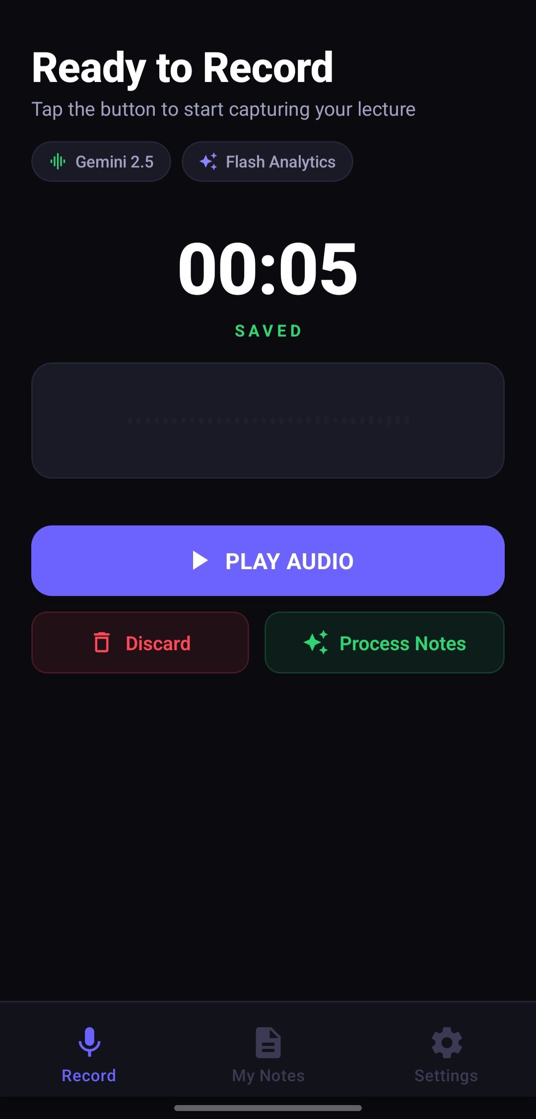 | 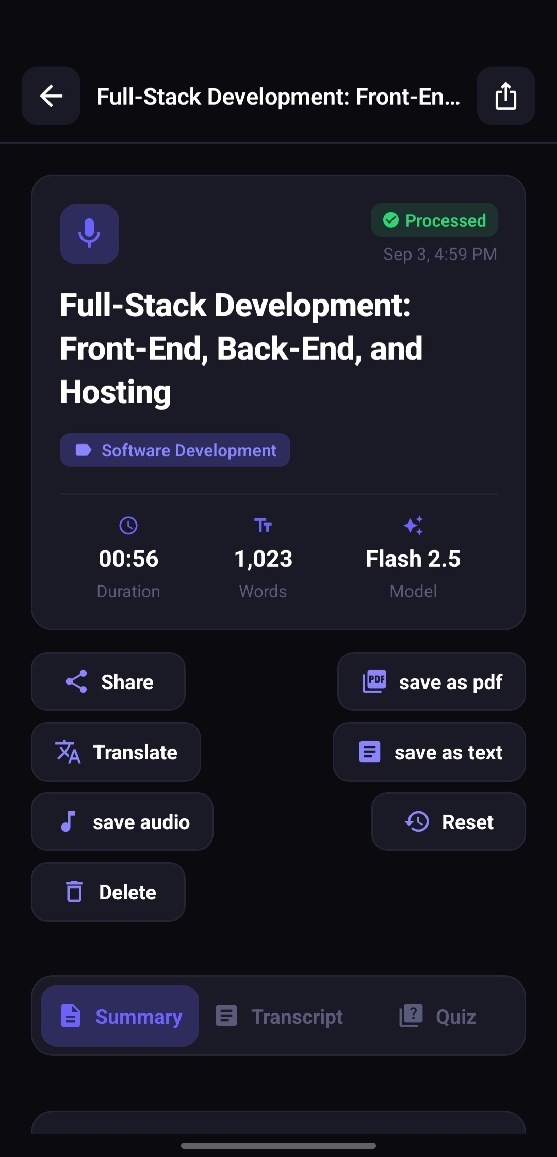
Figure 2.3: Ingestion and Note Generation – (Left: Saved Recording Decision Screen [s4]; Right: Processed Note with Gemini 2.5 Flash Badge [s6])
2.3 REAL-WORLD CHALLENGES IN AUDIO CONVERSION
Building a reliable speech-to-note application for real university environments requires overcoming several practical challenges. These challenges are particularly pronounced in developing educational contexts such as Nigerian higher institutions.
2.3.1 Background Noise and Acoustic Reflections
In many universities, lecture rooms are large concrete halls without acoustic wall padding. When a lecturer speaks, the sound reflects off walls, floors, and metal desks, creating reverberation (echo). Additionally, environmental sounds such as rain hitting corrugated iron roofs, diesel generator noise during power outages, noisy ceiling fans, and chatter among students can drown out the lecturer's voice. If the audio recorded on the student's phone is muffled, speech recognition systems face higher error rates.
2.3.2 Accents and Regional Dialectal Variations
English is the official language of instruction in Nigeria, but it is spoken with a wide variety of regional accents influenced by the speaker's mother tongue (such as Yoruba, Hausa, or Igbo). Many commercial speech recognition tools developed in Western countries were trained predominantly on North American or British accents, causing them to struggle with Nigerian English pronunciations. Furthermore, lecturers frequently use Nigerian idioms or switch briefly into pidgin or local languages to explain a concept. A robust educational app needs an AI model with broad global language exposure to understand these speech variations.
2.3.3 Domain-Specific Jargon and Technical Terms
Computer science, engineering, and medical lectures are filled with specialized terminology. For example, a computer science lecturer might mention 'PostgreSQL', 'Kubernetes', 'asynchronous functions', or 'polymorphism'. A general speech-to-text model that has not been conditioned for technical topics might transcribe 'PostgreSQL' as 'post grey sequel' or 'API' as 'a pie'. Ensuring that technical terms are transcribed accurately requires intelligent language models that recognize the academic context.
2.3.4 Mobile Hardware and Data Network Constraints
Undergraduate students use a wide variety of mobile smartphones, ranging from budget Android phones with modest processors to modern devices. An application cannot expect to run a massive AI model locally on the phone because it would quickly drain the battery and overheat the device. At the same time, mobile data in Nigeria can be costly and campus Wi-Fi may be intermittent. Therefore, the mobile application must compress audio efficiently before sending it to the cloud server, minimizing data usage while preserving audio clarity.
Table 2.2: Comparison of Text Summarization Techniques for Lecture Notes
Summarization Type | Technique Used | Readability | Risk of Hallucination | Suitability for Study Notes
Sentence Extraction | TF-IDF / Frequency Scoring | Low; disjointed sentences | None (copies verbatim) | Poor; keeps verbal filler and pauses
Graph-Based Extraction | TextRank Algorithm | Moderate; selects key sentences | None (copies verbatim) | Fair; lacks natural conversational flow
Early Seq2Seq Neural | LSTM / RNN Encoder-Decoder | Moderate; some grammatical errors | Low to Moderate | Fair; forgets context in long lectures
Modern Abstractive AI | Transformer LLMs (Gemini 2.5 Flash) | Very High; structured markdown | Low with proper prompt grounding | Excellent; produces clear academic summaries

2.4 MACHINE LEARNING APPROACHES IN SPEECH RECOGNITION
Machine learning is the branch of computer science that allows systems to learn from data rather than following strictly hardcoded rules. In speech processing, machine learning models are trained on thousands of hours of audio recordings paired with text transcripts to learn the mapping from sound vibrations to written words.
2.4.1 Supervised, Unsupervised, and Self-Supervised Learning
Traditionally, speech recognition relied on supervised learning, where every second of training audio had to be manually transcribed by humans. This was extremely expensive and made it difficult to build speech models for languages with fewer resources. Recently, the AI community adopted self-supervised learning (SSL) models, such as wav2vec 2.0. In self-supervised learning, the AI model listens to massive amounts of unlabeled audio and learns how speech sounds work on its own by trying to predict masked or hidden parts of the audio. Once this general understanding is established, the model only needs a small amount of labeled text to become an accurate transcriber.
2.4.2 The Transformer Architecture in Speech and NLP
The introduction of the Transformer architecture by Vaswani et al. in 2017 fundamentally changed natural language processing and speech recognition. Before Transformers, systems processed words one by one using recurrent loops (RNNs), which were slow and frequently forgot information from earlier parts of long sentences. The Transformer introduced the 'self-attention' mechanism, which allows the model to examine all parts of an audio clip or text document at the same time. This capability allows models to understand the broad context of an entire lecture and generate accurate notes without losing the central topic.
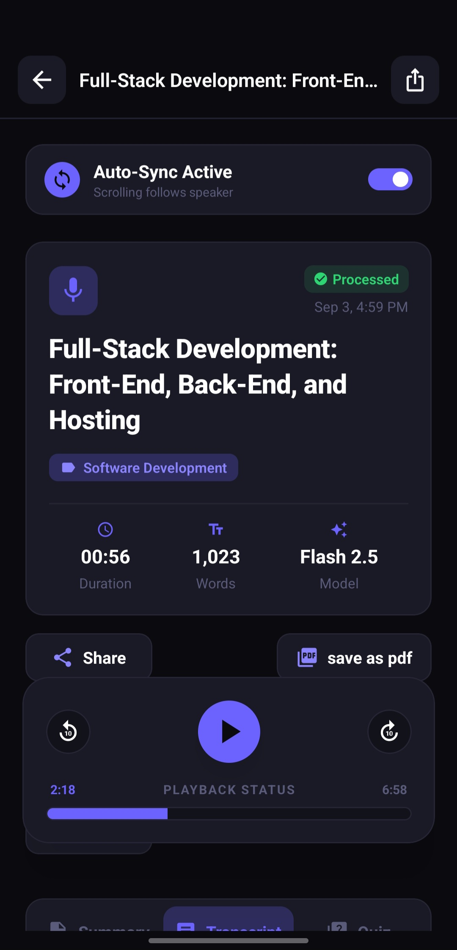 | 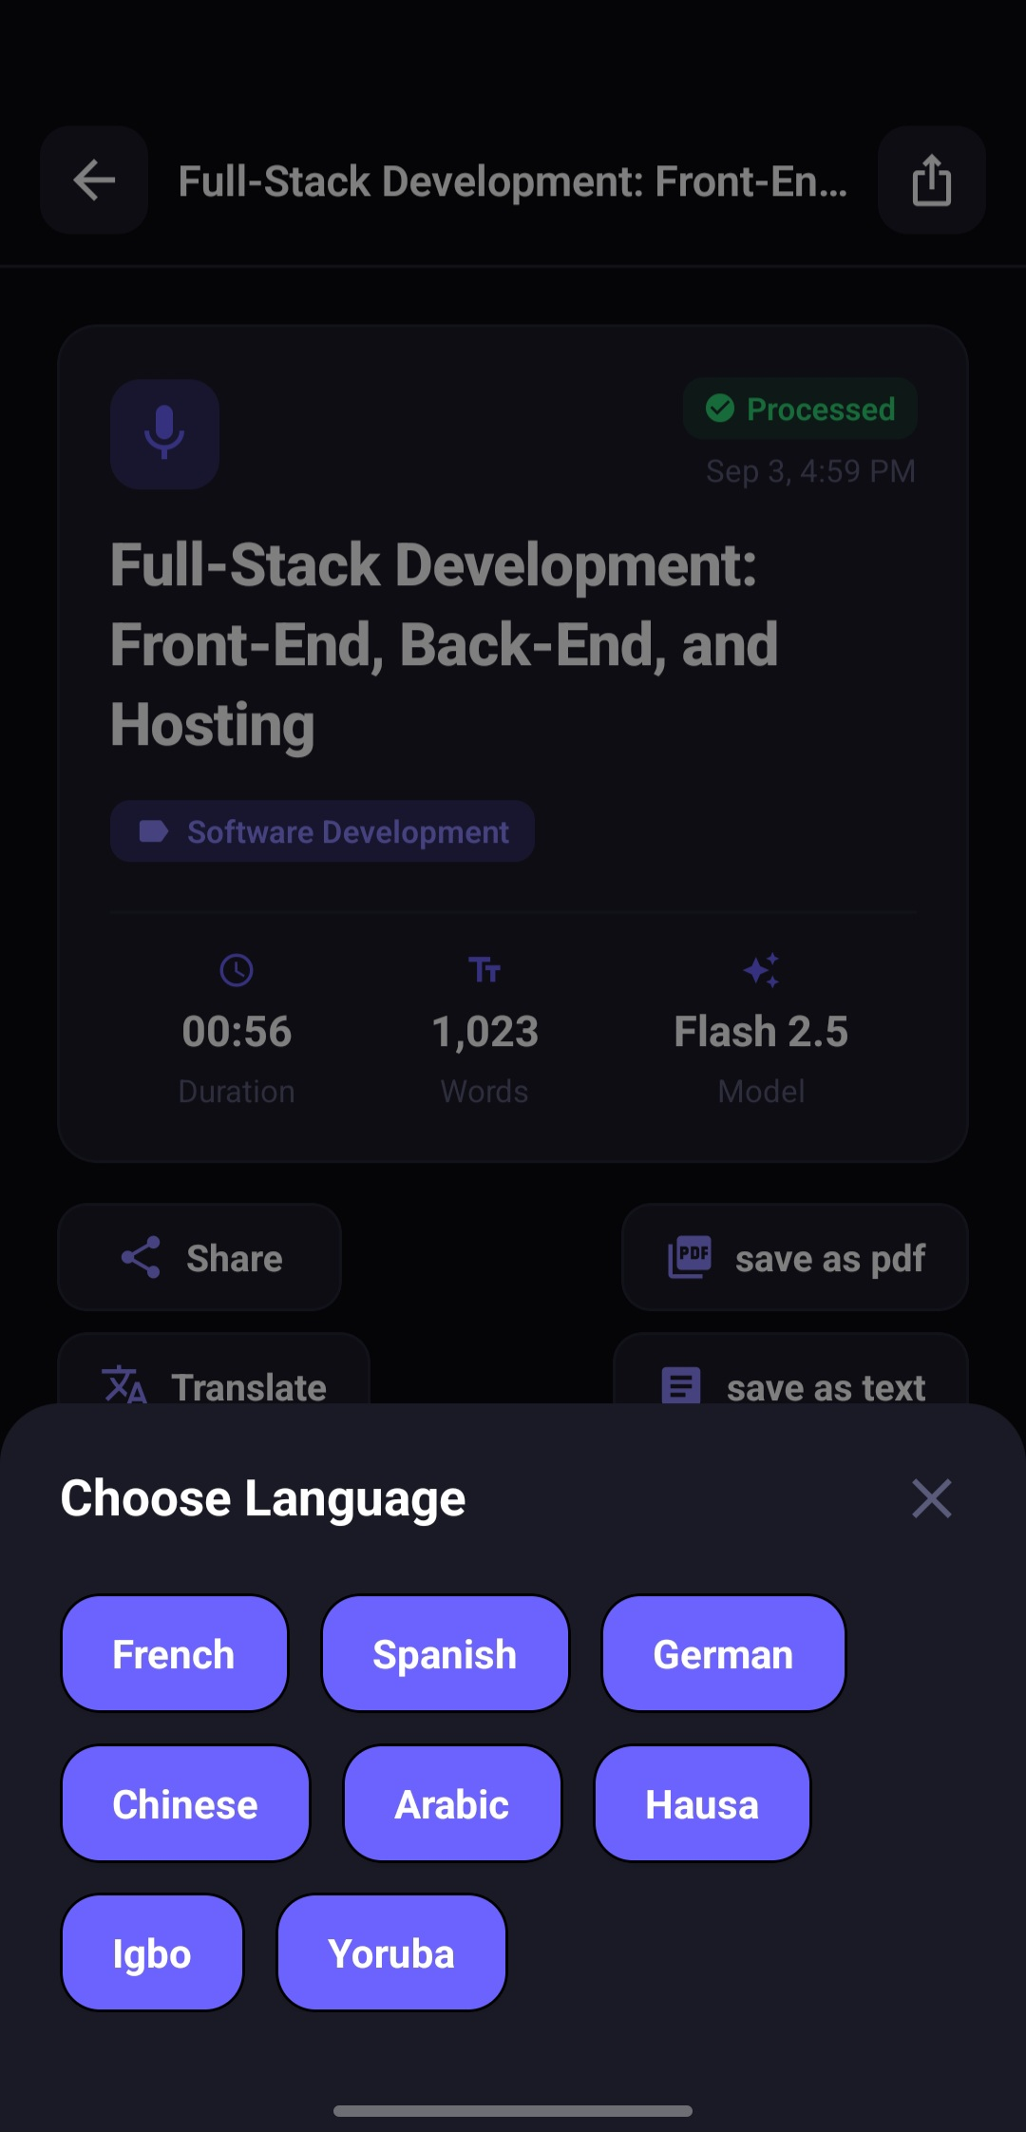
Figure 2.4: Study and Accessibility Features – (Left: Synchronized Audio Playback [s7]; Right: Multilingual Translation Dialog [s8])
2.5 ADVANCEMENTS IN MULTIMODAL AI AND PEDAGOGICAL TOOLS
The latest breakthrough in artificial intelligence is the shift towards native Multimodal Models. Earlier AI tools operated in separate stages: one model converted audio to text, another model summarized the text, and a third model translated it. If the first model made a mistake, the mistake propagated and grew worse through each subsequent stage. Native multimodal models eliminate this problem by processing audio directly within a single neural network.
2.5.1 Google Gemini 2.5 Flash Multimodal Pipeline
Google's Gemini 2.5 Flash is an advanced multimodal model designed for high-speed, cost-effective reasoning. Unlike older text-only models, Gemini 2.5 Flash can ingest audio files directly. It listens to the audio, understands the speaker's tone, emphasis, and context, and generates structured text in one step. In AudioNote AI, the backend uses Google's AI File Manager API to stream the lecture audio directly to Gemini. The model returns an organized JSON payload containing a clear lecture title, categorized topic tags, a structured markdown summary, a timestamped verbatim transcript, and a practice quiz.
2.5.2 Automated Quiz Generation for Active Recall
Educational research consistently shows that simply reading through notes is one of the least effective ways to study. Cognitive scientists recommend 'active recall'—testing oneself on the material to strengthen memory retention. By leveraging Gemini's generative capabilities, AudioNote AI automatically turns lecture content into an interactive 10-question multiple-choice quiz. Each question includes four answer options and explanations for why an answer is correct. In the mobile app, students can answer questions and receive instant scoring and celebratory feedback, turning study sessions into an engaging learning experience.
2.5.3 Multilingual Translation for Inclusive Learning
Language accessibility is vital for students who are non-native English speakers. In Nigeria, while university education is in English, many students find it easier to understand difficult technical concepts when explained in their mother tongue. AudioNote AI integrates a neural translation engine supporting 9 languages: English, French, Spanish, German, Chinese, Arabic, and three prominent Nigerian languages: Hausa, Yoruba, and Igbo. With one tap, students can translate the summary and transcript into their chosen language while preserving all headings, bullet points, and timestamp markers.
Table 2.3: State-of-the-Art Multimodal Foundation Models for Educational Applications
Model | Provider | Direct Audio Ingestion | Speed / Latency | Support for African Languages
Whisper Large-v3 | OpenAI | Yes (Speech only) | Moderate (generates text only) | Moderate; limited for regional dialects
GPT-4o Audio | OpenAI | Yes (Multimodal) | Fast (high cloud API cost) | Good global coverage
Claude 3.5 Sonnet | Anthropic | No (requires text transcript first) | Fast (text only) | Good global coverage
Gemini 2.5 Flash | Google | Yes (Direct Multimodal audio & text) | Very Fast (low cost & high speed) | Strong multilingual support including Nigerian languages

2.6 MOBILE-FIRST ARCHITECTURE AND TECHNOLOGIES USED
To deliver a smooth, practical experience to students, the software architecture of AudioNote AI was carefully designed using modern open-source JavaScript and TypeScript libraries. The system consists of a cross-platform mobile frontend, a RESTful backend API, and a relational database.
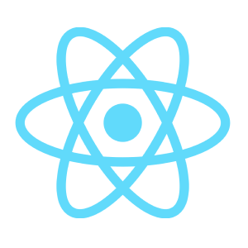
Figure 2.5: React Native Framework Architectural Ecosystem Utilized for the Mobile Client
2.6.1 React Native and Expo Framework
React Native is a cross-platform mobile framework developed by Meta that allows developers to write code once in JavaScript or TypeScript and deploy it natively to both Android and iOS devices. Unlike hybrid web-view wrappers, React Native renders true native UI components, ensuring 60 frames-per-second performance and a smooth user experience. Expo (SDK 54) provides a comprehensive set of tools that simplify hardware access, app building, and testing without requiring complex native platform setup.
2.6.2 Audio Recording and Waveform Libraries
Capturing audio reliably on a smartphone requires specialized libraries. In this project, `expo-av` and `expo-audio` manage the microphone hardware sessions. To give the student visual feedback that their recording is working, the app polls the microphone's decibel levels every 250 milliseconds and animates a dynamic audio waveform using `react-native-reanimated`. The recorded audio is temporarily stored in `FileSystem.documentDirectory` on the phone before being uploaded to the backend server.
2.6.3 Backend Architecture: Node.js, Express.js, and Prisma ORM
The backend service is built using Node.js and Express.js in TypeScript. Express.js provides a clean routing mechanism for handling HTTP requests such as user registration, audio uploads, and note retrieval. Audio file uploads are handled using `multer`, which streams incoming audio directly to disk storage to avoid consuming excessive server RAM. Database operations are handled using Prisma ORM v6 connected to a PostgreSQL relational database. Prisma provides type-safe database queries, automated migrations, and connection pooling, ensuring that user records and generated notes are stored securely and retrieved quickly.
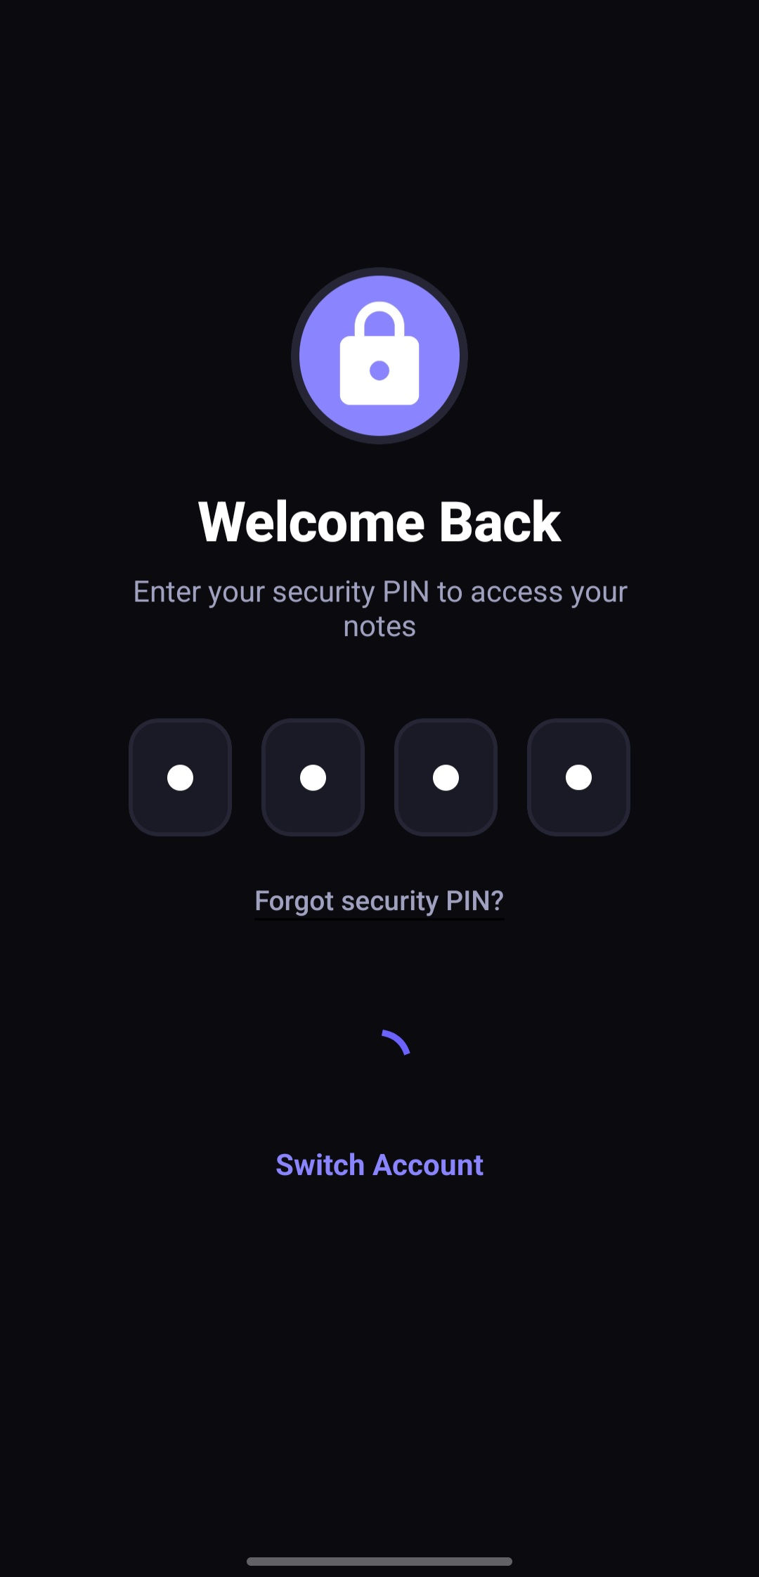 | 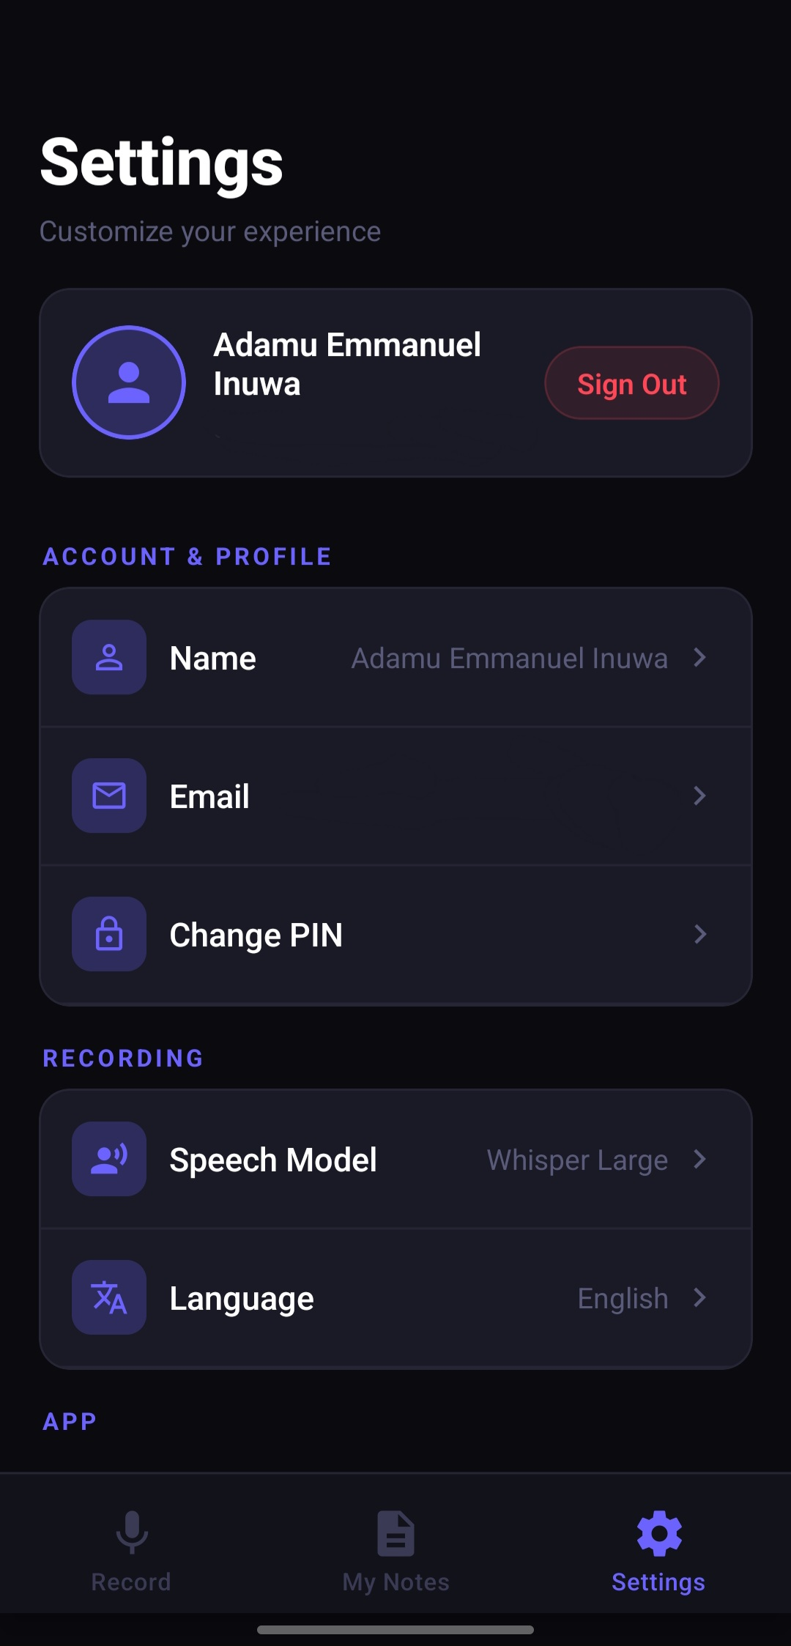
Figure 2.6: Security and User Settings – (Left: 4-Digit Security PIN Gateway [s1]; Right: User Settings and Speech Model Configuration [s5])
2.7 RELATED WORKS
Several commercial and academic systems have explored audio transcription and note-taking. Examining these existing works helps highlight the unique contributions of AudioNote AI.
Otter.ai is one of the most well-known automated meeting transcription platforms. It provides live transcription, speaker identification, and integration with video platforms like Zoom. However, Otter.ai is designed primarily for corporate business meetings. Its summaries focus on meeting action items rather than academic lecture concepts. In addition, its subscription costs are prohibitive for students in developing countries, and it does not support translations into local African languages or automated study quizzes.
Fireflies.ai is another conversational intelligence tool focused on recording and transcribing corporate calls. It connects with business tools like Slack and Salesforce, but it lacks a dedicated mobile study interface with flashcards, active recall quizzes, or student-oriented note formatting. Other apps such as Coconote and Wave AI have recently emerged for students, but many of them rely on multi-step pipelines that introduce transcription errors and require expensive recurring monthly subscriptions.
AudioNote AI addresses these gaps by combining direct multimodal AI processing (Google Gemini 2.5 Flash) with an undergraduate-focused mobile design. It provides structured lecture notes, timestamped transcripts, self-assessment quizzes, and translations into major Nigerian languages, offering a comprehensive, inclusive academic study companion.
2.8 SUMMARY OF LITERATURE REVIEW
In conclusion, the literature review shows that manual note-taking creates significant cognitive fatigue for students, causing them to miss important lecture material. While early speech recognition tools were limited by noise sensitivity and inflexible statistical models, modern deep learning and multimodal foundation models like Gemini 2.5 Flash have made high-accuracy speech-to-note conversion a reality. By leveraging React Native on the mobile client, Express.js on the backend, and Google's multimodal AI in the cloud, this project provides a practical, student-centered solution designed to overcome the acoustic and linguistic challenges found in university classrooms.

