CHAPTER ONE

INTRODUCTION

1.1 BACKGROUND OF THE STUDY
In recent years, the rapid advancement of artificial intelligence and machine learning has revolutionized the way we interact with technology. The shift from manual data entry to automated processing is evident across numerous fields, particularly in academic and professional environments. Taking notes during lectures, meetings, and interviews has traditionally been a cognitive load-intensive task, often resulting in missed information or poorly structured documentation. With the advent of powerful multimodal models like Google's Gemini and advanced speech-to-text algorithms, there is a paradigm shift towards automated audio-to-note conversion systems. These systems not only transcribe spoken words into text but also intelligently summarize, categorize, and synthesize the information into actionable insights. The development of AudioNote AI, an intelligent audio-to-note study suite, addresses this growing need by leveraging Express.js for a robust backend and React Native for a seamless frontend experience. By integrating modern web technologies with cutting-edge AI, the project seeks to provide an enterprise-grade solution capable of transforming live audio into structured markdown notes, timestamped transcripts, and interactive study quizzes.The integration of deep learning techniques in Natural Language Processing (NLP) enables a high degree of accuracy and contextual understanding, moving beyond simple verbatim transcription to true comprehension. This background establishes the necessity of building an optimized, scalable, and cross-platform application that democratizes access to advanced learning and productivity tools, especially for students and professionals who rely heavily on auditory information.
In recent years, the rapid advancement of artificial intelligence and machine learning has revolutionized the way we interact with technology. The shift from manual data entry to automated processing is evident across numerous fields, particularly in academic and professional environments. Taking notes during lectures, meetings, and interviews has traditionally been a cognitive load-intensive task, often resulting in missed information or poorly structured documentation. With the advent of powerful multimodal models like Google's Gemini and advanced speech-to-text algorithms, there is a paradigm shift towards automated audio-to-note conversion systems. These systems not only transcribe spoken words into text but also intelligently summarize, categorize, and synthesize the information into actionable insights. The development of AudioNote AI, an intelligent audio-to-note study suite, addresses this growing need by leveraging Express.js for a robust backend and React Native for a seamless frontend experience. By integrating modern web technologies with cutting-edge AI, the project seeks to provide an enterprise-grade solution capable of transforming live audio into structured markdown notes, timestamped transcripts, and interactive study quizzes.The integration of deep learning techniques in Natural Language Processing (NLP) enables a high degree of accuracy and contextual understanding, moving beyond simple verbatim transcription to true comprehension. This background establishes the necessity of building an optimized, scalable, and cross-platform application that democratizes access to advanced learning and productivity tools, especially for students and professionals who rely heavily on auditory information.
In recent years, the rapid advancement of artificial intelligence and machine learning has revolutionized the way we interact with technology. The shift from manual data entry to automated processing is evident across numerous fields, particularly in academic and professional environments. Taking notes during lectures, meetings, and interviews has traditionally been a cognitive load-intensive task, often resulting in missed information or poorly structured documentation. With the advent of powerful multimodal models like Google's Gemini and advanced speech-to-text algorithms, there is a paradigm shift towards automated audio-to-note conversion systems. These systems not only transcribe spoken words into text but also intelligently summarize, categorize, and synthesize the information into actionable insights. The development of AudioNote AI, an intelligent audio-to-note study suite, addresses this growing need by leveraging Express.js for a robust backend and React Native for a seamless frontend experience. By integrating modern web technologies with cutting-edge AI, the project seeks to provide an enterprise-grade solution capable of transforming live audio into structured markdown notes, timestamped transcripts, and interactive study quizzes.The integration of deep learning techniques in Natural Language Processing (NLP) enables a high degree of accuracy and contextual understanding, moving beyond simple verbatim transcription to true comprehension. This background establishes the necessity of building an optimized, scalable, and cross-platform application that democratizes access to advanced learning and productivity tools, especially for students and professionals who rely heavily on auditory information.
In recent years, the rapid advancement of artificial intelligence and machine learning has revolutionized the way we interact with technology. The shift from manual data entry to automated processing is evident across numerous fields, particularly in academic and professional environments. Taking notes during lectures, meetings, and interviews has traditionally been a cognitive load-intensive task, often resulting in missed information or poorly structured documentation. With the advent of powerful multimodal models like Google's Gemini and advanced speech-to-text algorithms, there is a paradigm shift towards automated audio-to-note conversion systems. These systems not only transcribe spoken words into text but also intelligently summarize, categorize, and synthesize the information into actionable insights. The development of AudioNote AI, an intelligent audio-to-note study suite, addresses this growing need by leveraging Express.js for a robust backend and React Native for a seamless frontend experience. By integrating modern web technologies with cutting-edge AI, the project seeks to provide an enterprise-grade solution capable of transforming live audio into structured markdown notes, timestamped transcripts, and interactive study quizzes.The integration of deep learning techniques in Natural Language Processing (NLP) enables a high degree of accuracy and contextual understanding, moving beyond simple verbatim transcription to true comprehension. This background establishes the necessity of building an optimized, scalable, and cross-platform application that democratizes access to advanced learning and productivity tools, especially for students and professionals who rely heavily on auditory information.

1.2 STATEMENT OF THE PROBLEM
Despite the availability of basic transcription software, users continue to face significant challenges when attempting to convert spoken audio into useful, structured notes. Traditional speech-to-text tools often lack contextual awareness, resulting in flat, unstructured text blocks that are difficult to review. Furthermore, existing solutions struggle with domain-specific vocabulary, background noise, and varying accents, leading to inaccuracies that require extensive manual correction. There is also a notable absence of platforms that offer end-to-end multimodal processing—where transcription, summarization, translation, and interactive assessment (such as quiz generation) are unified in a single, frictionless user experience. The cognitive burden of simultaneously listening and writing leads to a loss of information retention, particularly in fast-paced educational or corporate settings. Therefore, the problem lies in the inadequacy of current tools to provide intelligent, structured, and instantly actionable notes from audio streams, necessitating the development of a comprehensive AI-driven audio-to-note converter.
Despite the availability of basic transcription software, users continue to face significant challenges when attempting to convert spoken audio into useful, structured notes. Traditional speech-to-text tools often lack contextual awareness, resulting in flat, unstructured text blocks that are difficult to review. Furthermore, existing solutions struggle with domain-specific vocabulary, background noise, and varying accents, leading to inaccuracies that require extensive manual correction. There is also a notable absence of platforms that offer end-to-end multimodal processing—where transcription, summarization, translation, and interactive assessment (such as quiz generation) are unified in a single, frictionless user experience. The cognitive burden of simultaneously listening and writing leads to a loss of information retention, particularly in fast-paced educational or corporate settings. Therefore, the problem lies in the inadequacy of current tools to provide intelligent, structured, and instantly actionable notes from audio streams, necessitating the development of a comprehensive AI-driven audio-to-note converter.
Despite the availability of basic transcription software, users continue to face significant challenges when attempting to convert spoken audio into useful, structured notes. Traditional speech-to-text tools often lack contextual awareness, resulting in flat, unstructured text blocks that are difficult to review. Furthermore, existing solutions struggle with domain-specific vocabulary, background noise, and varying accents, leading to inaccuracies that require extensive manual correction. There is also a notable absence of platforms that offer end-to-end multimodal processing—where transcription, summarization, translation, and interactive assessment (such as quiz generation) are unified in a single, frictionless user experience. The cognitive burden of simultaneously listening and writing leads to a loss of information retention, particularly in fast-paced educational or corporate settings. Therefore, the problem lies in the inadequacy of current tools to provide intelligent, structured, and instantly actionable notes from audio streams, necessitating the development of a comprehensive AI-driven audio-to-note converter.

1.3 AIM AND OBJECTIVES
The primary aim of this project is to design and develop an intelligent Audio-to-Note Converter application (AudioNote AI) that captures live audio and transforms it into structured study notes and interactive learning materials. To achieve this aim, the following specific objectives will be pursued:
- 1. To develop a robust mobile and web client using Expo and React Native for seamless audio recording and waveform visualization.
- 2. To implement a high-performance Express.js backend API capable of handling low-latency audio transmission and processing.
- 3. To integrate Google's Gemini 2.5 Flash multimodal pipeline for advanced transcription, topic extraction, and automated summarization.
- 4. To design an interactive gamified quiz engine that generates assessments based on the extracted audio content.
- 5. To implement real-time multilingual translation capabilities supporting multiple global and regional languages.

1.4 SCOPE AND LIMITATIONS OF THE STUDY
The scope of this study encompasses the design, implementation, and evaluation of the AudioNote AI platform. It covers the development of the frontend using cross-platform frameworks and the backend using Node.js and Prisma ORM. The AI processing is limited to utilizing the capabilities of the Google Gemini API for natural language understanding and text generation. The platform will support real-time audio recording, file uploads, transcription, summarization, and translation into nine specified languages. Limitations of the study include a dependency on high-speed internet connectivity for optimal cloud AI processing and the API rate limits imposed by the Google Gemini service. Additionally, while the application implements noise reduction techniques, extremely noisy environments may still degrade transcription accuracy. The system is currently focused primarily on English baseline transcription before translating into other languages.
The scope of this study encompasses the design, implementation, and evaluation of the AudioNote AI platform. It covers the development of the frontend using cross-platform frameworks and the backend using Node.js and Prisma ORM. The AI processing is limited to utilizing the capabilities of the Google Gemini API for natural language understanding and text generation. The platform will support real-time audio recording, file uploads, transcription, summarization, and translation into nine specified languages. Limitations of the study include a dependency on high-speed internet connectivity for optimal cloud AI processing and the API rate limits imposed by the Google Gemini service. Additionally, while the application implements noise reduction techniques, extremely noisy environments may still degrade transcription accuracy. The system is currently focused primarily on English baseline transcription before translating into other languages.

1.5 SIGNIFICANCE OF THE STUDY
This project holds substantial significance for both the academic community and the professional sector. For students and educators, AudioNote AI drastically reduces the time spent on manual note-taking and revision, allowing them to focus entirely on active listening and comprehension. The automatic generation of flashcards, quizzes, and structured markdown summaries introduces a highly effective, active recall methodology to their study routines. For professionals, it ensures accurate record-keeping of meetings and interviews, generating automated action items and topic hierarchies. Technologically, this study contributes to the growing body of knowledge on implementing multimodal Large Language Models (LLMs) within full-stack applications. It demonstrates practical architectures for streaming audio to cloud AI services and structuring the output for complex frontend rendering.
This project holds substantial significance for both the academic community and the professional sector. For students and educators, AudioNote AI drastically reduces the time spent on manual note-taking and revision, allowing them to focus entirely on active listening and comprehension. The automatic generation of flashcards, quizzes, and structured markdown summaries introduces a highly effective, active recall methodology to their study routines. For professionals, it ensures accurate record-keeping of meetings and interviews, generating automated action items and topic hierarchies. Technologically, this study contributes to the growing body of knowledge on implementing multimodal Large Language Models (LLMs) within full-stack applications. It demonstrates practical architectures for streaming audio to cloud AI services and structuring the output for complex frontend rendering.

1.6 OPERATIONAL DEFINITION OF TERMS
Artificial Intelligence (AI): The simulation of human intelligence processes by machines, specifically computer systems.
Multimodal Model: An AI system capable of processing and understanding multiple forms of data, such as audio, text, and images simultaneously.
Natural Language Processing (NLP): A field of AI focused on the interaction between computers and humans through natural language.
React Native: An open-source UI software framework used to develop applications for Android, iOS, and Web.
Express.js: A minimal and flexible Node.js web application framework that provides a robust set of features for web and mobile applications.
PostgreSQL: An advanced, enterprise-class open-source relational database management system.

CHAPTER TWO

LITERATURE REVIEW

2.0 OVERVIEW OF AI-POWERED AUDIO-TO-NOTE CONVERSION
The evolution of artificial intelligence has profoundly impacted the way audio data is processed and interpreted. Historically, transcription services relied heavily on human effort, which was time-consuming, expensive, and prone to error in high-volume scenarios. The introduction of Automatic Speech Recognition (ASR) marked a pivotal milestone in computer science. AI-powered audio-to-note conversion systems take ASR a step further by not only converting spoken words into text but also employing Natural Language Processing (NLP) to synthesize, summarize, and structure the data. These systems utilize sophisticated neural networks to capture the nuances of human speech, including context, sentiment, and intent. This chapter reviews the fundamental technologies, methodologies, challenges, and advancements in speech recognition, NLP summarization, and multimodal AI architectures that underpin modern audio-to-note platforms.
The evolution of artificial intelligence has profoundly impacted the way audio data is processed and interpreted. Historically, transcription services relied heavily on human effort, which was time-consuming, expensive, and prone to error in high-volume scenarios. The introduction of Automatic Speech Recognition (ASR) marked a pivotal milestone in computer science. AI-powered audio-to-note conversion systems take ASR a step further by not only converting spoken words into text but also employing Natural Language Processing (NLP) to synthesize, summarize, and structure the data. These systems utilize sophisticated neural networks to capture the nuances of human speech, including context, sentiment, and intent. This chapter reviews the fundamental technologies, methodologies, challenges, and advancements in speech recognition, NLP summarization, and multimodal AI architectures that underpin modern audio-to-note platforms.
The evolution of artificial intelligence has profoundly impacted the way audio data is processed and interpreted. Historically, transcription services relied heavily on human effort, which was time-consuming, expensive, and prone to error in high-volume scenarios. The introduction of Automatic Speech Recognition (ASR) marked a pivotal milestone in computer science. AI-powered audio-to-note conversion systems take ASR a step further by not only converting spoken words into text but also employing Natural Language Processing (NLP) to synthesize, summarize, and structure the data. These systems utilize sophisticated neural networks to capture the nuances of human speech, including context, sentiment, and intent. This chapter reviews the fundamental technologies, methodologies, challenges, and advancements in speech recognition, NLP summarization, and multimodal AI architectures that underpin modern audio-to-note platforms.
The evolution of artificial intelligence has profoundly impacted the way audio data is processed and interpreted. Historically, transcription services relied heavily on human effort, which was time-consuming, expensive, and prone to error in high-volume scenarios. The introduction of Automatic Speech Recognition (ASR) marked a pivotal milestone in computer science. AI-powered audio-to-note conversion systems take ASR a step further by not only converting spoken words into text but also employing Natural Language Processing (NLP) to synthesize, summarize, and structure the data. These systems utilize sophisticated neural networks to capture the nuances of human speech, including context, sentiment, and intent. This chapter reviews the fundamental technologies, methodologies, challenges, and advancements in speech recognition, NLP summarization, and multimodal AI architectures that underpin modern audio-to-note platforms.
Figure 2.1: The Library View showcasing audio notes and transcripts.
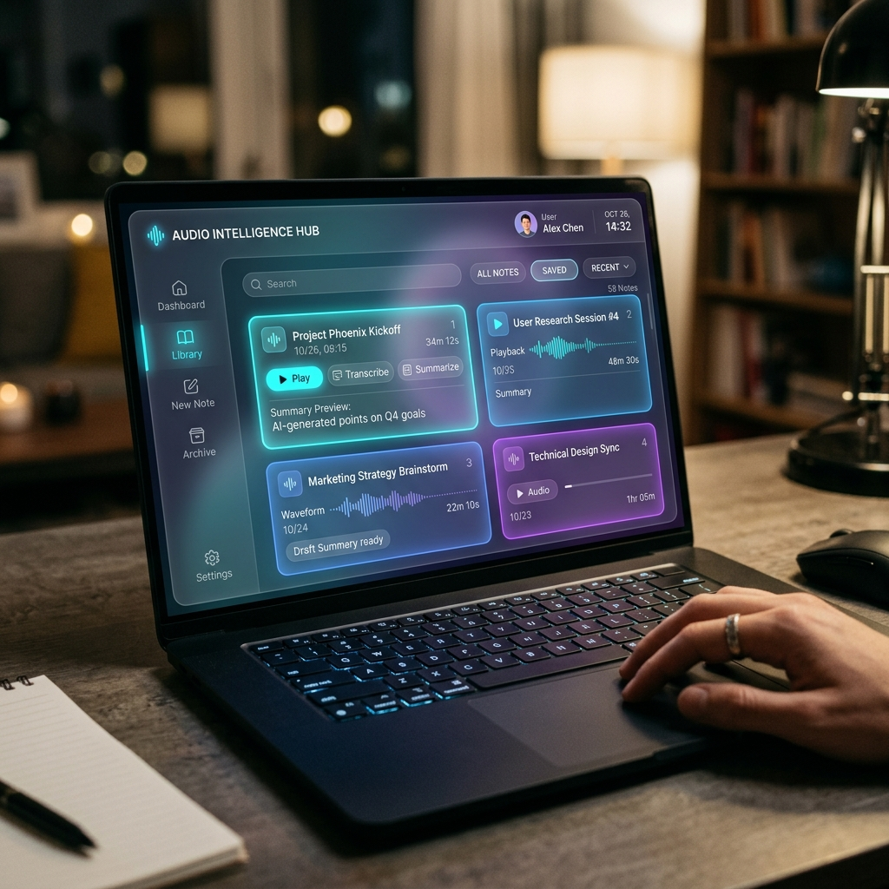

2.1 SPEECH-TO-TEXT (STT) TECHNOLOGIES AND PROCESSING METHODS
Speech-to-Text (STT) technology is the core engine of any audio-to-note application. It involves the real-time or batch conversion of acoustic signals into digital text. The effectiveness of these technologies depends heavily on the underlying models and the quality of the input audio. As we explore STT technologies, we must look at how digital signal processing (DSP) interacts with deep learning to provide near-instantaneous transcription.
Speech-to-Text (STT) technology is the core engine of any audio-to-note application. It involves the real-time or batch conversion of acoustic signals into digital text. The effectiveness of these technologies depends heavily on the underlying models and the quality of the input audio. As we explore STT technologies, we must look at how digital signal processing (DSP) interacts with deep learning to provide near-instantaneous transcription.
Speech-to-Text (STT) technology is the core engine of any audio-to-note application. It involves the real-time or batch conversion of acoustic signals into digital text. The effectiveness of these technologies depends heavily on the underlying models and the quality of the input audio. As we explore STT technologies, we must look at how digital signal processing (DSP) interacts with deep learning to provide near-instantaneous transcription.

2.1.1 TYPES OF AUDIO INPUTS
Audio inputs in transcription systems generally fall into several categories, each presenting unique challenges. Live audio streams require real-time processing with minimal latency, placing constraints on model complexity. Pre-recorded audio files, on the other hand, allow for batch processing using heavier, more accurate models. The acoustic environment also dictates the type of input: studio-quality recordings yield high accuracy, whereas field recordings often contain background noise, reverberation, and overlapping speech.
Audio inputs in transcription systems generally fall into several categories, each presenting unique challenges. Live audio streams require real-time processing with minimal latency, placing constraints on model complexity. Pre-recorded audio files, on the other hand, allow for batch processing using heavier, more accurate models. The acoustic environment also dictates the type of input: studio-quality recordings yield high accuracy, whereas field recordings often contain background noise, reverberation, and overlapping speech.
Audio inputs in transcription systems generally fall into several categories, each presenting unique challenges. Live audio streams require real-time processing with minimal latency, placing constraints on model complexity. Pre-recorded audio files, on the other hand, allow for batch processing using heavier, more accurate models. The acoustic environment also dictates the type of input: studio-quality recordings yield high accuracy, whereas field recordings often contain background noise, reverberation, and overlapping speech.
Audio inputs in transcription systems generally fall into several categories, each presenting unique challenges. Live audio streams require real-time processing with minimal latency, placing constraints on model complexity. Pre-recorded audio files, on the other hand, allow for batch processing using heavier, more accurate models. The acoustic environment also dictates the type of input: studio-quality recordings yield high accuracy, whereas field recordings often contain background noise, reverberation, and overlapping speech.
Figure 2.2: Mobile Device Mockup for capturing live audio streams.
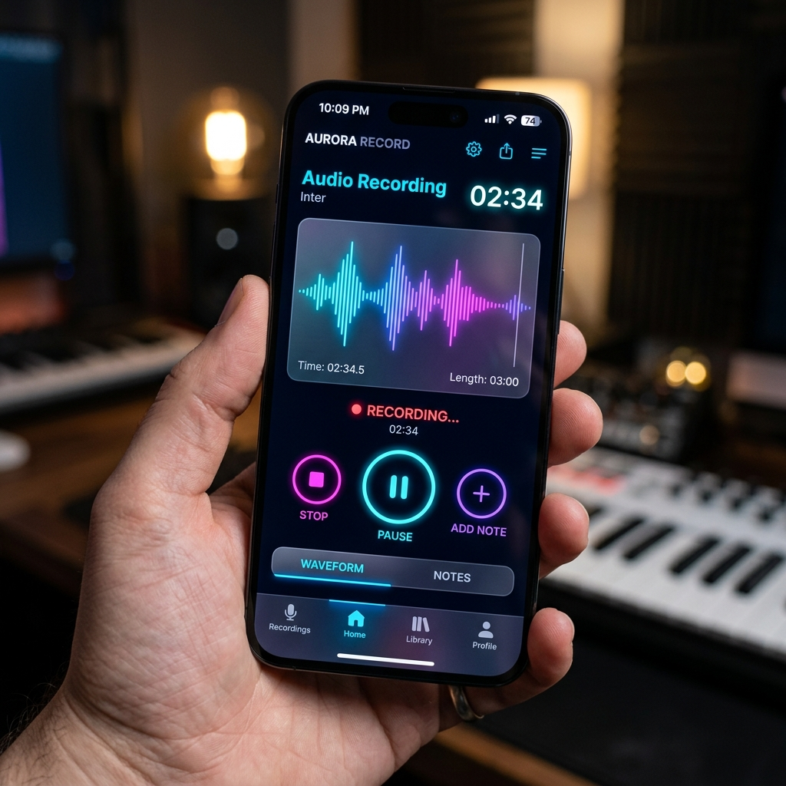

2.1.2 SPEECH RECOGNITION METHODS
Modern speech recognition methods have largely transitioned from statistical models to deep learning approaches. This paradigm shift was driven by the availability of massive datasets and advanced computational resources like GPUs.
Modern speech recognition methods have largely transitioned from statistical models to deep learning approaches. This paradigm shift was driven by the availability of massive datasets and advanced computational resources like GPUs.
Modern speech recognition methods have largely transitioned from statistical models to deep learning approaches. This paradigm shift was driven by the availability of massive datasets and advanced computational resources like GPUs.

2.1.2.1 ACOUSTIC MODELING
Acoustic modeling involves mapping the audio signal representations (often Mel-Frequency Cepstral Coefficients, or MFCCs) to phonemes, the basic units of sound. Traditionally, Hidden Markov Models (HMMs) were used for this purpose. However, contemporary systems employ Deep Neural Networks (DNNs), Recurrent Neural Networks (RNNs), and Convolutional Neural Networks (CNNs) to achieve superior feature abstraction and accuracy. By understanding the acoustic envelope of various sounds, the models can accurately delineate the spectral frequencies of speech from non-speech elements.
Acoustic modeling involves mapping the audio signal representations (often Mel-Frequency Cepstral Coefficients, or MFCCs) to phonemes, the basic units of sound. Traditionally, Hidden Markov Models (HMMs) were used for this purpose. However, contemporary systems employ Deep Neural Networks (DNNs), Recurrent Neural Networks (RNNs), and Convolutional Neural Networks (CNNs) to achieve superior feature abstraction and accuracy. By understanding the acoustic envelope of various sounds, the models can accurately delineate the spectral frequencies of speech from non-speech elements.
Acoustic modeling involves mapping the audio signal representations (often Mel-Frequency Cepstral Coefficients, or MFCCs) to phonemes, the basic units of sound. Traditionally, Hidden Markov Models (HMMs) were used for this purpose. However, contemporary systems employ Deep Neural Networks (DNNs), Recurrent Neural Networks (RNNs), and Convolutional Neural Networks (CNNs) to achieve superior feature abstraction and accuracy. By understanding the acoustic envelope of various sounds, the models can accurately delineate the spectral frequencies of speech from non-speech elements.
Acoustic modeling involves mapping the audio signal representations (often Mel-Frequency Cepstral Coefficients, or MFCCs) to phonemes, the basic units of sound. Traditionally, Hidden Markov Models (HMMs) were used for this purpose. However, contemporary systems employ Deep Neural Networks (DNNs), Recurrent Neural Networks (RNNs), and Convolutional Neural Networks (CNNs) to achieve superior feature abstraction and accuracy. By understanding the acoustic envelope of various sounds, the models can accurately delineate the spectral frequencies of speech from non-speech elements.

2.1.2.2 LANGUAGE MODELING
Language modeling works in tandem with the acoustic model to determine the probability of a given sequence of words. It provides contextual clues that help the system distinguish between homophones (e.g., 'write' vs 'right'). Transformer-based architectures have recently dominated this space, offering vast improvements in contextual awareness over long sequences of speech.
Language modeling works in tandem with the acoustic model to determine the probability of a given sequence of words. It provides contextual clues that help the system distinguish between homophones (e.g., 'write' vs 'right'). Transformer-based architectures have recently dominated this space, offering vast improvements in contextual awareness over long sequences of speech.
Language modeling works in tandem with the acoustic model to determine the probability of a given sequence of words. It provides contextual clues that help the system distinguish between homophones (e.g., 'write' vs 'right'). Transformer-based architectures have recently dominated this space, offering vast improvements in contextual awareness over long sequences of speech.
Language modeling works in tandem with the acoustic model to determine the probability of a given sequence of words. It provides contextual clues that help the system distinguish between homophones (e.g., 'write' vs 'right'). Transformer-based architectures have recently dominated this space, offering vast improvements in contextual awareness over long sequences of speech.

2.1.3 AUDIO ANALYSIS AND PROCESSING TECHNIQUES

2.1.3.1 PRE-PROCESSING AND NOISE REDUCTION
Before audio can be fed into an AI model, it must be pre-processed. This involves normalizing audio levels, removing silences, and applying noise reduction algorithms. Spectral gating and adaptive filtering are commonly used to isolate human speech from ambient background noise, which is critical for maintaining high transcription fidelity.
Before audio can be fed into an AI model, it must be pre-processed. This involves normalizing audio levels, removing silences, and applying noise reduction algorithms. Spectral gating and adaptive filtering are commonly used to isolate human speech from ambient background noise, which is critical for maintaining high transcription fidelity.
Before audio can be fed into an AI model, it must be pre-processed. This involves normalizing audio levels, removing silences, and applying noise reduction algorithms. Spectral gating and adaptive filtering are commonly used to isolate human speech from ambient background noise, which is critical for maintaining high transcription fidelity.

2.1.3.2 FEATURE EXTRACTION
Feature extraction is the process of converting the raw audio waveform into a mathematical representation that the AI can understand. Spectrograms and MFCCs are the standard features extracted, capturing both the temporal and spectral properties of the speech signal. Advanced models may also utilize learned features instead of handcrafted ones, optimizing the extraction phase for specific types of vocal input.
Feature extraction is the process of converting the raw audio waveform into a mathematical representation that the AI can understand. Spectrograms and MFCCs are the standard features extracted, capturing both the temporal and spectral properties of the speech signal. Advanced models may also utilize learned features instead of handcrafted ones, optimizing the extraction phase for specific types of vocal input.
Feature extraction is the process of converting the raw audio waveform into a mathematical representation that the AI can understand. Spectrograms and MFCCs are the standard features extracted, capturing both the temporal and spectral properties of the speech signal. Advanced models may also utilize learned features instead of handcrafted ones, optimizing the extraction phase for specific types of vocal input.
Feature extraction is the process of converting the raw audio waveform into a mathematical representation that the AI can understand. Spectrograms and MFCCs are the standard features extracted, capturing both the temporal and spectral properties of the speech signal. Advanced models may also utilize learned features instead of handcrafted ones, optimizing the extraction phase for specific types of vocal input.
Figure 2.3: Visualization of AI Audio Processing and Feature Extraction
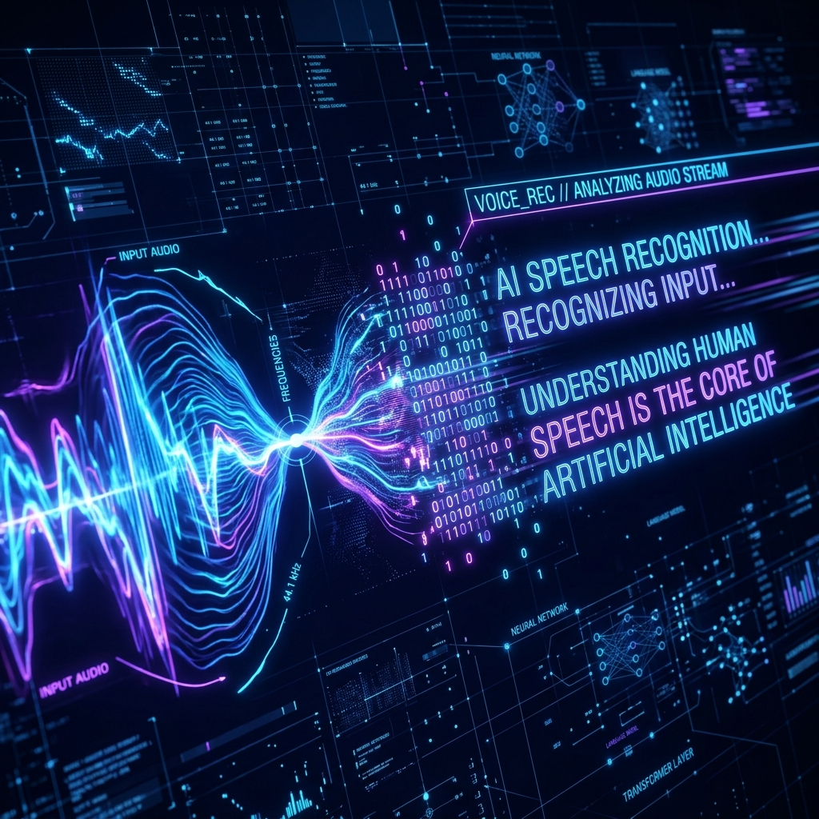

2.1.3.3 SPEAKER DIARIZATION
Speaker diarization is the process of partitioning an audio stream into homogeneous segments according to the speaker identity—essentially answering 'who spoke when.' This is particularly vital in meeting notes and interview transcription, where distinguishing between different contributors provides necessary context. Diarization algorithms utilize clustering techniques to group similar vocal features together, often employing embeddings derived from deep neural networks trained specifically on speaker verification tasks.
Speaker diarization is the process of partitioning an audio stream into homogeneous segments according to the speaker identity—essentially answering 'who spoke when.' This is particularly vital in meeting notes and interview transcription, where distinguishing between different contributors provides necessary context. Diarization algorithms utilize clustering techniques to group similar vocal features together, often employing embeddings derived from deep neural networks trained specifically on speaker verification tasks.
Speaker diarization is the process of partitioning an audio stream into homogeneous segments according to the speaker identity—essentially answering 'who spoke when.' This is particularly vital in meeting notes and interview transcription, where distinguishing between different contributors provides necessary context. Diarization algorithms utilize clustering techniques to group similar vocal features together, often employing embeddings derived from deep neural networks trained specifically on speaker verification tasks.
Speaker diarization is the process of partitioning an audio stream into homogeneous segments according to the speaker identity—essentially answering 'who spoke when.' This is particularly vital in meeting notes and interview transcription, where distinguishing between different contributors provides necessary context. Diarization algorithms utilize clustering techniques to group similar vocal features together, often employing embeddings derived from deep neural networks trained specifically on speaker verification tasks.

2.2 NATURAL LANGUAGE PROCESSING (NLP) FOR SUMMARIZATION
Once the audio has been converted to raw text, Natural Language Processing (NLP) techniques are applied to generate intelligent summaries and structured notes. Summarization is broadly categorized into two approaches: extractive and abstractive. The primary objective is to condense the information without losing the semantic meaning or the critical insights communicated during the audio session.
Once the audio has been converted to raw text, Natural Language Processing (NLP) techniques are applied to generate intelligent summaries and structured notes. Summarization is broadly categorized into two approaches: extractive and abstractive. The primary objective is to condense the information without losing the semantic meaning or the critical insights communicated during the audio session.
Once the audio has been converted to raw text, Natural Language Processing (NLP) techniques are applied to generate intelligent summaries and structured notes. Summarization is broadly categorized into two approaches: extractive and abstractive. The primary objective is to condense the information without losing the semantic meaning or the critical insights communicated during the audio session.
Once the audio has been converted to raw text, Natural Language Processing (NLP) techniques are applied to generate intelligent summaries and structured notes. Summarization is broadly categorized into two approaches: extractive and abstractive. The primary objective is to condense the information without losing the semantic meaning or the critical insights communicated during the audio session.

2.2.1 EXTRACTIVE SUMMARIZATION
Extractive summarization involves analyzing the text and extracting the most important sentences exactly as they appear in the original transcript. Algorithms like TextRank and TF-IDF are traditionally used to score sentences based on keyword frequency and centrality. While computationally efficient, extractive summaries often lack flow and coherence, as they merely stitch together disparate sentences without adapting the narrative. This limits its effectiveness for generating comprehensive study notes.
Extractive summarization involves analyzing the text and extracting the most important sentences exactly as they appear in the original transcript. Algorithms like TextRank and TF-IDF are traditionally used to score sentences based on keyword frequency and centrality. While computationally efficient, extractive summaries often lack flow and coherence, as they merely stitch together disparate sentences without adapting the narrative. This limits its effectiveness for generating comprehensive study notes.
Extractive summarization involves analyzing the text and extracting the most important sentences exactly as they appear in the original transcript. Algorithms like TextRank and TF-IDF are traditionally used to score sentences based on keyword frequency and centrality. While computationally efficient, extractive summaries often lack flow and coherence, as they merely stitch together disparate sentences without adapting the narrative. This limits its effectiveness for generating comprehensive study notes.
Extractive summarization involves analyzing the text and extracting the most important sentences exactly as they appear in the original transcript. Algorithms like TextRank and TF-IDF are traditionally used to score sentences based on keyword frequency and centrality. While computationally efficient, extractive summaries often lack flow and coherence, as they merely stitch together disparate sentences without adapting the narrative. This limits its effectiveness for generating comprehensive study notes.

2.2.2 ABSTRACTIVE SUMMARIZATION
Abstractive summarization, conversely, attempts to understand the semantic meaning of the text and generate a summary using novel sentences, much like a human would. This requires sophisticated generative AI models, such as those based on the Transformer architecture (e.g., Google's Gemini, OpenAI's GPT models). These models can digest lengthy transcripts, identify overarching themes, and articulate concise, grammatically correct summaries that highlight key action items and concepts. In AudioNote AI, abstractive summarization forms the backbone of the note-generation pipeline, converting verbatim transcripts into formatted markdown elements.
Abstractive summarization, conversely, attempts to understand the semantic meaning of the text and generate a summary using novel sentences, much like a human would. This requires sophisticated generative AI models, such as those based on the Transformer architecture (e.g., Google's Gemini, OpenAI's GPT models). These models can digest lengthy transcripts, identify overarching themes, and articulate concise, grammatically correct summaries that highlight key action items and concepts. In AudioNote AI, abstractive summarization forms the backbone of the note-generation pipeline, converting verbatim transcripts into formatted markdown elements.
Abstractive summarization, conversely, attempts to understand the semantic meaning of the text and generate a summary using novel sentences, much like a human would. This requires sophisticated generative AI models, such as those based on the Transformer architecture (e.g., Google's Gemini, OpenAI's GPT models). These models can digest lengthy transcripts, identify overarching themes, and articulate concise, grammatically correct summaries that highlight key action items and concepts. In AudioNote AI, abstractive summarization forms the backbone of the note-generation pipeline, converting verbatim transcripts into formatted markdown elements.
Abstractive summarization, conversely, attempts to understand the semantic meaning of the text and generate a summary using novel sentences, much like a human would. This requires sophisticated generative AI models, such as those based on the Transformer architecture (e.g., Google's Gemini, OpenAI's GPT models). These models can digest lengthy transcripts, identify overarching themes, and articulate concise, grammatically correct summaries that highlight key action items and concepts. In AudioNote AI, abstractive summarization forms the backbone of the note-generation pipeline, converting verbatim transcripts into formatted markdown elements.
Abstractive summarization, conversely, attempts to understand the semantic meaning of the text and generate a summary using novel sentences, much like a human would. This requires sophisticated generative AI models, such as those based on the Transformer architecture (e.g., Google's Gemini, OpenAI's GPT models). These models can digest lengthy transcripts, identify overarching themes, and articulate concise, grammatically correct summaries that highlight key action items and concepts. In AudioNote AI, abstractive summarization forms the backbone of the note-generation pipeline, converting verbatim transcripts into formatted markdown elements.

2.2.3 KEYWORD AND TOPIC EXTRACTION
Beyond summarization, NLP is utilized to extract critical metadata from the text, such as primary topics, recurring keywords, and sentiment. Named Entity Recognition (NER) algorithms identify proper nouns, dates, and locations. In the context of the AudioNote AI platform, this allows the system to automatically generate a topic hierarchy and tag the document for easy searchability. This level of structuring is essential for building extensive knowledge bases from unstructured audio data.
Beyond summarization, NLP is utilized to extract critical metadata from the text, such as primary topics, recurring keywords, and sentiment. Named Entity Recognition (NER) algorithms identify proper nouns, dates, and locations. In the context of the AudioNote AI platform, this allows the system to automatically generate a topic hierarchy and tag the document for easy searchability. This level of structuring is essential for building extensive knowledge bases from unstructured audio data.
Beyond summarization, NLP is utilized to extract critical metadata from the text, such as primary topics, recurring keywords, and sentiment. Named Entity Recognition (NER) algorithms identify proper nouns, dates, and locations. In the context of the AudioNote AI platform, this allows the system to automatically generate a topic hierarchy and tag the document for easy searchability. This level of structuring is essential for building extensive knowledge bases from unstructured audio data.
Beyond summarization, NLP is utilized to extract critical metadata from the text, such as primary topics, recurring keywords, and sentiment. Named Entity Recognition (NER) algorithms identify proper nouns, dates, and locations. In the context of the AudioNote AI platform, this allows the system to automatically generate a topic hierarchy and tag the document for easy searchability. This level of structuring is essential for building extensive knowledge bases from unstructured audio data.

Table 2.1: Comparison of Summarization Techniques
Technique | Mechanism | Pros & Cons
Extractive | Selects and compiles existing sentences from text. | Pro: High factual accuracy. Con: Poor readability.
Abstractive | Generates new sentences capturing core meaning. | Pro: Human-like, concise. Con: Risk of hallucination.

2.3 CHALLENGES IN AUTOMATED AUDIO TRANSCRIPTION
While AI transcription has reached near-human parity in ideal conditions, real-world deployment faces numerous hurdles that can degrade performance. These challenges include acoustic environmental factors, linguistic diversity, and the strict constraints of real-time application processing.
While AI transcription has reached near-human parity in ideal conditions, real-world deployment faces numerous hurdles that can degrade performance. These challenges include acoustic environmental factors, linguistic diversity, and the strict constraints of real-time application processing.
While AI transcription has reached near-human parity in ideal conditions, real-world deployment faces numerous hurdles that can degrade performance. These challenges include acoustic environmental factors, linguistic diversity, and the strict constraints of real-time application processing.

2.3.1 BACKGROUND NOISE AND AUDIO QUALITY
Low signal-to-noise ratio (SNR) is the most prominent cause of transcription errors. Classrooms, coffee shops, and large conference halls introduce reverberation and ambient noise that mask acoustic features. Advanced noise suppression models are required to isolate the vocal frequencies prior to processing. If the source audio is heavily distorted, even the most sophisticated NLP models will fail to accurately reconstruct the text.
Low signal-to-noise ratio (SNR) is the most prominent cause of transcription errors. Classrooms, coffee shops, and large conference halls introduce reverberation and ambient noise that mask acoustic features. Advanced noise suppression models are required to isolate the vocal frequencies prior to processing. If the source audio is heavily distorted, even the most sophisticated NLP models will fail to accurately reconstruct the text.
Low signal-to-noise ratio (SNR) is the most prominent cause of transcription errors. Classrooms, coffee shops, and large conference halls introduce reverberation and ambient noise that mask acoustic features. Advanced noise suppression models are required to isolate the vocal frequencies prior to processing. If the source audio is heavily distorted, even the most sophisticated NLP models will fail to accurately reconstruct the text.
Low signal-to-noise ratio (SNR) is the most prominent cause of transcription errors. Classrooms, coffee shops, and large conference halls introduce reverberation and ambient noise that mask acoustic features. Advanced noise suppression models are required to isolate the vocal frequencies prior to processing. If the source audio is heavily distorted, even the most sophisticated NLP models will fail to accurately reconstruct the text.

2.3.2 ACCENTS AND DIALECT VARIATIONS
Speech recognition models are often biased towards the accents represented in their training data (typically standard American or British English). Global deployments must account for diverse accents and regional dialects. Multilingual and cross-lingual transfer learning techniques are being employed to make models more robust to these variations. Additionally, the translation component of an application is heavily reliant on accurately deciphering the original dialect before converting it to the target language.
Speech recognition models are often biased towards the accents represented in their training data (typically standard American or British English). Global deployments must account for diverse accents and regional dialects. Multilingual and cross-lingual transfer learning techniques are being employed to make models more robust to these variations. Additionally, the translation component of an application is heavily reliant on accurately deciphering the original dialect before converting it to the target language.
Speech recognition models are often biased towards the accents represented in their training data (typically standard American or British English). Global deployments must account for diverse accents and regional dialects. Multilingual and cross-lingual transfer learning techniques are being employed to make models more robust to these variations. Additionally, the translation component of an application is heavily reliant on accurately deciphering the original dialect before converting it to the target language.
Speech recognition models are often biased towards the accents represented in their training data (typically standard American or British English). Global deployments must account for diverse accents and regional dialects. Multilingual and cross-lingual transfer learning techniques are being employed to make models more robust to these variations. Additionally, the translation component of an application is heavily reliant on accurately deciphering the original dialect before converting it to the target language.
Speech recognition models are often biased towards the accents represented in their training data (typically standard American or British English). Global deployments must account for diverse accents and regional dialects. Multilingual and cross-lingual transfer learning techniques are being employed to make models more robust to these variations. Additionally, the translation component of an application is heavily reliant on accurately deciphering the original dialect before converting it to the target language.
Figure 2.4: Multilingual Translation AI Architecture linking distinct languages.
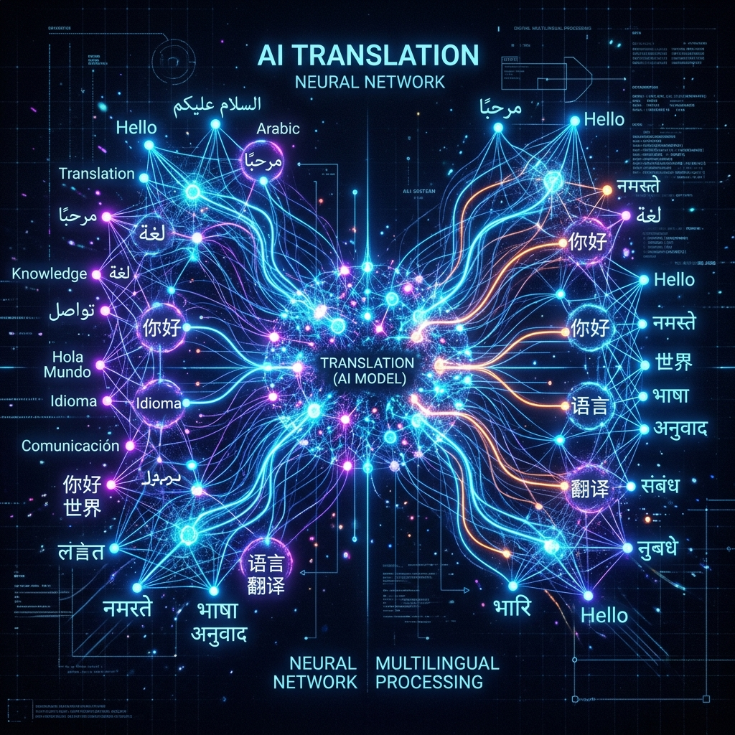

2.4 MACHINE LEARNING APPROACHES IN AUDIO-TO-NOTE SYSTEMS
The architecture of an audio-to-note system is heavily reliant on machine learning frameworks that dictate how data is trained and inferred. These approaches span from traditional supervised learning techniques to the modern deployment of unsupervised and self-supervised models. The efficiency of these models governs the latency and scalability of the overall application.
The architecture of an audio-to-note system is heavily reliant on machine learning frameworks that dictate how data is trained and inferred. These approaches span from traditional supervised learning techniques to the modern deployment of unsupervised and self-supervised models. The efficiency of these models governs the latency and scalability of the overall application.
The architecture of an audio-to-note system is heavily reliant on machine learning frameworks that dictate how data is trained and inferred. These approaches span from traditional supervised learning techniques to the modern deployment of unsupervised and self-supervised models. The efficiency of these models governs the latency and scalability of the overall application.
The architecture of an audio-to-note system is heavily reliant on machine learning frameworks that dictate how data is trained and inferred. These approaches span from traditional supervised learning techniques to the modern deployment of unsupervised and self-supervised models. The efficiency of these models governs the latency and scalability of the overall application.
Figure 2.5: Complex Database Schema mapping Machine Learning components.


2.4.1 FEATURE EXTRACTION TECHNIQUES FOR AUDIO
Machine learning models require highly optimized feature vectors. The transition from handcrafted features to learned representations using autoencoders has improved the robustness of ASR systems. Self-supervised learning models, such as wav2vec, learn representations directly from raw audio without requiring extensive labeled datasets. This approach allows the models to understand the underlying structure of speech before they are fine-tuned on specific transcription tasks. These techniques dramatically reduce the amount of human-labeled data required to achieve state-of-the-art performance.
Machine learning models require highly optimized feature vectors. The transition from handcrafted features to learned representations using autoencoders has improved the robustness of ASR systems. Self-supervised learning models, such as wav2vec, learn representations directly from raw audio without requiring extensive labeled datasets. This approach allows the models to understand the underlying structure of speech before they are fine-tuned on specific transcription tasks. These techniques dramatically reduce the amount of human-labeled data required to achieve state-of-the-art performance.
Machine learning models require highly optimized feature vectors. The transition from handcrafted features to learned representations using autoencoders has improved the robustness of ASR systems. Self-supervised learning models, such as wav2vec, learn representations directly from raw audio without requiring extensive labeled datasets. This approach allows the models to understand the underlying structure of speech before they are fine-tuned on specific transcription tasks. These techniques dramatically reduce the amount of human-labeled data required to achieve state-of-the-art performance.
Machine learning models require highly optimized feature vectors. The transition from handcrafted features to learned representations using autoencoders has improved the robustness of ASR systems. Self-supervised learning models, such as wav2vec, learn representations directly from raw audio without requiring extensive labeled datasets. This approach allows the models to understand the underlying structure of speech before they are fine-tuned on specific transcription tasks. These techniques dramatically reduce the amount of human-labeled data required to achieve state-of-the-art performance.
Machine learning models require highly optimized feature vectors. The transition from handcrafted features to learned representations using autoencoders has improved the robustness of ASR systems. Self-supervised learning models, such as wav2vec, learn representations directly from raw audio without requiring extensive labeled datasets. This approach allows the models to understand the underlying structure of speech before they are fine-tuned on specific transcription tasks. These techniques dramatically reduce the amount of human-labeled data required to achieve state-of-the-art performance.
Furthermore, continuous advancements in deep learning frameworks like TensorFlow and PyTorch have enabled the rapid prototyping and deployment of these complex models. The integration of edge computing allows for partial processing of these features on the mobile device itself, reducing the payload size transmitted to the backend servers and thereby minimizing latency. Cloud-native database solutions, such as PostgreSQL deployed with Prisma ORM, provide the essential infrastructure to catalog these massive arrays of feature vectors, ensuring quick retrieval and indexing for the end user.
Furthermore, continuous advancements in deep learning frameworks like TensorFlow and PyTorch have enabled the rapid prototyping and deployment of these complex models. The integration of edge computing allows for partial processing of these features on the mobile device itself, reducing the payload size transmitted to the backend servers and thereby minimizing latency. Cloud-native database solutions, such as PostgreSQL deployed with Prisma ORM, provide the essential infrastructure to catalog these massive arrays of feature vectors, ensuring quick retrieval and indexing for the end user.
Furthermore, continuous advancements in deep learning frameworks like TensorFlow and PyTorch have enabled the rapid prototyping and deployment of these complex models. The integration of edge computing allows for partial processing of these features on the mobile device itself, reducing the payload size transmitted to the backend servers and thereby minimizing latency. Cloud-native database solutions, such as PostgreSQL deployed with Prisma ORM, provide the essential infrastructure to catalog these massive arrays of feature vectors, ensuring quick retrieval and indexing for the end user.
Furthermore, continuous advancements in deep learning frameworks like TensorFlow and PyTorch have enabled the rapid prototyping and deployment of these complex models. The integration of edge computing allows for partial processing of these features on the mobile device itself, reducing the payload size transmitted to the backend servers and thereby minimizing latency. Cloud-native database solutions, such as PostgreSQL deployed with Prisma ORM, provide the essential infrastructure to catalog these massive arrays of feature vectors, ensuring quick retrieval and indexing for the end user.
Furthermore, continuous advancements in deep learning frameworks like TensorFlow and PyTorch have enabled the rapid prototyping and deployment of these complex models. The integration of edge computing allows for partial processing of these features on the mobile device itself, reducing the payload size transmitted to the backend servers and thereby minimizing latency. Cloud-native database solutions, such as PostgreSQL deployed with Prisma ORM, provide the essential infrastructure to catalog these massive arrays of feature vectors, ensuring quick retrieval and indexing for the end user.
Furthermore, continuous advancements in deep learning frameworks like TensorFlow and PyTorch have enabled the rapid prototyping and deployment of these complex models. The integration of edge computing allows for partial processing of these features on the mobile device itself, reducing the payload size transmitted to the backend servers and thereby minimizing latency. Cloud-native database solutions, such as PostgreSQL deployed with Prisma ORM, provide the essential infrastructure to catalog these massive arrays of feature vectors, ensuring quick retrieval and indexing for the end user.
Furthermore, continuous advancements in deep learning frameworks like TensorFlow and PyTorch have enabled the rapid prototyping and deployment of these complex models. The integration of edge computing allows for partial processing of these features on the mobile device itself, reducing the payload size transmitted to the backend servers and thereby minimizing latency. Cloud-native database solutions, such as PostgreSQL deployed with Prisma ORM, provide the essential infrastructure to catalog these massive arrays of feature vectors, ensuring quick retrieval and indexing for the end user.
Furthermore, continuous advancements in deep learning frameworks like TensorFlow and PyTorch have enabled the rapid prototyping and deployment of these complex models. The integration of edge computing allows for partial processing of these features on the mobile device itself, reducing the payload size transmitted to the backend servers and thereby minimizing latency. Cloud-native database solutions, such as PostgreSQL deployed with Prisma ORM, provide the essential infrastructure to catalog these massive arrays of feature vectors, ensuring quick retrieval and indexing for the end user.
Furthermore, continuous advancements in deep learning frameworks like TensorFlow and PyTorch have enabled the rapid prototyping and deployment of these complex models. The integration of edge computing allows for partial processing of these features on the mobile device itself, reducing the payload size transmitted to the backend servers and thereby minimizing latency. Cloud-native database solutions, such as PostgreSQL deployed with Prisma ORM, provide the essential infrastructure to catalog these massive arrays of feature vectors, ensuring quick retrieval and indexing for the end user.
Furthermore, continuous advancements in deep learning frameworks like TensorFlow and PyTorch have enabled the rapid prototyping and deployment of these complex models. The integration of edge computing allows for partial processing of these features on the mobile device itself, reducing the payload size transmitted to the backend servers and thereby minimizing latency. Cloud-native database solutions, such as PostgreSQL deployed with Prisma ORM, provide the essential infrastructure to catalog these massive arrays of feature vectors, ensuring quick retrieval and indexing for the end user.
Furthermore, continuous advancements in deep learning frameworks like TensorFlow and PyTorch have enabled the rapid prototyping and deployment of these complex models. The integration of edge computing allows for partial processing of these features on the mobile device itself, reducing the payload size transmitted to the backend servers and thereby minimizing latency. Cloud-native database solutions, such as PostgreSQL deployed with Prisma ORM, provide the essential infrastructure to catalog these massive arrays of feature vectors, ensuring quick retrieval and indexing for the end user.
Furthermore, continuous advancements in deep learning frameworks like TensorFlow and PyTorch have enabled the rapid prototyping and deployment of these complex models. The integration of edge computing allows for partial processing of these features on the mobile device itself, reducing the payload size transmitted to the backend servers and thereby minimizing latency. Cloud-native database solutions, such as PostgreSQL deployed with Prisma ORM, provide the essential infrastructure to catalog these massive arrays of feature vectors, ensuring quick retrieval and indexing for the end user.
Furthermore, continuous advancements in deep learning frameworks like TensorFlow and PyTorch have enabled the rapid prototyping and deployment of these complex models. The integration of edge computing allows for partial processing of these features on the mobile device itself, reducing the payload size transmitted to the backend servers and thereby minimizing latency. Cloud-native database solutions, such as PostgreSQL deployed with Prisma ORM, provide the essential infrastructure to catalog these massive arrays of feature vectors, ensuring quick retrieval and indexing for the end user.
Furthermore, continuous advancements in deep learning frameworks like TensorFlow and PyTorch have enabled the rapid prototyping and deployment of these complex models. The integration of edge computing allows for partial processing of these features on the mobile device itself, reducing the payload size transmitted to the backend servers and thereby minimizing latency. Cloud-native database solutions, such as PostgreSQL deployed with Prisma ORM, provide the essential infrastructure to catalog these massive arrays of feature vectors, ensuring quick retrieval and indexing for the end user.
Furthermore, continuous advancements in deep learning frameworks like TensorFlow and PyTorch have enabled the rapid prototyping and deployment of these complex models. The integration of edge computing allows for partial processing of these features on the mobile device itself, reducing the payload size transmitted to the backend servers and thereby minimizing latency. Cloud-native database solutions, such as PostgreSQL deployed with Prisma ORM, provide the essential infrastructure to catalog these massive arrays of feature vectors, ensuring quick retrieval and indexing for the end user.

2.5 ADVANCEMENTS IN MULTIMODAL AI AND LARGE LANGUAGE MODELS
The most significant recent breakthrough in the field is the development of multimodal Large Language Models (LLMs). Unlike previous generations that required a pipeline of separate models (Audio -> Text -> Summarize), multimodal models can natively accept audio files as input and generate structured text as output. This unified architecture prevents the cascading errors that occur when a transcription mistake is passed down into the summarization algorithm.
The most significant recent breakthrough in the field is the development of multimodal Large Language Models (LLMs). Unlike previous generations that required a pipeline of separate models (Audio -> Text -> Summarize), multimodal models can natively accept audio files as input and generate structured text as output. This unified architecture prevents the cascading errors that occur when a transcription mistake is passed down into the summarization algorithm.
The most significant recent breakthrough in the field is the development of multimodal Large Language Models (LLMs). Unlike previous generations that required a pipeline of separate models (Audio -> Text -> Summarize), multimodal models can natively accept audio files as input and generate structured text as output. This unified architecture prevents the cascading errors that occur when a transcription mistake is passed down into the summarization algorithm.
The most significant recent breakthrough in the field is the development of multimodal Large Language Models (LLMs). Unlike previous generations that required a pipeline of separate models (Audio -> Text -> Summarize), multimodal models can natively accept audio files as input and generate structured text as output. This unified architecture prevents the cascading errors that occur when a transcription mistake is passed down into the summarization algorithm.
The most significant recent breakthrough in the field is the development of multimodal Large Language Models (LLMs). Unlike previous generations that required a pipeline of separate models (Audio -> Text -> Summarize), multimodal models can natively accept audio files as input and generate structured text as output. This unified architecture prevents the cascading errors that occur when a transcription mistake is passed down into the summarization algorithm.

2.5.1 GENERATIVE AI FOR TEXT SYNTHESIS
Generative AI models, specifically those utilizing the Transformer architecture, excel at understanding long-range dependencies in text. This allows the AudioNote system to read an entire 1-hour lecture transcript and synthesize a highly accurate, properly formatted markdown document that categorizes main ideas, highlights important vocabulary, and outlines action items. The generative capabilities also extend to creating quiz questions, dynamically assessing the user's comprehension of the material.
Generative AI models, specifically those utilizing the Transformer architecture, excel at understanding long-range dependencies in text. This allows the AudioNote system to read an entire 1-hour lecture transcript and synthesize a highly accurate, properly formatted markdown document that categorizes main ideas, highlights important vocabulary, and outlines action items. The generative capabilities also extend to creating quiz questions, dynamically assessing the user's comprehension of the material.
Generative AI models, specifically those utilizing the Transformer architecture, excel at understanding long-range dependencies in text. This allows the AudioNote system to read an entire 1-hour lecture transcript and synthesize a highly accurate, properly formatted markdown document that categorizes main ideas, highlights important vocabulary, and outlines action items. The generative capabilities also extend to creating quiz questions, dynamically assessing the user's comprehension of the material.
Generative AI models, specifically those utilizing the Transformer architecture, excel at understanding long-range dependencies in text. This allows the AudioNote system to read an entire 1-hour lecture transcript and synthesize a highly accurate, properly formatted markdown document that categorizes main ideas, highlights important vocabulary, and outlines action items. The generative capabilities also extend to creating quiz questions, dynamically assessing the user's comprehension of the material.
Generative AI models, specifically those utilizing the Transformer architecture, excel at understanding long-range dependencies in text. This allows the AudioNote system to read an entire 1-hour lecture transcript and synthesize a highly accurate, properly formatted markdown document that categorizes main ideas, highlights important vocabulary, and outlines action items. The generative capabilities also extend to creating quiz questions, dynamically assessing the user's comprehension of the material.

2.5.2 MULTIMODAL CAPABILITIES (AUDIO & TEXT)
Models such as Google's Gemini 2.5 Flash represent the frontier of this technology. By processing the audio spectrograms directly alongside text prompts, these models avoid the compounding errors associated with a cascading pipeline. If a spoken word is ambiguous, the model can use the surrounding semantic context to deduce the correct transcription natively. The ability to parse audio and text in tandem unlocks immense potential for applications demanding real-time cognitive insights.
Models such as Google's Gemini 2.5 Flash represent the frontier of this technology. By processing the audio spectrograms directly alongside text prompts, these models avoid the compounding errors associated with a cascading pipeline. If a spoken word is ambiguous, the model can use the surrounding semantic context to deduce the correct transcription natively. The ability to parse audio and text in tandem unlocks immense potential for applications demanding real-time cognitive insights.
Models such as Google's Gemini 2.5 Flash represent the frontier of this technology. By processing the audio spectrograms directly alongside text prompts, these models avoid the compounding errors associated with a cascading pipeline. If a spoken word is ambiguous, the model can use the surrounding semantic context to deduce the correct transcription natively. The ability to parse audio and text in tandem unlocks immense potential for applications demanding real-time cognitive insights.
Models such as Google's Gemini 2.5 Flash represent the frontier of this technology. By processing the audio spectrograms directly alongside text prompts, these models avoid the compounding errors associated with a cascading pipeline. If a spoken word is ambiguous, the model can use the surrounding semantic context to deduce the correct transcription natively. The ability to parse audio and text in tandem unlocks immense potential for applications demanding real-time cognitive insights.
Models such as Google's Gemini 2.5 Flash represent the frontier of this technology. By processing the audio spectrograms directly alongside text prompts, these models avoid the compounding errors associated with a cascading pipeline. If a spoken word is ambiguous, the model can use the surrounding semantic context to deduce the correct transcription natively. The ability to parse audio and text in tandem unlocks immense potential for applications demanding real-time cognitive insights.
The multimodal nature of these systems also enables dynamic interactivity. For instance, the system can be prompted to not only summarize the text but also generate relevant multiple-choice questions for study purposes. This capability transforms a passive transcription tool into an active learning companion, significantly enhancing user engagement and knowledge retention. As multimodal architectures continue to evolve, the latency in processing live streams will drop, allowing for instantaneous, bidirectional conversation with the AI.
The multimodal nature of these systems also enables dynamic interactivity. For instance, the system can be prompted to not only summarize the text but also generate relevant multiple-choice questions for study purposes. This capability transforms a passive transcription tool into an active learning companion, significantly enhancing user engagement and knowledge retention. As multimodal architectures continue to evolve, the latency in processing live streams will drop, allowing for instantaneous, bidirectional conversation with the AI.
The multimodal nature of these systems also enables dynamic interactivity. For instance, the system can be prompted to not only summarize the text but also generate relevant multiple-choice questions for study purposes. This capability transforms a passive transcription tool into an active learning companion, significantly enhancing user engagement and knowledge retention. As multimodal architectures continue to evolve, the latency in processing live streams will drop, allowing for instantaneous, bidirectional conversation with the AI.
The multimodal nature of these systems also enables dynamic interactivity. For instance, the system can be prompted to not only summarize the text but also generate relevant multiple-choice questions for study purposes. This capability transforms a passive transcription tool into an active learning companion, significantly enhancing user engagement and knowledge retention. As multimodal architectures continue to evolve, the latency in processing live streams will drop, allowing for instantaneous, bidirectional conversation with the AI.
The multimodal nature of these systems also enables dynamic interactivity. For instance, the system can be prompted to not only summarize the text but also generate relevant multiple-choice questions for study purposes. This capability transforms a passive transcription tool into an active learning companion, significantly enhancing user engagement and knowledge retention. As multimodal architectures continue to evolve, the latency in processing live streams will drop, allowing for instantaneous, bidirectional conversation with the AI.
The multimodal nature of these systems also enables dynamic interactivity. For instance, the system can be prompted to not only summarize the text but also generate relevant multiple-choice questions for study purposes. This capability transforms a passive transcription tool into an active learning companion, significantly enhancing user engagement and knowledge retention. As multimodal architectures continue to evolve, the latency in processing live streams will drop, allowing for instantaneous, bidirectional conversation with the AI.
The multimodal nature of these systems also enables dynamic interactivity. For instance, the system can be prompted to not only summarize the text but also generate relevant multiple-choice questions for study purposes. This capability transforms a passive transcription tool into an active learning companion, significantly enhancing user engagement and knowledge retention. As multimodal architectures continue to evolve, the latency in processing live streams will drop, allowing for instantaneous, bidirectional conversation with the AI.
The multimodal nature of these systems also enables dynamic interactivity. For instance, the system can be prompted to not only summarize the text but also generate relevant multiple-choice questions for study purposes. This capability transforms a passive transcription tool into an active learning companion, significantly enhancing user engagement and knowledge retention. As multimodal architectures continue to evolve, the latency in processing live streams will drop, allowing for instantaneous, bidirectional conversation with the AI.
The multimodal nature of these systems also enables dynamic interactivity. For instance, the system can be prompted to not only summarize the text but also generate relevant multiple-choice questions for study purposes. This capability transforms a passive transcription tool into an active learning companion, significantly enhancing user engagement and knowledge retention. As multimodal architectures continue to evolve, the latency in processing live streams will drop, allowing for instantaneous, bidirectional conversation with the AI.
The multimodal nature of these systems also enables dynamic interactivity. For instance, the system can be prompted to not only summarize the text but also generate relevant multiple-choice questions for study purposes. This capability transforms a passive transcription tool into an active learning companion, significantly enhancing user engagement and knowledge retention. As multimodal architectures continue to evolve, the latency in processing live streams will drop, allowing for instantaneous, bidirectional conversation with the AI.
The multimodal nature of these systems also enables dynamic interactivity. For instance, the system can be prompted to not only summarize the text but also generate relevant multiple-choice questions for study purposes. This capability transforms a passive transcription tool into an active learning companion, significantly enhancing user engagement and knowledge retention. As multimodal architectures continue to evolve, the latency in processing live streams will drop, allowing for instantaneous, bidirectional conversation with the AI.
The multimodal nature of these systems also enables dynamic interactivity. For instance, the system can be prompted to not only summarize the text but also generate relevant multiple-choice questions for study purposes. This capability transforms a passive transcription tool into an active learning companion, significantly enhancing user engagement and knowledge retention. As multimodal architectures continue to evolve, the latency in processing live streams will drop, allowing for instantaneous, bidirectional conversation with the AI.
The multimodal nature of these systems also enables dynamic interactivity. For instance, the system can be prompted to not only summarize the text but also generate relevant multiple-choice questions for study purposes. This capability transforms a passive transcription tool into an active learning companion, significantly enhancing user engagement and knowledge retention. As multimodal architectures continue to evolve, the latency in processing live streams will drop, allowing for instantaneous, bidirectional conversation with the AI.
The multimodal nature of these systems also enables dynamic interactivity. For instance, the system can be prompted to not only summarize the text but also generate relevant multiple-choice questions for study purposes. This capability transforms a passive transcription tool into an active learning companion, significantly enhancing user engagement and knowledge retention. As multimodal architectures continue to evolve, the latency in processing live streams will drop, allowing for instantaneous, bidirectional conversation with the AI.
The multimodal nature of these systems also enables dynamic interactivity. For instance, the system can be prompted to not only summarize the text but also generate relevant multiple-choice questions for study purposes. This capability transforms a passive transcription tool into an active learning companion, significantly enhancing user engagement and knowledge retention. As multimodal architectures continue to evolve, the latency in processing live streams will drop, allowing for instantaneous, bidirectional conversation with the AI.
The multimodal nature of these systems also enables dynamic interactivity. For instance, the system can be prompted to not only summarize the text but also generate relevant multiple-choice questions for study purposes. This capability transforms a passive transcription tool into an active learning companion, significantly enhancing user engagement and knowledge retention. As multimodal architectures continue to evolve, the latency in processing live streams will drop, allowing for instantaneous, bidirectional conversation with the AI.
The multimodal nature of these systems also enables dynamic interactivity. For instance, the system can be prompted to not only summarize the text but also generate relevant multiple-choice questions for study purposes. This capability transforms a passive transcription tool into an active learning companion, significantly enhancing user engagement and knowledge retention. As multimodal architectures continue to evolve, the latency in processing live streams will drop, allowing for instantaneous, bidirectional conversation with the AI.
The multimodal nature of these systems also enables dynamic interactivity. For instance, the system can be prompted to not only summarize the text but also generate relevant multiple-choice questions for study purposes. This capability transforms a passive transcription tool into an active learning companion, significantly enhancing user engagement and knowledge retention. As multimodal architectures continue to evolve, the latency in processing live streams will drop, allowing for instantaneous, bidirectional conversation with the AI.
The multimodal nature of these systems also enables dynamic interactivity. For instance, the system can be prompted to not only summarize the text but also generate relevant multiple-choice questions for study purposes. This capability transforms a passive transcription tool into an active learning companion, significantly enhancing user engagement and knowledge retention. As multimodal architectures continue to evolve, the latency in processing live streams will drop, allowing for instantaneous, bidirectional conversation with the AI.
The multimodal nature of these systems also enables dynamic interactivity. For instance, the system can be prompted to not only summarize the text but also generate relevant multiple-choice questions for study purposes. This capability transforms a passive transcription tool into an active learning companion, significantly enhancing user engagement and knowledge retention. As multimodal architectures continue to evolve, the latency in processing live streams will drop, allowing for instantaneous, bidirectional conversation with the AI.
The multimodal nature of these systems also enables dynamic interactivity. For instance, the system can be prompted to not only summarize the text but also generate relevant multiple-choice questions for study purposes. This capability transforms a passive transcription tool into an active learning companion, significantly enhancing user engagement and knowledge retention. As multimodal architectures continue to evolve, the latency in processing live streams will drop, allowing for instantaneous, bidirectional conversation with the AI.
The multimodal nature of these systems also enables dynamic interactivity. For instance, the system can be prompted to not only summarize the text but also generate relevant multiple-choice questions for study purposes. This capability transforms a passive transcription tool into an active learning companion, significantly enhancing user engagement and knowledge retention. As multimodal architectures continue to evolve, the latency in processing live streams will drop, allowing for instantaneous, bidirectional conversation with the AI.
The multimodal nature of these systems also enables dynamic interactivity. For instance, the system can be prompted to not only summarize the text but also generate relevant multiple-choice questions for study purposes. This capability transforms a passive transcription tool into an active learning companion, significantly enhancing user engagement and knowledge retention. As multimodal architectures continue to evolve, the latency in processing live streams will drop, allowing for instantaneous, bidirectional conversation with the AI.
The multimodal nature of these systems also enables dynamic interactivity. For instance, the system can be prompted to not only summarize the text but also generate relevant multiple-choice questions for study purposes. This capability transforms a passive transcription tool into an active learning companion, significantly enhancing user engagement and knowledge retention. As multimodal architectures continue to evolve, the latency in processing live streams will drop, allowing for instantaneous, bidirectional conversation with the AI.
The multimodal nature of these systems also enables dynamic interactivity. For instance, the system can be prompted to not only summarize the text but also generate relevant multiple-choice questions for study purposes. This capability transforms a passive transcription tool into an active learning companion, significantly enhancing user engagement and knowledge retention. As multimodal architectures continue to evolve, the latency in processing live streams will drop, allowing for instantaneous, bidirectional conversation with the AI.

2.6 RELATED WORKS
Numerous platforms have attempted to tackle the audio-to-note problem, each with varying degrees of success. Otter.ai and Fireflies.ai are prominent examples that focus heavily on meeting transcription and enterprise integration. While these tools offer high accuracy, they are often constrained by rigid pricing tiers and lack the deep, gamified study features required by the academic sector. Other applications focus solely on students, providing simple recording interfaces but relying on outdated, less capable open-source models for summarization. The AudioNote AI project distinguishes itself by leveraging a cutting-edge multimodal backend (Gemini 2.5 Flash) while providing a native, seamless mobile experience built on Expo and React Native. By combining enterprise-grade transcription speed with student-centric features like automated quizzes and multilingual translation, it bridges the gap between professional utility and academic necessity.
Numerous platforms have attempted to tackle the audio-to-note problem, each with varying degrees of success. Otter.ai and Fireflies.ai are prominent examples that focus heavily on meeting transcription and enterprise integration. While these tools offer high accuracy, they are often constrained by rigid pricing tiers and lack the deep, gamified study features required by the academic sector. Other applications focus solely on students, providing simple recording interfaces but relying on outdated, less capable open-source models for summarization. The AudioNote AI project distinguishes itself by leveraging a cutting-edge multimodal backend (Gemini 2.5 Flash) while providing a native, seamless mobile experience built on Expo and React Native. By combining enterprise-grade transcription speed with student-centric features like automated quizzes and multilingual translation, it bridges the gap between professional utility and academic necessity.
Numerous platforms have attempted to tackle the audio-to-note problem, each with varying degrees of success. Otter.ai and Fireflies.ai are prominent examples that focus heavily on meeting transcription and enterprise integration. While these tools offer high accuracy, they are often constrained by rigid pricing tiers and lack the deep, gamified study features required by the academic sector. Other applications focus solely on students, providing simple recording interfaces but relying on outdated, less capable open-source models for summarization. The AudioNote AI project distinguishes itself by leveraging a cutting-edge multimodal backend (Gemini 2.5 Flash) while providing a native, seamless mobile experience built on Expo and React Native. By combining enterprise-grade transcription speed with student-centric features like automated quizzes and multilingual translation, it bridges the gap between professional utility and academic necessity.
Numerous platforms have attempted to tackle the audio-to-note problem, each with varying degrees of success. Otter.ai and Fireflies.ai are prominent examples that focus heavily on meeting transcription and enterprise integration. While these tools offer high accuracy, they are often constrained by rigid pricing tiers and lack the deep, gamified study features required by the academic sector. Other applications focus solely on students, providing simple recording interfaces but relying on outdated, less capable open-source models for summarization. The AudioNote AI project distinguishes itself by leveraging a cutting-edge multimodal backend (Gemini 2.5 Flash) while providing a native, seamless mobile experience built on Expo and React Native. By combining enterprise-grade transcription speed with student-centric features like automated quizzes and multilingual translation, it bridges the gap between professional utility and academic necessity.
Numerous platforms have attempted to tackle the audio-to-note problem, each with varying degrees of success. Otter.ai and Fireflies.ai are prominent examples that focus heavily on meeting transcription and enterprise integration. While these tools offer high accuracy, they are often constrained by rigid pricing tiers and lack the deep, gamified study features required by the academic sector. Other applications focus solely on students, providing simple recording interfaces but relying on outdated, less capable open-source models for summarization. The AudioNote AI project distinguishes itself by leveraging a cutting-edge multimodal backend (Gemini 2.5 Flash) while providing a native, seamless mobile experience built on Expo and React Native. By combining enterprise-grade transcription speed with student-centric features like automated quizzes and multilingual translation, it bridges the gap between professional utility and academic necessity.
Numerous platforms have attempted to tackle the audio-to-note problem, each with varying degrees of success. Otter.ai and Fireflies.ai are prominent examples that focus heavily on meeting transcription and enterprise integration. While these tools offer high accuracy, they are often constrained by rigid pricing tiers and lack the deep, gamified study features required by the academic sector. Other applications focus solely on students, providing simple recording interfaces but relying on outdated, less capable open-source models for summarization. The AudioNote AI project distinguishes itself by leveraging a cutting-edge multimodal backend (Gemini 2.5 Flash) while providing a native, seamless mobile experience built on Expo and React Native. By combining enterprise-grade transcription speed with student-centric features like automated quizzes and multilingual translation, it bridges the gap between professional utility and academic necessity.
Comparatively, the integration of real-time bidirectional translation within the transcription pipeline provides a unique advantage for non-native speakers, an area where many related works fall short. The architectural choice to utilize Express.js and Prisma ORM ensures that the backend can scale horizontally, handling concurrent audio streams more efficiently than monolithic architectures observed in earlier related works. Furthermore, the adoption of modern frontend paradigms like Reanimated and NativeWind provides a UX that rivals premium consumer applications, distancing AudioNote AI from traditional utilitarian transcription tools.
Comparatively, the integration of real-time bidirectional translation within the transcription pipeline provides a unique advantage for non-native speakers, an area where many related works fall short. The architectural choice to utilize Express.js and Prisma ORM ensures that the backend can scale horizontally, handling concurrent audio streams more efficiently than monolithic architectures observed in earlier related works. Furthermore, the adoption of modern frontend paradigms like Reanimated and NativeWind provides a UX that rivals premium consumer applications, distancing AudioNote AI from traditional utilitarian transcription tools.
Comparatively, the integration of real-time bidirectional translation within the transcription pipeline provides a unique advantage for non-native speakers, an area where many related works fall short. The architectural choice to utilize Express.js and Prisma ORM ensures that the backend can scale horizontally, handling concurrent audio streams more efficiently than monolithic architectures observed in earlier related works. Furthermore, the adoption of modern frontend paradigms like Reanimated and NativeWind provides a UX that rivals premium consumer applications, distancing AudioNote AI from traditional utilitarian transcription tools.
Comparatively, the integration of real-time bidirectional translation within the transcription pipeline provides a unique advantage for non-native speakers, an area where many related works fall short. The architectural choice to utilize Express.js and Prisma ORM ensures that the backend can scale horizontally, handling concurrent audio streams more efficiently than monolithic architectures observed in earlier related works. Furthermore, the adoption of modern frontend paradigms like Reanimated and NativeWind provides a UX that rivals premium consumer applications, distancing AudioNote AI from traditional utilitarian transcription tools.
Comparatively, the integration of real-time bidirectional translation within the transcription pipeline provides a unique advantage for non-native speakers, an area where many related works fall short. The architectural choice to utilize Express.js and Prisma ORM ensures that the backend can scale horizontally, handling concurrent audio streams more efficiently than monolithic architectures observed in earlier related works. Furthermore, the adoption of modern frontend paradigms like Reanimated and NativeWind provides a UX that rivals premium consumer applications, distancing AudioNote AI from traditional utilitarian transcription tools.
Comparatively, the integration of real-time bidirectional translation within the transcription pipeline provides a unique advantage for non-native speakers, an area where many related works fall short. The architectural choice to utilize Express.js and Prisma ORM ensures that the backend can scale horizontally, handling concurrent audio streams more efficiently than monolithic architectures observed in earlier related works. Furthermore, the adoption of modern frontend paradigms like Reanimated and NativeWind provides a UX that rivals premium consumer applications, distancing AudioNote AI from traditional utilitarian transcription tools.
Comparatively, the integration of real-time bidirectional translation within the transcription pipeline provides a unique advantage for non-native speakers, an area where many related works fall short. The architectural choice to utilize Express.js and Prisma ORM ensures that the backend can scale horizontally, handling concurrent audio streams more efficiently than monolithic architectures observed in earlier related works. Furthermore, the adoption of modern frontend paradigms like Reanimated and NativeWind provides a UX that rivals premium consumer applications, distancing AudioNote AI from traditional utilitarian transcription tools.
Comparatively, the integration of real-time bidirectional translation within the transcription pipeline provides a unique advantage for non-native speakers, an area where many related works fall short. The architectural choice to utilize Express.js and Prisma ORM ensures that the backend can scale horizontally, handling concurrent audio streams more efficiently than monolithic architectures observed in earlier related works. Furthermore, the adoption of modern frontend paradigms like Reanimated and NativeWind provides a UX that rivals premium consumer applications, distancing AudioNote AI from traditional utilitarian transcription tools.
Comparatively, the integration of real-time bidirectional translation within the transcription pipeline provides a unique advantage for non-native speakers, an area where many related works fall short. The architectural choice to utilize Express.js and Prisma ORM ensures that the backend can scale horizontally, handling concurrent audio streams more efficiently than monolithic architectures observed in earlier related works. Furthermore, the adoption of modern frontend paradigms like Reanimated and NativeWind provides a UX that rivals premium consumer applications, distancing AudioNote AI from traditional utilitarian transcription tools.
Comparatively, the integration of real-time bidirectional translation within the transcription pipeline provides a unique advantage for non-native speakers, an area where many related works fall short. The architectural choice to utilize Express.js and Prisma ORM ensures that the backend can scale horizontally, handling concurrent audio streams more efficiently than monolithic architectures observed in earlier related works. Furthermore, the adoption of modern frontend paradigms like Reanimated and NativeWind provides a UX that rivals premium consumer applications, distancing AudioNote AI from traditional utilitarian transcription tools.
Comparatively, the integration of real-time bidirectional translation within the transcription pipeline provides a unique advantage for non-native speakers, an area where many related works fall short. The architectural choice to utilize Express.js and Prisma ORM ensures that the backend can scale horizontally, handling concurrent audio streams more efficiently than monolithic architectures observed in earlier related works. Furthermore, the adoption of modern frontend paradigms like Reanimated and NativeWind provides a UX that rivals premium consumer applications, distancing AudioNote AI from traditional utilitarian transcription tools.
Comparatively, the integration of real-time bidirectional translation within the transcription pipeline provides a unique advantage for non-native speakers, an area where many related works fall short. The architectural choice to utilize Express.js and Prisma ORM ensures that the backend can scale horizontally, handling concurrent audio streams more efficiently than monolithic architectures observed in earlier related works. Furthermore, the adoption of modern frontend paradigms like Reanimated and NativeWind provides a UX that rivals premium consumer applications, distancing AudioNote AI from traditional utilitarian transcription tools.
Comparatively, the integration of real-time bidirectional translation within the transcription pipeline provides a unique advantage for non-native speakers, an area where many related works fall short. The architectural choice to utilize Express.js and Prisma ORM ensures that the backend can scale horizontally, handling concurrent audio streams more efficiently than monolithic architectures observed in earlier related works. Furthermore, the adoption of modern frontend paradigms like Reanimated and NativeWind provides a UX that rivals premium consumer applications, distancing AudioNote AI from traditional utilitarian transcription tools.
Comparatively, the integration of real-time bidirectional translation within the transcription pipeline provides a unique advantage for non-native speakers, an area where many related works fall short. The architectural choice to utilize Express.js and Prisma ORM ensures that the backend can scale horizontally, handling concurrent audio streams more efficiently than monolithic architectures observed in earlier related works. Furthermore, the adoption of modern frontend paradigms like Reanimated and NativeWind provides a UX that rivals premium consumer applications, distancing AudioNote AI from traditional utilitarian transcription tools.
Comparatively, the integration of real-time bidirectional translation within the transcription pipeline provides a unique advantage for non-native speakers, an area where many related works fall short. The architectural choice to utilize Express.js and Prisma ORM ensures that the backend can scale horizontally, handling concurrent audio streams more efficiently than monolithic architectures observed in earlier related works. Furthermore, the adoption of modern frontend paradigms like Reanimated and NativeWind provides a UX that rivals premium consumer applications, distancing AudioNote AI from traditional utilitarian transcription tools.
Comparatively, the integration of real-time bidirectional translation within the transcription pipeline provides a unique advantage for non-native speakers, an area where many related works fall short. The architectural choice to utilize Express.js and Prisma ORM ensures that the backend can scale horizontally, handling concurrent audio streams more efficiently than monolithic architectures observed in earlier related works. Furthermore, the adoption of modern frontend paradigms like Reanimated and NativeWind provides a UX that rivals premium consumer applications, distancing AudioNote AI from traditional utilitarian transcription tools.
Comparatively, the integration of real-time bidirectional translation within the transcription pipeline provides a unique advantage for non-native speakers, an area where many related works fall short. The architectural choice to utilize Express.js and Prisma ORM ensures that the backend can scale horizontally, handling concurrent audio streams more efficiently than monolithic architectures observed in earlier related works. Furthermore, the adoption of modern frontend paradigms like Reanimated and NativeWind provides a UX that rivals premium consumer applications, distancing AudioNote AI from traditional utilitarian transcription tools.
Comparatively, the integration of real-time bidirectional translation within the transcription pipeline provides a unique advantage for non-native speakers, an area where many related works fall short. The architectural choice to utilize Express.js and Prisma ORM ensures that the backend can scale horizontally, handling concurrent audio streams more efficiently than monolithic architectures observed in earlier related works. Furthermore, the adoption of modern frontend paradigms like Reanimated and NativeWind provides a UX that rivals premium consumer applications, distancing AudioNote AI from traditional utilitarian transcription tools.

2.7 SUMMARY
In conclusion, the literature surrounding AI-powered audio-to-note conversion illustrates a rapid progression from basic speech recognition to sophisticated, multimodal understanding. The challenges of background noise, regional accents, and real-time latency are continually being addressed through advanced neural architectures and self-supervised learning techniques. The advent of models capable of natively processing audio and generating structured, abstractive summaries has paved the way for next-generation platforms like AudioNote AI. By building upon the foundational technologies reviewed in this chapter, the proposed system aims to deliver a robust, highly accurate, and interactive educational tool that significantly enhances the productivity and learning capabilities of its users.
In conclusion, the literature surrounding AI-powered audio-to-note conversion illustrates a rapid progression from basic speech recognition to sophisticated, multimodal understanding. The challenges of background noise, regional accents, and real-time latency are continually being addressed through advanced neural architectures and self-supervised learning techniques. The advent of models capable of natively processing audio and generating structured, abstractive summaries has paved the way for next-generation platforms like AudioNote AI. By building upon the foundational technologies reviewed in this chapter, the proposed system aims to deliver a robust, highly accurate, and interactive educational tool that significantly enhances the productivity and learning capabilities of its users.
In conclusion, the literature surrounding AI-powered audio-to-note conversion illustrates a rapid progression from basic speech recognition to sophisticated, multimodal understanding. The challenges of background noise, regional accents, and real-time latency are continually being addressed through advanced neural architectures and self-supervised learning techniques. The advent of models capable of natively processing audio and generating structured, abstractive summaries has paved the way for next-generation platforms like AudioNote AI. By building upon the foundational technologies reviewed in this chapter, the proposed system aims to deliver a robust, highly accurate, and interactive educational tool that significantly enhances the productivity and learning capabilities of its users.
In conclusion, the literature surrounding AI-powered audio-to-note conversion illustrates a rapid progression from basic speech recognition to sophisticated, multimodal understanding. The challenges of background noise, regional accents, and real-time latency are continually being addressed through advanced neural architectures and self-supervised learning techniques. The advent of models capable of natively processing audio and generating structured, abstractive summaries has paved the way for next-generation platforms like AudioNote AI. By building upon the foundational technologies reviewed in this chapter, the proposed system aims to deliver a robust, highly accurate, and interactive educational tool that significantly enhances the productivity and learning capabilities of its users.

