Chapter 1: Introduction

Regional Context
Located along the I-95, I-85, and I-295 corridors about 25 miles south of Richmond, the Tri-Cities region is situated at the confluence of the James and Appomattox Rivers. The Tri-Cities Area Metropolitan Planning Organization (TCAMPO) is the federally designated planning body responsible for transportation planning in south-central Virginia's Tri-Cities region. Contained within the Crater Planning District Commission (PDC), TCAMPO is composed of six member jurisdictions, including the independent cities of Colonial Heights, Hopewell, and Petersburg and portions of the adjoining Chesterfield, Dinwiddie, and Prince George Counties. The Tri-Cities region is part of the Greater Richmond Region, which is defined by the Office of Management and Budget (OMB) as the Richmond, Virginia Metropolitan Statistical Area (MSA).
Figure 2 depicts the TCAMPO planning area in the context of the Richmond MSA. According to the 2020 decennial census, the population of TCAMPO was 167,920. With a land area of approximately 324 square miles, the MPO has a population density of approximately 518 people per square mile. Among all MPOs in Virginia, TCAMPO is ranked fifth in terms of population, sixth in land area, and tenth in population density. Although the population of the Tri-Cities region grew by 24.4 percent between the last two decennial censuses, it lags behind the state (39.5 percent) and the nation (33.3 percent).
Figure 1. Greater Richmond Region and Metropolitan Planning Organization Boundaries
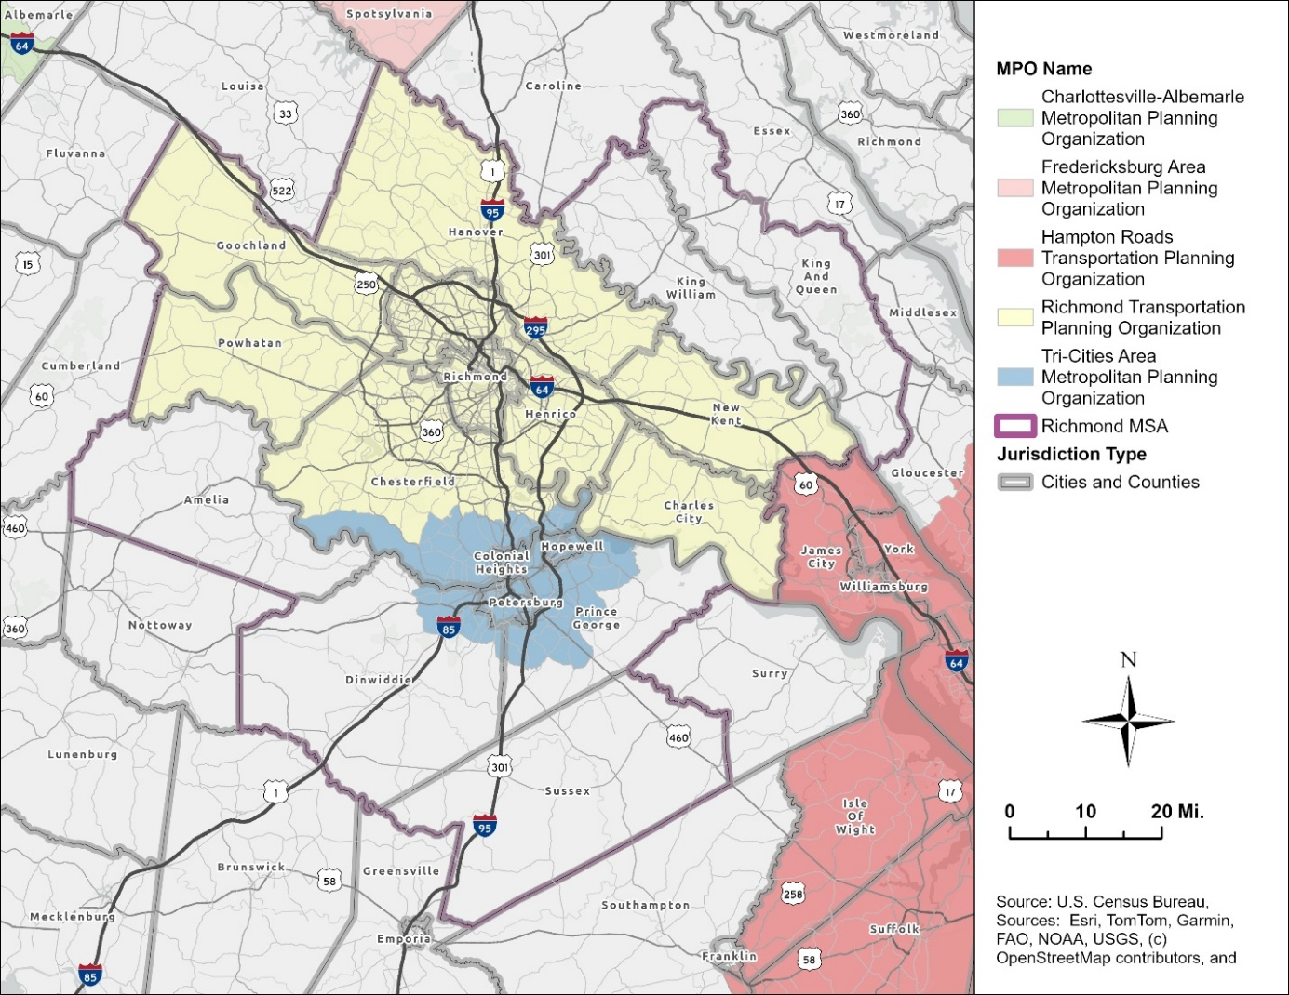
Unincorporated communities located within the Tri-Cities region include portions of Chester, Enon, Ettrick, Fort Gregg-Adams (Fort Lee), Matoaca, and Prince George. These communities, which are defined as Census Designated Places (CDP) by the United States Census Bureau, are integral to the TCAMPO planning area. Ettrick is home to Virginia State University (VSU), the region’s largest university or college. Fort Lee is a large United States Army post and is one of the region’s largest employers. The Chester, Enon, Matoaca, and Prince George CDPs are additional clusters that contain large residential and commercial activity centers. Each of these communities have significant amounts of the region’s employment and housing and are major sources of trip generation. To carry out transportation planning activities for the region, TCAMPO coordinates with its six member jurisdictions, the Virginia Department of Transportation (VDOT), the Department of Rail and Public Transportation (DRPT), Crater PDC, Petersburg Area Transit (PAT), and other planning partners to guide investment in the region's transportation network.

TCAMPO Organization and Structure
TCAMPO consists of a Policy Committee and a Technical Advisory Committee (TAC), each playing a distinct role in the regional planning process. The Policy Committee serves as the primary decision-making body and is responsible for adopting all federally required planning products. Voting members include elected representatives from each of the member jurisdictions, appointed representatives from the Office of the Virginia Secretary of Transportation, the Crater Planning District Commission (CPDC), and Petersburg Area Transit (PAT). Representatives from the Federal Transit Administration (FTA), the Federal Highway Administration (FHWA), and DRPT participate as nonvoting members.
The TAC is composed of staff representatives from the member jurisdictions, Secretary of Transportation, PAT, and Crater PDC. It provides technical support and serves in an advisory capacity to the Policy Committee. Representatives from Fort Lee, RideFinders, and the National Park Service at Petersburg National Battlefield participate as advisory, nonvoting members given their importance to transportation in the Tri-Cities region.
Regional and state transportation and air quality planning agencies have executed Memoranda of Agreement pursuant to 23 CFR 450.310, defining the roles and responsibilities of each participating agency. During the long-range planning process, TCAMPO and Richmond Regional Transportation Planning Organization (RRTPO) develop an accompanying Conformity Report to comply with metropolitan transportation and air quality planning requirements.

Purpose of the Plan
Plan2050 is TCAMPO's Long Range Transportation Plan (LRTP). Also known as a Metropolitan Transportation Plan (MTP), Plan2050 is a federally required document that establishes the vision, goals, and multimodal investment priorities for the Tri-Cities region’s transportation system. As TCAMPO's core long-range planning document, Plan2050 creates a strategic framework for decision-making across the region, guiding investments that improve mobility, safety, equity, and economic development over the next 20 years. Plan2050 provides the basis from which shorter-range programming documents, such as the Metropolitan Transportation Improvement Program (MTIP), will be developed. Consistent with federal requirements, projects must be in the MPO’s current approved LRTP to be eligible for federal transportation funding. Federal regulations also require that the LRTP address a planning horizon of at least 20 years and is fiscally constrained. This means that Plan2050 includes only projects and programs for which a reasonable funding source can be identified. Plan2050 ensures that investments in its transportation network are coordinated, strategic, and aligned with the goals of the communities it serves.

Role of TCAMPO
TCAMPO is responsible for carrying out the federally mandated continuing, comprehensive, and cooperative (3C) planning process on behalf of the region's member jurisdictions. In this role, TCAMPO coordinates regional transportation planning, prioritizes investments, and ensures that federal transportation funds are directed toward projects that reflect the needs and priorities of the Tri-Cities region. In addition to the LRTP, TCAMPO develops and maintains the following federally required planning products:
- Unified Planning Work Program (UPWP) – updated annually
- Metropolitan Transportation Plan (MTP) – updated every four years
- Metropolitan Transportation Improvement Program (MTIP) – updated every four years
- Congestion Management Process (CMP) maintained on an ongoing basis
TCAMPO also maintains a Public Participation Plan and Title VI Compliance Plan in accordance with federal public involvement and civil rights requirements (23 CFR 450.316; 49 U.S.C. 5332). Together, these planning products establish the region's transportation priorities, which in turn guide TCAMPO's role in selecting and recommending projects for federal funding, including the Surface Transportation Block Grant (STBG), Congestion Mitigation and Air Quality (CMAQ), and Transportation Alternatives Program (TAP). Beyond federal allocations, TCAMPO also evaluates and recommends projects through Virginia's SMART SCALE prioritization process and provides technical assistance to its member jurisdictions in developing competitive applications.

Federal Regional Transportation Planning Requirements
Federal law requires that transportation plans in urbanized areas with a population of 50,000 or more be developed through the 3C planning process (23 U.S.C. 134; 49 U.S.C. 5303). MPOs must develop and maintain a Long-Range Transportation Plan and a Transportation Improvement Program, each updated every four years. MPOs serving urbanized areas with a population of 200,000 or more, designated as Transportation Management Areas (TMAs), are also required to maintain a Congestion Management Process (23 CFR 450.322).
Federal planning requirements also emphasize performance-driven, outcome based planning, first introduced under MAP-21 in 2012 and continued under the FAST Act and the Infrastructure Investment and Jobs Act (IIJA). This framework requires MPOs and states to establish measurable targets tied to national performance goals covering safety, infrastructure condition, system reliability, and freight movement (23 U.S.C. 150; 23 CFR 490), ensuring federal investments advance national transportation priorities.

National Transportation Planning Factors
Since the Intermodal Surface Transportation Efficiency Act of 1991 (ISTEA), Congress has identified key planning areas for MPOs and states to consider when developing multimodal transportation plans. MAP-21 established ten planning factors under 23 CFR 450.306 that remain in effect through the FAST Act and IIJA:
- Support the economic vitality of the metropolitan area, especially by enabling global competitiveness, productivity, and efficiency
- Increase the safety of the transportation system for motorized and non-motorized users
- Increase the security of the transportation system for motorized and non-motorized users
- Increase the accessibility and mobility of people and freight
- Protect and enhance the environment, promote energy conservation, improve quality of life, and promote consistency between transportation improvements and planned growth and economic development
- Enhance the integration and connectivity of the transportation system across and between modes for people and freight
- Promote efficient system management and operation
- Emphasize the preservation of the existing transportation system
- Improve the resiliency and reliability of the transportation system and reduce or mitigate stormwater impacts of surface transportation
- Enhance travel and tourism

Federal Performance Measures
Under MAP-21 and continued through the IIJA, MPOs and states must set targets tied to seven national goal areas:
- Safety — reducing fatalities and serious injuries
- Infrastructure condition — pavement and bridge condition ratings
- System reliability — travel time consistency on highways and freight corridors
- Freight movement — truck travel time reliability
- CMAQ — traffic congestion and on-road mobile source emissions
- Transit asset management — state of good repair for transit systems
- Transit safety — fatalities, injuries, and safety events on transit
These are governed primarily under 23 CFR 490 and require states and MPOs to establish measurable targets and report progress regularly to FHWA and FTA.

Plan2050 Goals, Objectives, Performance Measures
The goals and objectives for Plan2050 build on the framework established for the region’s previously adopted LRTP, Plan2045, and were affirmed through the MPO’s Multimodal Mobility Plan in 2025. Rather than beginning from scratch, TCAMPO used the multimodal planning process as an opportunity to validate that the existing goals remained relevant to the region's evolving conditions, community priorities, and federal performance requirements. Guided by the previous public survey developed for the region’s previous LRTP (Plan2045) and subsequent planning efforts, TCAMPO adopted the following goals and objectives:
- Safety:
Improve the safety of the transportation system for all people.
  - Enhance safety and comfort of bicycle and pedestrian facilities
  - Work to eliminate all serious injuries and fatalities resulting from crashes
- Environment/Land Use:
Reduce the negative impact the transportation system has on the natural and built environment.
  - Address roadways prone to flooding and consider climate impacts in transportation planning prioritization and funding decisions.
  - Reduce transportation related pollutants.
  - Increase number and share of trips taken by shared and active transportation modes.
  - Assist and support localities as they perform land use planning regarding transportation investments that encourage walkable and transit-oriented communities.
  - Minimize impacts of transportation system on natural resources and communities with a particular emphasis on Environmental Justice (EJ) populations
- Equity/Accessibility:
Improve equitable access through greater availability of mode choices that are affordable and efficient
  - Reduce trip lengths for all people with a focus on Environmental Justice (EJ) populations.
  - Increase access to jobs and community services via transit, walking, and biking for all people with a focus on EJ populations
- Economic Development:
Improve connectivity and mobility for strong economic vitality
  - Reduce peak period travel times.
  - Increase transportation investment which focuses on economic vitality.
  - Improve reliability and accessibility of travel to and within the regional activity centers.
  - Reduce freight bottlenecks.
  - Increase multimodal access to tourist destinations.
- Mobility:
Increase travel efficiency and mode choices by maintaining the transportation system in a state of good repair
  - Increase the percent of complete streets across the highway network to maximize use of available capacity.
  - Increase system efficiency through operational, transportation demand management (TDM), and technology-based solutions.
  - Improve system reliability across all modes.
Each goal in Plan2050 is supported by objectives that define what the region is working toward, including reducing highway congestion, improving system reliability, expanding equitable access to transit, and reducing fatalities and serious injuries. As shown in Figure 1, Plan2050 performance measures such as Travel Time Index (TTI), Peak Hours of Excessive Delay (PHED), percent of person-miles traveled on the Interstate/non-Interstate provide a quantitative basis for evaluating plan outcomes in alignment with federal requirements under 23 CFR 490.
Figure 2. Plan2050 Congestion Management Plan Performance Measures

Planning Process
The development of Plan2050 followed a process designed to meet federal requirements while remaining grounded on the region’s priorities. The process followed multiple phases including data collection and existing conditions assessment, community and stakeholder engagement, scenario development and evaluation, project prioritization, and fiscal constraint analysis.

Data Collection and Conditions Assessment
TCAMPO began the planning process by establishing a comprehensive understanding of national and regional trends and forecasts (see Chapter 2: National and Regional Trends and Forecasts). This was followed by an assessment of existing transportation conditions across the region, including an inventory of roadway network performance, bridge and pavement conditions, transit service coverage and ridership patterns, bicycle and pedestrian infrastructure, interregional travel, and freight movement corridors (see Chapter 3: Our Transportation System Today). Travel demand modeling, drawing on current and projected demographic and land use data from member jurisdictions and the Crater Planning District Commission, was used to forecast future conditions under a no-build scenario. This baseline served as the foundation against which future investment scenarios were evaluated.

Community and Stakeholder Engagement
Public and stakeholder engagement was conducted during the planning process in accordance with TCAMPO's Public Participation Plan and Title VI requirements. Outreach efforts were designed to reach a broad cross-section of the region's residents, including populations that are traditionally underserved or underrepresented in transportation planning processes. Engagement activities included public meetings, online surveys, and coordination with local jurisdiction staff. Input gathered through these efforts informed the development of plan goals, the identification of transportation needs, and the evaluation of investment priorities.

Scenario Development and Evaluation
TBD

Project Identification and Prioritization
Transportation needs and candidate projects were identified through a combination of local jurisdiction input, travel demand modeling outputs, and asset management data. Projects were evaluated using factors related to safety, mobility and congestion, accessibility and equity, environment, and economic development. This evaluation informed how projects were ranked and advanced for potential inclusion in the financially constrained plan.

Fiscal Constraint
Federal regulations require that the LRTP be fiscally constrained, meaning the total cost of projects and programs included in the Plan must not exceed the funding reasonably expected to be available over the planning horizon. TCAMPO developed revenue projections based on historical federal, state, and regional funding allocations, anticipated formula program apportionments, and guidance from VDOT, DRPT, and the Central Virginia Transportation Authority (CVTA) on projected funding levels. Projects were organized into funding tiers reflecting the degree of certainty associated with available revenues, ensuring that the Plan presents a realistic and implementable program of investments rather than an unconstrained wish list.

Interagency and Regional Coordination
Throughout the planning process, TCAMPO coordinated with VDOT, DRPT, PAT, and RRTPO. This coordination ensured consistency with statewide transportation plans and investment programs, addressed cross-boundary travel needs, and fulfilled the consultation procedures established under the Memoranda of Agreement executed pursuant to 23 CFR 450.310. Fort Gregg-Adams, RideFinders, and the National Park Service at Petersburg National Battlefield also contributed perspectives relevant to their roles in the regional transportation system.

Relationship to Other Plans, Reports, and Studies
TBD

What We Heard: Stakeholder Involvement and Public Outreach
TBD

Chapter 2: National and Regional Trends and Forecasts

Introduction
This section examines the region’s population, employment, and activity density; evaluates socioeconomic growth trends and forecasts within TCAMPO, the Commonwealth of Virginia (Commonwealth), and the United States of America; and maps demographic patterns within the Tri-Cities. Understanding where the region’s existing residents and jobs are concentrated and where they are growing is critical for identifying the region’s current and emerging transportation needs. Additionally, Environmental Justice (EJ) analysis of the region’s demographic patterns provides insight into equity considerations, helping to identify areas that may face transportation disadvantages due to race, income, limited English proficiency, household vehicle availability, disability, or age, helping to ensure equitable access to multimodal transportation options throughout the region.
Because Chesterfield, Dinwiddie, and Prince George extend beyond the TCAMPO boundary, block group, tract, and county-level data from various sources were adjusted using area-weighted interpolation to reflect only the portion of these jurisdictions within TCAMPO. Geographic units located entirely within the boundary, such as census blocks and Traffic Analysis Zones (TAZ), were included without adjustment.
Population, Employment, and Activity Density
The following maps illustrate existing population, employment, and activity density by block group in the Tri-Cities region and beyond. Population estimates are drawn from the American Community Survey (ACS) 2023 5-Year Estimates. Employment estimates are drawn from the 2023 Longitudinal Employer-Household Dynamics (LEHD) Origin-Destination Employment Statistics (LODES) Workplace Area Characteristics (WAC) dataset.
Figure 3 shows population density (residents per square mile) across the region. Population density is highest in Petersburg, Colonial Heights, and Hopewell, with additional concentrations in Chesterfield, Dinwiddie, and Prince George Counties, particularly along the I-95 and I-85 corridors and near major institutions such as Virginia State University (VSU) and Fort Lee. Notable exceptions to this pattern exist within eastern Hopewell and southwestern Petersburg, where lower population densities are due to industrial, commercial, and park land uses rather than rural or undeveloped land.
Figure 3. TCAMPO Population Density by Block Group
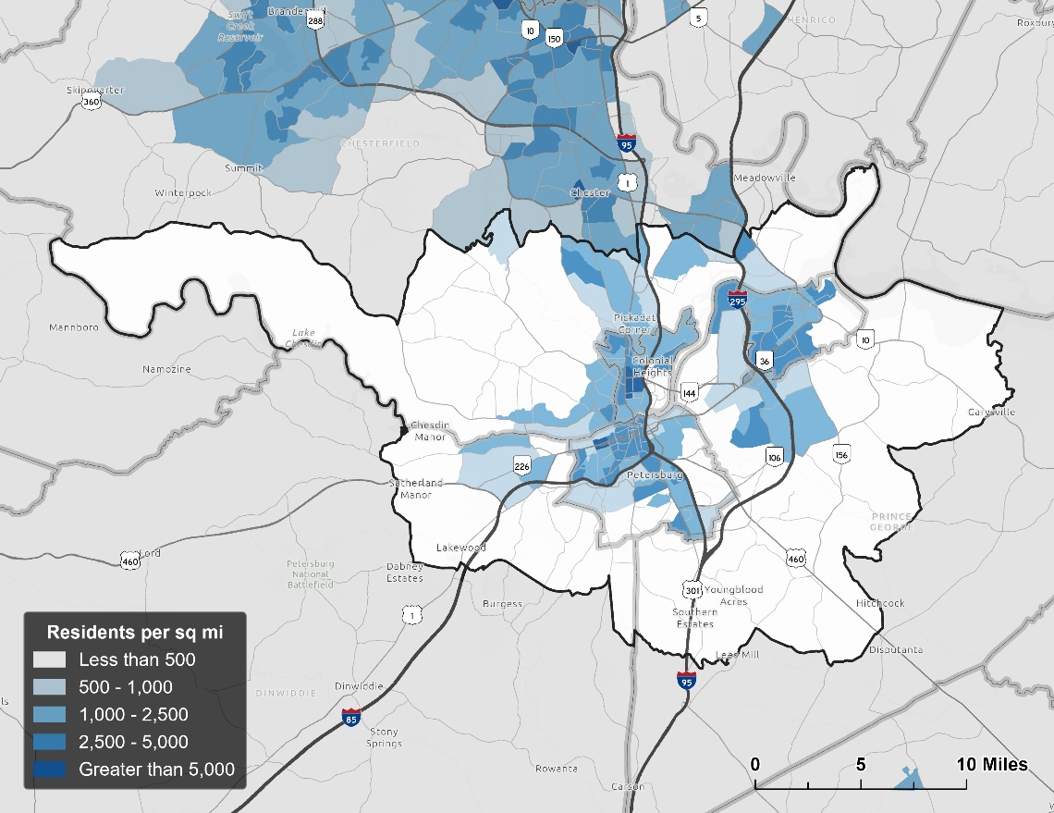
Source: 2023 ACS 5-Year

Figure 4 illustrates the region’s employment density (jobs per square mile). Employment is primarily concentrated along the I-95 and I-85 corridors through Dinwiddie, Colonial Heights, and Petersburg, with additional dense clusters just north of the TCAMPO boundary in Chester and Meadowville. Other areas of high employment density are evident in the historic downtown cores of Petersburg and Hopewell, near VSU in Ettrick, at Southpark Mall in Colonial Heights, and along arterial principal arterial corridors such as South Crater Road (US-301), Oaklawn Boulevard (VA-36), and East Hundred Road (SR-10). Rural portions of the region, particularly to the west, south, and east, show minimal employment density. Overall, employment distribution in the region is tied to interstate access, and major commercial and institutional centers. Due to limitations in federal jobs reporting within the LEHD dataset, employment associated with Fort Lee is not captured in this map.
Figure 4. TCAMPO Employment Density by Block Group
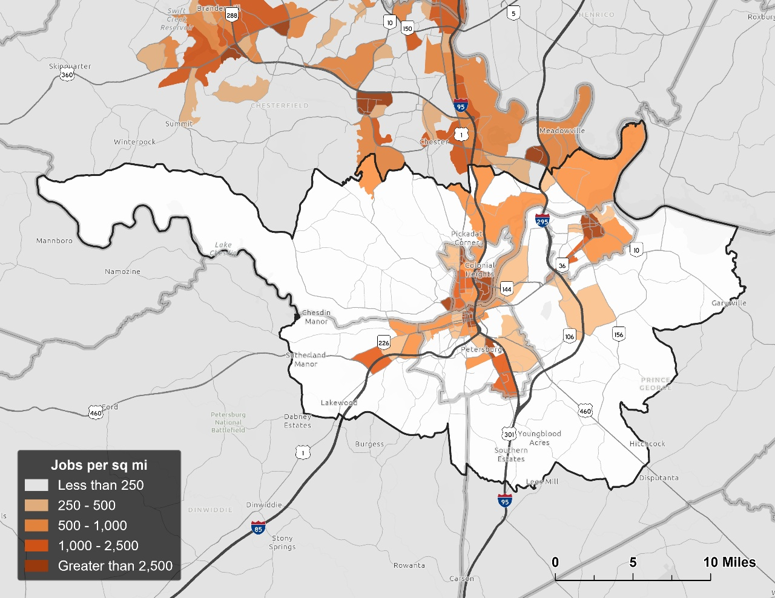
Source: 2023 LEHD
Figure 5 combines the two measures above to show activity density (residents plus jobs per square mile) across the region. Activity density is highest where population and employment concentrations overlap, most notably in Colonial Heights, Hopewell, and Petersburg and along the I-95 and I-85 corridors. High activity is also illustrated near VSU and Fort Lee. As with population and employment densities individually, activity density is lowest in the rural portions of the region to the west, south, and east.
Figure 5. TCAMPO Activity Density by Block Group
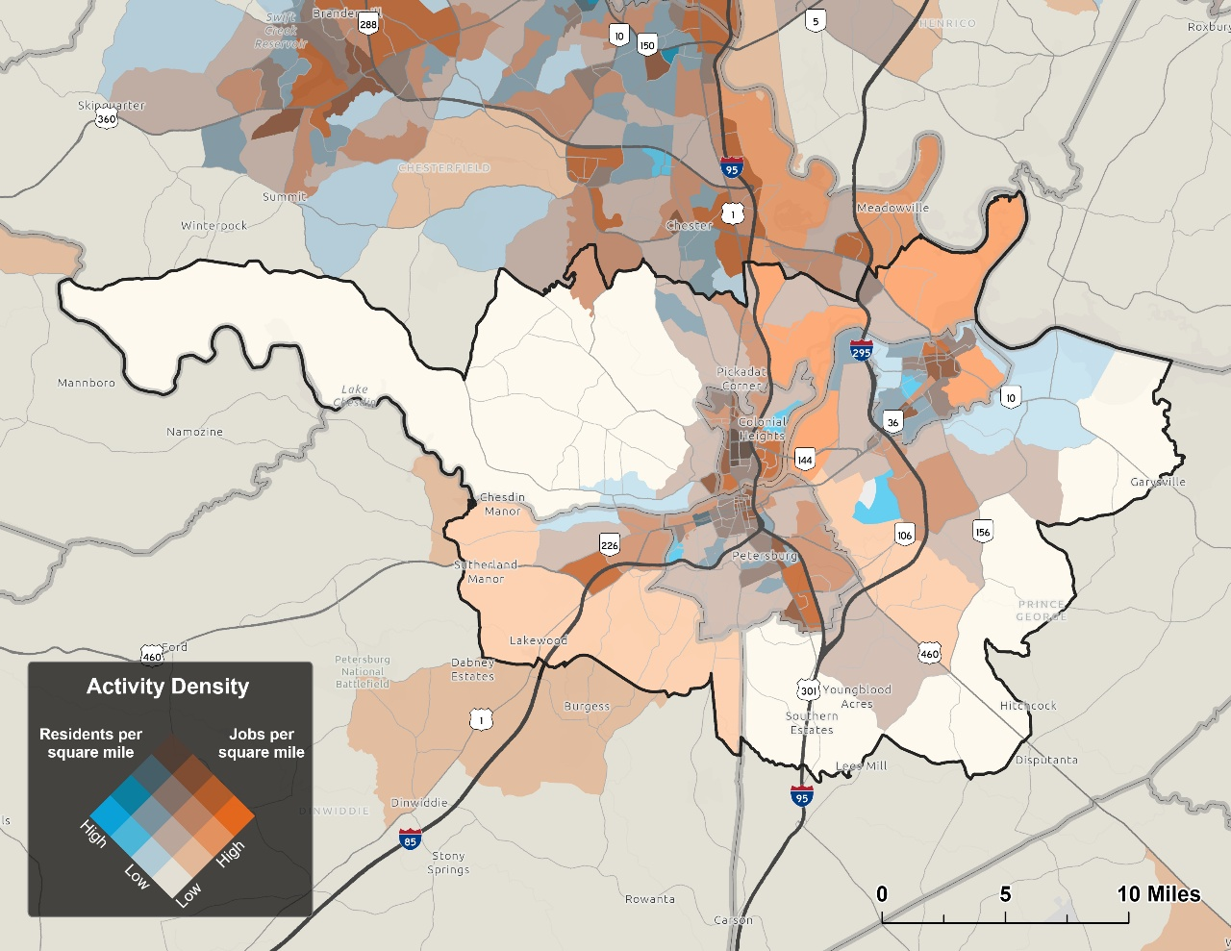
Source: 2023 ACS 5-Year, 2023 LEHD

Population, Household, and Employment Trends
Historical population and household trends from 1990 to 2020 were analyzed using decennial census block-level data obtained from the Integrated Public Use Microdata Series (IPUMS) National Historical Geographic Information System (NHGS). Employment trends for the Tri-Cities region were estimated using county-level annual averages from the Bureau of Labor Statistics (BLS) Quarterly Census of Employment and Wages (QCEW) during the same period. Population and employment growth supports economic development. It also directly affects travel demand, leading to increased congestion, emissions, and greater crash frequency due to higher traffic volumes. These factors indicate that as a region grows, there is a clear need for higher investment in a robust multimodal transportation system, including pedestrian and bicycle safety improvements, increased transit accessibility, and reductions in highway congestion, as well greater destination access for all modes of transportation.
As shown in Figure 6, the population of the Tri-Cities region grew steadily between 1990 and 2020, increasing by 24.4 percent from 134,954 to 167,920. Over the same period, population growth in both Virginia and the United States outpaced that of the region, with Virginia’s population increasing by 39.5 percent and the nation’s population increasing by 33.3 percent.
Figure 6. Regional, State, and National Population Growth by Decade, 1990-2020

Source: IPUMS National Historical Geographic Information System

Figure 7 illustrates that population growth has been uneven across the six jurisdictions and the three decennial periods between 1990 and 2020. During this period, the region’s largest population growth has occurred in counties dominated by suburban and rural areas. The TCAMPO portion of Chesterfield County grew by 69.3 percent between 1990 and 2020, experiencing the largest decennial increases between 1990-2000 and 2000-2010. The TCAMPO portion of Dinwiddie County also experienced strong growth, increasing by 58.3 percent over the same period, although growth slowed considerably after 2010. The TCAMPO portion of Prince George County grew by approximately 56 percent between 1990 and 2020, with its largest increase occurring between 2010 and 2020. Colonial Heights experienced steady population growth in each decade between 1990 and 2020 resulting in a 13.1 percent overall increase. In contrast, Petersburg experienced a 12.8 percent population decline between 1990 and 2020, with a 3 percent increase since 2010. During this period, Hopewell’s population remained stable with only a 0.3 percent decline between 1990 and 2020, although its population has slightly recovered in the last two decennial periods.

Figure 7. TCAMPO Population Growth by Jurisdiction and Decade, 1990-2020

Source: IPUMS National Historical Geographic Information System
Figure 8 shows that the number of households in the region grew by 28.4 percent between 1990 and 2020, increasing from 48,586 to 62,362. Like population growth during this same period, households grew at a slower rate than both Virginia (44.9 percent) and the nation as a whole (37.9 percent). Furthermore, this growth was not evenly distributed among the region’s jurisdictions studied in this analysis. Chesterfield County experienced the highest growth (74.2 percent), followed by Dinwiddie County (61.1 percent) and Prince George County (46.9 percent). In contrast, household growth was positive, but substantially less in Colonial Heights (20.0 percent), Hopewell (4.2 percent), and Petersburg (4.4 percent). The latter two are notable given that Petersburg's and Hopewell’s population actually declined over this same period.
The relationship between population and household growth rates is reflected in changes in household size. Across all jurisdictions, average household size declined by 3.1 percent from 2.8 to 2.7 people per household between 1990 and 2020. This reduction is consistent with broader demographic trends toward smaller households across the Commonwealth (minus 3.7 percent) and the United States (minus 3.4 percent). Within the region, household size decreased in all jurisdictions except Prince George, where it increased from 3.4 to 3.6 people per household. In contrast, Petersburg experienced the largest decline, falling by 16.5 percent from 2.6 to 2.2 people per household.

Figure 8. Regional, State, and National Household Growth by Decade, 1990-2020

Source: IPUMS National Historical Geographic Information System
As with population growth, Figure 9 illustrates that household growth varied significantly by jurisdiction and decennial period. In Chesterfield, Dinwiddie, Prince George, and Colonial Heights, household growth was strongest between 1990 and 2000. Hopewell and Petersburg followed the opposite pattern, with both cities recording their fastest household growth between 2010 and 2020. After losing households throughout the 1990s and 2000s, Petersburg had the highest household growth rate of any TCAMPO jurisdiction between 2010 and 2020, even as its population growth remained the second lowest in the region. This discrepancy suggests that much of Petersburg's new housing stock was absorbed by smaller households.
Figure 9. TCAMPO Household Growth by Jurisdiction and Decade, 1990-2020

Source: IPUMS National Historical Geographic Information System
Because the earliest available year for LEHD data is 2002, historical block-level employment data is not available for this analysis. Therefore, QCEW county-level annual averages were proportionally allocated to the Tri-Cities boundaries using area weighted interpolation based on block-level total employment in the 2023 LODES WAC dataset. Figure 10 shows that employment in the Tri-Cities region has increased by about 47.3 percent from 37,198 in 1990 to 54,780 in 2020. In contrast with population and households, employment is growing at a faster rate than the state (32.3%) and the country (28.1%). Employment growth was comparatively slower between 2000 and 2010, reflecting the impacts of the Great Recession and broader economic conditions that reduced job growth during that period.
Figure 10. Regional, State, and National Employment Growth by Decade, 1990-2020
Source: Bureau of Labor Statistics QCEW County-Level Annual Averages
Shift-Share Employment Growth by BLS Supersector
In this section, employment growth in the Tri-Cities region is evaluated across all BLS supersectors using shift-share analysis. Supersectors are high-level industry groupings used by BLS for the QCEW program, aggregating employment across related two-digit NAICS sectors to provide a wider view of economic activity in an area. These industries can be further grouped into the Goods-Producing and Service-Providing domains. Figure 11 illustrates the NAICS sectors that comprise each super-sector and domain.
As shown in Figure 12, net employment in the Tri-Cities region increased across most major industry supersectors between 2019 and 2023, although the magnitude and causes of growth varied by sector. Shift-share analysis decomposes a regional employment change into three components: the National Growth Component (NGC), which measures growth attributable to the overall national employment trends; the Industrial Mix Component (IMC), which reflects the industry-specific national growth patterns; and the Local Share Component (LSC), which captures growth resulting from factors unique to the region. Combined, the NGC, the IMC, and the LSC help identify the industries driving regional employment growth and determine whether observed changes reflect broader national trends or a competitive advantage specific to the Tri-Cities region.

Figure 11. QCEW High-Level Industry Crosswalk
Domain | Super-Sector | NAICS-Sector

The analysis revealed that Trade, Transportation & Utilities was the region's largest source of net employment growth between 2019 and 2023, adding 950 jobs. Most of that growth came from the NGC (+585 jobs), or what the region would have gained/lost in this industry if it simply grew at the national economy's overall rate. The IMC (+158 jobs) and LSC (+208 jobs) were both smaller than the NGC but positive, suggesting this industry grew faster than the overall national economy and the region also outperformed the national trend for this specific industry.
The strong positive local growth in both Trade, Transportation & Utilities and Manufacturing is consistent with the region's position along the I-95 and I-85 corridors and its growing role as a goods movement and freight logistics hub, reflected in warehousing, distribution, and freight-dependent manufacturing activity in the Tri-Cities region. The Professional & Business Services, Public Administration, and Financial Activities supersectors also had strong local growth and outperformed national growth for these industries. Because freight-dependent sectors in the Goods-Producing and Service-Providing domains are outperforming national trends at the local level, freight infrastructure including highway capacity, interchange access, and rail/intermodal connections along the I-95 corridor will be increasingly important to sustaining this growth going forward.
Figure 12. TCAMPO Shift-Share by Supersector vs. National, 2019-2023
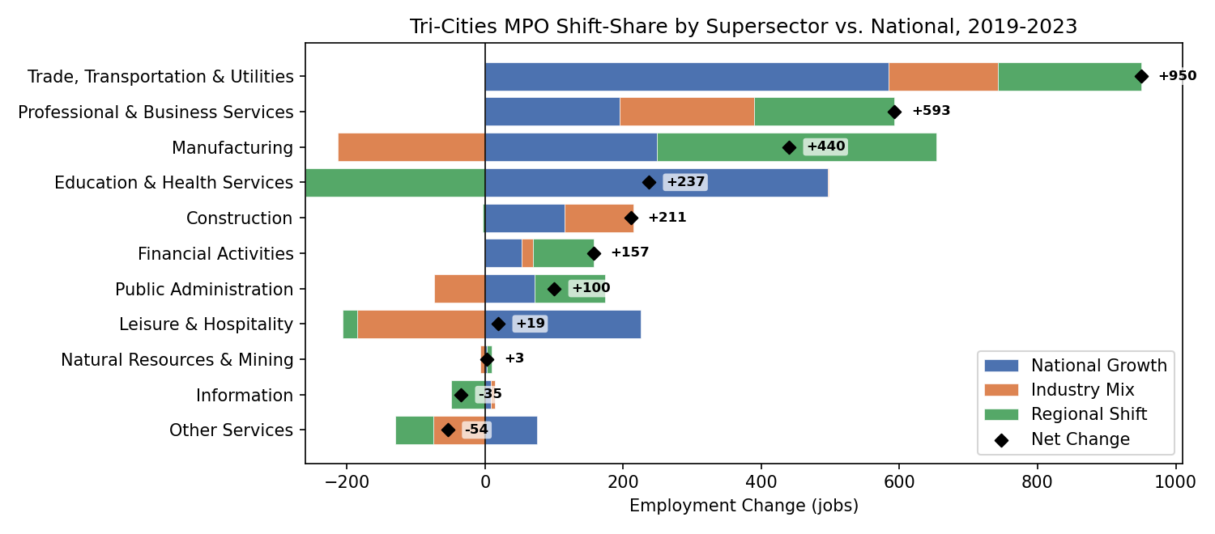

Demographic Profiles
This section summarizes the Environmental Justice (EJ) analysis which is incorporated into TCAMPO’s prioritization process for projects considered for inclusion in Plan2050. The analysis designates EJ Areas of Concern, defined as census block groups having relatively higher concentrations of residents or households that may have limited access to viable transportation choices. Identifying areas where these populations are concentrated helps ensure that transportation investments are planned and prioritized in a way that promotes equitable access across the region.
For this analysis, six EJ indicators are derived from 2023 ACS 5-Year Estimates. Each indicator addresses a distinct dimension of vulnerability relevant to transportation access and investment equity: minority and low-income populations, persons with limited English proficiency, persons with disabilities, elderly persons, and households without access to a vehicle. These population groups were selected based on federal Title VI considerations, as they may experience have fewer transportation options, exhibit greater dependence on transit, or require additional accommodations to access employment, healthcare, education, and other essential services. Because raw percentages for each of the six indicators vary in scale and distribution, each indicator is reclassified into 1-3 (lowest to highest EJ Concern) ordinal vulnerability score using tertile breaks derived from the Tri-Cities block group distribution. The six reclassified indicator scores are summed to produce a composite vulnerability index. , which maps the Composite EJ Index Because each reclassified factor ranges from 1 to 3, the composite index has a potential range of 6 (all indicators at lowest vulnerability) to 18 (all indicators at highest vulnerability). The equal weighting of all six factors reflects the absence of a defensible empirical basis for differential weighting. A shown in Figure 13, the composite vulnerability index is reclassified into a final three-level Environmental Justice Composite Index, representing relative concentrations of EJ-related vulnerability across the Tri-Cities region.
Figure 13. Composite EJ Index by Block Group
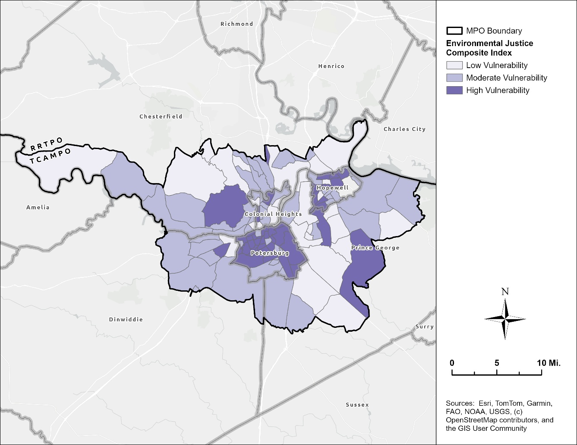

Socioeconomic Forecasts
The MPO developed 2017-2050 socioeconomic forecasts (population, housing, autos, school enrollment, and employment) by TAZ to support the Richmond/Tri-Cities (RTC) Travel Demand Model, which TCAMPO and RRTPO use for long-range planning and corridor studies. Note that forecasts were assigned to TAZs across all of Dinwiddie County and Prince George County, not just the portions within the TCAMPO planning area. Across the six jurisdictions, total population is projected to grow by about 20.0% from 191,300 to 229,600; households (occupied housing units) by about 30.9% from 64,400 to 84,300, and total employment by about 22.9% from about 62,400 to 76,800 by 2050. As shown in Table 1, growth is uneven across jurisdictions. Chesterfield and Prince George are expected to see the largest growth (Prince George's households will nearly double, up 88.5%), while Dinwiddie, Hopewell, and Petersburg are expected to grow more slowly, and Colonial Heights' employment is projected to stay flat.
Table 1. 2017-2045 Socioeconomic Forecasts
Jurisdictions | Total Population |  | Households |  | Total Employment
Jurisdictions | 2017 | 2050 | 2017 | 2050 | 2017 | 2050
Chesterfield | 43,683 | 61,806 | 14,909 | 21,403 | 10,384 | 16,645
Dinwiddie | 28,504 | 30,477 | 9,980 | 10,500 | 8,647 | 10,438
Prince George | 45,881 | 60,888 | 12,543 | 23,640 | 13,790 | 19,422
Colonial Heights | 17,395 | 19,646 | 6,782 | 7,682 | 9,344 | 9,344
Hopewell | 22,941 | 23,471 | 8,910 | 9,325 | 7,137 | 7,366
Petersburg | 32,918 | 33,280 | 11,280 | 11,727 | 13,130 | 13,540
TCAMPO | 191,322 | 229,568 | 64,404 | 84,277 | 62,432 | 76,755
Figure 14. Employment Change per Acre by Traffic Analysis Zone (TAZ), 2017-2050
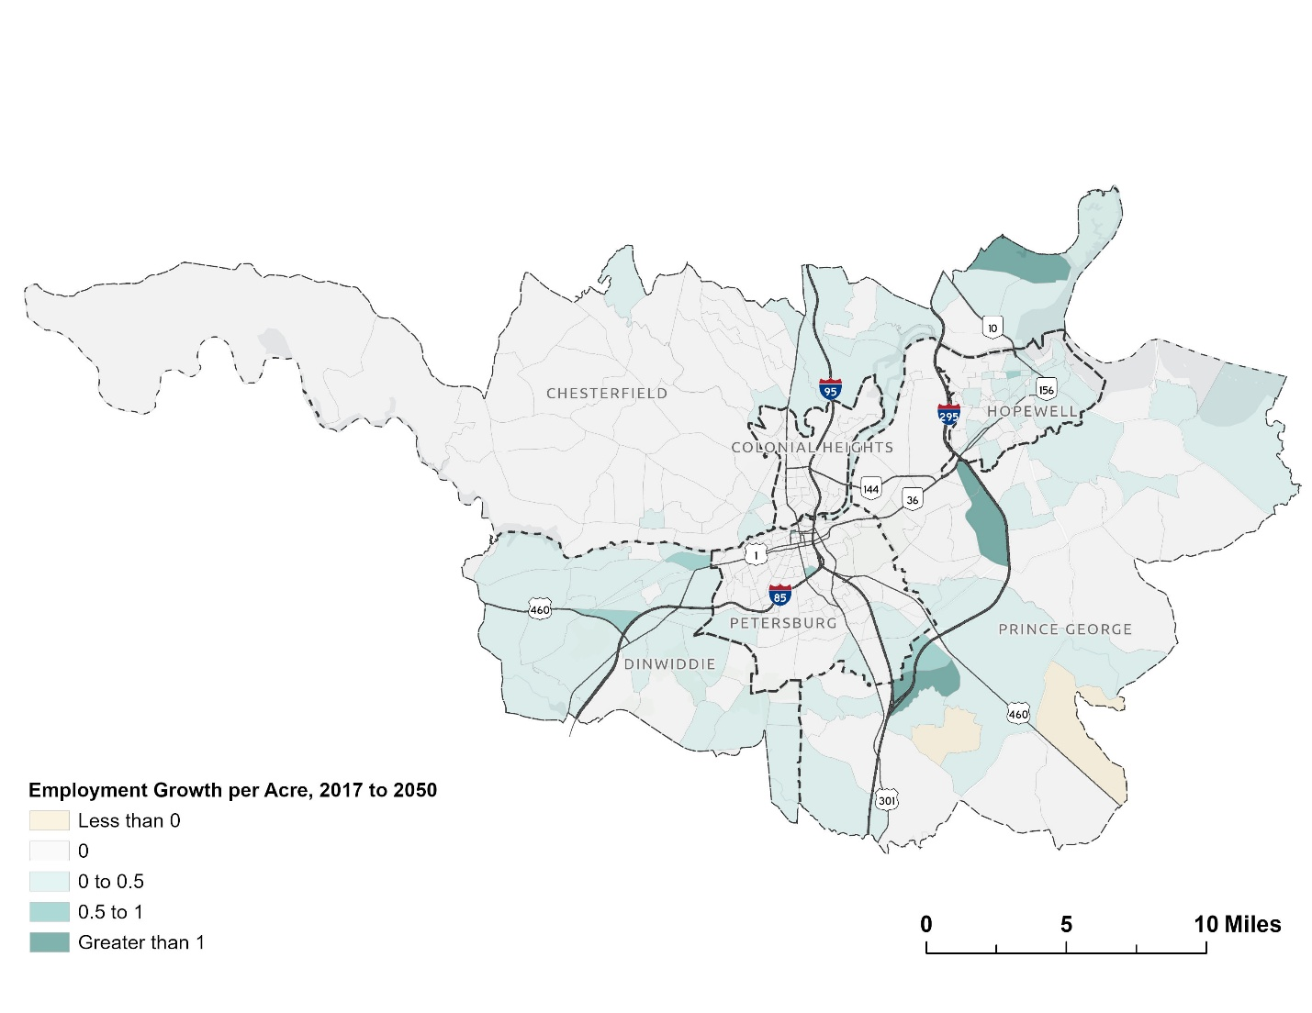

Land Use and Development
Land use in the Tri-Cities region is characterized by a wide range of land cover classes, varying from high intensity developed areas to undeveloped land cover classes such as forests, cultivated areas, and wetlands. As shown in Figure 15, which shows land cover change between 2014 and 2024 using data from the National Land Cover Database (NLCD), the region's most developed areas are located in the urbanized cores of Petersburg, Colonial Heights, and Hopewell, as well as the region’s major transportation corridors. The NLCD is a national land cover dataset produced from satellite imagery and provides detailed classifications of both developed and undeveloped land across the United States.
The map below highlights areas that remained developed or undeveloped in 2024, as well as locations where undeveloped land transitioned to developed land. These development changes are primarily concentrated along existing growth corridors and at the urban fringe. Areas that experienced little or no change are generally associated with established urban centers, agricultural lands, forested tracts, and environmentally sensitive areas such as wetlands and riparian corridors.
Figure 15. Existing Land Cover and Transitions from Undeveloped to Developed Areas, 2014-2024
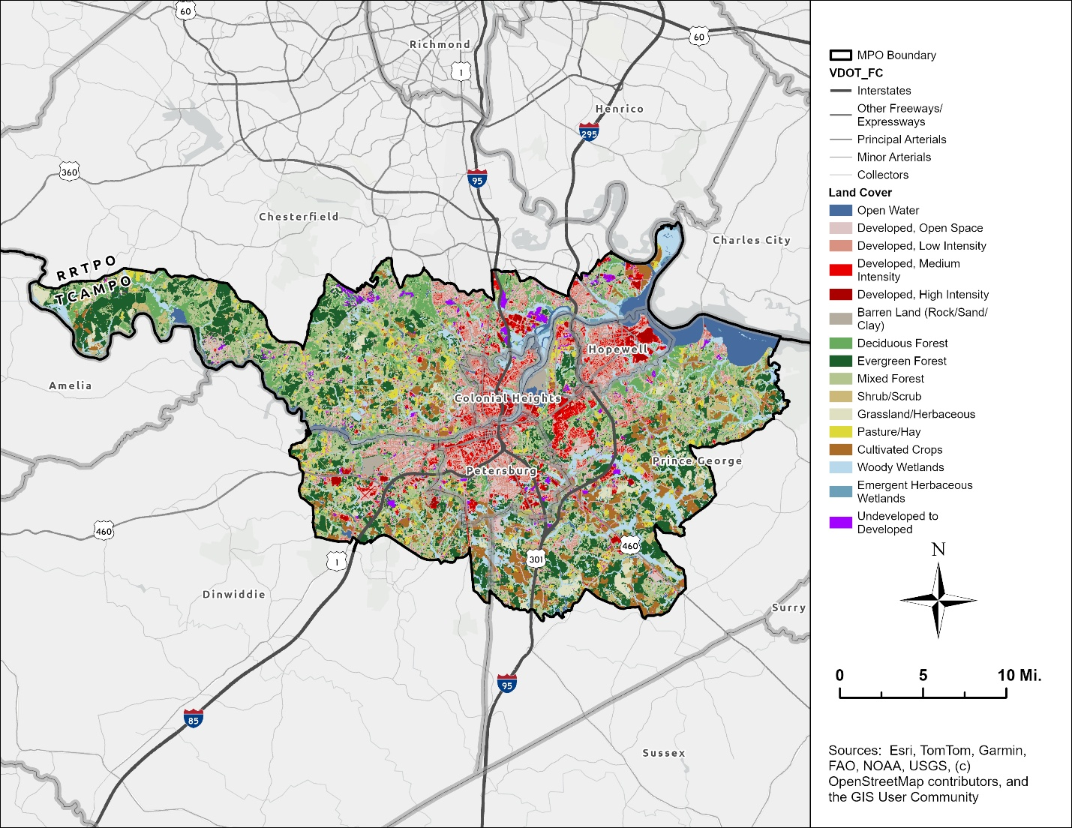
Source: U.S. Geological Survey (USGS), 2014 and 2024, Annual NLCD Collection

Figure 16 illustrates the current extent of developed land across the region's six jurisdictions. The chart below summarizes, for the portions of each jurisdiction within the Tri-Cities MPO, the percentage of land that is developed, undeveloped, or changed from undeveloped to developed between 2014 and 2024. To highlight regional growth patterns, individual land cover classes were consolidated into broader “developed” and “undeveloped” categories for this analysis.
This chart shows that region’s urban core – Colonial Heights, Hopewell, and Petersburg – has more than 60 percent of total land developed, while Dinwiddie, Prince George, and Chesterfield each has less than 30 percent developed. Across the Tri-Cities MPO as a whole, about 28 percent of land is developed, suggesting a region defined by a densely developed core surrounded by lower-density, largely undeveloped areas. While the conversion of undeveloped to developed land is not directly tied to long-range transportation planning needs, this trend mirrors the region’s broader patterns of population, household, and employment growth. Petersburg’s comparatively high rate of land conversion reflects both its population growth during the last decade and its relatively small size and limited remaining undeveloped land. The areas in Petersburg that transitioned from undeveloped to developed land are concentrated along Wells Road in south Petersburg, and along the US-301/I-95 corridor near the Bon Secours Medical Center and the Wagner Road interchange (Exit 48).
Figure 16. Percentage of Land that is Developed, Undeveloped, and Transitioned to Developed Use, 2014-2024

Source: U.S. Geological Survey (USGS), 2014 and 2024, Annual NLCD Collection

Travel Patterns
Population and employment changes shape both development and travel patterns throughout the region. Understanding these existing patterns provides a basis for developing future transportation needs. Examining trip flows, household vehicle availability, mode share, and forecasted travel demand helps inform decision makers about the investments that are needed to support economic vitality, improve mobility, and enhance quality of life for residents and visitors alike. Figure X illustrates how residents currently travel throughout the region, showing the distribution of trips across different modes of transportation.
Trips by Mode - TBD
Household vehicle availability is one of the biggest determinants of travel behavior and mode choice, shaping whether a trip is made by car, transit, walking, or not at all. Table 2 presents the distribution of households by vehicle availability and jurisdiction. Vehicle availability is categorized by the number of vehicles available per household, ranging from zero vehicles to three or more vehicles. Because census tracts are the smallest geographic unit for which vehicle availability data are available from the American Community Survey (ACS), estimates for the portions of Chesterfield, Dinwiddie, and Prince George within TCAMPO were calculated using population-weighted spatial interpolation.
As shown below, vehicle availability varies considerably across the region, generally tracking differences in population density and household income. Petersburg has the highest share of zero-vehicle households (14.84%) and the highest combined zero-and-one-vehicle share (63.27%). Hopewell also shows an above-average zero-vehicle share (11.66%). At the other end, Dinwiddie has the highest share of three-plus-vehicle households (46.34%), reflecting its more rural, auto-dependent character, with Prince George and Chesterfield showing similar trends. Overall, TCAMPO (8.20% zero-vehicle) skews slightly higher than Virginia statewide (6.10% zero-vehicle) in low-vehicle-availability households, driven mainly by Petersburg and Hopewell.
Table 2. Household Vehicle Availability by Jurisdiction
Jurisdiction | Households | No Vehicle | 1 Vehicle | 2 Vehicles | 3+ Vehicles
Chesterfield | 16,017 | 4.22% | 22.22% | 40.93% | 32.63%
Dinwiddie | 4,409 | 5.90% | 19.37% | 28.42% | 46.34%
Prince George | 10,204 | 3.47% | 22.95% | 34.08% | 39.50%
Colonial Heights | 7,530 | 6.79% | 33.73% | 35.96% | 23.52%
Hopewell | 9,255 | 11.66% | 35.73% | 26.12% | 26.49%
Petersburg | 15,138 | 14.84% | 48.43% | 25.84% | 10.89%
TCAMPO | 62,553 | 8.20% | 31.87% | 32.49% | 27.45%
Virginia | 3,365,732 | 6.10% | 31.13% | 37.25% | 25.52%
Source: 2024 ACS 5-Year
In addition to household vehicle availability, mode share is determined by other factors including trip purpose and trip distance or travel time. Figure 17 shows that the majority of workers who are 16 years and over and who did not work from home drove alone to work across all commute durations, accounting for 82% of all commuters and more than 85% of commuters in travel times between 15 minutes to one hour. Walking was most prevalent among the shortest commutes, comprising nearly 24 percent of workers with travel times under 10 minutes, and declining sharply for commutes of 20 minutes or more. Carpooling represented a small but consistent share across all time intervals, ranging from approximately 7 to 11 percent. Transit use was minimal overall but was most notable among the longest commuters, representing about 10 percent of workers with travel times of 60 minutes or more.
Figure 17. Mode Share by Travel Time, TCAMPO Region
Source: 2024 ACS 5-Year Estimates
Changes in Traffic Congestion (2020-2025) - TBD
County to County Commuter Flows
The Tri-Cities region is part of an interconnected metropolitan area that extends beyond its borders. Examining commuting patterns both within the region and beyond provides insight into the interconnectedness of the region's economy and the role of the transportation network in supporting those connections.
Table 3 summarizes county-to-county commuter flow data derived from 2025 StreetLight Origin-Destination traffic volumes (Average Daily Traffic) and Home-Based Work (HBW) trip purpose data. This 2025 traffic volume dataset covers all days of the week using default time periods, and includes the TCAMPO-area portions of Chesterfield, Dinwiddie, and Prince George Counties, along with the Cities of Colonial Heights, Hopewell, and Petersburg. External volumes were derived using Traffic Analysis Zones (TAZs), including zones outside the Tri-Cities Region from the RTC model, as well as other origin and destination trips outside the RTC model.
As shown in Figure 18, the share of Internal-Internal (I-I) trips that begin and end within TCAMPO varies considerably by jurisdiction, ranging from a high of 71.7 percent in Prince George to a low of 37.6 percent in Chesterfield. Prince George, Colonial Heights, Petersburg, and Hopewell have the greatest share of internal trips, with all but Hopewell retaining more than two-thirds of commute trips within the MPO. Prince George also has the highest proportion of trips that begin and end within the same jurisdiction (45.4 percent), reflecting the influence of Fort Gregg-Adams as a major local employer and trip generator.
In contrast, nearly two-thirds of commute trips associated with the TCAMPO portion of Chesterfield travel outside the MPO. Much of this travel is to destinations within the Richmond region, particularly the portions of Chesterfield County located within the Richmond Regional TPO, as well as Henrico and the City of Richmond. This pattern reflects the strong economic and commuting relationship between the Tri-Cities area and the greater Richmond metropolitan region.
Figure 18. Share of TCAMPO Trips Staying Within the Region, by Jurisdiction

Source: StreetLight, 2025

Among internal TCAMPO flows, the strongest connections are centered on Prince George and Petersburg (Table 3). Prince George exchanges the highest volume of trips with any other jurisdiction in the region, particularly with Petersburg (2,203 trips) and Hopewell (2,086 trips), reflecting its high levels of population and employment and its role as the geographic center between the region's urban cores. Chesterfield also shows a notable bidirectional relationship with Prince George, Colonial Heights, and Petersburg (approximately 600–700 trips in both directions), which is consistent with Chesterfield’s overall size growing employment in both jurisdictions and Petersburg's role as an activity center for surrounding jurisdictions.

Table 3. Commute Flows within Tri-Cities Area MPO
 |  | TCAMPO Destinations
 |  | Chesterfield | Colonial Heights | Dinwiddie | Hopewell | Petersburg | Prince George
TCAMPO Origins | Chesterfield | 1,562 | 654 | 312 | 319 | 618 | 733
TCAMPO Origins | Colonial Heights | 606 | 1,850 | 263 | 271 | 506 | 684
TCAMPO Origins | Dinwiddie | 283 | 265 | 427 | 91 | 535 | 326
TCAMPO Origins | Hopewell | 312 | 321 | 101 | 2,036 | 319 | 1,052
TCAMPO Origins | Petersburg | 628 | 507 | 586 | 301 | 2,155 | 1,106
TCAMPO Origins | Prince George | 625 | 671 | 250 | 1,034 | 1,097 | 6,340
Source: StreetLight, 2025

Jonathan Schroeder, David Van Riper, Steven Manson, Grace Cooper, Zachary Krause, Tracy Kugler, and Steven Ruggles. IPUMS National Historical Geographic Information System: Version 21.0 [dataset]. Minneapolis, MN: IPUMS. 2026. http://doi.org/10.18128/D050.V21.0

