Chapter 1: Introduction

Regional Context
Located along the I-95, I-85, and I-295 corridors about 25 miles south of Richmond, the Tri-Cities region is situated at the confluence of the James and Appomattox Rivers. The Tri-Cities Area Metropolitan Planning Organization (TCAMPO) is the federally designated planning body responsible for transportation planning in south-central Virginia's Tri-Cities region. Contained within the Crater Planning District Commission (PDC), TCAMPO is composed of six member jurisdictions, including the independent cities of Colonial Heights, Hopewell, and Petersburg and portions of the adjoining Chesterfield, Dinwiddie, and Prince George Counties. The Tri-Cities region is part of the Greater Richmond Region, which is defined by the Office of Management and Budget (OMB) as the Richmond, Virginia Metropolitan Statistical Area (MSA).
Figure 2 depicts the TCAMPO planning area in the context of the Richmond MSA. According to the 2020 decennial census, the population of TCAMPO was 167,920. With a land area of approximately 324 square miles, the MPO has a population density of approximately 518 people per square mile. Among all MPOs in Virginia, TCAMPO is ranked fifth in terms of population, sixth in land area, and tenth in population density. Although the population of the Tri-Cities region grew by 24.4 percent between the last two decennial censuses, it lags behind the state (39.5 percent) and the nation (33.3 percent).
Figure 1. Greater Richmond Region and Metropolitan Planning Organization Boundaries
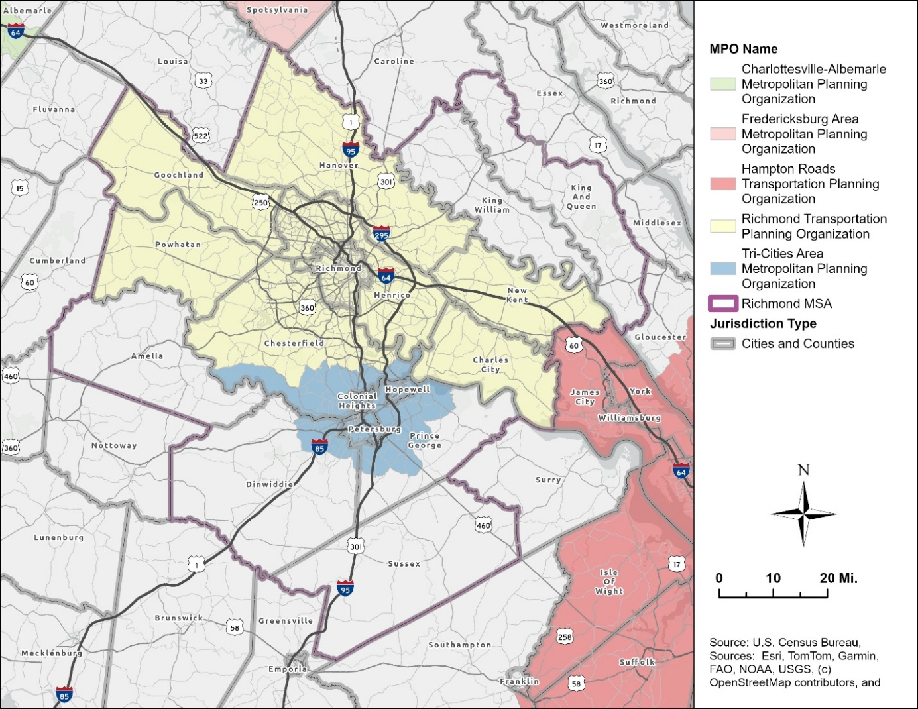
Unincorporated communities located within the Tri-Cities region include portions of Chester, Enon, Ettrick, Fort Gregg-Adams (Fort Lee), Matoaca, and Prince George. These communities, which are defined as Census Designated Places (CDP) by the United States Census Bureau, are integral to the TCAMPO planning area. Ettrick is home to Virginia State University (VSU), the region’s largest university or college. Fort Lee is a large United States Army post and is one of the region’s largest employers. The Chester, Enon, Matoaca, and Prince George CDPs are additional clusters that contain large residential and commercial activity centers. Each of these communities have significant amounts of the region’s employment and housing and are major sources of trip generation. To carry out transportation planning activities for the region, TCAMPO coordinates with its six member jurisdictions, the Virginia Department of Transportation (VDOT), the Department of Rail and Public Transportation (DRPT), Crater PDC, Petersburg Area Transit (PAT), and other planning partners to guide investment in the region's transportation network.

Jonathan Schroeder, David Van Riper, Steven Manson, Grace Cooper, Zachary Krause, Tracy Kugler, and Steven Ruggles. IPUMS National Historical Geographic Information System: Version 21.0 [dataset]. Minneapolis, MN: IPUMS. 2026. http://doi.org/10.18128/D050.V21.0

