Chapter 2: National and Regional Trends and Forecasts
Population, Employment, and Activity Density
The following maps illustrate existing population, employment, and activity density by block group in the Tri-Cities region and beyond. Population estimates are drawn from the American Community Survey (ACS) 2023 5-Year Estimates. Employment estimates are drawn from the 2023 Longitudinal Employer-Household Dynamics (LEHD) Origin-Destination Employment Statistics (LODES) Workplace Area Characteristics (WAC) dataset.
Figure 3 shows population density (residents per square mile) across the region. Population density is highest in Petersburg, Colonial Heights, and Hopewell, with additional concentrations in Chesterfield, Dinwiddie, and Prince George Counties, particularly along the I-95 and I-85 corridors and near major institutions such as Virginia State University (VSU) and Fort Lee. Notable exceptions to this pattern exist within eastern Hopewell and southwestern Petersburg, where lower population densities are due to industrial, commercial, and park land uses rather than rural or undeveloped land.
Figure 3. TCAMPO Population Density by Block Group
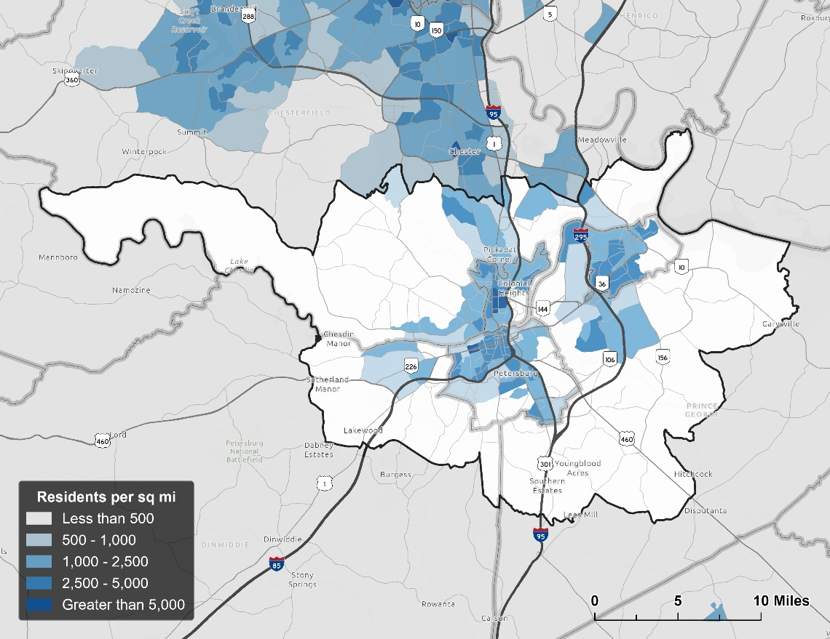
Source: 2023 ACS 5-Year

Figure 4 illustrates the region’s employment density (jobs per square mile). Employment is primarily concentrated along the I-95 and I-85 corridors through Dinwiddie, Colonial Heights, and Petersburg, with additional dense clusters just north of the TCAMPO boundary in Chester and Meadowville. Other areas of high employment density are evident in the historic downtown cores of Petersburg and Hopewell, near VSU in Ettrick, at Southpark Mall in Colonial Heights, and along arterial principal arterial corridors such as South Crater Road (US-301), Oaklawn Boulevard (VA-36), and East Hundred Road (SR-10). Rural portions of the region, particularly to the west, south, and east, show minimal employment density. Overall, employment distribution in the region is tied to interstate access, and major commercial and institutional centers. Due to limitations in federal jobs reporting within the LEHD dataset, employment associated with Fort Lee is not captured in this map.
Figure 4. TCAMPO Employment Density by Block Group
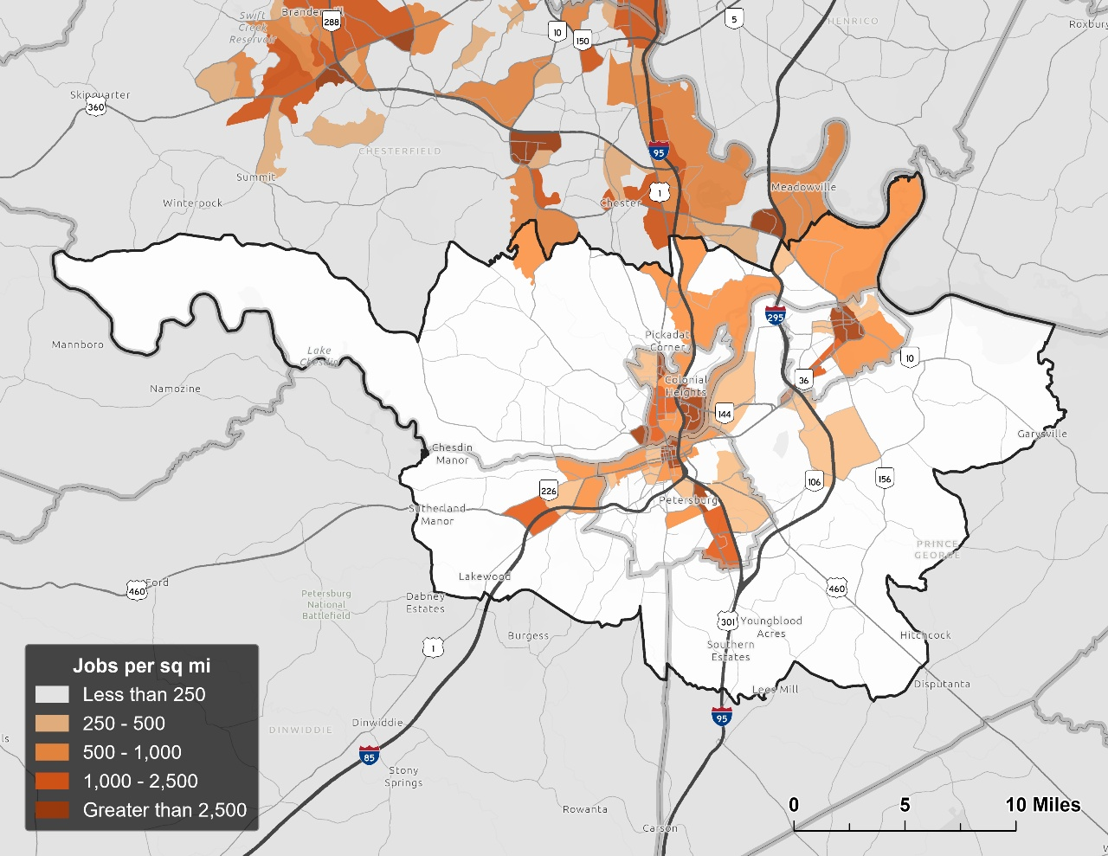
Source: 2023 LEHD
Figure 5 combines the two measures above to show activity density (residents plus jobs per square mile) across the region. Activity density is highest where population and employment concentrations overlap, most notably in Colonial Heights, Hopewell, and Petersburg and along the I-95 and I-85 corridors. High activity is also illustrated near VSU and Fort Lee. As with population and employment densities individually, activity density is lowest in the rural portions of the region to the west, south, and east.
Figure 5. TCAMPO Activity Density by Block Group
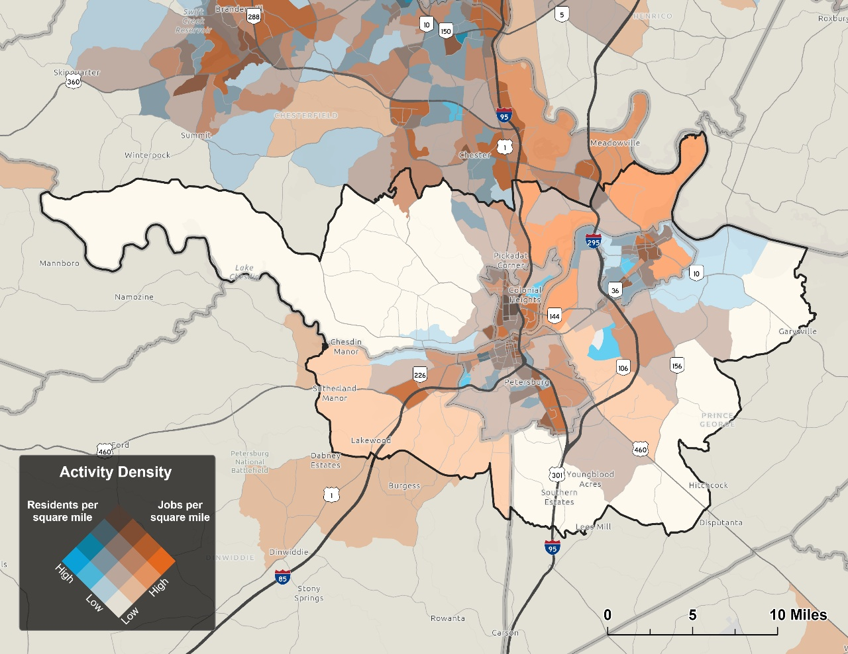
Source: 2023 ACS 5-Year, 2023 LEHD

Jonathan Schroeder, David Van Riper, Steven Manson, Grace Cooper, Zachary Krause, Tracy Kugler, and Steven Ruggles. IPUMS National Historical Geographic Information System: Version 21.0 [dataset]. Minneapolis, MN: IPUMS. 2026. http://doi.org/10.18128/D050.V21.0

