Chapter 2: National and Regional Trends and Forecasts
Shift-Share Employment Growth by BLS Supersector
In this section, employment growth in the Tri-Cities region is evaluated across all BLS supersectors using shift-share analysis. Supersectors are high-level industry groupings used by BLS for the QCEW program, aggregating employment across related two-digit NAICS sectors to provide a wider view of economic activity in an area. These industries can be further grouped into the Goods-Producing and Service-Providing domains. Figure 11 illustrates the NAICS sectors that comprise each super-sector and domain.
As shown in Figure 12, net employment in the Tri-Cities region increased across most major industry supersectors between 2019 and 2023, although the magnitude and causes of growth varied by sector. Shift-share analysis decomposes a regional employment change into three components: the National Growth Component (NGC), which measures growth attributable to the overall national employment trends; the Industrial Mix Component (IMC), which reflects the industry-specific national growth patterns; and the Local Share Component (LSC), which captures growth resulting from factors unique to the region. Combined, the NGC, the IMC, and the LSC help identify the industries driving regional employment growth and determine whether observed changes reflect broader national trends or a competitive advantage specific to the Tri-Cities region.

Figure 11. QCEW High-Level Industry Crosswalk
Domain | Super-Sector | NAICS-Sector

The analysis revealed that Trade, Transportation & Utilities was the region's largest source of net employment growth between 2019 and 2023, adding 950 jobs. Most of that growth came from the NGC (+585 jobs), or what the region would have gained/lost in this industry if it simply grew at the national economy's overall rate. The IMC (+158 jobs) and LSC (+208 jobs) were both smaller than the NGC but positive, suggesting this industry grew faster than the overall national economy and the region also outperformed the national trend for this specific industry.
The strong positive local growth in both Trade, Transportation & Utilities and Manufacturing is consistent with the region's position along the I-95 and I-85 corridors and its growing role as a goods movement and freight logistics hub, reflected in warehousing, distribution, and freight-dependent manufacturing activity in the Tri-Cities region. The Professional & Business Services, Public Administration, and Financial Activities supersectors also had strong local growth and outperformed national growth for these industries. Because freight-dependent sectors in the Goods-Producing and Service-Providing domains are outperforming national trends at the local level, freight infrastructure including highway capacity, interchange access, and rail/intermodal connections along the I-95 corridor will be increasingly important to sustaining this growth going forward.
Figure 12. TCAMPO Shift-Share by Supersector vs. National, 2019-2023
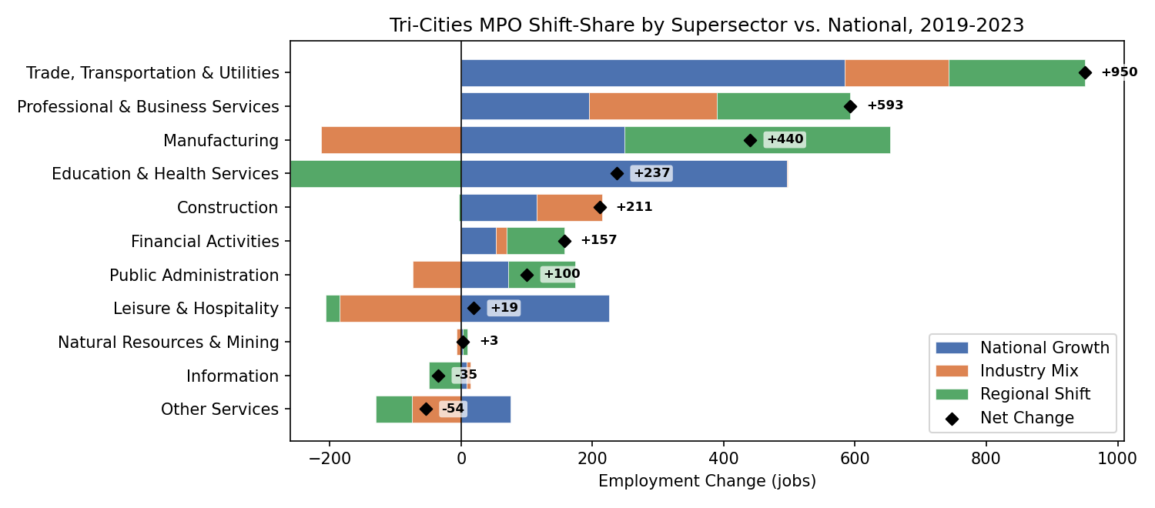

Jonathan Schroeder, David Van Riper, Steven Manson, Grace Cooper, Zachary Krause, Tracy Kugler, and Steven Ruggles. IPUMS National Historical Geographic Information System: Version 21.0 [dataset]. Minneapolis, MN: IPUMS. 2026. http://doi.org/10.18128/D050.V21.0

