Chapter 2: National and Regional Trends and Forecasts

Demographic Profiles
This section summarizes the Environmental Justice (EJ) analysis which is incorporated into TCAMPO’s prioritization process for projects considered for inclusion in Plan2050. The analysis designates EJ Areas of Concern, defined as census block groups having relatively higher concentrations of residents or households that may have limited access to viable transportation choices. Identifying areas where these populations are concentrated helps ensure that transportation investments are planned and prioritized in a way that promotes equitable access across the region.
For this analysis, six EJ indicators are derived from 2023 ACS 5-Year Estimates. Each indicator addresses a distinct dimension of vulnerability relevant to transportation access and investment equity: minority and low-income populations, persons with limited English proficiency, persons with disabilities, elderly persons, and households without access to a vehicle. These population groups were selected based on federal Title VI considerations, as they may experience have fewer transportation options, exhibit greater dependence on transit, or require additional accommodations to access employment, healthcare, education, and other essential services. Because raw percentages for each of the six indicators vary in scale and distribution, each indicator is reclassified into 1-3 (lowest to highest EJ Concern) ordinal vulnerability score using tertile breaks derived from the Tri-Cities block group distribution. The six reclassified indicator scores are summed to produce a composite vulnerability index. , which maps the Composite EJ Index Because each reclassified factor ranges from 1 to 3, the composite index has a potential range of 6 (all indicators at lowest vulnerability) to 18 (all indicators at highest vulnerability). The equal weighting of all six factors reflects the absence of a defensible empirical basis for differential weighting. A shown in Figure 13, the composite vulnerability index is reclassified into a final three-level Environmental Justice Composite Index, representing relative concentrations of EJ-related vulnerability across the Tri-Cities region.
Figure 13. Composite EJ Index by Block Group
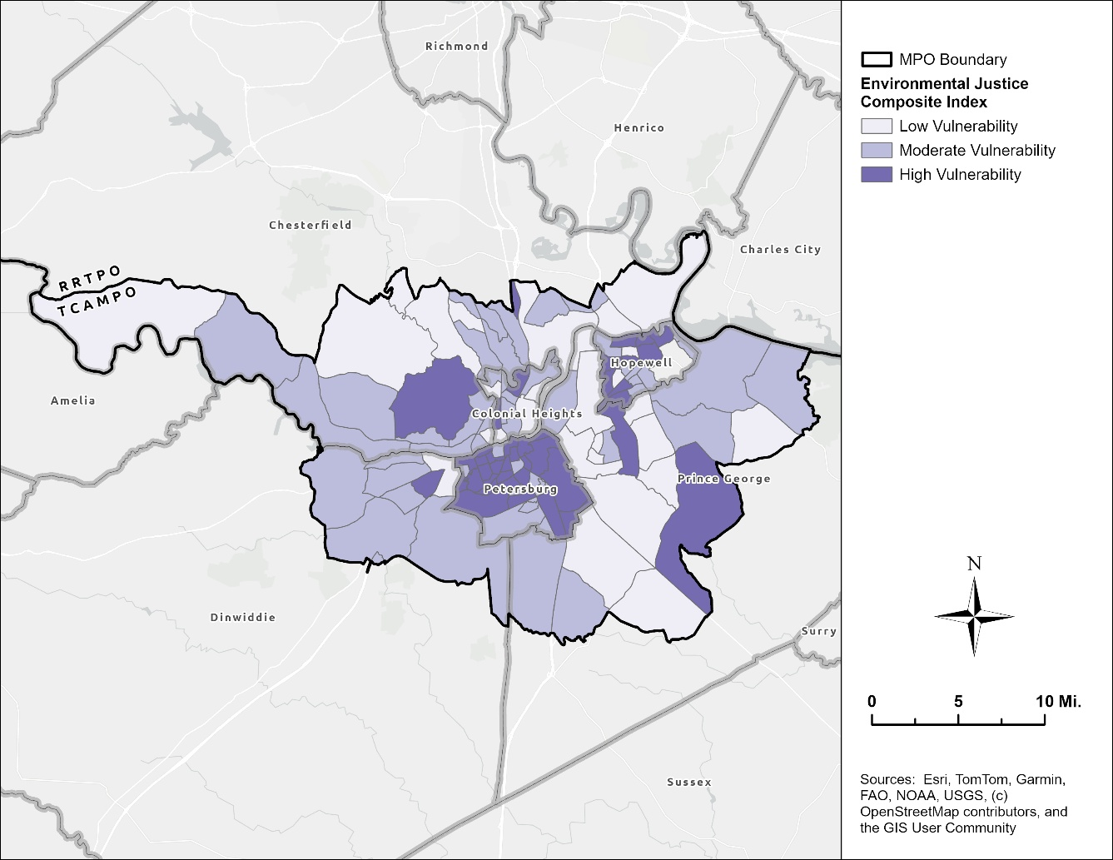

Jonathan Schroeder, David Van Riper, Steven Manson, Grace Cooper, Zachary Krause, Tracy Kugler, and Steven Ruggles. IPUMS National Historical Geographic Information System: Version 21.0 [dataset]. Minneapolis, MN: IPUMS. 2026. http://doi.org/10.18128/D050.V21.0

