Chapter 2: National and Regional Trends and Forecasts

Socioeconomic Forecasts
The MPO developed 2017-2050 socioeconomic forecasts (population, housing, autos, school enrollment, and employment) by TAZ to support the Richmond/Tri-Cities (RTC) Travel Demand Model, which TCAMPO and RRTPO use for long-range planning and corridor studies. Note that forecasts were assigned to TAZs across all of Dinwiddie County and Prince George County, not just the portions within the TCAMPO planning area. Across the six jurisdictions, total population is projected to grow by about 20.0% from 191,300 to 229,600; households (occupied housing units) by about 30.9% from 64,400 to 84,300, and total employment by about 22.9% from about 62,400 to 76,800 by 2050. As shown in Table 1, growth is uneven across jurisdictions. Chesterfield and Prince George are expected to see the largest growth (Prince George's households will nearly double, up 88.5%), while Dinwiddie, Hopewell, and Petersburg are expected to grow more slowly, and Colonial Heights' employment is projected to stay flat.
Table 1. 2017-2045 Socioeconomic Forecasts
Jurisdictions | Total Population |  | Households |  | Total Employment
Jurisdictions | 2017 | 2050 | 2017 | 2050 | 2017 | 2050
Chesterfield | 43,683 | 61,806 | 14,909 | 21,403 | 10,384 | 16,645
Dinwiddie | 28,504 | 30,477 | 9,980 | 10,500 | 8,647 | 10,438
Prince George | 45,881 | 60,888 | 12,543 | 23,640 | 13,790 | 19,422
Colonial Heights | 17,395 | 19,646 | 6,782 | 7,682 | 9,344 | 9,344
Hopewell | 22,941 | 23,471 | 8,910 | 9,325 | 7,137 | 7,366
Petersburg | 32,918 | 33,280 | 11,280 | 11,727 | 13,130 | 13,540
TCAMPO | 191,322 | 229,568 | 64,404 | 84,277 | 62,432 | 76,755
Figure 14. Employment Change per Acre by Traffic Analysis Zone (TAZ), 2017-2050
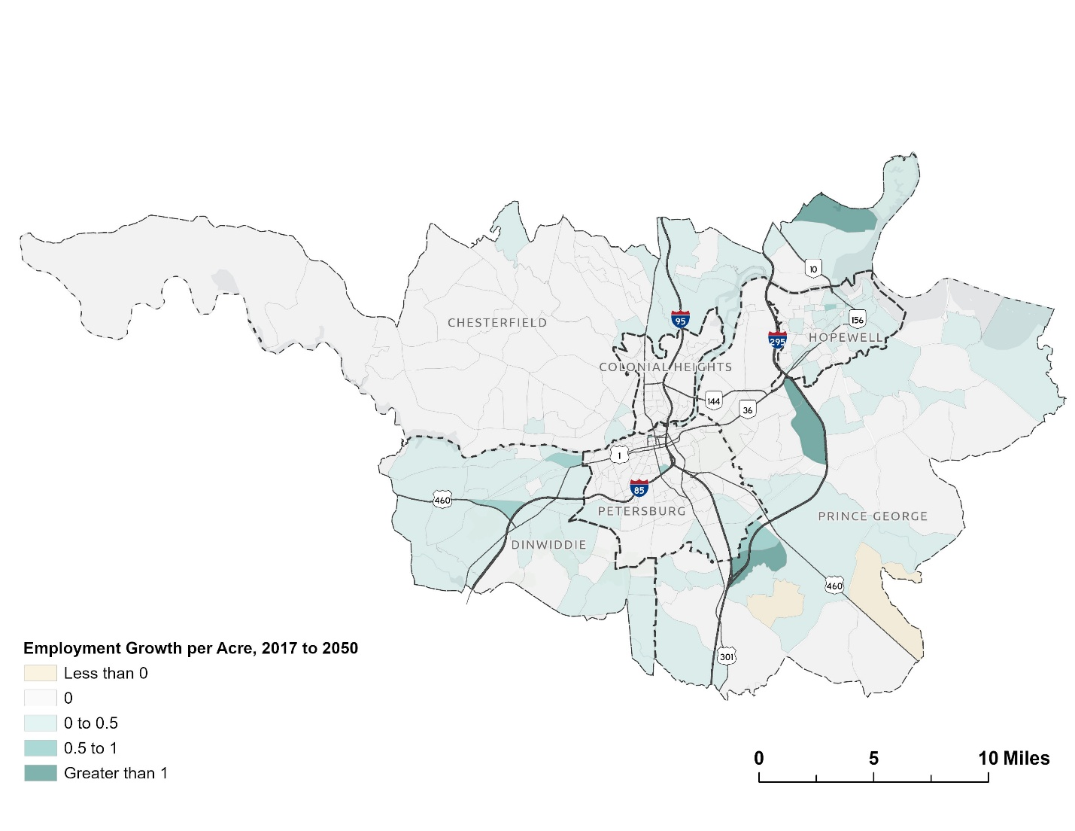

Jonathan Schroeder, David Van Riper, Steven Manson, Grace Cooper, Zachary Krause, Tracy Kugler, and Steven Ruggles. IPUMS National Historical Geographic Information System: Version 21.0 [dataset]. Minneapolis, MN: IPUMS. 2026. http://doi.org/10.18128/D050.V21.0

