Chapter 2: National and Regional Trends and Forecasts

Land Use and Development
Land use in the Tri-Cities region is characterized by a wide range of land cover classes, varying from high intensity developed areas to undeveloped land cover classes such as forests, cultivated areas, and wetlands. As shown in Figure 15, which shows land cover change between 2014 and 2024 using data from the National Land Cover Database (NLCD), the region's most developed areas are located in the urbanized cores of Petersburg, Colonial Heights, and Hopewell, as well as the region’s major transportation corridors. The NLCD is a national land cover dataset produced from satellite imagery and provides detailed classifications of both developed and undeveloped land across the United States.
The map below highlights areas that remained developed or undeveloped in 2024, as well as locations where undeveloped land transitioned to developed land. These development changes are primarily concentrated along existing growth corridors and at the urban fringe. Areas that experienced little or no change are generally associated with established urban centers, agricultural lands, forested tracts, and environmentally sensitive areas such as wetlands and riparian corridors.
Figure 15. Existing Land Cover and Transitions from Undeveloped to Developed Areas, 2014-2024
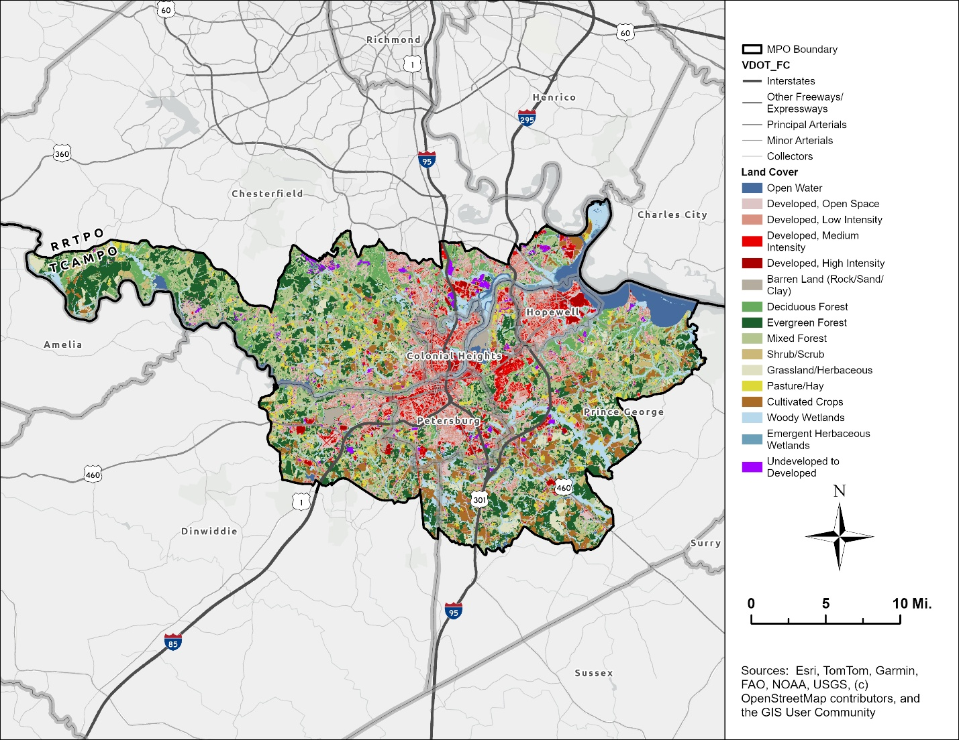
Source: U.S. Geological Survey (USGS), 2014 and 2024, Annual NLCD Collection

Figure 16 illustrates the current extent of developed land across the region's six jurisdictions. The chart below summarizes, for the portions of each jurisdiction within the Tri-Cities MPO, the percentage of land that is developed, undeveloped, or changed from undeveloped to developed between 2014 and 2024. To highlight regional growth patterns, individual land cover classes were consolidated into broader “developed” and “undeveloped” categories for this analysis.
This chart shows that region’s urban core – Colonial Heights, Hopewell, and Petersburg – has more than 60 percent of total land developed, while Dinwiddie, Prince George, and Chesterfield each has less than 30 percent developed. Across the Tri-Cities MPO as a whole, about 28 percent of land is developed, suggesting a region defined by a densely developed core surrounded by lower-density, largely undeveloped areas. While the conversion of undeveloped to developed land is not directly tied to long-range transportation planning needs, this trend mirrors the region’s broader patterns of population, household, and employment growth. Petersburg’s comparatively high rate of land conversion reflects both its population growth during the last decade and its relatively small size and limited remaining undeveloped land. The areas in Petersburg that transitioned from undeveloped to developed land are concentrated along Wells Road in south Petersburg, and along the US-301/I-95 corridor near the Bon Secours Medical Center and the Wagner Road interchange (Exit 48).
Figure 16. Percentage of Land that is Developed, Undeveloped, and Transitioned to Developed Use, 2014-2024

Source: U.S. Geological Survey (USGS), 2014 and 2024, Annual NLCD Collection

Jonathan Schroeder, David Van Riper, Steven Manson, Grace Cooper, Zachary Krause, Tracy Kugler, and Steven Ruggles. IPUMS National Historical Geographic Information System: Version 21.0 [dataset]. Minneapolis, MN: IPUMS. 2026. http://doi.org/10.18128/D050.V21.0

