**2e.** 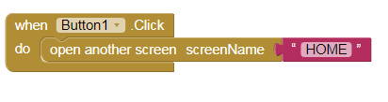

screen 1:

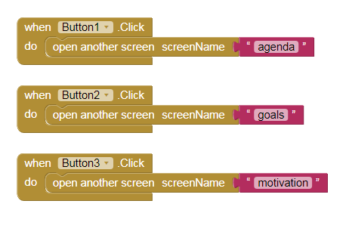

HOME screen:

agenda screen:



goals screen:motivation screen:



picture used:

back button image- <https://www.freepik.com/free-icon/back-arrow-ios-7-interface-symbol_754190.htm>