2a. My program is an interactive life planner and motivator app. I created this app in App Inventor from MIT using their scripts to write the code fro the program. This app is called Life Plan (also called get my life together). The purpose of my program is to have the user be able to plan their week in advance, keep a list of goals to accomplish, and get motivation when needed. All together, the app will help keep the user’s life more organized. The first part of the app is an agenda that will allow the user to input events that go on through out the week. The video shows that the user can input their plans for the week in order to stay organized and not allow their events to conflict with one another. The second part is the goals page. In the video, the user can add up to 6 goals and type in their personalized task to achieve. Once achieved they can mark it as done with the check box on the side. Both the agenda and the goals can be completely cleared in order to start fresh when it is a new week. The last part is a motivational quotes random generator. The video shows that random quotes will be shown when the generate button is clicked. These quotes re intended to give the user inspiration to preserve through whatever obstacle they may be going through.

2b. The creation of this app took about two weeks. In the beginning, there was a bit of a struggle to begin my code, but once I tried out different code segments, I choose the most effective one as the final code. A big struggle in creating the code was with the

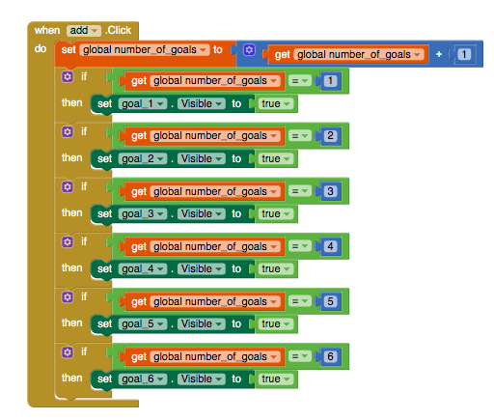

2c.

This block of code is an algorithm that will add a new text box and check box when the button add is clicked by increasing the counter by one every time it is click, but the maximum amount of clicks is 6. Within the main algorithm “add”, there are several if-then statements. Each statement functions independently as they make a mathematical comparison by checking if the “global_number of_goals” is equal to a specific number. If true, then a new set of checkboxes and textboxes appear. The textbox and corresponding check box will allow the user to input their own goals and record if they have accomplished it or not. Because one of the purposes of my app is to keep a list of goals to accomplish, the algorithm is necessary in order to add more goals for the user to record and eventually accomplish.

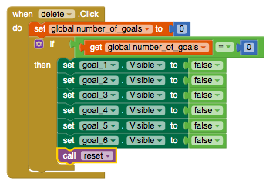

Another essential algorithm in my app is the algorithm “delete”. This code allows the user to delete all of the goals they have set weather they are accomplished or not. Since another purpose of the app is not only to keep track of their goals, but also to stay organized, the algorithm helps fulfill the purpose. First, the “global_number_of_goals” is set to the value of zero. This value becomes extremely relevant in the child algorithm inside “delete”. Because the “global_number_of_goals” was set to zero, the if-statement becomes true and continues to run through the then-statement, which will make the goals and checkboxes not be visible. This gives the illusion that they were deleted, but calling the reset procedure ensures that the goals are deleted because it will uncheck all of the checkboxes and set all of the textboxes to be blank.

2d.