**Linear system (Heat transfer in 2D)**

Q1)The four sides of a square plate of side 10, made of homogeneous material, is kept at constant temperature (about time) 0℃ , 100sin(𝜋𝑥/10)℃ . Find the steady-state temperature at the mesh points & plot temperature distribution

Mesh information : h 1 , number of nodes = 9 X 9 = 81

Consider the square slab,

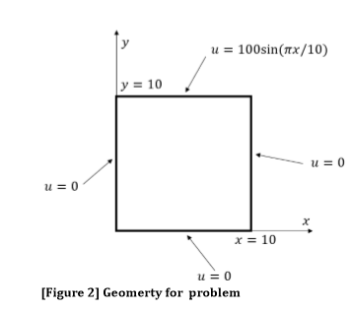

Let u be temperature. There are four boundary conditions:

* At x = 0, u = 0.
* At y = 0, u = 0.
* At x = 10, u = 0.
* At y = 10, u = 100sin(pi*x/10)

In our slab, we will create 81 mesh points ranging from 1 to 9 in the x and y axis.

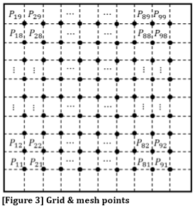

For each node, there are four neighbouring nodes. Below is a diagram of a single node and its neighbours.

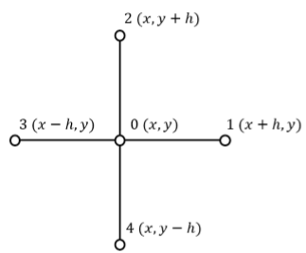

Let du/dt be the temperature change. From the diagram above, we can say that

). - (1)

We can use this equation to find our steady state temperatures at each node. At steady state temperature, let Therefore by rearranging, equation (1) becomes

-(2)

For each node, we will use this equation to find the steady state temperatures. We will implement this in Matlab using the following method:

|  |  |
| --- | --- |
| Input | Explanation |
| A = matrix | The A matrix will hold the coefficients that will multiply by the temperature at nodes in the u matrix, that will equal the corresponding temperature in B.  A will be 81 x 81 dimensional as there are 81 nodes. |
| U = matrix | Matrix that holds all the nodes temperatures.  U will be 81 x 1. |
| B = matrix | Matrix that holds all the temperatures we already know.  B will be 81 x 1. |

1. Create matrix A from the equation Au=b.

Using equation (2), we will create matrix A to hold the coefficients.

For example, for the node , by equation (2)

-

We know from the boundary conditions, so we have

-. -(3)

Given

The first row of as when you multiply this row of A with u, it will give equation (3). We repeat this for each node, moving left to right from to and then to row 2 and so on. We store these equations in matrix A. It actually creates a pattern in the matrix A

* 4 is on leading diagonal
* Both diagonals left and right of main diagonal have values -1
* Diagonal starting from A(1,10), value is -1

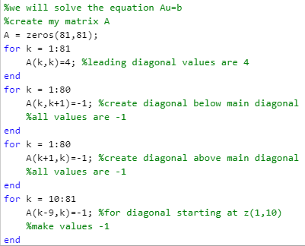

1. Create matrix b

This matrix will store the temperatures we already know.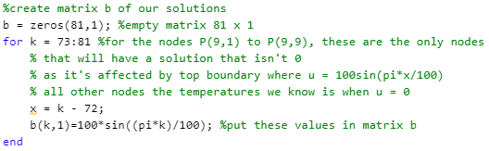

1. Create matrix u

This matrix stores all the steady state temperatures at each node

As we know our matrices A and b, we can do 

1. Now we have the steady state temperatures, create the temperature distribution graph of the slab

As we have u, a 81 x 1 dimensional matrix, I will create a new matrix 9 x 9 that stores the temperatures for each row of nodes in one row. For example, all temperatures for to will be the first row and to will be in the second row and so on.

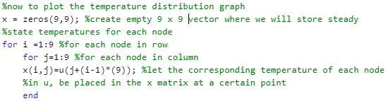

Now to plot the temperature distribution,



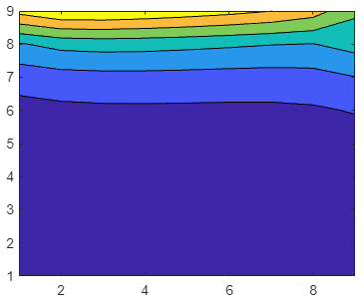

In the diagram, dark blue is where the temperature is lowest and as the shades of blue get closer and the colour turns green, the temperature increases. The highest temperature is in the yellow section (at the top).