Architect a Real Agentic AI System (Step by Step)
It walks through the process of taking an agentic AI system from a simple, non-functional demo to an enterprise-grade, production-ready customer support architecture for a banking organization.

1. Problem Context & Business Use Case
- The Problem: A banking organization’s customer support team handles thousands of incoming requests (with 65% being repetitive queries). Human support agents currently have to toggle across more than 14 different screens to resolve customer issues, costing the organization millions of dollars.
- The Goal: Architect a secure, autonomous AI customer support system capable of handling complex account inquiries, transactions, and service requests safely and reliably.

2. Step-by-Step Architectural Evolution
The video structures the transition into clear architectural stages:
- Step 1: The Raw LLM Baseline Asking a standalone language model a question like "What is my account balance?" fails because LLMs are isolated and lack direct access to internal banking databases.
- Step 2: Tool-Based Agent Tools and APIs are introduced to connect the LLM to internal systems (e.g., balance inquiries, statement requests, address changes). However, adding dozens of banking tools to a single agent causes tool overload, degrading reasoning and reliability.
- Step 3: Domain-Specific Sub-Agents To solve tool overload, the system is modularized into specialized sub-agents:
  - Accounts Agent
  - Transaction Agent
  - Service / Customer Service Agent
- Step 4: Decoupling with Model Context Protocol (MCP) Rather than writing tightly coupled programs, the architecture integrates MCP servers (Accounts MCP server, Transaction MCP server, Service MCP server) to standardize how sub-agents interact with internal banking tools and data sources.

3. Production Enterprise Hardening
To make the agentic system enterprise-ready, several critical engineering layers are added:
- Authentication & Role-Based Access Control (RBAC): Integrates with existing identity providers using token-based authentication. The system applies permission tiers based on customer status—for example, a privileged/premium customer may be authorized to request a credit limit increase, whereas a standard customer receives a permission refusal.
- Stateful Memory & Conversation History: Because LLMs are stateless by default, the system incorporates a shared conversation history and state management. This allows the agent to recall context across multiple turns (e.g., connecting a debit transaction query to a previously flagged suspicious transaction).
- PII (Personally Identifiable Information) Redaction & Hybrid Hosting(LLM): A dedicated PII redaction service strips sensitive data (such as credit card numbers) before data leaves internal systems. The design suggests using self-hosted models for data privacy, reserving third-party cloud models only when heavy, complex reasoning is required.
- Deterministic Guardrails: Hard business rules are enforced before the agent triggers real-world actions (e.g., requiring the agent to confirm the delivery address with the customer before submitting a checkbook order).
- Evaluation & Hallucination Prevention: Techniques to address non-deterministic outputs—such as an agent hallucinating an account balance of 18,200 when the actual customer balance is 52,340—to ensure factual correctness before responding to users.
- Observability, Infrastructure & Network Security:
  - Observability: Tracks system health (CPU, memory, disk) as well as specific LLM interactions and metrics.
  - Edge & Network Security: Implements a Web Application Firewall (WAF), Denial of Service (DoS) protection, rate limiting, and an API gateway to secure external entry points into the banking environment.
Steps Covered

✅ Multi-agent design (Coordinator + domain sub-agents)
✅ MCP servers for tool abstraction
✅ Authentication & Authorization (and why they're not the same thing)
✅ Session management, conversation memory & inter-agent state sharing
✅ Hybrid LLM strategy — why PII never leaves the bank
✅ Prompt injection risks & guardrails (a real attack scenario)
✅ Agent evaluation pipelines (catching regressions before they ship)
✅ Observability & tracing for agentic systems
✅ Cost tracking & runaway-loop protection
✅ Message queues, human-in-the-loop approval & async writes
✅ Production deployment, networking & failure handling
- Simple Demo
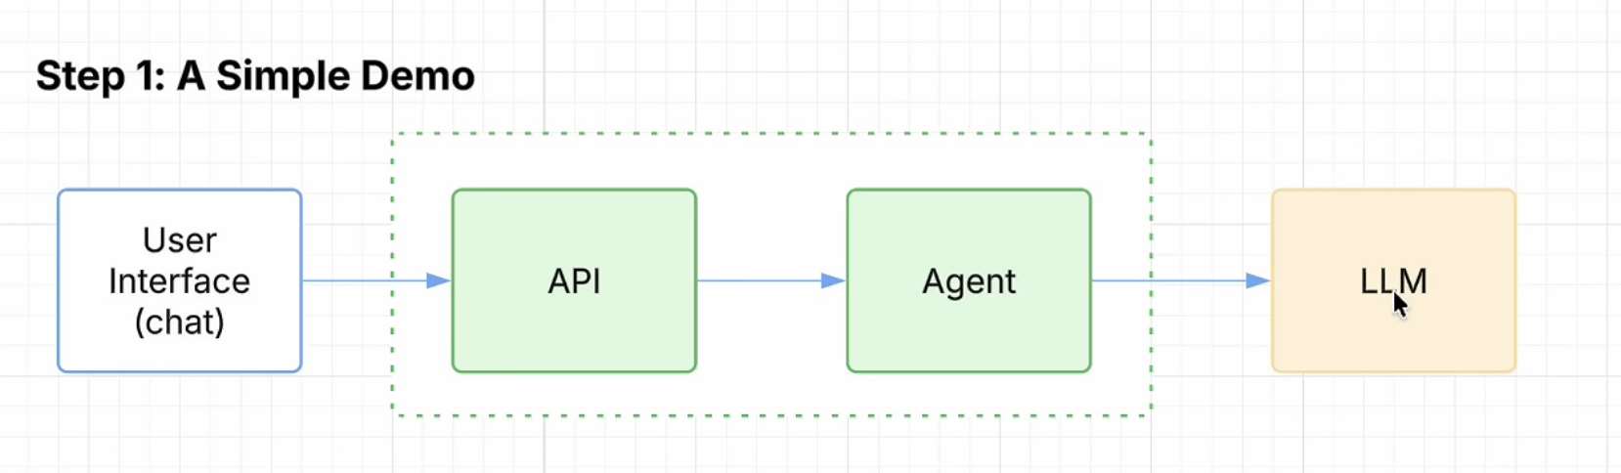

⏱️ Timestamps 00:00 Intro 1, The Business Problem 2. The Starting Point 3. Connecting Agent to the Bank 4. One Agent. Too Many Tools 06:21 Who Plans Agent Execution? 07:28 Tool Integration Headache 08:13 MCP Servers 09:09 Demo - The Security Issue 10:08 Agent Knows Who is Talking 12:58 AI vs Software Engineering 13:40 The Memory 15:22 PII Never Leaves the Bank 17:29 Prompt that breaks the system 18:35 Where did my system go wrong 20:39 The bill that tripled 21:15 Edge Layer Security
- One Agent. Too Many Tools
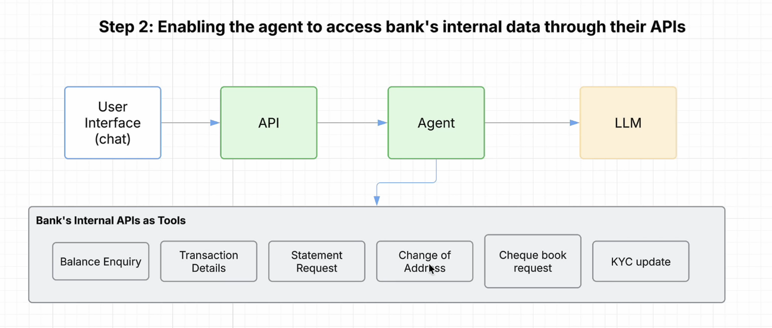

Step 4: Adding the sub agent
We are going to do the spawning(grouping) the tool

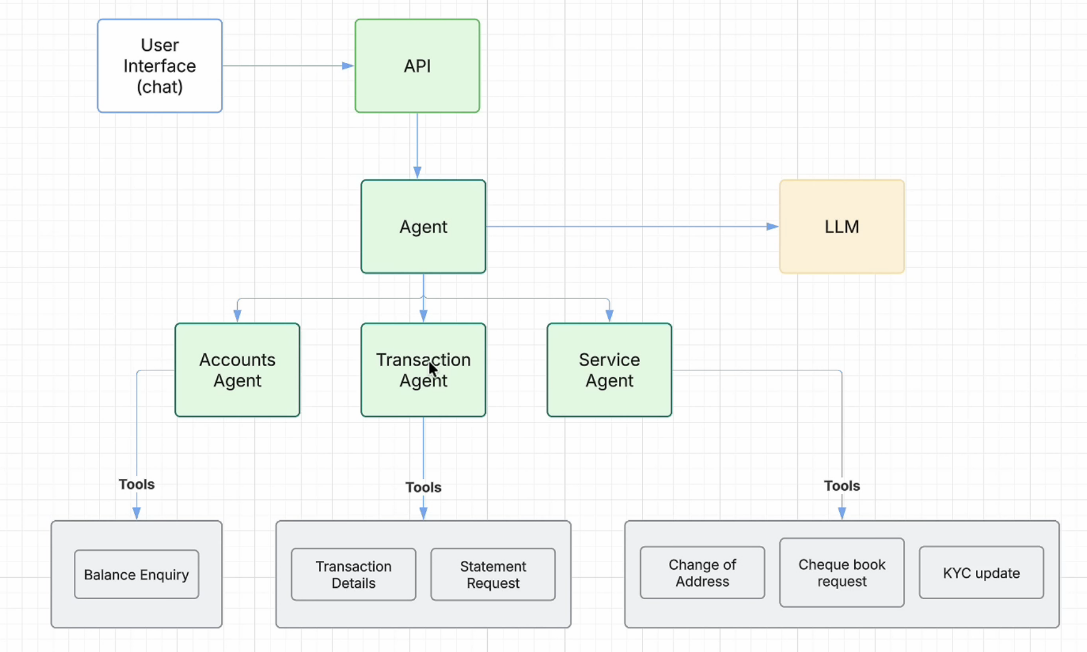
Step 5: Exposing MCP Call
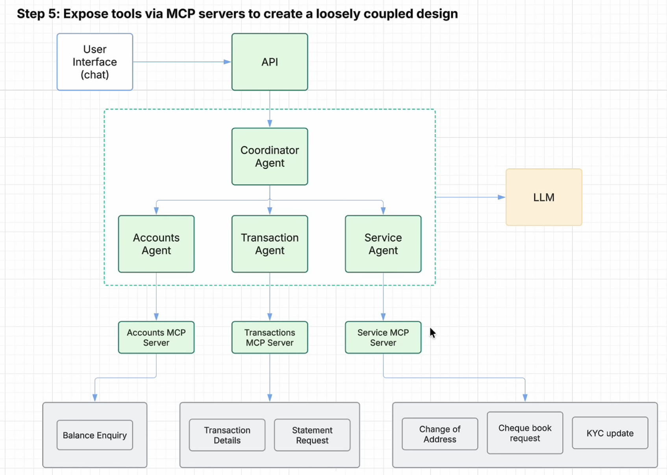

Full Architecture View – Blue is software engineer and green is AI engineer

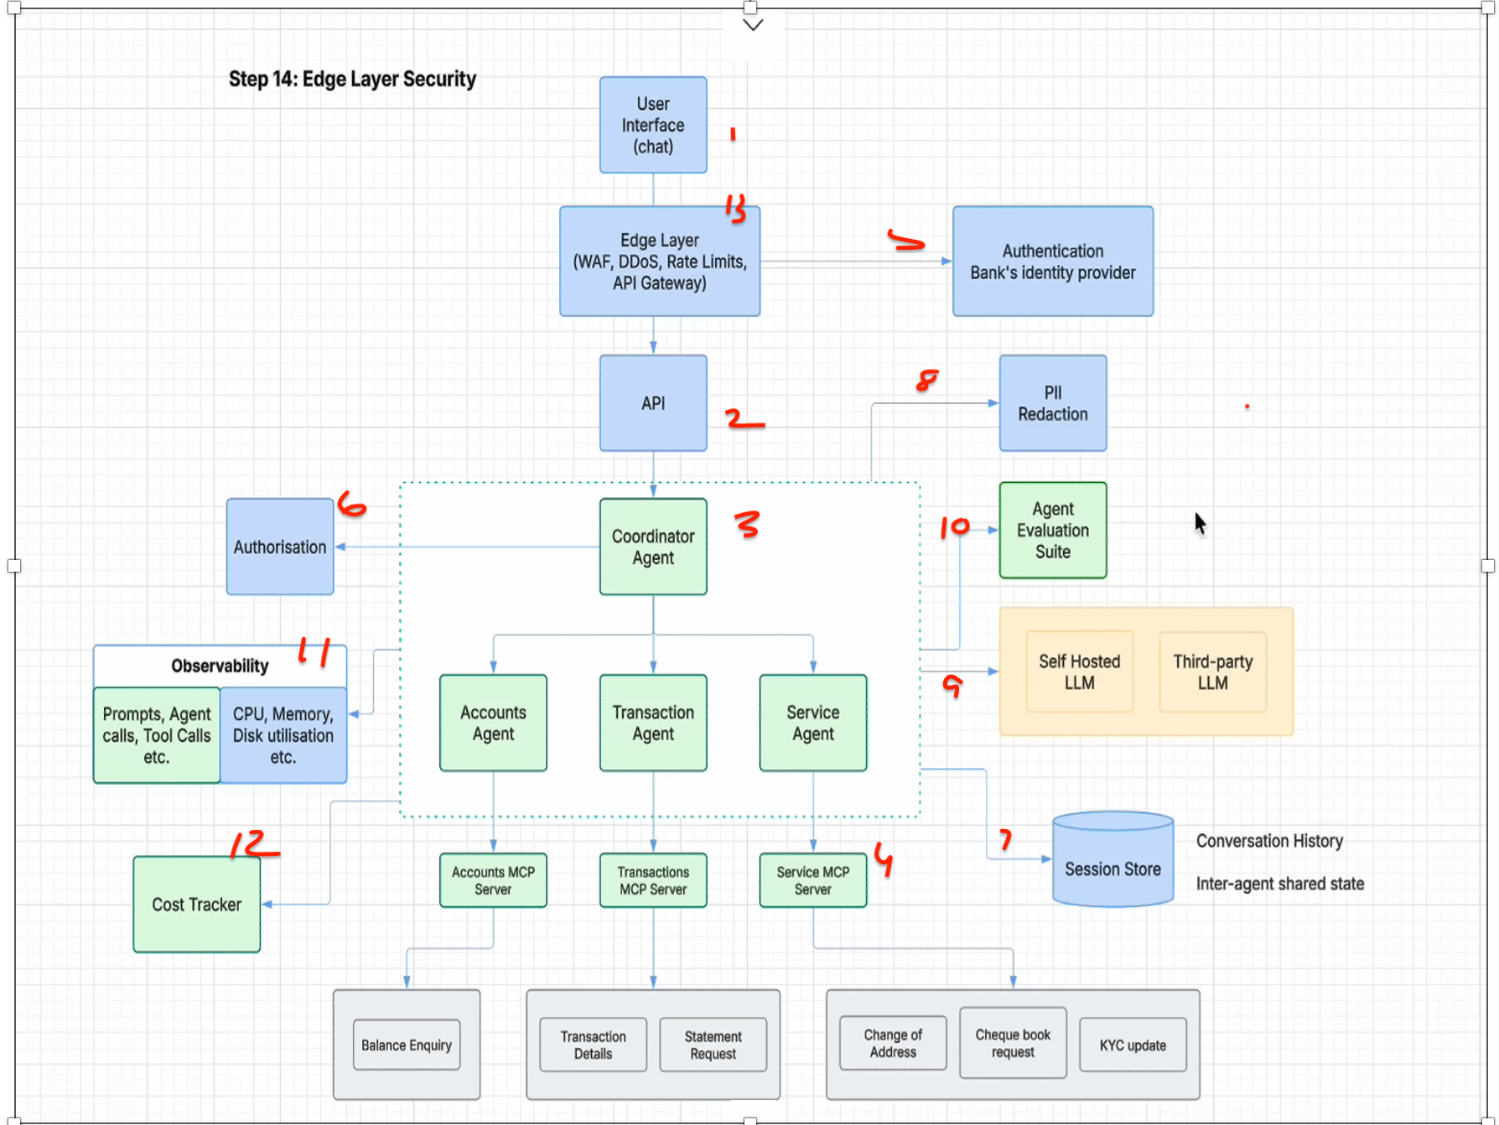

Agentic AI System Design

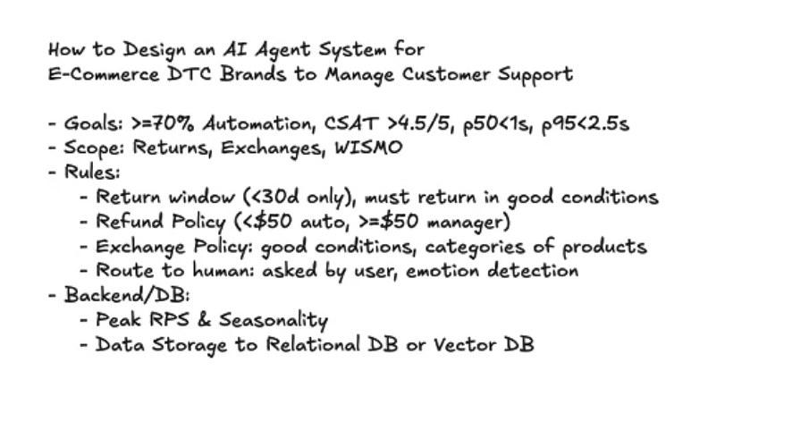
This video outlines how to design a professional AI Agent System for e-commerce cu

stomer support, focusing on automating tasks like returns, exchanges, and order tracking while maintaining high customer satisfaction.
Core System Design Goals:
- Efficiency: Achieve over 70% automation in support flows (1:09).
- Performance: Ensure 50% of responses occur under 1 second and 95% under 2.5 seconds (1:32).
- Quality: Maintain a customer satisfaction rating above 4.5/5 (1:25).
Key Architectural Components:
- Router Agent: Analyzes user intent to determine the next steps and decides if a human needs to be looped into the conversation (7:08).
- Q&A Agent: Acts as the central "brain" for customer interaction, managing communications and maintaining context (7:38).
- Planner Agent: Coordinates the execution of specific tasks, such as triggering APIs for refunds or order status checks (9:33).
- Vector Database (RAG): Used for Retrieval-Augmented Generation, allowing the system to semantically search unstructured private data like return policies (12:28).
- Functional Calling: Integrates external tools like Shopify, Stripe, and CRM systems to perform real-world actions automatically (10:15).
Operational Best Practices:
- Human-in-the-loop: A critical safety mechanism for handling complex or emotionally charged customer interactions (8:36).
- Observability: Continuously monitoring system metrics and evaluations to ensure goals are met (17:10).
- Deterministic Workflows: Sometimes using fixed rules is more reliable than an agent; knowing when to use standard automation versus AI is vital for system stability (11:24).

