**Bugs**

1. **Subject:**

first question textbox

**Steps:**

* upload the Trivia game site
* insert the letter "a" on the text box

**Expected result:**

The letter "A" written on the textbox

**Actual result:**

The textbox field Left blank

**Severity:**

Critical

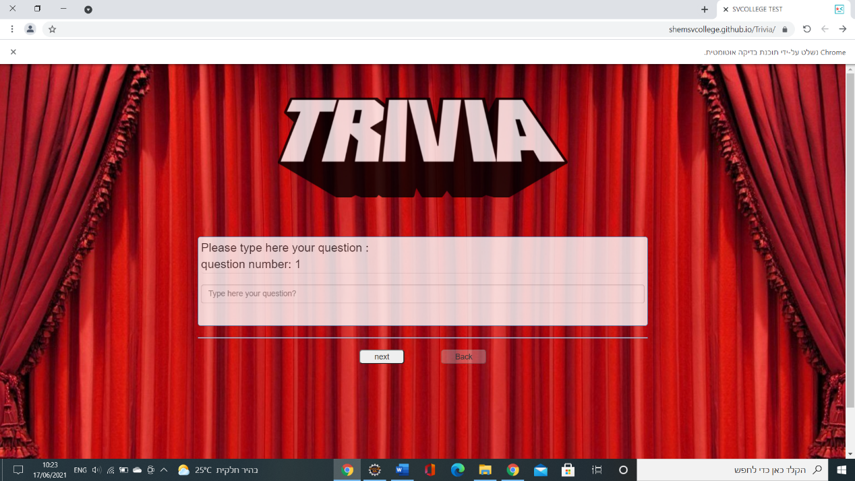

1. **Subject:**

The next button does not move to the answers page

**Steps:**

* upload the Trivia game site
* insert the letter "a" on the text box
* press on the next button

**Expected result:**

Go to page four answers of the first question

**Actual result:**

An empty page appears

**Severity:**

Critical

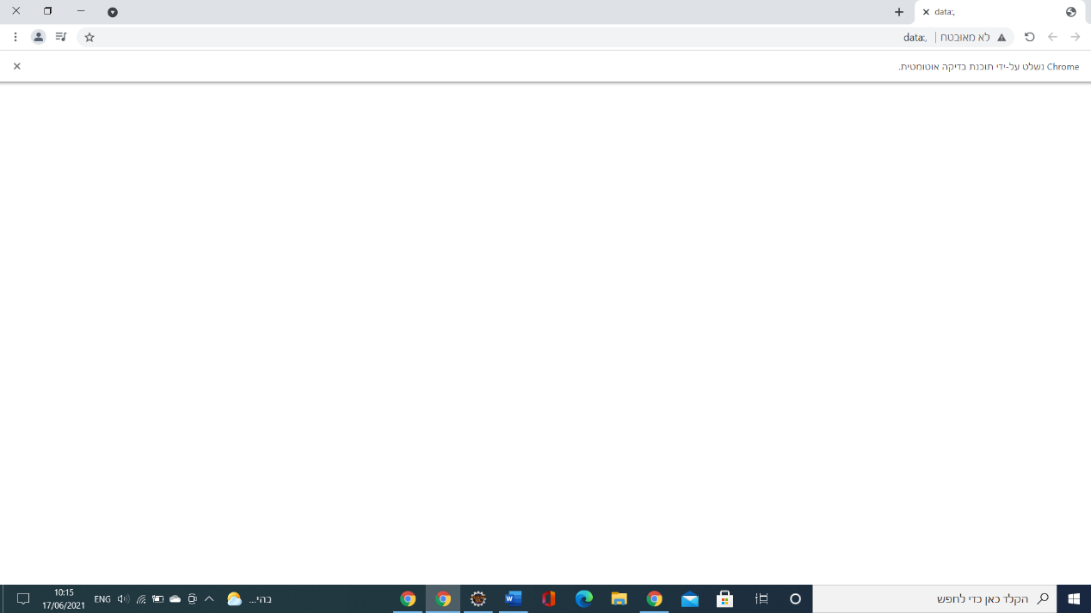

1. **Subject:**

Start button on edge browser

**Steps:**

* Insert the trivia game site URL
* Press on the start button

**Expected result:**

The question screen appears

**Actual result:**

No edge browser upload

java.lang.NullPointerException

**Severity:**

medium

because of we have a work around

on chrome driver it's works

1. **Subject:**

Play game on Firefox browser

**Steps:**

* Insert the trivia game site URL
* Press on the start button
* Insert value on question line
* Insert value on the all 4 answer line
* Click on play button
* Choose the inappropriate radio button

**Expected result:**

"fail" "try again" t  
The result is wrong

**Actual result:**

" success" "share on Facebook"

**Severity:**

low

1. **Subject:**

quit button (chrome browser)

**Steps:**

* Play the trivia game
* Press on quit button

**Expected result:**

Exit the browser

**Actual result:**

Blank page uploaded

**Severity:**

low