Version Control

1. Intro to Version Control
   1. What it is
      1. Version control systems regulate changes so that developers can keep track of their own work and collaborate with others on the same project at the same time.[1]
   2. Purpose/Benefits
      1. It allows developers to know who made what changes and when so that everything is organized and controlled. At any time, developers can go back and redo a project or file from any point in ‘history’. Additionally, VCSs allows developers to compare different versions and not override other developer’s code too easily. [2]
   3. Types
      1. Local
         1. On each PC there is a directory where the files are saved every so often. This is not ideal because it is only available on one computer and it’s very easy to make mistakes.[3]
      2. Centralized
         1. Figure 1
         2. One server with all the versions saved. Each developer ‘checks-out’ the versions that they need.[4]
         3. Advantages are that there is communication between developers. Everyone can see what others are doing because there is one centralized server. Administrators have more control. It’s easier to work with.
         4. Disadvantages are that if the central server goes down or is compromised, all the data could potentially be lost. [5]
      3. Distributed
         1. Figure 2
         2. Developers checkout all versions every time they clone.
         3. Advantages are if a server goes down, they can copy from one of the other developers back to the server. Additionally, developers can connect to more than one repository at once.[6]
         4. Disadvantages are that it could take up more space.
      4. In short, local is one copy on one machine, centralized is one copy that can be accessed from many machines, and distributed is many copies on many machines.[7]
2. Version Control Terminology
   1. Repository
      1. A group of files that is under version control
      2. Other older VCSs it means the central code[8], which there is no such thing in distributed systems.
   2. Checkout- checkout a specific branch from central repository
   3. Revert- reverts to initial state and deletes pending changes[9]
   4. Working copy- developers personal copy of the central repository.[10]
   5. Trunk- main branch meaning the most up to date branch where all developers push to and pull from
   6. Branches- divide from the trunk to attempt something new[11]
   7. Patch- A change done to one version that produces a new version.[12]
   8. Commit-
      1. Save new changes to original on your computer[13]
      2. CVS- Send changes to central repository[14]
   9. Pull/ Update- update your current branch by ‘pulling’ from the shared central repository. Used when other developers made changes to central repository. Needs to be done before merging changes to central repository so that there is no conflicts.[15] Does fetch and merge together.
   10. Merge- merge working copy to central repository[16]
   11. Fork- branch off the main code to produce entirely new file. Will not be merged back. Now owned by you and does slight or big differences from the original.[17]
   12. Status- new, changed, and deleted files[18]
   13. Log- See who did what[19]
3. Comparing Version Control software and how to use them
   1. Local
      1. RCS
         1. RCS saves just patches so if a developer wants a specific version the computer combines the patches.[20]
   2. Centralized
      1. CVS
         1. Can ‘rollback’ and completely delete[21]
         2. Not so easy to store any type of file and metadata[22]
      2. Subversion
         1. Can’t ‘rollback’ meaning you can change it back but will always be in history.[23]
         2. Can store all types of files without user specifying the type and can store metadata.[24]
         3. Easier tracking
         4. Better revision numbering
         5. Can list branches
         6. Delete branches and if necessary revert
         7. Have copy of repository that is under control on personal PC (takes up a lot of room)[25]
   3. Distributed
      1. Git
      2. Mercurial
4. Comparing the different VCSs
5. An Example of a Popular VC: Git and GitHub in Detail
   1. Installing Git and Git Bash
   2. Cloning repositories
   3. Branching, committing, updating, etc.
      1. Figure 3
   4. Reverting back
   5. Using GitHub
6. Full Version Control Plan
   1. If a system goes down
   2. If a version blows up
      1. How to revert
         1. Check the log. Developers should have made sure to write thorough messages which will describe the changes made. Find which commit you want to go back to.

Git revert logNumber

1. Conclusion
   1. Reinforce why we need VC (Card 22)
      1. Track code revisions
      2. Show history
      3. Support multiple users on same code at once
      4. Support branching
      5. Support merging of branches
      6. Reveal conflicts and allow to fix them
      7. Support going back in history

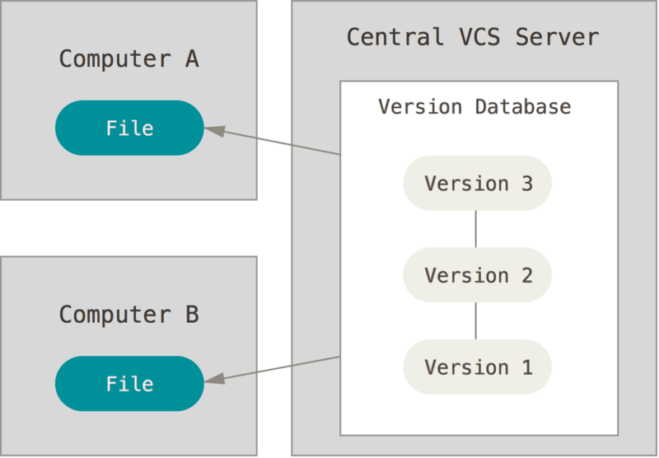

Figure 1 From Pro Git

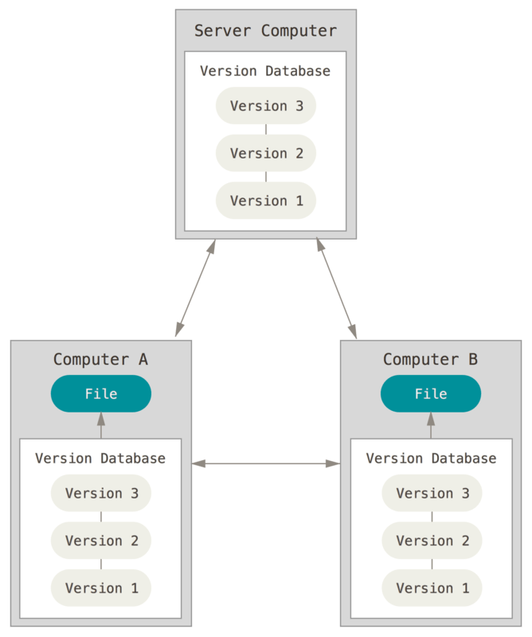

Figure 2 From Pro Git

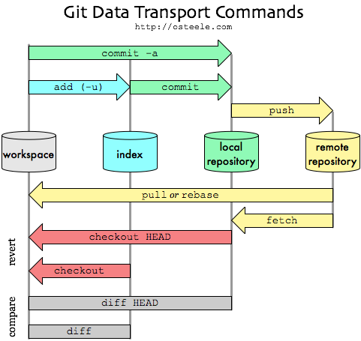

Figure 3

1. Source 1 (Card 1)
2. 1 (2)
3. 1 (4)
4. 1 (6)
5. 1 (7)
6. 1 (8)
7. 3b (13)
8. 3c (16)
9. 2 (24)
10. 3b (14)
11. 3c (16)
12. 1 (3)
13. 3b (14)
14. 5 (20)
15. 3b (14)
16. 3b (14)
17. 3b (14)
18. 7 (23)
19. 2 (24)
20. 1 (5)
21. 9 (26)
22. 9 (27)
23. 9 (26)
24. 9 (27)
25. 10 (28)