Table of Contents

Intro to Version Control 1

What it is 1

Purpose/Benefits 1

Types 1

Local 1

Centralized 1

Distributed 2

Summary 3

Version Control Terminology 3

Comparing Version Control software and how to use them 4

Local 4

Centralized 5

Distributed 6

An Example of a Popular VC: Git and GitHub in Detail 6

Installing Git 6

Creating repositories 7

Clone an existing repository 7

Create a new repository 8

Adding, Committing 9

Finding differences 11

Updating your local repository, fetching 12

Reverting, cherry-picking 12

Branching, merging 12

Remotes 14

History 15

Using GitHub 15

Full Version Control Plan 15

If a system goes down 15

If a version blows up 15

If a new software or version is introduced to your company 16

Conclusion 16

Version Control

# Intro to Version Control

## What it is

Version control systems regulate changes so that developers can keep track of their own work and collaborate with others on the same project at the same time.[1]

## Purpose/Benefits

It allows developers to know who made what changes and when so that everything is organized and controlled. At any time, developers can go back and redo a project or file from any point in ‘history’. Additionally, VCSs allows developers to compare different versions and not override other developer’s code too easily. [2]

## Types

### Local

On each PC there is a directory where the files are saved every so often. This is not ideal because it is only available on one computer and it’s very easy to make mistakes.[3]

### Centralized

Figure 1

Centralized VCSs have one central server with all the versions saved on it. Each developer ‘checks-out’ the versions that they need.[4]

Advantages of a centralized system are that there is communication between developers. Everyone can see what others are doing because there is one centralized server. Additionally, administrators have more control over the project. Lastly, a centralized system is easier to work with.

One disadvantage is that if the central server goes down or is compromised, all the data could potentially be lost. [5]

### Distributed

Figure 2

While using distributed VCS, developers download all the versions (the entire history) when they first get the database onto their local machine. To help developers work together, there is usually a central server that all developers can access. That central server is the version kept most up to date and is where all the developers send their code when they have updated it. Each developer can work locally, make changes, and test their work, and then just send it to the central server for the other developers to access.[6]

There are many advantages to using a distributed system. Firstly, they are much faster to use because everything is stored on the developer’s machine. Secondly, developers don’t need to use the internet or be connected to any network.[7] Additionally, if a server goes down, developers can copy their own code back to the server because each developer has all the code. Lastly, developers can connect to more than one repository at once.[8]

There are not many disadvantages to using a distributed system over centralized or local but, in some situations, distributed systems can take up more space.

### Summary

In summary, local is one copy on one machine, centralized is one copy that can be accessed from many machines, and distributed is many copies on many machines.[9]

# Version Control Terminology

* 1. Repository
     1. A group of files that is under version control
     2. Other older VCSs it means the central code[10], which there is no such thing in distributed systems.
  2. Checkout- checkout a specific branch from central repository
  3. Revert- reverts to initial state and deletes pending changes[11]
  4. Working copy- developers personal copy of the central repository.[12]
  5. Trunk- main branch meaning the most up to date branch where all developers push to and pull from
  6. Branches- divide from the trunk to attempt something new.[13] Branching will completely change your working directory to be identical to your new branch.[14]
  7. Patch- A change done to one version that produces a new version.[15]
  8. Commit-
     1. Save new changes to original on your computer[16]
     2. CVS- Send changes to central repository[17]
  9. Pull/ Update- update your current branch by ‘pulling’ from the shared central repository. Used when other developers made changes to central repository. Needs to be done before merging changes to central repository so that there is no conflicts.[18] Does fetch and merge together.
  10. Merge- merge working copy to central repository[19]
  11. Fork- branch off the main code to produce entirely new file. Will not be merged back. Now owned by you and does slight or big differences from the original.[20]
  12. Status- new, changed, and deleted files[21]
  13. Log- See who did what[22]

# Comparing Version Control software and how to use them

## Local

* 1. RCS
     1. RCS saves just patches so if a developer wants a specific version the computer combines the patches.[23]

## Centralized

* 1. Like RCS in way stores data
     1. Uses patches, file based, saves each file change and has to calculate all the changes
     2. Only use <version system> add to add a file the first time. After that, you just commit[24]
  2. CVS
     1. Can ‘rollback’ and completely delete[25]
     2. Not so easy to store any type of file and metadata[26]
  3. Subversion
     1. Can’t ‘rollback’ meaning you can change it back but will always be in history.[27]
  4. Perversion
     1. Can store all types of files without user specifying the type and can store metadata.[28]
     2. Easier tracking
     3. Better revision numbering
     4. Can list branches
     5. Delete branches and if necessary revert
     6. Have copy of repository that is under control on personal PC (twakes up a lot of room)[29]

## Distributed

* 1. Git
     1. Open-source
     2. Never deletes history, just moves pointer to new place
     3. Snapshots
        1. git add is done whenever you make changes because your saying you want this new change to be included in next commit/ snapshot.
        2. git commit produces new snapshots with different hash codes for each new snapshot. Can compare different versions of the same file because your just comparing snapshots.
        3. When sending the files, it is stored as changes not as whole files to minimize content and maximize speed and efficiency.[30]
  2. Mercurial
  3. Bazaar

# An Example of a Popular VC: Git and GitHub in Detail

## Installing Git

Git can be installed in a few ways, I will be using the command prompt which can be accessed in all three installation methods.

Developers can use Git Bash, a version of the command prompt with git already preconfigured.

Git, the actual source code which can we used from the command prompt is another good option.

GitHub Desktop is a graphical interface that works with your local repository to track changes and differences between your local repository and the repository stored on GitHub. It is easy to use and comes preconfigured with a command prompt that has git installed.

When you have a command prompt with git installed open, set up your name and email by using the following,

1. git config--global user.name "your name"
2. git config--global user.email "your email"

## Creating repositories

Once you have git installed, you want to start keeping track of files. You can either clone an existing repository or create a new one.

### Clone an existing repository

GitHub is a website that stores repositories, allows the developers to do all git functions, and much more. Developers use GitHub like a central repository, in that it is the most up to date branch. All developers can access it and update their local repositories from it when necessary. They also merge their own updates to the repository stored on GitHub.

To clone an existing repository, open the command prompt and move to the directory where you want your local repository to exist.

1. cd <local/repository/URL>

Clone the repository by

1. git clone <URL>

You should get back something like the following:

1. Cloning into '<Name of Repository>'...  
   remote:  Counting objects:  97, done.  
   remote:  Compressing objects:  100 % (10 / 10), done.  
   remote:  Total 97 (delta 1), reused 0 (delta 0), pack - reused 87  
    Unpacking objects:  100 % (97 / 97), done.

### Create a new repository

To create a new repository instead cloning, open the command prompt and move to the directory where your new repository is stored. As a reminder you need to use the “cd” prompt.

Then git init to initialize the repository as a git-controlled repository. This will produce a .git folder within your repository.

1. git init

Add and commit all the existing files to your repository. See adding and committing later. (git add . and git commit). Now you should have a version-controlled repository on your local computer.

To clone your new repository to GitHub, open the command prompt and cd into your local repository.

Create a completely empty repository in GitHub.

In the command prompt, add the GitHub remote repository as a remote repository and name it. In this example origin is the name of your new remote repository.

1. git remote add origin git@ github.com: < username > /<repository name>.git

Push your current repository (here master) to the remote repository (called origin)

1. git push origin master

You will be asked for your username and password of your GitHub account. Keep in mind that when entering your password the command prompt will appear as if nothing is being entered. The command prompt will look very similar to this:

1. fatal:  HttpRequestException encountered.  
     An error occurred
2. while sending the request.  
   Username
3. for  'https://github.com': < username >   
   Password
4. for  'https://<username>@github.com':   
   Counting objects:  53,  done.  
   Delta compression using up to 4 threads.  
   Compressing objects:  100 %  (51 / 51),  done.  
   Writing objects:  100 %  (53 / 53),  55.79  KiB  |  5.58  MiB / s,  done.  
   Total  53 (delta 2), reused 0 (delta 0)  
    remote:  Resolving deltas:  100 %  (2 / 2),  done.  
   To https: //github.com/elishevastrauss1/SchoolWork.git  
   * [new branch]      master -> master

As we mentioned earlier, when cloning and passing files, git compresses them by saving the changes (called Deltas) to maximize speed. As shown in the previous lines that are reiterated below.

1. Delta compression using up to 4 threads.  
   Compressing objects:  100 %  (51 / 51),  done.

## Adding, Committing

Figure 3

There are many steps to change and save changes to a git repository.

First find out what is the status of each file in the repository to find out what was changed.

1. git status

The output will be:

1. On branch master  
    Your branch is up to date with  'origin/master'.  
     
   Changes  not staged
2. for commit:    (use  "git add <file>..."
3. to update what will be committed)  
     (use  "git checkout -- <file>..."
4. to discard changes in working directory)  
     
            modified:    < file name >

The first two lines are saying that your local repository, master is “up to date” with your remote repository, origin. If the other developers changed the remote repository, you would have to update your local repository before committing. See updating your local repository.

Add those files to the pending list to be committed.

1. git add <file name>

or

1. git add .

“git add” is called staging a commit. Those files are now staged and ready for committing. They have not been saved to your local repository and you can still change the files. “git add <file name>” stages just one file, while “git add .” stages all changed files to be committed.

Additionally, you can do git add -p which will allow you to choose which items to commit in a given file. This allows just parts of files to be commited.

Commit the changes to your local repository.

1. git commit

You can add all files and commit at the same time by

1. git commit - a

A message editor will pop-up to write a detailed message about your commit. Save the message and close the editor.

Another option would be to just add the message after the commit command by saying

1. git commit - m "<message>"

This will not open an editor and will just continue as if the editor was opened, saved, and closed.

Once the editor is closed, the command prompt will say something like:

1. [master(root - commit)  < Commit Log Number > ]  < Your Message >   
   40 files changed,  1136 insertions(+)  
    create mode 100644 .classpath  
    create mode 100644 .project  
    create mode 100644 .settings / org.eclipse.jdt.core.prefs  
    create mode 100644  MusicLessons.html  
    create mode 100644  MusicNotes.jpg  
    create mode 100644  StudentLists.txt  
    create mode 100644 bin / dataStructures / LinkList.class

To unstage a file that was already added to the pending list:

1. git reset HEAD < file name >
   * 1. To undo all changes since the last commit

## Finding differences

* + 1. git diff <file name>

## Updating your local repository, fetching

* + 1. git remote update
    2. git fetch
    3. git pull

## Reverting, cherry-picking

* + 1. git log to find the commit that you want to go back to.
    2. Revert
       1. Copy the log number and then git revert <log number>. This will make a new commit that does the opposite of the reverted commit. All + become – and visa-versa. You only need the first eight numbers.

## Branching, merging

* + 1. As a reminder, branching will completely change your working directory to be identical to your new branch.
    2. Benefits
       1. Experiment
       2. “Isolate work units”
       3. “Long running topics”
    3. git branch to determine what branches exist and what is your current branch.
    4. git branch <new branch name> to create a new branch
    5. git checkout <file> to checkout a specific branch into your working directory
    6. git checkout -b <new branch name> to make a new branch and switch to it at the same time
    7. “Working directory needs to be clean”, meaning no pending changes or unstaged changes, if you want to switch to another branch.
    8. git stash will clean out the working directory and save your unstaged changes.
       1. To get back previously stashed changes
       2. git stash show will give a list of the branches and files that have stashed changes.
       3. git stash apply will reapply stashed changes
    9. HEAD is pointer to current branch
       1. When commit, HEAD moves forward along with the current branch.
    10. Merging
        1. checkout the branch you want to change.
        2. git merge <branch> will merge the branch listed into your current branch.
    11. Conflicts
        1. Occur when trying to merge two files that changed the same area of code.
        2. Go to the file and resolve the conflict
           1. It will be in between “merge conflict markers” (<<<<< and >>>>>)
        3. Open a merge tool by git mergetool that will help you merge the conflict.
    12. Deleting branches
        1. git branch -d <branch name> if the branch was already merged
        2. git branch -D <branch name> if the branch was not merged and you want to forcibly delete it anyway.

## Remotes

* + 1. A fancy way to say the URL of another server with the git repository on it.
    2. When you clone, you get two pointers:
       1. master is your main working directory where all your updates get merged to.
       2. origin/master points to where the remote repository was last up to when you cloned or last updated.
    3. Pushing back to the remote
       1. If the remote’s file has not been changed since you last updated:
          1. git push <remote url or alias for the remote url> <branch that you’re pushing to in the remote server>
          2. Usually will be git push origin master – pushing your work to the origin server to add the differences to the master branch.
          3. Will move origin/master pointer to point to where you just committed.
       2. If the remote has changed since your last update, then git will not allow you to push your file changes because they will be overwriting other changes. Therefore, you need to:
          1. Fetch

Fetch the updated repository by git fetch. This only is fetched to your local repository, not your working directory.

Merge the updated repository file with what you want to commit. Usually with master checked out git merge origin/master, the most up to date version of the remote repository.

Now that the remote’s updated version is in this files history, you can push to the remote.

* + - * 1. Pull

Fetches and then automatically merges with your current branch. Can get confusing sometimes.

## History

* + 1. git log displays commit number (sha), who committed, date of commit, and the commit message.

## Using GitHub

* + 1. Pull requests

# Full Version Control Plan

## If a system goes down

## If a version blows up

* + 1. How to revert
       1. Check the log. Developers should have made sure to write thorough messages which will describe the changes made. Find which commit you want to go back to.
       2. git revert <log number>

## If a new software or version is introduced to your company

* + 1. Trainings
       1. Old people
       2. New people

# Conclusion

* 1. Reinforce why we need VC (Card 22)
     1. Track code revisions
     2. Show history
     3. Support multiple users on same code at once
     4. Support branching
     5. Support merging of branches
     6. Reveal conflicts and allow to fix them
     7. Support going back in history

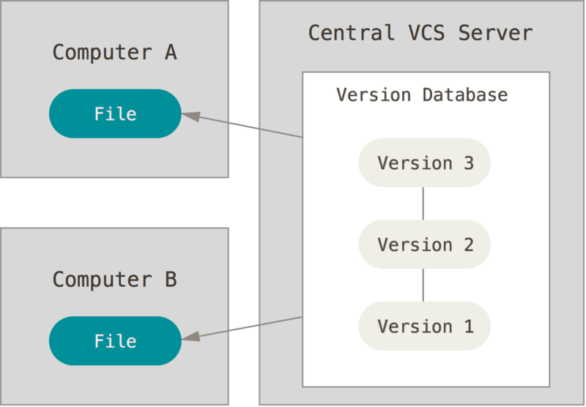

Figure 1 From Pro Git

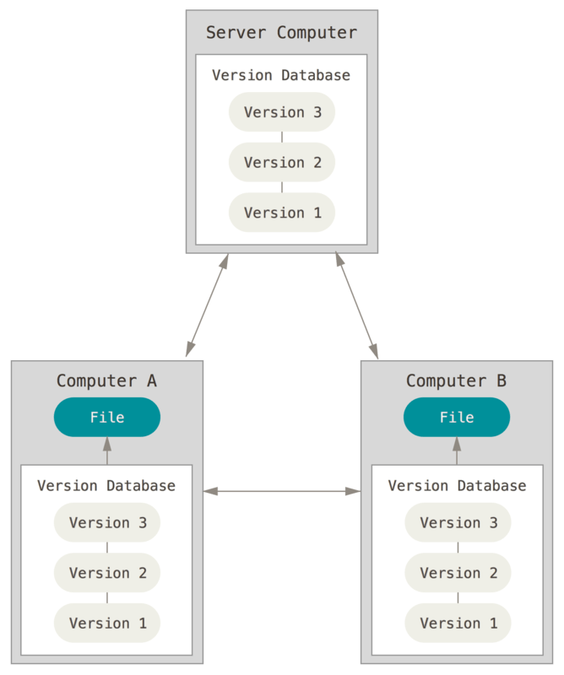

Figure 2 From Pro Git

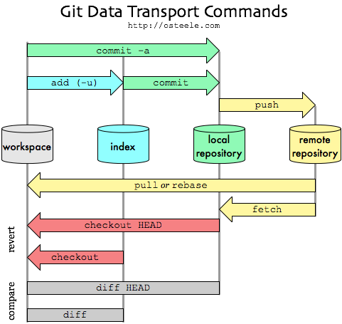

Figure 3

1. Source 1 (Card 1)
2. 1 (2)
3. 1 (4)
4. 1 (6)
5. 1 (7)
6. 11
7. 11
8. 1 (8)
9. 3b (13)
10. 3c (16)
11. 2 (24)
12. 3b (14)
13. 3c (16)
14. 11
15. 1 (3)
16. 3b (14)
17. 5 (20)
18. 3b (14)
19. 3b (14)
20. 3b (14)
21. 7 (23)
22. 2 (24)
23. 1 (5)
24. 11
25. 9 (26)
26. 9 (27)
27. 9 (26)
28. 9 (27)
29. 10 (28)
30. 11