Contents

Game Overview 4

High Concept 4

Unique Selling Points 4

Platform Minimum Requirements 5

Competence Titles 5

Synopsis 6

Game Objectives 6

Game Rules 6

Game Structure 6

Gameplay 7

Game Controls 7

Game Camera 8

HUD 8

Player 9

Player Characters 9

Player Metrics 9

Player States 9

Player Weapons 9

Character Line-up 10

NPC Enemies 10

Enemy: Clown 10

Enemy: ZomBear 10

Enemy: ZomBunny 10

Enemy: ZomDuck 10

Enemy: Hellephant 10

Enemy States 11

Enemy Spawning 11

NPC Allies 11

Sheep 11

Ally Spawning 11

Art 12

Setting 12

Level Design 12

Audio 13

MVP (Minimum Viable Product) 14

Wishlist 14

# Game Overview

Title: Nexus Chronicle

Platform: PC Standalone

Genre: 3D JRPG

Rating: (13+) ESRB

Target: RPG gamer (aging from 13 - 30)

Nexus chronicles is a 3D Japanese Role Playing Game(JRPG); There are 4 characters in a party and the player is able to control one of them to lead the party around the map. The objective of the game is to explore the map, kill enemies to complete quests, get stronger by leveling up which will allow them to further progress the story.

# High Concept

In Nexus Chronicle is a single player 3D JRPG where the player controls a party of 4 characters to explore the fantasy world, Celino. The player will get stronger by fighting enemies, completing quests and exploring what Celino has to offer.

# Unique Selling Points

1. 4 unique playable characters
2. Combat uses all 4 characters who have their own roles in combat (e.g. attacker, healer)

# Platform Minimum Requirements

PC STANDALONE

OS: Windows10

Graphics card: NVIDIA GeForce RTX 2060 capabilities; generally everything made since 2020 should work

# Competing Titles

“Tales” series made by Bandai Namco

Xenoblade Series made by Monolith Soft

Personal Series made by P-Studio

Yakuza Series made by Ryu Ga Gotoku Studio

# Synopsis

You follow a explorer as he tries to visit all the wonders of Celino, On his journey he meets a pair of siblings and a runaway noble, together they will visit all corners of Celino, getting stronger, making memories and maybe fulfill a prophecy.

# Game Objectives

The objective of the game is to progress the story until it reaches the end. As the story progresses the party will encounter stronger and stronger enemies, thus requiring the player to level up the party by completing quests and fighting enemies.

# Game Rules

The game is set is a semi-open world environment, there are monsters spread around the map that the player can fight. When the character is standing still and close enough to the enemy, they will automatically attack the target to deal damage. When a character hp reaches 0 they will be downed and needs to be revived by another party member. When an enemy hp reaches 0, the enemy will die, and the player will gain exp depending on the level of the enemy. If all 4 characters die it will reset back to the last save point

# Game Structure

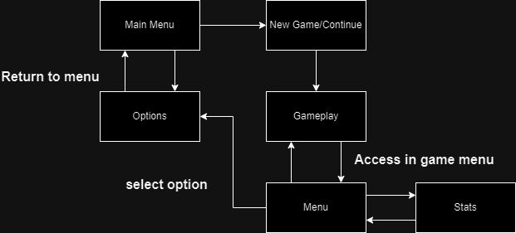

# Gameplay

Game Controls (PC)

# Player

## Player Character

There are 4 characters named(TBC) Explorer, sister, Brother, Noble

## Role Metrics

Each character can have one role equipped which changes their stats and behavior.

The base Stat is what they have at level 1. Max stat is what they have at level 100

|  |  |  |  |  |  |  |
| --- | --- | --- | --- | --- | --- | --- |
| Role Name | BaseHP | MaxHp | BaseAtk | MaxAtk | Range | Atk Speed |
| Attacker | 100 | 6500 | 10 | 400 | 7 | 1.5 |
| Defender | 150 | 8000 | 5 | 250 | 4 | 1 |
| Healer | 75 | 5500 | 3 | 190 | 10 | 3 |
|  |  |  |  |  |  |  |

## Player States

Idle: The idle state is activated when the player has no movement inputs or skill inputs

Move: The movement state is activate when the player does a movement input

Reviving: This state is activated when reviving another character and does not allow them to attack or use skills

Attacking: This state is activated when the character does a basic attack.

Unleash: This state is activated when the character uses a skill.

Death: Currently the player will just not be able to do anything with the character when they enter this state

## Player Weapons

Nil.

# Character Line-up

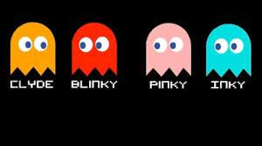

# NPC Enemies

The Ghosts spawn from the room in the middle of the game level.

Mushroom

|  |  |  |  |  |  |
| --- | --- | --- | --- | --- | --- |
| Base Hp | MAX Hp | Base Atk | Max Atk | TIME TO ATTACK | Range |
| 100 | 5000 | 10 | 100 | 4 | 6 |

Tenna Ray

|  |  |  |  |  |  |
| --- | --- | --- | --- | --- | --- |
| Base Hp | MAX Hp | Base Atk | Max Atk | TIME TO ATTACK | Range |
| 150 | 6000 | 11 | 200 | 5 | 6 |

## Enemy States

All Ghosts possess the same behavior and states, as described below:

Idle: When the enemy is not attacking

Wander: when the player is not in range and will just cause the enemy to wander around a point

Attack: Activated when the enemy does an attack

Death: Plays the death animation and afterwards the enemy will dissapear

## Enemy Spawning

Each Ghost will spawn in the middle of the game level

# Art

## Setting

There would be 4 distinct continents each with their own season as well as a central continent where the final arc of the story takes place. Art direction would be realistic fantasy.

# Level Design

Currently the first area is a forrest surrounded by tall hills that will keep the player in it. Spread around the forest are monsters wandering about. When the player spawns there is a Quest NPC right in front of them to get them into the game.

# Audio

Nil

# MVP (Minimum Viable Product)

* One Player character only
* Built for the PC platform

# Wishlist

ADD MORE SKINS

In a future DLC, add more skins for the Player to apply on the game background.