1. Project Overview
System Description
HealthPredict is a web-based health management system that allows patients to submit their health data and receive diabetes risk predictions powered by a machine learning model. It also supports appointment booking, secure messaging between patients and healthcare staff, and a full admin dashboard for system management.

Purpose of the System
The system aims to:
- Help patients monitor and understand their health risk for diabetes.
- Provide a secure platform for managing health records and appointments.
- Allow healthcare staff to communicate with patients through a secure messaging system.
- Give administrators full control over user accounts, system logs, and reports.
- Protect all user data using industry-standard security practices.

Intended Users
- Guests – Visitors who can view the landing page and register for an account.
- Patients (Health Users) – Registered users who submit health data, view predictions, book appointments, and send messages.
- Healthcare Staff – Medical team members who manage appointments and communicate with patients.
- Administrators – System managers who oversee all users, view audit logs, manage roles, and configure the system.

Platform and Technology Used
Category | Technology
Programming Language | JavaScript (Node.js), Python
Frontend Framework | React.js
Backend Framework | Express.js (Node.js)
Machine Learning | Python (scikit-learn / custom model)
Database | MySQL
Platform | Web Application (accessible via browser)
Authentication | JSON Web Tokens (JWT) + httpOnly Cookies
Encryption | AES-256-GCM (health data), bcrypt (passwords)
Security Libraries | Helmet, CORS, express-rate-limit, express-validator

2. Secure Coding Practices
No Hardcoded Credentials
All sensitive values such as database passwords, encryption keys, JWT secrets, and API keys are stored in environment variable files (.env) that are never uploaded to the internet. The code only reads these values at runtime from the server environment.

Sample – Environment Variable Usage
// Secure: reading from environment, never written in code
const jwtSecret = process.env.JWT_SECRET;
const dbPassword = process.env.DB_PASSWORD;
const encryptionKey = process.env.ENCRYPTION_KEY;

Other Secure Coding Practices Applied
- JSON body size is limited to 10 KB to prevent large-payload attacks.
- All API routes are protected with security headers via the Helmet library (stops common browser-based attacks).
- CORS is configured to only allow requests from the official frontend address.
- Passwords are never stored or logged anywhere in the system.
- Database queries use parameterized statements to prevent SQL Injection.
[.env file]
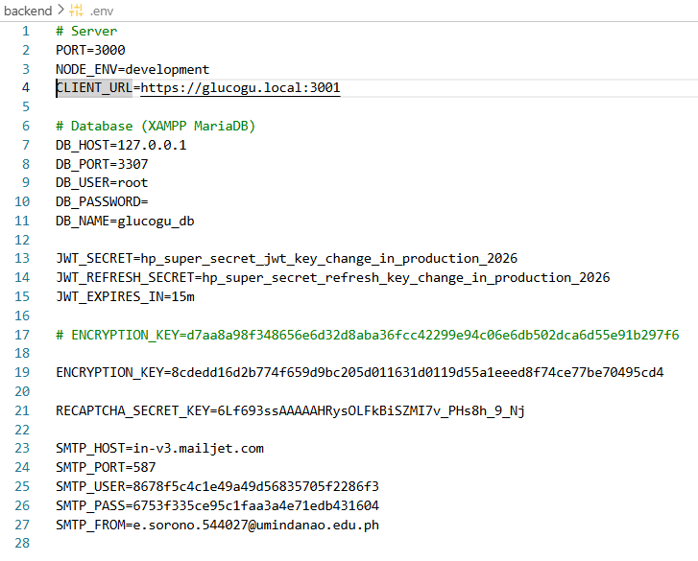

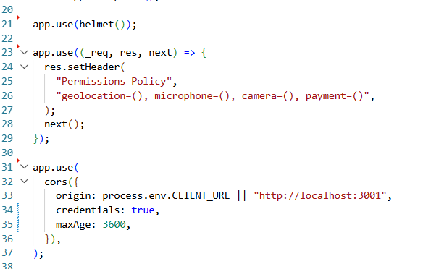
[Helmet & Cors server.js]

3. Authentication and Authorization
Registration Process
When a user registers, the system:
- Validates all form inputs (name, email, password format, phone number).
- Requires the user to complete a Google reCAPTCHA challenge to prevent bots.
- Hashes the password using bcrypt with a strength setting of 12 rounds before saving it.
- Stores only the hashed password — the original password is never saved.

Login Process
When a user logs in, the system:
- Checks that the account exists and is active.
- Verifies the password against the stored hash using bcrypt.
- Issues a short-lived Access Token (15 minutes) and a Refresh Token (7 days), both stored as secure httpOnly cookies.
- Records the login attempt in the audit log.
- Locks the account after 5 consecutive failed login attempts.

Password Hashing
Passwords are protected using bcrypt with 12 salt rounds. This means even if someone got access to the database, they could not read any user's password.
// Password is hashed before saving — never stored as plain text
const SALT_ROUNDS = 12;
const hashedPassword = await bcrypt.hash(plainPassword, SALT_ROUNDS);

Account Lockout Policy
- After 5 failed login attempts — account is temporarily locked.
- Lockout duration — 1 minute.
- Administrators can manually unlock accounts from the admin dashboard.

User Roles
- Guest — Not logged in. Can only view the landing page and register.
- Patient (health_user) — Logged-in patient. Can use health features and messaging.
- Staff — Healthcare staff. Manages appointments and communicates with patients.
- Admin — Full system access including user management and logs.

[Registration Form with reCAPTCHA]

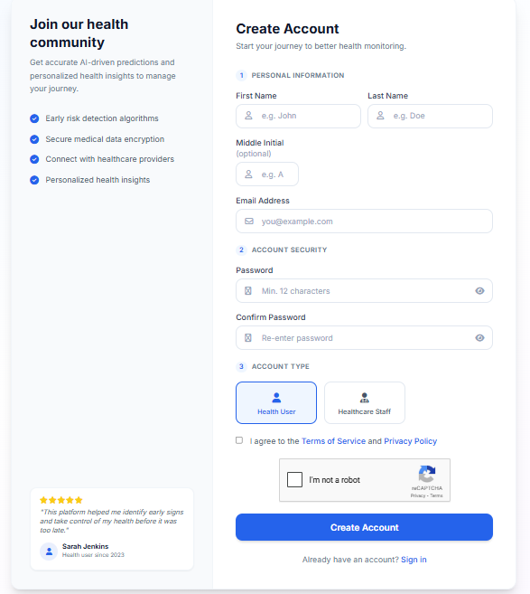

[SCREENSHOT – Login Page]
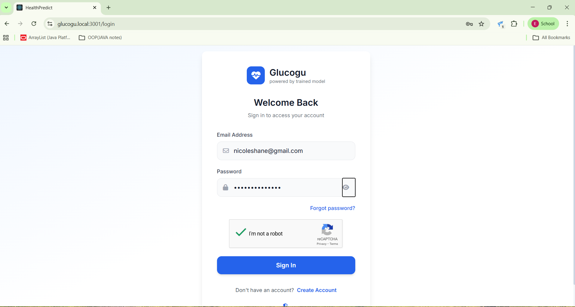

[ SCREENSHOT – Account Lockout Message]
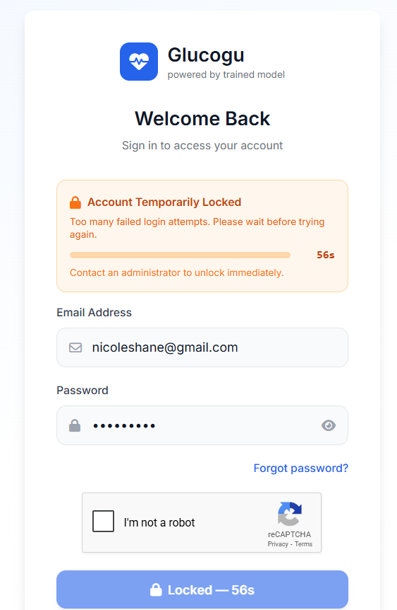

[SCREENSHOT – Hashed Password in Database]
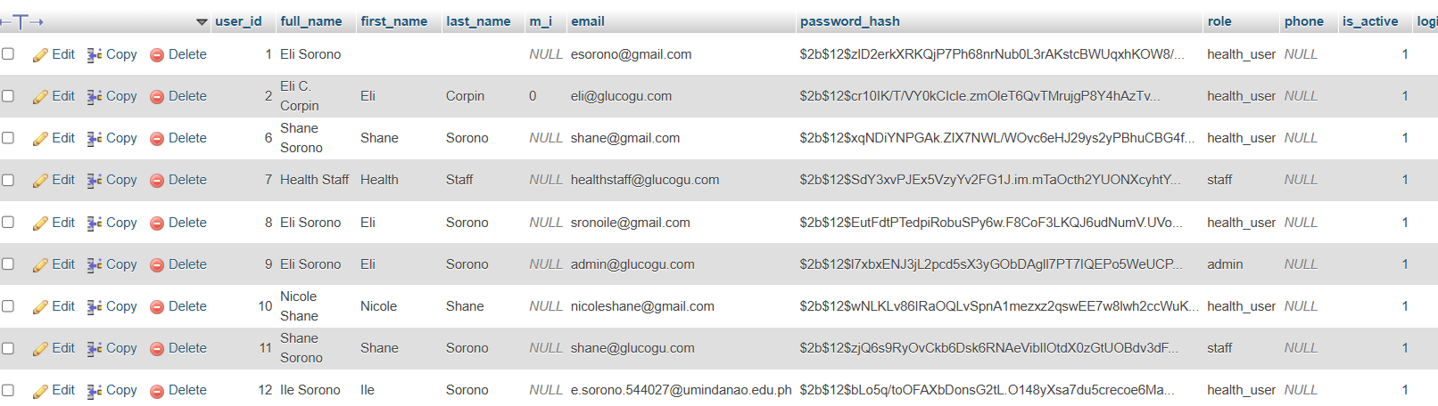
SCREENSHOT – Hashed Password in Database

4. Data Encryption
What Data is Encrypted
The following types of data are protected with encryption:
- Passwords — hashed using bcrypt (one-way, cannot be reversed).
- Sensitive health records — encrypted using AES-256-GCM before being saved to the database.
- All communication between browser and server — protected by HTTPS/TLS.
- Authentication tokens — stored in secure, httpOnly cookies that JavaScript cannot access.

Encryption Methods
What is Protected | Method Used | Purpose
User Passwords | bcrypt (12 rounds) | Prevent password theft
Sensitive Health Data | AES-256-GCM | Secure data stored in database
Browser ↔ Server Traffic | HTTPS / TLS | Prevent network eavesdropping
Auth Tokens | httpOnly Cookies | Prevent JavaScript access (XSS protection)

AES-256-GCM is a military-grade encryption standard. Each piece of data is encrypted with a unique random key component (IV) so that even identical inputs produce different encrypted outputs.

[SCREENSHOT – Encrypted Health Data in Database]

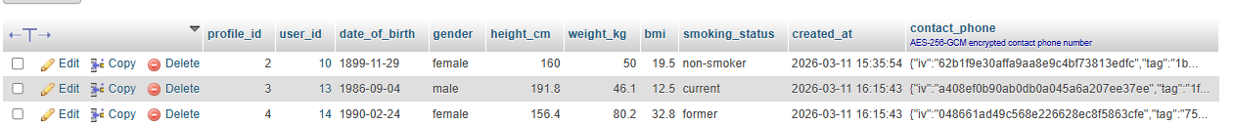

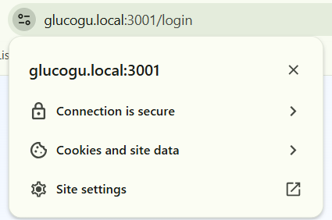
[SCREENSHOT – HTTPS Padlock in Browser]

5. Input Validation and Sanitization
What Inputs are Validated
Every piece of data submitted by users is checked before being processed:
- Registration form — first name, last name, email format, password strength, selected role.
- Login form — email format and presence of password.
- Health data form — numeric ranges for health metrics (e.g., glucose, BMI, blood pressure).
- Appointment form — valid date, time, and reason.
- Messages — length limits and HTML-tag stripping.
- Password reset — matching codes and new password strength.

Validation and Sanitization Tools
- express-validator — checks that all submitted fields meet required formats and lengths before any processing.
- Custom XSS sanitizer — automatically strips all HTML tags from every incoming request body, query, and URL parameter. This prevents Cross-Site Scripting (XSS) attacks.
- Body size limit — request bodies are capped at 10 KB to prevent memory-exhaustion attacks.

Password Strength Requirements
- Minimum 8 characters.
- Must include at least one uppercase letter.
- Must include at least one number.
- Must include at least one special character (e.g., !, @, #).

[SCREENSHOT – Validation Error — Missing or Invalid Fields]

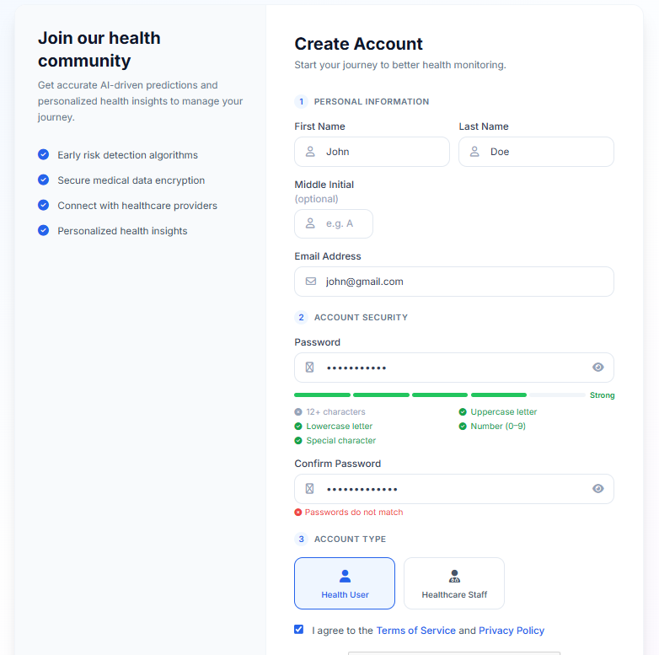

[SCREENSHOT – XSS Attempt Rejected]

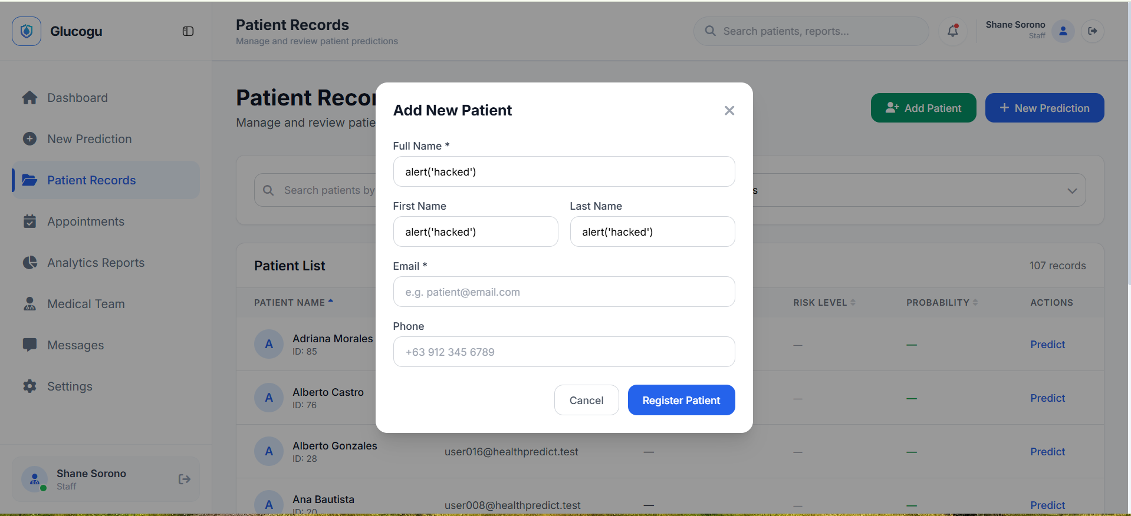

6. Error Handling and Logging
Safe Error Messages
When an error occurs, the system shows a simple, user-friendly message without revealing any technical details (such as database structure, stack traces, or internal file paths). For example:
- "Invalid credentials" — instead of "User not found in table users"
- "Something went wrong" — instead of showing a full database error
This prevents attackers from using error messages to learn about the system's internals.

What Gets Logged
The system records the following events in a secure audit log stored in the database:
- LOGIN_SUCCESS — Successful user login with timestamp and IP address.
- LOGIN_FAILED — Failed login attempt with IP address.
- ACCOUNT_LOCKED — Account locked after too many failed attempts.
- LOGOUT — User logout event.
- REGISTER — New account created.
- PASSWORD_RESET — Password reset requested or completed.
- ROLE_CHANGED — Admin changed a user's role.
- USER_DEACTIVATED / USER_ACTIVATED — Account status changes.
- PREDICTION_MADE — Patient submitted a health prediction.

Each log entry includes: the user's ID, the action type, a description, and a timestamp.

[SCREENSHOT – System Logs in Admin Dashboard]

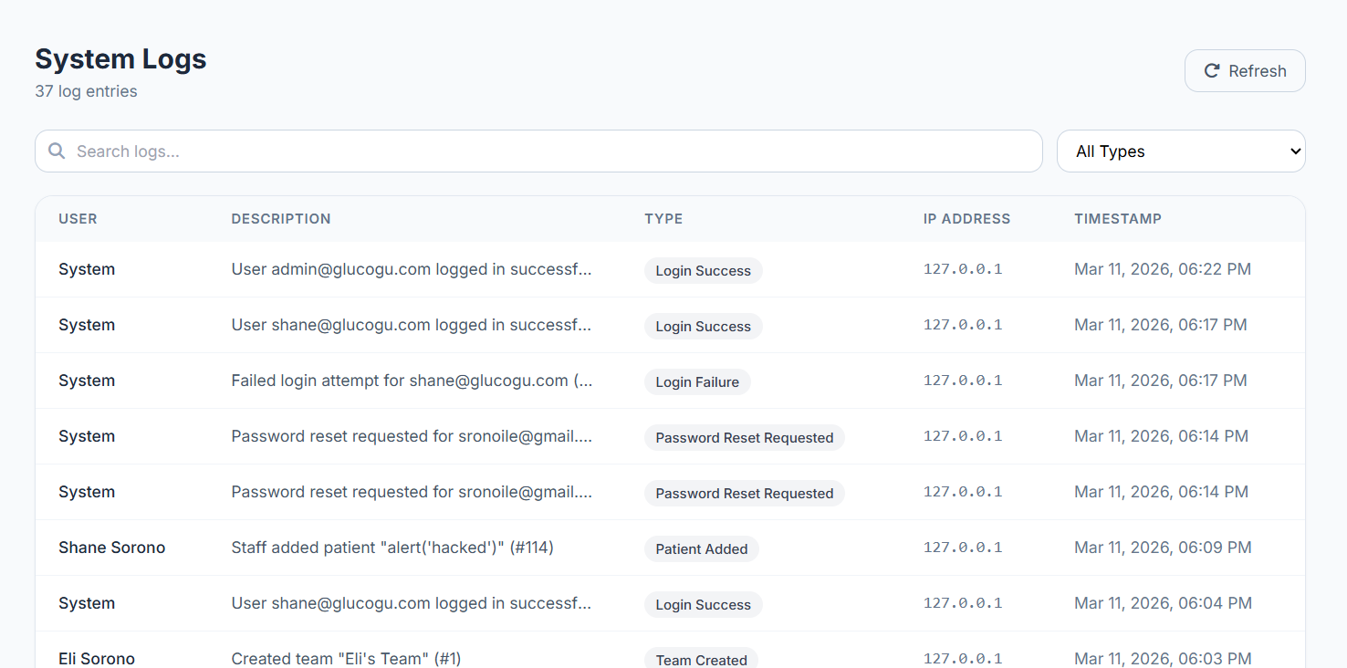

[SCREENSHOT – User-Friendly Error Message]

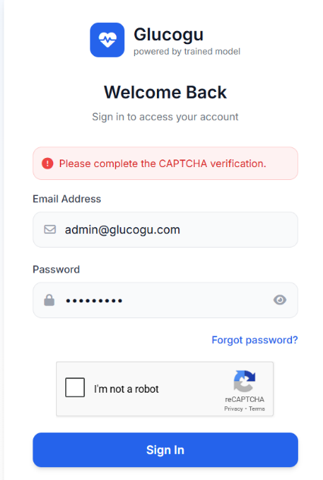
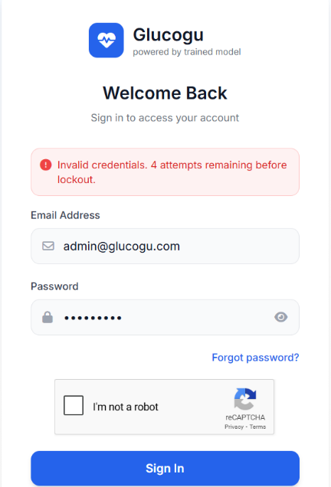

7. Access Control
How Unauthorized Access is Prevented
Every protected page and API route checks two things before allowing access:
- Authentication — Is the user logged in? (Valid JWT token required)
- Authorization — Does the user have the correct role for this action?
If either check fails, the system returns an error and the user is redirected to the login page or shown an 'Access Denied' message. The token is stored in a secure httpOnly cookie that cannot be stolen via JavaScript.

Role-Based Access Control (RBAC) Table

System Feature / Resource | Guest | Patient / User | Staff | Admin
View Homepage / Landing Page | ✔ Yes | ✔ Yes | ✔ Yes | ✔ Yes
Register Account | ✔ Yes | ✘ No | ✘ No | ✘ No
Login | ✔ Yes | ✔ Yes | ✔ Yes | ✔ Yes
View Own Health Dashboard | ✘ No | ✔ Yes | ✔ Yes | ✔ Yes
Edit Personal Profile | ✘ No | ✔ Yes | ✔ Yes | ✔ Yes
Submit Health Data & Predict | ✘ No | ✔ Yes | ✘ No | ✘ No
View Own Prediction History | ✘ No | ✔ Yes | ✘ No | ✘ No
Book Appointments | ✘ No | ✔ Yes | ✘ No | ✘ No
View Appointments | ✘ No | ✔ Yes | ✔ Yes | ✔ Yes
Send / Receive Messages | ✘ No | ✔ Yes | ✔ Yes | ✔ Yes
View All Users & Predictions | ✘ No | ✘ No | ✘ No | ✔ Yes
Manage Users (activate/lock) | ✘ No | ✘ No | ✘ No | ✔ Yes
Assign / Change User Roles | ✘ No | ✘ No | ✘ No | ✔ Yes
View System Logs | ✘ No | ✘ No | ✘ No | ✔ Yes
View Activity Monitor | ✘ No | ✘ No | ✘ No | ✔ Yes
Delete User Accounts | ✘ No | ✘ No | ✘ No | ✔ Yes
Manage ML Model | ✘ No | ✘ No | ✘ No | ✔ Yes

Note: Tokens are automatically invalidated on logout using a server-side token blacklist. Expired tokens are also rejected.

[ SCREENSHOT – Admin Dashboard — User Management]

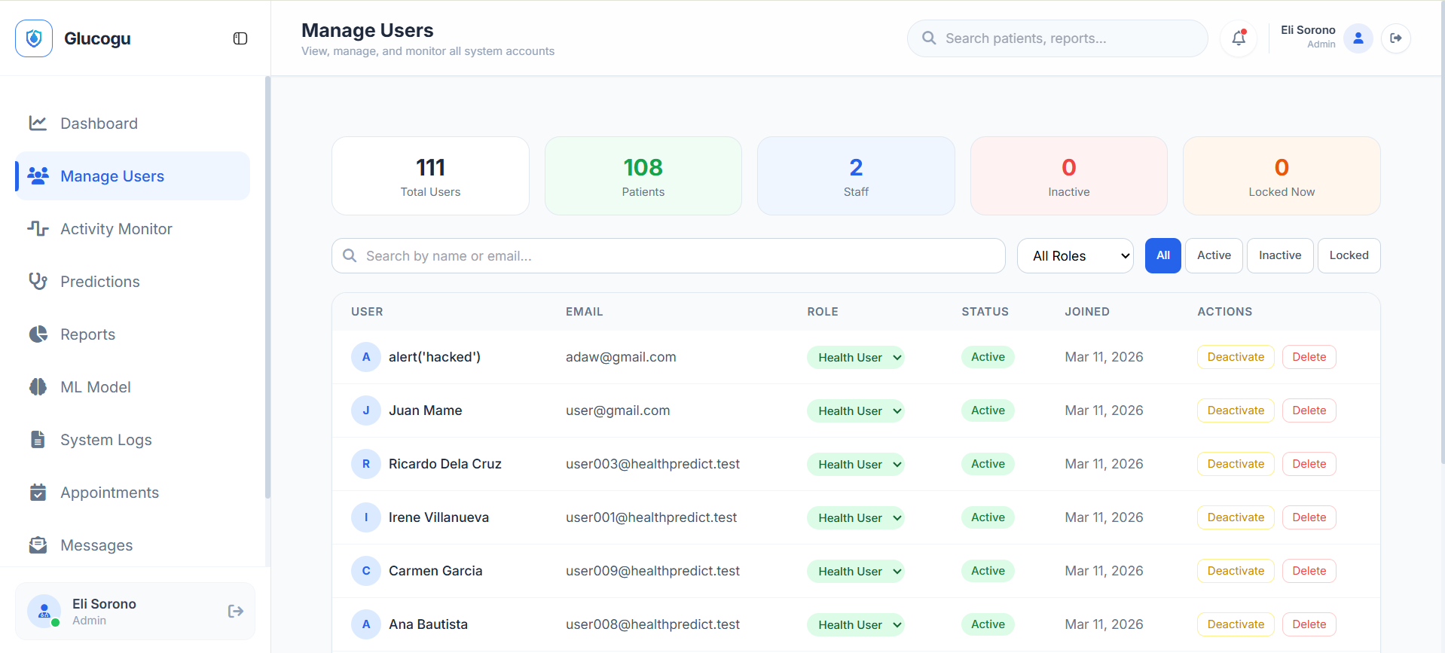

[SCREENSHOT – Access Denied — Non-Admin tries Admin Page]

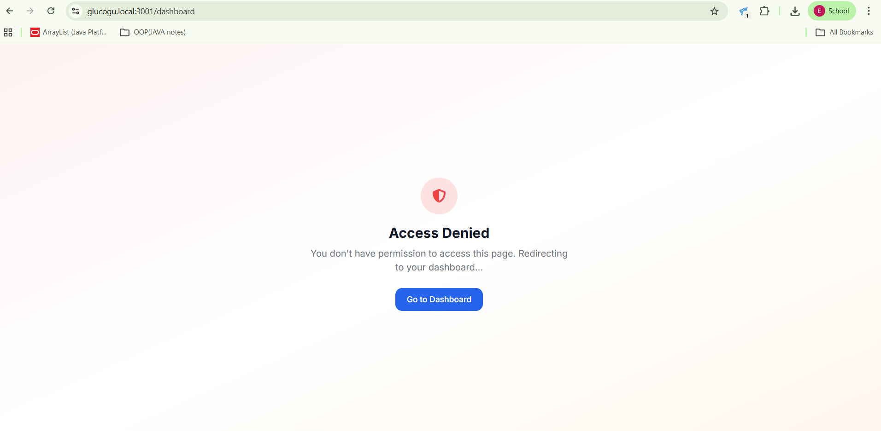

[SCREENSHOT – Protected Route — Not Logged In]

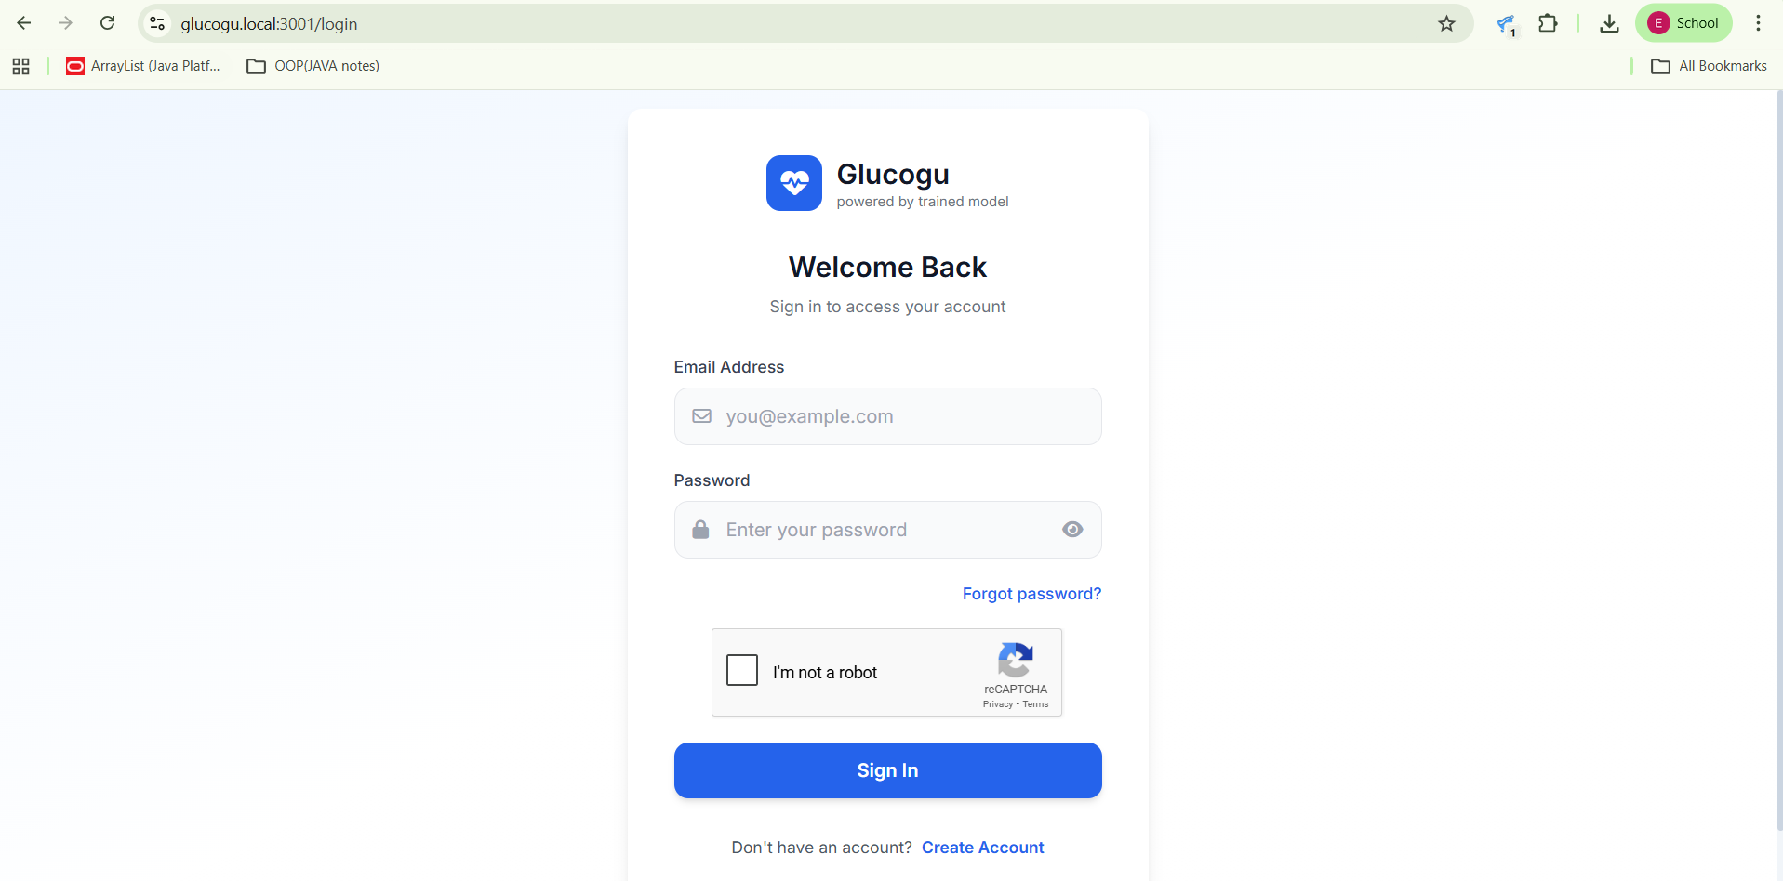
The user was sent back to the login page after trying to redirect to /dashboard.

8. Code Auditing Tools
Tools Used
- ESLint — Scans JavaScript code for syntax errors, insecure patterns, and coding standard violations. Configured with security-focused rules.
- npm audit — Built-in Node.js tool that checks all installed packages against a database of known security vulnerabilities.
- SonarLint (VS Code extension) — Real-time code quality and security scanning inside the code editor.

Scan Results Summary
Tool | Finding | Action Taken
npm audit | 0 high/critical vulnerabilities found | No action required
ESLint | Unused variable warnings | Variables removed
SonarLint | Minor code smell suggestions | Code cleaned up
Manual Review | Hardcoded credentials | Moved to .env files

[SCREENSHOT – npm audit Result]

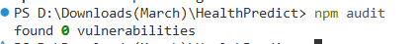

[SCREENSHOT – ESLint Output]

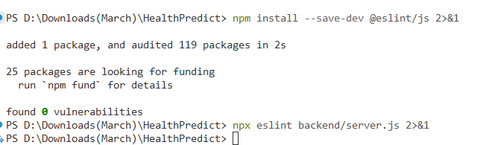

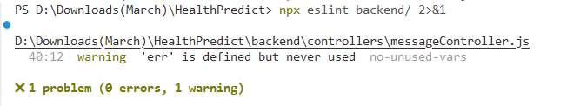

9. Testing
Types of Tests Performed
The following scenarios were manually tested to verify the system works securely and correctly:

Authentication Tests
- Register a new account with valid data — account created successfully.
- Register with an existing email — error message shown, no duplicate account.
- Register with a weak password — validation error shown.
- Login with correct credentials — dashboard loaded.
- Login with wrong password — error shown, attempt logged.
- Login after 5 wrong attempts — account locked message shown.
- Logout — token invalidated, redirect to login page.

Access Control Tests
- Visit admin pages while logged in as a patient — access denied.
- Visit dashboard while not logged in — redirected to login.
- Access API endpoints without a token — 401 Unauthorized returned.

Input Validation Tests
- Submit form with empty fields — validation errors shown.
- Submit HTML/script tags in text fields — tags stripped, no popup.
- Submit an extremely long input — request rejected.

Feature Tests
- Health prediction form — submits data, returns risk result.
- Appointment booking — creates appointment, visible in list.
- Messaging — patient sends message, staff can reply.
- Admin: activate / deactivate user — status changes reflected.
- Admin: view system logs — logs load correctly with filters.
- Forgot password flow — OTP sent by email, password reset works.

SCREENSHOT – Successful Login and Dashboard
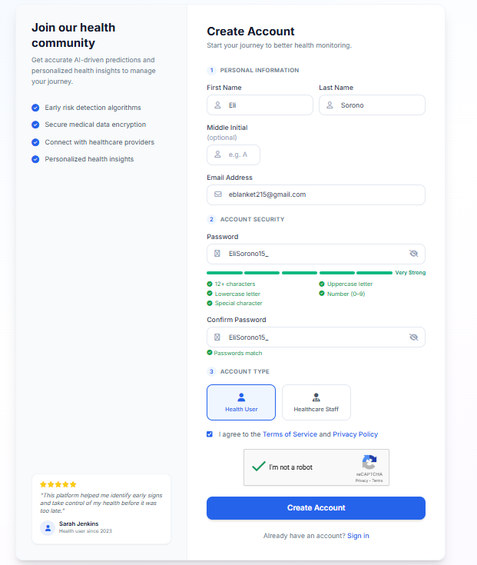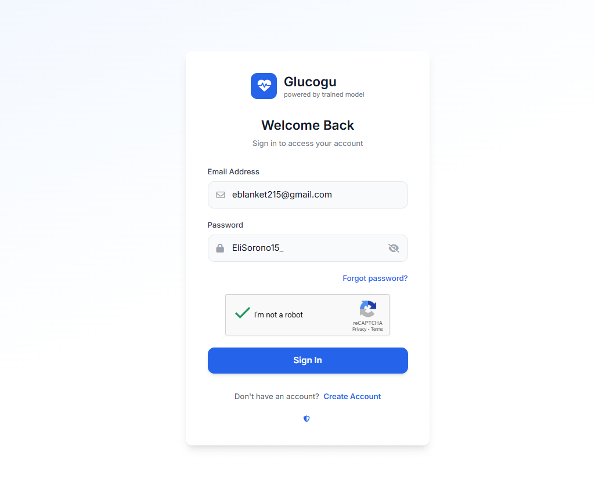

[SCREENSHOT – Health Prediction Result]
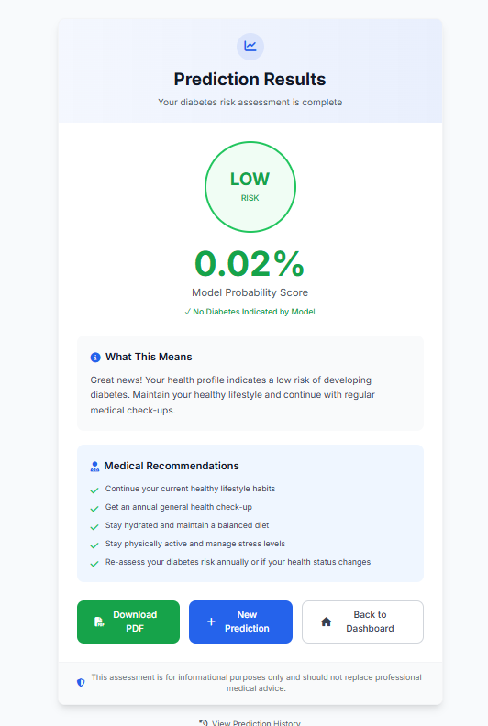

[SCREENSHOT – Appointment Booking Confirmation]
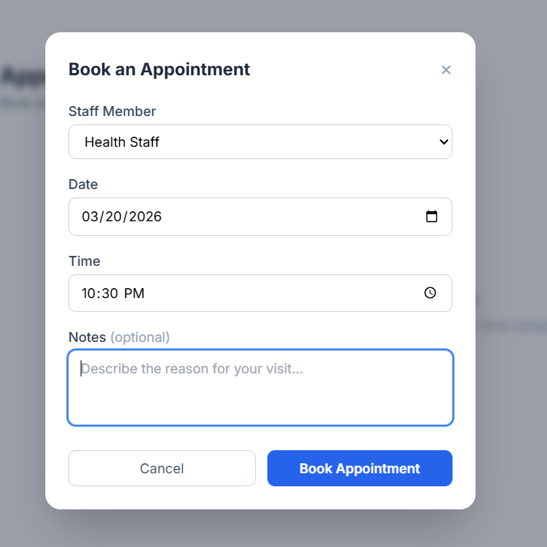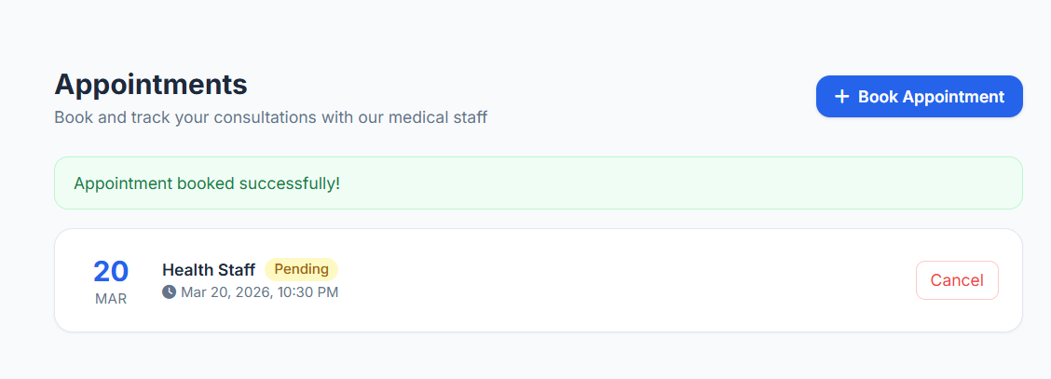

[SCREENSHOT – Messaging — Sent and Received]
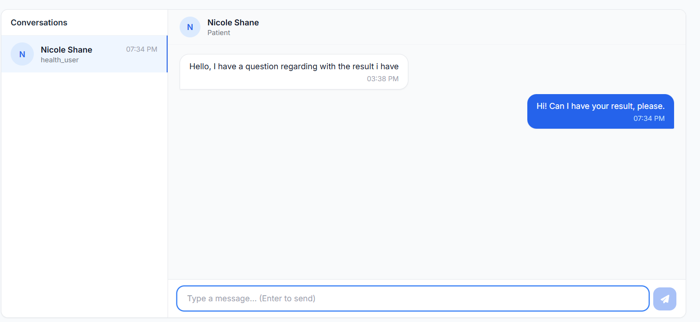

[SCREENSHOT – Admin — Activate/Deactivate User]

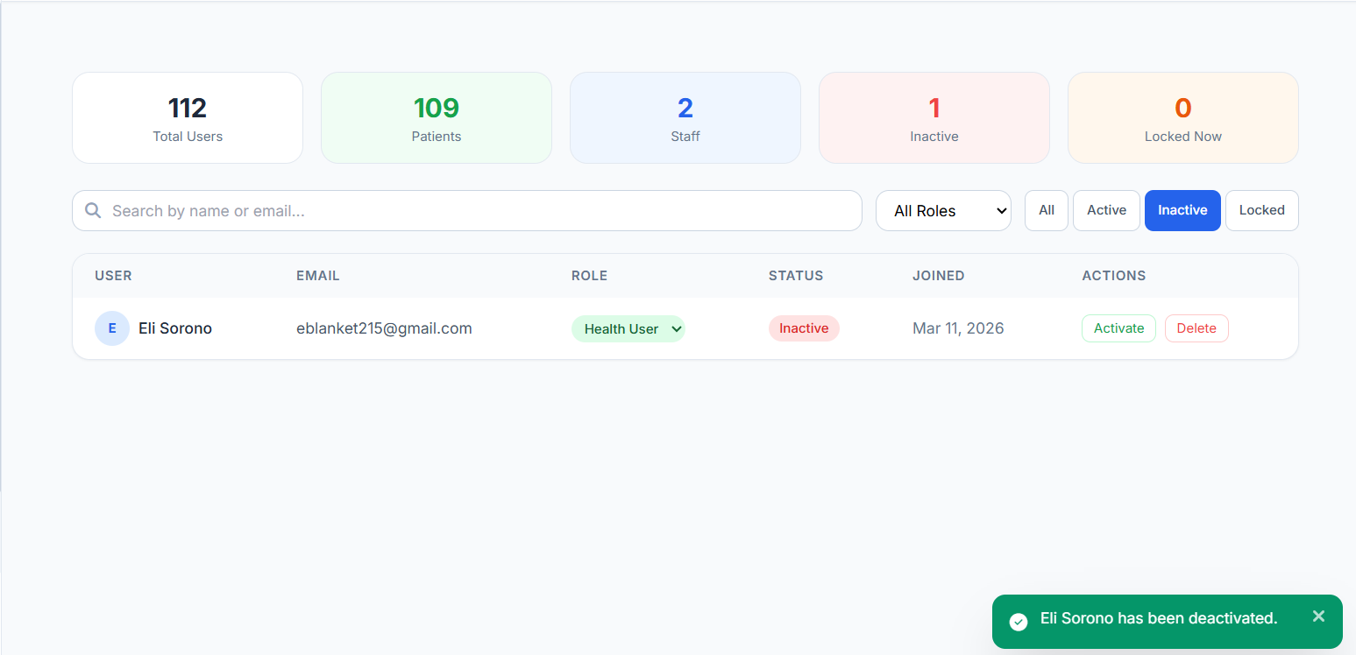

10. Security Policies
Password Policy
- Minimum length: 12 characters.
- Must contain uppercase letters, numbers, and special characters.
- Passwords are never stored in plain text — always hashed with bcrypt.
- Password reset requires a one-time PIN (OTP) sent to the registered email.

Login Attempt Policy
- Maximum of 5 failed login attempts before account is locked.
- Account lockout duration: 1 minute.
- Rate limiting: Maximum 10 login requests per 15 minutes per IP address.
- All failed attempts are logged with the IP address and timestamp.

Data Handling Policy
- All sensitive health data is encrypted with AES-256-GCM before database storage.
- Only authorized users can access their own health data.
- Administrators can view anonymized statistics but not individual health records.
- Soft-deleted accounts are marked for deletion and purged after a scheduled period.

Access Control Policy
- All API routes are protected — unauthenticated requests are rejected.
- Role checks are enforced server-side, not just in the frontend.
- Admin-only routes require both authentication and the 'admin' role.
- All unauthorized access attempts are recorded in the audit log.

Logging and Monitoring Policy
- All user actions (login, logout, profile changes, predictions) are logged.
- Logs store: user ID, action type, IP address, description, and timestamp.
- Administrators can review logs from the System Logs page.
- Suspicious activity (multiple failed logins, locked accounts) is visible in the Activity Monitor.

Backup and Recovery Policy
- Database backups should be performed at least weekly.
- Backups should be stored in a secure, separate location.
- Environment variable files (.env) must be backed up separately and kept confidential.
- System recovery involves restoring the latest backup and redeploying the application.

11. Incident Response Plan
An incident is any event that threatens the security or availability of the system, such as unauthorized access, data breach, or system failure.

Step 1 — Detection
Incidents are detected through:
- System logs and audit trails — administrators review the System Logs page for unusual activity.
- Activity Monitor — shows recent actions, failed logins, and locked accounts in real time.
- User reports — users can report suspicious activity through the messaging system.
- Automated rate limiting — repeated unusual requests are automatically blocked and logged.

Step 2 — Reporting
Once an incident is detected:
- The administrator documents the incident: date, time, type, and affected accounts.
- Affected users are notified if their data may have been compromised.
- The incident is escalated to the system owner or security team.

Step 3 — Containment
To stop the threat from spreading:
- Affected user accounts are immediately deactivated from the Admin Dashboard.
- Suspicious IP addresses can be blocked at the server or firewall level.
- Active sessions are invalidated by clearing the token blacklist and rotating JWT secrets.
- The compromised feature or route is temporarily disabled if necessary.

Step 4 — Recovery
To restore normal operation:
- The system is restored from the most recent clean backup.
- Security patches are applied to address the vulnerability that was exploited.
- Affected users are required to reset their passwords before logging in again.
- All actions taken during the response are documented for future reference.

Phase | Action | Responsible Party
Detection | Review System Logs and Activity Monitor | Administrator
Reporting | Document and escalate the incident | Administrator / System Owner
Containment | Deactivate accounts, invalidate tokens | Administrator
Recovery | Restore from backup, patch, reset affected passwords | Administrator / Developer

