class4.R

eliso

2024-10-11

# my first R script  
x <- 1:50  
plot(x)

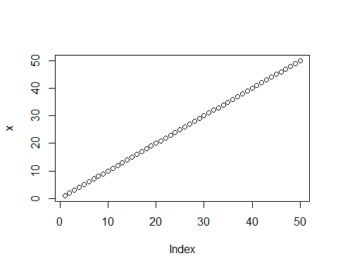

plot(x=x,y=sin(x),typ="l",col="blue",lwd=8)

