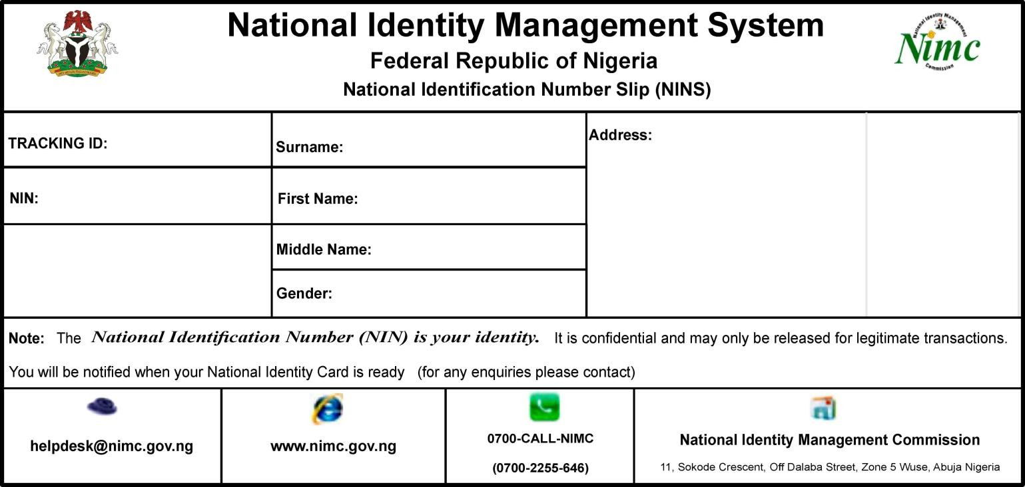
[middle]

[trackid]

[surname]

[address]

[nin]

[firstname]

[gender]

[address1]

[state]

