A Mini Project Report on

ONLINE REALTY MARKETING SYSTEM

T. E. Computer Engineering-B

Submitted By

Ambrose Tuscano 73
Elison Tuscano 74
Onish Dmello 79

Under The Guidance Of
Miss



ST. FRANCIS INSTITUTE OF TECHNOLOGY
(ENGINEERING COLLEGE)
Mount Poinsur S.V.P Road, Borivali (W), Mumbai-400103
UNIVERSITY OF MUMBAI
2017-18

CERTIFICATE

This to certify that the Mini Project report on ONLINE REALTY MARKETING SYSTEM has been carried out by Ambrose Tuscano(TE/CMPN-B/73), Elison Tuscano(TE/CMPN-B/74), Onish Dmello(TE/CMPN-B/74), who are bonafide students of St. Francis Institute of Technology, Mumbai in partial fulfillment of the requirement of T. E. degree in Computer Engineering at St. Francis Institute of Technology, Mumbai, India. It is also certified that this work has not been presented anywhere else for award of any other degree or diploma prior to this.

Project Incharge: Ms.

Internal Examiner External Examiner

_________________________ __________________________
( ) ( )

ACKNOWLEDGEMENT

The success and final outcome of this project required a lot of guidance and assistance from many people and we are extremely fortunate to have got this all along the completion of our project work.

We are extremely grateful to our guide Ms. …………… for providing us all support, encouragement, suggestions and guidance which made us complete our project on time.

We owe our profound gratitude to our honourable Head of Department Dr. Kavita Sonawane for her cooperation, constant encouragement and guided us all along the project.

I would not forget to heartily thank our Principal Dr. Sincy George for her unlisted encouragement and more over for her timely support and guidance.

I am thankful to and fortunate enough to get constant encouragement, support and guidance from all Teaching staffs of Department of computer science which helped us in successfully completing our project work. We are thankful and indebted to all those who helped us directly or indirectly to complete our report

TABLE OF CONTENTS

Chapter No | Contents | Page No
1 | Introduction | 5
2 | System Analysis | 6
3 | System Requirements Specification | 8
4 | System Environment | 10
5 | System Design | 14
6 | Architectural Design | 18
7 | System Implementation | 21
8 | Software Testing | 22
9 | Conclusion | 23
10 | Screen -Shots | 24

INTRODUCTION

Online Realty Marketing allows user to store property, customer, seller, and staff details. It will allow users to update, search property details and use them whenever necessary. It will also be able to provide financial, sold properties, all staff, all contacts reports. Using this we can improve seller’s customer response rates, tune their plans and generate additional sales. There would be features like login, registration, searching properties, browsing properties, etc. User can also post their properties for sale. Due to this system there is no need to visit various places in search of property. All this information can be accessible at one place.

SYSTEM ANALYSIS

Purpose:
In existing system manual record keeping of property, staff and customers are time-consuming. There is a lot of duplication and common errors are faced while entering and updating property data, making it inconsistent and unavailable at times for future use. In addition, to this, the retrieval of the information is the slow and boring task to perform. The security of data is also a concern as it is placed in cabinets that could be accessed by others.
The existing structure should be converted to the computerized system, in which user can easily store every information regarding his system. We prefer you to make a web based system, that will be easily accessible by every customer and seller at any time. This system will also be able to track your all previous records.

Feasibility:
Feasibility analysis is used to determine if the application can be implemented and used effectively. We need positive results to determine if we can implement the application or not. The main objective of this study is to understand the resources required by our application.

Technical Feasibility:
Technical feasibility deals with the technical aspects of application such as the hardware requirements, software and technologies used.
Technical needs of a system mainly includes: -
(a) Facility to produce outputs in a given system
(b) Response time under certain conditions.
(c) Providing security.
(d) Facility to communicate data to distant location.

Hardware Requirements
- Database
- Server
Software requirements
- Database Software
- Windows
- Apache Server
- MySQL
- XAMPP

Functional Feasibility:
This is done to ensure whether the system is feasible with the user using the software. It includes the GUI (Graphical User Interface) and getting data automatically from the database. The software is functionally feasible.

Time Feasibility:
The stipulated time for the development of the project is three Months and it can be finished within that span of time. Hence the system is feasible in terms of time.

Financial Feasibility:
The software product, which is to be developed, is financially feasible. The cost required for the maintenance of the software is also realizable.

Operational Feasibility:
This is mainly related to human organization and political aspects. The points to be considered are:-
- Likelihood of project attaining desired objectives.
- How it fits into current day-to-day operations?
- How new system will affect organizational structures and processes?
This project is a Web-based application, which can be used at anytime, anywhere, due to the viability of internet services.

SYSTEM REQUIREMENTS SPECIFICATION

User Interface
- Ensure that the sequence of action to achieve a task are as simple as possible.
- Ensure that user always knows what She or He can and should do next.
- User understandable encoding techniques.
- Consider the needs of different groups of users.
- Design UI on user task.
- Be consistent.
Database Requirements
The database should be designed in such a way that it enhances the efficient searching.
The database should be organized in such a way that it helps in searching and reserving various essential summaries needed for users.

Functional Requirements
- The system requires user to enter parameters in the correct format.
- The system must save time and money.
- The area searched should exist
- The user gets the filter output based on:
- Rank of property
- Nearby amenities such as hospitals, schools, etc.
- Acceptable: Verified as meeting the stated objectives.
- Secured and Restorable: System and data backup.
- Maintainability: Configuration and content management.
- Responsive / Performance: Response times. Speed of page loads and calculations
- Reliable: Consistent and dependable quality of service.

Non-Functional Requirements
- Availability 24*7.
- User friendly.
- Moderately security.
- Interactive.

Other Requirements
Performance Requirements
Should run on 500 GHz, 64MB machine.
Should have a proper internet connection.
The response time for occurs a change will be no more than 4 seconds.
The response time for access the database will be no more than 5 seconds.
Design Requirements
Controlling the amount of input.
Keeping the process simple.

System Environment

Hardware:

The hardware environment consists of the following:

CPU: Intel Pentium and above versions
Hard Disk Space: 5GB or more
Display: 15 inches monitors
Memory: 128 MB RAM
Other Devices: Color Monitor, Keyboard, Mouse

Software:

Technically the system will run on any OS having Web Browser.

Development Tools:
Front End: HTML, CSS, JavaScript, PHP, SQL
Libraries: Jquery, Bootstrap
Back End: Apache PHP server and MySQL server

Operating System: Windows, MAC and Linux PC

HTML (Hypertext Markup Language)

HTML (Hypertext Markup Language) is the set of markup symbols or codes inserted in a file intended for display on a World Wide Web browser page. The markup tells the Web browser how to display a Web page's words and images for the user. Each individual markup code is referred to as an element (but many people also refer to it as a tag). Some elements come in pairs that indicate when some display effect is to begin and when it is to end.
HTML is a formal Recommendation by the World Wide Web Consortium (W3C) and is generally adhered to by the major browsers, Microsoft's Internet Explorer and Netscape's Navigator, which also provide some additional non-standard codes. The current version of HTML is HTML 4.0. However, both Internet Explorer and Netscape implement some features differently and provide non-standard extensions. Web developers using the more advanced features of HTML 4 may have to design pages for both browsers and send out the appropriate version to a user. Significant features in HTML 4 are sometimes described in general as dynamic HTML. What is sometimes referred to as HTML 5 is an extensible form of HTML called Extensible Hypertext Markup Language (XHTML).

Cascading style sheet (CSS)

A cascading style sheet (CSS) is a Web page derived from multiple sources with a defined order of precedence where the definitions of any style element conflict. The Cascading Style Sheet, level 1 (CSS1) recommendation from the World Wide Web Consortium (W3C), which is implemented in the latest versions of the Netscape and Microsoft Web browsers, specifies the possible style sheets or statements that may determine how a given element is presented in a Web page.
CSS gives more control over the appearance of a Web page to the page creator than to the browser designer or the viewer. With CSS, the sources of style definition for a given document element are in this order of precedence:

- The STYLE attribute on an individual element tag
- The STYLE element that defines a specific style sheet containing style declarations or a LINK element that links to a separate document containing the STYLE element. In a Web page, the STYLE element is placed between the TITLE statement and the BODY statement.
- An imported style sheet, using the CSS @import notation to automatically import and merge an external style sheet with the current style sheet
- Style attributes specified by the viewer to the browser
- The default style sheet assumed by the browser

JAVASCRIPT
JavaScript is an interpreted programming or script language from Netscape. It is somewhat similar in capability to Microsoft'sVisual Basic, Sun's Tcl, the UNIX-derived Perl, and IBM's REXX. In general, script languages are easier and faster to code in than the more structured and compiled languages such as C and C++. Script languages generally take longer to process than compiled languages, but are very useful for shorter programs.
JavaScript is used in Web site development to do such things as:
- Automatically change a formatted date on a Web page
- Cause a linked-to page to appear in a popup window
- Cause text or a graphic image to change during a mouse rollover

PHP
PHP is an open source, interpreted and object-oriented scripting language i.e. executed at server side. It is used to develop web applications (an application i.e. executed at server side and generates dynamic page).
- PHP is a server side scripting language.
- PHP is an interpreted language, i.e. there is no need for compilation.
- PHP is an object-oriented language.
- PHP is an open-source scripting language.
- PHP is simple and easy to learn language.

PHP Features
- Performance: Script written in PHP executes much faster then those scripts written in other languages such as JSP & ASP.
- Open Source Software: PHP source code is free available on the web, you can developed all the version of PHP according to your requirement without paying any cost.
- Platform Independent: PHP are available for WINDOWS, MAC, LINUX and UNIX operating system. A PHP application developed in one OS can be easily executed in other OS also.
- Compatibility: PHP is compatible with almost all local servers used today like Apache, IIS etc.
- Embedded: PHP code can be easily embedded within HTML tags and script.

MYSQL
MySQL is a fast, easy to use relational database. It is currently the most popular open-source database. It is very commonly used in conjunction with PHP scripts to create powerful and dynamic server-side applications. MySQL is used for many small and big businesses. It is developed, marketed and supported by MySQL AB, a Swedish company. It is written in C and C++.

MySQL is becoming so popular because of these following reasons:
- MySQL is an open-source database so you don't have to pay a single penny to use it.
- MySQL is a very powerful program so it can handle a large set of functionality of the most expensive and powerful database packages.
- MySQL is customizable because it is an open source database and the open-source GPL license facilitates programmers to modify the SQL software according to their own specific environment.
- MySQL is quicker than other databases so it can work well even with the large data set.
- MySQL supports many operating systems with many languages like PHP, PERL, C, C++, JAVA, etc.
- MySQL uses a standard form of the well-known SQL data language.
- MySQL is very friendly with PHP, the most popular language for web development.
- MySQL supports large databases, up to 50 million rows or more in a table. The default file size limit for a table is 4GB, but you can increase this (if your operating system can handle it) to a theoretical limit of 8 million terabytes (TB).

System Design

Input Design
Input design is the link that ties the information system into the world of its users. The input design involves determining what the inputs are, how to validate the data, how to minimize the data entry and how to provide a multi-user facility.

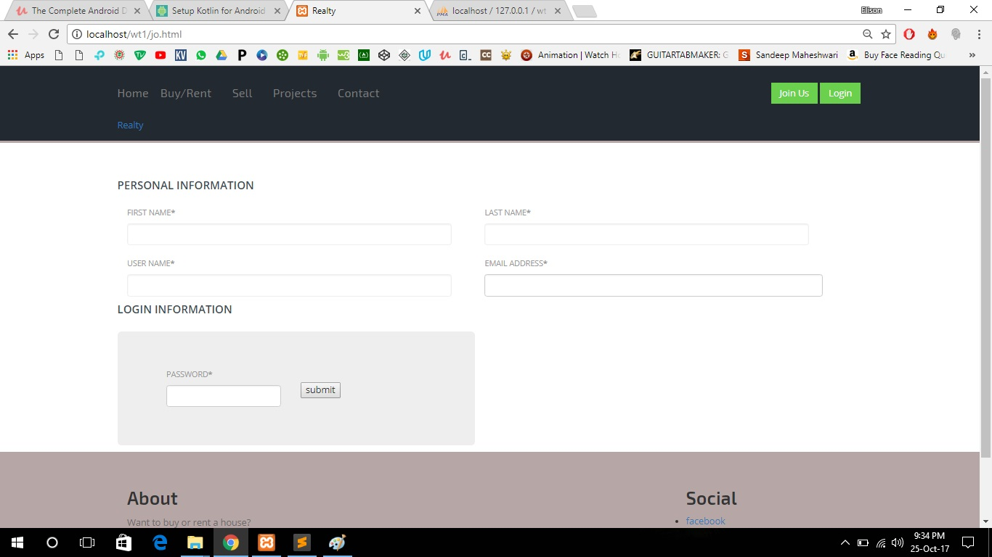

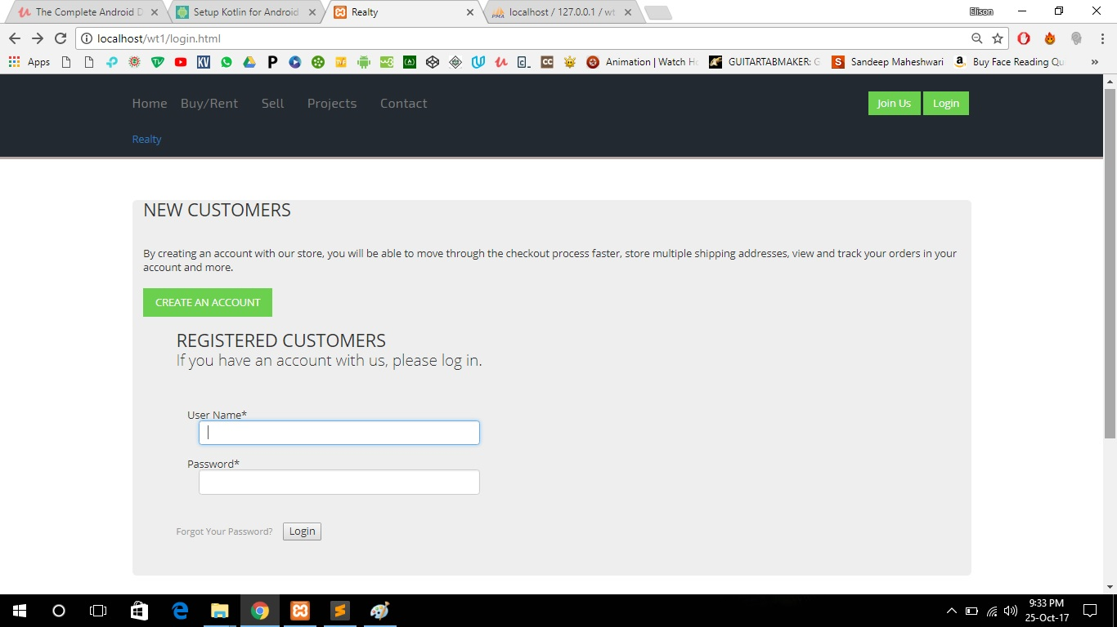

Output Design
Computer output is the most important and direct source of information to the user. Output design is a very important phase since the output needs to be in an attractive manner. Efficient and intelligible output design improves the system relationship with the user and helps in decision making.

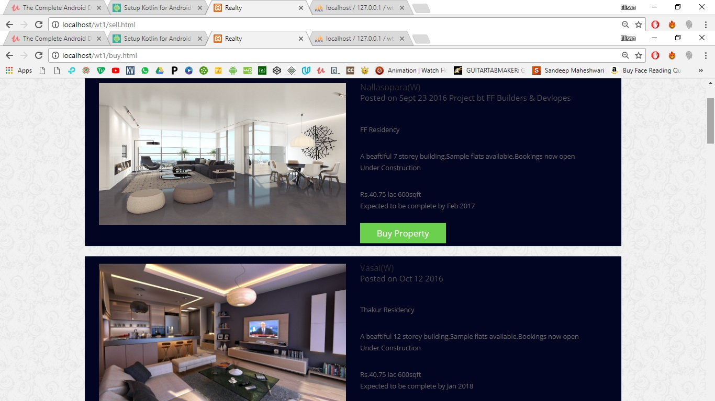

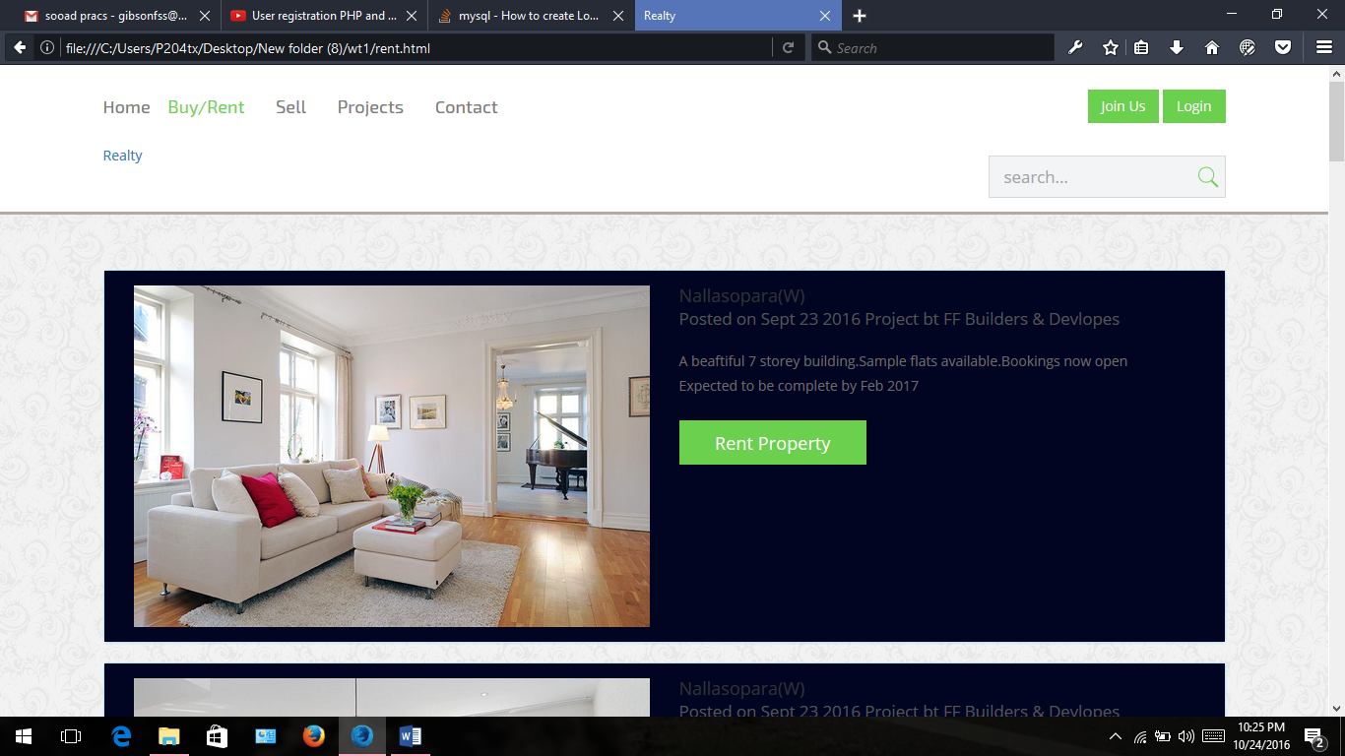

Database Design
Databases are the storehouses of data used in the software systems. The data is stored in tables inside the database. Several tables are created for the manipulation of the data for the system.
Two essential settings for a database are
- Primary Key- the field that is unique for all the record occurrences.
- Foreign Key-the field used to set relation between tables. Normalization is a technique to avoid redundancy in the tables.

Important tables used in the project include:

Table 1: Users
FIELD | TYPE | SIZE | CONSTRAINTS
First_Name | Varchar | 30 | NOT NULL
Last_Name | Varchar | 30 | NOT NULL
Username | Varchar | 30 | NOT NULL
email | Varchar | 20 | NOT NULL
password | Varchar | 40 | NOT NULL

ARCHITECTURAL DESIGN

DFD:
A data flow diagram (DFD) maps out the flow of information for any process or system. It uses defined symbols like rectangles, circles and arrows, plus short text labels, to show data inputs, outputs, storage points and the routes between each destination. Data flowcharts can range from simple, even hand-drawn process overviews, to in-depth, multi-level DFDs that dig progressively deeper into how the data is handled. They can be used to analyse an existing system or model a new one.
Data flow diagrams are well suited for analysis or modeling of various types of systems in different fields. DFDs can provide a focused approached to technical development, in which more research is done up front to get to coding.

Context Level and Level 0 DFD

Level 1.1 DFD

Level 2.1 DFD

ER diagram:

An entity-relationship diagram (ERD) is a graphical representation of an information system that shows the relationship between people, objects, places, concepts or events within that system. An ERD is a data modeling technique that can help define business processes and can be used as the foundation for a relational database.
In software engineering, an ER diagram is often an initial step in determining requirements for an information systems project. It’s also later used to model a particular database or databases. A relational database has an equivalent relational table and can potentially be expressed that way as needed. The diagrams are used to design or analyze relational databases used in business processes.

7. SYSTEM IMPLEMENTATION

System Implementation:
Systems implementation is the process of:
- Defining how the information system should be built.
- Ensuring that the information system is operational and used.
- Ensuring that the information system meets quality standard.

Systems design
- Conceptual design – what the system should do
- Logical design – what the system should look to the user
- Physical design – how the system should be built

Physical system design using structured design approach:
- To produce a system that is easy to read, code, and maintain

Structured design tools
- Organization of programs and program modules

Converting DFDs to structure charts
- Locate the central transform/transaction center
- Find a coordinating module for the top of the chart
- Identify the primary input and output data flows
- Draw a top-level chart (consists of two hierarchical level)
- Refine the chart until the data origin, system function, and output dispositions are defined

System Maintenance:
- Adaptive: Modifying the system to cope with changes in the software environment.
- Perfective: Implementing new or changed user requirements which concern functional enhancements to the software
- Corrective: Diagnosing and fixing errors, possibly ones found by users
- Preventive: Increasing software maintainability or reliability to prevent problems in the future

8.SOFTWARE TESTING

- Testing is the process of evaluating a system or its component(s) with the intent to find whether it satisfies the specified requirements or not.
- Testing is executing a system in order to identify any gaps, errors, or missing requirements in contrary to the actual requirements.
- This tutorial will give you a basic understanding on software testing, its types, methods, levels, and other related terminologies.

Unit Testing:
Unit testing is a level of software testing where individual units/ components of a software are tested. The purpose is to validate that each unit of the software performs as designed. For each part various inputs are given based on the fields of those particular forms and match with the possible outputs and its acceptable ranges are retrieved. Then the various sets of input values are devised with various combinations of inputs being out of range.

Module Testing:
Module testing allows to implement parallelism into the testing process by giving the opportunity to test multiple modules simultaneously. We tested each and every page carefully with various sets of input values with various combinations of inputs being out of range. And we found all the components in the module are working perfectly. These bring out the behavior of software.

System Testing:
Entire system is tested as per the requirements. Black-box type testing that is based on overall requirements specifications, covers all combined parts of a system. Testing is done by evaluating the software performance by putting into test more than one forms hence the system. This testing was done at the library with some real data and found that system was working properly and the performance was good.

CONCLUSION

The World Wide Web has spread across millions of household, so Internet has become the best platform for real estate marketing today. It is an online portal for buyer and seller who wants to invest in real estate business. Online Realty Marketing allows user to store property, customer, seller, and staff details. It will allow users to update, search property details and use them whenever necessary. It will also be able to provide financial, sold properties, all staff, all contacts reports. Using this we can improve seller’s customer response rates, tune their plans and generate additional sales. There would be features like login, registration, searching properties, browsing properties, etc. User can also post their properties for sale. Due to this system there is no need to visit various places in search of property. All this information can be accessible at one place.

Scope:
Online Realty Marketing allows user to store property, customer, seller, and staff details. It will allow users to update, search property details and use them whenever necessary. It will also be able to provide financial, sold properties, all staff, all contacts reports. Using this we can improve seller’s customer response rates, tune their plans and generate additional sales. There would be features like login, registration, searching properties, browsing properties, etc. User can also post their properties for sale. Due to this system there is no need to visit various places in search of property. All this information can be accessible at one place

SNAPSHOTS

