Gray Spring
- 6.6mm max compression (from datasheet)
- 17.24 deg ankle angle (from CAD)
- 452 N/mm (from datasheet)
- 62 Nm peak moment (code below)
- 206 Nm/rad peak stiffness
Yellow Spring
- 8 mm max compression (from datasheet)
- 20.51 deg ankle angle (from CAD)
- 224 N/mm (from datasheet)
- 37 Nm peak moment (code below)
- 103 Nm/rad peak stiffness
VSO Linear Cam
- Peak stiffness is 232% stiffness of yellow tango
- Peak stiffness is 116% stiffness of gray tango
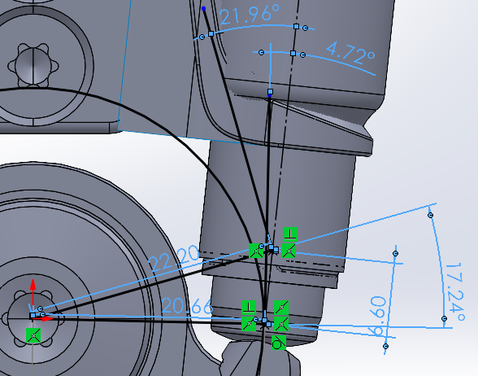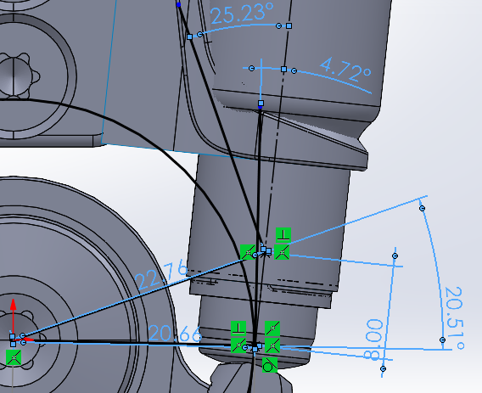
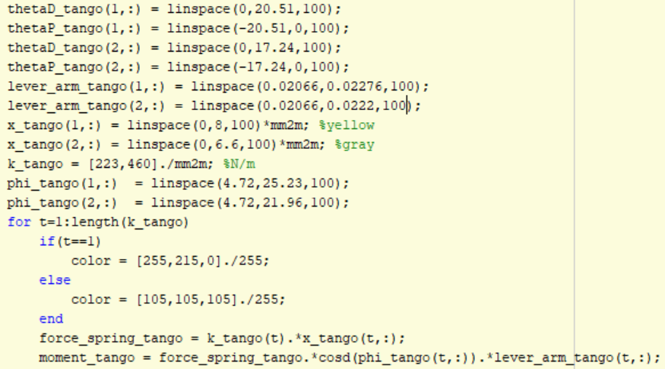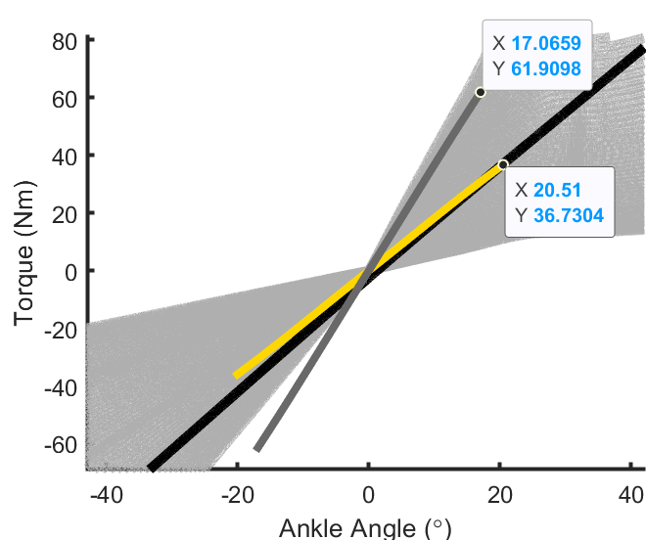
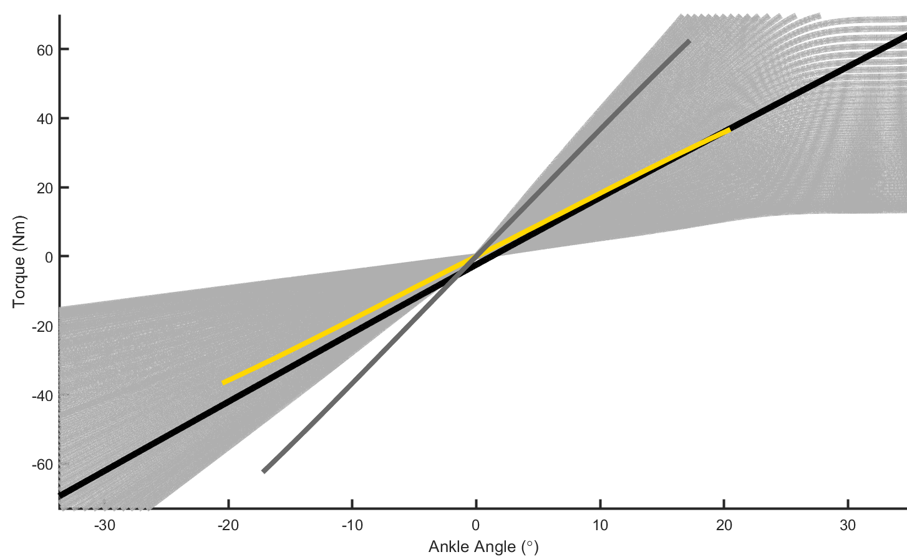
Black: estimated torque-angle function for plastic cam tested at Ottobock
Yellow: yellow spring tango
Dark Gray: gray spring tango
Light gray lines: VSO at different spring support locations with linear cam

