Personality-Driven Animation

Elissa Wolf

Advisor: Funda Durupinar  
University of Pennsylvania

# Abstract

*Virtual environments can benefit from natural and expressive virtual characters. One approach is to create characters that express individual personalities. Although research has been done in incorporating emotions into movement and in personality-based decision making, there is not yet a model for character movement with a formal psychological model of personality. We propose a system to parameterize motion with OCEAN personality traits using Laban Motion Analysis.*

Project Blog: *http://wolfseniordesign.blogspot.com*

GitHub Repository: *https://github.com/elissawolf92/Personality*

# INTRODUCTION

**Problem Statement.** There are many applications for virtual characters: games, simulations, virtual therapy, and more. If such pursuits are to be successful, virtual characters must appear natural and convincingly human. For a user to relate to and connect with a virtual character, the character must be able to express personality in a human-like fashion. Additionally, in multi-character environments, characters must be able to express individual differences. Thus far, most research studies have focused on variation through steering behaviors, and have not had a formal basis in psychology. Steering encompasses only a small piece of individual expression; humans are social creatures, and convey large amounts of information from body language alone. Expression through motion with empirical backing and a formal psychological basis can help create more realistic and varied virtual characters.

**Motivation.**  Real humans display a wide range of both personalities and moods. Personality is shown to be stable over time for a given person, while mood is dynamic and externally affected; both affect a person’s psychological state. Both are expressed through body language, and humans are highly trained at recognizing body cues and perceiving from them psychological states and social roles. This is particularly true at long distances: body cues are the first to be perceived when humans initiate social interactions [VGS*06]. Therefore, personality and emotion can effectively be expressed in body motion of virtual characters. This approach may produce characters that are more expressive, natural and human-like.

**Proposed Solution.** We propose expressing personality and emotion through body motion using Laban Motion Analysis (LMA) as an intermediary. LMA is a technique for movement analysis that is used to evaluate motion in a systematic fashion. We will produce a framework for giving personality-based expressive motion to virtual characters. The user will adjust a character’s personality with sliders, and the generated motion will change based on a mapping with LMA. This will enable the creation of multiple characters with a variety of natural motion styles.

**Contributions.**

This project makes the following contributions:

* Experimentally derives a mapping from OCEAN personality factors to LMA parameters
* Creates a system to parameterize body movement sequences by personality
* Provides a solution for creating multiple characters with expressed individual differences

## Design Goals

The target audience for this project is other animators and game developers. This project will allow users to create emotionally expressive characters with more realistic body motions.

## Projects Proposed Features and Functionality

What features and functionality will you implement for your design project?

* Mapping from OCEAN factors to LMA factors
* Algorithm to procedurally generate motion parameters from personality
* Integration into ADAPT framework with sliders for user to tune personality factors
* Retargeting of motions to better fit ADAPT models

# RELATED WORK

A variety of work has been done towards the end of animating expressive characters. There are three ways through which virtual characters can express themselves: body movement, static body posture, and proxemics, the body’s position relative to other characters and objects [VGS*06]. Significant contributions have been made for character expression through each of these mediums; some have also used LMA.

## Laban Motion Analysis

There are four components in LMA: Body, Effort, Shape, and Space. Our work will use the Effort and Shape components. They are defined as follows:

Effort: Qualities of motion that change with a person’s inner attitudes.

Shape: The form of the movement, and how the form progresses.

**Effort**

The Effort of a motion is described in four dimensions, each which ranges over a spectrum:

Space (Direct vs. Indirect)

Weight (Light vs. Strong)

Time (Sustained vs. Sudden)

Flow (Free vs. Bound).

Element factors can be combined in groups of three to form *Drives*. This produces four different Drives:

Action Drive: Weight + Space + Time

Passion Drive: Weight + Time + Flow

Vision Drive: Time + Space + Flow

Spell Drive: Weight + Space + Flow

**Shape**

There are three directions defining Shape:

Horizontal (Enclosing vs. Spreading)

Vertical (Rising vs. Sinking)

Sagittal (Retreating vs. Advancing)

Together, the LMA features comprise a method for systematically evaluating motion [A02].

## Body Movement

The Expressive MOTion Engine (EMOTE) System parameterizes animation key frames with the Effort and Shape components of LMA. The goal of EMOTE is to create characters with natural-looking motion. The system is based off of an empirically derived mapping from Laban Effort to low-level motion parameters. Effort characteristics proved too subtle for motion capture systems, so the mapping was derived with consultation with a certified motion analyst (CMA) [CCZB00].

The EMOTE system has been extended to apply more general and intuitive qualities to motion in the form of natural language instructions. Motions can be tuned using adverbs such as carefully, sadly, angrily, etc. Though the approach does not use a formally defined personality, these traits can be viewed as components or effects of personality [ZBC00]. Our project will also build upon the EMOTE System, but with a formal personality model.

It also has been hypothesized that personality and Laban Effort are linked, specifically the Extroversion and Neuroticism components of the FFM. This link is not empirically based, but theorized based on shared traits [AB02]. Our research will extend this work with data from user studies, and apply the results to create a practical framework.

Additional work has connected depression and anxiety levels to Laban movement. This, too, was in collaboration with a CMA who designed movement improvisation sessions and analyzed the resulting videos. Subjects’ depression and anxiety levels were evaluated with questionnaires. The results primarily focused on correlations with Laban Shape. Effort was examined in general, rather than by specific Effort factors: higher anxiety and depression is correlated with less variation in Effort [LD03].

Finally, research has shown that body movement is an effective way to convey emotion. Emotions from a basic set (anger, sadness, contentment, joy, and neutral) were triggered in 42 test subjects, whose movements were then recorded using motion capture. Others were able to accurately perceive the subjects’ emotions based on just their movements; body movement is an important way by which humans deliver social information [CG07]. Although emotions are not stable as is personality, the two are deeply connected.

## Body Position

Kleinsmith et al. extracted three “affect dimensions” of posture: arousal, valence, and action tendency. This multi-dimensional scale is used to distinguish emotions: for instance, arousal differentiates sad, depressed and upset from fearful, happy, joyful, and surprised. They developed a model to automatically recognize location within these affect dimensions from a set of 24 low-level posture features [KB07]. Similarly, we will use a scale based on mapping OCEAN dimensions to low-level factors.

## Proxemics

The FFM has been applied to create autonomous virtual characters. In this system, characters have predefined goals and perform goal-oriented behaviors based on their personality. The work is primarily focused on decision-making, but becomes relevant in how the characters carry out their decisions. Specifically, distance between multiple interacting characters is influenced by Extroversion, while animation speed is influenced by Neuroticism [CS04]. Our model will use the same model for personality but focus on character motion and expression.

# PROJECT PROPOSAL

We will use OCEAN personality factors (also known as the Five Factor Model, FFM) to parameterize personality. Through user studies, we will derive a mapping from personality factors to LMA parameters. LMA parameters will also map to low-level motion parameters, which directly impact the trajectory of a given motion. With this flow, we can create a framework where users can adjust a character’s motion by directly changing their personality.

## Anticipated Approach

I will first take time to familiarize myself with the technologies and the existing code. This will require reading papers and documentation, completing tutorials, and meeting with others who have worked with ADAPT. When I am sufficiently prepared, I will begin by retargeting the existing neutral motions to get rid of collisions, extreme motions, etc. This will be a good first step to get into the project before starting the larger problem.

Another component I will work on in parallel is conducting user studies. I will do this remotely via messaging as well as with in-person sessions. I plan to hold an event in the SIG Center at which food will be offered while attendees complete the research tests.

To procedurally generate motion parameters from personality, I will begin by creating a UI by which the user can input personality values. This will be in the form of sliders for the Extraversion and Neuroticism scales. The first step will be the ability to get this information without using it. Once this is working, I can begin using the input to change the motion parameters. I will first implement the simplest solution possible: a linear combination of Efforts. Based on results from user studies, I will map the personality inputs to their associated Laban Effort components, and then apply the motion parameters associated for each Effort component to the key frames.

Once I achieve natural looking motion with this approach, I will test more complex and thoughtful algorithms/weightings. For instance, one issue to be resolved is how to combine Efforts which have conflicting parameters. If we produce multiple working solutions, we can do user studies to determine which is most successful.

## Target Platforms

I will use Unity with the ADAPT and EMOTE systems to develop the application, MotionBuilder and Maya to edit and retarget captured motions, and potentially the Vicon system if we would like to capture more motions.

## Evaluation Criteria

There are three main areas of evaluation for this project. The first is software usability. The final product should be a framework for parameterizing motion with personality. Questions to ask include: Is the product easy to use? Can it accommodate any variation in personality?

The second area is the general aesthetics of the motion. The overarching goal is to create natural looking, human-like motions. Do the generated motions look smooth, or awkward?

Finally, and most importantly, is determining if the generated motions successfully express personality. A CMA could perform this analysis. Additionally, we could run user studies to see how people perceive personality from motion. Subjects could view the generated motions and rate the personality traits they believe the character to have, either on a sliding or binary (i.e., extroverted vs. introverted) scale. These results can be compared to the actual parameters used to generate the motion to get an accuracy score.

# RESEARCH TIMELINE

**Project Milestone Report (Alpha Version)**

* Complete all background reading
* Perform user studies with student subjects
* Complete tutorials and become familiar with Unity
* Retarget existing neutral motions
* Create a UI to input personality parameters
* Implement a linear combination of Efforts to generate motion parameters
* Implement/test more thoughtful methods of generating motion parameters

**Project Final Deliverables**

List what you will deliver at the end of the semester

* Unity motion player with personality sliders
* Results of user study(s)
* Demo
* Documentation

**Project Future Tasks**

* Extend to all five OCEAN factors, rather than just Extroversion and Neuroticism
* Apply to a wider range of motions
* Combine emotional responses to events with personality, so that movement is affected by a combination of both
* Generate heterogeneous crowds with different personalities

**Gantt Chart**

See Figure 1.

# Method

In my first iteration of the project, I built a Unity application with an interface for selecting and playing animation clips. Because I had never worked with Unity before, I chose to build off of the existing code that had been written for conducting user studies. This code showed me how to control a character in Unity and how to start and stop animations. From this base, I primarily had to make a GUI with a centered character, a dropdown bar for selecting animations, sliders for adjusting the character’s OCEAN parameters, and a play button. The OCEAN parameters were stored and changeable, but did not yet affect the motion. This was a good exercise in working with Unity, and resulted in a working bare-bones application I would then build upon.

I needed an empirically-derived model before I could move forward in implementing a mapping from OCEAN factors to Laban Motion components, and from those to the EMOTE motion parameters. At this point, it was decided that we would conduct trials through Amazon Mechanical Turk to derive the mapping.

Gathering and analyzing this data would take a couple of weeks, during which I did not want to be stagnant, so I met with Norm Badler to formulate a plan. We decided to build a model for cultural personality. In this model, the character has a culture (selected by the user from a list), and each culture has a mean and range for each OCEAN factor. The character has individual differences in personality, which determine how it varies from its cultural mean. In the future, this model could be used to create heterogeneous crowds that are still cohesive and together convey a given culture.

I implemented this model in the second iteration of the application. I updated the UI with a dropdown culture selector, sliders to adjust “relative” personality, and a display showing the resulting “absolute” personality. For the cultural models, I used data from a study of 17,408 participants across 56 nations. This research additionally provided justification for the inter-cultural use of the Five Factor Model: results of countries in the same geographical region were highly correlated, indicating that comparisons between countries are meaningful. The results of the research were OCEAN values for the 56 countries as differences from the US (where the US mean for all factors is 50, with a standard deviation of 10) [SAMB07]. I chose a couple of countries covering the widest range of values (US, Japan, and Lebanon) for this application.

To incorporate this data, I had to rescale it from the given 0 to 100 scale to my -50 to 50 scale. Thus, I subtracted 50 from all of the found mean values. To determine value ranges, I multiplied the empirical standard deviations by 3, thus including 97.7% of variation in the range.

To calculate absolute personality from culture values and relative personality, I scaled the relative offset from 0 by the cultural range, and then added it to the cultural mean. As an example, consider the following values to calculate the openness for an individual Japanese man:

Japanese Openness, mean: -8.46

Japanese Openness, range: 31.38

Absolute range: 50

Relative Openness: 20

Then, the Absolute Openness can be calculated:

Abs. O = -8.46 + [20 * (31.38 / 50)]

= **4.092**

Next, I created a similar mean and range-based model for gender, based on a study of 2643 participants [WDH11]. I followed the same method for calculating absolute personality from relative personality and gender values. The user is able to choose between the culture-based model, the gender-based model, or a combined-model, which averages the two (model choice is done through selecting a “mode” from a dropdown). Finally, the user is also able to adjust the default means and ranges for all cultures and genders for the purpose of testing other models.

After completing this framework, I received the empirical user study data, and was able to apply it to create a final and fully completed application. The result of the user studies was a set of coefficients for calculating Laban effort/shape from personality, and a set of coefficients for calculating EMOTE parameters from Laban effort. I set up the application to read these coefficients in from files, so that the application can easily be modified for other models.

Calculating both Laban effort and EMOTE parameters was done in a linear fashion. Each Laban effort component (space, weight, time, flow) is a linear combination of the 5 OCEAN values, weighted with the empirically derived coefficients. Each EMOTE parameter is a linear combination of the 4 Laban effort components, weighted with empirically derived coefficients. The workflow is as follows:

1. User input (any or all)
   1. Mode, culture, gender selection
   2. Mode or culture mean/range adjustment
   3. Animation clip selection
   4. Relative personality adjustment
2. Calculate absolute personality
3. Calculate Laban components
4. Calculate EMOTE parameters
5. Play animation through EMOTE system

# RESULTS

Mechanical Turk trials yielded a set of coefficients for calculating Laban motion from personality and EMOTE parameters from Laban motion.

Research into existing personality models for cultures and gender yielded empirical mean/range models, included in Appendices A and B.

The final result is a modular, fully adaptable Unity application for applying various personality models to Vicon animation clips:

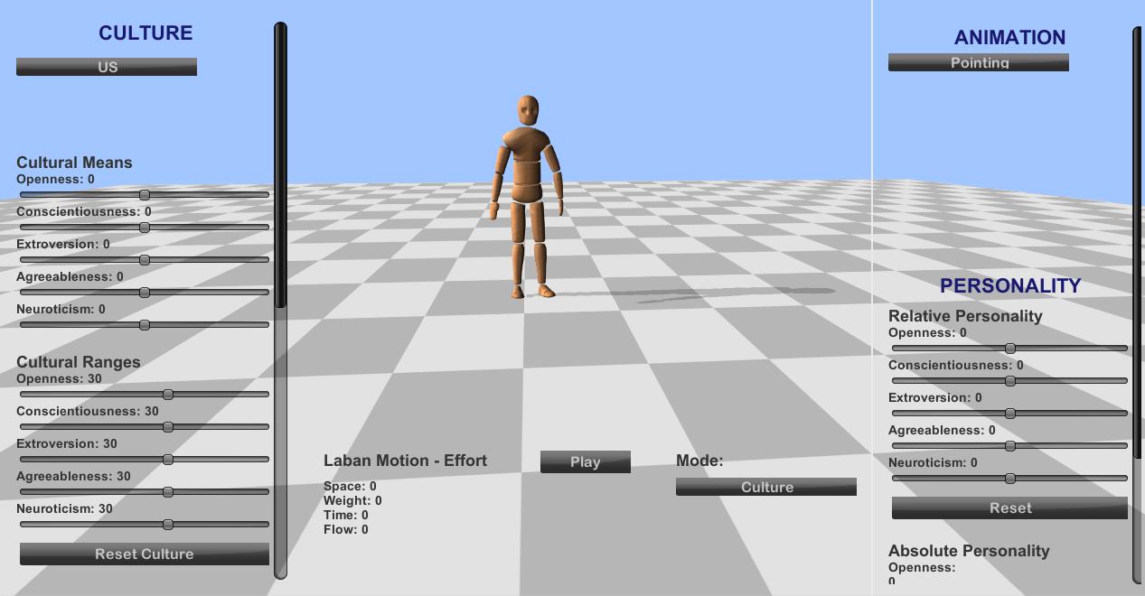

**Figure 1:** Full application

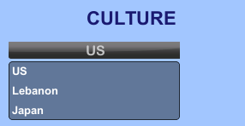

**Figure 2:** Culture selector

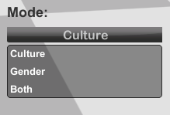

**Figure 3:** Mode selector

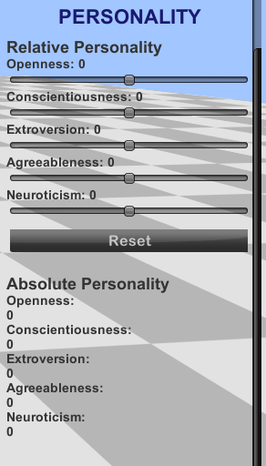

**Figure 4:** Personality components

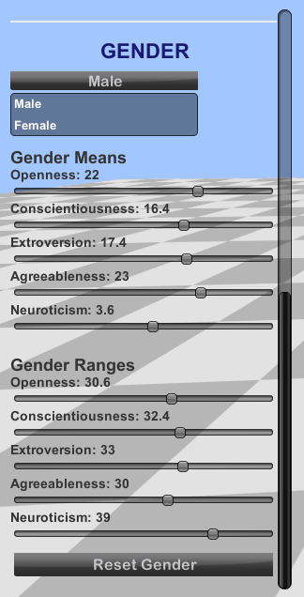

**Figure 5:** Gender selector and sliders

To evaluate the application’s success, we may revisit the previously determined evaluation criteria:

1. **Usability**

The end product is highly usable, allowing the user to adjust all parts of the model, with minimal hard-coded values. The usability is, in fact, more extensive than originally planned: the user can tune not just the character’s individual personality, but also their culture and gender.

1. **Aesthetics of Motion**

The product is successful in creating motion with a range of expressive qualities. Motions are occasionally awkward, but are smooth for the most part.

1. **Expression of Personality**

The product has yet to be formally evaluated, through expert analysis or user studies, for how accurately different personalities are expressed in the motion. However, since the model is based on a formal, psychological personality model and empirical results of extensive user studies, it is likely to be expressive with quite some accuracy.

# CONCLUSIONS and FUTURE WORK

My project lays a solid groundwork for continuing work in motion and personality. There are several ways I would like to see this work extended.

1. Test/evaluate the current model more extensively. It would be useful to get the feedback of an LMA expert. We could also conduct user studies where the user views a generated motion and guesses the characters’ personality, and then calculate the accuracy.
2. Building a more generalized model. At present, all of the empirical weights were determined from studies with the Woody character. It is not clear that this model will extend to other, more human-like characters.
3. Applying the work to crowd simulations. We could generate crowds for specific cultures, where the characters within the crowd all fit the model for that culture, and make sense together, but also display individual differences.
4. Incorporate additional models for personality variation. Many longitudinal studies have shown that OCEAN factors change with age; for instance, conscientiousness typically increases over time, while neuroticism decreases. A future iteration of the application could allow the user to select the character’s age.

Work that integrates the domains of psychology and character animation is relatively new, and the current research is the first attempt to integrate a formal psychological model of personality. My project is a step towards the overarching goal of creating realistic and emotional characters.

**APPENDIX**

1. **Culture Model (before rescaling)**

|  |  |  |  |
| --- | --- | --- | --- |
|  | US | Lebanon | Japan |
| O – Mean | 50 | 49.4 | 41.53 |
| O – SD | 10 | 9.11 | 10.46 |
| C – Mean | 50 | 44.56 | 37.83 |
| C – SD | 10 | 10.4 | 9.3 |
| E – Mean | 50 | 48.32 | 46.73 |
| E – SD | 10 | 8.58 | 8.06 |
| A – Mean | 50 | 46.1 | 42.21 |
| A – SD | 10 | 8.14 | 8.81 |
| N – Mean | 50 | 53.35 | 57.87 |
| N - SD | 10 | 9.14 | 7.38 |

1. **Gender Model (before rescaling)**

|  |  |  |
| --- | --- | --- |
|  | Male | Female |
| O – Mean | 3.60 | 3.61 |
| O – SD | 0.51 | 0.52 |
| C – Mean | 3.32 | 3.35 |
| C – SD | 0.54 | 0.58 |
| E – Mean | 3.37 | 3.42 |
| E – SD | 0.55 | 0.59 |
| A – Mean | 3.65 | 3.89 |
| A – SD | 0.50 | 0.50 |
| N – Mean | 2.68 | 2.94 |
| N - SD | 0.65 | 0.67 |

# References

|  |  |
| --- | --- |
| [A02] | Adrian, B. An Introduction to Laban Movement Analysis for Actors: A Historical, Theoretical, and Practical Perspective, Allworth Pr., 2002. |
| [AB02] | Allbeck, J., Badler, N.: Toward Representing Agent Behaviors Modified by Personality and Emotion, 2002. |
| [CCZB00] | Chi, D., Costa, M., Zhao, L., Badler, N. I.: The emote model for effort and shape. In *Proc. SIGGRAPH (July 2000)*, ACM Computer Graphics Annual Conference, 173–182. |
| [CG07] | Crane, E. A., Gross, M. M.: Motion Capture and Emotion: Affect Detection in Whole Body Movement. *In Proc. Affective Computing and Intelligent Interaction, Second International Conference,* 2007, 2007. |
| [CS04] | Chittaro, L., Serra, M.: Behavioral Programming of Autonomous Characters based on Probablistic Automata and Probability, 2004. |
| [KB07] | Kleinsmith, A., Bianchi-Berthouze, N.: Recognizing Affective Dimensions from Body Posture, 2007. |
| [LD03] | Levy, J. A., Duke, M. P.: The Use of Laban Movement Analysis in the Study of Personality, Emotional State and Movement Style: An Exploratory Investigation of the Veridicality of Body Language. *Individual Differences Research*, 1(1), 2003. |
| [SAMB07] | Schmitt, D.P., Allik, J., McCrae, R. R., Benet-Martinez, V.: The Geographic Distribution of Big Five Personality Traits: Patterns and Profiles of Human Self-Description Across 56 Countries, 2007. |
| [VGS*06] | Vinayagamoorthy, V., Gillies, M., Steed, A., Tanguy,E. Pan, X., Loscos, C., Slater, M.: Building expression into virtual characters. *In Eurographics Conference State of the Art Reports* 2006, 2006. |
| [WDH11] | Weisberg, Y. J., DeYoung, C. G., Hirsh, J. B.: Gender Differences in Personality across the Ten Aspects of the Big Five, 2011. |
| [ZCB00] | Zhao, L., Costa, M., Badler, N.: Interpreting Movement Manner. Proceedings of Computer Graphics 2000, May 2000,  98-103. |

|  |
| --- |
|  |
| Screen Shot 2014-01-29 at 2  Screen Shot 2014-01-29 at 2 |

**Figure 1:** *Gantt chart for project trajectory.*