Personality-Driven Animation
Elissa Wolf
Advisor: Funda Durupinar
University of Pennsylvania

Abstract
Virtual environments can benefit from natural and expressive virtual characters. One approach is to create characters that express individual personalities. Although research has been done in incorporating emotions into movement and in personality-based decision making, there is not yet a model for character movement with a formal psychological model of personality. We propose a system to parameterize motion with OCEAN personality traits using Laban Motion Analysis.

Project Blog: http://wolfseniordesign.blogspot.com
GitHub Repository: https://github.com/elissawolf92/Personality

INTRODUCTION
Problem Statement. There are many applications for virtual characters: games, simulations, virtual therapy, and more. If such pursuits are to be successful, virtual characters must appear natural and convincingly human. For a user to relate to and connect with a virtual character, the character must be able to express personality in a human-like fashion. Additionally, in multi-character environments, characters must be able to express individual differences. Thus far, most research studies have focused on variation through steering behaviors, and have not had a formal basis in psychology. Steering encompasses only a small piece of individual expression; humans are social creatures, and convey large amounts of information from body language alone. Expression through motion with empirical backing and a formal psychological basis can help create more realistic and varied virtual characters.

Motivation. Real humans display a wide range of both personalities and moods. Personality is shown to be stable over time for a given person, while mood is dynamic and externally affected; both affect a person’s psychological state. Both are expressed through body language, and humans are highly trained at recognizing body cues and perceiving from them psychological states and social roles. This is particularly true at long distances: body cues are the first to be perceived when humans initiate social interactions [VGS*06]. Therefore, personality and emotion can effectively be expressed in body motion of virtual characters. This approach may produce characters that are more expressive, natural and human-like.

Proposed Solution. We propose expressing personality and emotion through body motion using Laban Motion Analysis (LMA) as an intermediary. LMA is a technique for movement analysis that is used to evaluate motion in a systematic fashion. We will produce a framework for giving personality-based expressive motion to virtual characters. The user will adjust a character’s personality with sliders, and the generated motion will change based on a mapping with LMA. This will enable the creation of multiple characters with a variety of natural motion styles.

Contributions.

This project makes the following contributions:
- Experimentally derives a mapping from OCEAN personality factors to LMA parameters
- Creates a system to parameterize body movement sequences by personality
- Provides a solution for creating multiple characters with expressed individual differences

Design Goals
The target audience for this project is other animators and game developers. This project will allow users to create emotionally expressive characters with more realistic body motions.

Projects Proposed Features and Functionality
What features and functionality will you implement for your design project?
- Mapping from OCEAN factors to LMA factors
- Algorithm to procedurally generate motion parameters from personality
- Integration into ADAPT framework with sliders for user to tune personality factors
- Retargeting of motions to better fit ADAPT models

RELATED WORK
A variety of work has been done towards the end of animating expressive characters. There are three ways through which virtual characters can express themselves: body movement, static body posture, and proxemics, the body’s position relative to other characters and objects [VGS*06]. Significant contributions have been made for character expression through each of these mediums; some have also used LMA.

Laban Motion Analysis
There are four components in LMA: Body, Effort, Shape, and Space. Our work will use the Effort and Shape components. They are defined as follows:
Effort: Qualities of motion that change with a person’s inner attitudes.
Shape: The form of the movement, and how the form progresses.
Effort
The Effort of a motion is described in four dimensions, each which ranges over a spectrum:
Space (Direct vs. Indirect)
Weight (Light vs. Strong)
Time (Sustained vs. Sudden)
Flow (Free vs. Bound).
Element factors can be combined in groups of three to form Drives. This produces four different Drives:
Action Drive: Weight + Space + Time
Passion Drive: Weight + Time + Flow
Vision Drive: Time + Space + Flow
Spell Drive: Weight + Space + Flow
Shape
There are three directions defining Shape:
Horizontal (Enclosing vs. Spreading)
Vertical (Rising vs. Sinking)
Sagittal (Retreating vs. Advancing)
Together, the LMA features comprise a method for systematically evaluating motion [A02].

Body Movement
The Expressive MOTion Engine (EMOTE) System parameterizes animation key frames with the Effort and Shape components of LMA. The goal of EMOTE is to create characters with natural-looking motion. The system is based off of an empirically derived mapping from Laban Effort to low-level motion parameters. Effort characteristics proved too subtle for motion capture systems, so the mapping was derived with consultation with a certified motion analyst (CMA) [CCZB00].
The EMOTE system has been extended to apply more general and intuitive qualities to motion in the form of natural language instructions. Motions can be tuned using adverbs such as carefully, sadly, angrily, etc. Though the approach does not use a formally defined personality, these traits can be viewed as components or effects of personality [ZBC00]. Our project will also build upon the EMOTE System, but with a formal personality model.
It also has been hypothesized that personality and Laban Effort are linked, specifically the Extroversion and Neuroticism components of the FFM. This link is not empirically based, but theorized based on shared traits [AB02]. Our research will extend this work with data from user studies, and apply the results to create a practical framework.
Additional work has connected depression and anxiety levels to Laban movement. This, too, was in collaboration with a CMA who designed movement improvisation sessions and analyzed the resulting videos. Subjects’ depression and anxiety levels were evaluated with questionnaires. The results primarily focused on correlations with Laban Shape. Effort was examined in general, rather than by specific Effort factors: higher anxiety and depression is correlated with less variation in Effort [LD03].
Finally, research has shown that body movement is an effective way to convey emotion. Emotions from a basic set (anger, sadness, contentment, joy, and neutral) were triggered in 42 test subjects, whose movements were then recorded using motion capture. Others were able to accurately perceive the subjects’ emotions based on just their movements; body movement is an important way by which humans deliver social information [CG07]. Although emotions are not stable as is personality, the two are deeply connected.

Body Position
Kleinsmith et al. extracted three “affect dimensions” of posture: arousal, valence, and action tendency. This multi-dimensional scale is used to distinguish emotions: for instance, arousal differentiates sad, depressed and upset from fearful, happy, joyful, and surprised. They developed a model to automatically recognize location within these affect dimensions from a set of 24 low-level posture features [KB07]. Similarly, we will use a scale based on mapping OCEAN dimensions to low-level factors.

Proxemics
The FFM has been applied to create autonomous virtual characters. In this system, characters have predefined goals and perform goal-oriented behaviors based on their personality. The work is primarily focused on decision-making, but becomes relevant in how the characters carry out their decisions. Specifically, distance between multiple interacting characters is influenced by Extroversion, while animation speed is influenced by Neuroticism [CS04]. Our model will use the same model for personality but focus on character motion and expression.

PROJECT PROPOSAL
We will use OCEAN personality factors (also known as the Five Factor Model, FFM) to parameterize personality. Through user studies, we will derive a mapping from personality factors to LMA parameters. LMA parameters will also map to low-level motion parameters, which directly impact the trajectory of a given motion. With this flow, we can create a framework where users can adjust a character’s motion by directly changing their personality.

Anticipated Approach
I will first take time to familiarize myself with the technologies and the existing code. This will require reading papers and documentation, completing tutorials, and meeting with others who have worked with ADAPT. When I am sufficiently prepared, I will begin by retargeting the existing neutral motions to get rid of collisions, extreme motions, etc. This will be a good first step to get into the project before starting the larger problem.
Another component I will work on in parallel is conducting user studies. I will do this remotely via messaging as well as with in-person sessions. I plan to hold an event in the SIG Center at which food will be offered while attendees complete the research tests.
To procedurally generate motion parameters from personality, I will begin by creating a UI by which the user can input personality values. This will be in the form of sliders for the Extraversion and Neuroticism scales. The first step will be the ability to get this information without using it. Once this is working, I can begin using the input to change the motion parameters. I will first implement the simplest solution possible: a linear combination of Efforts. Based on results from user studies, I will map the personality inputs to their associated Laban Effort components, and then apply the motion parameters associated for each Effort component to the key frames.
Once I achieve natural looking motion with this approach, I will test more complex and thoughtful algorithms/weightings. For instance, one issue to be resolved is how to combine Efforts which have conflicting parameters. If we produce multiple working solutions, we can do user studies to determine which is most successful.

Target Platforms
I will use Unity with the ADAPT and EMOTE systems to develop the application, MotionBuilder and Maya to edit and retarget captured motions, and potentially the Vicon system if we would like to capture more motions.

Evaluation Criteria
There are three main areas of evaluation for this project. The first is software usability. The final product should be a framework for parameterizing motion with personality. Questions to ask include: Is the product easy to use? Can it accommodate any variation in personality?
The second area is the general aesthetics of the motion. The overarching goal is to create natural looking, human-like motions. Do the generated motions look smooth, or awkward?
Finally, and most importantly, is determining if the generated motions successfully express personality. A CMA could perform this analysis. Additionally, we could run user studies to see how people perceive personality from motion. Subjects could view the generated motions and rate the personality traits they believe the character to have, either on a sliding or binary (i.e., extroverted vs. introverted) scale. These results can be compared to the actual parameters used to generate the motion to get an accuracy score.

RESEARCH TIMELINE
Project Milestone Report (Alpha Version)
- Complete all background reading
- Perform user studies with student subjects
- Complete tutorials and become familiar with Unity
- Retarget existing neutral motions
- Create a UI to input personality parameters
- Implement a linear combination of Efforts to generate motion parameters
- Implement/test more thoughtful methods of generating motion parameters

Project Final Deliverables
List what you will deliver at the end of the semester
- Unity motion player with personality sliders
- Results of user study(s)
- Demo
- Documentation

Project Future Tasks
- Extend to all five OCEAN factors, rather than just Extroversion and Neuroticism
- Apply to a wider range of motions
- Combine emotional responses to events with personality, so that movement is affected by a combination of both
- Generate heterogeneous crowds with different personalities

Gantt Chart
See figure 1.

(remove line)

You will fill in the following sections as you make progress on your project, particularly for the alpha review and the final deliverable. In these sections, list pseudo-code, charts, images, examples, etc. to show what you’ve done over the course of the semester.

Method

RESULTS

CONCLUSIONS and FUTURE WORK
APPENDIX
- Optional Appendix
Some text here. Some text here. Some text here.

(remove line)

References
[A02] | Adrian, B. An Introduction to Laban Movement Analysis for Actors: A Historical, Theoretical, and Practical Perspective, Allworth Pr., 2002.
[AB02] | Allbeck, J., Badler, N.: Toward Representing Agent Behaviors Modified by Personality and Emotion, 2002.
[CCZB00] | Chi, D., Costa, M., Zhao, L., Badler, N. I.: The emote model for effort and shape. In Proc. SIGGRAPH (July 2000), ACM Computer Graphics Annual Conference, 173–182.
[CG07] | Crane, E. A., Gross, M. M.: Motion Capture and Emotion: Affect Detection in Whole Body Movement. In Proc. Affective Computing and Intelligent Interaction, Second International Conference, 2007, 2007.
[CS04] | Chittaro, L., Serra, M.: Behavioral Programming of Autonomous Characters based on Probablistic Automata and Probability, 2004.
[KB07] | Kleinsmith, A., Bianchi-Berthouze, N.: Recognizing Affective Dimensions from Body Posture, 2007.
[LD03] | Levy, J. A., Duke, M. P.: The Use of Laban Movement Analysis in the Study of Personality, Emotional State and Movement Style: An Exploratory Investigation of the Veridicality of Body Language. Individual Differences Research, 1(1), 2003.
[ VGS*06] | Vinayagamoorthy, V., Gillies, M., Steed, A., Tanguy,E. Pan, X., Loscos, C., Slater, M.: Building expression into virtual characters. In Eurographics Conference State of the Art Reports 2006, 2006.
[ZCB00] | Zhao, L., Costa, M., Badler, N.: Interpreting Movement Manner. Proceedings of Computer Graphics 2000, May 2000, 98-103.

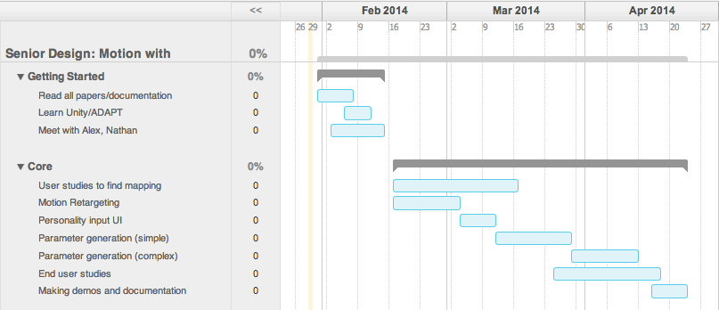
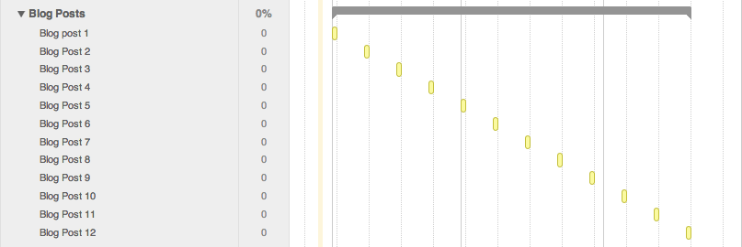
Figure 1: Gantt Chart for project trajectory.

