Kütüphaneler :Sys,sqllite, PyQt5

Veri tabanı:Sqllite

Veri tabanı ilişkisi

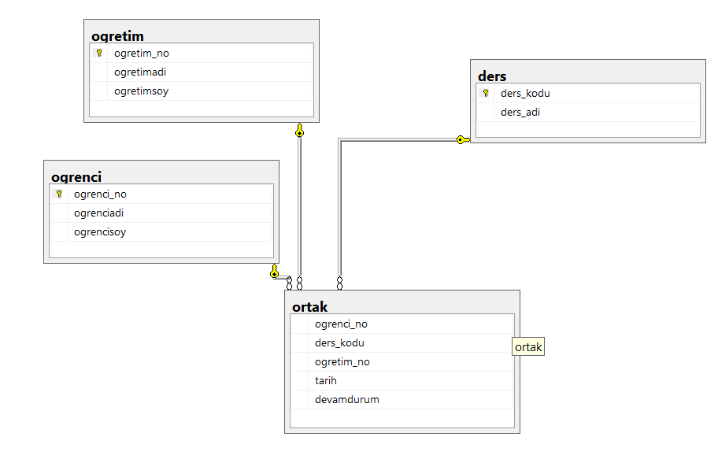

Program Görseller Ve Kodları

Ana Ekran

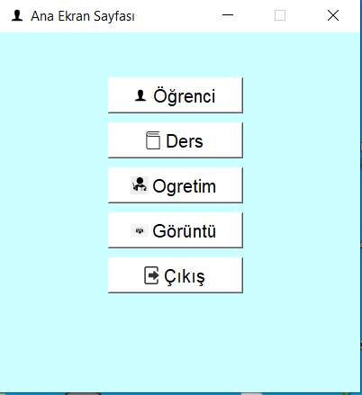

import sys  
from PyQt5.QtWidgets import *  
from PyQt5.QtGui import QFont,QIcon  
import ogrenciler  
  
import ogretim  
import dersler  
  
  
butonFont=QFont(**"Arial"**,12)  
yaziFont=QFont(**"Arial"**,16)  
  
class Pencere(QWidget):  
 def __init__(self):  
 super().__init__()  
 self.setWindowTitle(**"Ana Ekran Sayfası"**)  
 self.setGeometry(50,50,400,400)  
 self.setStyleSheet(**"background-color:#ccffff"**)  
 self.setFixedSize(self.size())  
 self.setWindowIcon(QIcon(**'resimler/ogr.png'**))  
 self.arayuz()  
  
 def arayuz(self):  
 ogrbuton=QPushButton(**"Öğrenci"**,self)  
 ogrbuton.setStyleSheet(**"background-color:white"**)  
 ogrbuton.resize(150,40)  
 ogrbuton.move(120,50)  
 ogrbuton.setFont(butonFont)  
 ogrbuton.setIcon(QIcon(**'resimler/ogr.png'**))  
 ogrbuton.clicked.connect(self.ogrenciler)  
 *#######################################################* dersbuton = QPushButton(**"Ders"**, self)  
 dersbuton.setStyleSheet(**"background-color:white"**)  
 dersbuton.resize(150, 40)  
 dersbuton.move(120, 100)  
 dersbuton.setFont(butonFont)  
 dersbuton.setIcon(QIcon(**'resimler/ders.png'**))  
 dersbuton.clicked.connect(self.dersler)  
 *#######################################################* ogretimbuton = QPushButton(**"Ogretim"**, self)  
 ogretimbuton.setStyleSheet(**"background-color:white"**)  
 ogretimbuton.resize(150, 40)  
 ogretimbuton.move(120, 150)  
 ogretimbuton.setFont(butonFont)  
 ogretimbuton.setIcon(QIcon(**'resimler/ogret.jpg'**))  
 ogretimbuton.clicked.connect(self.ogretim)  
 *#######################################################* goruntubuton = QPushButton(**"Görüntü"**, self)  
 goruntubuton.setStyleSheet(**"background-color:white"**)  
 goruntubuton.resize(150, 40)  
 goruntubuton.move(120, 200)  
 goruntubuton.setFont(butonFont)  
 goruntubuton.setIcon(QIcon(**'resimler/kamera.jpg'**))  
 *#######################################################* cikisbuton = QPushButton(**"Çıkış"**, self)  
 cikisbuton.setStyleSheet(**"background-color:white"**)  
 cikisbuton.resize(150, 40)  
 cikisbuton.move(120, 250)  
 cikisbuton.setFont(butonFont)  
 cikisbuton.setIcon(QIcon(**'resimler/exit.png'**))  
 cikisbuton.clicked.connect(self.dialog)  
  
 self.show()  
  
 def ogrenciler(self):  
 self.ogr=ogrenciler.Person()  
 self.ogr.show()  
  
 def dersler(self):  
 self.dr = dersler.Personders()  
 self.dr.show()  
  
 def ogretim(self):  
 self.ogret = ogretim.Personogretim()  
 self.ogret.show()  
  
 def dialog(self):  
 mesajkutusu = QMessageBox.question(self, **"Uyarı"**, **"Çıkmak İstiyormusun?"**, QMessageBox.Yes | QMessageBox.No, QMessageBox.No)  
 if mesajkutusu == QMessageBox.Yes:  
 sys.exit()  
 else:  
 pass  
  
  
  
def main():  
 uygulama=QApplication(sys.argv)  
 pencere=Pencere()  
 sys.exit(uygulama.exec_())  
  
if __name__==**'__main__'**:  
 main()

Öğrenci Sayfası ve Öğrenci Düzenle Sayfası

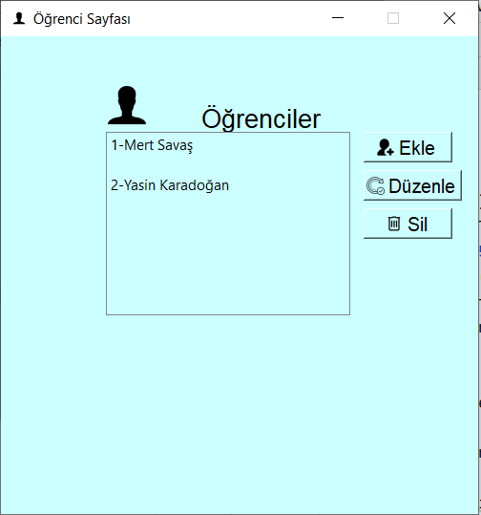

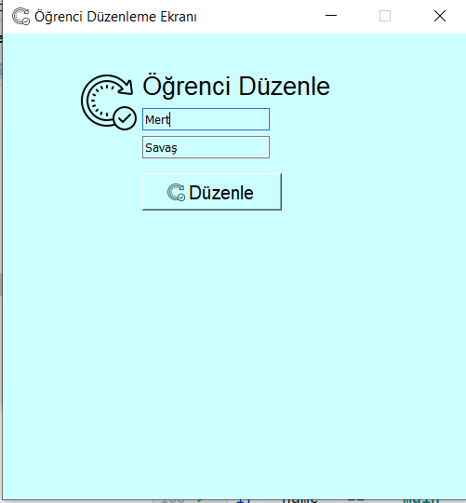

import sys  
from PyQt5.QtWidgets import *  
from PyQt5.QtGui import QFont, QIcon, QPixmap  
import sqlite3  
import ogrenciekle  
  
butonFont = QFont(**"Arial"**, 12)  
yaziFont = QFont(**"Arial"**, 16)  
  
connect = sqlite3.connect(**'database.db'**)  
cursor = connect.cursor()  
  
  
class Person(QWidget):  
 def __init__(self):  
 super().__init__()  
 self.setGeometry(50, 50, 500, 500)  
 self.setFixedSize(self.size())  
 self.setWindowTitle(**"Öğrenci Sayfası"**)  
 self.setStyleSheet(**"background-color:#ccffff"**)  
 self.setWindowIcon(QIcon(**'resimler/ogr.png'**))  
  
 baslik = QLabel(**"Öğrenciler"**, self)  
 baslik.setFont(yaziFont)  
 baslik.move(210, 70)  
 resim = QLabel(self)  
 resim.setPixmap(QPixmap(**'resimler/ogr.png'**))  
 resim.move(100, 40)  
 *########################################* self.liste = QListWidget(self)  
 self.liste.move(110, 100)  
  
 ogrenci = cursor.execute(**"select * from ogrenci"**)  
 for i in ogrenci.fetchall():  
 self.liste.addItem(str(i[0]) + **"-"** + i[1] + **" "** + i[2])  
  
 *########################################* addButon = QPushButton(**"Ekle"**, self)  
 addButon.setFont(butonFont)  
 addButon.move(380, 100)  
 addButon.setFont(butonFont)  
 addButon.setIcon(QIcon(**'resimler/add.png'**))  
 addButon.clicked.connect(self.ogrenciekle)  
 *########################################* updateButon = QPushButton(**"Düzenle"**, self)  
 updateButon.setFont(butonFont)  
 updateButon.move(380, 140)  
 updateButon.setFont(butonFont)  
 updateButon.setIcon(QIcon(**'resimler/update.png'**))  
 updateButon.clicked.connect(self.ogrenciduzenle)  
 *########################################* deleteButon = QPushButton(**"Sil"**, self)  
 deleteButon.setFont(butonFont)  
 deleteButon.move(380, 180)  
 deleteButon.setFont(butonFont)  
 deleteButon.setIcon(QIcon(**'resimler/delete.png'**))  
 deleteButon.clicked.connect(self.ogrencisil)  
  
 def ogrenciekle(self):  
 self.ekle = ogrenciekle.Ekle()  
 self.ekle.show()  
 self.close()  
  
 def ogrencisil(self):  
 ogrenci = self.liste.currentItem().text()  
 no = ogrenci.split(**"-"**)[0]  
  
 onay = QMessageBox.question(self, **"Uyarı"**, **"Sİlmek istiyormusun"**, QMessageBox.Yes | QMessageBox.No,QMessageBox.No)  
  
 if (onay == QMessageBox.Yes):  
 try:  
 cursor.execute(**"delete from ogrenci where ogrenci_no=?"**, (no,))  
 connect.commit()  
 QMessageBox.information(self, **"BİLGİ"**, **"SİLİNDİ"**)  
 except:  
 QMessageBox.information(self, **"HATA"**, **"SİLİNEMEDİ"**)  
 else:  
 pass  
 self.close()  
  
  
 def ogrenciduzenle(self):  
 self.ogrenci = self.liste.currentItem().text()  
 global ogrenci_no  
 ogrenci_no = self.ogrenci.split(**"-"**)[0]  
  
  
 self.duzenle = Duzenle()  
 self.duzenle.show()  
 self.close()  
  
  
class Duzenle(QWidget):  
 def __init__(self):  
 super().__init__()  
 self.setWindowTitle(**"Öğrenci Düzenleme Ekranı"**)  
 self.setGeometry(50,50,500,500)  
 self.setFixedSize(self.size())  
 self.setStyleSheet(**"background-color:#ccffff"**)  
 self.setWindowIcon(QIcon(**'resimler/update.png'**))  
  
 try:  
 sorgu=cursor.execute(**"select * from ogrenci where ogrenci_no=?"**,(ogrenci_no,))  
 ogrenci_bilgi = sorgu.fetchall()  
 self.ogrenci_no=ogrenci_bilgi[0][0]  
 ogrenci_adi = ogrenci_bilgi[0][1]  
 ogrenci_soyadi = ogrenci_bilgi[0][2]  
  
  
  
  
 except:  
 pass  
  
 baslik=QLabel(**"Öğrenci Düzenle"**,self)  
 baslik.move(150,40)  
 baslik.setFont(yaziFont)  
 resim = QLabel(self)  
 resim.setPixmap(QPixmap(**'resimler/update.png'**))  
 resim.move(80, 40)  
 *########################* self.ad=QLineEdit(self)  
 self.ad.move(150,80)  
 self.ad.setText(ogrenci_adi)  
 *##########################* self.soyad=QLineEdit(self)  
 self.soyad.move(150,110)  
 self.soyad.setText(ogrenci_soyadi)  
 *#############################3* duzenlebuton=QPushButton(**"Düzenle"**,self)  
 duzenlebuton.setFont(butonFont)  
 duzenlebuton.move(150,150)  
 duzenlebuton.resize(150, 40)  
 duzenlebuton.setIcon(QIcon(**'resimler/update.png'**))  
 duzenlebuton.setFont(butonFont)  
 duzenlebuton.clicked.connect(self.ogrenciguncelle)  
 *#############################* def ogrenciguncelle(self):  
 ogrenci_nosu=self.ogrenci_no  
 adi=self.ad.text()  
 soyadi=self.soyad.text()  
  
 try:  
 cursor.execute(**"update ogrenci set ogrenciadi=?, ogrencisoy=? where ogrenci_no=?"**,(adi,soyadi,ogrenci_nosu,))  
 connect.commit()  
  
 QMessageBox.information(self, **"BİLGİ"**, **"Guncelendi"**)  
 self.close()  
  
 except:  
 QMessageBox.information(self, **"BİLGİ"**, **"Guncelenmedi"**)  
  
  
  
  
  
def main():  
 uygulama = QApplication(sys.argv)  
 pencere = Person()  
 sys.exit(uygulama.exec_())  
  
  
if __name__ == **'__main__'**:  
 main()

Öğrenci Ekle

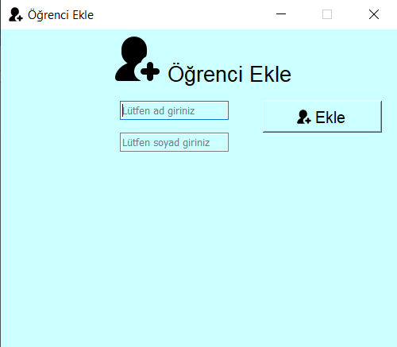

import sys  
from PyQt5.QtWidgets import *  
from PyQt5.QtGui import QFont,QIcon,QPixmap  
import sqlite3  
  
butonFont=QFont(**"Arial"**,12)  
yaziFont=QFont(**"Arial"**,16)  
  
connect=sqlite3.connect(**'database.db'**)  
cursor=connect.cursor()  
class Ekle(QWidget):  
 def __init__(self):  
 super().__init__()  
 self.setGeometry(50,50,500,400)  
 self.setFixedSize(self.size())  
 self.setStyleSheet(**"background-color:#ccffff"**)  
 self.setWindowIcon(QIcon(**'resimler/add.png'**))  
 self.setWindowTitle(**"Öğrenci Ekle"**)  
  
 baslik=QLabel(**"Öğrenci Ekle"**,self)  
 baslik.move(210,40)  
 baslik.setFont(yaziFont)  
 resim = QLabel(self)  
 resim.setPixmap(QPixmap(**'resimler/add.png'**))  
 resim.move(140,5)  
 *##############################################* self.isim=QLineEdit(self)  
 self.isim.move(150,90)  
 self.isim.setPlaceholderText(**"Lütfen ad giriniz"**)  
 *##############################################* self.soyisim = QLineEdit(self)  
 self.soyisim.move(150, 130)  
 self.soyisim.setPlaceholderText(**"Lütfen soyad giriniz"**)  
 *##############################################* eklebuton=QPushButton(**"Ekle"**,self)  
 eklebuton.setFont(butonFont)  
 eklebuton.move(330,90)  
 eklebuton.resize(150, 40)  
 eklebuton.setFont(butonFont)  
 eklebuton.setIcon(QIcon(**'resimler/add.png'**))  
 eklebuton.clicked.connect(self.ekle)  
  
  
 def ekle(self):  
 isim=self.isim.text()  
 soyisim = self.soyisim.text()  
 if(isim and soyisim!=**""** ):  
  
 try:  
 cursor.execute(**"insert into ogrenci(ogrenciadi,ogrencisoy) values(?,?)"**,(isim,soyisim,))  
 connect.commit()  
 QMessageBox.information(self,**"Bilgi"**,**"Eklendi"**)  
 self.isim.setText(**""**)  
 self.soyisim.setText(**""**)  
  
 except:  
 QMessageBox.information(self, **"Hata"**, **"Eklenmedi"**)  
  
 else:  
 QMessageBox.information(self, **"Hata"**, **"Boş geçmeyin"**)

Dersler Ve Dersler Düzenle Sayfası

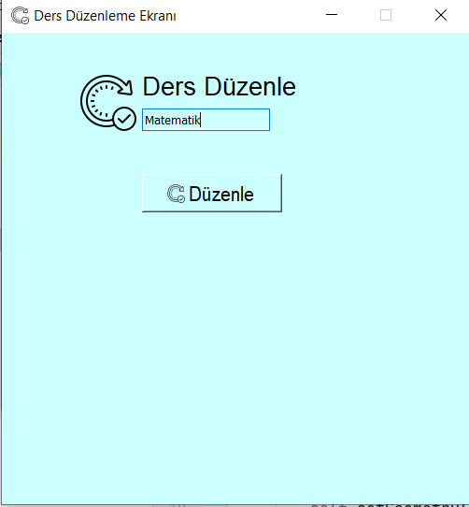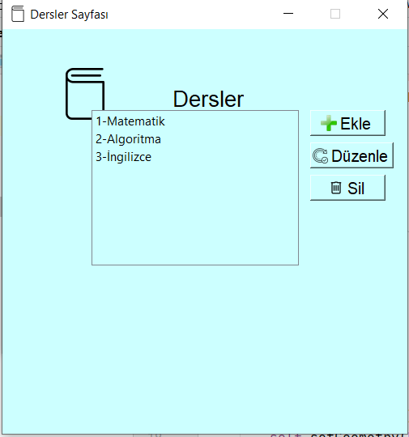

import sys  
from PyQt5.QtWidgets import *  
from PyQt5.QtGui import QFont, QIcon, QPixmap  
import sqlite3  
import dersekle  
  
  
  
butonFont = QFont(**"Arial"**, 12)  
yaziFont = QFont(**"Arial"**, 16)  
  
connect = sqlite3.connect(**'database.db'**)  
cursor = connect.cursor()  
  
  
class Personders(QWidget):  
 def __init__(self):  
 super().__init__()  
 self.setGeometry(50, 50, 500, 500)  
 self.setFixedSize(self.size())  
 self.setWindowTitle(**"Dersler Sayfası"**)  
 self.setStyleSheet(**"background-color:#ccffff"**)  
 self.setWindowIcon(QIcon(**'resimler/ders.png'**))  
  
 baslik = QLabel(**"Dersler"**,self)  
 baslik.setFont(yaziFont)  
 baslik.move(210, 70)  
 resim = QLabel(self)  
 resim.setPixmap(QPixmap(**'resimler/ders.png'**))  
 resim.resize(120,120)  
 resim.move(70, 20)  
 *########################################* self.liste = QListWidget(self)  
 self.liste.move(110, 100)  
  
 ders = cursor.execute(**"select * from ders"**)  
 for i in ders.fetchall():  
 self.liste.addItem(str(i[0]) + **"-"** + i[1])  
  
 *########################################* addButon = QPushButton(**"Ekle"**, self)  
 addButon.setFont(butonFont)  
 addButon.move(380, 100)  
 addButon.setFont(butonFont)  
 addButon.setIcon(QIcon(**'resimler/addbook.png'**))  
 addButon.clicked.connect(self.dersekle)  
 *########################################* updateButon = QPushButton(**"Düzenle"**, self)  
 updateButon.setFont(butonFont)  
 updateButon.move(380, 140)  
 updateButon.setFont(butonFont)  
 updateButon.setIcon(QIcon(**'resimler/update.png'**))  
 updateButon.clicked.connect(self.dersduzenle)  
 *########################################* deleteButon = QPushButton(**"Sil"**, self)  
 deleteButon.setFont(butonFont)  
 deleteButon.move(380, 180)  
 deleteButon.setFont(butonFont)  
 deleteButon.setIcon(QIcon(**'resimler/delete.png'**))  
 deleteButon.clicked.connect(self.derssil)  
 def dersekle(self):  
 self.ekle = dersekle.dersEkle()  
 self.ekle.show()  
 self.close()  
  
  
 def derssil(self):  
 ders = self.liste.currentItem().text()  
 no = ders.split(**"-"**)[0]  
  
 onay = QMessageBox.question(self, **"Uyarı"**, **"Sİlmek istiyormusun"**, QMessageBox.Yes | QMessageBox.No,QMessageBox.No)  
  
 if (onay == QMessageBox.Yes):  
 try:  
 cursor.execute(**"delete from ders where ders_kodu=?"**, (no))  
 connect.commit()  
 QMessageBox.information(self, **"BİLGİ"**, **"SİLİNDİ"**)  
 except:  
 QMessageBox.information(self, **"HATA"**, **"SİLİNEMEDİ"**)  
 else:  
 pass  
 self.close()  
  
  
 def dersduzenle(self):  
 self.ders = self.liste.currentItem().text()  
 global ders_kodu  
 ders_kodu = self.ders.split(**"-"**)[0]  
  
  
 self.duzenle = Duzenleders()  
 self.duzenle.show()  
 self.close()  
  
  
class Duzenleders(QWidget):  
 def __init__(self):  
 super().__init__()  
 self.setWindowTitle(**"Ders Düzenleme Ekranı"**)  
 self.setGeometry(50,50,500,500)  
 self.setFixedSize(self.size())  
 self.setStyleSheet(**"background-color:#ccffff"**)  
 self.setWindowIcon(QIcon(**'resimler/update.png'**))  
  
 try:  
 sorgu=cursor.execute(**"select * from ders where ders_kodu=?"**,(ders_kodu,))  
 ders_bilgi = sorgu.fetchall()  
 self.ders_kodu=ders_bilgi[0][0]  
 ders_adi = ders_bilgi[0][1]  
  
  
  
  
  
 except:  
 pass  
  
 baslik=QLabel(**"Ders Düzenle"**,self)  
 baslik.move(150,40)  
 baslik.setFont(yaziFont)  
  
 resim = QLabel(self)  
 resim.setPixmap(QPixmap(**'resimler/update.png'**))  
 resim.move(80, 40)  
 *########################* self.ad=QLineEdit(self)  
 self.ad.move(150,80)  
 self.ad.setText(ders_adi)  
  
  
 *#############################3* duzenlebuton=QPushButton(**"Düzenle"**,self)  
 duzenlebuton.setFont(butonFont)  
 duzenlebuton.move(150,150)  
 duzenlebuton.resize(150, 40)  
 duzenlebuton.setIcon(QIcon(**'resimler/update.png'**))  
 duzenlebuton.setFont(butonFont)  
 duzenlebuton.clicked.connect(self.dersguncelle)  
 *#############################* def dersguncelle(self):  
 ders_kodusu=self.ders_kodu  
 adi=self.ad.text()  
  
  
 try:  
 cursor.execute(**"update ders set ders_adi=? where ders_kodu=?"**,(adi,ders_kodusu,))  
 connect.commit()  
  
 QMessageBox.information(self, **"BİLGİ"**, **"Guncellendi"**)  
 self.close()  
  
 except:  
 QMessageBox.information(self, **"BİLGİ"**, **"Guncellenmedi"**)  
  
def main():  
 uygulama = QApplication(sys.argv)  
 pencere = Personders()  
 sys.exit(uygulama.exec_())  
  
  
if __name__ == **'__main__'**:  
 main()

Dersekle Sayfası

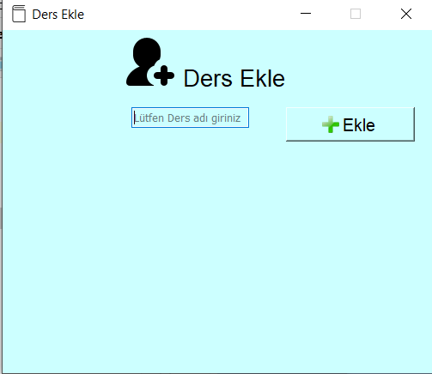

import sys  
from PyQt5.QtWidgets import *  
from PyQt5.QtGui import QFont,QIcon,QPixmap  
import sqlite3  
  
butonFont=QFont(**"Arial"**,12)  
yaziFont=QFont(**"Arial"**,16)  
  
connect=sqlite3.connect(**'database.db'**)  
cursor=connect.cursor()  
class dersEkle(QWidget):  
 def __init__(self):  
 super().__init__()  
 self.setGeometry(50,50,500,400)  
 self.setFixedSize(self.size())  
 self.setStyleSheet(**"background-color:#ccffff"**)  
 self.setWindowIcon(QIcon(**'resimler/ders.png'**))  
 self.setWindowTitle(**"Ders Ekle"**)  
  
 baslik=QLabel(**"Ders Ekle"**,self)  
 baslik.move(210,40)  
 baslik.setFont(yaziFont)  
 resim = QLabel(self)  
 resim.setPixmap(QPixmap(**'resimler/add.png'**))  
 resim.move(140,5)  
 *##############################################* self.isim=QLineEdit(self)  
 self.isim.move(150,90)  
 self.isim.setPlaceholderText(**"Lütfen Ders adı giriniz"**)  
 *##############################################  
  
 ##############################################* eklebuton=QPushButton(**"Ekle"**,self)  
 eklebuton.setFont(butonFont)  
 eklebuton.move(330,90)  
 eklebuton.resize(150, 40)  
 eklebuton.setFont(butonFont)  
 eklebuton.setIcon(QIcon(**'resimler/addbook.png'**))  
 eklebuton.clicked.connect(self.dersekle)  
  
 def dersekle(self):  
 isim = self.isim.text()  
  
 if (isim!=**""** ):  
  
 try:  
 cursor.execute(**"insert into ders(ders_adi) values(?)"**, (isim,))  
 connect.commit()  
 QMessageBox.information(self, **"Bilgi"**, **"Eklendi"**)  
 self.isim.setText(**""**)  
  
  
 except:  
 QMessageBox.information(self, **"Hata"**, **"Eklenmedi"**)  
  
 else:  
 QMessageBox.information(self, **"Hata"**, **"Boş geçmeyin"**)  
  
  
  
Öğretim Görevlisi Sayfası ve Öğretim Görevlisi Düzenle Sayfası

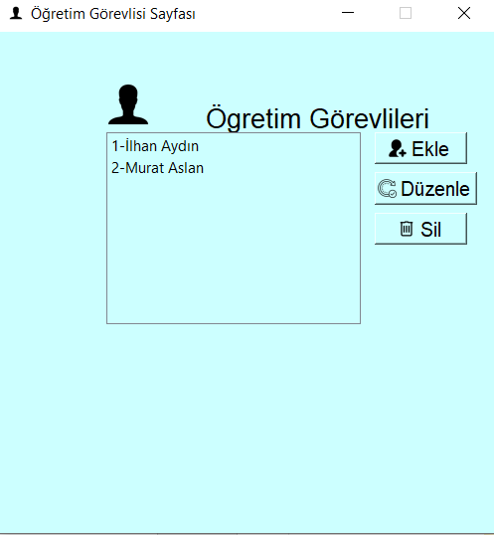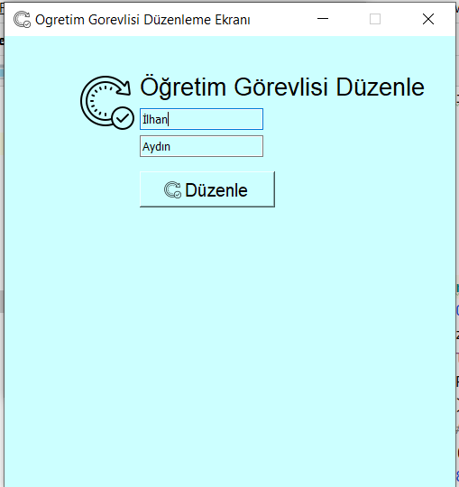

import sys  
from PyQt5.QtWidgets import *  
from PyQt5.QtGui import QFont, QIcon, QPixmap  
import sqlite3  
import ogretimekle  
  
  
  
butonFont = QFont(**"Arial"**, 12)  
yaziFont = QFont(**"Arial"**, 16)  
  
connect = sqlite3.connect(**'database.db'**)  
cursor = connect.cursor()  
  
  
class Personogretim(QWidget):  
 def __init__(self):  
 super().__init__()  
 self.setGeometry(50, 50, 500, 500)  
 self.setFixedSize(self.size())  
 self.setWindowTitle(**"Öğretim Görevlisi Sayfası"**)  
 self.setStyleSheet(**"background-color:#ccffff"**)  
 self.setWindowIcon(QIcon(**'resimler/ogr.png'**))  
  
 baslik = QLabel(**"Ögretim Görevlileri"**, self)  
 baslik.setFont(yaziFont)  
 baslik.move(210, 70)  
 resim = QLabel(self)  
 resim.setPixmap(QPixmap(**'resimler/ogr.png'**))  
 resim.move(100, 40)  
 *########################################* self.liste = QListWidget(self)  
 self.liste.move(110, 100)  
  
 ogretim = cursor.execute(**"select * from ogretim"**)  
 for i in ogretim.fetchall():  
 self.liste.addItem(str(i[0]) + **"-"** + i[1] + **" "** + i[2])  
  
 *########################################* addButon = QPushButton(**"Ekle"**, self)  
 addButon.setFont(butonFont)  
 addButon.move(380, 100)  
 addButon.setFont(butonFont)  
 addButon.setIcon(QIcon(**'resimler/add.png'**))  
 addButon.clicked.connect(self.ogretimekle)  
 *########################################* updateButon = QPushButton(**"Düzenle"**, self)  
 updateButon.setFont(butonFont)  
 updateButon.move(380, 140)  
 updateButon.setFont(butonFont)  
 updateButon.setIcon(QIcon(**'resimler/update.png'**))  
 updateButon.clicked.connect(self.ogretimduzenle)  
 *########################################* deleteButon = QPushButton(**"Sil"**, self)  
 deleteButon.setFont(butonFont)  
 deleteButon.move(380, 180)  
 deleteButon.setFont(butonFont)  
 deleteButon.setIcon(QIcon(**'resimler/delete.png'**))  
 deleteButon.clicked.connect(self.ogretimsil)  
  
 def ogretimekle(self):  
 self.ekle = ogretimekle.OgretimEkle()  
 self.ekle.show()  
 self.close()  
  
 def ogretimsil(self):  
 ogrenci = self.liste.currentItem().text()  
 no = ogrenci.split(**"-"**)[0]  
  
 onay = QMessageBox.question(self, **"Uyarı"**, **"Sİlmek istiyormusun"**, QMessageBox.Yes | QMessageBox.No,QMessageBox.No)  
  
 if (onay == QMessageBox.Yes):  
 try:  
 cursor.execute(**"delete from ogretim where ogretim_no=?"**, (no,))  
 connect.commit()  
 QMessageBox.information(self, **"BİLGİ"**, **"SİLİNDİ"**)  
 except:  
 QMessageBox.information(self, **"HATA"**, **"SİLİNEMEDİ"**)  
 else:  
 pass  
 self.close()  
  
  
 def ogretimduzenle(self):  
 self.ogretim = self.liste.currentItem().text()  
 global ogretim_no  
 ogretim_no = self.ogretim.split(**"-"**)[0]  
  
  
 self.duzenle = Duzenleogretim()  
 self.duzenle.show()  
 self.close()  
  
  
class Duzenleogretim(QWidget):  
 def __init__(self):  
 super().__init__()  
 self.setWindowTitle(**"Ogretim Gorevlisi Düzenleme Ekranı"**)  
 self.setGeometry(50,50,500,500)  
 self.setFixedSize(self.size())  
 self.setStyleSheet(**"background-color:#ccffff"**)  
 self.setWindowIcon(QIcon(**'resimler/update.png'**))  
  
 try:  
 sorgu=cursor.execute(**"select * from ogretim where ogretim_no=?"**,(ogretim_no,))  
 ogretim_bilgi = sorgu.fetchall()  
 self.ogretim_no=ogretim_bilgi[0][0]  
 ogretim_adi = ogretim_bilgi[0][1]  
 ogretim_soyadi = ogretim_bilgi[0][2]  
  
  
  
  
 except:  
 pass  
  
 baslik=QLabel(**"Öğretim Görevlisi Düzenle"**,self)  
 baslik.move(150,40)  
 baslik.setFont(yaziFont)  
 resim = QLabel(self)  
 resim.setPixmap(QPixmap(**'resimler/update.png'**))  
 resim.move(80, 40)  
 *########################* self.ad=QLineEdit(self)  
 self.ad.move(150,80)  
 self.ad.setText(ogretim_adi)  
 *##########################* self.soyad=QLineEdit(self)  
 self.soyad.move(150,110)  
 self.soyad.setText(ogretim_soyadi)  
 *#############################3* duzenlebuton=QPushButton(**"Düzenle"**,self)  
 duzenlebuton.setFont(butonFont)  
 duzenlebuton.move(150,150)  
 duzenlebuton.resize(150, 40)  
 duzenlebuton.setIcon(QIcon(**'resimler/update.png'**))  
 duzenlebuton.setFont(butonFont)  
 duzenlebuton.clicked.connect(self.ogrenciguncelle)  
 *#############################* def ogrenciguncelle(self):  
 ogretim_nosu=self.ogretim_no  
 adi=self.ad.text()  
 soyadi=self.soyad.text()  
  
 try:  
 cursor.execute(**"update ogretim set ogretimadi=?, ogretimsoy=? where ogretim_no=?"**,(adi,soyadi,ogretim_nosu,))  
 connect.commit()  
  
 QMessageBox.information(self, **"BİLGİ"**, **"Guncellendi"**)  
 self.close()  
  
 except:  
 QMessageBox.information(self, **"BİLGİ"**, **"Guncellenmedi"**)  
  
  
  
  
  
  
  
  
def main():  
 uygulama = QApplication(sys.argv)  
 pencere = Personogretim()  
 sys.exit(uygulama.exec_())  
  
  
if __name__ == **'__main__'**:  
 main()

Öğretim Görevlisi Ekle

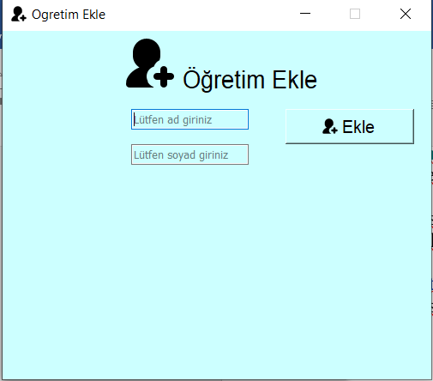

import sys  
from PyQt5.QtWidgets import *  
from PyQt5.QtGui import QFont,QIcon,QPixmap  
import sqlite3  
  
butonFont=QFont(**"Arial"**,12)  
yaziFont=QFont(**"Arial"**,16)  
  
connect=sqlite3.connect(**'database.db'**)  
cursor=connect.cursor()  
class OgretimEkle(QWidget):  
 def __init__(self):  
 super().__init__()  
 self.setGeometry(50,50,500,400)  
 self.setFixedSize(self.size())  
 self.setStyleSheet(**"background-color:#ccffff"**)  
 self.setWindowIcon(QIcon(**'resimler/add.png'**))  
 self.setWindowTitle(**"Ogretim Ekle"**)  
  
 baslik=QLabel(**"Öğretim Ekle "**,self)  
 baslik.move(210,40)  
 baslik.setFont(yaziFont)  
 resim = QLabel(self)  
 resim.setPixmap(QPixmap(**'resimler/add.png'**))  
 resim.move(140,5)  
 *##############################################* self.isim=QLineEdit(self)  
 self.isim.move(150,90)  
 self.isim.setPlaceholderText(**"Lütfen ad giriniz"**)  
 *##############################################* self.soyisim = QLineEdit(self)  
 self.soyisim.move(150, 130)  
 self.soyisim.setPlaceholderText(**"Lütfen soyad giriniz"**)  
 *##############################################* eklebuton=QPushButton(**"Ekle"**,self)  
 eklebuton.setFont(butonFont)  
 eklebuton.move(330,90)  
 eklebuton.resize(150, 40)  
 eklebuton.setFont(butonFont)  
 eklebuton.setIcon(QIcon(**'resimler/add.png'**))  
 eklebuton.clicked.connect(self.ogretimekle)  
  
  
 def ogretimekle(self):  
 isim=self.isim.text()  
 soyisim = self.soyisim.text()  
 if(isim and soyisim!=**""** ):  
  
 try:  
 cursor.execute(**"insert into ogretim(ogretimadi,ogretimsoy) values(?,?)"**,(isim,soyisim,))  
 connect.commit()  
 QMessageBox.information(self,**"Bilgi"**,**"Eklendi"**)  
 self.isim.setText(**""**)  
 self.soyisim.setText(**""**)  
  
 except:  
 QMessageBox.information(self, **"Hata"**, **"Eklenmedi"**)  
  
 else:  
 QMessageBox.information(self, **"Hata"**, **"Boş geçmeyin"**)