**REPAIR SERVICE**

**Restrictions:**

* Repair cost the same for all models of cars.

**USE Case:**

Customer

Admin

**Conceptual schema**

|  |  |
| --- | --- |
| **CAR** | **Description** |
| Manufacturer | The car manufaturer like FORD or Audi |
| Model | The car model like Focus or A6 |
| Mileage | Current car mileage |
| Owner | Owner of the car |
| Number | The car number |

|  |  |
| --- | --- |
| **SERVICE** | **Description** |
| Name | The name of the service like 'Diagnostic' |
| Price | cost of service |

|  |  |
| --- | --- |
| **USER** | **Description** |
| First name | - |
| Last name | - |
| Phone | - |
| Email | - |

|  |  |
| --- | --- |
| **ROLE** | **Description** |
| Name | Name of the role like ‘Customer’ or ‘Admin’ |

|  |  |
| --- | --- |
| **ORDER** | **Description** |
| Service | Services related to the order |
| Car | The car related to the order |
| Status | Status of this order |

**Logical schema**

|  |  |  |
| --- | --- | --- |
| **CARS** | | |
| carID | INT | Primary |
| customerID | INT | Foreign |
| manufacturer | String | - |
| Number | String | 1 char then 3 digit then 2 chars |
| model | String |  |
| mileage | INT | >=0 |

|  |  |  |
| --- | --- | --- |
| **SERVICES** | | |
| serviceID | INT | Primary |
| name | String |  |
| price | INT | >=0 |

|  |  |  |
| --- | --- | --- |
| **ROLES** | | |
| roleID | INT | Primary |
| Name | String | Role name |

|  |  |  |
| --- | --- | --- |
| **USERS** | | |
| userID | INT | Primary |
| roleID | INT | Foreign |
| firstName | String |  |
| lastName | String |  |
| phoneNumber | INT | >=0 |
| email | String | Proper email |

|  |  |  |
| --- | --- | --- |
| **ORDERS** | | |
| orderID | INT | Primary |
| serviceID | INT | Foreign |
| carID | INT | Foreign |
| status | String | Enum(open, processing, done) |

**Normalization**

|  |  |  |
| --- | --- | --- |
| **ORDERS** | | |
| orderID | INT | Primary |
| serviceID | INT | Foreign |
| carID | INT | Foreign |
| status | String | Enum(open, processing, done) |

|  |  |  |
| --- | --- | --- |
| **ORDER_INFO** | | |
| infoID | INT | Primary |
| orderID | INT | Foreign |
| serviceID | INT | Foreign |

|  |  |  |
| --- | --- | --- |
| **ORDERS** | | |
| orderID | INT | Primary |
| carID | INT | Foreign |
| status | String | Enum(open, processing, done) |

|  |  |  |
| --- | --- | --- |
| **CARS** | | |
| carID | INT | Primary |
| customerID | INT | Foreign |
| number | String | 1 char then 3 digit then 2 chars |
| manufacturer | String |  |
| model | String |  |
| mileage | INT | >=0 |

|  |  |  |
| --- | --- | --- |
| **MANUFACTURERS** | | |
| manufacturerID | INT | Primary |
| name | INT | Foreign |

|  |  |  |
| --- | --- | --- |
| **CARS** | | |
| carID | INT | Primary |
| customerID | INT | Foreign |
| manufacturerID | INT | Foreign |
| number | String | 1 char then 3 digit then 2 chars |
| model | String |  |
| mileage | INT | >=0 |

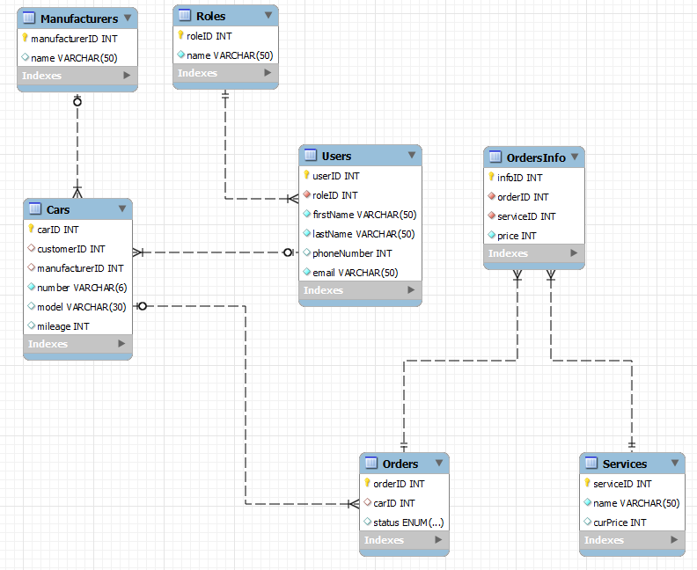

**Physical schema**

*Types:*

* Int unsigned for price, phoneNumber, mileage to restrict negative values;
* ENUM for status;
* Autoincremental int primary keys.

*Manual indexes*:

1. On email in Users;
2. On car number in Cars;
3. On price in OrdersInfo.

*Character set*: UTF-8

*Access restriction*:

1. User SELECT access to tables:

* Orders;
* OrdersInfo;
* Cars;
* Services.

1. User INSERT access to tables:

* Orders;
* OrdersInfo.

1. User DELETE access to tables:

* OrdersInfo.