RecruitAI
Information System Management Report
Recruitment Decision Support System using semantic AI matching
Prepared for: Information System Management
Scope: use case analysis, workflow analysis, system architecture, data governance, security, deployment, and managerial value.

Project | Technology Stack | Demo Scale | Default User
RecruitAI | React + Vite, FastAPI, SQLite, SQLAlchemy, Sentence Transformers | 97 jobs / 3191 candidates | HR/Admin

Executive Summary
RecruitAI is a recruitment decision support system designed to help HR users convert a large candidate pool into an explainable, auditable shortlist. The system combines master data management, semantic candidate ranking, detailed profile review, recruiter decisions, dashboard monitoring, and deployment automation.
From an Information System Management perspective, the project demonstrates how people, process, data, and technology can be integrated into one operational decision workflow. The system is not positioned as a fully autonomous hiring tool; instead, it augments HR judgment with transparent scoring components and preserves a human-in-the-loop decision record.
Management value
RecruitAI reduces screening time, standardizes evaluation evidence, improves traceability, and gives stakeholders a live view of recruitment workload and decisions.

1. Business Context and Problem Statement
Recruitment teams often handle hundreds or thousands of profiles per job opening. Manual screening is slow, inconsistent, and difficult to audit. The main information management challenge is transforming unstructured job descriptions and candidate profiles into useful, comparable decision information.
- Business problem: HR needs to find relevant candidates quickly without losing explainability.
- Information problem: candidate skills, experience, desired role, and location are spread across semi-structured text fields.
- Control problem: recruiter decisions must be stored with context so future review and reporting are possible.

2. Project Scope
Scope Area | Implemented Capability | ISM Relevance
Authentication | Login, token session, password change | Access control and accountability
Master Data | Full CRUD for jobs, candidates, and decisions | Data stewardship and operational ownership
Decision Support | AI ranking and score breakdown per candidate/job | Decision quality and information processing
Workflow | Job selection -> ranking -> candidate detail -> decision | Process standardization
Monitoring | Dashboard KPIs and decision history | Management control and feedback
Deployment | Docker Space with seeded demo data | System availability for stakeholders

3. Stakeholders and Use Case Diagram
The primary actor is the HR user or recruiter. The admin role maintains the master data and ensures the system remains usable. An instructor or viewer interacts mainly with the deployed demo, dashboard, and decision evidence during evaluation.
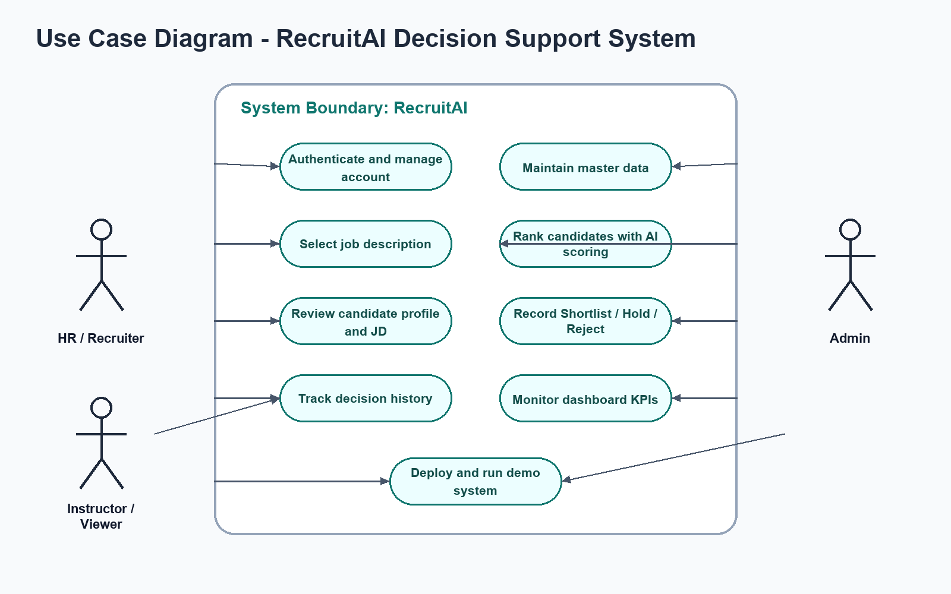
Figure 1. Use case diagram for RecruitAI.
Use Case | Actor | Outcome
Authenticate and manage account | HR/Admin | Only authorized users can use protected workflows.
Maintain master data | Admin | Jobs and candidate records remain accurate and searchable.
Select job description | HR | A specific JD becomes the basis for matching.
Rank candidates | HR | System returns top candidates with score breakdowns.
Review candidate profile and JD | HR | Decision maker sees evidence before acting.
Record decision | HR | Shortlist, Hold, or Reject is stored for audit/history.
Monitor dashboard | HR/Admin | Recruitment status and quality indicators are visible.

4. Workflow Analysis
The workflow is organized around a human-in-the-loop decision cycle. The system recommends and explains; the recruiter decides. This structure is appropriate for a management information system because it improves decision efficiency while preserving managerial control.
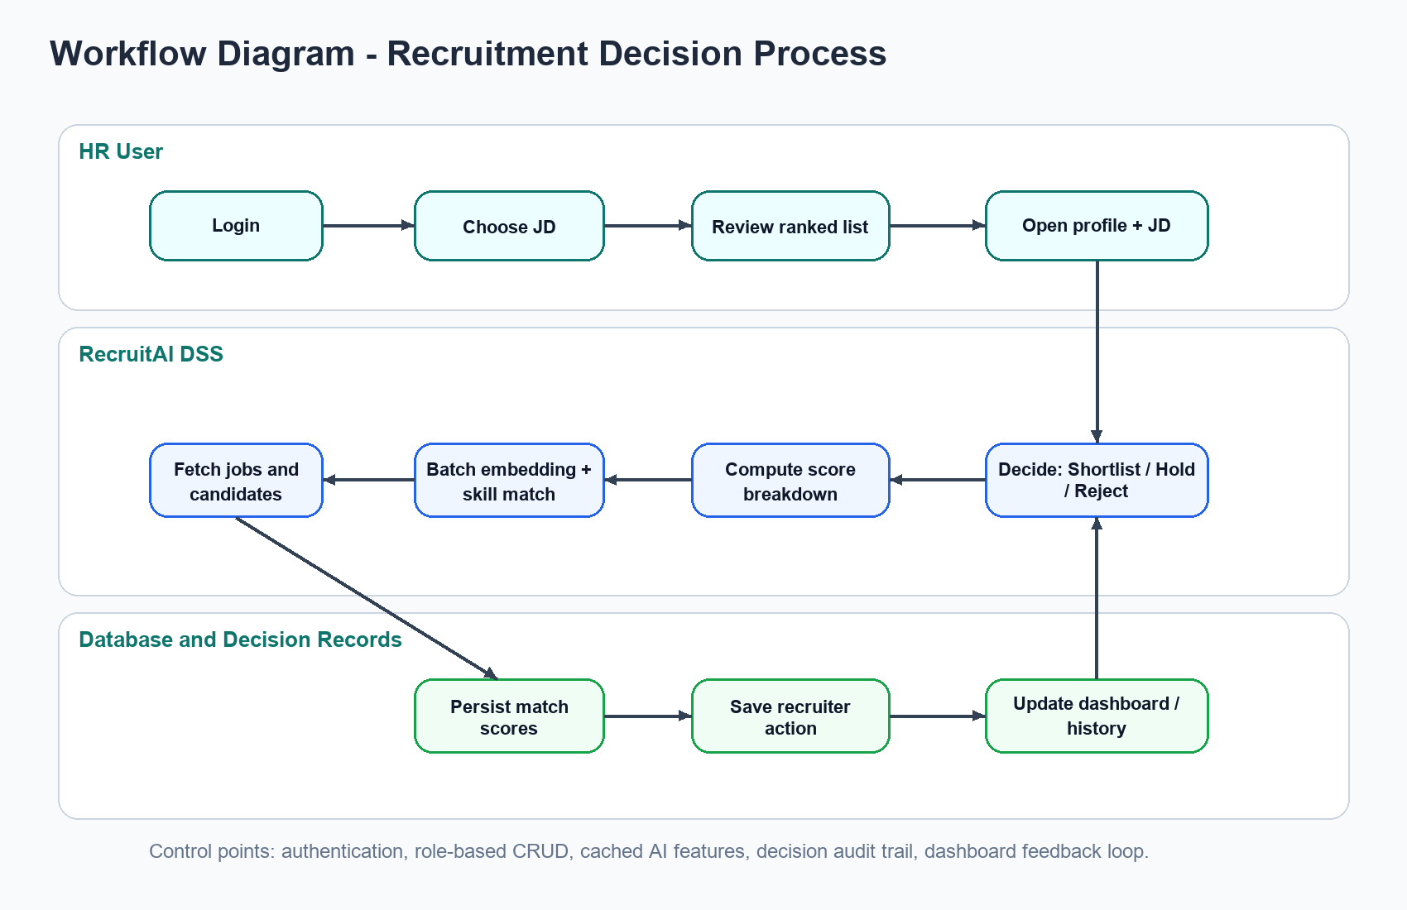
Figure 2. End-to-end recruitment workflow.
Workflow Step | System Support | Control / Output
Login | Token-based authenticated session | User accountability
Select JD | Job catalog and selected job state | Clear decision context
AI ranking | Semantic matching, skill overlap, experience/location scoring | Candidate list ranked by evidence
Detail review | Profile, JD, score details, matched/missing skills | Transparent recommendation
Decision | Shortlist/Hold/Reject and notes | Audit-ready recruiter action
Feedback | Dashboard and history update | Management reporting loop

5. System Architecture
RecruitAI follows a three-layer architecture: a React single-page application, a FastAPI application service, and a data/AI layer. For deployment, the React build is served by FastAPI inside one Docker container, which simplifies access for classroom demonstration.
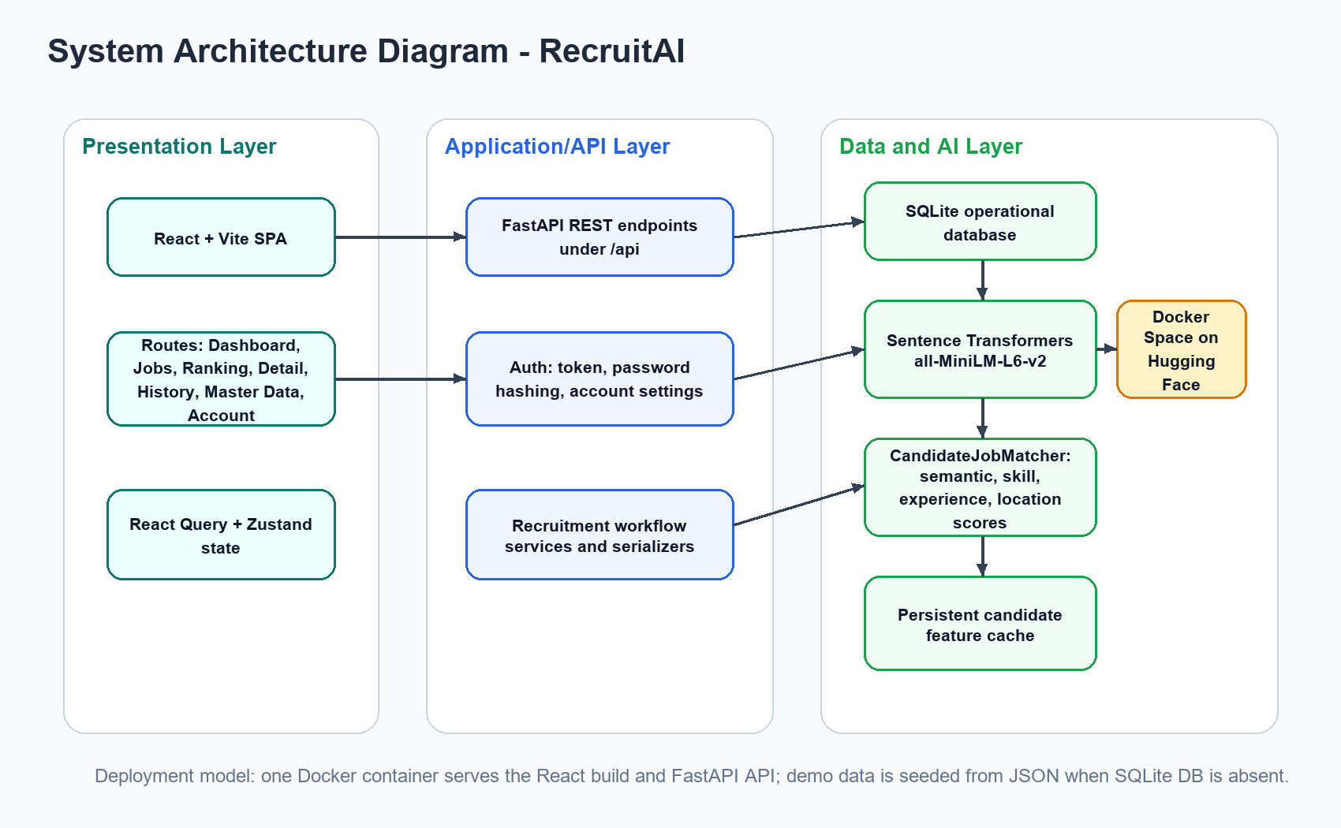
Figure 3. System architecture diagram.
Layer | Components | Responsibility
Presentation | React, Vite, React Query, Zustand, Tailwind UI | Navigation, data forms, ranking table, dashboard, decision screens
Application/API | FastAPI, Pydantic models, auth helpers, serializers | Expose REST APIs, validate payloads, enforce authentication, orchestrate workflow
Data | SQLite, SQLAlchemy models | Persist jobs, candidates, matches, recruiter actions, users
AI/Decision | Sentence Transformers, CandidateJobMatcher, feature cache | Generate embeddings, compute score components, rank candidates
Deployment | Dockerfile, HF Space startup script, demo seed JSON | Package and run the full system through one public link

6. Data Management Design
The operational database stores five central entities: Job, Candidate, Match, RecruiterAction, and User. This model separates source data from decision records, which is important because the same candidate may be evaluated against multiple jobs.
Entity | Key Fields | Management Purpose
Job | job_id, title, description, requirements, location, salary | Represents the demand side of recruitment.
Candidate | user_id, name, desired_job, skills, experience, degree, location | Represents the applicant or talent pool.
Match | job_id, user_id, fit_score, component scores | Stores computed decision-support evidence.
RecruiterAction | decision, notes, recruiter_name, timestamps | Stores final human action and audit trail.
User | username, password_hash, role | Controls access to protected functions.

7. Decision Support Logic
The matching engine combines semantic text similarity with structured business rules. Candidate and job text are embedded with all-MiniLM-L6-v2, producing 384-dimensional vectors. The final score is then computed from semantic similarity, skill overlap, experience match, and location match.
Score Component | Default Weight | How It Supports HR Decision
Text similarity | 35% | Captures semantic fit between JD and candidate desired role/skills.
Skill match | 35% | Measures overlap between extracted job requirements and candidate skills.
Experience match | 20% | Rewards candidates meeting the required years of experience.
Location match | 10% | Adds operational fit and applies penalty for explicit mismatch.

Accuracy-preserving optimization
The project caches candidate embeddings and extracted skills by content hash. This reduces ranking latency without changing the scoring formula or model.

8. Information System Management Evaluation
ISM Dimension | Assessment | Project Evidence
People | Supports HR staff rather than replacing them | Human recruiter still records final decision.
Process | Standardizes screening workflow | Job selection, ranking, profile review, decision history.
Data | Turns semi-structured text into managed decision data | SQLite schema plus demo seed data.
Technology | Uses AI/NLP within a web information system | FastAPI, React, SQLAlchemy, sentence-transformers.
Control | Provides authentication and audit trail | Token auth, password change, recruiter actions.
Performance | Improves responsiveness for large candidate lists | Cached features and paginated master data.

The system's management value is strongest in the middle layer between raw data and final hiring decision. It does not merely store records; it processes information into ranked alternatives, explanatory evidence, and dashboard feedback. This aligns with the purpose of a decision support system in management information systems.

9. Security, Privacy, and Governance
Risk | Current Control | Recommended Improvement
Unauthorized data changes | Authenticated CRUD endpoints | Add role granularity and server-side authorization policies.
Weak default credentials | Password change screen exists | Force password change on first login in production.
Candidate privacy exposure | Local SQLite and demo deployment | Mask sensitive fields and define data retention policy.
Algorithmic bias | Human-in-the-loop decision | Add fairness testing across gender/location/experience segments.
Ephemeral free hosting storage | Seed demo data on startup | Use persistent storage for production use.

10. Deployment and Operations
For classroom demonstration, the project is packaged as a Hugging Face Docker Space. The Docker image builds the frontend, installs backend dependencies, seeds the database from JSON when needed, and runs FastAPI on the required web port. This creates a single public URL for the instructor.
Operational Concern | Implementation
Startup | scripts/start_hf_space.py sets environment paths and runs seed.py if data/app.db is missing.
Data bootstrap | data/demo_seed.json contains 97 jobs and 3191 candidates.
Model cache | HF_HOME and TRANSFORMERS_CACHE point to data/processed/hf_cache.
Frontend delivery | FastAPI serves frontend/dist and /assets in the same container.
Known limitation | Free Hugging Face storage is ephemeral, so demo edits may reset after restart.

11. Limitations and Future Improvements
- Add role-based access control for separate HR, Admin, and Viewer permissions.
- Add structured import/export pipelines for CSV/Excel master data maintenance.
- Add fairness dashboards and bias checks before using the tool for real hiring decisions.
- Add persistent cloud database for production instead of ephemeral demo SQLite.
- Add interview scheduling and email notification integrations to complete the recruitment lifecycle.

12. Conclusion
RecruitAI is a strong Information System Management project because it demonstrates a complete information lifecycle: data capture, processing, decision support, human action, storage, reporting, and deployment. The system creates practical value for HR by reducing screening friction while maintaining transparency and accountability.

References
- Project source code: Recruitment Decision Support System repository.
- Backend framework: FastAPI application source in backend/main.py.
- Frontend framework: React/Vite application source in frontend/src.
- Data model: SQLAlchemy ORM models in backend/src/storage/models.py.
- AI model: Sentence Transformers all-MiniLM-L6-v2 usage in backend/src/models/embedder.py.
- Deployment: Dockerfile and Hugging Face Spaces startup script in scripts/start_hf_space.py.

