**FLAPPY ROCKET GAME**

01 Software.

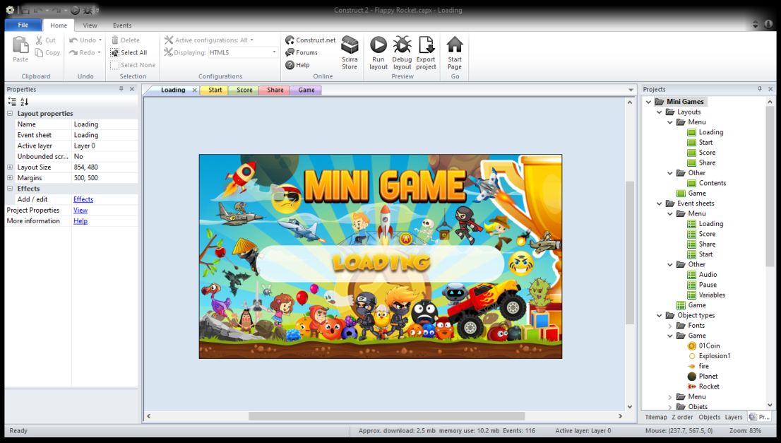

02. Share

You can edit share event sheet “Share” only this java script. You can place any link or text.

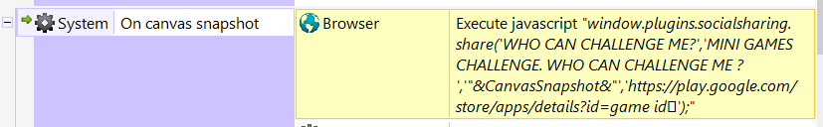

03. Variables in single sheet.

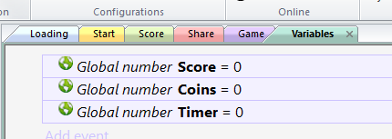

04 Double click on layouts to open and edit.

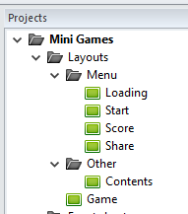

05 Double click on events to open and edit.

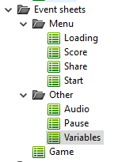

06 To edit or change graphics, double click on graphics.

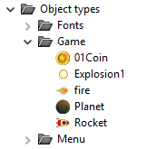

And open the images

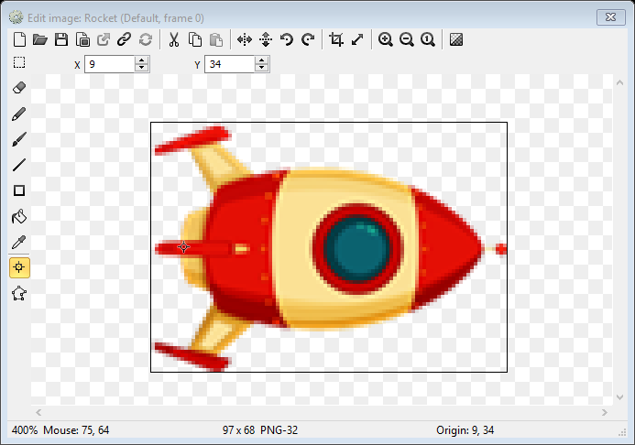

07. Build apk

Export

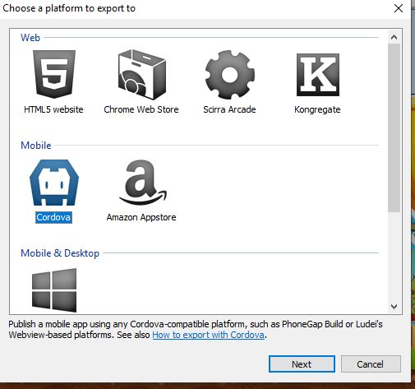

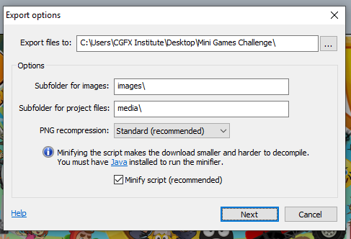

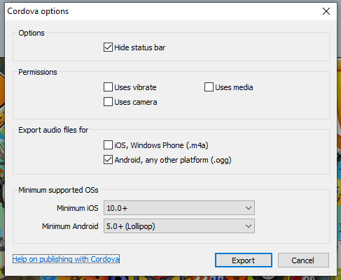

After export edit “config.xml’ to add social sharing plugin.

Add this : <plugin name="cordova-plugin-x-socialsharing" />

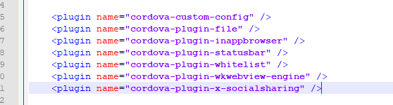

and build.

08. Ads

Admob Ads plugin:

Add your ads ids :

Select Admob Plugin and add IDs.



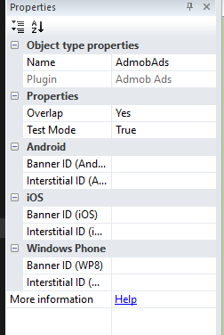

and build.

09. If you have any question or need help you can contact me.

and if you need to hire me to change or edit game use link below and login.

[Login](http://www.fiverr.com/s2/264cbcc9b1)

and after log in find me!

[Find Me](https://www.fiverr.com/cgfx_studio?up_rollout=true)

Thank you for punches!

Enjoy!