FXCM REST API

Quick Start Guide

JavaScript and node.js

1.Introduction

FXCM provides a RESTful API (henceforth the “API”) to interact with its trading platform. Among others, it allows the retrieval of historical data as well as of streaming data. In addition, it allows to place different types of orders and to read out account information. The overall goal is to allow the implementation automated, algortithmic trading programs.

In this documentation, you learn how to use JavaScript and node.js in order to connect to the API, get live feed of currency pairs, retrieve historical prices, retrieve acct / open position / closed position table, place market or entry order and modify prices of entry orders.

2. Prerequisites

To get started with the API, a demo account with FXCM is sufficient. You can open such an account under https://www.fxcm.com/uk/algorithmic-trading/api-trading/.

Also you will need to install socket.io library and then reference it in your code.

You can download the code you need from this link <https://github.com/fxcm/fxcm-api-rest-nodejs-example>

This is a node.js client which is created to help you use our REST API with ease.

Download the code and use a text editor of your choice to see the node.js program for convenience.

3. First steps

After you’ve done the required steps properly you are good to go.

Now it’s time to paste the token of your account in the *config.sample.js* file.

var config = {};

config.token = "PASTE_YOUR_TOKEN_HERE"; // get this from http://tradingstation.fxcm.com/

config.trading_api_host = 'api-demo.fxcm.com';

config.trading_api_port = 443;

config.trading_api_proto = 'https'; // http or https

module.exports = config;

Then you should rename or copy the *config.sample.js* file into *config.js*.

You are able to change the host, port and protocol also.

4. Use our node.js client

Open the command prompt of your PC and navigate do the folder you’ve saved the node.js client in.

Then run it by typing *node main.js*

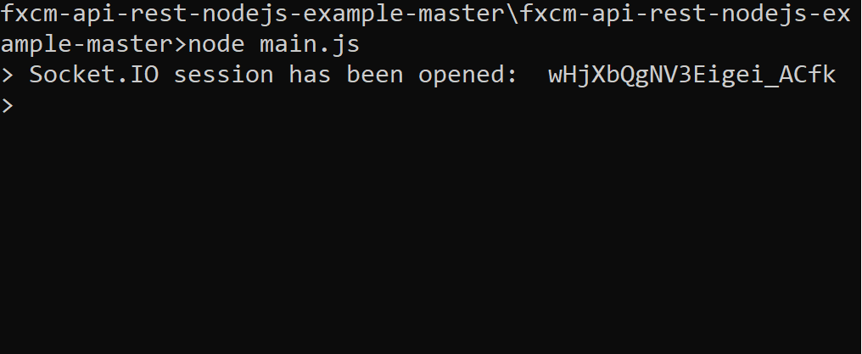

The *Socket.IO session has been opened* messagemeans that you’ve established a connection with no errors and you are ready to use the API.

You can do so by copying the commands from the *commands.txt* file.

Examples:

*Get live feed (EUR/USD):*

For the sake of convenience you can copy the required commands from here:

load {"filename":"liveprices.js"}

price_subscribe {"pairs":"EUR/USD"}

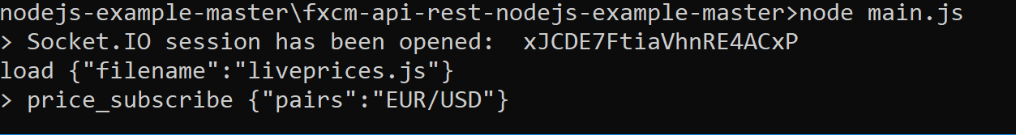

You should get a result that looks like this:

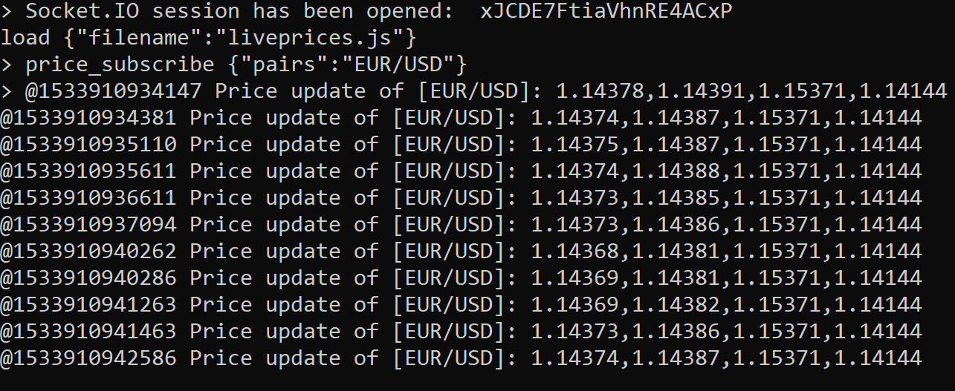

*Retrieve historical price (m1):*

send { "method":"GET", "resource":"/candles/1/m1", "params": { "num":10 } }

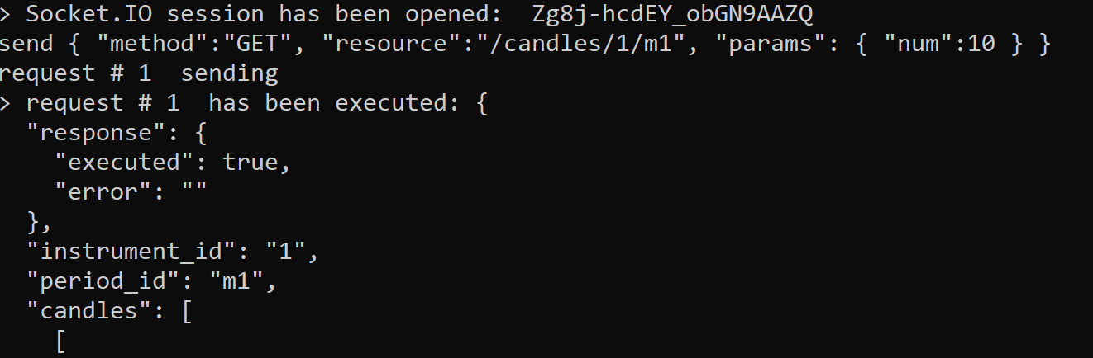

*Retrieve account / open position / closed position table :*

Account

send { "method":"GET", "resource":"/trading/get_model", "params": { "models":["Account"] } }

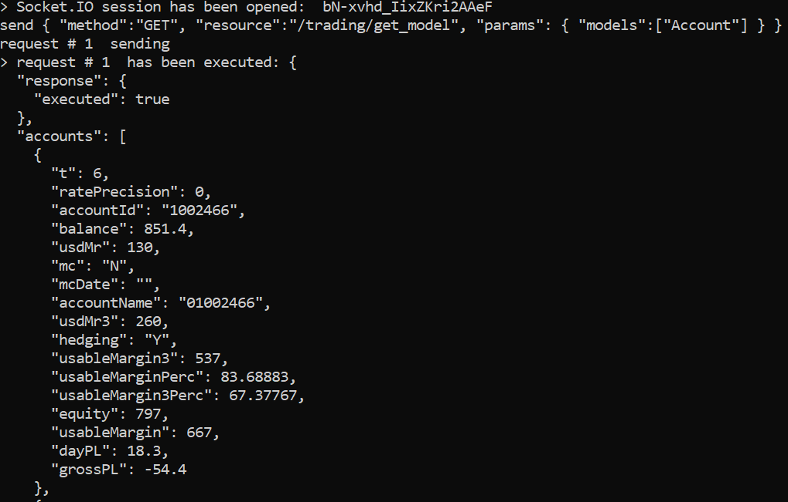

Open and Close positions

send { "method":"GET", "resource":"/trading/get_model", "params": { "models":["Offer","OpenPosition","ClosedPosition","Order","Account", "Summary","LeverageProfile","Properties"] } }

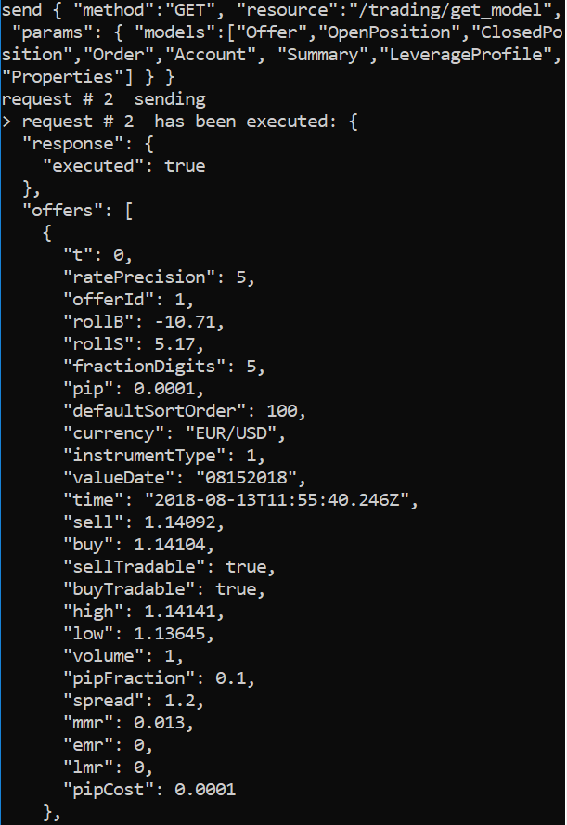

*Place market or entry order:*

Market order

send { "method":"POST", "resource":"/trading/open_trade", "params": { "account_id":"1027808", "symbol":"EUR/USD", "is_buy":true, "amount":1, "time_in_force":"FOK" } }

Please note that “account_id” is a number that you can retrieve from Account table as “accountId”.

Different accounts have different minimum trade size, and amount must be divisible by that number:

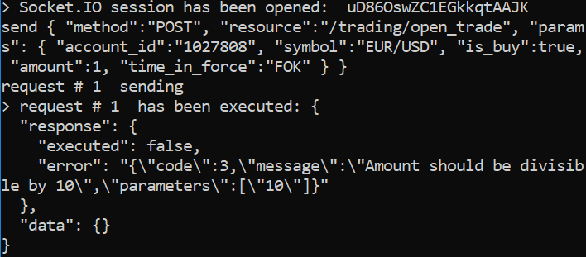

Entry order

send { "method":"POST", "resource":"/trading/create_entry_order", "params": { "account_id":"1027808", "symbol":"EUR/USD", "is_buy":true, "rate":1.22, "amount":100 } }

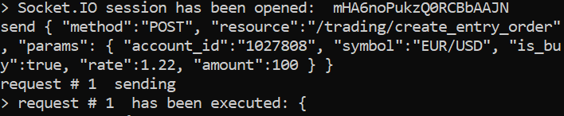

*Modify the price of entry order:*

send { "method":"POST", "resource":"/trading/change_order", "params": { "order_id":"241163945", "rate":1.25, "amount":7 } }

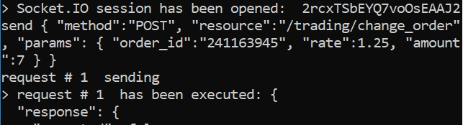

5. Conclusion

This is the JavaScript/node.js startup guide for the FXCM REST API.

Always keep in mind that your account should be valid and you have to choose the correct commands from the commands.txt file. Also be careful with the input parameters you type in the commands.