WEEK 4

DIVIDE AND CONQUER:

Divide And Conquer
This technique can be divided into the following three parts:
- Divide: This involves dividing the problem into smaller sub-problems.
- Conquer: Solve sub-problems by calling recursively until solved.
- Combine: Combine the sub-problems to get the final solution of the whole problem.

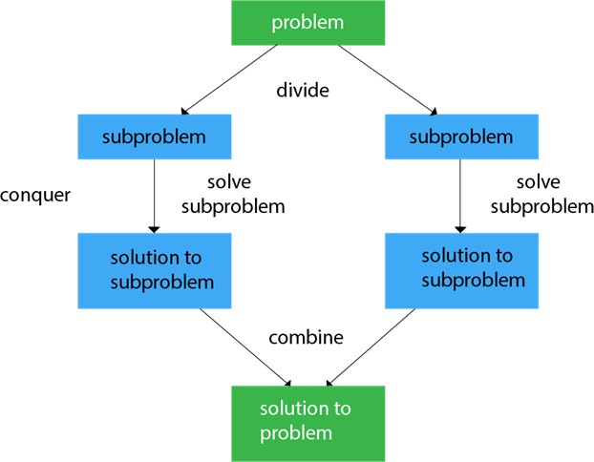

EXAMPLES:

  - Merge Sort
  - Quick Sort
  - Binary Search
  - Strassen's Matrix Multiplication

  - Closest pair (points)

MERGE SORT:
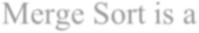
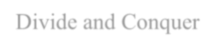
Merge Sort is a Divide and Conquer algorithm. It divides input array in two halves, calls itself for the two halves and then merges the two sorted halves.
It divides the given list in the two halves, calls itself for the two halves and then merges the
two sorted halves. We define the merge() function used to merging two halves.

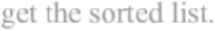
The sub lists are divided again and again into halves until we get the only one element each.
Then we combine the pair of one element lists into two element lists, sorting them in the
process. The sorted two element pairs is merged into the four element lists, and so on until we
get the sorted list.

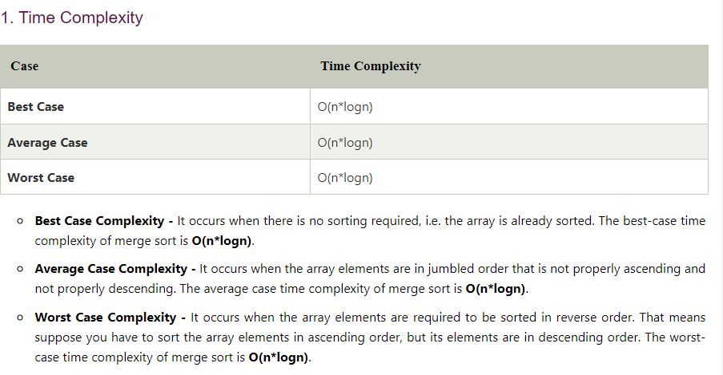

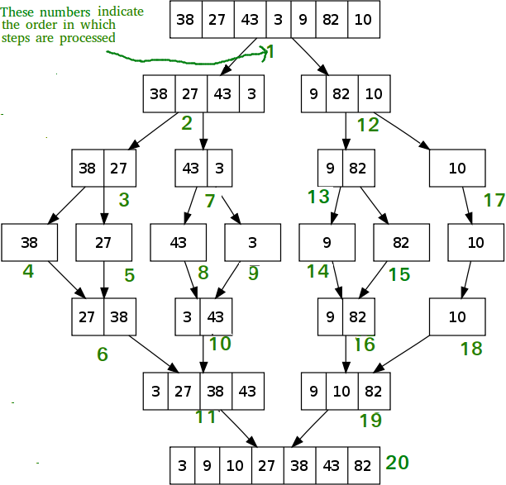

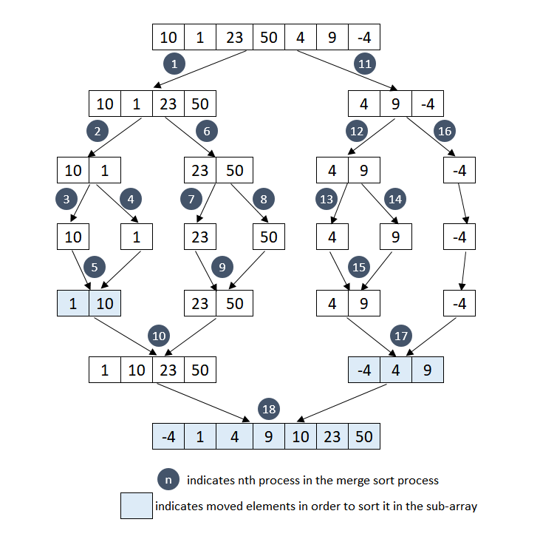

QUICK SORT:

QuickSort is a Divide and Conquer algorithm. It picks an element as pivot and partitions the given array around the picked pivot. There are many different versions of quickSort that pick pivot in different ways.
- Always pick first element as pivot.
- Always pick last element as pivot (implemented below)
- Pick a random element as pivot.
- Pick median as pivot.

Quicksort picks an element as pivot, and then it partitions the given array around the picked pivot element. In quick sort, a large array is divided into two arrays in which one holds values that are smaller than the specified value (Pivot), and another array holds the values that are greater than the pivot.

After that, left and right sub-arrays are also partitioned using the same approach. It will continue until the single element remains in the sub-array.

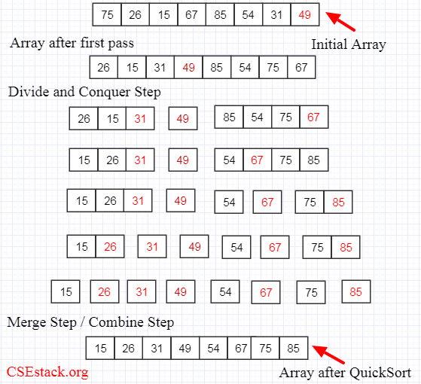

TIME COMPLEXITY AND SPACE COMPLEXITY FOR QUICK SORT
Worst Case Time Complexity [ Big-O ]: O(n2)
Best Case Time Complexity [Big-omega]: O(n*log n) Average Time Complexity [Big-theta]: O(n*log n) Space Complexity: O(n*log n)

BINARY SEARCH:

Binary search follows the divide and conquer approach in which the list is divided into two halves, and the item is compared with the middle element of the list. If the match is found then, the location of the middle element is returned. Otherwise, we search into either of the halves depending upon the result produced through the match.
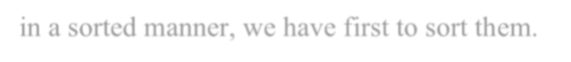
Binary search can be implemented on sorted array elements. If the list elements are not arranged
in a sorted manner, we have first to sort them.

TIME COMPLEXITY AND SPACE COMPLEXITY:

- Best Case Time Complexity of Binary Search: O(1)
- Average Case Time Complexity of Binary Search: O(logN)
- Worst Case Time Complexity of Binary Search: O(logN)
- Space Complexity of Binary Search: O(1) for iterative, O(logN) for recursive.

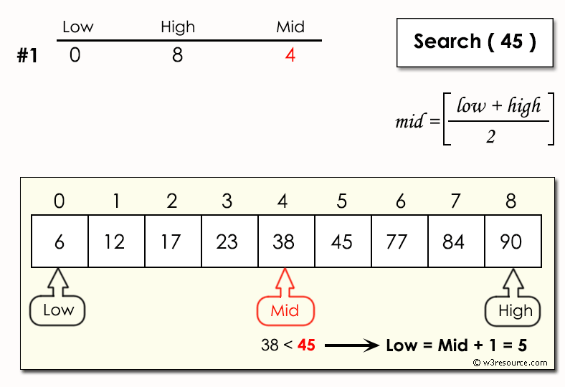
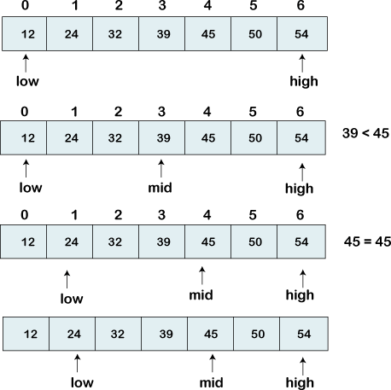

DYNAMIC PROGRAMMING:

Dynamic programming is a technique that breaks the problems into sub-problems, and saves the result for future purposes so that we do not need to compute the result again. The sub problems are optimized to optimize the overall solution is known as optimal substructure property. The main use of dynamic programming is to solve optimization problems. Here, optimization problems mean that when we are trying to find out the minimum or the maximum solution of a problem. The dynamic programming guarantees to find the optimal solution of a problem if the solution exists.

The following are the steps that the dynamic programming follows:

- It breaks down the complex problem into simpler sub problems.
- It finds the optimal solution to these sub-problems.
- It stores the results of sub problems (memorization). The process of storing the results of sub problems is known as memorization.
- It reuses them so that same sub-problem is calculated more than once.
- Finally, calculate the result of the complex problem.
EXAMPLE:
The Fibonacci numbers are the numbers in the following integer sequence. 0, 1, 1, 2, 3, 5, 8, 13, 21, 34, 55, 89, 144,…

BACKTRACKING: (CONCEPT ONLY)

Backtracking is an algorithmic-technique for solving problems recursively by trying to build a solution incrementally, one piece at a time, removing those solutions that fail to satisfy the constraints of the problem at any point of time

There are three types of problems in backtracking –

- Decision Problem – In this, we search for a feasible solution.
- Optimization Problem – In this, we search for the best solution.
- Enumeration Problem – In this, we find all feasible solutions.

In backtracking, if the current solution is not suitable, then we backtrack and try to find other solutions. Hence, recursion is used. This approach is used to solve problems that have multiple solutions.

GREEDY ALGORITHM TECHINQUE:

This method is used for solving optimization problems. An optimization problem is a problem that demands either maximum or minimum results.

The Greedy method is the simplest and straightforward approach. It is not an algorithm, but it is a technique. The main function of this approach is that the decision is taken on the basis of the currently available information. Whatever the current information is present, the decision is made without worrying about the effect of the current decision in future.

This technique is basically used to determine the feasible solution that may or may not be optimal. The feasible solution is a subset that satisfies the given criteria. The optimal solution is the solution which is the best and the most favorable solution in the subset. In the case of feasible, if more than one solution satisfies the given criteria then those solutions will be considered as the feasible, whereas the optimal solution is the best solution among all the solutions

Applications of Greedy Algorithm
- It is used in finding the shortest path.
- It is used to find the minimum spanning tree using the prim's algorithm or the Kruskal's algorithm.
- It is used in a job sequencing with a deadline.
- This algorithm is also used to solve the fractional knapsack problem.

POINTS TO REMEMBER:

- To construct the solution in an optimal way, this algorithm creates two sets where one set contains all the chosen items, and another set contains the rejected items.
- A Greedy algorithm makes good local choices in the hope that the solution should be either feasible or optimal.

