Vue.js

Directives are prefixed with  v-

They indicate that they are special attributes provided by Vue, and as you may have guessed, they apply special reactive behavior to the rendered DOM.

v-bind

The v-bind attribute you are seeing is called a **directive**.  Here, it is basically saying “keep this element’s title attribute up-to-date with the message property on the Vue instance.”

v-if

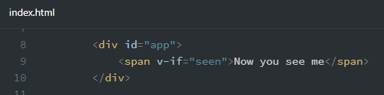 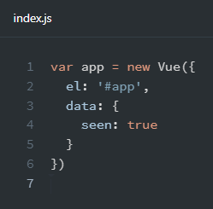

This example demonstrates that we can bind data to not only text and attributes, but also the **structure**of the DOM. Moreover, Vue also provides a powerful transition effect system that can automatically apply [**transition effects**](https://vuejs.org/v2/guide/transitions.html)  when elements are inserted/updated/removed by Vue.

v-for

can be used for displaying a list of items using the data from an Array:

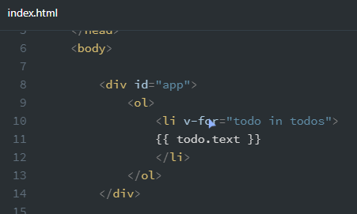 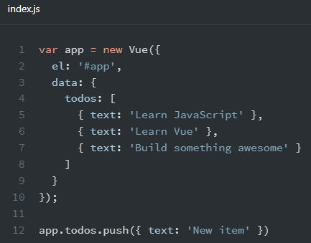

Result:

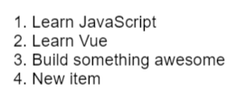

v-on

To let users interact with your app, we can use the v-on directive to attach event listeners that invoke methods on our Vue instances:

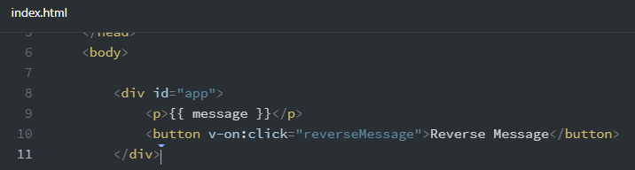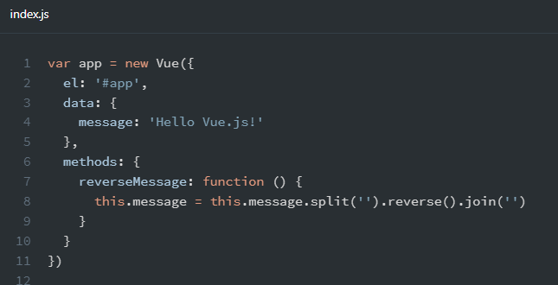

Result:

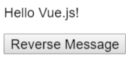 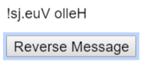 

Note that in this method we update the state of our app without touching the DOM - all DOM manipulations are handled by Vue, and the code you write is focused on the underlying logic.

v-model

Vue also provides the v-model directive that makes two-way binding between form input and app state a breeze:

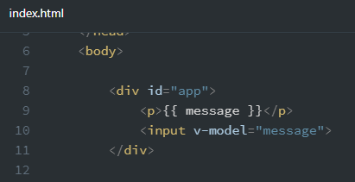 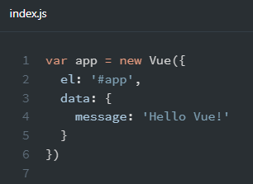

Results:

