Consider integer numbers from 0 to n - 1 written down along the circle in such a way that the distance between any two neighboring numbers is equal (note that 0 and n - 1 are neighboring, too).

Given n and firstNumber, find the number which is written in the radially opposite position to firstNumber.

Example

For n = 10 and firstNumber = 2, the output should be  
circleOfNumbers(n, firstNumber) = 7.

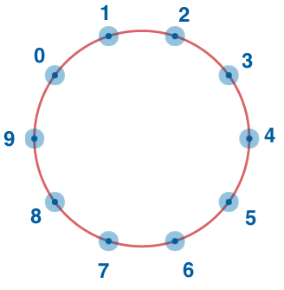

Input/Output

* **[execution time limit] 4 seconds (js)**
* **[input] integer n**

A positive **even** integer.

*Guaranteed constraints:*  
4 ≤ n ≤ 20.

* **[input] integer firstNumber**

*Guaranteed constraints:*  
0 ≤ firstNumber ≤ n - 1.

* **[output] integer**

**[JavaScript] Syntax Tips**